Prompt:

añade a la imagen adjunta Blueprint lines and glowing cyan (#00A8FF) technical overlays superimposed on the structure. Deep navy blue sky (#0A1128), subtle golden lights from construction cranes.

Prompt:

From the attached image generate an image including Blueprint grid lines and structural annotations (like load vectors) in cyan (#00A8FF) are overlaid on the image. Dark navy blue color grading in the shadows. Photorealistic architectural render, professional, clean, 8k.

Prompt:

From attached image generate an image of Structural engineering analysis of a tall skyscraper with a distinctive cantilevered top section, resembling Torre Insignia in Panama. The image shows a 3D finite element model in Autodesk Robot Structural Analysis software. White and grey wireframe mesh on a dark grid background. Visible nodes, beams, and columns. The lower section is a detailed core, while the top heavy block is supported by massive transfer beams. Technical interface, stress analysis colors (red to blue) showing tension and compression. High resolution, architectural engineering render, blueprint style.

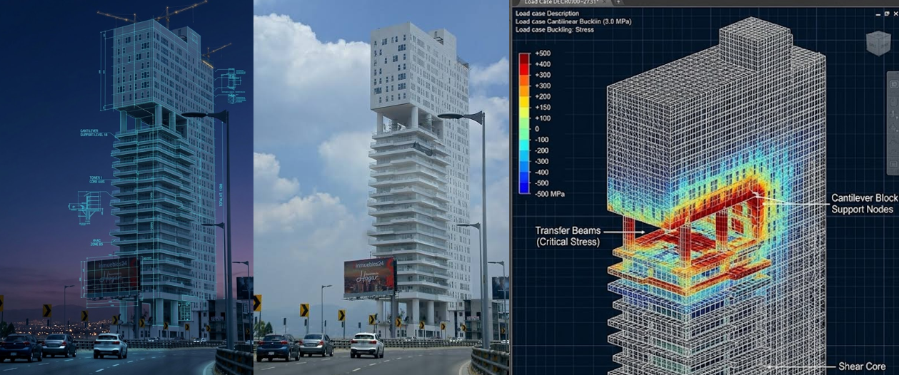

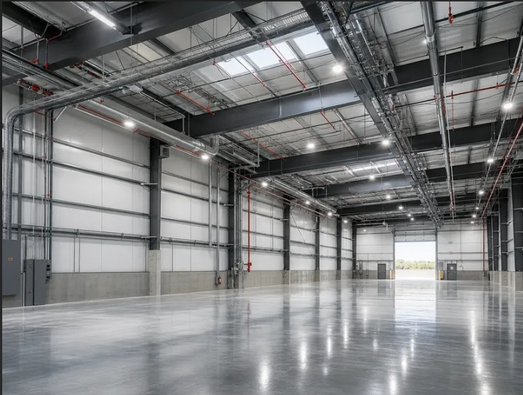
Prompt:
from the image atached generate the image of Structural engineering analysis of the structure in tha image. The image shows a 3D finite element model in Autodesk Robot Structural Analysis software. White and grey wireframe mesh on a dark grid background. Visible nodes, beams, and columns. The lower section is a detailed core, while the top heavy block is supported by massive transfer beams. Technical interface, stress analysis colors (red to blue) showing tension and compression. igh resolution, architectural engineering render, blueprint style.
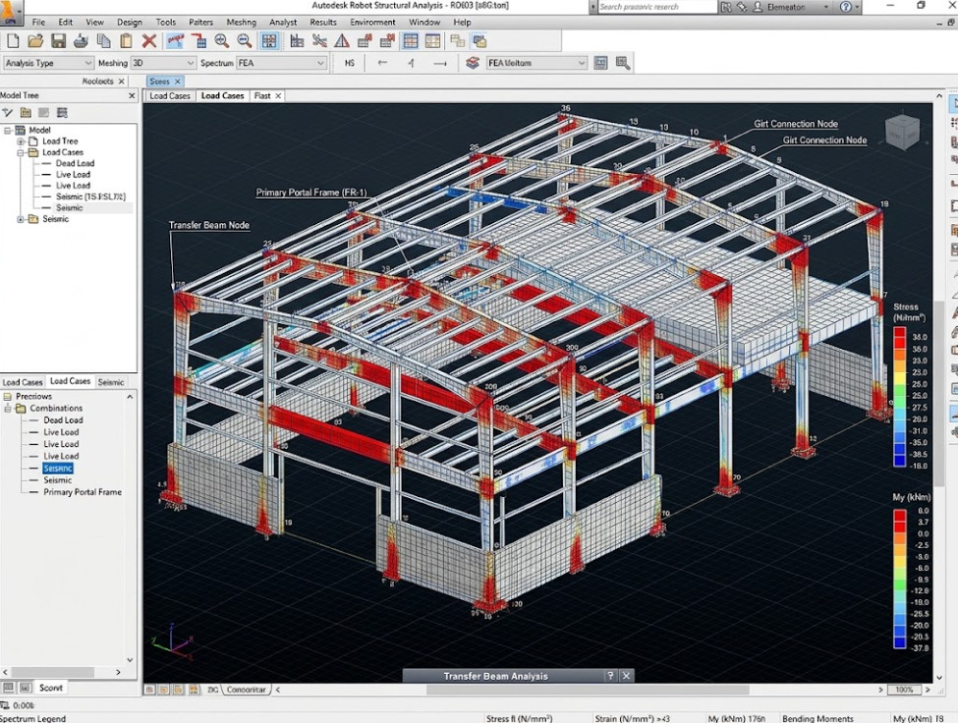
Prompt:
from the atached image generate an image of Technical blueprint lines in cyan (#00A8FF) and golden (#D4AF37) overlay the steel beams, showing load distribution. Wide-angle lens, dark navy blue shadows, photorealistic, industrial engineering aesthetic, 8k.
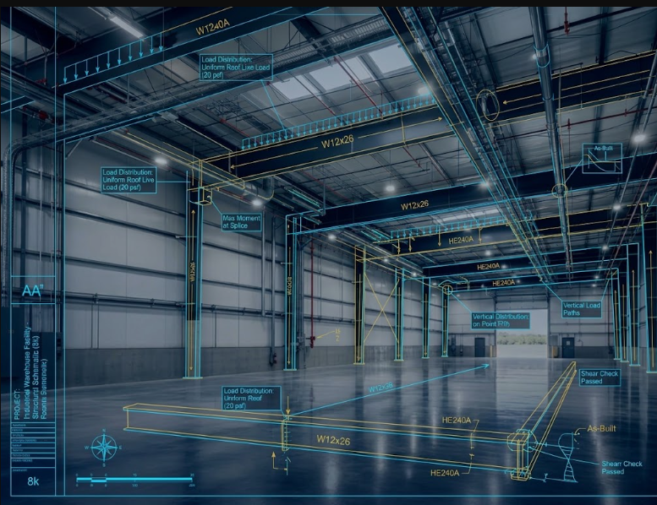

Prompt: Technical blueprint lines in cyan (#00A8FF) and golden (#D4AF37) overlay the steel beams, showing load distribution. Wide-angle lens, dark navy blue shadows, photorealistic, industrial engineering aesthetic, 8k.
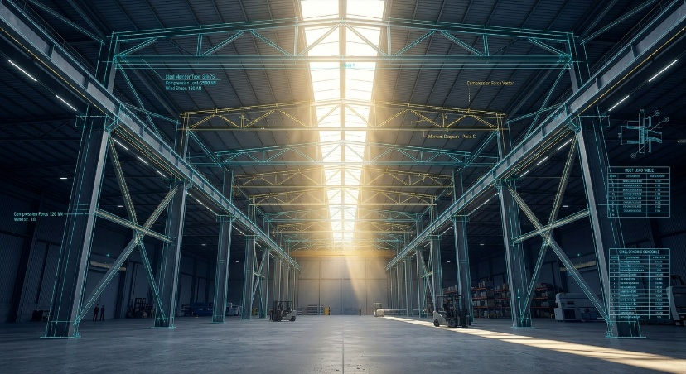

Prompt: Blueprint lines and glowing cyan (#00A8FF) technical overlays superimposed on the structure. Deep navy blue sky (#0A1128), subtle golden lights from construction cranes. 3D isometric render style, highly detailed, professional engineering aesthetic, 8k resolution, photorealistic.
