1. Introduction
This document provides information on the AI-enabled internal developer platform for web content creation and deployment in an on-premise, governance environment (NGINE). It will cover topics such as features of the application, the installation/ configuration process, and the overall architecture/ functionality. The application is built on top Bolt.diy, an open-source browser-first AI coding environment with a server-side LLM orchestration layer

2. Features
- Prompt to preview experience for web page generation
- LLM orchestration components
- Drag and drop editing capabilities for generated pages
- One-click deployment of generated pages
- Analytics tracking for deployed pages
These features are intentionally connected as one continuous workflow: the user begins in chat, iterates in preview, refines visually if needed, deploys the generated project, and then monitors usage through deployment analytics.

3. Installation configurations
3.1 Installation
Clone the repository and navigate into the project repository:
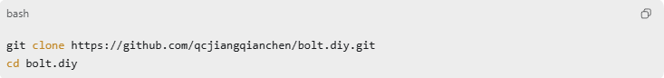
3.2 Environment variable configurations
Create a .env file in the bolt.diy root directory with the following content:
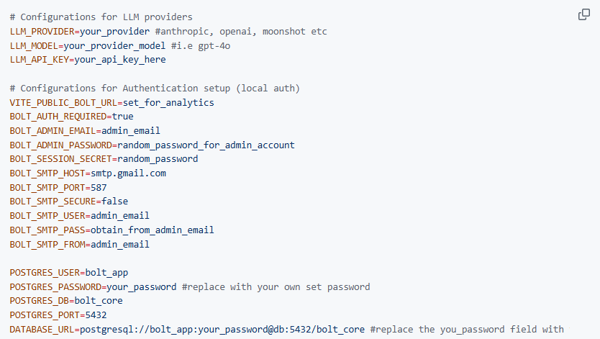
3.3 Authentication setup and login flow
Authentication in this application supports two login paths:
- a configured admin account from environment variables
- local user accounts created through signup and verified by email
3.3.1 Minimum settings required for authentication
To ensure authentication works properly, the following variables must be set:
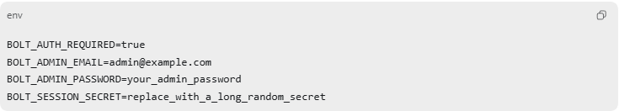
These are required because:
- BOLT_AUTH_REQUIRED=true forces protected routes and APIs to require login.
- BOLT_ADMIN_EMAIL and BOLT_ADMIN_PASSWORD define the fallback admin account.
- BOLT_SESSION_SECRET is used to sign the __bolt_session cookie. Without it, session handling will be insecure or inconsistent across restarts.
3.3.2 Admin login flow
If only the admin account is needed:
- Set BOLT_AUTH_REQUIRED=true
- Set BOLT_ADMIN_EMAIL
- Set BOLT_ADMIN_PASSWORD
- Set BOLT_SESSION_SECRET
- Start the application
- Open /login
- Sign in using the configured admin email and password
This is the simplest way to enable authentication for testing or controlled internal use.
3.3.3 User signup and email verification flow
If non-admin users should be able to create accounts, SMTP must also be configured.
Required SMTP variables:
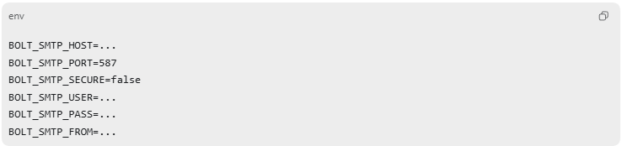
User account flow:
- The user opens /signup
- The user enters email, password, and confirm password
- The server creates a pending account and generates a 6-digit verification code
- The verification code is sent by email
- The user is redirected to /verify-account
- The user enters the 6-digit code
- If the code is valid, the account is marked as verified and a session is created
- The user is signed in automatically
Important notes:
- Password must be at least 8 characters
- Verification codes expire after 15 minutes
- Unverified users cannot log in
- If SMTP is not configured, signup and password reset emails will not be delivered
3.3.4 Configuring Gmail properly to ensure SMTP works
The app sends verification and reset emails through SMTP.
If you are using a Gmail account, you cannot use your normal Gmail password directly.
You must use a Google App Password.
Step 1: Sign in to the Gmail account that will send emails
Open:
- Gmail
- or Google Account
Sign in with the Gmail account that should send verification emails, for example:
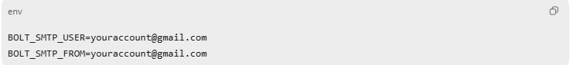
Step 2: Turn on 2-Step Verification
Google requires 2-Step Verification before App Passwords can be created.
Steps:
- Open Google Account Security
- Find 2-Step Verification
- Click Turn on 2-Step Verification
- Follow Google’s setup steps
- Complete the phone / prompt / authentication verification process
After this is enabled, you can create an App Password.
Note:
- If you are using a work or school Google account, this option may be restricted by your administrator
- If App Passwords does not appear, the account may be managed, restricted, or using Advanced Protection

Step 3: Create a Gmail App Password
Steps:
- Go to App Passwords
- Sign in again if prompted
- Under app selection, choose:
  - Mail
  - or choose Other (Custom name) and enter something like bolt.diy
- Click Generate
- Google will show a 16-character app password
Example format shown by Google:
This is not your normal Gmail password.
This generated password is what the app must use for SMTP.

Step 4: Put the Gmail SMTP settings into .env
Use the following values:
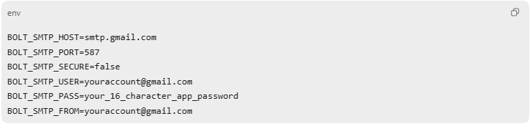
Recommended example: 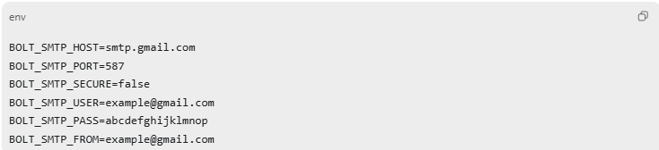

Important notes about BOLT_SMTP_PASS
- Use the App Password, not your Gmail password
- Google displays it with spaces, but in .env it is safest to:
  - either remove the spaces, or
  - wrap the value in quotes
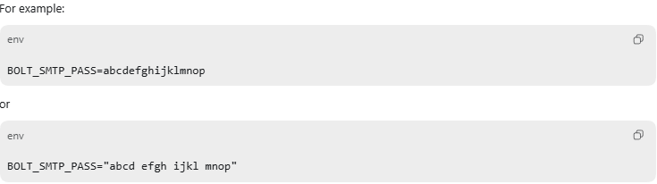
If this value is wrong, signup and reset-password emails will fail silently or not arrive.

Step 5: Restart the application
After updating .env, restart the app:
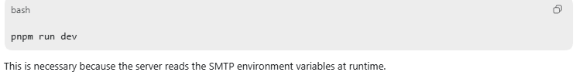

3.4 Analytics setup and Verification
Analytics in this application are not enabled manually inside the generated app code.
Instead, analytics are injected automatically during deployment.
3.4.1 How analytics works
When a generated project is deployed, the deployment route injects a tracker script into the generated index.html.
That script:
- sends a pageview event on page load
- tracks client-side route changes
- calls back to the main bolt.diy server through /api/stats
Analytics will only work if the deployed page can reach the bolt.diy server’s public URL.
3.4.2 Required setting for analytics
The most important variable is:
We will be passing this link into an ngrok tunnel to bolt.
1. Install and configure ngrok
Step 1: Create an ngrok account
- Open ngrok
- Sign up for an account
- Log in to the ngrok dashboard
- Find your authtoken in the dashboard getting-started page
ngrok requires an authenticated agent for normal usage.
Step 2: Install ngrok
Install the ngrok agent on the machine running bolt.diy.
After installation, verify it is available:
Step 3: Connect ngrok to your account
Run:
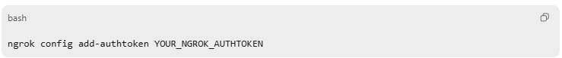
Replace YOUR_NGROK_AUTHTOKEN with the token from the ngrok dashboard.
This saves your token to ngrok’s local configuration so future tunnels can start successfully.

After this, start the application normally, and confirm that Bolt.diy runs on port 5173
3.4.3 Start a ngok tunnel to bolt
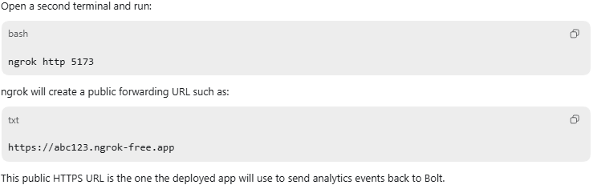
Important
Use the HTTPS forwarding URL, not the HTTP one.

3.4.4 Set vite_public_bolt_url
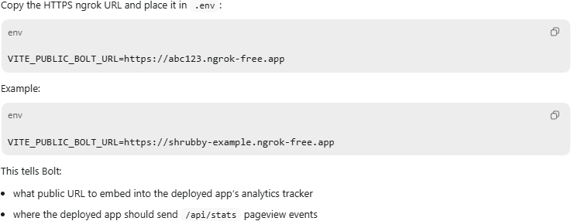

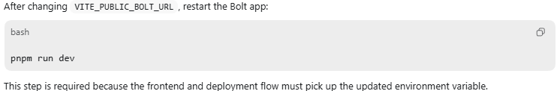
3.4.5 Redeploy the generated application
This is the most important step that is often missed.
The analytics tracker is injected during deployment.
That means if the app was already deployed before VITE_PUBLIC_BOLT_URL was set correctly, the deployed app will still contain the wrong tracker configuration.
So the user must:
- generate or open the project in Bolt
- click Deploy
- deploy the app again after VITE_PUBLIC_BOLT_URL has been set and Bolt has been restarted
Only then will the deployed index.html contain the correct analytics tracker script.

3.4.6 Common mistakes that stop analytics from working
1. VITE_PUBLIC_BOLT_URL still points to localhost
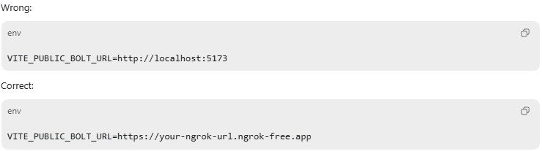
2. Bolt was not restarted after editing .env
The app must be restarted after updating VITE_PUBLIC_BOLT_URL.
3. The app was not redeployed
Analytics is injected into the deployed index.html during deployment, so an old deployment will still use the old URL.
4. ngrok was stopped
If the ngrok process is closed, the public URL stops working and analytics requests will fail.
5. Free ngrok URL changed
On free plans, the ngrok URL may change every time the tunnel restarts.
If that happens, the user must:
- copy the new ngrok URL
- update VITE_PUBLIC_BOLT_URL
- restart Bolt
- redeploy the generated app

3.5 Running locally
Prerequisites for Local Development
- Docker Desktop installed and running
- Node.js (v18 or higher) and npm installed
- Git for cloning the repository

Starting the application (docker container)
Run the following commands in the terminal to start up the application and its database as well:
docker compose --profile developement build --no-cache
docker compose --profile development up -d
To confirm that the docker containers are running as intended:
docker compose ps

4. Database design
The application uses a PostgreSQL database as the core persistence layer for user accounts, chat history, generated project state, deployment records, and associated file snapshots.
4.1 Design rationale
A relational database was selected because the application contains many entities with strong relationships, such as:
- one user having many chats
- one chat belonging to one project
- one project containing many snapshots
- one snapshot containing many files
- one deployment being associated with one project and one user
Although generated files and chat messages can be large in size, the data still benefits from relational structure because ownership, traceability, versioning, and consistency are important. To support this, the schema stores large file contents separately in a deduplicated blob table, while relational tables are used to maintain the links between users, chats, projects, and snapshots.
4.2 Schema overview and entity relations
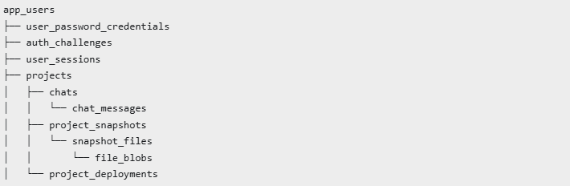

4. Architecture summary
The platform follows a split-runtime model with three major execution domains.
4.1 Browser Runtime
The browser is responsible for the interactive user experience and local orchestration concerns, including:
- Chat UI and message composition
- Incremental parsing of streamed model responses
- Preview iframe updates
- Visual (drag and drop) editing through GrapeJS
- WebContainer-backed project interaction

Relevant files:
- app/components/chat/Chat.client.tsx
- app/lib/hooks/useMessageParser.ts
- app/components/workbench/Preview.tsx
- app/components/workbench/VisualEditor.client.tsx

4.2 Server Runtime
The server runtime is responsible for orchestration, deployment, and ingestion workflows that should not be handled directly in the browser. These include:
- LLM request handling through /api/chat
- Deployment preparation and Fly execution through /api/deploy-docker
- Analytics event ingestion through /api/stats
- Authentication and session validation

Relevant files:
- app/routes/api.chat.ts
- app/routes/api.deploy-docker.ts
- app/routes/api.stats.ts
- app/lib/auth/*
4.3 WebContainer Runtime
The WebContainer layer acts as the isolated project execution environment used during generation and refinement. It supports:
- Filesystem writes generated by model actions
- Shell command execution for build/start tasks
- Local preview hosting for generated applications
This allows the platform to simulate a development workflow in-browser while keeping orchestration logic in the server layer

4.3 Architecture diagram
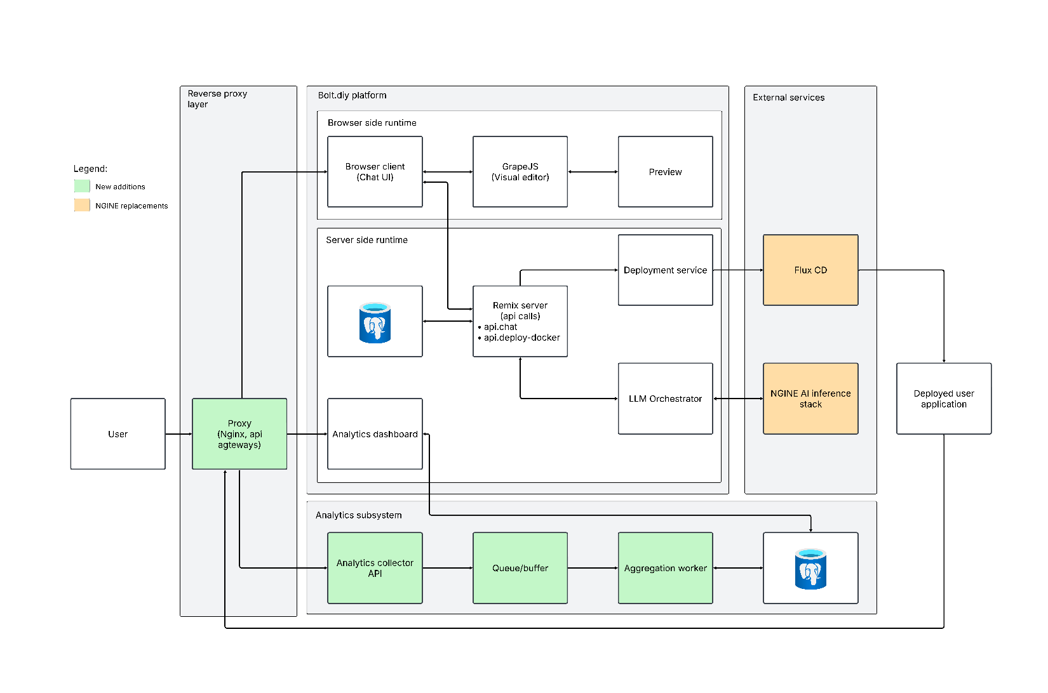

5. Prompt to preview orchestration
5.1 Prompt submission
The user enters a prompt through the chat interface implemented in app/components/chat/Chat.client.tsx. The client sends a request to /api/chat with:
- Prompt text and prior messages
- Active prompt variant
- Chat mode such as build or discuss
- Current project files and context state
- Optional metadata
5.2 Chat API entry point
app/routes/api.chat.ts is the request entry point. The route performs these steps:
- Validates the requesting user
- Parses the request payload
- Initializes stream lifecycle infrastructure
- Processes MCP tool invocations where applicable
- Delegates the actual provider call to stream-text.ts
- Returns progress, usage, and response annotations to the UI
5.3 LLM Streaming orchestration
app/lib/.server/llm/stream-text.ts is the runtime orchestration layer for LLM calls. It is responsible for:
- Resolving the provider and model
- Normalizes message content before it reaches the provider.
- Injecting runtime constraints such as context files and locked files
- Applying mode-specific behavior for build and discuss workflows
  - Build mode for code generation.
  - Discuss mode for response-oriented interaction.
- Sends the final request through the AI SDK stream API.
5.4 Provider-agnostic model routing
app/lib/.server/llm/model-factory.ts provides a provider-agnostic abstraction for model selection. It resolves the correct adapter based on runtime configuration variables such as:
- LLM_PROVIDER
- LLM_MODEL
- LLM_BASE_URL
- LLM_API_KEY
Because this abstraction sits between the API routes and provider-specific SDKs, the rest of the application can remain stable when switching providers.
5.5 Prompt stack and policy enforcement
The prompt behavior is defined across:
- app/lib/common/prompt-library.ts
- app/lib/common/prompts/prompts.ts
- app/lib/common/prompts/new-prompt.ts
- app/lib/common/prompts/discuss-prompt.ts
The flow is:
- PromptLibrary selects a template by promptId.
- Build mode uses prompts.ts and new-prompt.ts.
- Discuss mode uses discuss-prompt.ts.
- stream-text.ts merges the prompt with runtime constraints such as files, locked files, and summaries.
- api.chat.ts uses CONTINUE_PROMPT when a response needs continuation.
The prompt library selects the appropriate base prompt by promptId and chat mode. stream-text.ts then merges these base instructions with runtime constraints before the provider request is sent.
5.6 Streaming parser and action execution
The model output is parsed incrementally so the UI can react before the full response completes.
Relevant files:
- app/lib/hooks/useMessageParser.ts
- app/lib/runtime/message-parser.ts
- app/lib/runtime/enhanced-message-parser.ts
- app/lib/runtime/action-runner.ts
- app/lib/stores/workbench.ts
Behavior:
- useMessageParser processes assistant text as it arrives.
- StreamingMessageParser handles explicit bolt tags such as <boltArtifact> and <boltAction>.
- EnhancedStreamingMessageParser adds fallback extraction for markdown, code blocks, and shell snippets.
- Parser callbacks feed workbench events such as onArtifactOpen, onActionOpen, onActionStream, and onActionClose.
- ActionRunner executes file, shell, start, build, and deploy-related actions.
5.7 Preview refresh
Preview behavior is coordinated through:
- app/lib/stores/workbench.ts
- app/lib/stores/previews.ts
- app/components/workbench/Preview.tsx
Whenever actions mutate files or runtime state, the preview store emits a refresh signal. The preview iframe then reloads, allowing the user to observe the generated application in near real time.
5.8 User sequence diagram
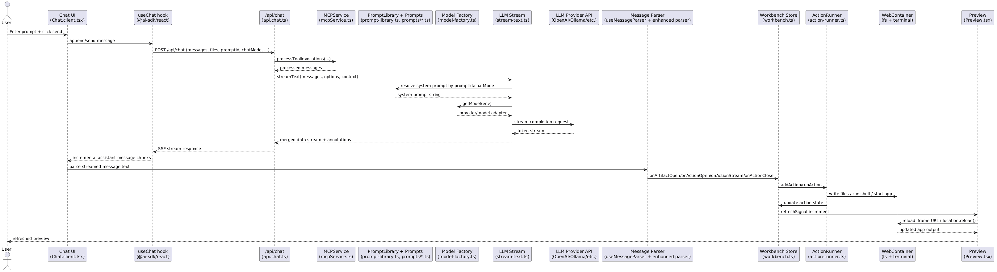

Insert the code below into a UML diagram generator to obtain a clearer image:
@startuml
actor User
participant "Chat UI\n(Chat.client.tsx)" as Chat
participant "useChat hook\n(@ai-sdk/react)" as UseChat
participant "/api/chat\n(api.chat.ts)" as ApiChat
participant "MCPService\n(mcpService.ts)" as MCP
participant "PromptLibrary + Prompts\n(prompt-library.ts, prompts/*.ts)" as Prompts
participant "Model Factory\n(model-factory.ts)" as ModelFactory
participant "LLM Stream\n(stream-text.ts)" as StreamText
participant "LLM Provider API\n(OpenAI/Ollama/etc.)" as Provider
participant "Message Parser\n(useMessageParser + enhanced parser)" as Parser
participant "Workbench Store\n(workbench.ts)" as Workbench
participant "ActionRunner\n(action-runner.ts)" as Runner
participant "WebContainer\n(fs + terminal)" as WC
participant "Preview\n(Preview.tsx)" as Preview

User -> Chat: Enter prompt + click send
Chat -> UseChat: append/send message
UseChat -> ApiChat: POST /api/chat (messages, files, promptId, chatMode, ...)

ApiChat -> MCP: processToolInvocations(...)
MCP --> ApiChat: processed messages

ApiChat -> StreamText: streamText(messages, options, context)
StreamText -> Prompts: resolve system prompt by promptId/chatMode
Prompts --> StreamText: system prompt string
StreamText -> ModelFactory: getModel(env)
ModelFactory --> StreamText: provider/model adapter
StreamText -> Provider: stream completion request
Provider --> StreamText: token stream
StreamText --> ApiChat: merged data stream + annotations
ApiChat --> UseChat: SSE stream response
UseChat --> Chat: incremental assistant message chunks

Chat -> Parser: parse streamed message text
Parser -> Workbench: onArtifactOpen/onActionOpen/onActionStream/onActionClose
Workbench -> Runner: addAction/runAction
Runner -> WC: write files / run shell / start app
Runner -> Workbench: update action state
Workbench -> Preview: refreshSignal increment
Preview -> WC: reload iframe URL / location.reload()
WC --> Preview: updated app output
Preview --> User: refreshed preview
@enduml

6. Visual editing with GrapeJs
6.1 Integration Layer
The visual editor is primarily implemented through:
- app/components/workbench/VisualEditor.client.tsx
- app/components/workbench/BlocksPanel.client.tsx
- app/lib/stores/visualEditorStore.ts
VisualEditor.client.tsx dynamically loads GrapeJS on the client and initializes the editor canvas, while BlocksPanel.client.tsx exposes the block manager and related UI controls.
6.2 Block and Component Model
Custom visual elements are defined in the BLOCKS array inside VisualEditor.client.tsx. New blocks can be introduced by:
- Adding a new block definition
- Registering it through editor.Blocks.add(...)
- Optionally adding a custom component type through editor.Components.addType(...)
This makes the visual editing layer extensible without requiring changes to the rest of the orchestration pipeline.
6.3 Drag-and-Drop Behavior
Drag-and-drop interaction is governed by component defaults such as:
- draggable
- droppable
- resizable
The implementation also differentiates between structural layout blocks and leaf content nodes, allowing the editor to provide stronger placement constraints and more useful resize behavior.
6.4 Synchronization with Project Files
The visual editor is not an isolated canvas. It synchronizes with the actual project files in the WebContainer environment. When the user edits visually, the corresponding HTML and CSS are written back to the project; when the LLM updates those files, the editor can resynchronize the canvas state.
This synchronization is coordinated through shared atoms and update signals to avoid write-loop conflicts.

7. One click deployment architecture
7.1 Deployment UI and Flow
The deployment flow begins from:
- app/components/deploy/DeployButton.tsx
- app/components/deploy/DockerDeploy.client.tsx
- app/components/deploy/DockerDeploymentDialog.tsx
The process is:
- The user triggers deployment from the UI
- Project files are collected from WebContainer
- The project type is detected
- Docker artifacts are generated
- A request is sent to /api/deploy-docker
7.2 Generated Deployment Artifacts
The deployment layer can generate:
- Dockerfile
- docker-compose.yml
- .dockerignore
- fly.toml when needed
The client-side generator prepares the project package, while the server-side route finalizes deployment-specific configuration.
7.3 Fly.io Execution
app/routes/api.deploy-docker.ts performs the server-side deployment workflow. Its responsibilities include:
- Preparing a temporary build directory
- Generating fly.toml if not already present
- Creating or reusing the Fly application
- Running flyctl deploy --remote-only
- Streaming deployment logs back to the client
This route is also where deployment-time analytics instrumentation is added to the generated project.
7.4 Runtime vs Generated Project Containerization
It is important to distinguish between two containerization concerns:
- The root-level Dockerfile and docker-compose.yaml are used to run bolt.diy itself
- The one-click deployment flow generates Docker artifacts for the user-created project
This distinction matters for troubleshooting because runtime issues with the platform container are separate from deployment issues in generated applications.

8. Analytics architecture
8.1 Purpose
The analytics layer provides lightweight usage visibility for deployed pages without requiring the generated application author to manually integrate a third-party analytics SDK. It is designed to capture page visits and route transitions for applications deployed through the one-click deployment flow.
8.2 Deployment-Time Injection
Analytics instrumentation is injected during deployment preparation in app/routes/api.deploy-docker.ts.
At deployment time, the server modifies the generated index.html and inserts a tracker script before the closing </body> tag, with a fallback to </html> if necessary. This means the deployed application is analytics-enabled as part of the deployment workflow rather than through post-deployment manual edits.
8.3 Tracker Behavior
The injected tracker performs the following functions:
- Creates or reuses a browser-scoped session identifier stored in sessionStorage
- Sends an initial pageview event when the page loads
- Hooks history.pushState and the popstate event to observe single-page application navigation
- Uses navigator.sendBeacon(...) when available
- Falls back to fetch(..., { keepalive: true }) or an image beacon when necessary
This design improves reliability while keeping the tracker implementation lightweight and self-contained.
8.4 Event Ingestion
Analytics events are received by app/routes/api.stats.ts.
The tracker sends the application identifier, path, session ID, and timestamp-related parameters to this route. The route acts as the ingestion layer for deployment analytics and can be used to aggregate route-level activity per deployed application.
8.5 Data Flow Summary
The analytics data path is:
- User visits a deployed page
- Injected tracker detects page load or client-side navigation
- Tracker sends a request to /api/stats
- The server records the event in the analytics ingestion layer
This gives the system a deployment-aware telemetry path that is tightly integrated with the generated application lifecycle.
8.6 Architectural Benefits
The analytics approach provides several benefits:
- No manual analytics integration is required for generated applications
- The tracker is consistent across deployments
- Initial page loads and SPA navigation are both captured
- Instrumentation is injected only when the deployment workflow is used
- Analytics remains under platform control, which aligns with governed deployment environments

9. Key file reference map
Prompt and LLM orchestration
- app/components/chat/Chat.client.tsx
- app/routes/api.chat.ts
- app/lib/.server/llm/stream-text.ts
- app/lib/.server/llm/model-factory.ts
- app/lib/common/prompt-library.ts
- app/lib/common/prompts/*.ts
Parsing, actions, and preview
- app/lib/hooks/useMessageParser.ts
- app/lib/runtime/*.ts
- app/lib/stores/workbench.ts
- app/lib/stores/previews.ts
- app/components/workbench/Preview.tsx
Visual editor
- app/components/workbench/VisualEditor.client.tsx
- app/components/workbench/BlocksPanel.client.tsx
- app/lib/stores/visualEditorStore.ts
Deployment and analytics
- app/components/deploy/DeployButton.tsx
- app/components/deploy/DockerDeploy.client.tsx
- app/components/deploy/DockerDeploymentDialog.tsx
- app/routes/api.deploy-docker.ts
- app/routes/api.stats.ts
- Dockerfile
- docker-compose.yaml

