Molecular Descriptor

Molecule → numerical representation/descriptors → machine-learning model → predicted property

Level | What information is used? | Aspirin example | Does it know molecular shape?
0D | Composition/global properties | C₉H₈O₄, molecular weight, atom counts | No
1D | Substructure/fragment information | aromatic ring, COOH, ester; fingerprint | No
2D | Atom connectivity/bonding | molecular graph, SMILES, adjacency matrix | No
3D | Atomic coordinates/geometry | x,y,z positions, distances, angles | Yes
4D | Multiple configurations/interactions/environment | protein–ligand interactions, conformers, dynamics | Yes environment/time/conformation

A molecular descriptor is a numerical representation of chemical information; going from 0D to 3D/4D progressively adds composition, substructural, connectivity, geometric, and environmental information about the molecule.

0D descriptors: “What atoms does the molecule contain?”

• molecular formula
• atom types
• number of C, H, O atoms
• atomic masses
• charges
• electronegativities
• polarizabilities

For aspirin C9H8O4
Immediately we know:
$$N_{C}=9,N_{H}=8,N_{O}=4$$
From the formula we can calculate molecular weight:
$$MW≈9(12.01)+8(1.008)+4(16.00) \\ MW≈180.16 g/mol$$

1D descriptors: “What chemical fragments are present?
The right-middle part of the figure shows a Morgan fingerprint.
For aspirin, we can recognize several local chemical environments:
- benzene/aromatic ring
- carboxylic acid group
- ester group
- carbonyl groups
- C–O bonds
- aromatic carbon environments
A molecular fingerprint converts this information into something like
$$\left[1,0,1,0,0,1,0,1,0,0,0,1,…\right]$$
This is a binary vector.
Here:
$$1=\text{a particular molecular pattern is present} \\ 0=\text{that pattern is absent}$$
For example, conceptually imagine:
$$\begin{matrix}\text{Feature} & \text{Bit} \\ \text{Aromatic C-C} & 1 \\ \text{Carboxylic acid environment} & 1 \\ \text{Ester environment} & 1 \\ \text{Amine} & 0 \\ \text{S-H group} & 0\end{matrix}$$
Morgan fingerprints are slightly more sophisticated than this. They examine the local neighborhood around every atomto a chosen radius.
For example, around a carbon atom we might examine:
$$C$$
then its immediate neighbors:
$$O-C-C$$
and then a larger neighborhood:
$$O-C-C-C-O$$
These local environments are hashed into fingerprint bits.
This is extremely common in cheminformatics and molecular ML.

2D descriptors: “Which atom is bonded to which atom?
Now we have much richer information.
A molecule is treated as a graph:
$$G=(V,E)$$
where
- $V$ = atoms/nodes
- $E$ = bonds/edges
For a tiny example:
$$C-O-C$$
we can label the atoms:
$$1=C,2=O,3=C$$
The connectivity is
$$1-2-3$$
and the adjacency matrix becomes
A = 0 1 0 / 1 0 1/0 1 0

3D descriptors: “Where exactly are the atoms in space?”
Now we provide coordinates:
$$\left(x_{i} , y_{i} , z_{i}\right)$$
for every atom.
That is why the bottom-left part contains a table like
$$\begin{matrix}\text{Atom} & x & y & z \\ C_{1} & -1.748 & -0.783 & 0.113 \\ C_{2} & -1.620 & -1.982 & -0.473 \\ ⋮ & & & \end{matrix}$$
The machine can now calculate geometric quantities such as bond distances:
Bond angle
Dihedral angle
• molecular energies
• conformational stability
• reaction barriers
• intermolecular interactions
• spectroscopy
4D descriptors extend 3D molecular information by incorporating different conformations, environments, interaction states, or time-dependent configurations.

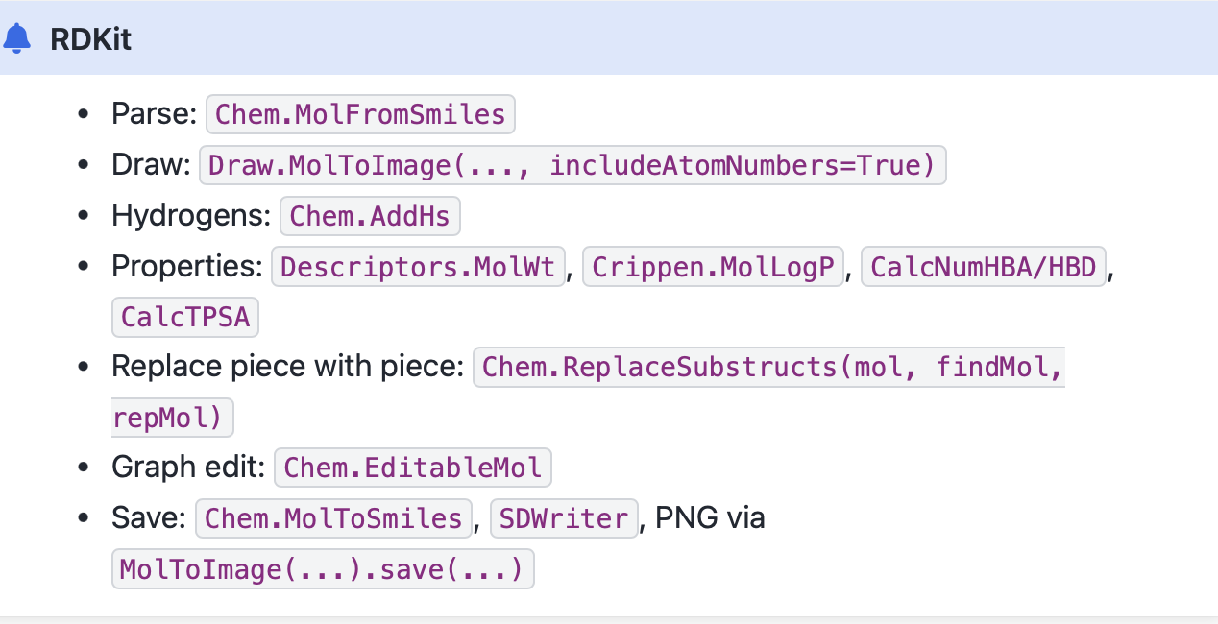

MolWt → The molecular weight (molar mass) of the compound, measured in grams per mole.
LogP → The logarithm of the partition coefficient (octanol/water); higher values mean more lipophilic (hydrophobic).
HBD (Hydrogen Bond Donors) → Atoms (often OH or NH groups) that can donate a hydrogen in hydrogen bonding.
HBA (Hydrogen Bond Acceptors) → Atoms (such as oxygen or nitrogen) that can accept a hydrogen bond.
TPSA (Topological Polar Surface Area) → A measure of the molecule’s polar area, correlated with solubility and permeability.
Atom Replacement
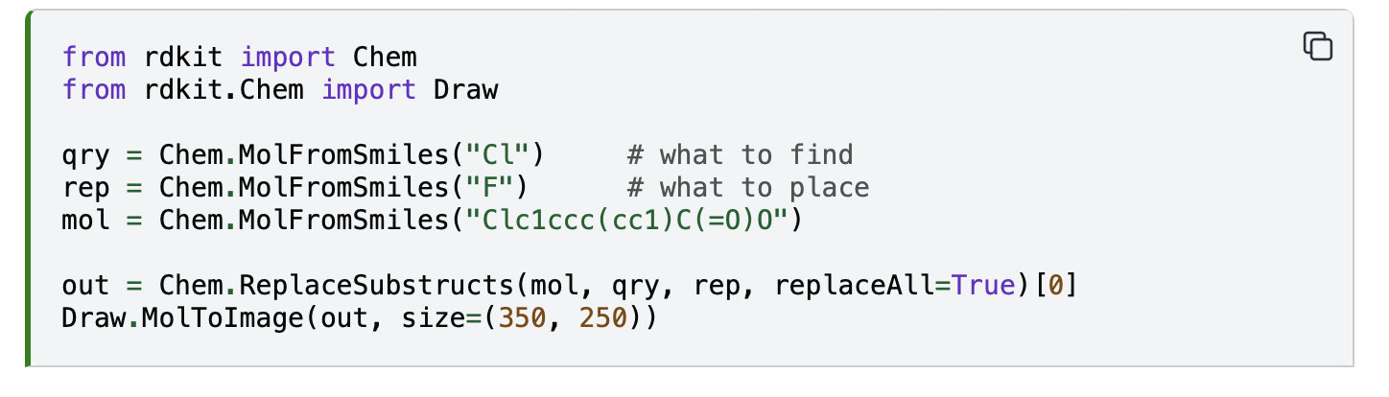

Addition of Substituents
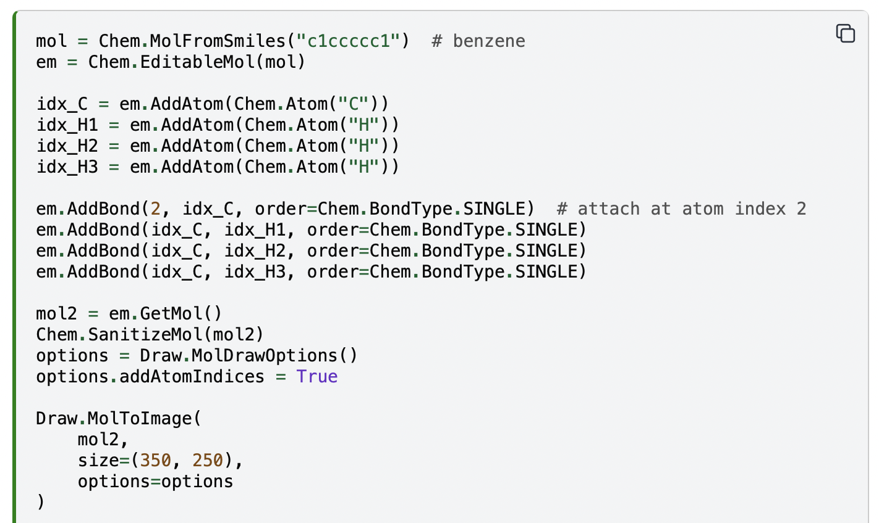

Why use EditableMol instead of just SMILES edits?
Text edits to SMILES can hit the wrong atom or make an invalid string. EditableMol lets you target an atom index, keep valence correct, and apply the same change across many molecules in a repeatable way. 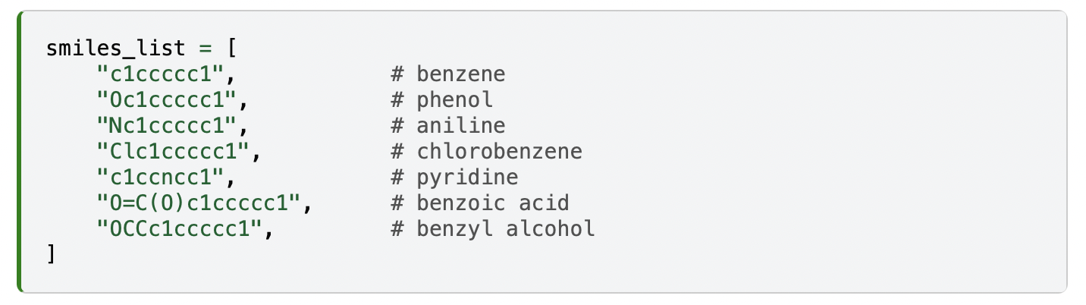

Canonicalization and similarity
SMILES strings are compact and easy to use, but there is a catch: they are not guaranteed to be unique. The same molecule can be written with different SMILES depending on how the atoms are traversed. This makes it difficult to compare molecules directly. In the example below we take three different SMILES notations, each of which corresponds to the molecule we have on quiz. Although the strings differ, the structures are identical once interpreted by RDKit.

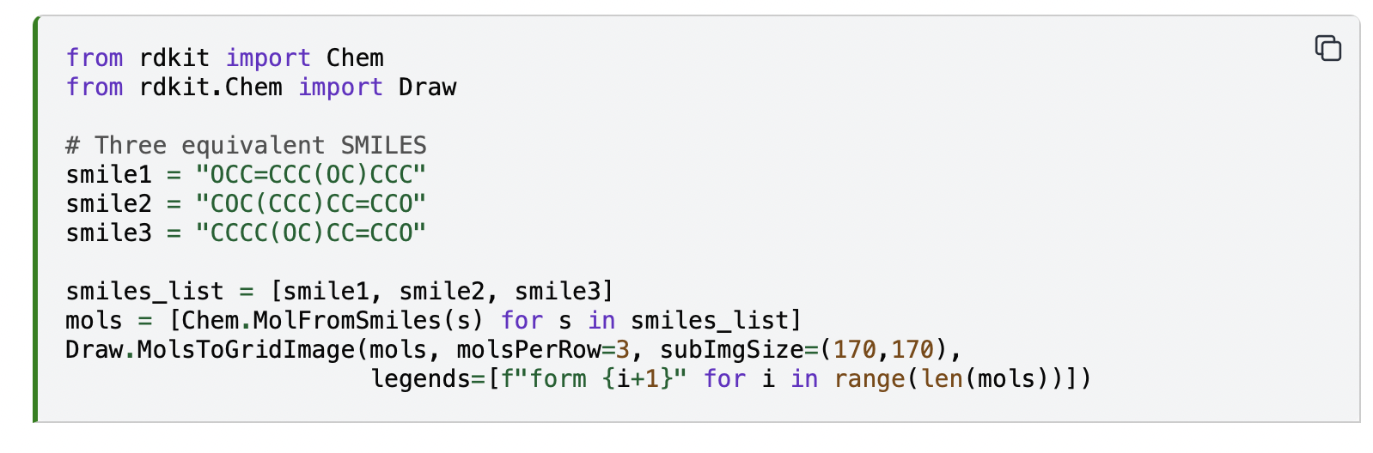
Different SMILES strings can represent the same molecule. This is useful for flexibility, but problematic if we want a unique key for each compound.
Canonicalization generates a standard SMILES for each molecule, which allows unambiguous comparisons and avoids duplicates.
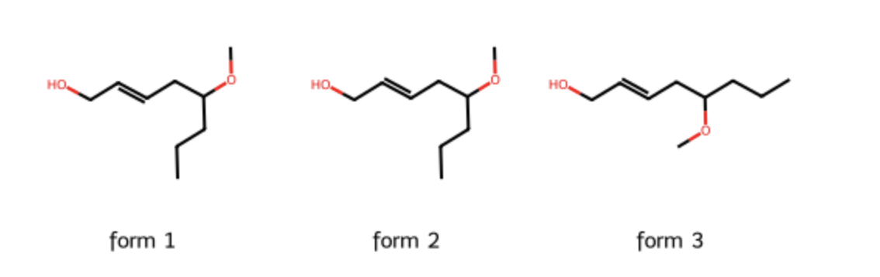
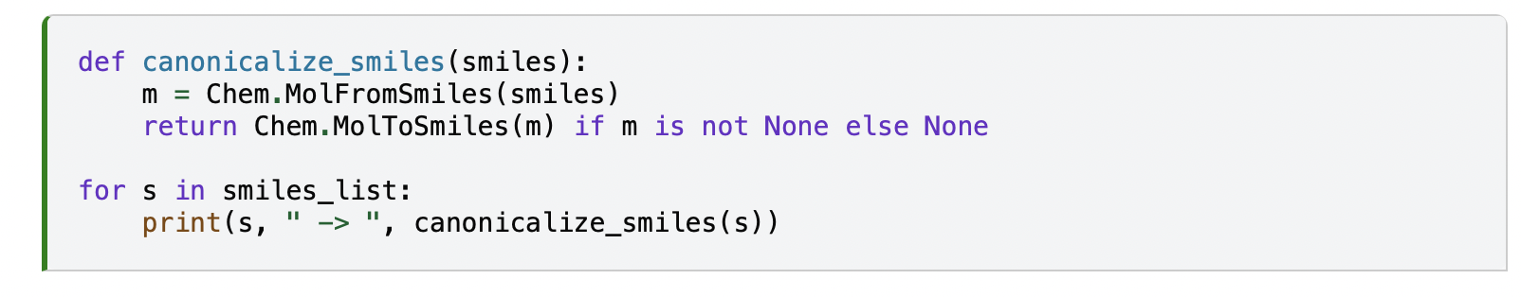

Morgan fingerprints and Tanimoto
Another way to compare molecules is not by SMILES text but by molecular features.
Fingerprints encode the presence or absence of atom environments in a binary vector. Morgan fingerprints (circular fingerprints) are widely used.

So, what is a fingerprint?
Think of a fingerprint as a barcode for a molecule.
Each bar (or bit) in the barcode answers a yes/no question: Does the molecule contain this feature?
Example features: “Does it have a benzene ring?”, “Does it have an OH group?”, “Does it have a nitrogen atom with three bonds?”

If the answer is yes, the bit is 1. If not, it’s 0. This gives us a long string of 0s and 1s that represents the molecule.

That’s said, Morgan fingerprints are a special kind of barcode. They look around each atom in the molecule and record the neighborhood (atoms directly attached, then atoms two steps away, etc.). The “radius” tells how far you look from each atom. Radius 2 means: “look two bonds away.” Morgan fingerprints are popular because they do a good job at capturing local environments around atom.
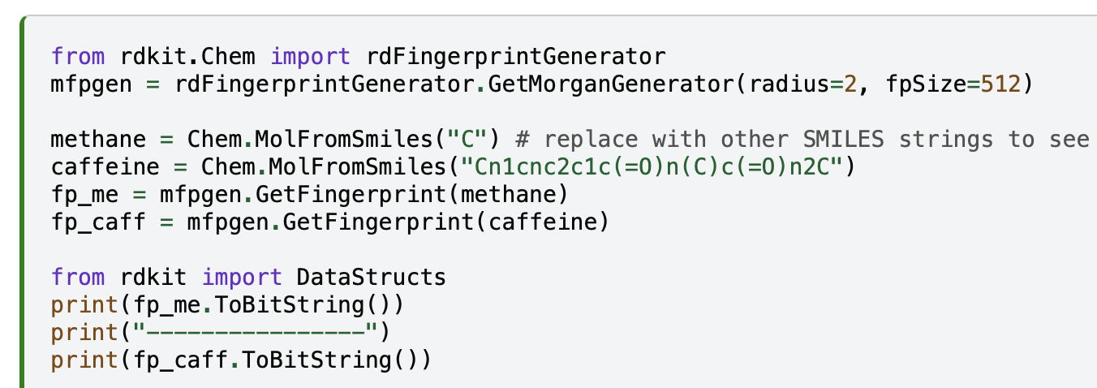

We can then measure how similar two fingerprints are with the Tanimoto coefficient.
It is one of the most common metrics for comparing chemical fingerprints and it measures how similar two molecules are by comparing their structural features represented as bit-vectors.
In terms of the formula, if we have two bit-vectors A and B:
- a = number of bits set to 1 in A
- b = number of bits set to 1 in B
- c = number of common bits set to 1 in both A and B
Then the Tanimoto similarity is:

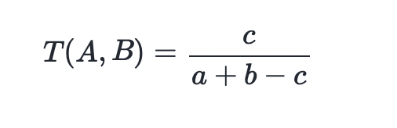
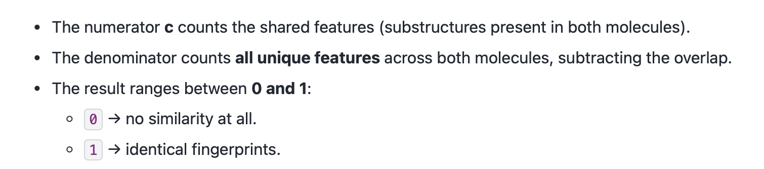
Suppose we compare caffeine and theobromine with Morgan fingerprints.
- Caffeine has about 250 “on” bits (features).
- Theobromine has about 240 “on” bits.
- They share about 180 bits.

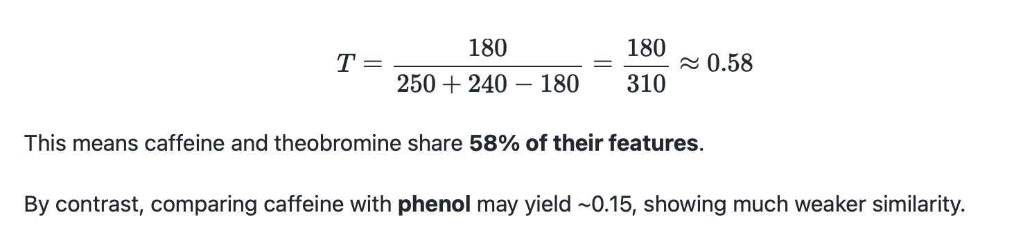
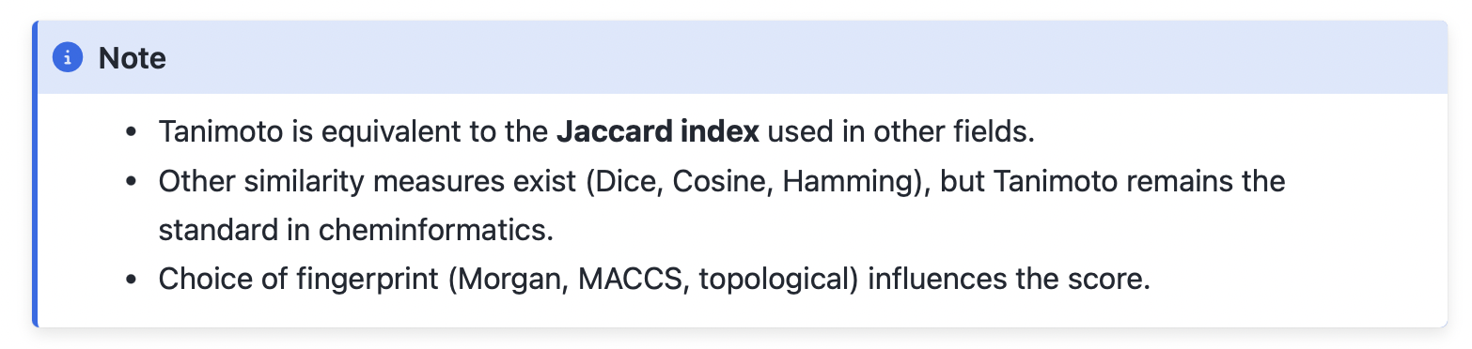
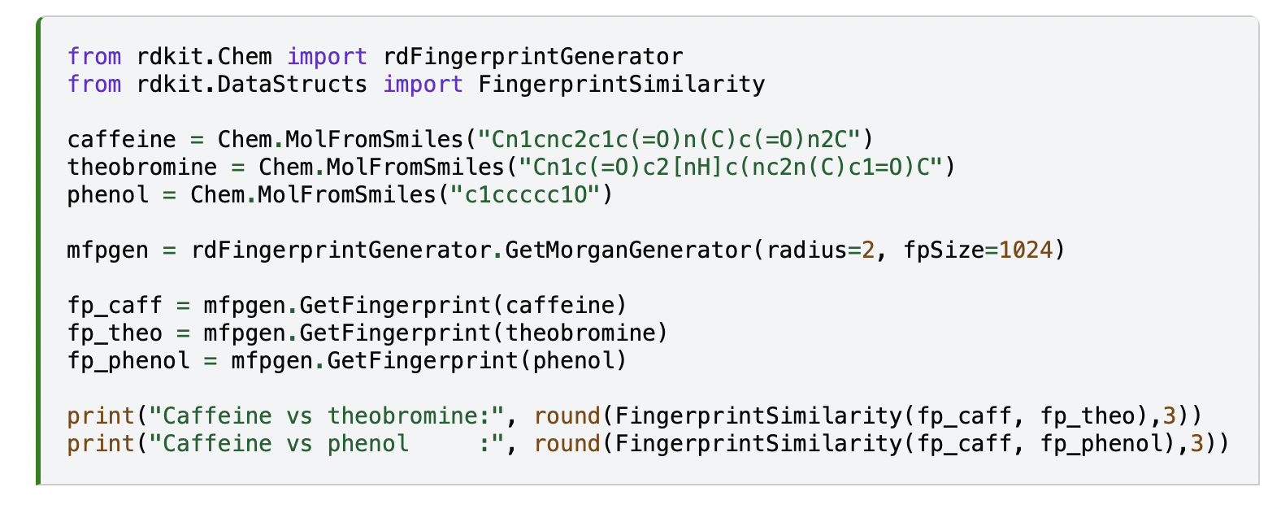
Bemis–Murcko scaffold
To simplify molecules further we can extract their scaffolds, which keep the core ring system and linkers but discard side chains.

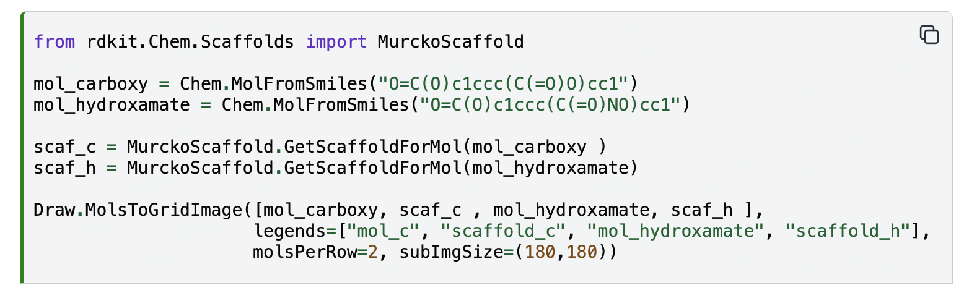

Tanimoto similarity (Jaccard index )is usually computed from fingerprints, not directly from a small descriptor table. Mathematically, Tanimoto/Jaccard can be generalized to nonnegative vectors. For descriptors such as MolWt, LogP, and TPSA, one usually standardizes values first and then uses Euclidean distance, cosine similarity, Mahalanobis distance, or a model/kernel-based comparison. Otherwise, units and scales make the result hard to interpret.

Mahalanobis distance:
a multi-variable statistical measure that finds how many standard deviations a data point is from the mean of a distribution, taking into account the correlations between variables

Fingerprint | Intuition | Common use
Morgan/ECFP | Circular local environments around atoms | Similarity search, QSAR, virtual screening
MACCS keys | Predefined structural questions, such as functional-group presence | Fast teaching, interpretable filtering
RDKit topological fingerprint | Fragments enumerated along graph paths | General similarity search
Atom-pair fingerprint | Atom-pair types and topological distances | Longer-range structural relationships
Pharmacophore fingerprint | Pharmacophore features and spatial/topological relations | Drug-discovery similarity

Method | Form / intuition | Good for | Limitation
Tanimoto/Jaccard | Shared fragments / total fragments | Sparse binary fingerprints | Does not know which fragments are more important; depends on fingerprint choice
Dice similarity | 2c / (a + b), emphasizes overlap | Binary set comparison | Often numerically higher than Tanimoto; not directly interchangeable across papers
Cosine similarity | Angle between vectors | Continuous vectors, embeddings, count vectors | Usable for binary fingerprints, but less common as the default chemical retrieval metric
Euclidean distance | Geometric distance | Standardized descriptor tables | Sensitive to scale; weak intuition on sparse high-dimensional bits

Strengths: Tanimoto is simple, fast, bounded between 0 and 1, and well suited to sparse fingerprints. Limitations: it only sees bit overlap. It does not know which fragment is mechanistically important, and it does not directly encode conformation, reaction conditions, experimental error, or mechanism.

RDKIT import

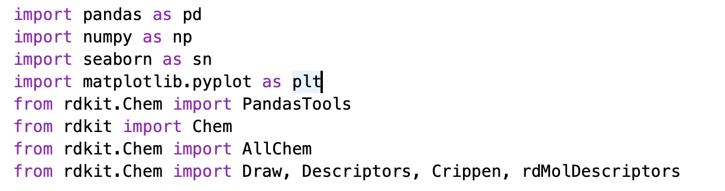
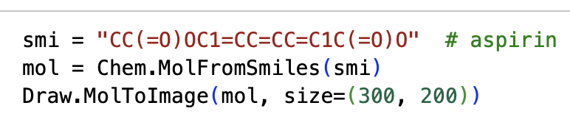
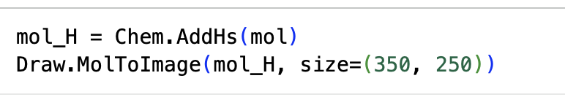
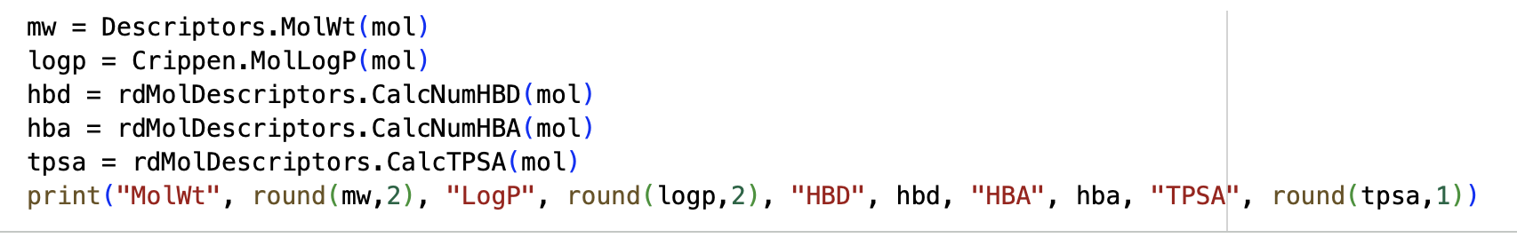

Lipinski's rule of five
Lipinski's rule of five is a concept frequently used in drug discovery. This rule helps to predict if a biologically active molecule is likely to have the chemical and physical properties to be orally bioavailable. The Lipinski rule bases pharmacokinetic drug properties such as absorption, distribution, metabolism and excretion on specific physicochemical properties such as:
- No more than 5 hydrogen bond donors
- No more than 10 hydrogen bond acceptors
- Molecular mass less than 500 Da
- Partition coefficient not greater than 5

