Project Iteration 2
Activity 2
User-Centric Computing II
COMP4600
Spring 2025
Usability Test 2
Project Name: Fresh Start
Team Name: Fresh Start
Team’s Project Trello board URL: https://trello.com/b/3FZeDMuj/fresh-start
Tream’s Project Github repo URL: https://github.com/qcooper2/QCooperFreshStartWebsite
Website URL: http://projectfreshstart.whf.bz/
Team members
# | Name
1 | Quince Cooper
2
3
4

Usability tests ran by all members
Member Name | Quince Cooper
Participant age | 23
Participant gender | Male
Test Date | 5/7
Test Time | 2 minutes
Total time taken | 49 seconds
Test Introduction script
Insert here the introductory speech you gave to the participant to put her at ease and inform him/her about what is expected. You know from our Usability Testing lectures, and videos that an introduction is necessary.
The following items must be present here –
- Hello my name is Quince Cooper I’m a computing major and I would like you to explore this website to see if you can navigate it easily and this may take either 4 or 5 minutes max. This test is very helpful for me to ensure people will have a very user-friendly experience when looking into changing their career path and seeking guidance on what to do next relating to that path.
The 10 Tasks users must complete and your observations
Here you will ask the user to be at ease and complete the tasks listed below
You must observe and collect/note necessary information on the left
Task 1 (Can you make a new account for me with fake information) | Completed successfully: yes  Time taken: 13 seconds  Facial expressions: calm  Any noises made: none  Any other gestures made:
Task 2 (Navigate to where you would learn about the website) | Completed successfully: yes  Time taken: 4 seconds  Facial expressions: calm  Any noises made: none  Any other gestures made:
Task 3 (navigate to where you would find help with a resume.) | Completed successfully: yes  Time taken: 8 seconds  Facial expressions: calm  Any noises made: none  Any other gestures made:
Task 4 (Navigate to where you would find a job template) | Completed successfully: yes  Time taken: 5 seconds  Facial expressions: calm  Any noises made: none  Any other gestures made:
Task 5 (Navigate to where you think events would be.) | Completed successfully: yes  Time taken: 3 seconds  Facial expressions: calm  Any noises made: none  Any other gestures made:
Task 6 (Navigate to where you would find successful stories) | Completed successfully: yes  Time taken: 3 seconds  Facial expressions: calm  Any noises made: none  Any other gestures made:
Task 7 (Navigate to where you would find help with interviews | Completed successfully: yes  Time taken: 4 seconds  Facial expressions: calm  Any noises made: none  Any other gestures made:
Task 8 (Naviagate to where you’re looking to contact someone) | Completed successfully: yes  Time taken: 2 seconds  Facial expressions: calm  Any noises made: none  Any other gestures made:
Task 9 (Navigate to where you are looking for tools for a job) | Completed successfully: yes  Time taken: 5 seconds  Facial expressions: calm  Any noises made: none  Any other gestures made:
Task 10 (click on a random page then navigate back to the home screen) | Completed successfully: yes  Time taken: 2 seconds  Facial expressions: calm  Any noises made: none  Any other gestures made:
User’s opinions/comments/suggestions about the site
Ask the users about the site and insert their answers here.
Questions that you must ask are below, but you are more than welcome ask them other questions you deem necessary -
- what they liked – They like the sites colors and overall how easy it was to navigate around and find information
- what they didn’t like They did not like that the about contact page was not working and felt like that information could be included in the home page.
- what suggestions they can provide to make the site better for users- fix the about page and provide more detailed information about the events taking place.
The “Thank You” note to conclude the test
Thank you for taking this test and providing feedback on how to improve my website.
Your experience, assessment of the Usability Test
My test was very easy and straightforward to take. The user did not have any issues following instructions and that provided a smooth experience.

Accessibility tests and Markup validation
Quince Cooper
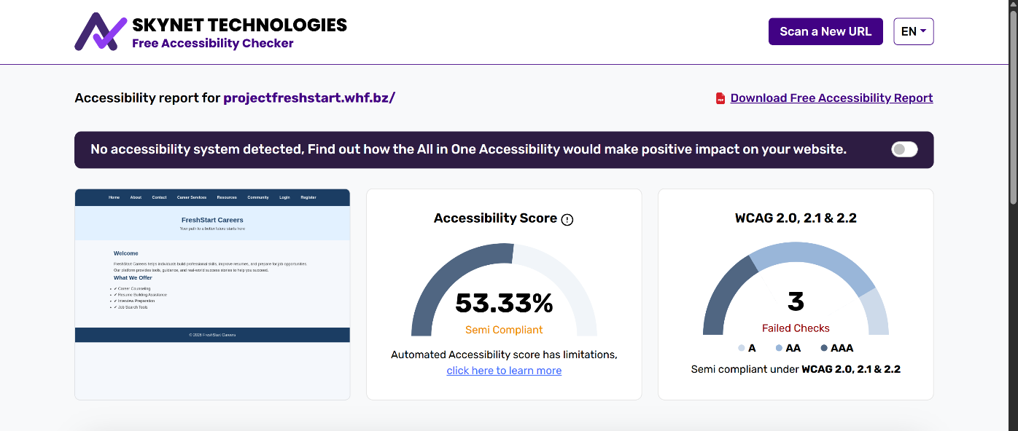
One of the pages did not contain an element

There pages were not completely disability friendly with the color contrast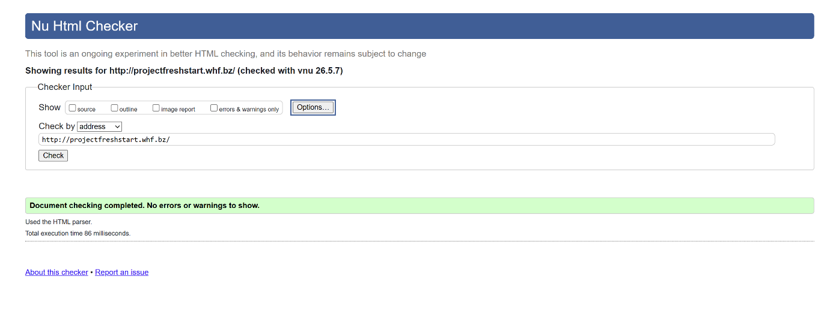
There were no issues

Team’s assessments
Usability test results, discussions, analysis
Insert team discussions and analysis of all the usability test results. The following must be included here -
  - summary and analysis of all the results from each member’s usability test
The analysis shows the elements in the website can be corrected or implemented better. A better contrast ratio can be used to create easier user experience for people with sight disabilities
  - The future enhancements that can be made on the site based on analysis above.
For future enhancements for the site I can fix the html elements, improve the color contrast and make the site links stand out more in something other can a blue link color

Accessibility issues
The color contrast on pages with links can be better. I can change the blue color to be slightly darker and change the link color to something or then blue but leave a blue underline to suggest its still a link
HTML Markup issues
The about and contact page does not function and I will need to link the pages to the site again, so they appear

