Paul Albrick Coronia

IT2C

The Ice Cream Shop

The Sell Panel(on the right) holds the order list and performs the selling transaction. 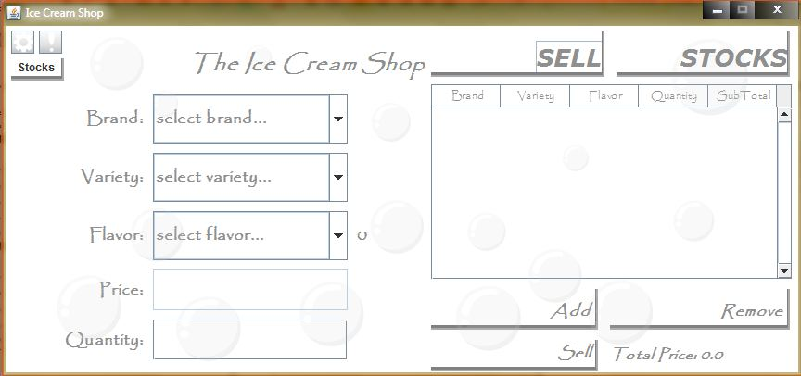

The Stocks Panel(on the right) – holds the buttons responsible for adding and removing items in the lists.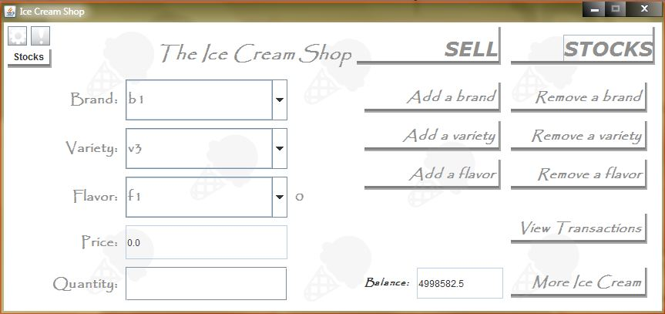 The common Panel holds the drop-down list boxes for ice cream selection

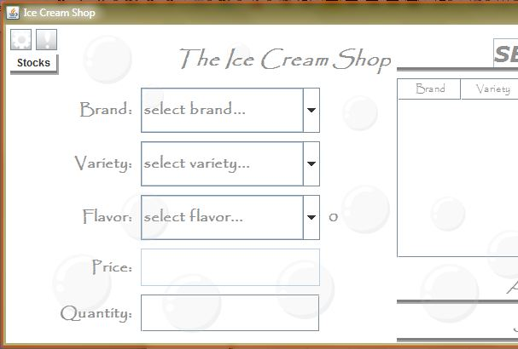

The Stocks Table shows the available ice creams including their price and quantity.

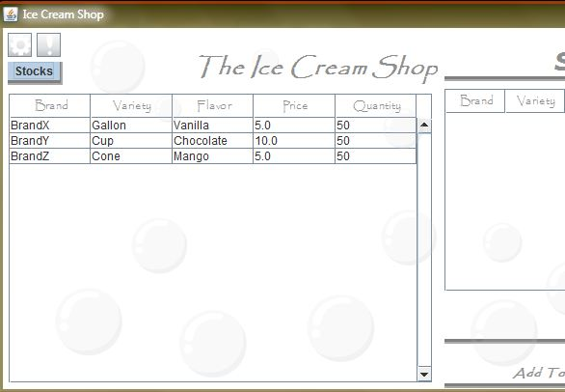

The Settings Panel lets the user to customize the program looks for convenience and satisfaction.

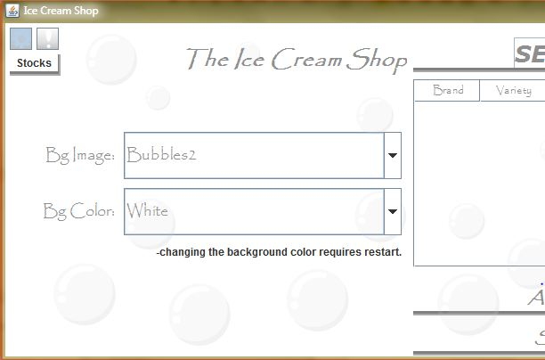

The Add-Ice-Cream panel holds the order list and performs the wholesale purchasing transaction.

