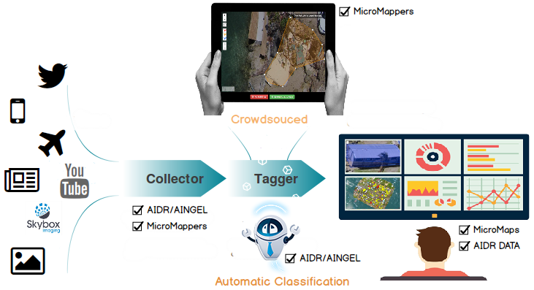
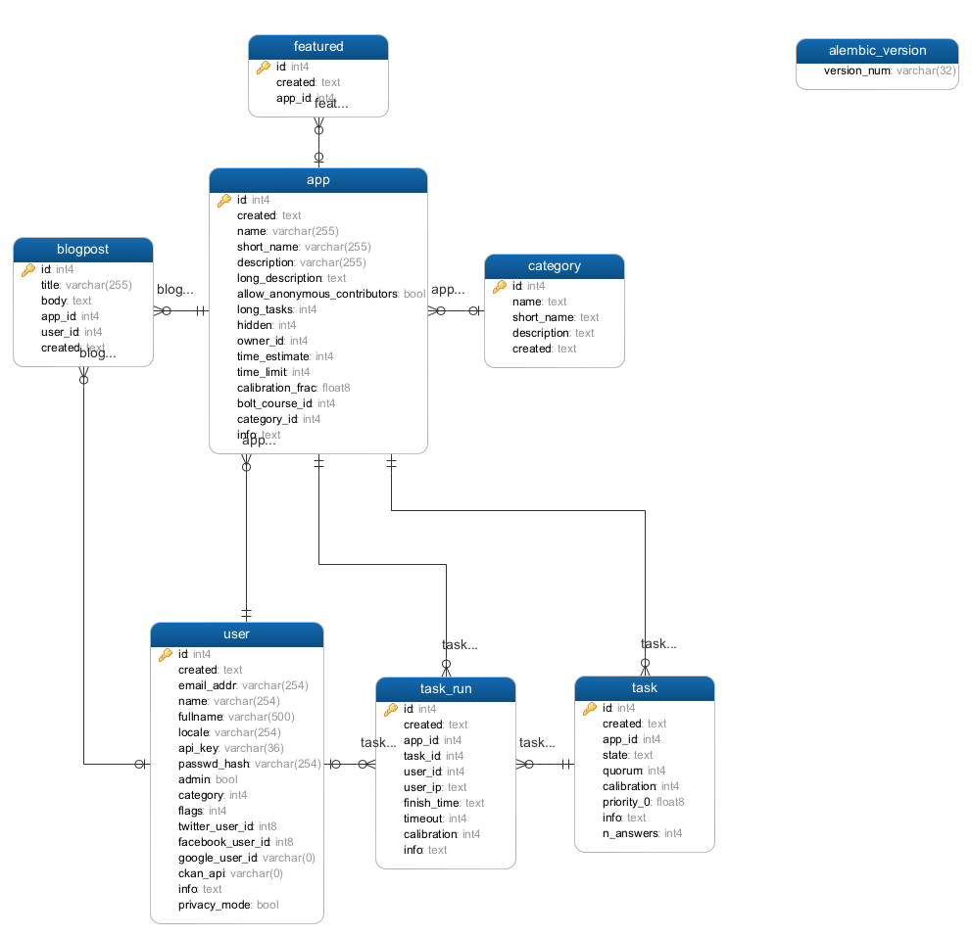
Crisis Computing Applications
REQ No.  1 | Project  Crisis Computing Overview

Abstract
The Crisis Computing has developed and has developing various modules/applications via the requests of searchers, user community and internal/external partners. Here, we should address the brief description, purpose and architect of each modules.

Rev | Date | Author | Status
1 | 11/16/2015 | Ji Lucas | First draft
2

Distribution List
Reviewers | FYI
Ji Lucas

Table of Contents
1.Introduction 4
2.Related Documents/Links/People 4
3.Glossary 5
4.Applications 5
5.AIDR 5
5.1.aidr-collector 5
5.2.aidr-persister 5
5.3.aidr-tagger 6
5.4.aidr-tagger-api 6
5.5.aidr-manager 6
5.6.aidr-trainer-api 6
5.7.aidr-trainer-pybossa 6
6.MicroMappers 6
6.1.MMAPI 6
6.2.MM-Trainer-Pybossa 7
6.3.Clickers 7
6.3.1.Text Clicker 8
6.3.2.Image Clicker 8
6.3.3.Video Clicker 8
6.3.4.3W Clicker 8
6.3.5.Text Geo Clicker 8
6.3.6.Image Geo Clicker 9
6.3.7.Video Geo Clicker 9
6.3.8.Aerial Clicker 9
6.3.9.Satelitte Clicker 9
6.4.MM-Business-Intelligent 9
6.5.MM-Image 9
6.6.MM-GDELT 9
7.MicroMaps 9
8.MicroFilters 9
9.AIDR DATA 9
10.Environment settings 9
11.Software 9
12.Development Life Cycle 9
13.Requirements Template 9
13.1.Non-functional 10
13.1.1.Security 10
13.1.2.QA/Testing 10
Issues/Questions 10
14.Revision History 11

Crisis Computing Overview

Introduction
Overview of Crisis Computing Applications will be descripted here. The details are coming soon.

Related Documents/Links/People

References in the text throughout this document appear in square brackets (e.g., [1], [JS]).

Reference | Document/Link/Person/Application

Glossary
Term | Definition

Applications
Application Name | Definition
AIDR
MicroMappers

AIDR
AIDR is a stream processing application in Java implemented through a series of modules. The following diagram illustrates at a very high level the relationships between the different modules.
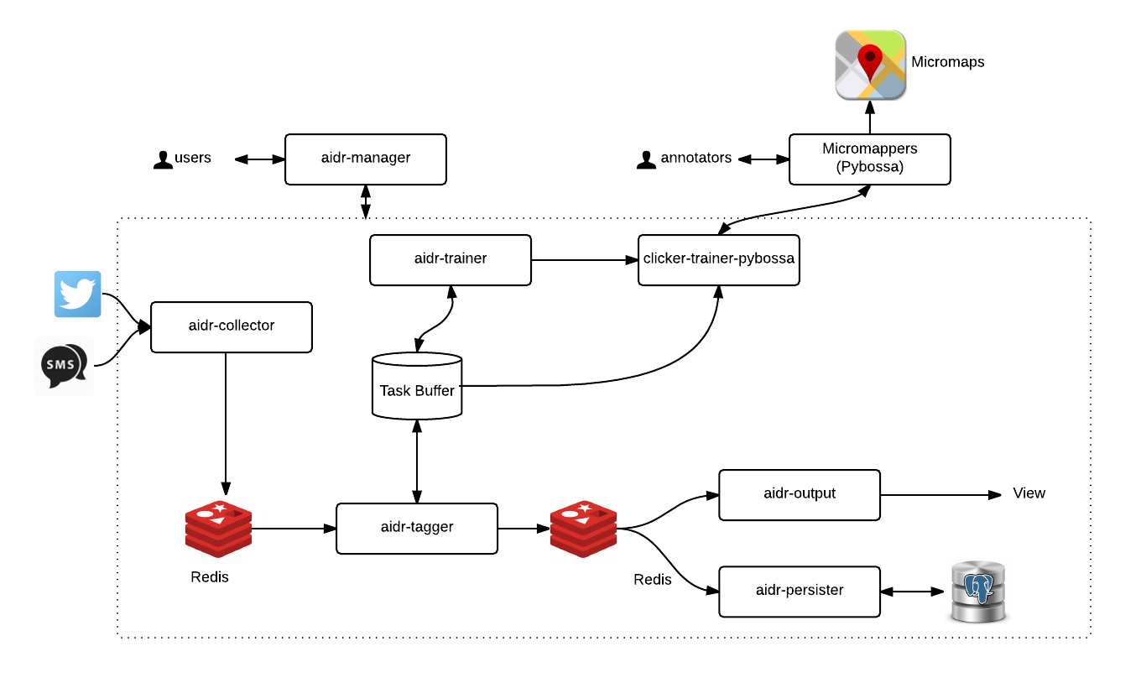

Aidr-collector
- restful api module that interacts with various sources like twitter/sms to fetch the data and publishes to redis server for further processing.
- Technology : ejb, redis, jersey for rest services
- Servers :
  - Azure VM1 – AIDR PRODUCTION(Production)
  - Azure VM2(QA)

aidr-persister
- The aidr-persister module stores (persists) the items that have been collected and/or tagged into files. The items are persisted in JSON format in zip-compressed files
- Technology : ejb, redis, jersey for rest services
- Servers :
  - Azure VM1 – AIDR PRODUCTION(Production)
  - Azure VM2(QA)

Aidr-tagger
The tagger module is the core of AIDR as a classification system.
The aidr-tagger module has three main functions: to tag (classify) new items, to build and re-build the classification model, and to sample for the human annotators.
Below is the diagram to provide an overview of how tagger works.
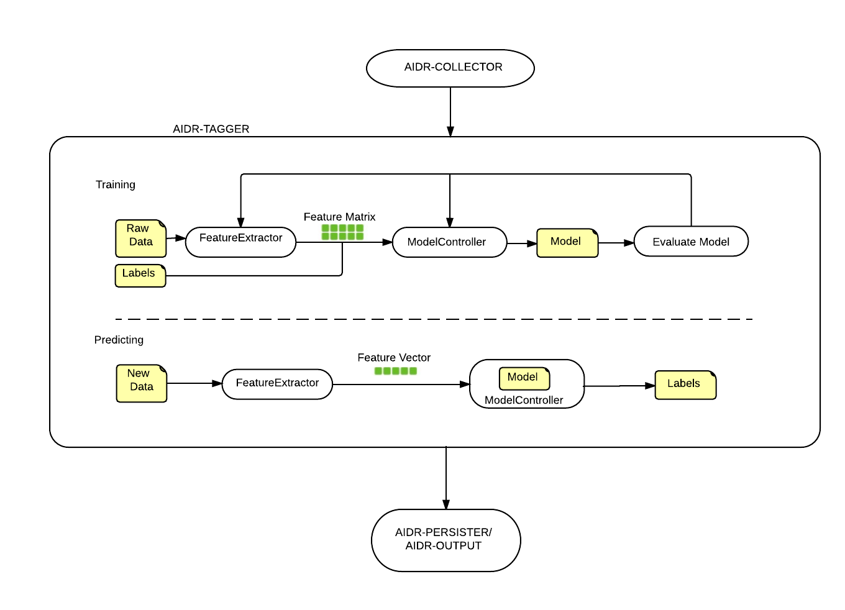

Aidr-tagger-api
- restful api module that is performing crud operations related to documents, tagging, labels, classifiers etc.
- Technology : Jersey, MySQL, ejb
- Servers :
  - Azure VM1 – AIDR PRODUCTION(Production)
  - Azure VM2(QA)

aidr-manager
- The aidr-manager module provides an interface for interacting with AIDR services. It performs tasks including user authorization, and keeping track of data about the different collections that have been created.
- Technology : Spring MVC, MySQL
- Servers :
  - Azure VM1 – AIDR PRODUCTION(Production)
  - Azure VM2(QA)

aidr-trainer-api
- restful api module that is interacting with aidr only to create text based clicker. And, populate task data for tagging. Also, import data for classification.
- Its handles only AIDR specific data
- Technology : Spring MVC, MySQL, ejb
- Servers :
  - Azure VM1 – AIDR PRODUCTION(Production)
  - Azure VM2(QA)

aidr-trainer-pybossa
- Scheduled service module that creates apps, publishes and imports tasks to/from Pybossa-Service. The module is a stand alone application that is running based on data
- Its handles only AIDR specific data and handles only text clicker
- Technology : Spring MVC, MySQL,
- Servers :
  - Azure VM1 – AIDR PRODUCTION(Production)
  - Azure VM2(QA)

MicroMappers

MMAPI

MM-Trainer-Pybossa

Clickers

Text Clicker
Classify text based data

Image Clicker
Classify image based data

Video Clicker
Classify video based data

3W Clicker
Classify news media data

Text Geo Clicker
geotag text based data that is promoted from Text Clicker

Image Geo Clicker
geotag Image based data that is promoted from Image Clicker

Video Geo Clicker
geotag video based data that is promoted from video Clicker

Aerial Clicker
Feature tracing on aerial imagery

Satelitte Clicker
Feature tracing on satellite imagery

MM-Business-Intelligent

MM-Image

MM-GDELT

MicroMaps
Centralized Map portal where clicker’s output will be displayed based on clicker type & crisis.

MicroFilters
- Module to consume AIDR output to generate image & video clicker’s data source.
- Technology : python, rebbitMQ
- Servers :
  - TAMU-Q(Production)
  - aws(Production in progress)
  - Azure(QA)

AIDR DATA

Environment settings

Software

Development Life Cycle

Requirements Template
The following subsections define software requirements. Each requirement is labeled as follows:
ID. The unique identifier for the requirement.
Requirement. A clear and concise description of the requirement.
Source. A cross-reference to the source of the requirement.
Category. A classification for the requirement using the selections from Table 1.

Table 1 - Requirement Categories
Category | Description
Mandatory | Required minimum functionality.
Optional | Nice to have and will be implemented if time permits.
Future | Will not be implemented now but should be considered for a future enhancement.
Dropped | Requirement determined to be completely out of scope after baseline.
Existing | Functionality already present in the software (for documentation purposes).
Operational | Will not be addressed in the software (documented for training purposes). This requirement should have a related item in the issue list in order to identify an owner.

ID | Requirement | Source | Cat
.1 |  |  | M
.2 |  |  | M
.3 |  |  | M
.4 |  |  | M

Non-functional

Security
ID | Requirement | Source | Cat
.1 |  |  | M

QA/Testing
ID | Use Case | Date/Status
.1
2.

Issues/Questions
Issue # | Issue/Resolution Description | Date/Status

Revision History
Changes to the text of this document are indicated by bars in the outside margin adjacent to the affected text.
Date | Change Description

