Crisis Computing Applications

|  |  |
| --- | --- |
| REQ No.  1 | Project  Crisis Computing Overview |

Abstract

The Crisis Computing has developed and has developing various modules/applications via the requests of searchers, user community and internal/external partners. Here, we should address the brief description, purpose and architect of each modules.

| **Rev** | **Date** | **Author** | **Status** |
| --- | --- | --- | --- |
| 1 | 11/16/2015 | Ji Lucas | First draft |
| 2 |  |  |  |
|  |  |  |  |

Distribution List

|  |  |
| --- | --- |
| **Reviewers** | **FYI** |
| Ji Lucas |  |

Table of Contents

1. Introduction 4

2. Related Documents/Links/People 4

3. Glossary 4

4. Applications 4

5. AIDR 5

5.1. aidr-collector 5

5.2. aidr-persister 5

5.3. aidr-tagger 5

5.4. aidr-tagger-api 5

5.5. aidr-manager 5

5.6. aidr-trainer-api 5

5.7. aidr-trainer-pybossa 5

6. MicroMappers 5

6.1. MMAPI 5

6.2. MM-Trainer-Pybossa 5

6.3. Clickers 5

6.4. MM-Business-Intelligent 5

6.5. MM-Image 5

6.6. MM-GDELT 5

7. MicroMaps 5

8. MicroFilters 5

9. Data Management 5

10. Environment settings 5

11. Software 5

12. Development Life Cycle 5

13. Requirements Template 5

13.1. Non-functional 6

13.1.1. Security 6

13.1.2. QA/Testing 6

Issues/Questions 6

14. Revision History 7

Crisis Computing Overview

# Introduction

Overview of Crisis Computing Applications will be descripted here. The details are coming soon.

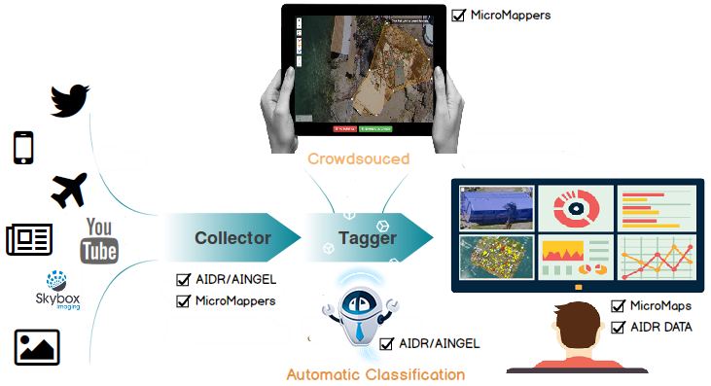



# Related Documents/Links/People

References in the text throughout this document appear in square brackets (e.g., [1], [JS]).

| **Reference** | **Document/Link/Person/Application** |
| --- | --- |
|  |  |
|  |  |
|  |  |
|  |  |
|  |  |
|  |  |
|  |  |
|  |  |
|  |  |

# Glossary

| **Term** | **Definition** |
| --- | --- |
|  |  |
|  |  |
|  |  |
|  |  |
|  |  |
|  |  |

# Applications

| **Application Name** | **Definition** |
| --- | --- |
| AIDR |  |
| MicroMappers |  |
|  |  |
|  |  |
|  |  |
|  |  |

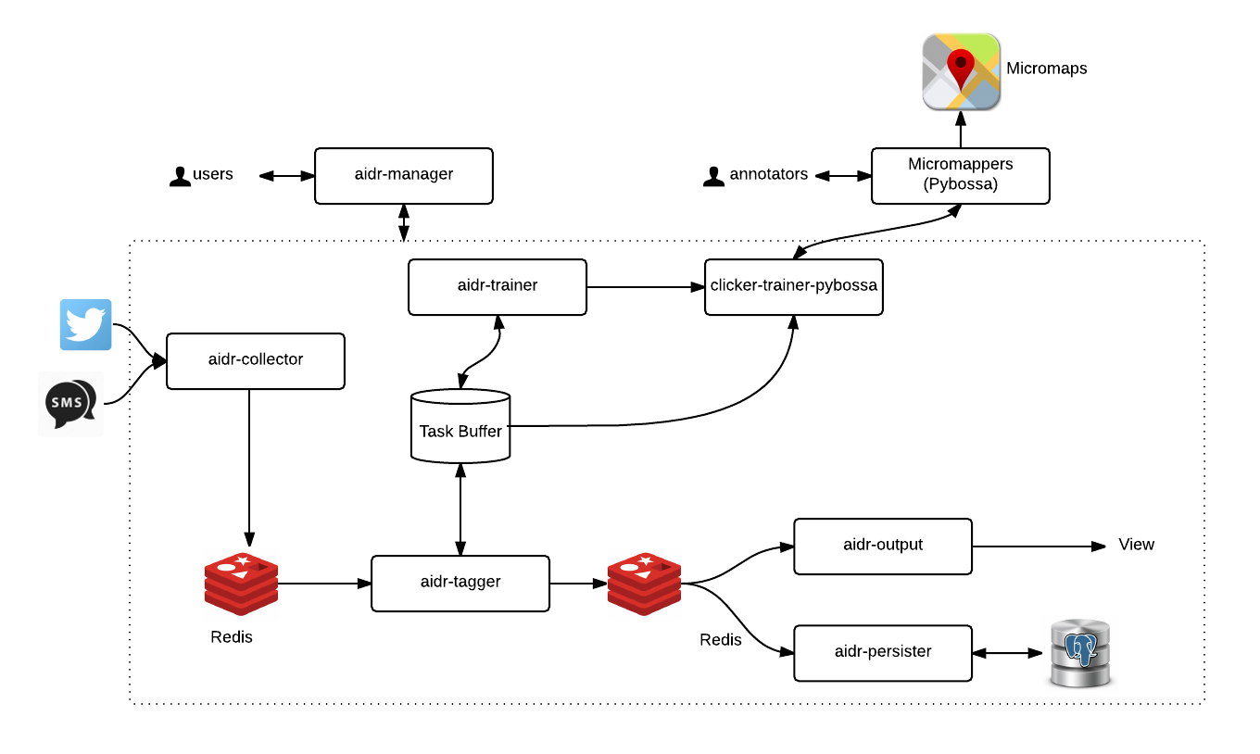

# AIDR

## aidr-collector

## aidr-persister





## aidr-tagger

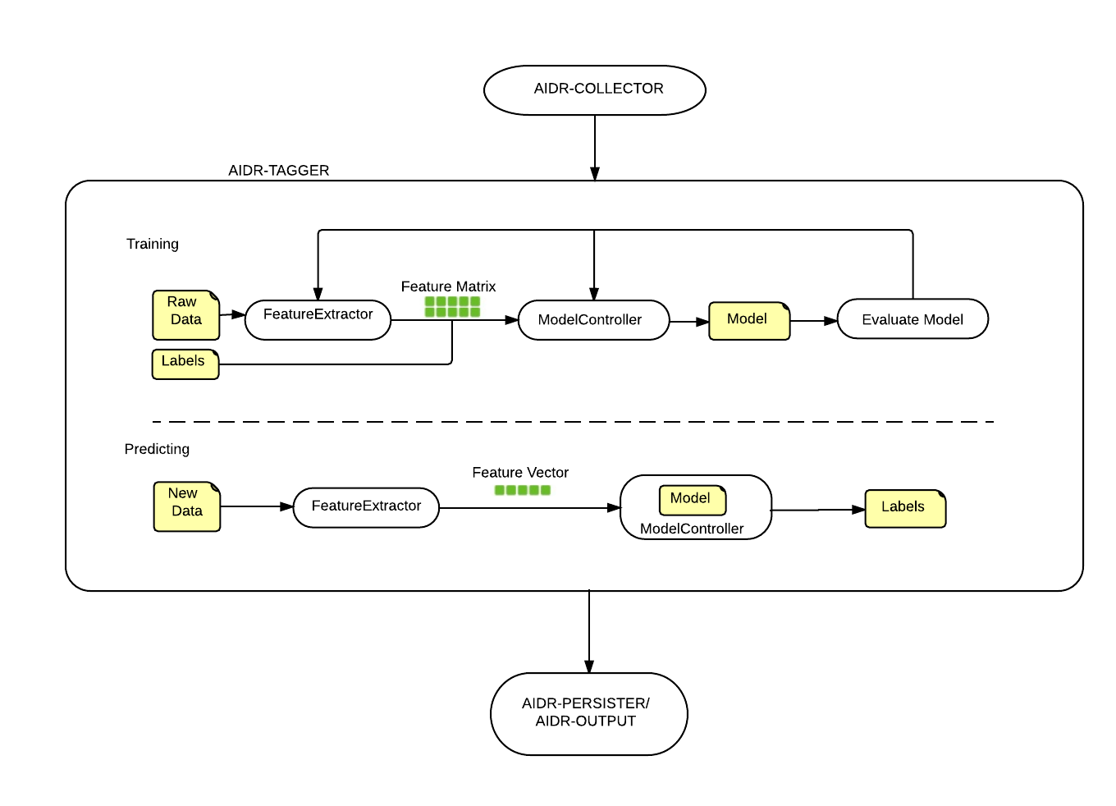

## aidr-tagger-api

## aidr-manager

## aidr-trainer-api

* restful api module that is interacting with aidr only to create text based clicker. And, populate task data for tagging. Also, import data for classification.
* Its handles only AIDR specific data
* Technology : Spring MVC, MySQL, ejb
* Servers :
  + Azure VM1 – AIDR PRODUCTION(Production)
  + Azure VM2(QA)

## aidr-trainer-pybossa

* Scheduled service module that creates apps, publishes and imports tasks to/from Pybossa-Service. The module is a stand alone application that is running based on data
* Its handles only AIDR specific data and handles only text clicker
* Technology : Spring MVC, MySQL,
* Servers :
  + Azure VM1 – AIDR PRODUCTION(Production)
  + Azure VM2(QA)

# MicroMappers

## MMAPI

## MM-Trainer-Pybossa

## Clickers



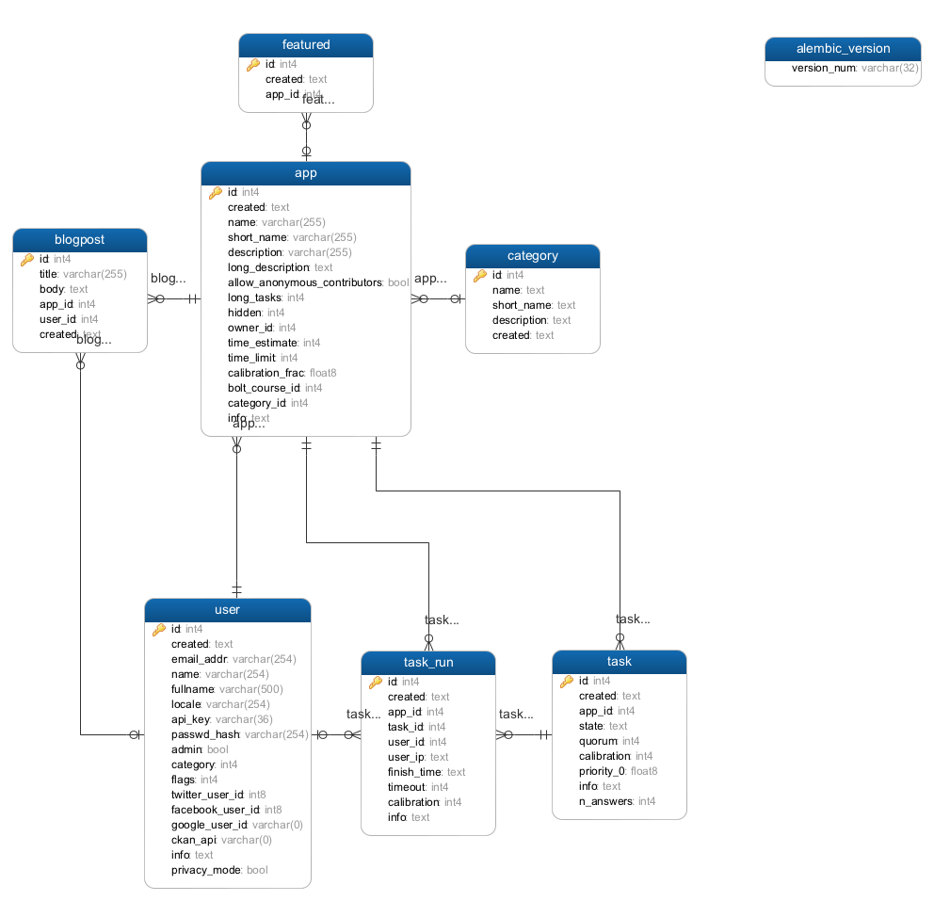

### Text Clicker

Classify text based data

### Image Clicker

Classify image based data

### Video Clicker

Classify video based data

### 3W Clicker

Classify news media data

### Text Geo Clicker

geotag text based data that is promoted from Text Clicker

### Image Geo Clicker

geotag Image based data that is promoted from Image Clicker

### Video Geo Clicker

geotag video based data that is promoted from video Clicker

### Aerial Clicker

Feature tracing on aerial imagery

### Satelitte Clicker

Feature tracing on satellite imagery

## MM-Business-Intelligent

## MM-Image

## MM-GDELT

# MicroMaps

Centralized Map portal where clicker’s output will be displayed based on clicker type & crisis.

# MicroFilters

* Module to consume AIDR output to generate image & video clicker’s data source.
* Technology : python, rebbitMQ
* Servers :
  + TAMU-Q(Production)
  + aws(Production in progress)
  + Azure(QA)

# AIDR DATA

# Environment settings

# Software

# Development Life Cycle

# Requirements Template

The following subsections define software requirements. Each requirement is labeled as follows:

* **ID.** The unique identifier for the requirement.
* **Requirement.** A clear and concise description of the requirement.
* **Source.** A cross-reference to the source of the requirement.
* **Cat**egory**.** A classification for the requirement using the selections from Table 1.

Table 1 - Requirement Categories

| **Category** | **Description** |
| --- | --- |
| **M**andatory | Required minimum functionality. |
| **O**ptional | Nice to have and will be implemented if time permits. |
| **F**uture | Will not be implemented now but should be considered for a future enhancement. |
| **D**ropped | Requirement determined to be completely out of scope **after** baseline. |
| **E**xisting | Functionality already present in the software (for documentation purposes). |
| **Op**erational | Will not be addressed in the software (documented for training purposes). This requirement should have a related item in the issue list in order to identify an owner. |

| **ID** | **Requirement** | **Source** | **Cat** |
| --- | --- | --- | --- |
| .1 |  |  | M |
| .2 |  |  | M |
| .3 |  |  | M |
| .4 |  |  | M |
|  |  |  |  |
|  |  |  |  |
|  |  |  |  |

## Non-functional

### Security

| **ID** | **Requirement** | **Source** | **Cat** |
| --- | --- | --- | --- |
| .1 |  |  | M |

### QA/Testing

| **ID** | **Use Case** | **Date/Status** |
| --- | --- | --- |
| .1 |  |  |
| 2. |  |  |

# Issues/Questions

| **Issue #** | **Issue/Resolution Description** | **Date/Status** |
| --- | --- | --- |
|  |  |  |
|  |  |  |
|  |  |  |
|  |  |  |
|  |  |  |
|  |  |  |
|  |  |  |

# Revision History

Changes to the text of this document are indicated by bars in the outside margin adjacent to the affected text.

| **Date** | **Change Description** |
| --- | --- |
|  |  |
|  |  |
|  |  |