Random Taco Cookbook

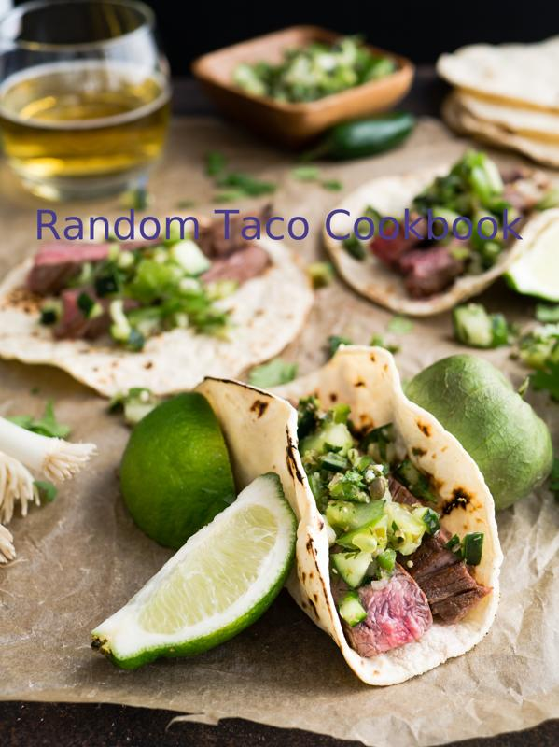

# Credits

Image: Christine Siracusa on Unsplash

Recipes from: https://taco-1150.herokuapp.com/random/?full_taco=true

Code by: Quinn Daniel

Baked Tilapia with Sweet Potato and Apple Hash, Mahi Mahi Rub and Guacamole (Simple) in Fresh Corn Tortillas

# Baked Tilapia

Baked Tilapia  
=============  
  
Oven fried fish for when you think you want to pretend you're eating healthier.  
  
* 1 pound mild fish (I usually use tilapia)  
* 1 cup masa  
* 2 tsp salt  
* 1/2 to 1 tsp cayenne  
* 2 tsp paprika  
* 2 tsps chili powder  
* 2 tsps garlic powder  
* 1/2 to 1 tsp black pepper (to taste)  
* olive oil  
  
  
1. Preheat oven to 400 degrees.  
2. Mix dry ingredients in a bowl to make the coating for the fish.  
3. Cut fish into slices or chunks, as your taste desires.   
4. Drizzle olive oil over cut fish, and dip fish into breading.  
5. Bake for 8ish minutes and finish, if you can, under the broiler.

# Sweet Potato and Apple Hash

Sweet Potato and Apple Hash  
===========================  
  
Sweet potatoes are my go-to taco punch-up. I was going my normal route of making small (1/4" or so) cubes of sweet potatoes when I thought: Hey, it's fall, I'm going to add an apple in there. Fuck yes.  
  
* 2 Small sweet potatoes (you'd be amazed how little sweet potato you need for tacos)  
* 1 Small apple  
* One can diced green chilis  
* A couple pinches of chili powder  
* A queeze of honey  
* Pat o' butter  
  
Mix this all into a pan, with about 1/4 cup of water, and boil it all up until the water goes away, toss in the butter, and continue to pan-fry until things get a little browned.

# Mahi Mahi Rub

Mahi Mahi Rub  
==============  
  
A rub for Mahi Mahi, if fish tacos be what you're fancying:  
  
* 1 Part spicy chili powder  
* 1 Part salt  
* 1 Part ground cumin  
* 1/2 Part chopped cilantro  
* 1/2 Part cayenne  
* 1/2 Part pepper  
* 1/2 Part oregano  
* 1/2 Part onion powder  
* 1/2 Part garlic powder  
  
You choose your measurements and enjoy!

# Guacamole (Simple)

Guacamole (Simple)  
=========  
  
If you're not in the mood to be fussy, this could be considered a minimum-viable guacamole recipe.  
  
* 2 ripe avocados  
* 2-4 limes, depending on juiciness, delivering 2-4T of lime juice  
* 1 diced tomato (seeded if it's a big one)  
* salt (to taste)  
* hot sauce (to taste; Frank's Red Hot is a standard, but go with what you like)  
  
1. Scoop the avocado meat into a bowl and mash them with a fork. Leave it a bit lumpy as we will do more stirring in a bit and we don't want to over-work them.  
2. Add the chopped tomato.  
3. Add the lime juice; hold some back for later adjustment).  
4. Add ½t salt.  
5. Add 2T hot sauce.  
6. Stir with the fork again.  
7. Taste.  
8. Adjust salt/lime/hot sauce as desired.  
  
This recipe will support one average-size bag of chips, so adjust quantities based on expectations.

# Fresh Corn Tortillas

Fresh Corn Tortillas  
===================  
  
This is the only way to go. So worth it. Makes roughly 15 tortillas.  
  
* 1 3/4 cups masa harina  
* 1 1/8 cups water  
  
1. In a medium bowl, mix together masa harina and hot water until thoroughly combined. Turn dough onto a clean surface and knead until pliable and smooth. If dough is too sticky, add more masa harina; if it begins to dry out, sprinkle with water. Cover dough tightly with plastic wrap and allow to stand for 30 minutes.  
2. Preheat a cast iron skillet or griddle to medium-high.  
3. Divide dough into 15 equal-size balls. Using a tortilla press, a rolling pin, press each ball of dough flat between two sheets of wax paper.  
4. Place tortilla in preheated pan and allow to cook for approximately 30 seconds, or until browned and slightly puffy. Turn tortilla over to brown on second side for approximately 30 seconds more, then transfer to a plate. Repeat process with each ball of dough. Keep tortillas covered with a towel to stay warm and moist (or a low temp oven) until ready to serve.

Moroccan Lamb with Drunken Green Beans, Packaged Seasonings and Baja White Sauce in Hard Corn Shells (Traditional; US)

# Moroccan Lamb

Moroccan Lamb  
=============  
  
A Differently Spiced Meat Than Your Usual Taco  
----------------------------------------------  
  
* 500 g ground lamb  
* 20 g Ras al Hanout spice. My mix contains:  
 * Paprika  
 * Cinnamon  
 * Allspice  
 * Clove  
 * Toasted Mustard  
 * Cumin  
 * Caraway  
 * Black Pepper  
* 10 g fresh lemon zest or 10 g finely ground Black Lemon Omani (Moroccoan dried preserved lemon)  
  
Mix together and brown.

# Drunken Green Beans

Drunken Green Beans  
===================  
  
Green beans are fine. Green beans cooked in beer are better. Maybe even the best.  
  
* 1 Surly fist full of green beans  
* half a beer  
* quarter cup vegetable broth  
* 2 cloves garlic  
* 1 Tbsp olive oil  
* some salt, whatever  
  
First peel and dice the garlic and sauté it in the olive oil. Before it gets all burned and ruined, add the beer and vegetable broth.   
   
As the liquid comes to a boil, cut the green beans up. Add the green beans and a pinch of salt and let them simmer for about five minutes. If you like your beans on the softer side you can let it go a little longer. But the trick is to pull them right after the color starts to turn and you've just made a delicious addition to any taco.

# Packaged Seasonings

Packaged Seasonings  
==============  
  
Lest we be accused of snobbery, let's acknowledge that a taco is a taco, and taco night can be well-served by not having to think at all.  
  
Feel free to use the pre-packaged seasoning of your choice. When I'm in an old-school mood, I head straight for...  
  
* Old El Paso Taco Seasoning

# Baja White Sauce

Baja White Sauce  
================  
  
This is a traditional white sauce for [Baja fish tacos](../full_tacos/baja_fish_tacos.md).  
  
* 1/4 cup mayo  
* 2 tbsp sour cream  
* 1 tbsp lime juice  
* 1/4 tsp celery salt (or garlic salt, etc)  
  
Mix, and refrigerate for an hour if possible.

# Hard Corn Shells (Traditional; US)

Hard Corn Shells (Traditional; US)  
======================  
  
Mistakenly thought by many to be traditionally Mexican, hard shells were actually popularized in the US in the mid-20th century.  
  
While they can certainly be made at home (if you have access to a deep-fryer), the best method of obtaining hard taco shells is to head to the grocery store.

Chorizo with Corn Salad, Universal Taco Seasoning and Beet Salsa in Fresh Corn Tortillas

# Chorizo

Chorizo  
=======  
  
_Adapted from [Aredridel's Lightly Seasoned Beef](aredridel_lightly_seasoned_beef.md)_  
  
* 20 oz chorizo  
* 20 g black cumin seed, ground  
* 2 cloves garlic  
* 15 ml white wine  
* 4 g salt if wine is unsalted  
* 1/2 small white onion, diced  
* Oil to coat the pan  
  
__Directions__  
  
1. Heat oil in the pan.  
2. Add in onions, stirring occasionally until onions become translucent.  
3. Toss in the garlic, and the chorizo on top of that.  
4. Add the cumin. Brown the chorizo.  
5. Use the splash of wine to loosen anything stuck to the pan.  
  
Perfect, lightly seasoned taco meat.

# Corn Salad

Corn Salad  
==========  
  
* 2 Ears of corn  
* 1 Lime, juiced  
* Small handful of Cilantro, chopped  
* A few green onions, chopped  
* Garlic salt, or Garlic AND salt. I use Trader Joe's Garlic Salt in the grinder usually.   
  
Cut the corn off of the cob, and in a mixing bowl mix together corn, lime juice, chopped cilantro and garlic salt. You can tweak any of this stuff as desired.  
  
---  
This is my first Github commit. I'm glad it's taco related.

# Universal Taco Seasoning

Universal Taco Seasoning  
========================  
  
I got tired of buying packets of store-bought taco seasoning, so I experimented with various spices and ratios until I landed on this recipe. I keep a jar of it in the cupboard at all times.  
  
* 6 tbsp chili powder  
* 4 tbsp cumin  
* 4 tbsp corn starch  
* 3 tbsp onion powder  
* 1 tbsp salt  
* 1 tbsp garlic powder  
* 4 tsp oregano (Mexican oregano, if you've got it)  
* 2 tsp crushed red pepper  
  
Combine in Mason jar and shake well to combine.  
  
This mix works well for chicken, pork and beef, destined for the grill, oven, slow cooker or stovetop. You could tweak it a bit to target a specific meat, but I like to have a base, universal mix around. Makes it super easy to turn leftover anything into delicious taco filling: Just chop up whatever it is, toss it into a skillet, sprinkle generously with seasoning, then add a bit of water and simmer to impart flavor.

# Beet Salsa

Beet Salsa  
==========  
  
Tired of plain ol' [Carne Asada Tacos](../base_layers/chooped_steak.md)? Get exotic with beet salsa.  
  
* 4 - 6 Roma tomatoes  
* 1 - 2 Serrano pepper  
* Reasonably sized onion (green or vidalia)  
* 10 garlic cloves (leave it up to your buds, I like 10 or more)  
* Salt and pepper to taste  
* 1 bunch of beets  
* 1 or more lemons  
  
Fry tomatoes, pepper(s), onion and garlic in a pan until they are brown and tomato skins are peeling away. Move ingredients to the blender and purèe. Chop beets to a blendable size and add to salsa. Add salt and pepper to taste. Squeeze in desired amount of lemon and blend one more time.

# Fresh Corn Tortillas

Fresh Corn Tortillas  
===================  
  
This is the only way to go. So worth it. Makes roughly 15 tortillas.  
  
* 1 3/4 cups masa harina  
* 1 1/8 cups water  
  
1. In a medium bowl, mix together masa harina and hot water until thoroughly combined. Turn dough onto a clean surface and knead until pliable and smooth. If dough is too sticky, add more masa harina; if it begins to dry out, sprinkle with water. Cover dough tightly with plastic wrap and allow to stand for 30 minutes.  
2. Preheat a cast iron skillet or griddle to medium-high.  
3. Divide dough into 15 equal-size balls. Using a tortilla press, a rolling pin, press each ball of dough flat between two sheets of wax paper.  
4. Place tortilla in preheated pan and allow to cook for approximately 30 seconds, or until browned and slightly puffy. Turn tortilla over to brown on second side for approximately 30 seconds more, then transfer to a plate. Repeat process with each ball of dough. Keep tortillas covered with a towel to stay warm and moist (or a low temp oven) until ready to serve.