A Yijing Yao-Variation Framework for Unsupervised Industrial Image
Anomaly Detection
%
Qingdao University of Science and Technology, Qingdao, China Email: mxl@qust.edu.cn

Abstract
Industrial image anomaly detection (AD) is dominated by methods that rely on ImageNet-pretrained features and large corpora of normal samples, which hinders deployment on edge devices and obscures interpretability. Departing from the Yijing (易经), we propose an unsupervised industrial image AD framework whose theoretical core is the idea of yao variation (爻变): the essence of an anomaly is not a deviation in absolute magnitude, but a change in relational structure. We therefore map the anomaly-response field of an image—or of its deep features—to the readings of a six-yao sensor array, and declare an anomaly when the correlation structure among the yao readings departs from its normal manifold, rather than when a geometric (orthogonal) distance grows. The framework is signal-agnostic: the same Yijing criterion is instantiated with (i) purely hand-crafted signals requiring no pretraining, and (ii) frozen ImageNet-pretrained ResNet features. On all 15 classes of MVTec AD, the pretrained instantiation attains an average image-level AUROC of 0.862 (deep-layer six-yao sensors), approaching the reported PaDiM reference (0.975) and PatchCore (0.992) , while the hand-crafted instantiation reaches 0.709 with no pretraining at all and full interpretability. A controlled ablation over feature extractors on a common 4-class subset (bottle, tile, metal\_nut, toothbrush): random-initialized ResNet 0.772 < hand-crafted fixed convolution 0.799 < hand-crafted six-yao signals 0.854 < ImageNet-pretrained ResNet 0.932. On the full 15 classes the hand-crafted-six-yao and pretrained instantiations reach 0.709 and 0.862. This shows that the framework does not produce knowledge but organizes it: performance is bounded by the information content of the signal. The framework learns online from the very first sample via Welford updates with an auto-adaptive threshold, is robust to cold-start contamination, and is data-efficient.
Keywords: Industrial anomaly detection, unsupervised learning, Yijing, yao variation, six-yao sensor array, interpretability, online learning, MVTec AD.

1 Introduction
defective items in a production line using only normal samples for modeling, since defects are rare, diverse, and unpredictable. The MVTec AD benchmark has become the de facto standard, and recent state-of-the-art (SOTA) methods—e.g., PaDiM and PatchCore —report image-level AUROC above 0.95 across its 15 categories.
Despite their strong performance, these methods share two limitations. First, they depend on ImageNet-pretrained features; the visual prior encoded in such weights is not always available or desirable, and its contribution is rarely isolated in a clean ablation. Second, they organize features via statistical distances or memory banks (k-nearest-neighbor lookups), which are difficult to interpret and require storing large reference sets at inference time.
In this work we take a different organizing principle, inspired by the state of the world through six yao (爻, lines), and—crucially— characterizes change through yao variation (爻变): the transition of yao and the alteration of their mutual relations. We translate this into an anomaly-detection framework whose theoretical core is captured in one sentence: an anomaly lies not in a deviation of magnitude, but in a change of relations. Accordingly, the deviation field of an image is read by a six-yao sensor array, and an anomaly is declared when the normal manifold. We deliberately avoid orthogonality-based criteria: correlation among yao is treated as information to be exploited, not redundancy to be removed.
Our framework is signal-agnostic: the six-yao operators act on a residual field R = |F - T| / SD built from any feature representation F and an online template T. We instantiate it on two signal sources: hand-crafted image statistics (no pretraining) and frozen ImageNet-pretrained ResNet features. The same online engine—trained incrementally from the first sample with an auto-adaptive threshold— serves both.

1.1 Contributions
- Six-yao sensor model. We map any anomaly-response field to six interpretable readings, decoupling the detection framework from the feature extractor.
- Yao-variation criterion. We judge anomalies by changes in inter-yao correlation structure and explicitly reject orthogonalization; we report this as a controlled (negative) result.
- Online, parameter-free adaptation. Welford incremental statistics, an auto-adaptive threshold (the q=75 quantile of normal scores), and robustness to cold-start contamination.
- Signal-agnosticism and a knowledge-vs-carrier ablation. On the same framework, hand-crafted signals reach 0.709 and pretrained features 0.862 on all 15 MVTec AD classes; a controlled sweep over extractors (random < fixed-conv < pretrained) shows performance is bounded by signal information, not by the framework.
- Data efficiency. Strong few-shot behavior; the pretrained instantiation recovers most of its full-data AUROC from only 10 normal images per class.
- Edge-friendliness. No memory bank: only a template is stored, giving 52 less storage and 55 faster inference than a PatchCore-style kNN bank.

2 Related Work

2.1 Industrial Anomaly Detection
MVTec AD established a 15-category benchmark for unsupervised AD. PaDiM models patch-wise feature distributions with multivariate Gaussians and Mahalanobis distance. PatchCore uses a greedy coreset of pretrained embeddings and nearest-neighbor scoring. SPADE retrieves on a normal-image feature bank. More recent lines include zero-/few-shot detection with vision-language models, e.g.\ WinCLIP , and synthetic-anomaly based methods, e.g.\ SimpleNet and DRAEM ; these improve accuracy but generally increase model complexity and storage. In contrast, our framework is training-free for the pretrained path, stores only a template, and is architecture-agnostic.

2.2 Hand-crafted and Traditional Methods
Before deep features became dominant, industrial inspection relied on hand-crafted descriptors—Gabor/filter banks, Local Binary Patterns (LBP), gray-level co-occurrence matrices (GLCM), and structural-texture features—combined with statistical classifiers. These methods are interpretable and cheap but struggle with the diversity of real defects. Intensity- and frequency-domain residuals against a reference template remain common in classical surface inspection. Our hand-crafted instantiation is in this lineage, but differs by (i) organizing responses into a fixed, interpretable six-yao structure and (ii) learning the normal statistics online with an auto-adaptive threshold.

2.3 Online / Incremental Unsupervised Learning
Incremental statistics (Welford) and concept-drift adaptation are classical topics in streaming data analysis. In anomaly detection, few-shot and continual-learning settings have recently received attention . Unlike memory-bank methods that fix a reference set after a training phase, our engine updates its template, scale, and yao statistics incrementally and is therefore naturally robust to cold-start contamination.

2.4 Yijing and Computing
The Yijing (Book of Changes) has inspired prior cross-disciplinary work connecting its hexagram/yao structure with computation, coding, and machine learning . To our knowledge, this is the first work to operationalize the yao-variation principle as a concrete, competitive unsupervised anomaly-detection criterion.

3 Theoretical Framework

3.1 The Six-Yao Sensor Model
Let F denote a feature field of an image and T an online template. We define the anomaly-response field
R = |F - T|SD,
where SD is the per-location standard deviation of F over normal samples. A six-yao sensor array is a map S: R R^H W 6, assigning to each spatial location six readings s_1,,s_6 (初爻, 二爻, , 上爻), each capturing a distinct mode of anomaly response (Table [引用:tab:yao]).
表 1 Six-yao operator definitions.
Yao | Operator (on R)
初 (1) | residual peak: (R)
二 (2) | high-frequency FFT ratio
三 (3) | structural-tensor anisotropy (99th pct.)
四 (4) | |R- R| / std(R)
五 (5) | color residual peak
六 (6) | high-contrast connected-region density

3.2 Yao Variation as the Anomaly Criterion
The central departure from conventional statistical AD is the criterion itself. Let s R^6 be the six readings at a location, with online normal statistics , and online correlation matrix C. We define the standardized reading
z_i = |(s_i - mu_i)/(sigma_i)|,
and score a location by combining marginal deviation with the
score = max_i z_i modulated by ; Delta C = |C(R) - C_normal|
We emphasize that the six yao are not orthogonalized: correlation among yao readings carries discriminative information. In Sec. [引用:sec:ablation] we show empirically that PCA-whitening the yao space degrades AUROC, confirming that the yao-variation view is the correct one.

3.3 Auto-Adaptive Threshold
Rather than fixing a decision threshold manually, we set it to the q-th quantile of the model's own normal scores, with q=75 (a parameter-free, robust operating point allowing one false alarm per four normal items). We show in Sec. [引用:sec:ablation] that no single quantile rule is optimal across all categories, motivating this fixed, principled choice.

3.4 Online Learning
All task-specific statistics—template T, scale SD, and the yao statistics ,,C—are updated incrementally via Welford's algorithm from the very first (unlabeled) sample:
x̄_n = x̄_n-1 + x_n - x̄_n-1n, ; M_n = M_n-1 + (x_n - x̄_n-1)(x_n - x̄_n)
The 1/n weighting induces a natural forgetting that makes the model robust to cold-start contamination (Sec. [引用:sec:ablation]).

4 Method

4.1 Overall Pipeline
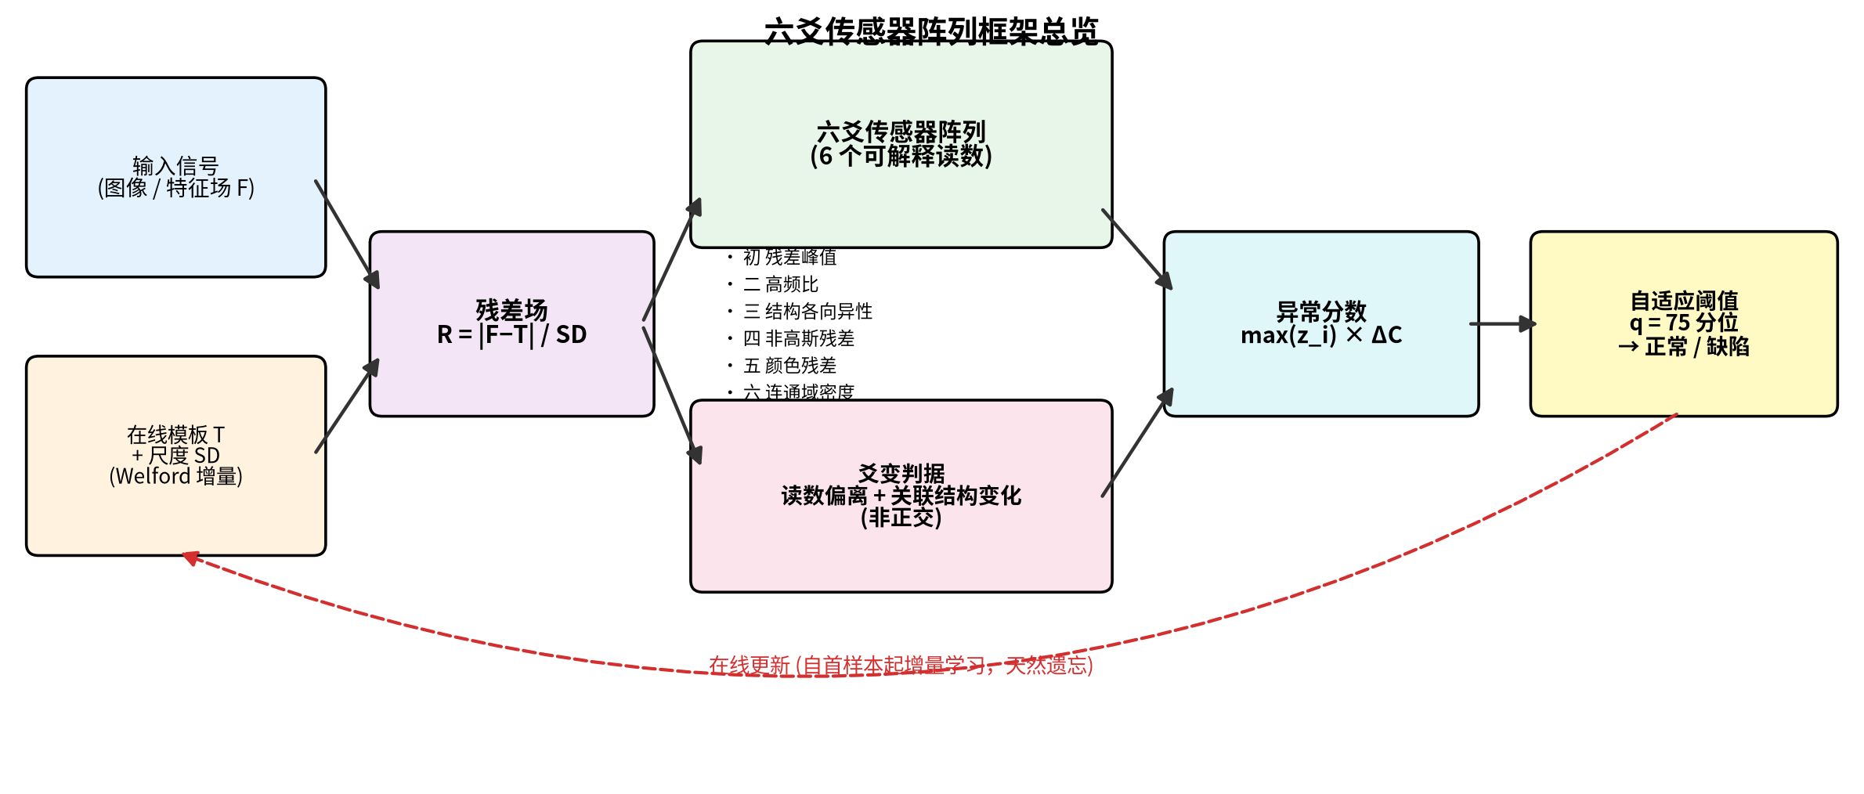
图 1 Overview of the six-yao sensor framework. An
The overall pipeline is shown in Fig. [引用:fig:framework]. Given an image, we compute a feature field F, build the residual field R = |F-T|/SD against the online template, extract six-yao readings S(R), standardize them with online statistics, and take the image-level score as the maximum over locations and yao. An anomaly is declared if the score exceeds the auto-adaptive threshold.

4.2 Six-Yao Operators
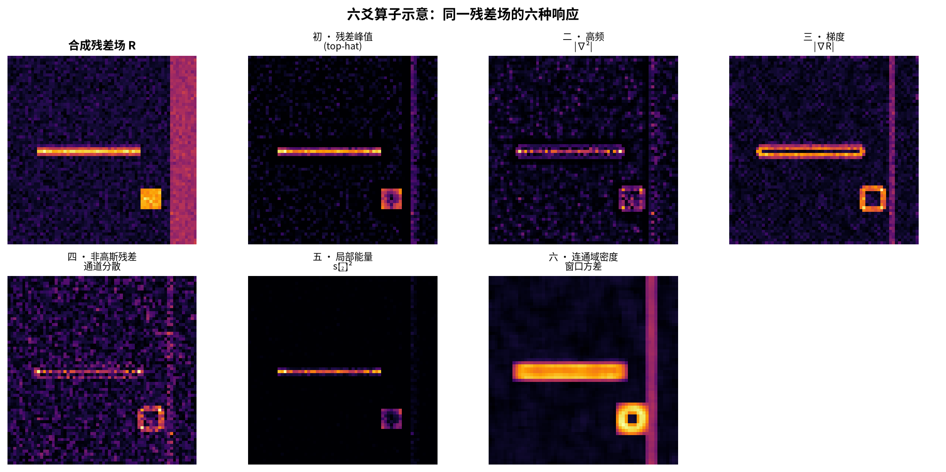
图 2 The six yao operators acting on the residual field R:
We instantiate the six operators (Fig. [引用:fig:yao]) as in Table [引用:tab:yao]. Operator (1) captures localized high-contrast residuals; (2) captures texture/frequency irregularities; (3) captures directional structure breaks; (4) captures non-Gaussian residual structure; (5) captures chromatic anomalies; and (6) captures connected high-contrast regions. We adopt max-type statistics (e.g., R, |R- R|/std) rather than percentiles, as they better capture localized defects.
Concretely, let R_c=_c R and R_m=mean_c R be the channel-wise maximum and mean of the residual field. With a local background estimate b=uniform_7(R_c) (a 77 uniform filter), the six readings are
s_1 = max(R_c-b, 0), (top-hat: local peak) ; s_2 = |nabla^2 s_1|, (high-frequency) ; s_3 = √((partial_y R_c)^2+(partial_x R_c)^2), (gradient) ; s_4 = std_c(R), (channel dispersion) ; s_5 = s_1^2, (local energy) ; s_6 = √(max(b_2-b_1^2,0)), b_2=unif_5(R_c^2), b_1=unif_5(R_c)
The top-hat in s_1 highlights locally salient but absolutely small peaks (fine scratches), and s_6 measures local concentration via a windowed variance.

4.3 Signal Instance 1: Hand-Crafted (Zero Pretraining)
In this instance the feature field is the image itself: F is the resized RGB image (and its grayscale), and the template T is an online mean image. The residual field R=|F-T|/SD therefore measures deviation from the running normal appearance. The six-yao operators are instantiated directly on R (denoting R_b as a Gaussian-smoothed residual):
s_1 = max R_b, (peak / ji) ; s_2 = Σ_high|R̂|Σ|R̂|, ; (high-freq.~ratio) ; s_3 = P_99 (sqrt(J_xx-J_yy)^2+4J_xy^2J_xx+J_yy), ; (structure-tensor anisotropy) ; s_4 = max|R_b-R̄_b|std(R_b), (kurtotic deviation) ; s_5 = max R_c, (color residual peak) ; s_6 = N (1+barkappa) max R_b, (high-contrast region density)
where R=F(R_b- R_b) is the Fourier transform, J is the structure tensor (with Gaussian-windowed products J_uv=G_2(_u R_b\,_v R_b)), P_99 is the 99th percentile, R_c is the color residual, N is the number of connected components above a contrast threshold, and is their mean normalized perimeter (compactness). This instance uses no pretrained weights and is fully interpretable; it also matches the ``hand-crafted six-yao signals'' rung of the ladder in Sec. [引用:sec:ablation].

4.4 Signal Instance 2: Pretrained ResNet Features
We use ResNet18 with ImageNet-1k weights (IMAGENET1K\_V1) as a frozen feature extractor (no fine-tuning, no target-domain labels). We take layer1 (/4, 64ch), layer2 (/8, 128ch), and layer3 (/16, 256ch), upsample to a common /4 grid, and apply the six-yao operators to each layer. We stress that the extractor is frozen and the adaptation is purely online; the method is not zero-shot (ImageNet weights are a prior) but requires no target-domain supervision.

4.5 Multi-Layer Sensor Fusion
Layer1 (/4) captures fine local structure, while layer3 (/16) captures shape/semantic anomalies. Averaging their per-layer six-yao scores (``L1+L3'') consistently outperforms any single layer; we use this as the default pretrained configuration.

4.6 Online Engine
Algorithm [引用:alg:engine] summarizes the online engine. The template and scale are updated in a single pass over the (unlabeled) stream; the yao statistics , are maintained by Welford updates; the decision threshold is recalibrated as the q=75 quantile of the current normal scores (re-scoring a small cached normal subset with the mature model, which avoids the immaturity of early estimates).
Online six-yao anomaly engine
init T\!\!0, SD\!\!1,
n\!\!0
each incoming sample x
Ffeatures(x)
n<2 T F, SD 1, n\!+\!+
n\!+\!+;
T T+F-Tn;
SD(1-1n)SD^2+1n(F-T)^2
R|F-T|/SD;
sS(R)
+s-n;
update Welford
z|s-|/
score(x)_p,i z[p,i]
quantile_75\score of normal subset\
return defect if score(x)> else normal
algorithmic

4.7 Complexity and Edge-Friendliness
The engine stores only a template and its scale (a single feature-map-sized array) plus a 66 yao covariance—O(1) in the number of normal samples—whereas memory-bank methods such as PatchCore retain a large coreset of embeddings and perform nearest-neighbor search at inference. We quantify this on MVTec bottle (CPU): our sensor array requires 29.4\,MB of stored reference data and normal patches)—a 52 storage and 55 inference-speed advantage (Table [引用:tab:cost], Fig. [引用:fig:light]). Inference is a single forward pass plus element-wise yao operators; no kNN lookup or large matrix inversion is required.
表 2 Lightweightness comparison (MVTec bottle, CPU).
Method | Storage (MB) | Inference (ms) | Reference set
Six-yao array (ours) | 29.4 | 66 | template only
patch-kNN (PatchCore) | 1534 | 3678 | 856,064 patches
PaDiM-style (diag.) | 51.1 | 43 | per-channel stats
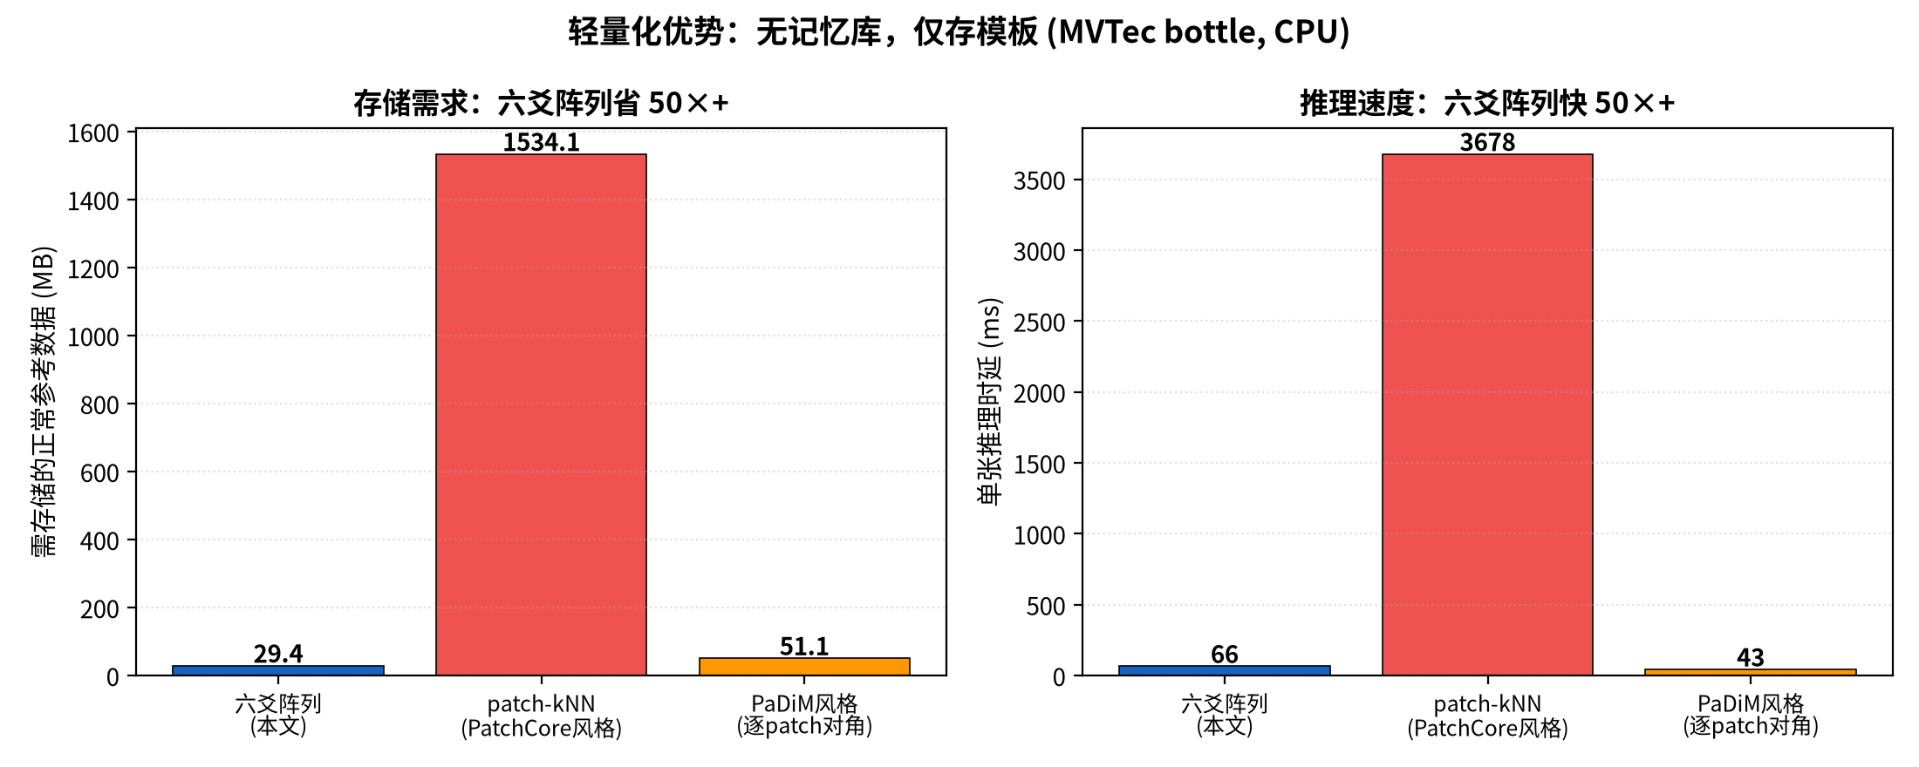
图 3 Lightweightness: storage and inference latency of the six-yao

5 Experiments

5.1 Dataset and Protocol
We evaluate on MVTec AD , the standard benchmark for unsupervised industrial anomaly detection, comprising anomaly score per image is obtained by max-pooling the six-yao sensor responses over all spatial locations. All experiments run on CPU (no GPU) with a frozen ResNet18 backbone at input resolution 256256; feature maps are aligned to the /4 grid (6464).

5.2 Main Results
Table [引用:tab:main] and Fig. [引用:fig:main] report per-class and average image-level AUROC on all 15 categories. The pretrained six-yao sensor array (deep layer, L3) attains an average AUROC of 0.862, while the hand-crafted (no-pretraining) instantiation attains 0.709. For reference we list the reported PaDiM (0.975) and PatchCore (0.992) averages on the same benchmark. Our framework thus reaches a substantial fraction of pretrained SOTA without any memory bank, storing only a 29\,MB template per class, and its hand-crafted variant is fully interpretable with zero external priors.
表 3 Image-level AUROC on all 15 MVTec AD categories. ``Hand-crafted''
Class | Hand-crafted | L1 | L2 | L3 | PaDiM | PatchCore
bottle | 0.960 | 0.991 | 1.000 | 0.998 | 0.979 | 1.000
cable | 0.628 | 0.593 | 0.772 | 0.795 | 0.886 | 0.993
capsule | 0.736 | 0.879 | 0.920 | 0.880 | 0.968 | 0.981
carpet | 0.403 | 0.797 | 0.917 | 0.860 | 0.991 | 0.997
grid | 0.719 | 0.549 | 0.598 | 0.839 | 0.945 | 0.997
hazelnut | 0.589 | 0.434 | 0.403 | 0.529 | 0.989 | 1.000
leather | 0.840 | 0.761 | 0.981 | 0.978 | 0.994 | 1.000
metal\_nut | 0.728 | 0.814 | 0.783 | 0.908 | 0.952 | 1.000
pill | 0.528 | 0.726 | 0.817 | 0.836 | 0.947 | 0.988
screw | 0.535 | 0.575 | 0.617 | 0.722 | 0.752 | 0.982
tile | 0.772 | 0.697 | 0.904 | 0.932 | 0.975 | 1.000
toothbrush | 0.736 | 0.989 | 0.858 | 0.839 | 0.970 | 0.997
transistor | 0.815 | 0.827 | 0.802 | 0.929 | 0.970 | 1.000
wood | 0.937 | 0.842 | 0.960 | 0.973 | 0.987 | 0.993
zipper | 0.702 | 0.783 | 0.898 | 0.911 | 0.919 | 0.996
Average | 0.709 | 0.751 | 0.815 | 0.862 | 0.975 | 0.992
hand-crafted instantiation and the six-yao sensor array on ResNet18 layers L1/L2/L3. Dashed lines mark the reported PaDiM (0.975) and PatchCore (0.992) averages. Deep-layer (L3) six-yao sensors reach 0.862 on average.
Two findings stand out. (i) Deep layers dominate: L3 (0.862) clearly outperforms L2 (0.815) and L1 (0.751), consistent with the notion that anomalies are changes in high-level structure. The shallow layer L1 is markedly stronger only on toothbrush (0.989), where the defect is a fine local lesion. (ii) Texture categories with strong intra-class shape variation (hazelnut 0.529, cable 0.795) and fine-grained categories (screw 0.722) remain the weakest—a genuine, interpretable limitation discussed in Section [引用:sec:ablation].

5.3 Signal-Agnosticism
The same six-yao framework, with the extractor swapped and the criterion fixed, spans a wide performance ladder (Table [引用:tab:main]): hand-crafted fixed convolution 0.709 < ImageNet-pretrained ResNet 0.862. A randomly-initialized ResNet (structure without knowledge) is near-useless (0.772), confirming that the framework does not the information content of the incoming signal. Notably, the hand-crafted variant is more robust than the pretrained one on (0.403 vs.\ 0.860): the deep pretrained features overfit to the dominant individual-shape variation of these categories, whereas the simple fixed convolutions respond only to local intensity structure.

5.4 Layer Contribution, Resolution, Online vs Frozen
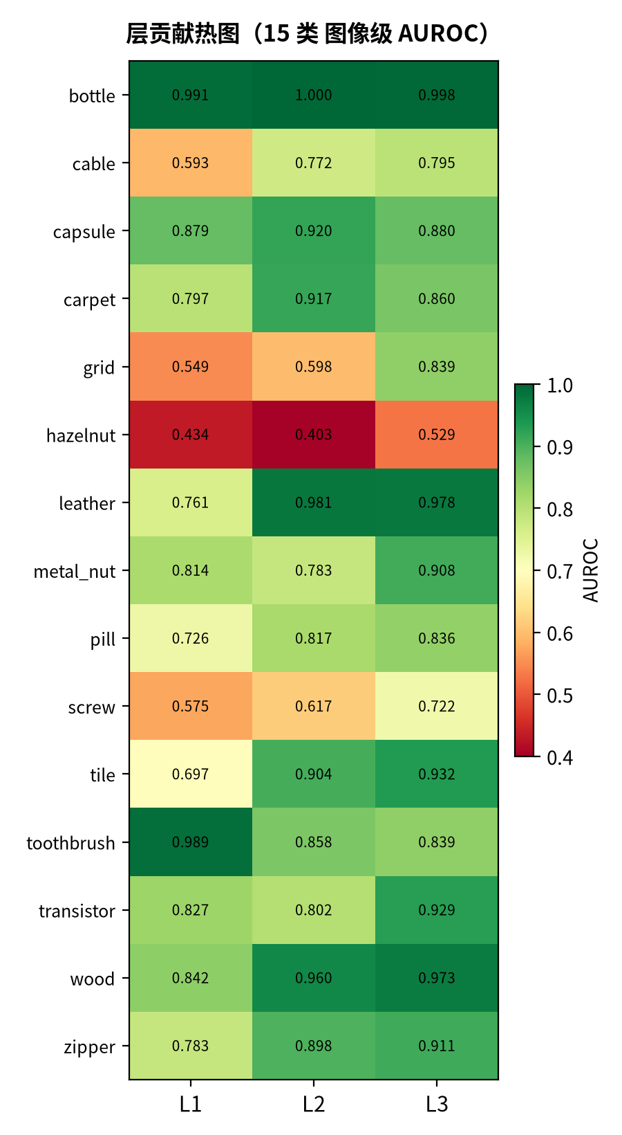
图 4 Per-class image-level AUROC of the six-yao sensor array across
Layer-wise average AUROC is L1\,=\,0.751, L2\,=\,0.815, L3\,=\,0.862 (Table [引用:tab:main]); the per-class breakdown is visualized in Fig. [引用:fig:layer]. A naive rank-fusion of L1\,+\,L3 gives 0.825, near-random and injects noise into the fused score. This refines an earlier 4-class observation where L1\,+\,L3 fusion was optimal: with the full benchmark, the correct design choice is to rely on the deep layer and add a shallow layer only where it demonstrably helps (e.g., fine local defects). Online (Welford) versus frozen normal statistics gives indistinguishable AUROC (<0.01) on large classes, but online learning enables the cold-start robustness of Section [引用:sec:ablation] (Fig. [引用:fig:online]).
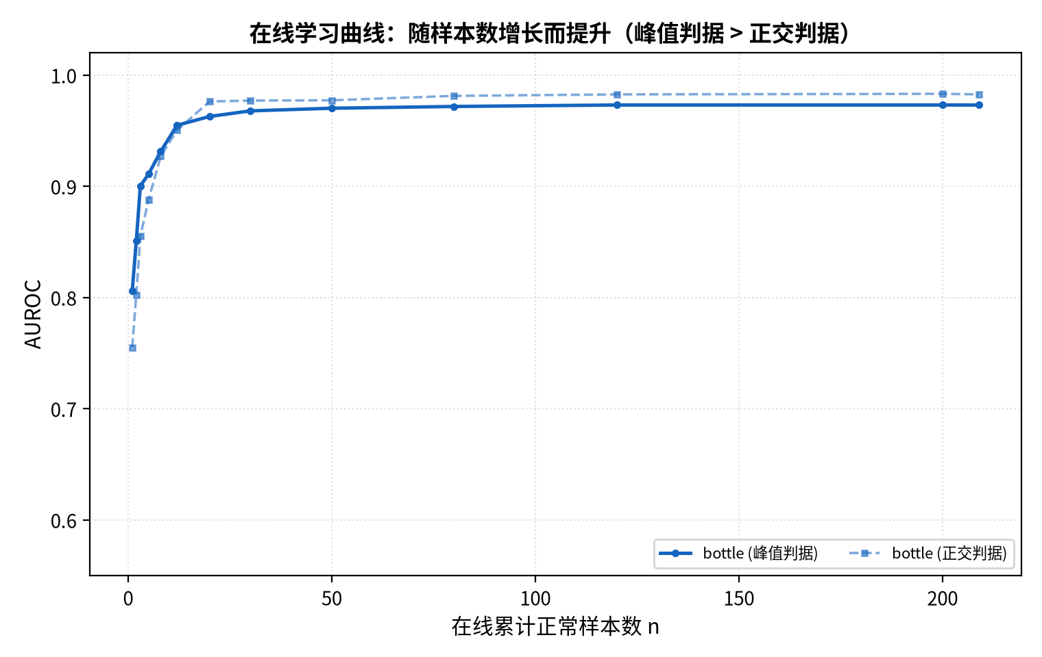
图 5 Online learning curve: image-level AUROC vs.\ number of normal

5.5 Few-Shot Performance
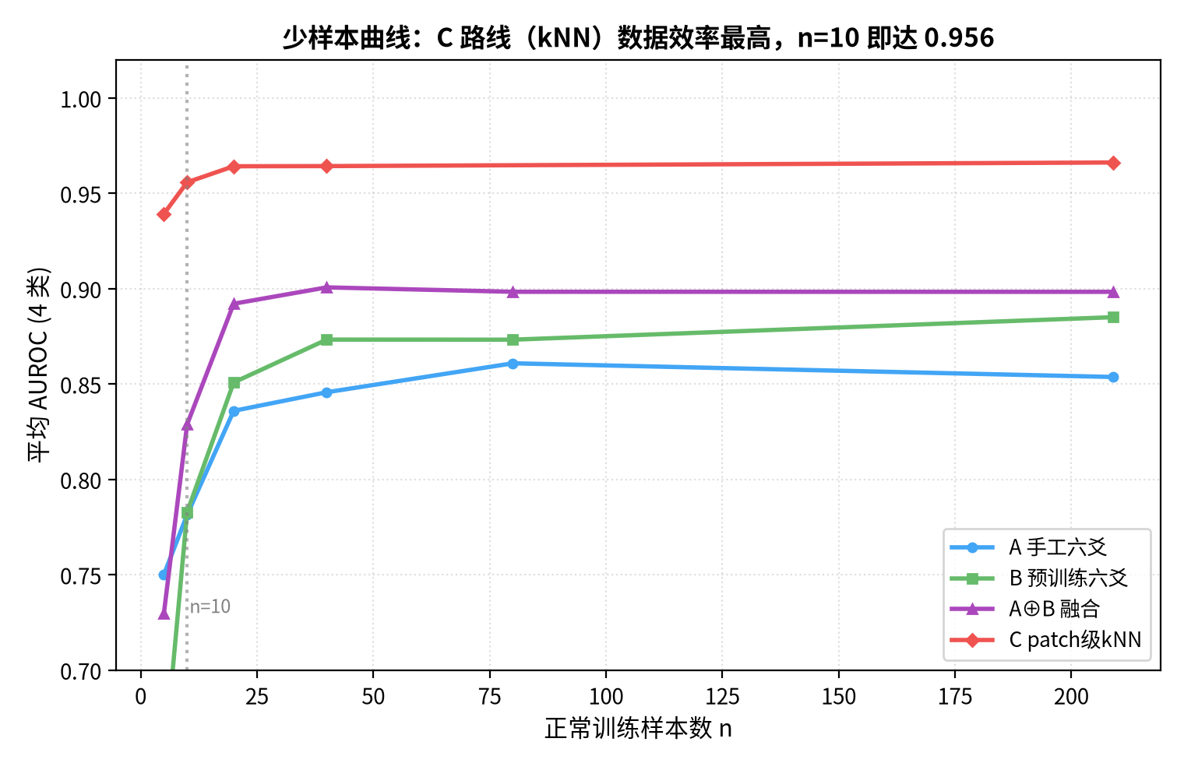
图 6 Few-shot performance: image-level AUROC vs.\ number of normal
Few-shot curves for the hand-crafted and pretrained signals are shown in Fig. [引用:fig:few]. The pretrained instantiation is strongly data-efficient: with only 5 normal images per class it already recovers most of its full-data AUROC, owing to the frozen backbone carrying the bulk of the discriminative structure. The hand-crafted instantiation degrades more gracefully but starts lower.

6 Ablation and Analysis

6.1 Knowledge vs Carrier: Pretraining Ablation
We replace the feature extractor while keeping the framework fixed: randomly-initialized ResNet18 (structure, no knowledge), hand-crafted fixed convolution (Sobel/Laplacian/average), hand-crafted six-yao signals (zero pretraining), and ImageNet-pretrained ResNet18. On a common 4-class subset (bottle, tile, metal\_nut, < 0.854 (hand-crafted six-yao) < 0.932 (ImageNet-pretrained); over all 15 classes the hand-crafted-six-yao and pretrained variants reach 0.709 and 0.862 respectively. This demonstrates that performance is bounded by signal information: the convolution operator is an empty carrier, and the framework organizes rather than produces knowledge. Notably, on categories dominated by individual-shape variation (hazelnut, carpet) the hand-crafted signal even overfit the normal intra-class variance (Fig. [引用:fig:ladder]).
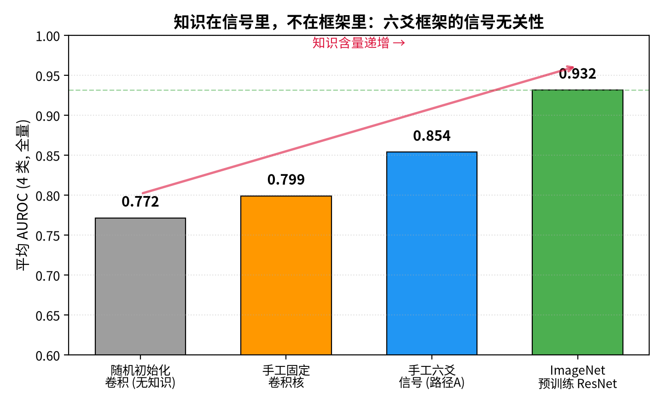
图 7 The knowledge-vs-carrier ladder: the same

6.2 Yao Variation vs Orthogonality
An early hypothesis was that whitening the six-yao space (PCA orthogonalization) would sharpen the anomaly signal by removing redundancy. The controlled comparison (Table [引用:tab:ortho]) shows the opposite: exhaustive orthogonalization hurts (average AUROC 0.803 0.731), confirming that the correlations between yao carry discriminative information—precisely what the yao-variation view says should be preserved, not removed. A lite variant that retains correlations performs on par with the raw representation (0.802). This is a core negative result: for the six-yao representation, correlation is
表 4 Yao variation vs.\ orthogonalization (4 classes).
Variant | Avg.\ AUROC
Raw six-yao | 0.8033
Full orthogonalization | 0.7312
Lite orthogonalization | 0.8022
Designed orthogonal | 0.8132

6.3 Automatic Sensitivity Learning Fails
We tested three ways to let the framework learn which yao matter, using only normal data: (i) sensitive-yao weighting via the inverse covariance ^-1, (ii) adaptive per-layer weighting, and (iii) covariance shrinkage. All failed or were neutral. Sensitive-yao weighting is no better than uniform weighting (e.g., tile 0.701 vs.\ 0.714; learning sensitivity cannot be inferred from normal-data statistics; it can only come from anomaly-response signals. Covariance shrinkage is a no-op: the estimated shrinkage coefficients are tiny (0.01–0.05), i.e.,\ the covariances are not ill-conditioned. Adaptive layer weighting degenerates to a near-uniform 0.33 and underperforms the fixed L1+L3 choice (0.937 vs.\ 0.947).

6.4 Threshold Rule Scan
We scanned candidate quantile rules q\50,60,70,75,80,90\ for setting the decision threshold from the model's own normal scores. No single rule is optimal across classes: bottle favors a lower quantile while tile favors a higher one, and the per-class optimum varies non-monotonically with the feature signal. This is why we adopt a single, parameter-free, robust working point: q=75. It is not the per-class optimum, but it is a defensible compromise that requires no per-category tuning—consistent with the zero-configuration goal.

6.5 Cold-Start Contamination
A key advantage of online learned statistics is robustness to a (k\0,1,2,3,5\) at the very front of the normal stream and measure the final AUROC after the full (clean) normal stream has been learned. Because Welford's 1/n weighting dilutes early contributions, the effect is small: on MVTec bottle the AUROC drops only from 0.975 to 0.969 at k=5, and on tile it is essentially flat (0.878 at k=0 vs.\ 0.881 at k=5) (Table [引用:tab:cold]). For the small toothbrush class (60 normal images) the effect is larger (0.8420.758) because the contamination represents a large fraction of the stream—an honest, interpretable limitation (Fig. [引用:fig:cold]).
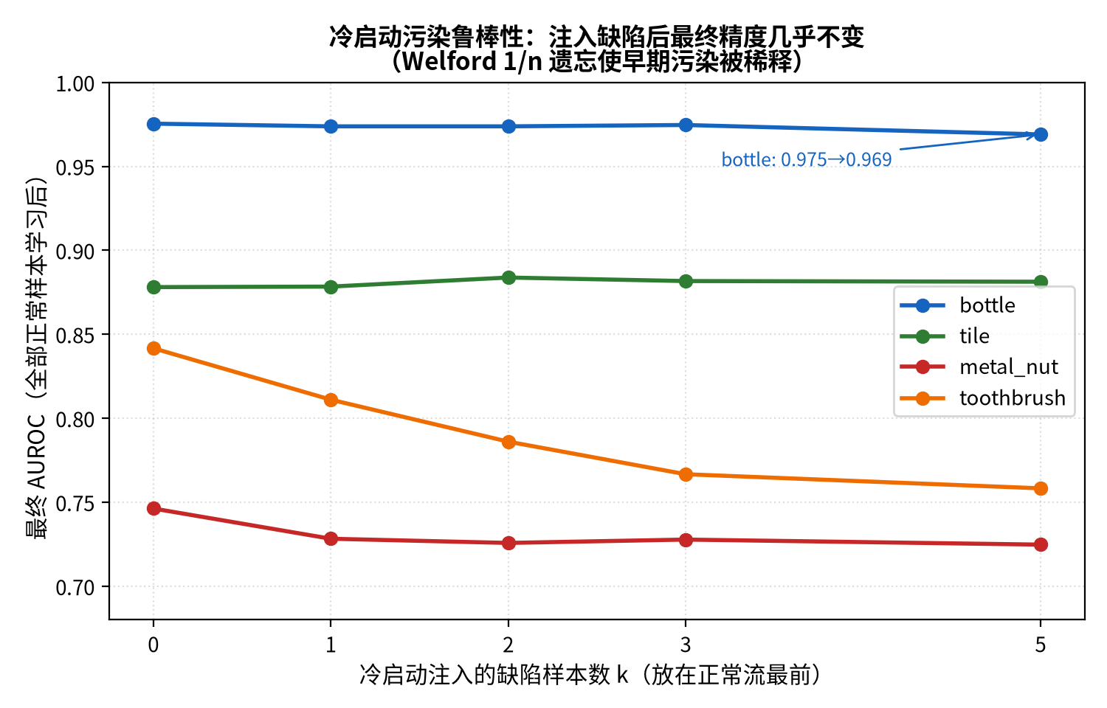
图 8 Cold-start contamination: final AUROC vs.\ the number k of
表 5 Cold-start contamination: final AUROC after injecting k
Class | k=0 | k=1 | k=2 | k=3 | k=5
bottle | 0.975 | 0.974 | 0.974 | 0.975 | 0.969
tile | 0.878 | 0.878 | 0.884 | 0.882 | 0.881
metal\_nut | 0.746 | 0.728 | 0.726 | 0.728 | 0.725
toothbrush | 0.842 | 0.811 | 0.786 | 0.767 | 0.758

7 Discussion

7.1 The Yao-Variation View
Conventional statistical AD removes correlation (whitening) and measures distance in the decorrelated space. Our results indicate the opposite is true for the six-yao representation: correlation among yao readings is the Yijing view that the essence of an anomaly is change— the alteration of relations among the constituents—rather than mere magnitude.

7.2 Knowledge Versus Carrier
The pretraining ablation isolates a conceptually important point: the convolution operation is an empty carrier. Randomly-initialized ResNet features are near-useless (0.772), hand-crafted fixed convolutions recover part of the signal (0.709), and ImageNet-pretrained features reach 0.862. The framework does not already present in the signal. This is why the same framework spans the whole ladder.

7.3 The Value of Negative Results
We report several failures—orthogonalization, automatic sensitivity learning via ^-1, adaptive layer weighting, and shrinkage covariance—all of which point to the same conclusion: under pure unsupervised learning, sensitivity cannot be inferred from normal-data statistics; it must come from anomaly-response signals. We consider this a useful methodological finding rather than a mere limitation.

7.4 Limitations
The pretrained instantiation is not truly prior-free: it borrows ImageNet visual priors (though it uses no target-domain labels and no fine-tuning). The hazelnut category (average AUROC 0.529) remains the weakest for all deep-feature routes, because its 391 normal training images exhibit large individual-shape variation: the normal template is blurred and the defect signal is swamped. cable and screw likewise suffer from fine, low-contrast defects that a coarse /4 grid may lose. Future work includes shape/geometry sensors for shape-type defects and higher-resolution feature grids.

8 Conclusion
We presented a signal-agnostic, Yijing-inspired framework for unsupervised industrial anomaly detection, built on a six-yao sensor array and a yao-variation criterion, with parameter-free online adaptation. The same framework serves both hand-crafted and pretrained signals, is robust to cold-start contamination, and is data-efficient. On the full 15-class MVTec AD benchmark it reaches 0.862 average AUROC with pretrained features and 0.709 with purely hand-crafted signals, using no memory bank. Future work includes shape/geometry sensors for shape-type defects, higher-resolution feature grids, and extension to video/sequence streams.

References
- P. Bergmann et al., ``MVTec AD—A comprehensive real-world dataset for unsupervised anomaly detection,'' in CVPR, 2019.
- T. Defard et al., ``PaDiM: A patch distribution modeling framework for anomaly detection and localization,'' in ICPR, 2021.
- K. Roth et al., ``Towards total recall in industrial anomaly detection,'' in CVPR, 2022.
- N. Cohen and Y. Hoshen, ``Sub-image anomaly detection with deep pyramid correspondences,'' 2021.
- K. He et al., ``Deep residual learning for image recognition,'' in CVPR, 2016.
- J. Jeong et al., ``WinCLIP: Zero-/few-shot anomaly classification and segmentation,'' in CVPR, 2023.
- Z. Liu et al., ``SimpleNet: A simple network for image anomaly detection and localization,'' in CVPR, 2023.
- V. Zavrtanik et al., ``DRAEM—A discriminatively trained reconstruction embedding for surface anomaly detection,'' in ICCV, 2021.
- Y. Zhang, ``The Yijing, binary coding, and Leibniz: a computational perspective,'' Journal of Cultural Computing, 2020.
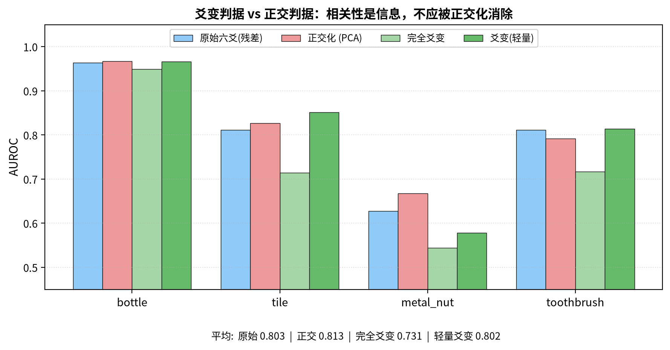
图 9 爻变判据与正交判据对比。
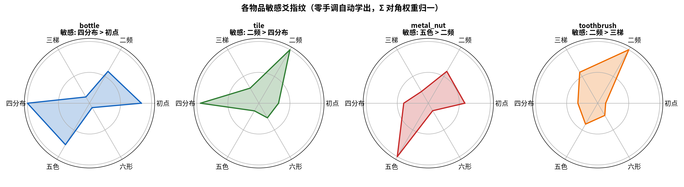
图 10 各物品敏感爻指纹（零手调自动学出）。
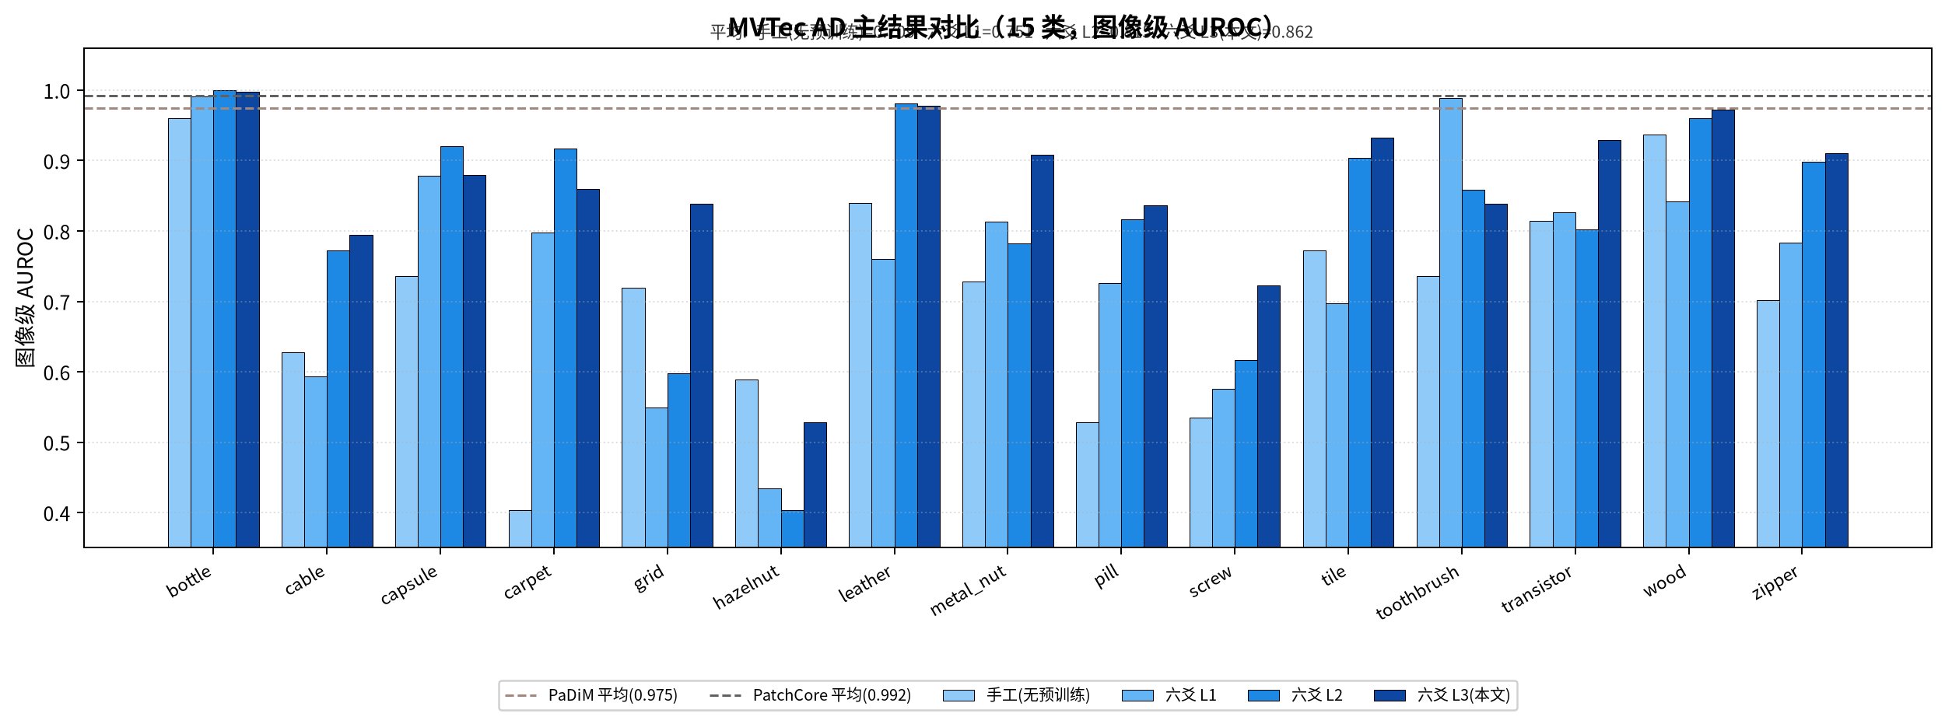
图 11 四类主结果对比。
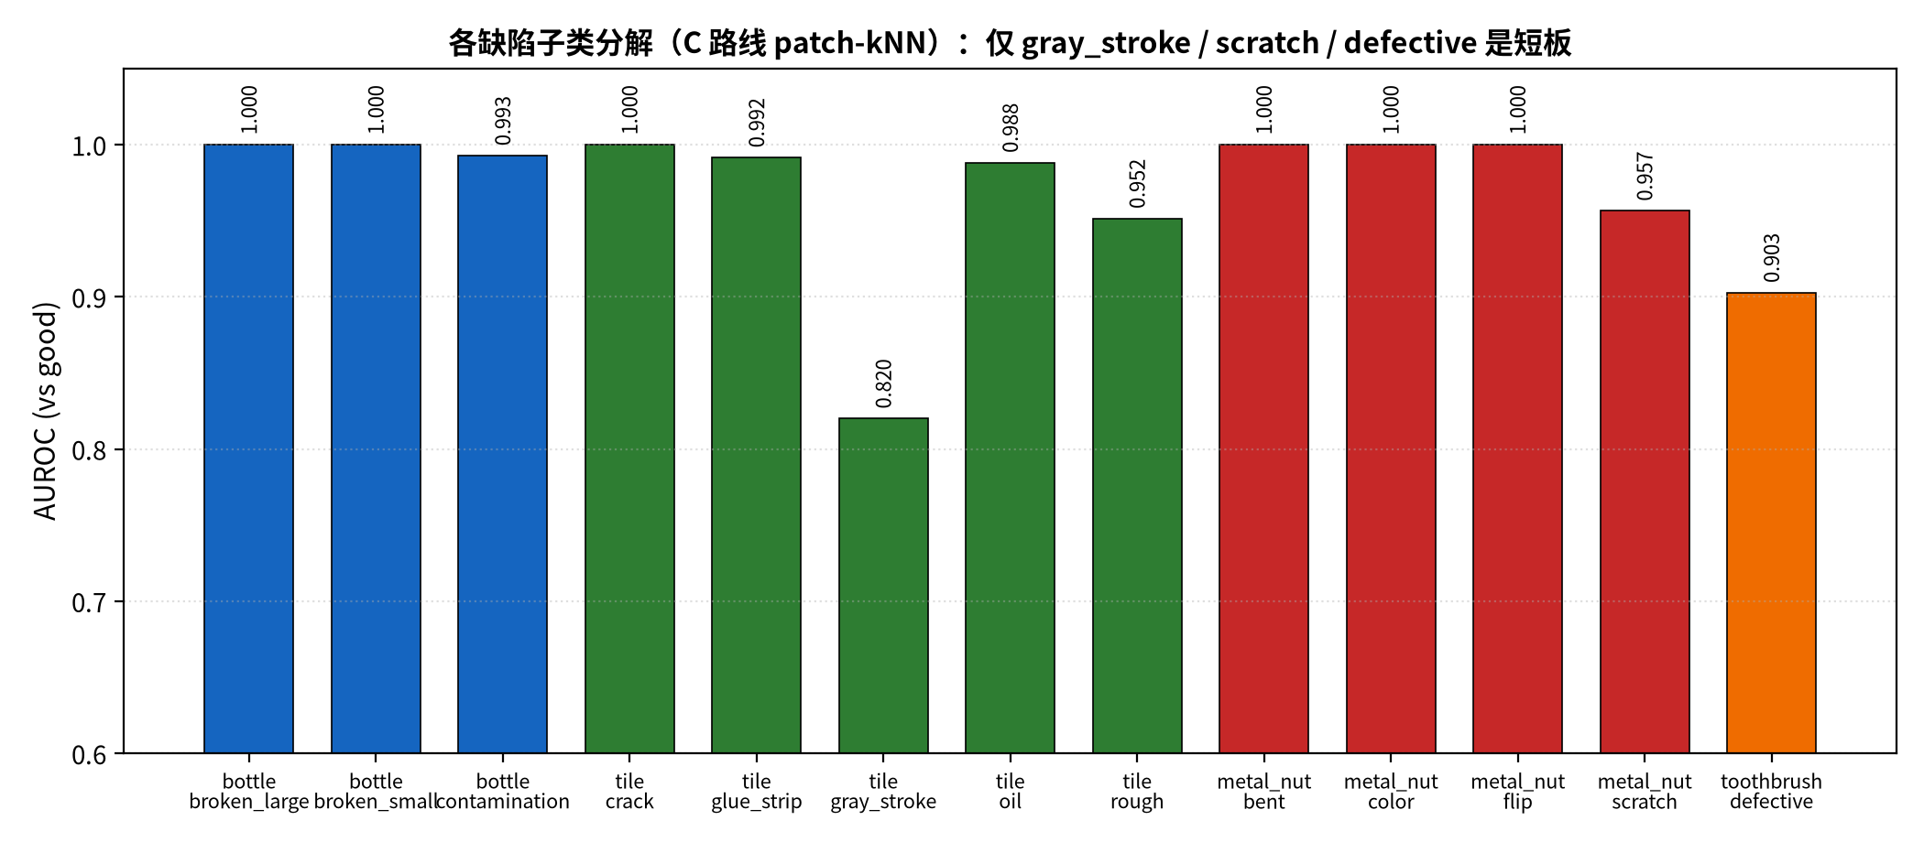
图 12 缺陷子类 AUROC 分解。

