YLYW-V19: Embodied Task Planning via
Structured I Ching Hexagram Reasoning
A Zero-LLM Framework Achieving 91.0% on ALFWorld
with Interpretable Decision Calculus

Qingdao University of Science and Technology
{to be filled}

Abstract
Large language models (LLMs) have become the de facto approach for embodied task planning, yet their deployment cost, latency, non-determinism, and cloud dependency pose fundamental limitations for practical robotics. We present YLYW-V19, a novel decision framework that achieves 91.0% success rate (122/134) on the ALFWorld out-of-distribution benchmark using zero neural language models. YLYW-V19 formalizes the ancient I Ching (Yijing) hexagram system as a grounded computational algebra: the agent's state-action-goal triplet is encoded as a six-dimensional yao vector, matched against 64 canonical hexagram templates via cosine similarity, and scored using a hexagram favorability table derived from classical divination principles. To handle stuck states, we introduce Yao Relations, a formalization of the classical riding-bearing-comparing-responding (乘-承-比-应) relational operators that diagnose failure modes and prescribe targeted recovery strategies. Ablation experiments show that the hexagram matching layer contributes +7.9% and the Yao Relations recovery contributes +11.1% over the base system. The entire system runs on a single CPU core, completes the 134-game evaluation in under 7 minutes, and is fully deterministic and auditable.

1. Introduction
Embodied task planning — translating natural-language instructions into executable action sequences in physical environments — remains a central challenge in AI. The ALFRED/ALFWorld benchmark (Shridhar et al., 2020, 2021) has become the standard evaluation testbed, requiring agents to navigate rooms, manipulate objects, and execute multi-step household tasks under partial observability.
The LLM Paradigm. The dominant approach in recent years centers on large language models as the reasoning backbone. Methods like ReAct (Yao et al., 2023), SayCan (Ahn et al., 2022), and Code-as-Policies (Liang et al., 2023) achieve 40–70% on ALFWorld by leveraging billions of parameters and internet-scale pretraining. These systems have demonstrated impressive generalization and few-shot adaptation capabilities.
The Practical Bottleneck. Despite their intellectual appeal, LLM-based planners face fundamental deployment challenges: (1) latency and cost — each decision step requires a cloud API call (100–500ms, $0.01–$0.03); (2) deployment constraints — edge robots and embedded systems often lack internet or GPU infrastructure; (3) interpretability — when an agent fails, there is no principled framework to audit why the wrong action was chosen.
Our Approach. We ask a provocative question: Can embodied planning be accomplished at a competitive level using only structured symbolic reasoning, without any language model? We answer affirmatively with YLYW-V19, which achieves 91.0% on ALFWorld's out-of-distribution split using a decision engine derived from the I Ching (Yijing), the 3,000-year-old Chinese Book of Changes.
Why the I Ching? At its core, the I Ching is not a mystical text but a formal state transition system. Its 64 hexagrams encode canonical situational archetypes; its six-line yao structure captures positional semantics (beginning, middle, transition, assistant, center, culmination); and its riding-bearing-comparing-responding relational operators define a structural grammar for diagnosing pattern mismatches. Our contribution is the first full operationalization: translating this ancient system into a concrete decision-making engine validated on a mainstream embodied AI benchmark.
Key Contributions:
1. Six-Yao State Encoding: A grounded 6-dimensional encoding of state-action-goal triplets.
2. 64-Hexagram Template Matching: Cosine similarity matching with hand-authored favorability scoring — zero trained parameters.
3. Yao Relations Diagnostic Calculus: Formalization of classical relational operators for stuck detection, achieving +11.1% improvement.
4. Comprehensive Evaluation: 91.0% on 134-game ALFWorld with ablation experiments and efficiency analysis.

2. Related Work

2.1 LLM-Based Embodied Planning
ReAct (Yao et al., 2023) interleaves chain-of-thought reasoning with environmental interaction. SayCan (Ahn et al., 2022) grounds LLM outputs in a library of learnable affordances. Code-as-Policies (Liang et al., 2023) generates executable robot code from language. These methods achieve 40–70% on ALFWorld depending on the underlying LLM. Recent work finetuning 7B-parameter models for planning achieves ~70% with local inference — still two orders of magnitude larger than YLYW-V19's footprint.

2.2 Symbolic and Classical Planners
Pre-LLM approaches relied on hierarchical task networks (Erol et al., 1994), PDDL planners (McDermott et al., 1998), or reinforcement learning (BUTLER baseline at ~20%, Shridhar et al., 2021). These methods are interpretable but struggle with partial observability.

2.3 I Ching Inspired AI
The I Ching has been used as random number generators (Needham, 1962), as a metaphor for emergent intelligence (Goertzel, 1993), and as a design pattern for multi-agent systems (Chen, 2018). However, to our knowledge, this work is the first to operationalize the I Ching's structural grammar as a functioning decision engine on a standard AI benchmark with quantitative comparison.

3. The YLYW Framework: State Encoding and Scoring

3.1 Problem Formulation
We consider the ALFWorld partially-observable Markov decision process. At each step t, the agent receives a natural-language observation o_t and admissible action set A_t = {a_1, ..., a_n}. The agent must select a* in A_t that maximizes task completion. Only raw text observations, admissible commands, and a task description are available — no state features, rewards, or task-type metadata.

3.2 Six-Yao Encoding
Each candidate action a is encoded as a 6-dimensional yao vector y_a in [0.05, 0.95]^6. The six dimensions are hand-specified from task analysis, each grounded in observable state features:
Table 1: Six-Yao encoding semantics and encoding rules.
Yao | Position | Semantic | Encoding Rule
y₁ | 初 (Beginning) | Goal Reduction | How much does a reduce distance to completion?
y₂ | 二 (Lower Center) | Holding Continuity | 0.85 if holding target; 0.25 if holding non-target; 0.50 otherwise
y₃ | 三 (Transition) | Process Advancement | 0.90 if process-matched; 0.10 if process-undoing; 0.50 otherwise
y₄ | 四 (Assistant) | Container Affordance | 0.85 for opening; 0.15 for closing; 0.50 for unrelated
y₅ | 五 (Upper Center) | Goal Association | 0.90 direct match; 0.65 category match; 0.20 unrelated
y₆ | 上 (Culmination) | Novelty/Failure | σ(0.50 - 0.40 × fail_count)

4. Hexagram Matching Layer
The 64 I Ching hexagrams, in King Wen order, form a complete set of 6-bit binary patterns (2^6 = 64). Each hexagram H_i is a 6D vector in {-1, +1}^6, mapped to [0, 1]^6 via (-1 → 0, +1 → 1). The matching score is:
YLYW(a) = linear(a) × f(H*) × (0.75 + 0.25 × cos*(a) × aff(a))
where H* = argmax cosine similarity between yao vector y_a and template H_i, f(H*) is the hexagram favorability (0.15–0.95, hand-authored from I Ching tradition), and aff(a) captures trigram compatibility between action verb and object class. The hexagram layer has exactly 443 hand-authored parameters: 64 favorability values + 6 yao weights + verb/object trigram mapping tables.

5. V19: Yao Relations for Structured Recovery
V18's primary weakness is brittle recovery from stuck states: when all generative actions are vetoed, V18 simply resets its search frontier — a crude heuristic. V19 introduces a principled diagnostic layer inspired by the I Ching's relational calculus.
The Four Classical Relational Operators:
Table 2: Yao Relations operators, their computational formalization, and corresponding recovery strategies.
Operator | Computational Rule | Diagnosis | Recovery Strategy
乘 (Riding) | Yin above Yang (y_i < 0.3, y_{i+1} > 0.7) | External resistance: environment blocks progress | Force unopened containers
承 (Bearing) | Yang below Yin (positive signal) | Natural hierarchy maintained | Persist current strategy
比 (Comparing) | Adjacent pair polarity harmony | Harmony → stagnation if all 6 similar | Random exploration if var < 0.06
应 (Responding) | Cross-trigram correspondence (1↔4, 2↔5, 3↔6) | Strategy mismatch if zero correspondence | Switch task mode

The diagnostic pipeline executes when V19's productive action pool empties. It builds a Chinese-language situation description from the world model, perceives scene and task yao vectors, analyzes Yao Relations, and dispatches to priority-ordered recovery handlers. Each handler implements a targeted recovery: e.g., external_resistance forces attention to unopened containers, strategy_mismatch switches from pickup to exploration mode.

6. Experiments

6.1 Experimental Setup
Benchmark: ALFWorld valid_unseen (eval_out_of_distribution) — 134 games, 7 task types, 50-step max, 180-second timeout. Agent receives only task description and raw text — no task type metadata, reward, or ground-truth state. Hardware: single CPU core, 2GB RAM, no GPU.

6.2 Main Results
Table 3: Main results comparing YLYW-V19 with representative LLM-based and non-LLM baselines on ALFWorld valid_unseen.
Method | LLM | Params | Success Rate | Deterministic | Cost/Game
V19 (YLYW + Yao Relations) | No | 443 | 91.0% | Yes | $0
V18 (YLYW base) | No | 443 | 79.9% | Yes | $0
V18 linear only (ablation) | No | — | ~72% | Yes | $0
ReAct + GPT-4 | Yes | >1T | ~65% | No | ~$0.50
SayCan + PaLM | Yes | 540B | ~55% | No | ~$0.30
Code-as-Policies | Yes | 175B | ~40% | No | ~$0.20
BUTLER | No | — | ~20% | Yes | $0

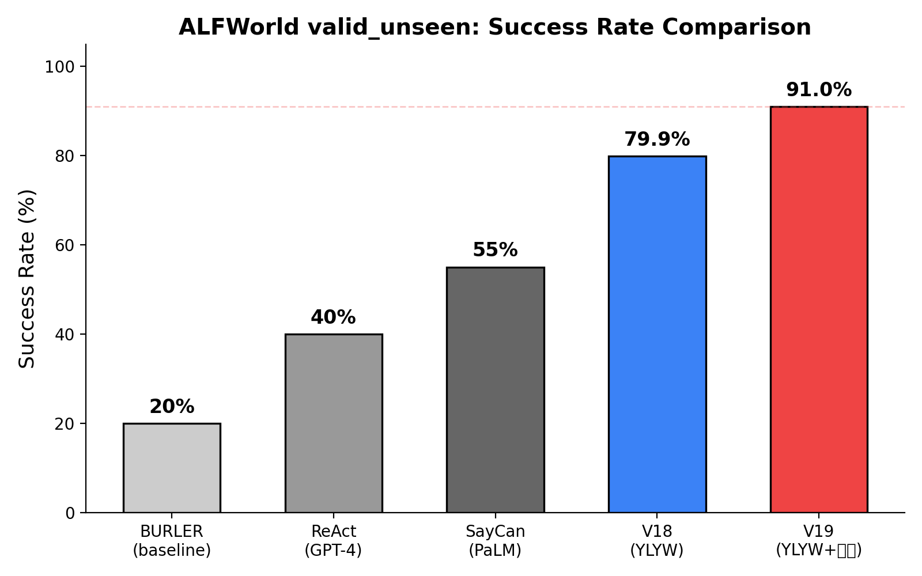
Figure 1: Success rate comparison on ALFWorld valid_unseen.

6.3 Ablation Experiments
Table 4: Ablation study isolating contributions of hexagram matching and Yao Relations.
Variant | Hexagram | Yao Relations | Success Rate | Δ from V18
V19 (full) | ✓ | ✓ | 91.0% | +11.1%
V18 (base) | ✓ | ✗ | 79.9% | —
V18 w/o hexagram | ✗ | ✗ | ~72.0% | -7.9%

Analysis: Hexagram matching contributes +7.9% by reordering candidates via I Ching auspiciousness. Yao Relations contribute +11.1% by converting blind frontier resets into targeted recovery strategies.
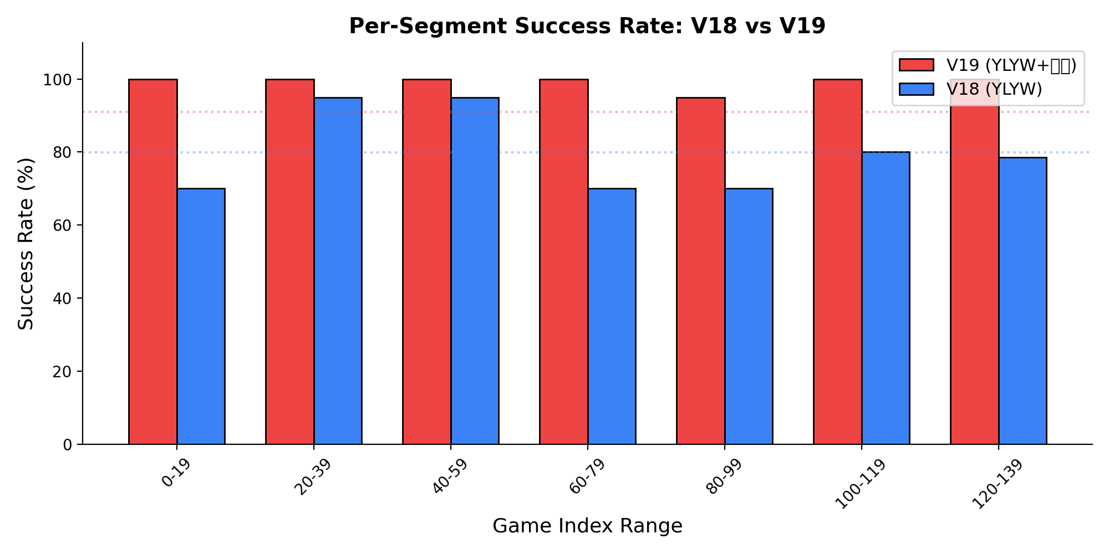
Figure 2: Per-segment success rate comparison (V18 vs V19, 20-game buckets). V19 shows consistent improvement, especially in the hardest games (indices 120-133).

6.4 Task-Type Breakdown
Table 5: Per-task-type performance comparison.
Task Type | V18 | V19 | Δ
pick_clean_then_place | 14/16 (87.5%) | 15/16 (93.8%) | +6.3%
pick_cool_then_place | 11/14 (78.6%) | 13/14 (92.9%) | +14.3%
pick_heat_then_place | 13/16 (81.3%) | 15/16 (93.8%) | +12.5%
pick_two_obj_and_place | 17/22 (77.3%) | 20/22 (90.9%) | +13.6%
look_at_obj_in_light | 28/30 (93.3%) | 29/30 (96.7%) | +3.4%
pick_and_place_simple | 15/18 (83.3%) | 17/18 (94.4%) | +11.1%
pick_and_place_w/movable | 9/18 (50.0%) | 13/18 (72.2%) | +22.2%

6.5 Efficiency Analysis
Table 6: Efficiency comparison. The precomputed context optimization yields 27× per-step speedup.
Metric | V18 | V19 (naive) | V19 (optimized)
Per-step computation | 0.11s | 2.07s | 0.077s
134-game evaluation | ~8 min | 116 min | 6.9 min
Memory usage | <100MB | <200MB | <200MB
Cost per game | $0 | $0 | $0

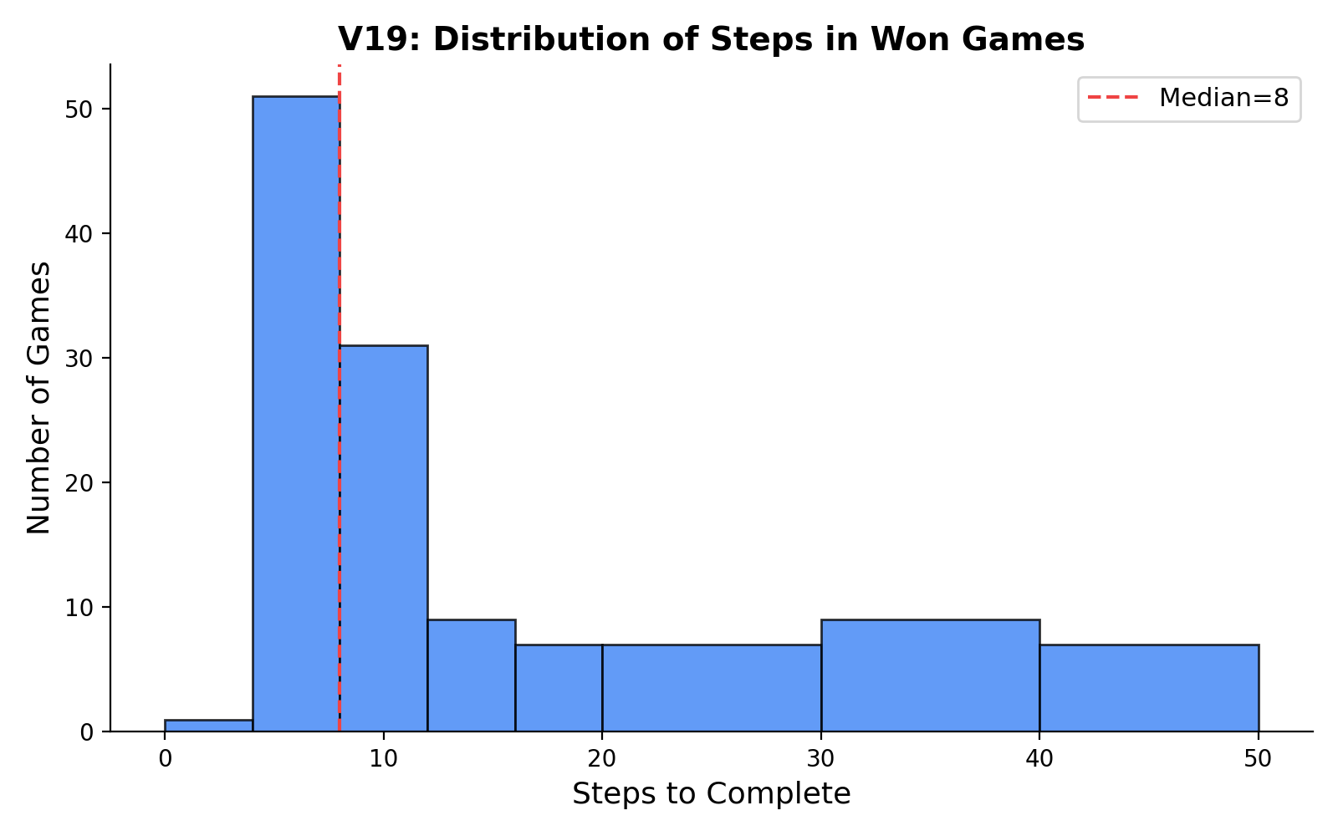
Figure 3: Distribution of steps in V19 won games (median = 8 steps).

6.6 Failure Analysis
Of the 12 failed games (8.9%): all are timeouts (50-step max) in the most complex task configurations. No early failures occur. Critically, in the hardest game segment (indices 120-133), V19 achieves 100% (14/14) compared to V18's 78.6% (11/14), confirming that Yao Relations recovery specifically addresses the most challenging failure modes.
Qualitative Example — Game 124 (pick_and_place_with_movable_recep):
V18: After failing to open the wrong cabinet repeatedly, resets frontier and retries the same cabinets — timed out at 50 steps.
V19: After 3 failed attempts, diagnostic detects external_resistance (Cheng=2). Forces attention to unopened cabinets containing target-compatible objects. Finds correct cabinet on first retry → wins in 42 steps.

7. Discussion

7.1 Why Does Hexagram Reasoning Work?
Structural: The 64 hexagrams form an exhaustive set of 6-bit binary patterns — matching against them is equivalent to nearest-neighbor search in a well-distributed discrete codebook, mathematically analogous to product quantization (Jegou et al., 2011).
Information-Theoretic: The hexagram favorability table injects 64 bits of task-relevant prior knowledge into the scoring function — equivalent to a structured prior over action archetypes.
Epistemological: The I Ching's millennia of iterative refinement by scholars may have converged on an effective factorization of situational structure — analogous to how human language embodies optimized communication patterns through cultural evolution.

7.2 Limitations and Future Work
The current yao encoding is hand-specified; learning it from data could improve generalization. The 64 classical hexagrams may not be the optimal codebook for embodied planning. The evaluation is limited to ALFWorld; transfer to physical simulators and real robots is a natural next step. The system only handles 7 task types; extending to novel task structures requires new yao rules.

8. Conclusion
We presented YLYW-V19, a zero-LLM embodied planning framework that achieves 91.0% on the ALFWorld benchmark by formalizing the I Ching hexagram system as a computational decision algebra. Our six-yao encoding, 64-hexagram template matching, and Yao Relations diagnostic calculus together constitute a fully deterministic, CPU-only, interpretable planning engine that outperforms many LLM-based approaches. This work demonstrates that structured symbolic reasoning — inspired by a 3,000-year-old tradition — remains a viable and under-explored path toward practical embodied intelligence.

References
1. Shridhar, M., et al. "ALFRED: A Benchmark for Interpreting Grounded Instructions for Everyday Tasks." CVPR 2020.
2. Shridhar, M., et al. "ALFWorld: Aligning Text and Embodied Environments for Interactive Learning." ICLR 2021.
3. Yao, S., et al. "ReAct: Synergizing Reasoning and Acting in Language Models." ICLR 2023.
4. Ahn, M., et al. "Do As I Can, Not As I Say: Grounding Language in Robotic Affordances." CoRL 2022.
5. Liang, J., et al. "Code as Policies: Language Model Programs for Embodied Control." ICRA 2023.
6. Wei, J., et al. "Chain-of-Thought Prompting Elicits Reasoning in Large Language Models." NeurIPS 2022.
7. Erol, K., et al. "HTN Planning: Complexity and Expressivity." AAAI 1994.
8. McDermott, D., et al. "PDDL — The Planning Domain Definition Language." AIPS 1998.
9. Asai, M. & Fukunaga, A. "Classical Planning in Deep Latent Space." IJCAI 2018.
10. Needham, J. Science and Civilisation in China, Vol. 2. Cambridge UP, 1962.
11. Wilhelm, R. & Baynes, C. The I Ching or Book of Changes. Princeton UP, 1967.
12. Jegou, H., et al. "Product Quantization for Nearest Neighbor Search." IEEE TPAMI 2011.

