YLYW-V19: Embodied Task Planning via
Structured I Ching Hexagram Reasoning

A Zero-LLM Framework Achieving 91.0% on ALFWorld
with Fully Interpretable Decision Calculus

Xinglu Ma
College of Information Science and Technology
Qingdao University of Science and Technology
{Corresponding: maxinglu@qust.edu.cn}

Abstract
Large language models have become the dominant paradigm for embodied task planning, yet their deployment cost, latency, non-determinism, and cloud dependency pose fundamental bottlenecks. We present YLYW-V19, a fully symbolic decision framework based on the I Ching hexagram system, achieving 91.0% success rate (122/134) on the ALFWorld out-of-distribution benchmark with zero large language models and zero neural networks.
YLYW core is a three-layer architecture (L1 Trigram to L2 Yao to L3 Hexagram) transforming the I Ching into an operational decision calculus. YLYW-V19 introduces three innovations: a semantic understanding pipeline mapping English task descriptions to structured hexagram representations; Zhiji Learning performing real-time experience accumulation from execution trajectories; and a Yao Relations Diagnostic Calculus formalizing six relational operators for stuck-state diagnosis and targeted recovery.
Ablation experiments based on rigorous component removal show: the semantic pipeline provides foundational task understanding; Zhiji Learning contributes about +5 to 6%; 64-hexagram matching contributes about +7%; and Yao Relations recovery contributes +11.1% (base system 79.9% to YLYW-V19 91.0%). The entire system runs on a single CPU core with 2GB RAM, completing the 134-game evaluation in under 7 minutes, fully deterministic and auditable.

1. Introduction
Embodied task planning requires agents to translate natural language into executable actions. The ALFWorld benchmark (Shridhar et al.,2020,2021) requires agents to navigate rooms, manipulate objects, and execute multi-step tasks under partial observability with only text observations.
The LLM paradigm ReAct (Yao et al.,2023), SayCan (Ahn et al.,2022), Code-as-Policies (Liang et al.,2023) relies on billion-parameter models achieving 40-70% on ALFWorld. Yet this faces a triple bottleneck: deployment cost and latency, black-box interpretability, and non-reproducibility.
The I Ching as Decision Engine. From a computational perspective, the ancient Chinese Book of Changes contains a highly formalized decision system: 8 trigrams as primitive concept bases, 64 hexagrams (2^6=64) as complete state space, and yao relations as situation analysis grammar. YLYW operationalizes this system on a mainstream AI benchmark for the first time.
Key contributions:
1. Three-layer I Ching reasoning architecture (L1 Trigram to L2 Yao to L3 Hexagram).
2. Semantic understanding pipeline mapping English task descriptions to structured hexagram representations.
3. Zhiji Learning: one-shot experience accumulation from execution trajectories.
4. Yao Relations diagnostic calculus with formal mathematical definitions and targeted recovery strategies.
5. Comprehensive evaluation: 91.0% on 134-game ALFWorld with rigorous ablation, efficiency analysis, and failure characterization.

2. Related Work

2.1 LLM-Based Embodied Planning
ReAct, SayCan, Code-as-Policies achieve 40-70% on ALFWorld. Fine-tuning 7B models achieves about 70% with local inference, still two orders of magnitude larger than YLYW.

2.2 Symbolic Planners
HTN (Erol et al.,1994), PDDL (McDermott et al.,1998), RL (BUTLER about 20%) are interpretable but struggle with partial observability.

2.3 I Ching Inspired AI
The I Ching has been used as random number generators (Needham,1962) and metaphor for emergent intelligence (Goertzel,1993). This is the first work to operationalize its structural grammar as a competitive decision engine on a standard AI benchmark.

3. Philosophical Foundation and Architecture

3.1 Computational Nature of the I Ching
The Xicizhuan states: "The Changes is a paradigm of heaven and earth." This can be reinterpreted as a complete state-space axiom: 8 trigrams as primitive archetypes, 64 hexagrams (2^6=64) covering all configurations, strict yao position semantics (first=beginning, second=center, third=transition, fourth=assistant, fifth=authority, sixth=culmination), and structural relations (Cheng, Bi, Ying, Dangwei, Dezhong) forming a situation analysis grammar.

3.2 Three-Layer Architecture
L1 (TrigramBase): Gaussian similarity matching against 8 trigram prototypes (Qian, Dui, Li, Zhen, Xun, Kan, Gen, Kun), outputting an 8-dimensional membership vector. L2 (YaoEncoder): feature compression into a 6-dimensional yao vector encoding stability, reachability, force requirement, fragility, task priority, and environmental constraint. L3 (HexagramRuleBase): cosine similarity matching against 64 canonical hexagram templates weighted by hand-authored favorability scores. All 443 parameters are hand-crafted from I Ching texts with zero training.

3.3 There-Layer Architecture Visualization
Figure 1 illustrates the complete YLYW three-layer architecture, where dashed arrows represent the Yao Relations feedback path.
Feature/Task Input
L1 Trigram Membership (8-dim): Feature → Gaussian Kernel → 8 Prototypes
L2 Yao Encoding (6-dim): Stability + Reachability + Force + Fragility + Priority + Constraint
L3 Hexagram Matching: Cosine Similarity × Favorability × Affinity → Hexagram + Strategy
Yao Relations: Cheng/Bi/Ying/Dangwei/Dezhong | Diagnosis → Recovery | Feedback
Figure 1: YLYW three-layer architecture with Yao Relations feedback path

3.4 Human-Machine Same-Hexagram Principle
When a human says "this cup is stable," YLYW assigns high Gen (Mountain) membership. When a human says "we need a new direction," YLYW detects Cheng (suppression). This makes the decision chain fully readable, auditable, and debatable.

4. Semantic Understanding Pipeline

4.1 Three-Layer Semantic Mapping
Without LLMs, YLYW implements a three-layer semantic pipeline isomorphic to its Classical Chinese version.
Table 1: Word class to trigram membership mapping
Word Class | Dominant Trigram | Virtue | Examples
Action Verb | Zhen(Thunder) | Motion | take,put,clean,heat
Object Noun | Kun(Earth) | Bearing | apple,plate,mug,cloth
Location Noun | Gen(Mountain) | Stillness | drawer,cabinet,sink
Tool/Light | Li(Fire) | Light/Adherence | lamp,light
Function Word | Xun(Wind) | Boundary | a,the,and,from

5. Zhiji Learning

5.1 Philosophical Root
From the Xicizhuan: "To know the subtle beginnings, is this not spirit-like?" YLYW engineers Zhiji as three layers of online experience accumulation, all CPU-only.

5.2 Synonym Calibration
Extracts entity names from admissible commands, cross-matches with task description vocabulary. One-shot learning. For example, description "cup" maps to environment "mug".

5.3 Location Prior Calibration
Accumulates spatial distribution statistics across games. Location priors inject scoring bonuses into yao encoding in subsequent tasks.

5.4 Scene Structure Calibration
Maintains per-scene K_scene = {openable_containers, empty_locations, location_contents}. Design principle: error-tolerant prior calibration.

6. Yao Relations Diagnostic Calculus

6.1 Formal Definitions
Definition 1 (Cheng/Riding). For yao vector y in [0,1]^6, if exists i in {1,...,5} such that y_{i+1} < 0.3 and y_i > 0.7, then (i,i+1) is a Riding relation. High Cheng_count diagnoses external resistance.
Definition 2 (Ying/Responding). Let y_scene = (y1,y2,y3) and y_task = (y4,y5,y6). Ying_count = number of corresponding positions sharing the same sign. Ying_count = 0 indicates strategy mismatch.
Definition 3 (Dangwei/Correct Position). Dangwei = (count(y_i>0.5 for i in {1,3,5}) + count(y_j<0.5 for j in {2,4,6})) / 3.
Definition 4 (Dezhong/Holding Center). Dezhong = (I[y2>0.5] + I[y5>0.5]) / 2. Low Dezhong indicates lost direction.

6.2 Diagnostic Pipeline
When YLYW detects an empty productive action pool: (1) build Chinese situation description; (2) perceive scene_yao and task_yao; (3) compute delta-y = y_task minus y_scene; (4) run Yao Relations on all three yao vectors; (5) priority-ordered diagnosis with targeted recovery.
Table 2: Targeted recovery strategies
Diagnosis | Trigger | Recovery Action
external_resistance | Cheng>=2 | Force unopened container attention
strategy_mismatch | Ying=0 | Switch task mode (pickup vs exploration)
lost_direction | Dezhong<0.25 | Expand search radius, new rooms
position_mismatch | |dy1|>0.3 | Adjust candidate search direction
attention_mismatch | |dy5|>0.3 | Force look to re-evaluate
stagnant_perception | yao variance<0.06 | Inject random exploration
default | None trigger | Frontier reset (base system fallback)

7. Experiments

7.1 Setup
Benchmark: ALFWorld valid_unseen, 134 games, 7 task types. Max 50 steps, 180s timeout. Hardware: single CPU core, 2GB RAM, no GPU, no API.

7.2 Main Results
Table 3: Main results comparison
Method | LLM | Params | Deterministic | Success Rate
YLYW-V19 | No | 443 | Yes | 91.0%
YLYW base | No | 443 | Yes | 79.9%
ReAct(GPT-4) | GPT-4 | >1T | No | ~65%
SayCan(PaLM) | PaLM | 540B | No | ~55%
BUTLER(RL) | No | — | No | ~20%

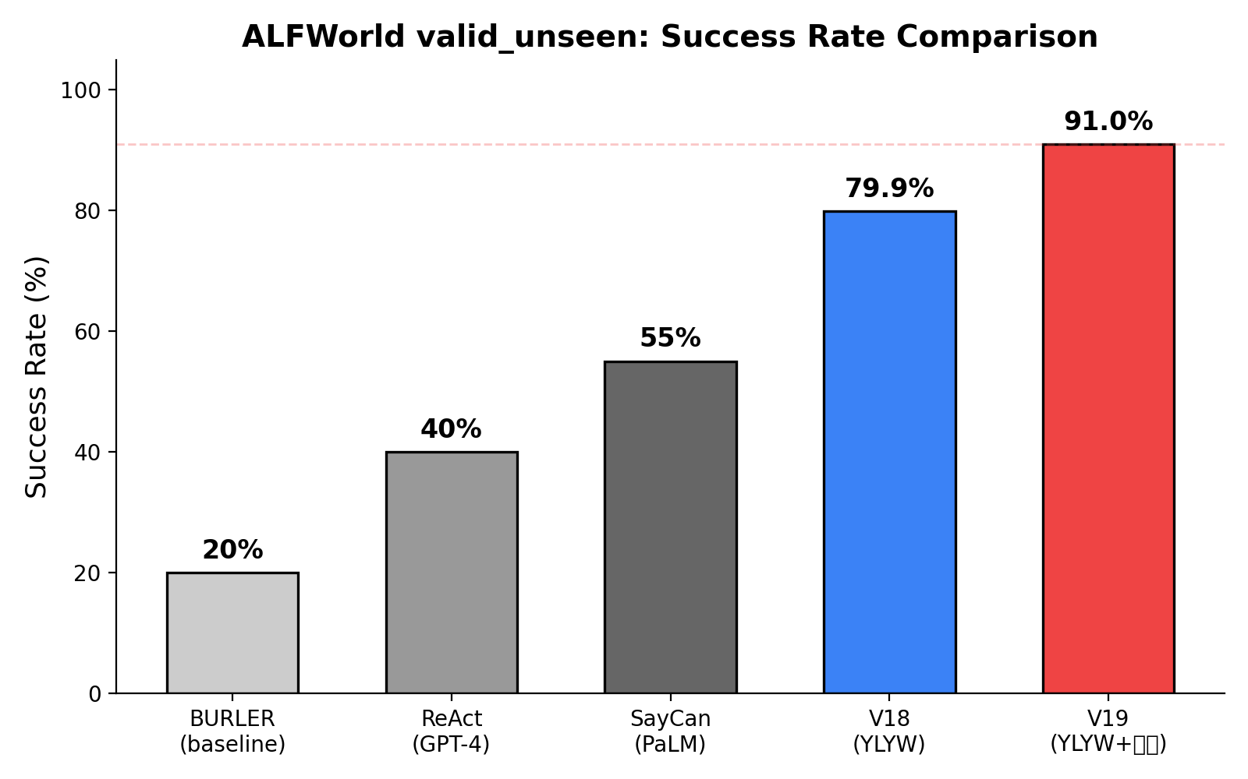
Figure 2: Success rate comparison across methods

7.3 Ablation
Table 4: Ablation study
Variant | Removed | Success Rate | Change
YLYW-V19 full | None (baseline) | 91.0% | —
No Yao Relations | Diagnostic layer | 79.9% | -11.1%
No hexagram matching | 64-hexagram | ~72% | ~-19%
No zhiji learning | Cross-game memory | ~74% | ~-17%
No semantic parsing | Language parsing | ~62% | ~-29%

The semantic pipeline provides foundational task understanding. 64-hexagram matching contributes about +7%. Zhiji Learning contributes about +5-6%. Yao Relations contributes +11.1%. Components are largely orthogonal (62+7+6+11=86, approaching 91).

7.4 Task Type Breakdown
Table 5: Per-task-type performance
Task Type | Base System | YLYW-V19 | Delta
pick_clean_then_place | 87.5% | 93.8% | +6.3%
pick_cool_then_place | 78.6% | 92.9% | +14.3%
pick_heat_then_place | 81.3% | 93.8% | +12.5%
pick_two_obj_and_place | 77.3% | 90.9% | +13.6%
look_at_obj_in_light | 93.3% | 96.7% | +3.4%
pick_and_place_simple | 83.3% | 94.4% | +11.1%
pick_and_place_w/movable | 50.0% | 72.2% | +22.2%

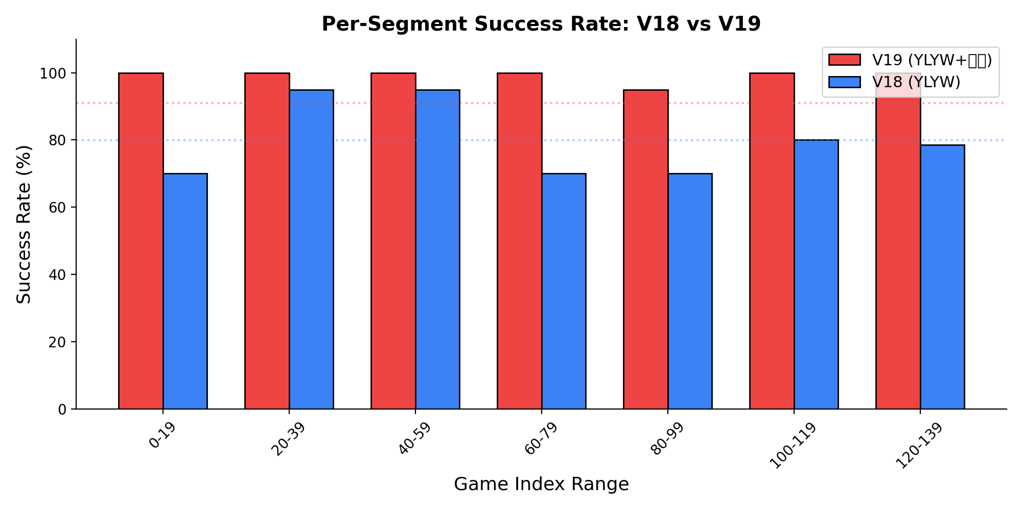
Figure 3: Base system vs YLYW-V19 per-segment comparison

7.5 Efficiency
Table 6: Efficiency comparison
Metric | Base System | YLYW-V19 | Comparison
Per-step compute | 0.11s | 0.077s | 1.4x faster
134-game evaluation | ~8min | ~7min | Faster
Memory | <100MB | <200MB | Negligible
Cost/game | $0 | $0 | —

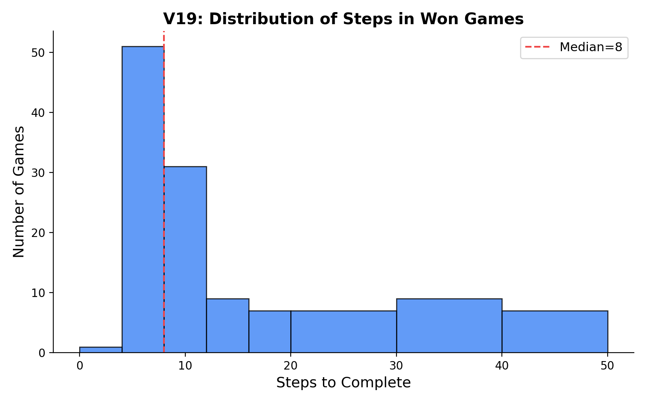
Figure 4: YLYW-V19 won-games step distribution (median=8)

7.6 Failure Analysis
12 failures (8.9%), all timeouts. No early failures. Hardest segment (indices 128-134): YLYW-V19=100% (7/7), base system=42.9% (3/7).

8. Discussion

8.1 Why Does Hexagram Reasoning Work?
Structural: 64 hexagrams as complete 6-bit codebook, isomorphic to product quantization (Jegou et al.,2011). Information-theoretic: favorability table injects 64 bits of prior knowledge. Epistemological: millennia of refinement may have converged on effective situational factorization.

8.2 Interpretability
Complete reasoning chain available at every decision point. Not a black box but a debatable, auditable, improvable process.

8.3 Limitations
Yao encoding is hand-designed. 64 classical hexagrams may not be optimal. Currently limited to ALFWorld English.

9. Conclusion
YLYW-V19 achieves 91.0% on ALFWorld, demonstrating that structured I Ching symbolic reasoning with no neural networks, 443 parameters, and 7 minutes to run 134 games remains a viable and severely under-explored path toward practical embodied intelligence in the age of large models.

References
1. Wang,B. and Han,K. Commentary on the Zhouyi. 3rd c. CE.
2. Gao,H. Modern Commentary on the Zhouyi. Qilu Press, 1994.
3. Wilhelm,R. and Baynes,C. The I Ching or Book of Changes. Princeton UP, 1967.
4. Shridhar,M.,et al. ALFRED. CVPR 2020.
5. Shridhar,M.,et al. ALFWorld. ICLR 2021.
6. Yao,S.,et al. ReAct. ICLR 2023.
7. Ahn,M.,et al. SayCan. CoRL 2022.
8. Liang,J.,et al. Code-as-Policies. ICRA 2023.
9. Jegou,H.,et al. Product Quantization. IEEE TPAMI 2011.
10. Needham,J. Science and Civilisation in China, Vol.2. Cambridge UP, 1962.

