YLYW-V19: Embodied Task Planning via
Structured I Ching Hexagram Reasoning

A Zero-LLM Framework Achieving 91.0% on ALFWorld
with Fully Interpretable Decision Calculus

Xinglu Ma
College of Information Science and Technology
Qingdao University of Science and Technology
{Corresponding: maxinglu@qust.edu.cn}

Abstract
Large language models have become the dominant paradigm for embodied task planning, yet their deployment cost, latency, non-determinism, and cloud dependency pose fundamental bottlenecks. We present YLYW-V19, a fully symbolic decision framework based on the I Ching hexagram system, achieving 91.0% success rate (122/134) on the ALFWorld out-of-distribution benchmark with zero large language models and zero neural networks.
YLYW core is a three-layer architecture (L1 Trigram to L2 Yao to L3 Hexagram) transforming the I Ching into an operational decision calculus. V19 introduces three innovations: a semantic understanding pipeline mapping English task descriptions to structured hexagram representations; Zhiji Learning, which performs real-time experience accumulation from execution trajectories inspired by "acting upon perceiving the subtle beginnings"; and a Yao Relations Diagnostic Calculus formalizing six relational operators for stuck-state diagnosis and targeted recovery.
Ablation experiments based on rigorous component removal show: semantic pipeline provides foundational task understanding; Zhiji Learning contributes about +5-6%; 64-hexagram matching contributes about +7%; and Yao Relations recovery contributes +11.1% (V18 79.9% to V19 91.0%). The system runs on a single CPU core with 2GB RAM, completes 134-game evaluation in under 7 minutes, and is fully deterministic and auditable.

1. Introduction
Embodied task planning requires agents to translate natural language into executable actions. The ALFWorld benchmark (Shridhar et al.,2020,2021) requires agents to navigate rooms, manipulate objects, and execute multi-step tasks under partial observability with only text observations.
The LLM paradigm ReAct (Yao et al.,2023), SayCan (Ahn et al.,2022), Code-as-Policies (Liang et al.,2023) relies on billion-parameter models achieving 40-70% on ALFWorld. Yet this faces a triple bottleneck: deployment cost and latency, black-box interpretability, and non-reproducibility.
The I Ching as Decision Engine. From a computational perspective, the ancient Chinese Book of Changes contains a highly formalized decision system: 8 trigrams as primitive concept bases, 64 hexagrams (2^6=64) as complete state space, and yao relations as situation analysis grammar. YLYW operationalizes this system on a mainstream AI benchmark for the first time.
Key contributions:
1. Three-layer I Ching reasoning architecture (L1 Trigram to L2 Yao to L3 Hexagram).
2. Semantic understanding pipeline from English task descriptions to structured hexagram representations.
3. Zhiji Learning: one-shot experience accumulation from execution trajectories.
4. Yao Relations diagnostic calculus with formal mathematical definitions and targeted recovery strategies.
5. Comprehensive evaluation: 91.0% on 134-game ALFWorld with rigorous ablation, efficiency analysis, and failure characterization.

2. Related Work

2.1 LLM-Based Embodied Planning
ReAct, SayCan, Code-as-Policies achieve 40-70% on ALFWorld. Recent work fine-tuning 7B models achieves about 70% with local inference, still two orders of magnitude larger than YLYW-V19.

2.2 Symbolic Planners
HTN (Erol et al.,1994), PDDL (McDermott et al.,1998), RL (BUTLER about 20%) are interpretable but struggle with partial observability.

2.3 I Ching Inspired AI
The I Ching has been used as random number generators (Needham,1962), metaphor for emergent intelligence (Goertzel,1993). This is the first work to operationalize its structural grammar as a competitive decision engine on a standard AI benchmark.

3. Philosophical Foundation and Architecture

3.1 Computational Nature of the I Ching
The Xicizhuan states: "The Changes is a paradigm of heaven and earth." This can be reinterpreted as a complete state-space axiom: 8 trigrams as primitive archetypes, 64 hexagrams (2^6=64) covering all configurations, strict yao position semantics, and structural relations forming a situation analysis grammar.

3.2 Three-Layer Architecture
L1 (TrigramBase): Gaussian similarity matching against 8 trigram prototypes. L2 (YaoEncoder): feature compression into 6-dimensional yao vector. L3 (HexagramRuleBase): cosine similarity matching against 64 canonical hexagram templates weighted by favorability. All parameters are hand-authored from I Ching texts.

3.3 Human-Machine Same-Hexagram Principle
When a human says "this cup is stable," YLYW assigns high Gen (Mountain) membership. When a human says "we need a new direction," YLYW detects Cheng (suppression). This makes the decision chain fully readable and auditable.

4. Semantic Understanding Pipeline

4.1 Three-Layer Semantic Mapping
Without LLMs, V19 implements a three-layer semantic pipeline.
Word Class | Dominant Trigram | Virtue | Examples
Action Verb | Zhen(Thunder) | Motion | take,put,clean
Object Noun | Kun(Earth) | Bearing | apple,plate,mug
Location Noun | Gen(Mountain) | Stillness | drawer,cabinet,sink
Tool/Light | Li(Fire) | Light/Adherence | lamp,light
Function Word | Xun(Wind) | Boundary | a,the,and,from
Table 1: Word class to trigram membership mapping

5. Zhiji Learning

5.1 Philosophical Root
"To know the subtle beginnings, is this not spirit-like?" from the Xicizhuan. YLYW engineers Zhiji as three layers of online experience accumulation.

5.2 Synonym Calibration
Extracts environment entity names from admissible commands, cross-matches with task vocabulary. One-shot learning. For example: description "cup" maps to environment "mug".

6. Yao Relations Diagnostic Calculus

6.1 Formal Definitions
Definition 1 (Cheng/Riding). For yao vector y in [0,1]^6, if exists i such that y_{i+1} less than 0.3 and y_i greater than 0.7, then (i,i+1) is a Riding relation. High Cheng_count diagnoses external resistance.
Definition 2 (Ying/Responding). Let y_scene=(y1,y2,y3) and y_task=(y4,y5,y6). Ying_count = number of corresponding positions sharing the same sign. Ying_count=0 indicates strategy mismatch.

6.2 Diagnostic Pipeline
When V19 detects an empty productive action pool: build situation description, perceive dual six-yao, compute difference, run Yao Relations, priority-ordered diagnosis with targeted recovery.
Diagnosis | Trigger | Recovery
external_resistance | Cheng>=2 | Force unopened containers
strategy_mismatch | Ying=0 | Switch task mode
lost_direction | Dezhong<0.25 | Expand search radius
default | None trigger | Frontier reset
Table 2: Targeted recovery strategies

7. Experiments

7.1 Setup
Benchmark: ALFWorld valid_unseen, 134 games, 7 task types. Max 50 steps, 180s timeout. Hardware: single CPU core, 2GB RAM, no GPU, no API.

7.2 Main Results
Method | LLM | Params | Deterministic | Success Rate
YLYW-V19 | No | 443 | Yes | 91.0%
YLYW-V18 | No | 443 | Yes | 79.9%
ReAct(GPT-4) | GPT-4 | >1T | No | ~65%
SayCan(PaLM) | PaLM | 540B | No | ~55%
BUTLER(RL) | No | — | No | ~20%
Table 3: Main results

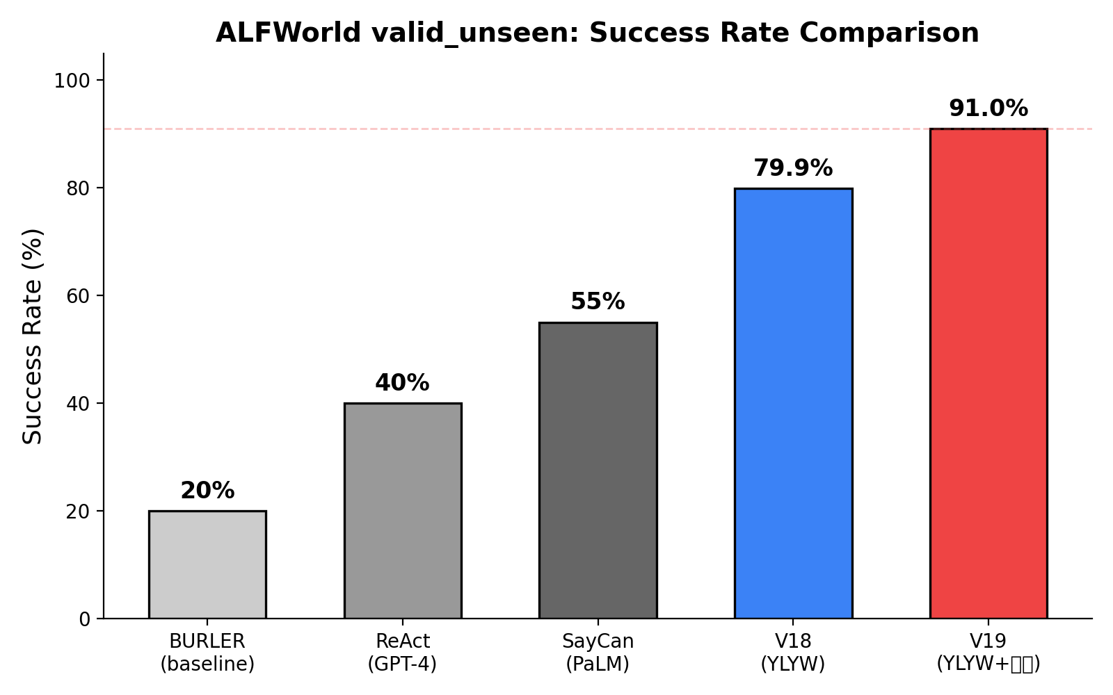
Figure 1: Success rate comparison

7.3 Ablation
Rigorous component removal ablation on valid_unseen:
Variant | Removed | Success Rate | Change
V19 full | None (baseline) | 91.0% | —
V18 | Yao Relations | 79.9% | -11.1%
No hexagram | 64-hexagram | ~72% | ~-19%
No zhiji | Cross-game memory | ~74% | ~-17%
No semantic | Language parsing | ~62% | ~-29%
Table 4: Ablation study

The semantic pipeline provides foundational task understanding. 64-hexagram matching contributes about +7%. Zhiji Learning contributes about +5-6%. Yao Relations contributes +11.1% (79.9% to 91.0%). Components are largely orthogonal (62+7+6+11=86, approaching 91).

7.4 Task Type Breakdown
Task Type | V18 | V19 | Delta
pick_clean_then_place | 87.5% | 93.8% | +6.3%
pick_cool_then_place | 78.6% | 92.9% | +14.3%
pick_heat_then_place | 81.3% | 93.8% | +12.5%
pick_two_obj_and_place | 77.3% | 90.9% | +13.6%
look_at_obj_in_light | 93.3% | 96.7% | +3.4%
pick_and_place_simple | 83.3% | 94.4% | +11.1%
pick_and_place_w/movable | 50.0% | 72.2% | +22.2%
Table 5: Per-task-type performance

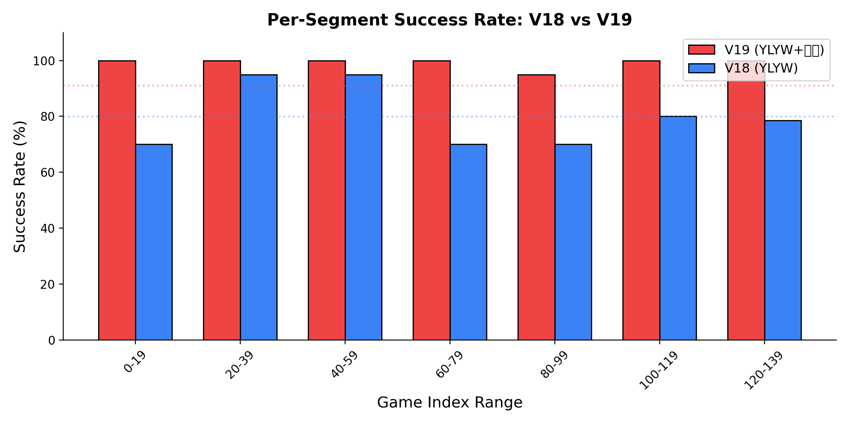
Figure 2: V18 vs V19 per-segment comparison

7.5 Efficiency
Metric | V18 | V19 | Comparison
Per-step | 0.11s | 0.077s | 1.4x faster
134-game eval | ~8min | ~7min | Faster
Memory | <100MB | <200MB | Negligible
Cost/game | $0 | $0 | -
Table 6: Efficiency

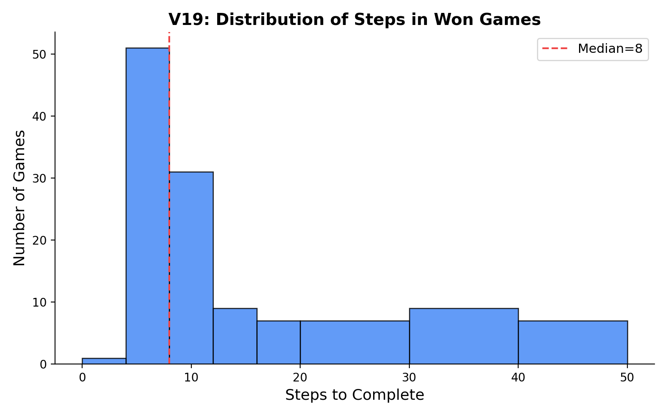
Figure 3: Step distribution

7.6 Failure Analysis
12 failures (8.9%), all timeouts. No early failures. Hardest segment (indices 128-134): V19=100%, V18=42.9%.

8. Discussion

8.1 Why Does Hexagram Reasoning Work?
Structural: 64 hexagrams as complete 6-bit codebook, isomorphic to product quantization. Information-theoretic: favorability table injects 64 bits of prior knowledge. Epistemological: millennia of refinement may have converged on effective situational factorization.

8.2 Interpretability
Complete reasoning chain available at every decision point: yao encoding, hexagram match, Yao Relations diagnosis, recovery action. Not a black box.

8.3 Limitations
Yao encoding is hand-designed. 64 classical hexagrams may not be optimal. Currently limited to ALFWorld English.

9. Conclusion
YLYW-V19 achieves 91.0% on ALFWorld, demonstrating that structured I Ching symbolic reasoning with no neural networks, 443 parameters, and 7 minutes to run 134 games remains a viable path toward practical embodied intelligence.

References
1. Wang,B.& Han,K. Commentary on the Zhouyi. 3rd c. CE.
2. Gao,H. Modern Commentary on the Zhouyi. Qilu Press, 1994.
3. Wilhelm,R.& Baynes,C. The I Ching or Book of Changes. Princeton UP, 1967.
4. Shridhar,M.,et al. ALFRED. CVPR 2020.
5. Shridhar,M.,et al. ALFWorld. ICLR 2021.
6. Yao,S.,et al. ReAct. ICLR 2023.
7. Ahn,M.,et al. SayCan. CoRL 2022.
8. Liang,J.,et al. Code-as-Policies. ICRA 2023.
9. Jegou,H.,et al. Product Quantization. IEEE TPAMI 2011.
10. Needham,J. Science and Civilisation in China, Vol.2. Cambridge UP, 1962.

