SUSTech CS302 OS Lab8 Report
Title: Memory allocation and segmentation paging mechanism
Name: ____唐千栋____, Student ID: __11612730______
Time: __2019___Year __4__Month __23__Day
Experimental Environment: linux, cpp
Objective: Master the process of memory allocation, understand the causes of fragmentation; learn how to reduce fragmentation; understand the mechanism of segmentation and paging.
Deadline: 11:59 AM, 2019-04-24
Summit by: Blackboard
Task：
Task 1.Understand the source codes
Task 2.Edit and modify the source codes

Experiments:
1. fundamental：
- What is Uniprogramming:
Uniprogramming allows only one program sits in main memory at a time.
- What is the shortcoming of Uniprogramming:
Uniprogramming is not efficient since it only allows one program at a time. It is not powerful.
- What is Multiprogramming:
Multiprogramming allows many programs sit in main memory at a time.
- What is the shortcoming of Multiprogramming:
Multiprogramming is more difficult because for multiprogramming, we need to consider fragmentation problem.
- What is the segmentation mechanism and its advantages & disadvantages:
Segmentation is that each job is divided into several segments of different sizes, one for each module that contains pieces that perform related functions.
Advantages: (1) No internal fragmentation (2) Segment table consumes less space in comparison to page table in paging.
Disadvantages: (1) As processes are loaded and removed from the memory, the free memory space is broken into little spaces, caused external fragmentation.
- What is the paging mechanism and its advantages & disadvantages:
Paging is a memory management scheme which a computer stores and retrieves data from secondary storage for use in main memory. In this scheme, the operating system retrieves data from secondary storage in same-size blocks called pages.
Advantages: (1) Paging reduces external fragmentation (2) Paging is simple and efficient
Disadvantages: (1) Paging can cause internal fragmentation (2) Paging requires extra memory space
2. Memory management(based on the code):
- What kind of data structure is the memory block used for storage?
Linked list
- How to reduce the occurrence of internal fragmentation when allocating memory? Briefly explain why this method works.
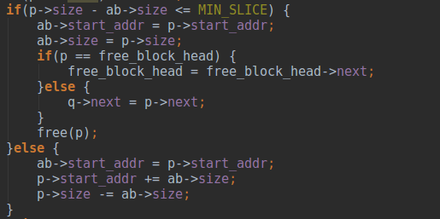
When the difference between free memory block size and the process memory size is smaller than minimal internal slice, we would directly give the process the free memory block size. By giving the minimal internal slice, we can ensure there is no internal fragmentation whose size is greater than minimal threshold.
- What kind of strategy does the original program take to allocate memory? Briefly describe the benefits of doing so.
It take First Fit strategy.
It tends to use memory space in low memory address, and the memory in high memory address is rarely used. It is beneficial for the latter process which needs large memory size. It is fast because it searches only the first block which is enough to assign a process. And it is simple.
3. Code result, screenshot and your comments:
For First Fit:
A)(1, 2048), 5, (3, 1024), 3(1023), 5, (4, 1), 5, (4, 2), 233
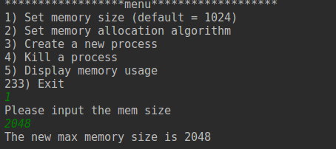
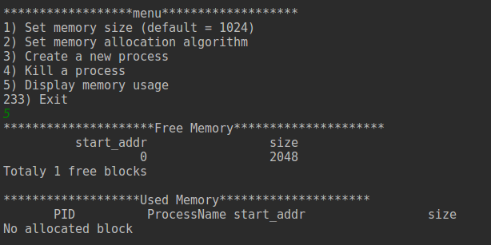
We can see that free memory size is 2048
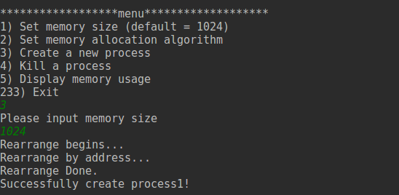
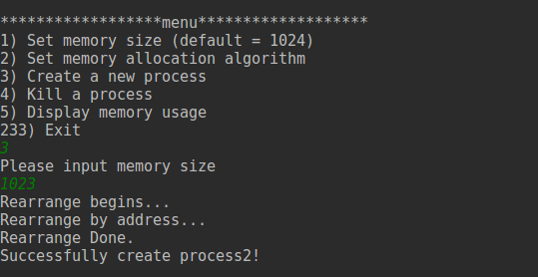
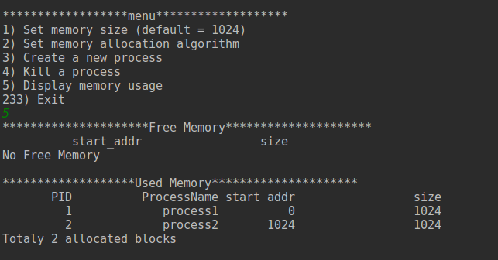
Process2’size is 2014 cause 2014-2013<=MIN_SLICE
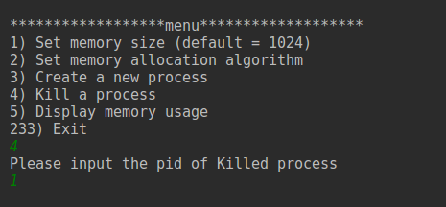
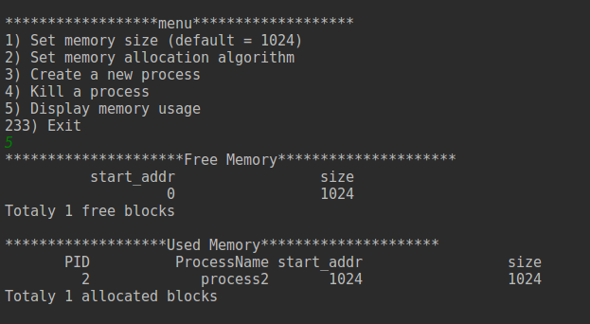
Process1 is killed
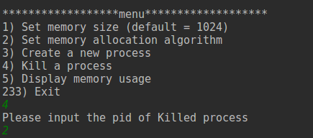
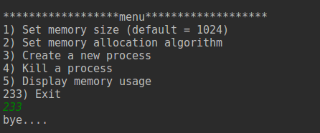
B) (3, 1024), 5, (3, 1), (4, 1), 5, (4, 2), 233
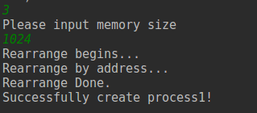
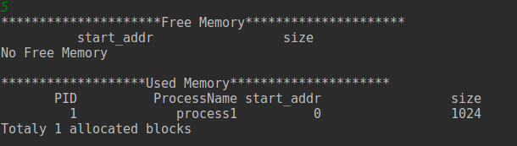
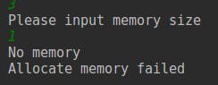
Process2 can not be allocated because no memory left.
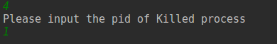
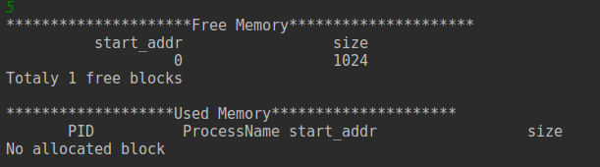
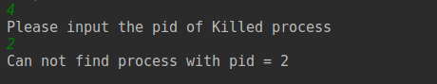
There is no process2 in allocated memory.
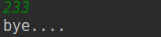
C) (1, 700), (3, 100), (3, 200), (3, 300), (4, 2), 5, (3, 300), 5, (4, 3), 5, 233
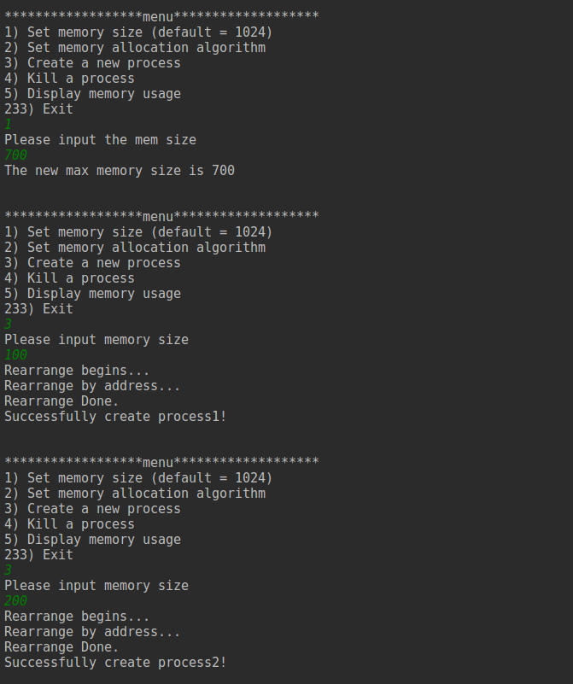
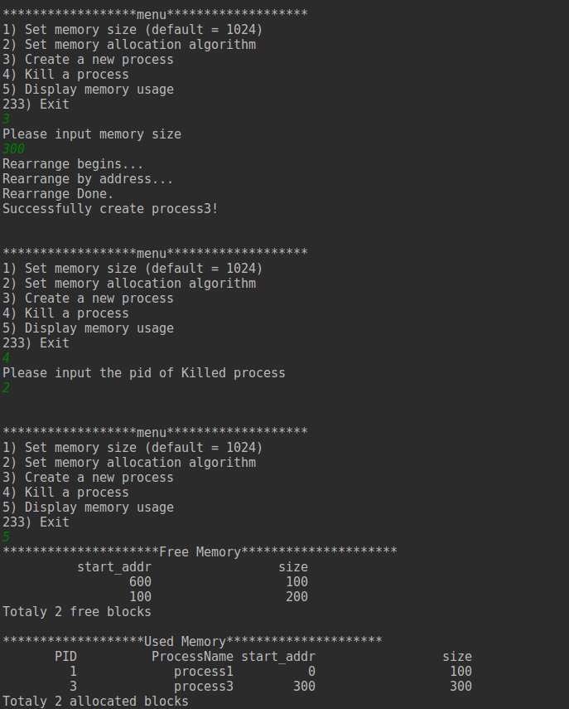
Process 2 is killed and there are two processes, process1 and process3
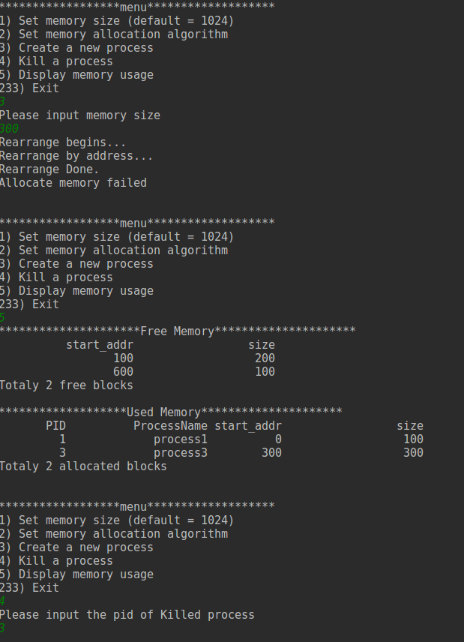
Process3 with memory 300 size can not be allocated cause there is no continuous free memory with 300 size.
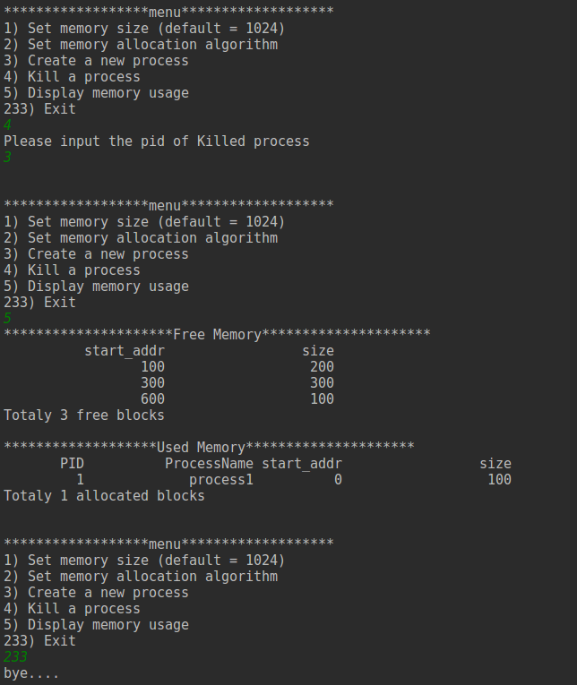

4. Problems you meet and your solutions
- Problem1:
Segmentation fault
- Solution1:
read null pointer value.
- Problem2:
Endless loop
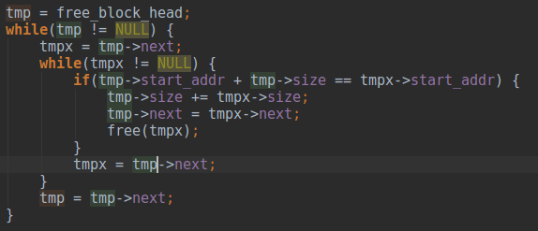
- Solution2:
Change tmpx=tmp->next to tmpx=tmpx->next

Conclusion:
I learn about First Fit, Best Fit and Worst Fit memory management algorithm.

