**Release and Sprint Plans**

**Team Number**

|  |  |
| --- | --- |
| Student Number | Team Member Name |
| N8623465 | Nicholas Martin |
| N9167901 | Darian Brandt |
| N9230424 | Huisuk Gyeong |
| N9326448 | Hang Su |
| N9579249 | Rick Pham |
| N9534849 | Anneyashan Dey |
| N9759522 | Askvin Kannianson |

Tutor: Dr. Syed Zaidi

Version: 1.4

Date: 26/08/2016

# Release 3

Delivery date: 02/11/2016 Total Story Points: 37.5

The goals for this release are to equip the management team with the necessary tools to change the entire public website, the portals, all classes and control of the database. The second goal is to give the opportunity for job seeks to apply for jobs within the music school and store their resumes accordingly for when appropriate jobs open up for their chance to get a position within the business.

## Management Team

The management team will be given the tools to fully edit the entire website all its features. These will help the business owner and their team change and create the websites to their demands and specifications on their own terms.

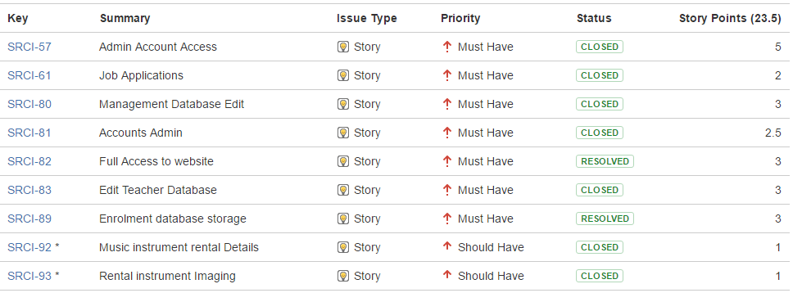

## Job Seekers

This will give job seekers an opportunity to apply for positions at the music school online instead of going to the school personally. This will give them a broader range of skills and qualifications that could vastly improve the quality of learning these students get

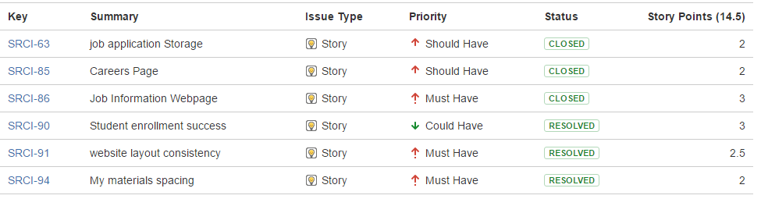

Sprint Plan

# Sprint 3

Total Story Points:38 Total Hours: 65.25

## Current Velocity: undefined

## Admin Account Access

|  |  |  |  |
| --- | --- | --- | --- |
| **Task ID** | **Task Description** | **Estimate** | **Taken** |
| 1 | Create management Page | 3 | 2 |
| 2 | Create database entry and web integration | 6 | 5 |
| 3 | Test against acceptance criteria | .5 | .5 |
|  | Story Points: 5 Total Hours: | 9.5 | 7.5 |

## Management Database Edit

|  |  |  |  |
| --- | --- | --- | --- |
| **Task ID** | **Task Description** | **Estimate** | **Taken** |
| 1 | Edit Database | 2 | 3 |
| 2 | Give management rights to edit music materials | .5 | .5 |
| 3 | Test against acceptance criteria | .5 | .5 |
|  | Story Points: 3 Total Hours: | 3 | 4 |

## Accounts Admin

|  |  |  |  |
| --- | --- | --- | --- |
| **Task ID** | **Task Description** | **Estimate** | **Taken** |
| 1 | Edit Database | 1.5 | 4 |
| 2 | Give management rights to edit accounts database | .5 | .5 |
| 3 | Test against acceptance criteria | .5 | .5 |
|  | Story Points: 2.5 Total Hours: | 2.5 | 5 |

## Full Access to Website

|  |  |  |  |
| --- | --- | --- | --- |
| **Task ID** | **Task Description** | **Estimate** | **Taken** |
| 1 | Give all usernames and passwords over | .5 | .25 |
| 2 | Give access to web servers | .5 | .25 |
| 3 | Test against acceptance criteria | .5 | .5 |
|  | Story Points: Total Hours: | 1.5 | 1 |

## Edit Teacher Database

|  |  |  |  |
| --- | --- | --- | --- |
| **Task ID** | **Task Description** | **Estimate** | **Taken** |
| 1 | Edit Database | 4 | 5 |
| 2 | Give management rights to edit teacher’s database | .5 | .5 |
| 3 | Test against acceptance criteria | .5 | .5 |
|  | Story Points: Total Hours: | 5 | 6 |

## Enrollment Database Storage

|  |  |  |  |
| --- | --- | --- | --- |
| **Task ID** | **Task Description** | **Estimate** | **Taken** |
| 1 | Edit database | 2 | 3 |
| 2 | Create web form storage | 1 | 3 |
| 3 | Give access rights to management team | .5 | .5 |
| 4 | Test against acceptance criteria | .5 | .5 |
|  | Story Points: 3 Total Hours: | 4 | 7 |

## Music Instrument Rental Details

|  |  |  |  |
| --- | --- | --- | --- |
| **Task ID** | **Task Description** | **Estimate** | **Taken** |
| 1 | Edit Text box | .25 | .25 |
| 2 | Gather and insert more information about said instrument | .5 | .5 |
| 3 | Test against acceptance criteria | .25 | .25 |
|  | Story Points: 1 Total Hours: | 1 | 1 |

## Rental Instrument Imaging

|  |  |  |  |
| --- | --- | --- | --- |
| **Task ID** | **Task Description** | **Estimate** | **Taken** |
| 1 | Find good sizing for each of the images | .25 | .25 |
| 2 | Resize to agree size | .25 | .25 |
| 3 | Test against acceptance criteria | .25 | .25 |
|  | Story Points: 1 Total Hours: | .75 | .75 |

## Job Application Storage

|  |  |  |  |
| --- | --- | --- | --- |
| **Task ID** | **Task Description** | **Estimate** | **Taken** |
| 1 | Edit Database | 2 | 2 |
| 2 | Create document storage for resumes | 3 | 4 |
| 3 | Test against acceptance criteria | .5 | .5 |
|  | Story Points: 2 Total Hours: | 5.5 | 6.5 |

## Careers Page

|  |  |  |  |
| --- | --- | --- | --- |
| **Task ID** | **Task Description** | **Estimate** | **Taken** |
| 1 | Create Careers web page | 2 | 2 |
| 2 | Code careers web page | 3 | 4 |
| 3 | Test against acceptance criteria | .5 | .5 |
|  | Story Points: 2 Total Hours: | 5.5 | 6.5 |

## Job Information Webpage

|  |  |  |  |
| --- | --- | --- | --- |
| **Task ID** | **Task Description** | **Estimate** | **Taken** |
| 1 | Create Information Webpage layout | 3 | 3 |
| 2 | Code Webpage | 4 | 4 |
| 3 | Test against acceptance criteria | .5 | .5 |
|  | Story Points: 3 Total Hours: | 7.5 | 7.5 |

## Student Enrollment Success

|  |  |  |  |
| --- | --- | --- | --- |
| **Task ID** | **Task Description** | **Estimate** | **Taken** |
| 1 | Set up email settings | 1.5 | 1.5 |
| 2 | Code and implement into website | 3 | 2 |
| 3 | Test against acceptance criteria | .5 | .5 |
|  | Story Points: 3 Total Hours: | 5 | 4 |

## Website Layout Consistency

|  |  |  |  |
| --- | --- | --- | --- |
| **Task ID** | **Task Description** | **Estimate** | **Taken** |
| 1 | Check code | 4 | 4.5 |
| 2 | Check layout of entire website | 1 | 2 |
| 3 | Test against acceptance criteria | .5 | .5 |
|  | Story Points: 2.5 Total Hours: | 5.5 | 7 |

## My Materials Spacing

|  |  |  |  |
| --- | --- | --- | --- |
| **Task ID** | **Task Description** | **Estimate** | **Taken** |
| 1 | Find suitable spacing | .5 | .5 |
| 2 | Implement spacing | .5 | .5 |
| 3 | Test against acceptance criteria | .5 | .5 |
|  | Story Points: 2 Total Hours: | 1.5 | 1.5 |