LAB10

1 Experiment Overview
In this lab I will stand up a KServe stack on Minikube and turn a scikit-learn iris model into an on-line inference API. My checklist: install KServe, deploy an InferenceService, watch it come alive, and finally hit the endpoint with a prediction request.
2 Experiment Tool and Environment
Minikube – local one-node cluster for quick iteration
KServe – Kubernetes-native model-serving layer
Model – pickled scikit-learn iris classifier (could just as easily be TF or PyTorch)
·

3 Experimental process

3.1 Start Minikube
Expected: Node is in Ready state.
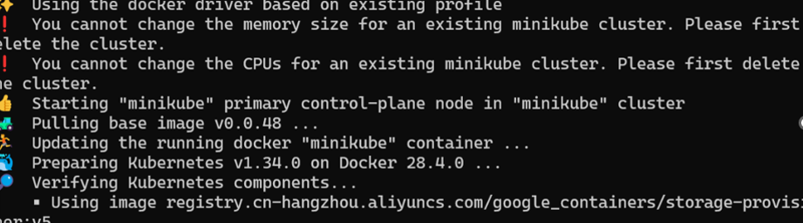
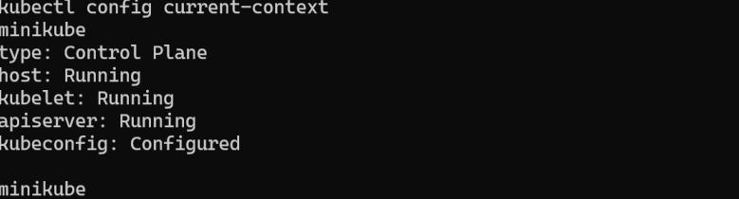

3.2 Install Helm
Expected output includes:

3.3 Install KServe CRDs

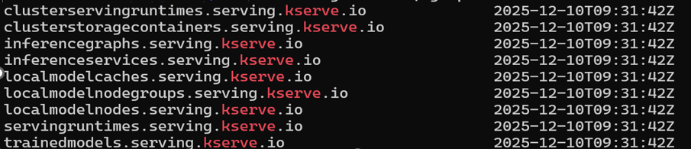

3.4 Install cert-manager (local YAML)
(Installed using local YAML due to WSL network limits)
All cert-manager pods must be Running.

3.5 Install KServe Core Components
kubectl apply --server-side -f kserve.yaml
kubectl apply --server-side -f kserve-cluster-resources.yaml

3.6 Deploy the InferenceService
Create namespace&Deploy the sklearn-iris model

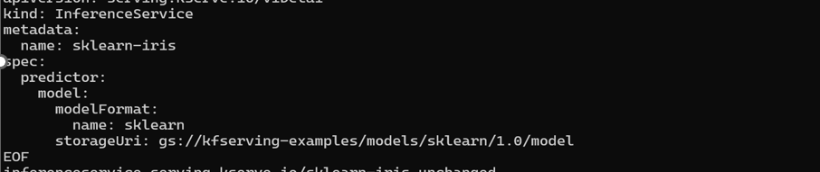
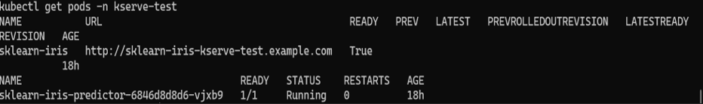

3.7 Access the Model Service (Port Forwarding)
\Forward port:

3.8 Send Inference Request
Prepare input:
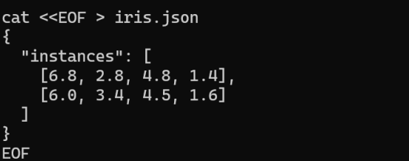
Send request:
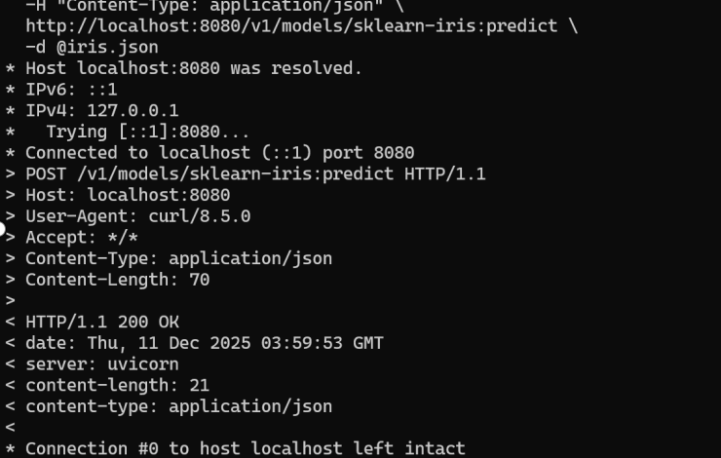

4 Summary and takeaways
- KServe installs cleanly on Minikube once the deployment mode is set to RawDeployment.
- cert-manager can be pre-loaded when external pulls are slow.
- InferenceService abstracts away the deployment, service, and route objects; I only supply the model container.
- Port-forward gives an instant outside-the-cluster smoke test before messing with ingress or LoadBalancers.

