1 Experiment Overview

The purpose of this lab is to learn the fundamentals of Kubernetes by installing and running a local cluster with Minikube, deploying an application, exploring the cluster, exposing services, scaling the workload, and performing updates. By completing this tutorial, I gained hands-on experience with basic Kubernetes concepts including pods, deployments, services, scaling, and rolling updates.

2Experiment Tool and Environment
Operating System | Windows 11
Driver | Docker Desktop
Kubernetes Version | v1.34.0
Minikube Version | v1.37.0
Kubectl Version | v1.32.2
Container Image | echoserver:1.10 (Aliyun Mirror)

3Experimental process

3.1 Install and Start Minikube
Install Docker Desktop and ensure it's running (Docker Engine running). Download and move minikube.exe to System32 or set it in PATH. Verify installations:
- docker version
- kubectl version --client
- minikube version
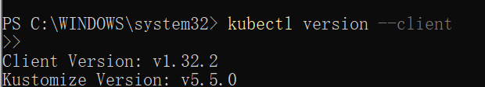

Start Minikube Cluster
Run the following command to start the local Kubernetes cluster:
- minikube start --driver=docker
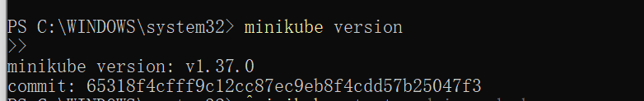

3.2 Verify Cluster Status
Check the node status:
- kubectl get nodes
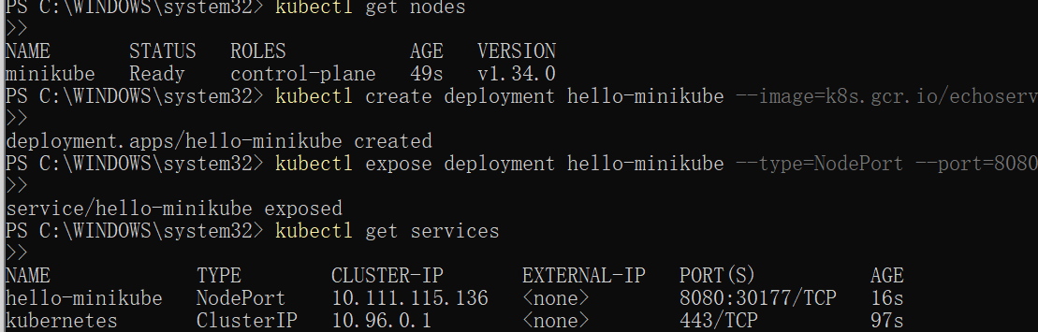

3.3 Create Deployment
Deploy the application using Aliyun echoserver image:
- kubectl create deployment hello-minikube --image=registry.cn-hangzhou.aliyuncs.com/google_containers/echoserver:1.10

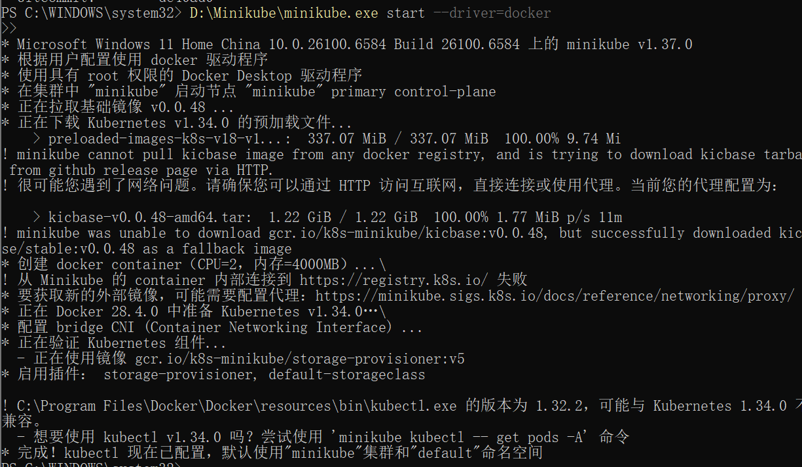

3.4 Expose Service
Expose the deployment as a NodePort service:
- kubectl expose deployment hello-minikube --type=NodePort --port=8080

3.5 Check Pod Status
Verify if Pod is running:
- kubectl get pods

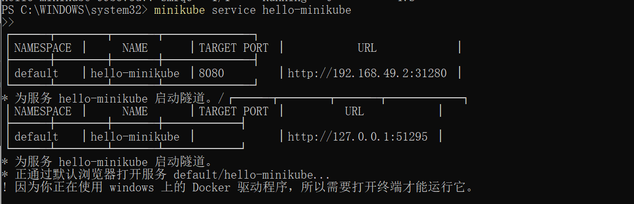

3.6 Access Service
Access the service via Minikube tunnel:
- minikube service hello-minikube
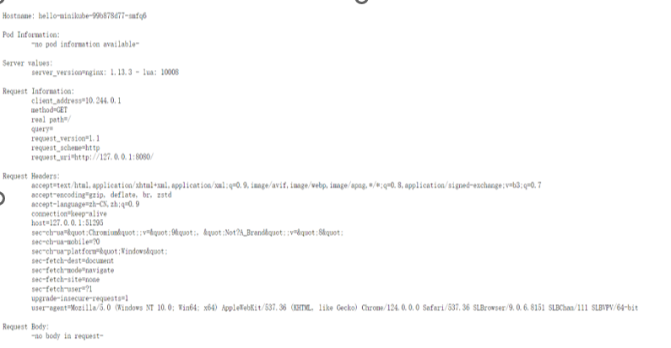

4 Summary
With Minikube, this experiment walked through the entire workflow of deploying a containerized app to a local Kubernetes cluster and reaching it from a browser. After Docker and Minikube were set up, I created a Deployment, exposed it via a Service, and solved an ImagePullBackOff error by switching to a domestic mirror registry.

