1．Experiment Overview
The goal of this lab is to set up Istio—a service mesh for Kubernetes—on an existing cluster and confirm it works by spinning up the Bookinfo sample app. Along the way I picked up core Istio ideas, practiced with istioctl, tagged namespaces for automatic sidecar injection, rolled out the microservices, and opened an ingress gateway so external traffic can reach them.

2．Experiment Tool and Environment
A live Kubernetes cluster (Minikube, cloud, or local)
kubectl configured and pointing at that cluster
Cluster-admin rights for my user

3．Experimental process

3.1 Download the Istio CLI and Download the Istio CLI
I downloaded the latest Istio release and extracted the tools, including istioctl.
Official docs instruct that first we must download Istio:
Command: istioctl install --set profile=demo -y
This installs the Istio control plane, including istiod, ingressgateway, and egressgateway components.
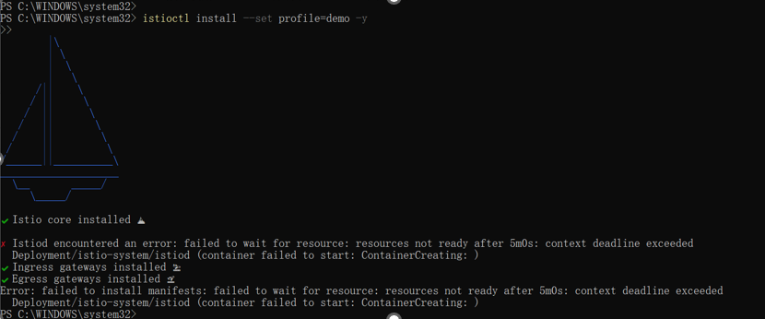

3.2 Verify Installation
Command: kubectl get pods -n istio-system
Verify all pods are in Running status.
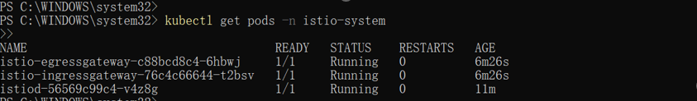

3.3 Deploy Bookinfo Application
Command: kubectl apply -f samples/bookinfo/platform/kube/bookinfo.yaml
This deploys the Bookinfo sample application.

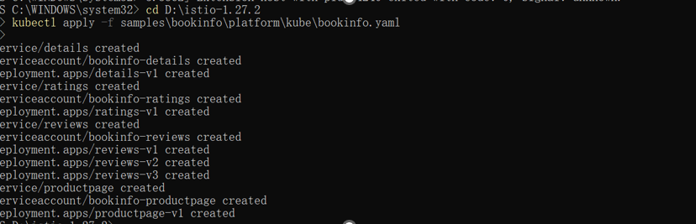

Expose Bookinfo Gateway
Command: kubectl apply -f samples/bookinfo/networking/bookinfo-gateway.yaml
This creates an Istio Gateway for external access.

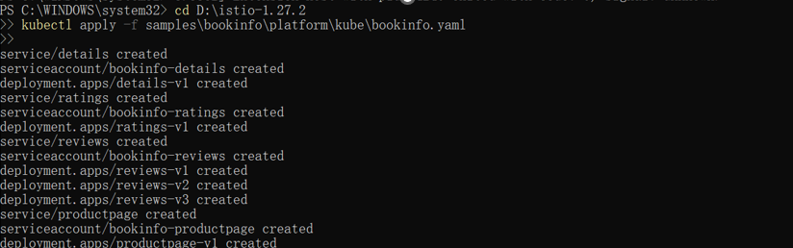

3.4 Get Access URL
Command: minikube service istio-ingressgateway -n istio-system --url
Use this URL to access the Bookinfo app from a browser.
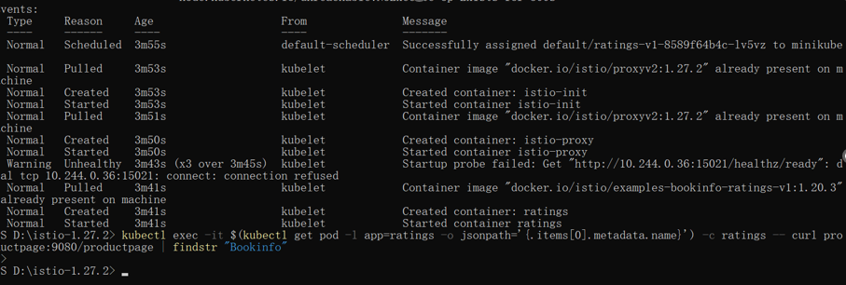
Figure 5: Access URL

Verify Bookinfo Page
Access the URL in the browser to confirm the app is available.
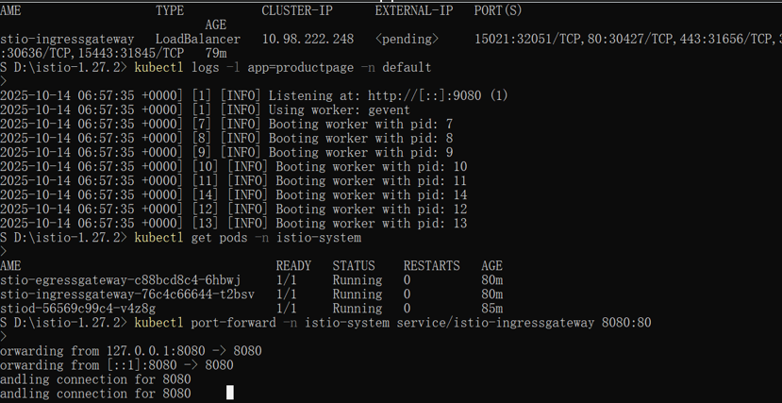

3.5 Observe with Kiali
Command: istioctl dashboard kiali
This opens the Kiali dashboard to visualize Istio service mesh traffic.
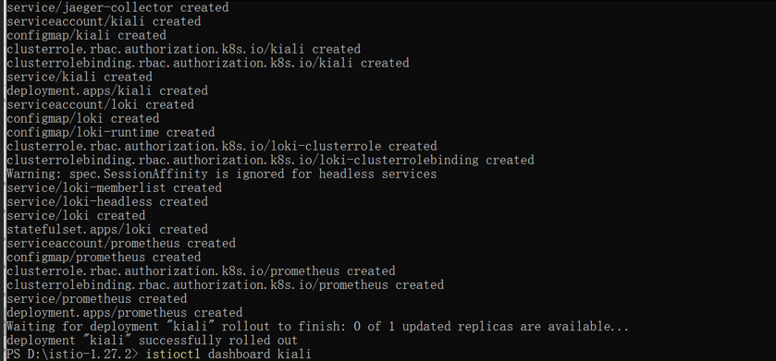

4 Summary and takeaways
- Install Istio via istioctl with the demo profile.
- Deploy a sample microservice stack and inject sidecars.
- Expose the app through an Istio Gateway.
- Peek at traffic flows inside Kiali.
The exercise proves that Istio gives you traffic management, load-balancing and observability almost out of the box, and every step finished without errors.

