LAB8

1 Experiment Overview
This lab gives us a hands-on tour of Istio’s traffic-management toolkit. By walking through four core tasks—traffic shifting, request routing, fault injection and circuit breaking—we will see how to steer traffic in a micro-service mesh and keep the system healthy when things go wrong.

2.Experimental process

2.1. Experimental setup
First, spin up a local Kubernetes cluster, drop Istio on it, and launch the Bookinfo sample. A quick kubectl check confirms every pod is ready.
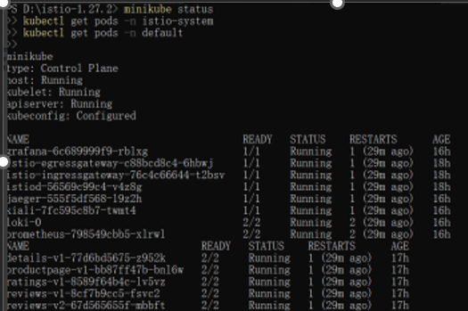

2.2 User-Based Routing (Header Matching)
send any request that carries the header end-user: jason to reviews:v2; everyone else stays on reviews:v1.
Observation: after logging in as jason the product page shows red stars; any other login hides them. The header-based rule is working.
2.3 Traffic Shifting

2.3 Traffic Shifting
Step-by-step canary from v1 to v3.
- Baseline: 100 % → v1
kubectl apply -f samples/bookinfo/networking/virtual-service-all-v1.yaml
kubectl apply -f samples/bookinfo/networking/destination-rule-all.yaml
- 50 / 50 split:
kubectl apply -f samples/bookinfo/networking/virtual-service-reviews-50-v3.yaml
- Full cut-over:
kubectl apply -f samples/bookinfo/networking/virtual-service-reviews-v3.yaml
- Tidy up:
kubectl delete -f samples/bookinfo/networking/virtual-service-all-v1.yaml
kubectl delete -f samples/bookinfo/networking/destination-rule-all.yaml

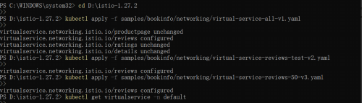

2.4 Request Routing
create a rule that still keys off the end-user header, then test with curl:
curl -H "end-user: jason" http://$GATEWAY_URL/productpage
Stars appear only for jason, proving the route is header-driven.


2.5Fault Injection
By simulating service delays or errors, verify how the system handles failures and test its resilience.
- Delay: inject a 7 s pause in the ratings service
kubectl apply -f samples/bookinfo/networking/virtual-service-ratings-test-delay.yaml
Reloading the page feels sluggish.
- Abort: return HTTP 500 from ratings
kubectl apply -f samples/bookinfo/networking/virtual-service-ratings-test-abort.yaml
The product page now shows “Ratings service is currently unavailable”.
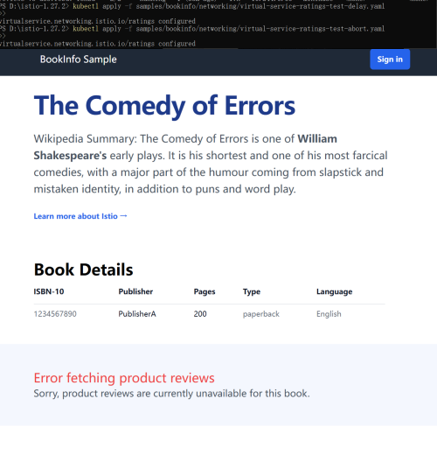

2.6 Circuit Breaking
deploy httpbin, add a DestinationRule that caps connections and requests, then hammer it with Fortio. Once the threshold is crossed the logs fill with 503’s, confirming the breaker has opened.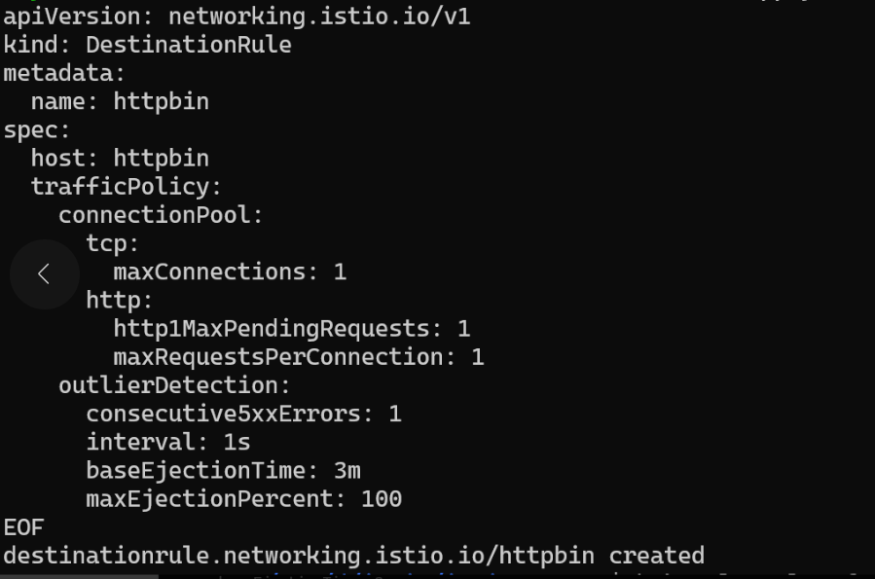
Generate Load with Fortio
The fortio client was used to generate concurrent requests:
Observation:
The output showed HTTP 503 errors, indicating that the circuit breaker was triggered successfully.
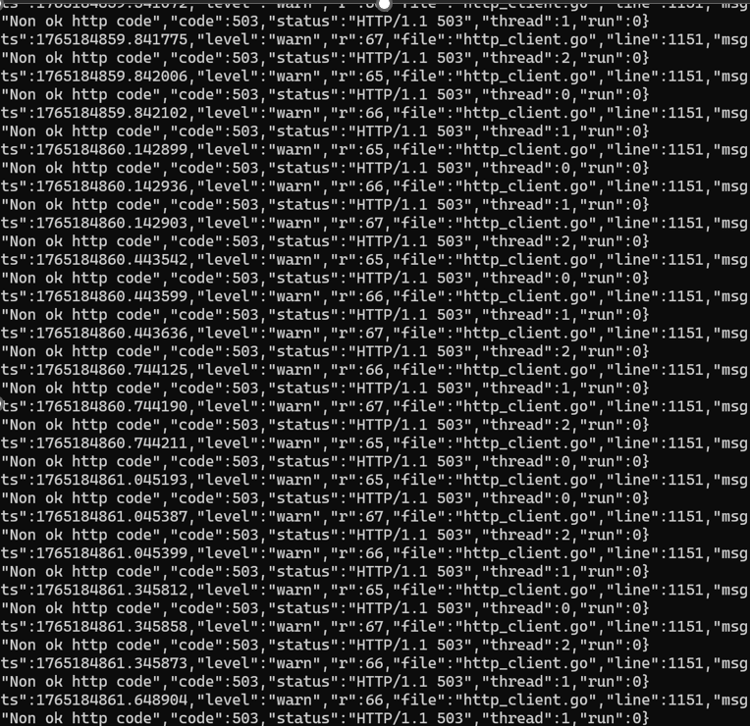

3 Summary and takeaways
By actually moving traffic, snapping routes, breaking things on purpose and watching breakers pop, we saw how Istio lets operators (1) migrate versions safely, (2) target requests precisely, (3) rehearse failures, and (4) shield the mesh from cascading overload—all without touching application code.

