LAB9

1 Experiment Overview

Through this lab I will get a solid, hands-on introduction to Knative: how it builds, deploys and scales serverless workloads on Kubernetes. My goals are to
- grasp the core ideas behind Knative Services and event-driven flow,
- practice deploying serverless apps with Knative Serving,
- wire up Knative Eventing sources, brokers and triggers, and
- experiment with Knative Functions for local code-to-service workflows.

2 Experiment Tool and Environment
Before I touched Knative I made sure I had:
- a live Kubernetes cluster (Minikube on my laptop),
- kubectl pointing at that context, and
- cluster-admin rights so I could install CRDs.

3 Experimental process

3.1 Local Docker registry
I started an in-cluster registry to push images quickly:
docker run -d -p 5000:5000 --name registry registry:2
Figure 1: Install the local Docker registry
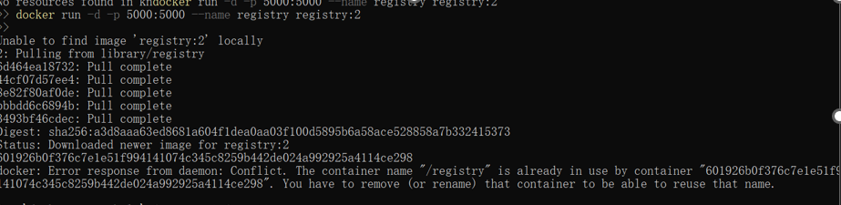

3.2 Knative Function section
Change the kube\config.yaml
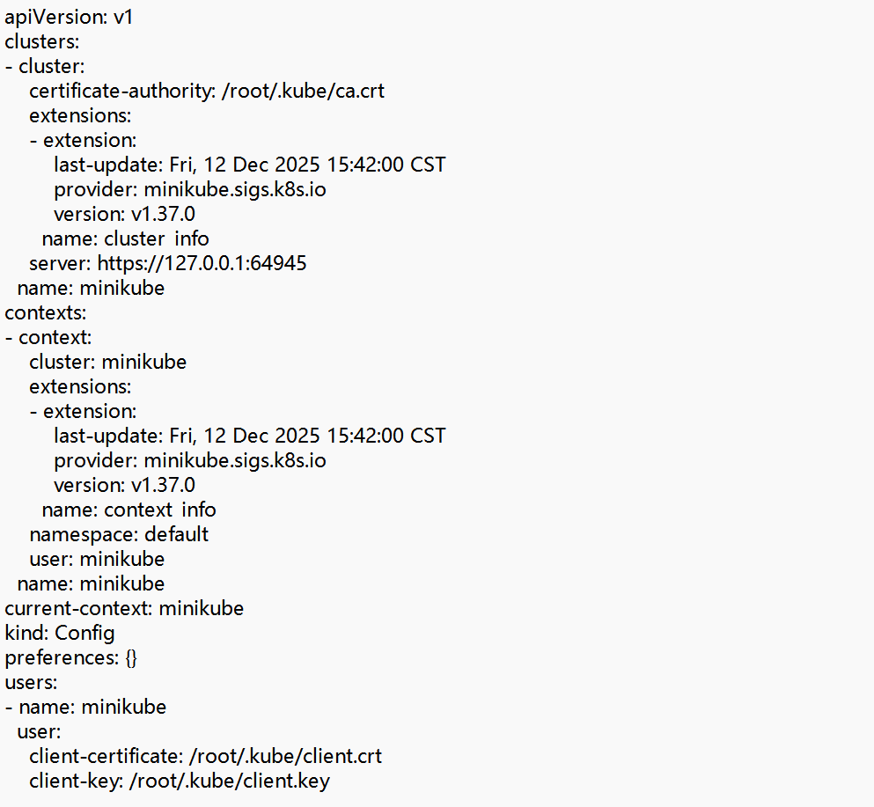

Run docker run --rm -v $HOME\.kube:/root/.kube gcr.io/knative-releases/knative.dev/client/cmd/kn:latest service list

3.3 Install Knative CRDs
To run Knative services in a Kubernetes cluster, first install Knative's custom resource definitions (CRDs). Use the following command to install:kubectl apply -f https://github.com/knative/serving/releases/download/v0.23.0/serving-crds.yaml
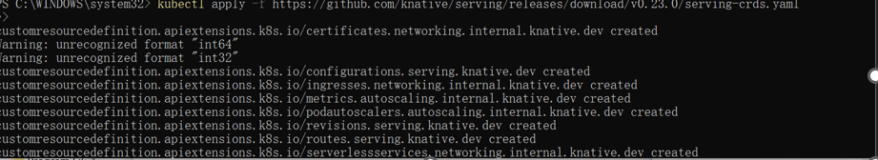

3.4 Install Knative Serving
kubectl apply -f https://github.com/knative/serving/releases/download/v0.23.0/serving-core.yaml
Check: kubectl get pods -n knative-serving → all Running.
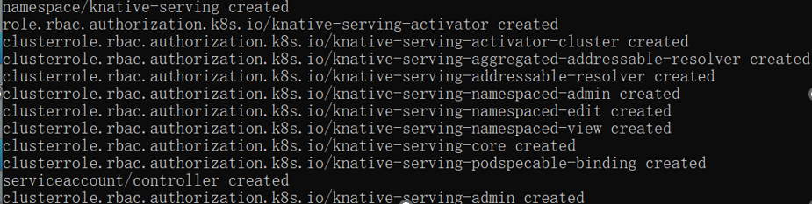
Verify if Knative service is installed
Run the following command to check if the Knative service is installed correctly:

kubectl get pods --namespace knative-serving
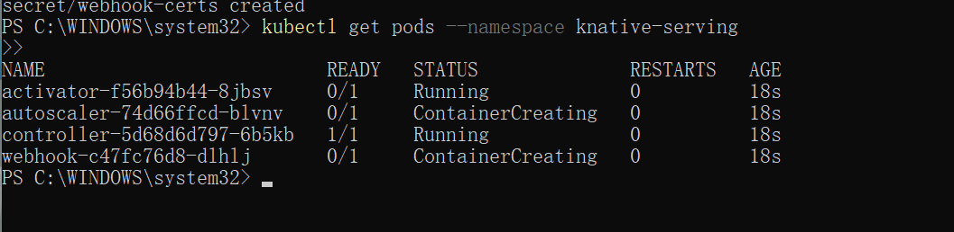

Create a simple Knative service
Create a simple Knative service. For example, create a hello-world service to run a simple Go application.

First, create a YAML file and add the following content:
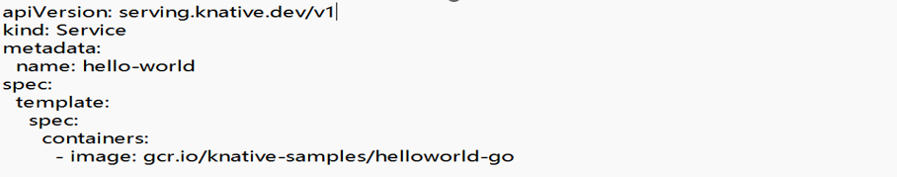

To deploy hello-world.yaml to your Kubernetes cluster, use the following command:

kubectl apply -f hello-world.yaml

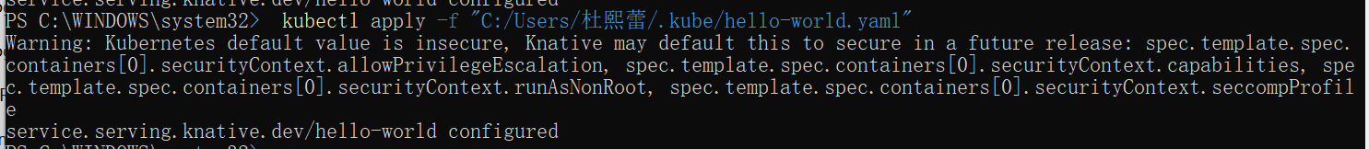
Figure 6: Deployment service

3.5 View Knative services
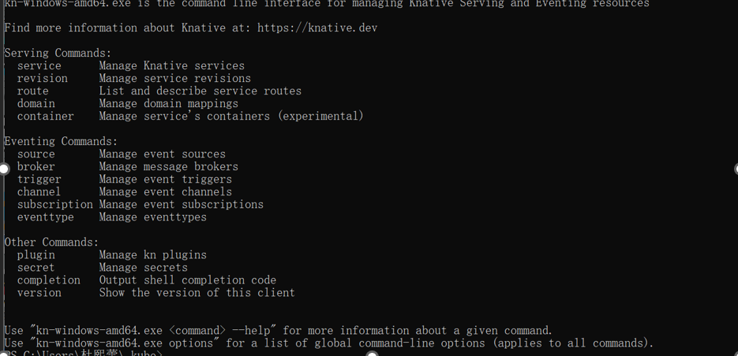

run the following command to create a service:
`kn service create hello-world --image=gcr.io/knative-samples/helloworld-go`
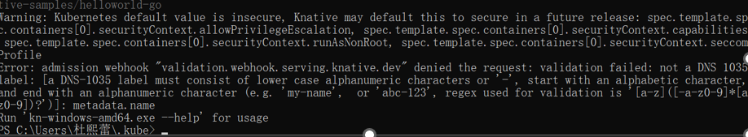

To check the status of the services you created, run:
kn service list

Then enter the URL

traffic stops going to the URL:kubectl get pod -l serving.knative.dev/service=hello -w
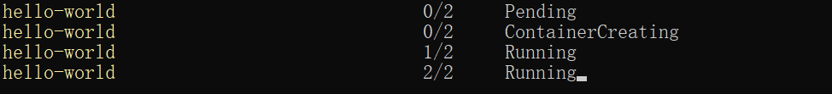

Use the Knative CLI to perform other administrative tasks, such as modifying or deleting services.

Eg:

Delete the file

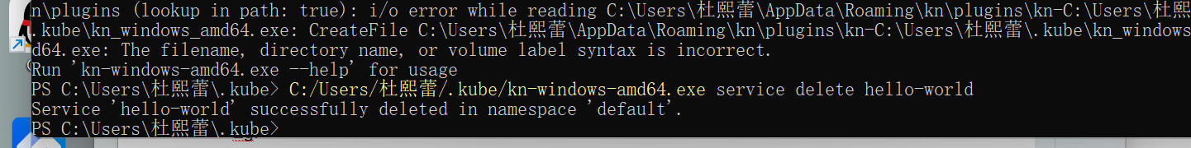

3.6 Traffic splitting
Deploy the updated version of your Knative Service by running the command:kn service update hello \--env TARGET=Knative

Access the Knative Service again on my browser or use curl in your terminal:


View a list of revisions by running the command:kn revisions list

3.7 Knative Eventing
Copy the following YAML into a file named cloudevents-player.yaml:
Apply the YAML file by running the command:
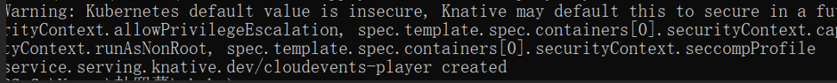
Run the command:
kn service create cloudevents-player \
--image quay.io/ruben/cloudevents-player:latest

A PingSource was created to generate periodic events and send them
to the event-display service.
The event flow was verified by checking the logs of the event-display pod.
CloudEvents generated by the PingSource were successfully received.
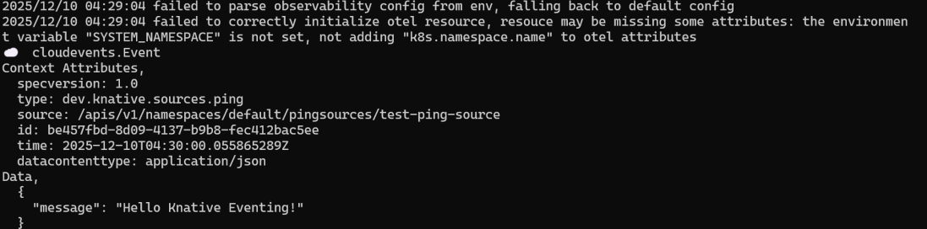

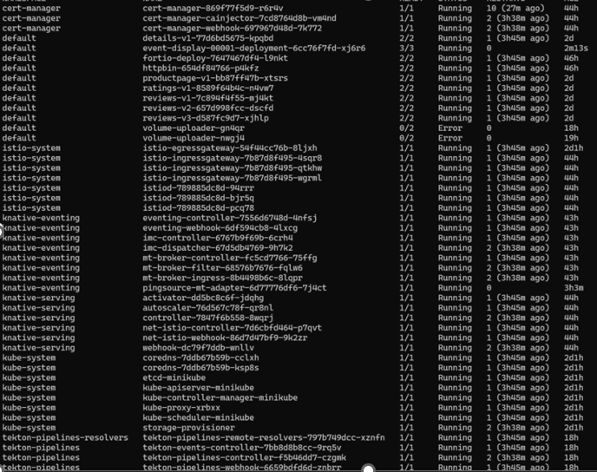

4 Summary and takeaways
- Local registry + Knative CLI lets me iterate in seconds.
- Serving handles scale-to-zero and traffic splitting without extra YAML.
- Eventing’s PingSource → Broker → Trigger pattern is a minimal yet powerful way to build reactive pipelines.
- Watching pods appear only when requests arrive drove home the “serverless” payoff.

