Lab3
- Page
Gu Jinyang – Personal Page
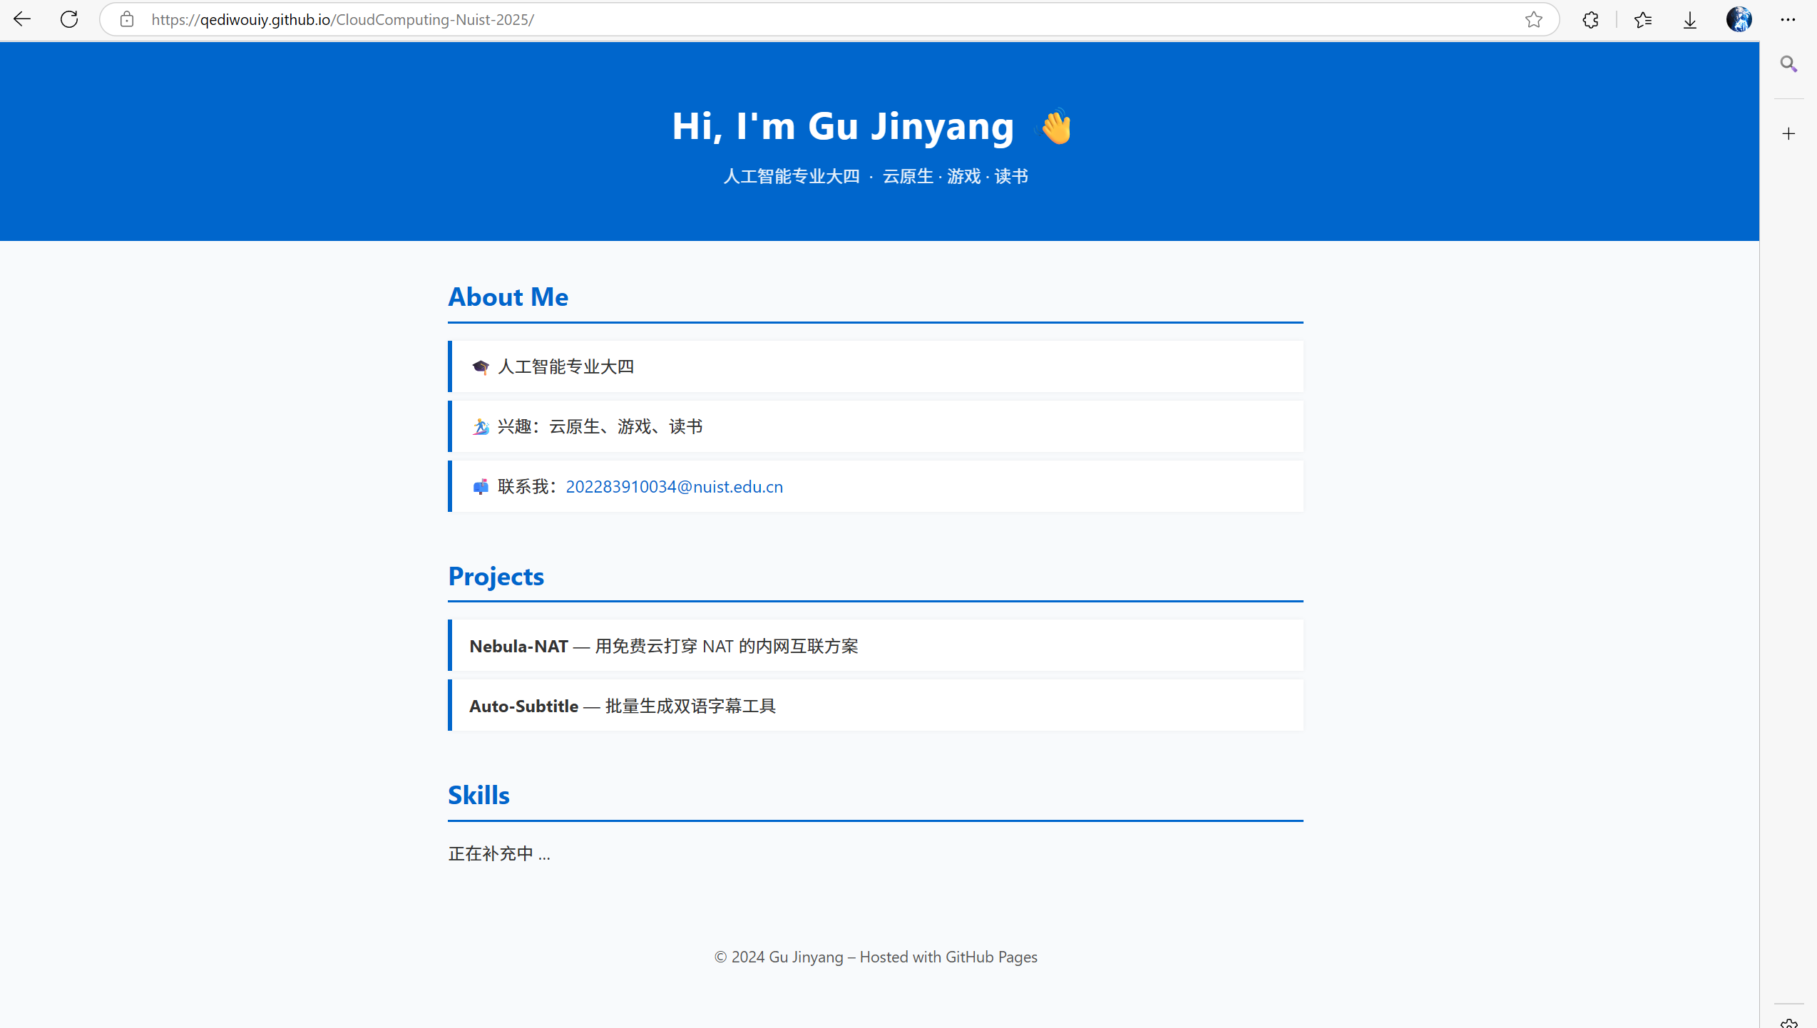
- code
<!DOCTYPE html>
<html lang="zh-CN">
<head>
<meta charset="UTF-8">
<title>Gu Jinyang – Personal Page</title>
<meta name="viewport" content="width=device-width, initial-scale=1">
<style>
:root {
--theme: #0066cc; /* 主色调，可换成任意色 */
--gray : #555;
}
body {
margin: 0;
font-family: -apple-system, BlinkMacSystemFont, "Segoe UI", Roboto, "Helvetica Neue", Arial, sans-serif;
line-height: 1.6;
color: #333;
background: #f8fafc;
}
header {
background: var(--theme);
color: #fff;
padding: 3rem 0;
text-align: center;
}
header h1 {
margin: 0;
font-size: 2.2rem;
letter-spacing: 1px;
}
header p {
margin: .5rem 0 0;
opacity: .9;
}
main {
max-width: 800px;
margin: 2rem auto;
padding: 0 1rem;
}
section {
margin-bottom: 2.5rem;
}
h2 {
color: var(--theme);
border-bottom: 2px solid var(--theme);
padding-bottom: .3rem;
margin-bottom: 1rem;
}
ul {
list-style: none;
padding: 0;
}
ul li {
background: #fff;
margin-bottom: .5rem;
padding: .7rem 1rem;
border-left: 4px solid var(--theme);
box-shadow: 0 0 4px rgba(0,0,0,.05);
}
a {
color: var(--theme);
text-decoration: none;
}
a:hover {
text-decoration: underline;
}
footer {
text-align: center;
font-size: .9rem;
color: var(--gray);
padding: 2rem 0;
}
</style>
</head>

<body>
<header>
<h1>Hi, I'm Gu Jinyang 👋</h1>
<p>人工智能专业大四 &nbsp;·&nbsp; 云原生 · 游戏 · 读书</p>
</header>

<main>
<section>
<h2>About Me</h2>
<ul>
<li>🎓 人工智能专业大四</li>
<li>🏄‍♂️ 兴趣：云原生、游戏、读书</li>
<li>📫 联系我：<a href="mailto:202283910034@nuist.edu.cn">202283910034@nuist.edu.cn</a></li>
</ul>
</section>

<section>
<h2>Projects</h2>
<ul>
<li><strong>Nebula-NAT</strong> — 用免费云打穿 NAT 的内网互联方案</li>
<li><strong>Auto-Subtitle</strong> — 批量生成双语字幕工具</li>
</ul>
</section>

<section>
<h2>Skills</h2>
<p>正在补充中 …</p>
</section>
</main>

<footer>
© 2024 Gu Jinyang – Hosted with GitHub Pages
</footer>
</body>
</html>

