Lab4
- Objectives
- Install Docker Desktop and register a free account
- Deploy Gitea + PostgreSQL with one-command stacks
- Validate built-in LFS support for ≥1 GB binaries
- Create “nuist-cloud-lab” repo and submit all artefacts

- Environment
- OS: Windows 11 23 H2 + WSL 2
- Docker Desktop: 4.37.1 (Linux engine)
- Images: postgres:15-alpine, gitea/gitea:1.21-rootless
- Shell: PowerShell 7.4
- Procedure & Evidence
3.1 Install Docker Desktop
Install Docker Desktop from official EXE and sign-in.
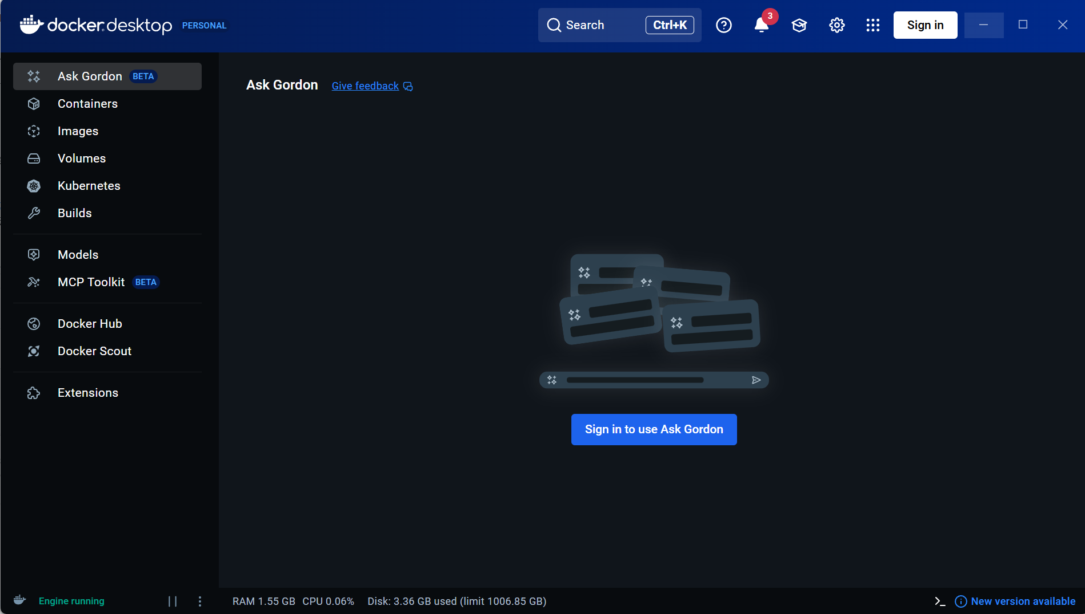
3.2 Start Gitea & PostgreSQL

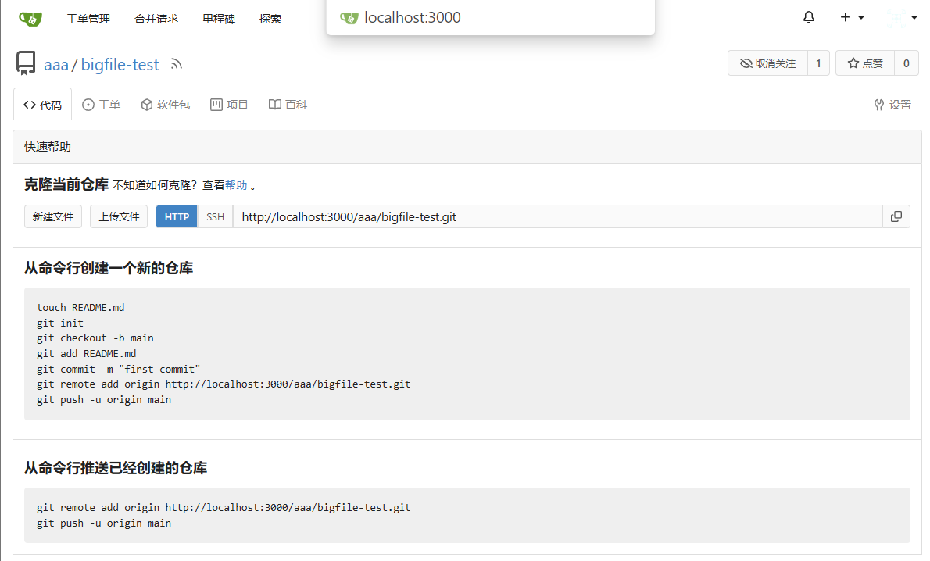
3.4 Large-File Repo (≥1 GB)
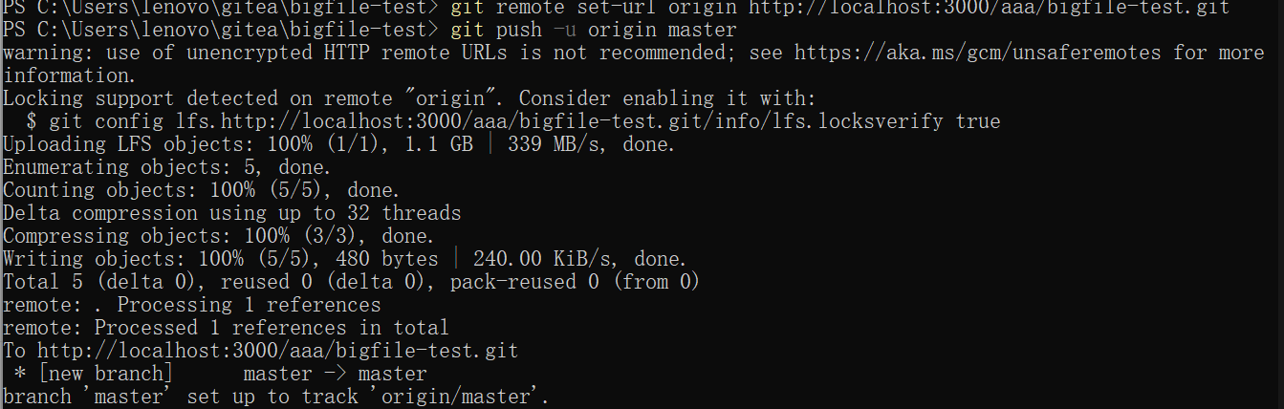
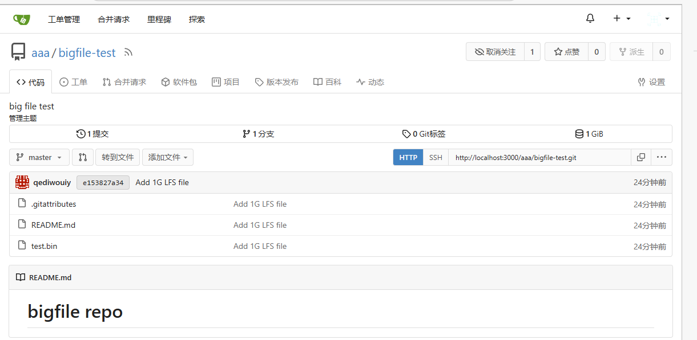

3.5 Course Repo Submission
Web: create nuist-cloud-lab
Browse http://localhost:3000 → all repos/users intact.

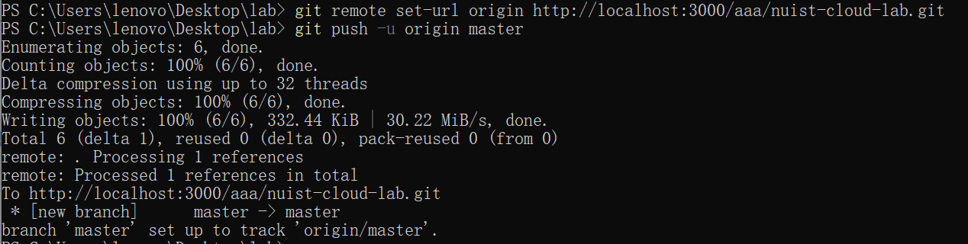
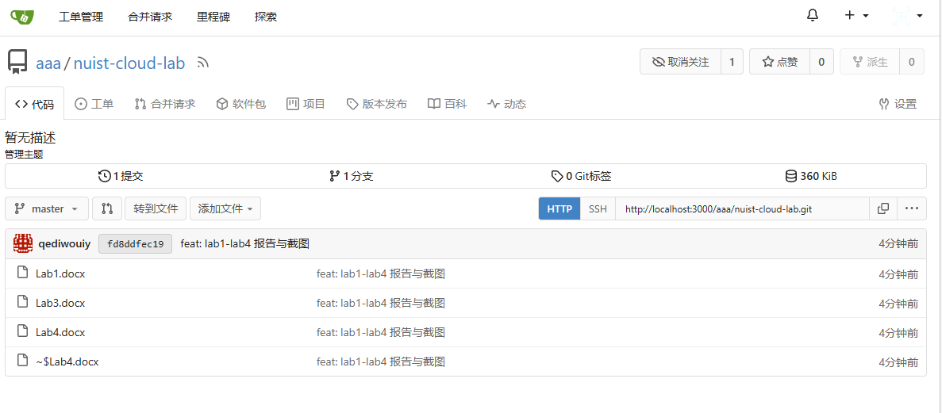
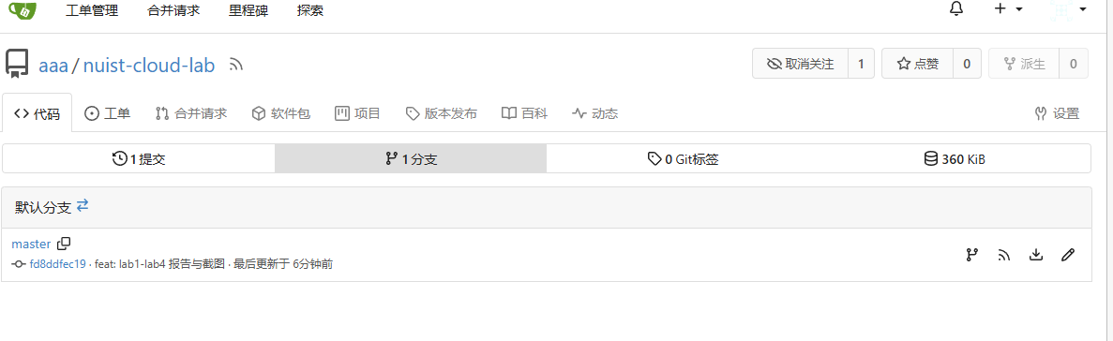
4.Conclusion
The lab demonstrates that Docker + Gitea provides a fully-functional, self-hosted Git service with enterprise-grade LFS support. Backup is as simple as archiving a single data volume, making the stack portable and course-work friendly.

