Docker Core Concepts and Practical Operation Guide

I. Document Description
This document is based on Docker's official tutorials and details core concepts such as containers, images, and Docker Compose, along with practical operations. It includes step-by-step instructions, screenshot annotations, and key notes. All operations are performed on a Windows 10 system with a WSL 2 backend, compatible with Docker Desktop 4.30+ versions.

II. Environment Preparation
1. System Requirements
- Operating System: Windows 10 64-bit (Enterprise/Pro/Education 22H2 or later)
- Hardware Configuration: 64-bit processor (supports SLAT), 4GB+ RAM
- Virtualization: Enable BIOS/UEFI hardware virtualization
- WSL Version: 2.1.5 or later
2. Installation Steps
(1) WSL 2 Configuration
1. Open PowerShell as an administrator and execute the following commands to install/update WSL:
powershell
wsl --install # For initial installation
wsl --update # To update to the latest version
`
2. Verify the WSL version:
powershell
wsl --version
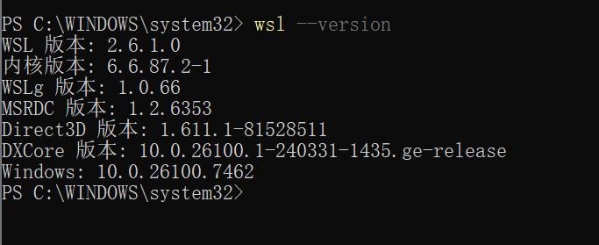

(2) Docker Desktop Installation
1. Download the installer: [Docker Desktop for Windows](https://docs.docker.com/desktop/install/windows-install/)
2. Double-click the installer file `Docker Desktop Installer.exe` and check "Use WSL 2 instead of Hyper-V"
3. After installation, launch Docker Desktop and accept the service agreement
4. Verify the installation: Open PowerShell and execute
powershell
docker --version
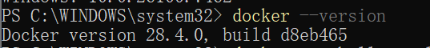

III. Core Concepts and Practical Operations
1. Containers
(1) Concept Explanation
A container is an isolated process for application components with the following characteristics:
- Self-contained: Includes all dependencies required for operation, no reliance on pre-installed software on the host
- Isolation: Isolated from the host and other containers, enhancing security
- Independence: Managed individually; deleting one container does not affect others
- Portability: Consistent behavior across development machines, data centers, and cloud environments

(2) Practical: Run Your First Container
Method 1: Via Docker Desktop GUI
1. Open Docker Desktop and enter `welcome-to-docker` in the top search bar
2. Click "Pull" to download the image, then click "Run" after completion
3. Expand "Optional settings" and configure:
- Container name: `welcome-to-docker`
- Host port: `8080` (maps to container port 80)
4. Click "Run" to start the container
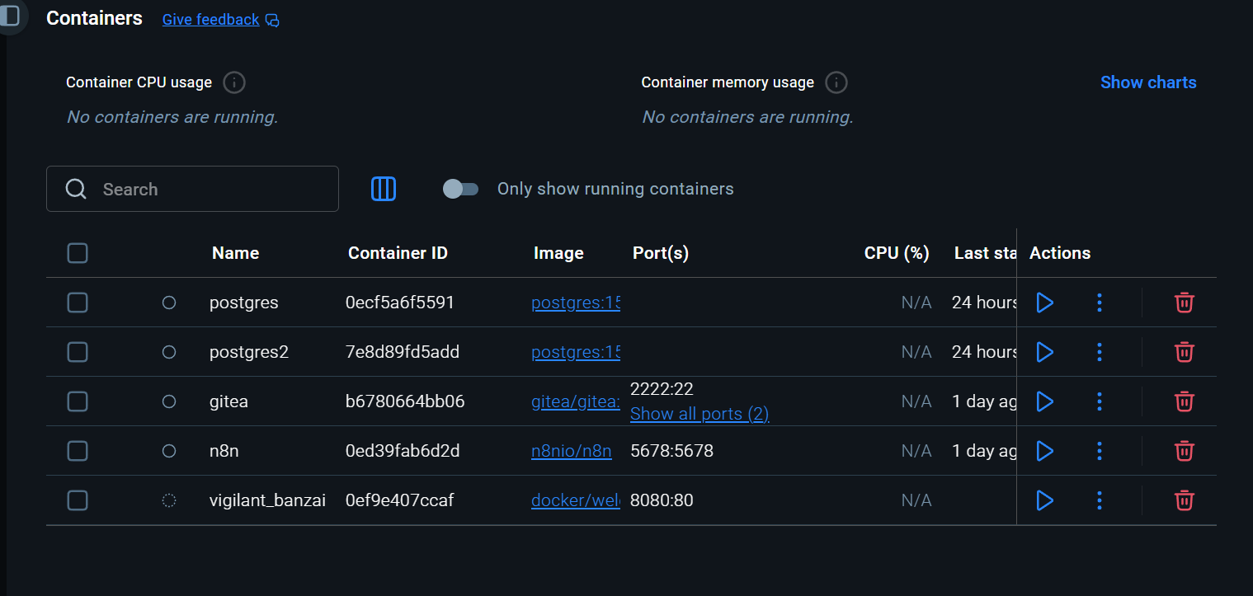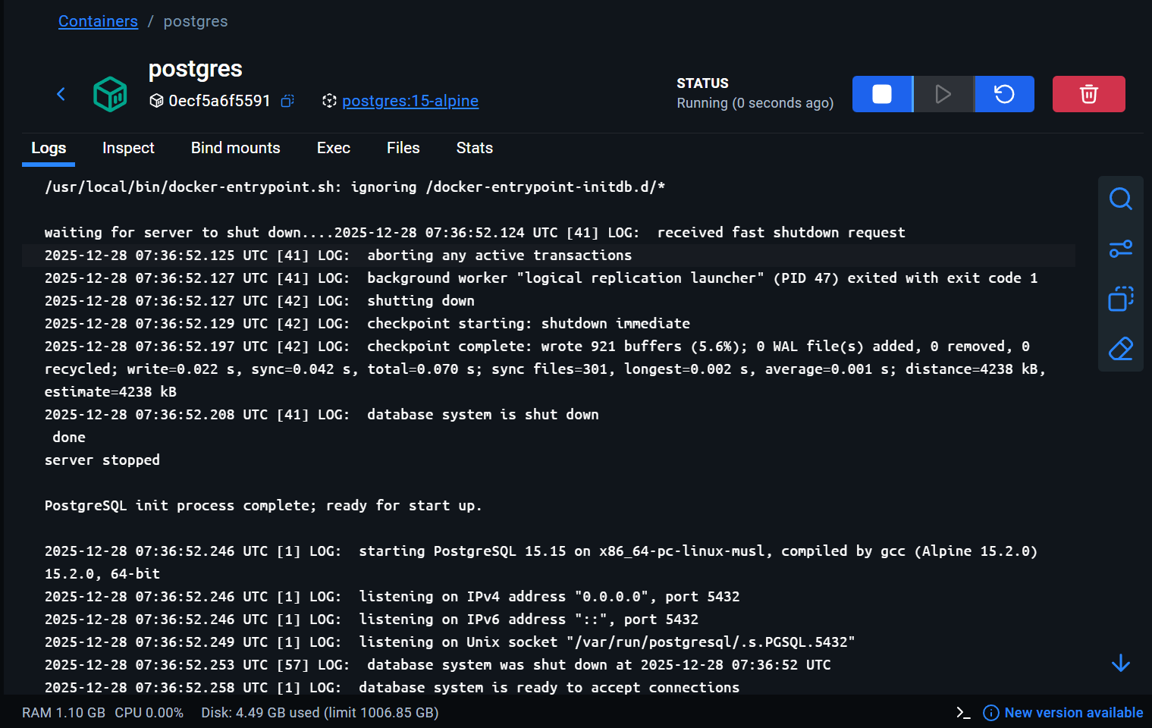

Method 2: Via CLI Commands
1. Open PowerShell and execute the following command:
powershell
docker run -d -p 8080:80 docker/welcome-to-docker
```
2. View running containers:
powershell
docker ps
```

(3) Access the Containerized Application
1. Open a browser and visit `http://localhost:8080` to see the welcome page
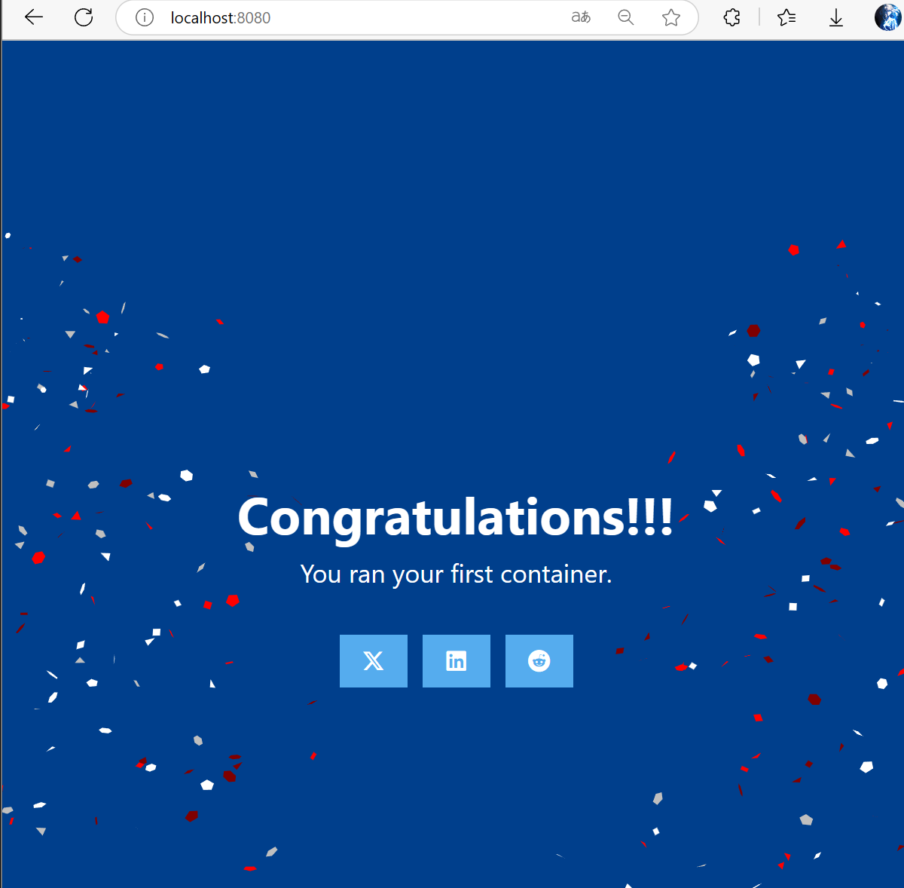

(4) Stop and Delete a Container
1. Via GUI: On Docker Desktop's "Containers" page, click "Stop" next to the container
2. Via CLI:
powershell
docker ps # Get the container ID
docker stop <container-id> # Stop the container (you can use the first 3 characters of the ID)
docker rm <container-id> # Delete the container

> Note: `docker ps` only shows running containers. Add the `-a` parameter to view all containers.

2. Images
(1) Concept Explanation
An image is a standardized software package that includes files, binaries, libraries, and configurations required to run a container. It has two key characteristics:
- Immutability: Cannot be modified after creation; only new images can be created or layers added
- Layered structure: Each layer represents a set of filesystem changes (adding/deleting/modifying files)

(2) Practical: Search and Manage Images
(1) Search for Images
Method 1: GUI Method
1. Open Docker Desktop, navigate to the "Images" page, and click "Search images to run"
2. Enter `welcome-to-docker` and select the `docker/welcome-to-docker` image
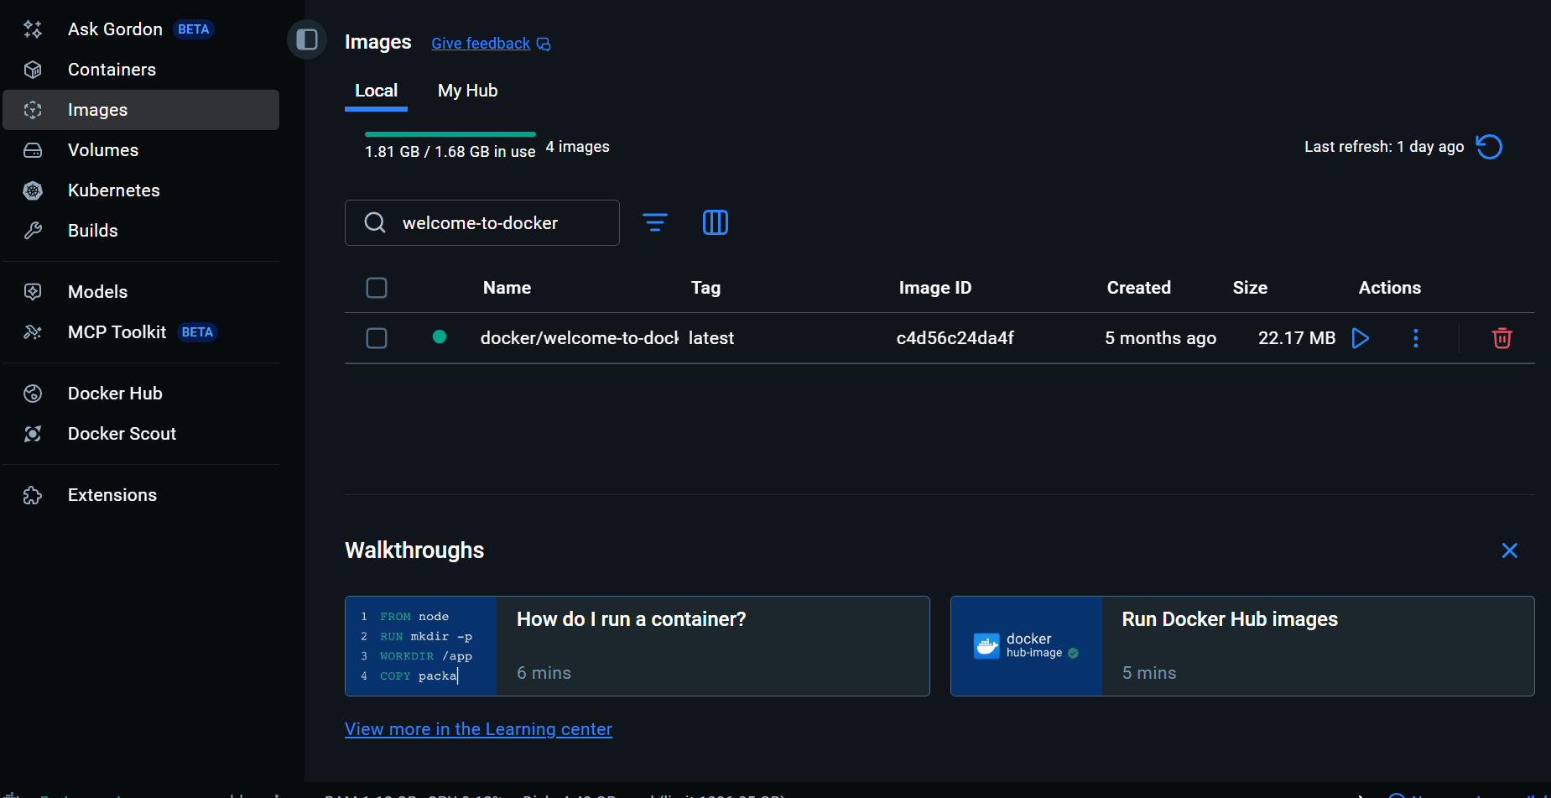
Method 2: CLI Method
powershell
docker search docker/welcome-to-docker
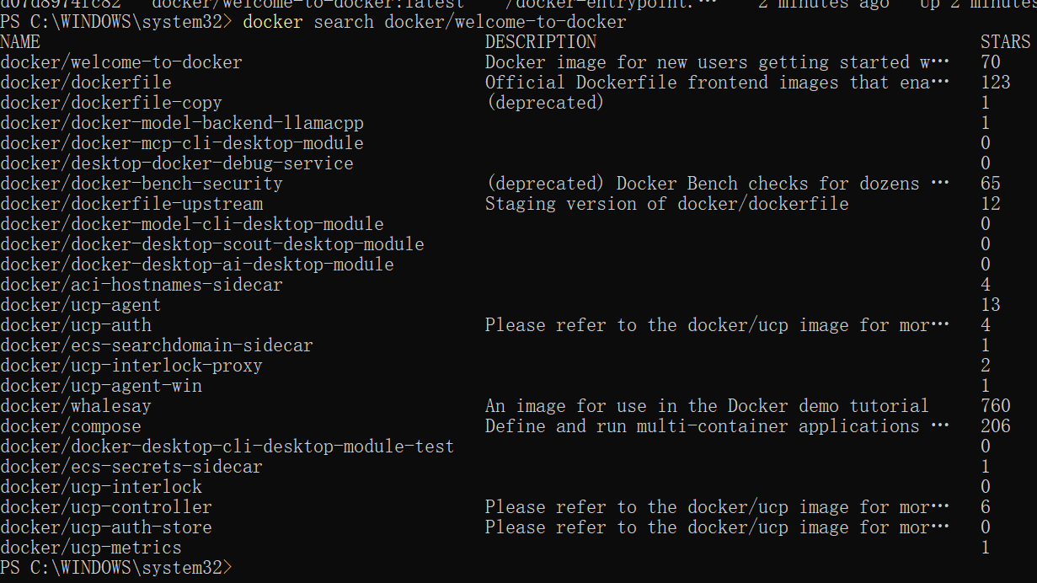
(2) Pull an Image
powershell
docker pull docker/welcome-to-docker
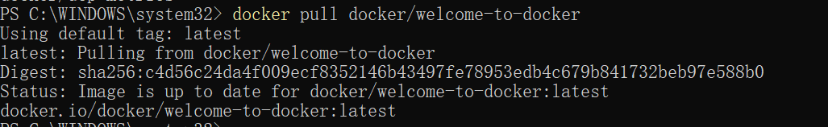
> Note: The pull process shows the download progress of each layer; images consist of multiple layers.

(3) View Image Information
1. List local images:
powershell
docker image ls

2. View image layers:
powershell
docker image history docker/welcome-to-docker

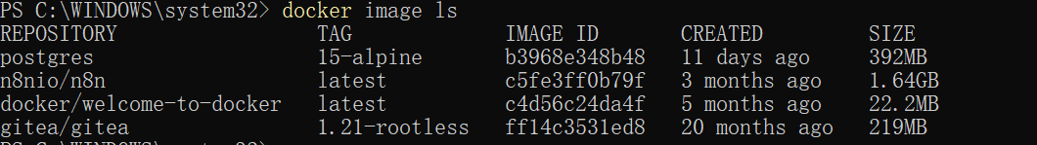
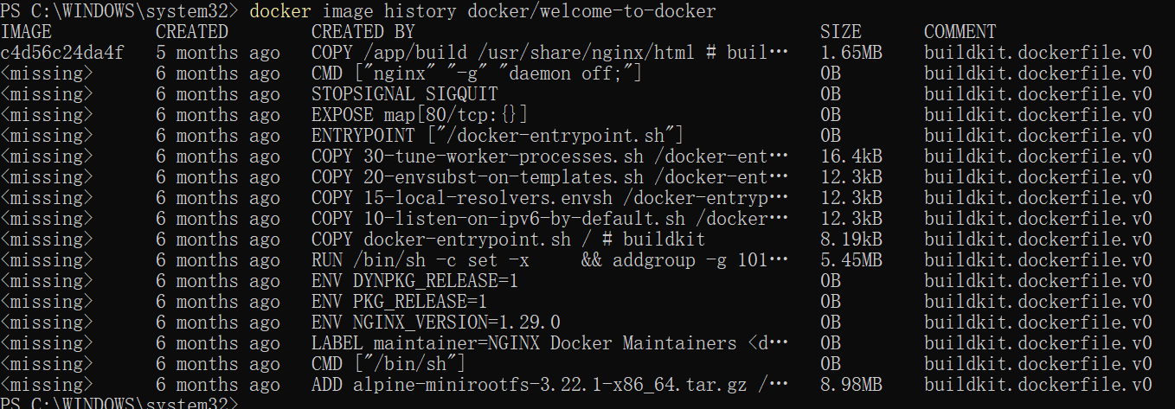

3. Docker Compose
(1) Concept Explanation
Docker Compose is used to define and run multi-container applications. It configures all services through a single YAML file (`compose.yaml`), supporting:
- Centralized management of configurations for multiple containers (ports, networks, volumes, etc.)
- One-click startup/shutdown of the entire application stack
- Intelligent configuration updates without recreating all containers

(2) Practical: Run a Multi-Container Application (Todo List)
1. Clone the sample project:
powershell
git clone https://github.com/dockersamples/todo-list-app
cd todo-list-app

2. View the `compose.yaml` file structure:
```yaml
services:
app:
build: .
ports:
- "3000:3000"
depends_on:
- mysql
mysql:
image: mysql:8.0
environment:
MYSQL_ROOT_PASSWORD: secret
volumes:
- todo-mysql-data:/var/lib/mysql
volumes:
todo-mysql-data:
```
3. Start the application:
powershell
docker compose up -d --build
```
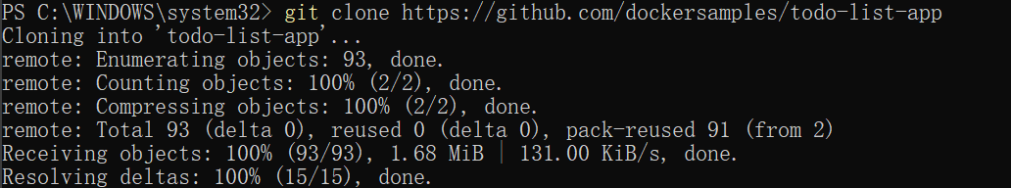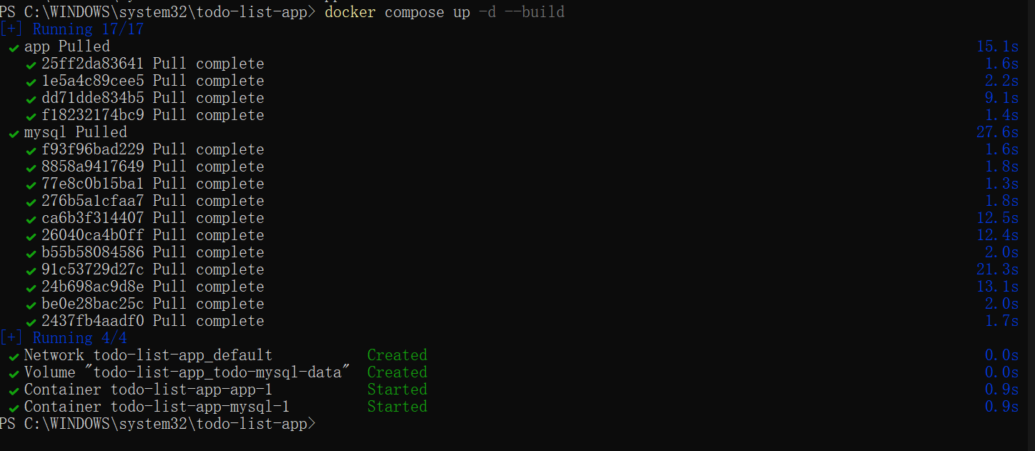
4. Access the application: Open a browser and visit `http://localhost:3000`
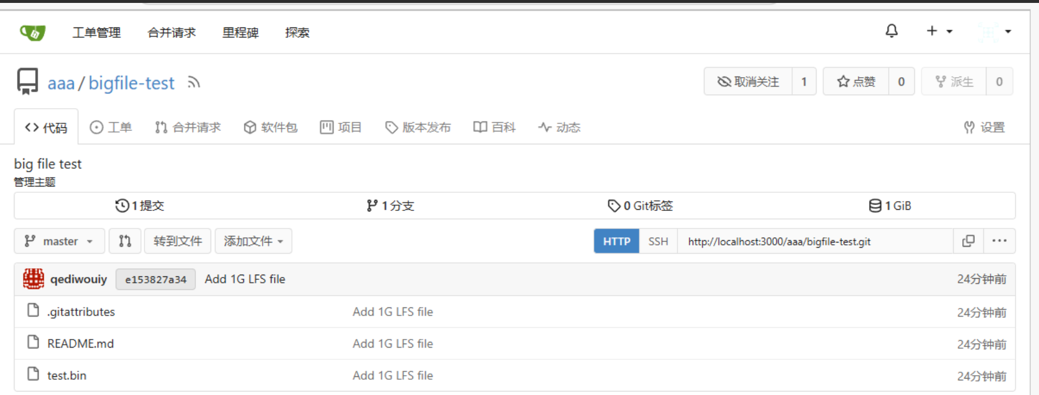
5. Stop and clean up:
`powershell
docker compose down # Stop containers and retain volumes
docker compose down --volumes # Stop containers and delete volumes
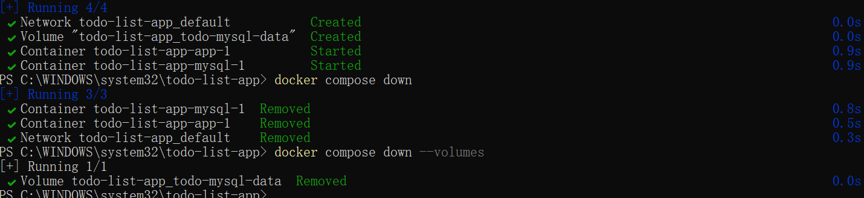
> Note: The `--build` parameter rebuilds the image, and `depends_on` defines the service startup order (starts mysql before app).

4. Publishing Ports
(1) Concept Explanation
Port publishing is used to break through container network isolation by forwarding host ports to container ports. Syntax:
```powershell
docker run -d -p HOST_PORT:CONTAINER_PORT <image-name>
```

(2) Practical Scenarios
(1) Specify a Fixed Port
```powershell
docker run -d -p 8080:80 nginx # Map host port 8080 to container port 80
```
(2) Random Port Mapping
```powershell
docker run -d -p 80 nginx # Docker automatically assigns a host port
docker ps # View the assigned port
```
(3) Map All Exposed Ports
```powershell
docker run -d -P nginx # Map all ports declared with EXPOSE in the image
```
> Note: `EXPOSE` is only a declarative instruction and does not actually publish ports. You need to use `-p` or `-P` for actual mapping.

5. Overriding Container Defaults
(1) Core Configuration Items
| Configuration Type | Command Example | Description |
| Port Mapping | `docker run -p 5433:5432 postgres ` | Avoid port conflicts |
| Environment Variables | `docker run -e POSTGRES_PASSWORD=secret postgres` | Set passwords and other configurations |
| Resource Limits | `docker run --memory=512m --cpus=0.5 postgres` | Limit to 512MB memory and 0.5 CPU cores |
| Network Configuration | `docker run --network=mynetwork postgres` | Connect to a custom network |

(2) Practical: Run Multiple Postgres Instances
1. Create a custom network:
```powershell
docker network create mynetwork
```
2. Start the first Postgres (default port 5432):
```powershell
docker run -d -e POSTGRES_PASSWORD=secret -p 5432:5432 --name db1 postgres
```
3. Start the second Postgres (mapped to port 5433):
```powershell
docker run -d -e POSTGRES_PASSWORD=secret -p 5433:5432 --name db2 --network=mynetwork postgres
```
4. View running containers:
```powershell
docker ps

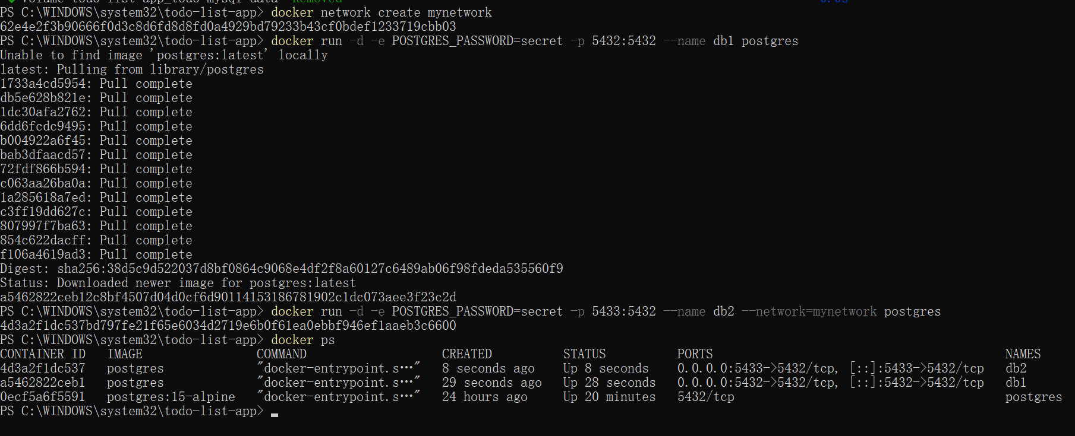
> Note: Use `--network` to add containers to a custom network, enabling communication between containers via names.

6. Persisting Container Data (Volumes)
(1) Concept Explanation
Volumes are a mechanism for persisting container data, independent of the container lifecycle, supporting:
- Data retention after container deletion
- Data sharing between multiple containers
- Data storage at a specified location on the host

(2) Practical: Postgres Data Persistence
1. Start Postgres with a volume:
```powershell
docker run --name=db -e POSTGRES_PASSWORD=secret -d -v postgres_data:/var/lib/postgresql postgres
```
2. Enter the container to create test data:
```powershell
docker exec -ti db psql -U postgres
# Execute SQL commands
CREATE TABLE tasks (id SERIAL PRIMARY KEY, description VARCHAR(100));
INSERT INTO tasks (description) VALUES ('Finish Docker tutorial');
SELECT * FROM tasks;
\q
```
3. Stop and delete the container:
```powershell
docker stop db
docker rm db
```
4. Start a new container and mount the same volume:
```powershell
docker run --name=new-db -d -v postgres_data:/var/lib/postgresql postgres
```
5. Verify data persistence:
```powershell
docker exec -ti new-db psql -U postgres -c "SELECT * FROM tasks"
```
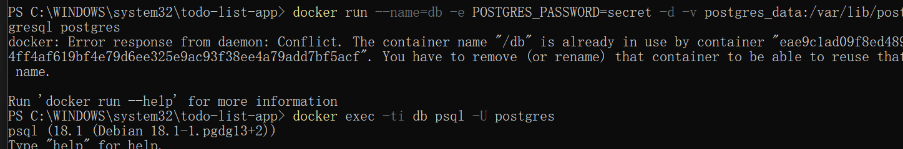
6. Manage volumes:
```powershell
docker volume ls # List all volumes
docker volume rm postgres_data # Delete a specific volume
docker volume prune # Delete all unused volumes
```

7. Sharing Local Files (Bind Mounts)
(1) Concept Explanation
Bind mounts are used to directly mount host directories/files to containers, suitable for:
- Development environments (real-time synchronization of code changes)
- Sharing configuration files
- Avoiding sensitive data storage in images

(2) Practical: Share Local HTML Files
1. Create a local directory and file:
```powershell
mkdir public_html
cd public_html
# Create the index.html file (content shown below)
```
`index.html` content:
```html
<!DOCTYPE html>
<html>
<head><title>Docker Bind Mount</title></head>
<body><h1>Hello from Host Machine!</h1></body>
</html>
```
2. Start the container and mount the directory:
```powershell
docker run -d -p 8080:80 --name my-site -v ${PWD}:/usr/local/apache2/htdocs/ httpd:2.4
```
> Note: Use `${PWD}` to represent the current directory in Windows PowerShell; use `$(pwd)` in Linux/Mac.
3. Access and verify: Open a browser and visit `http://localhost:8080`
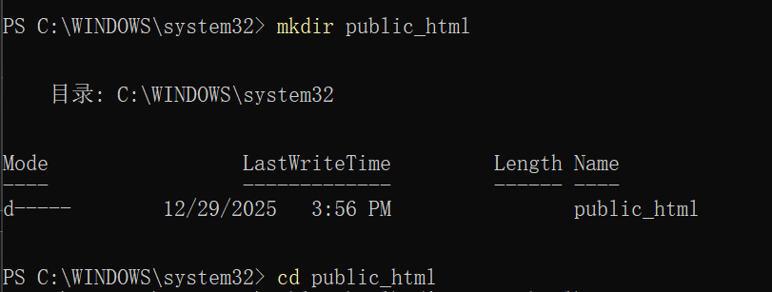
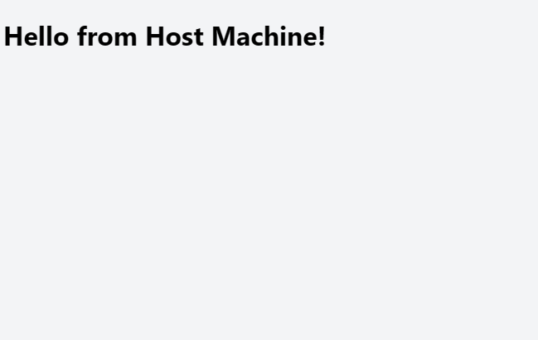
4. Modify the local file and refresh the browser to see the updates

8. Multi-Container Applications
(1) Architecture Explanation
Recommended Architecture: One container per function. Example architecture:
- Nginx: Reverse proxy (port 80)
- Node.js: Web application (2 instances for load balancing)
- Redis: Cache (stores access counts)

(2) Practical: Deploy with Docker Compose
1. Clone the sample project:
```powershell
git clone https://github.com/dockersamples/nginx-node-redis
cd nginx-node-redis
```
2. View the `compose.yml` configuration:
```yaml
services:
nginx:
build: ./nginx
ports:
- "80:80"
redis:
image: redis
web1:
build: ./web
environment:
- REDIS_HOST=redis
web2:
build: ./web
environment:
- REDIS_HOST=redis
```
3. Start the application:
```powershell
docker compose up -d --build
```
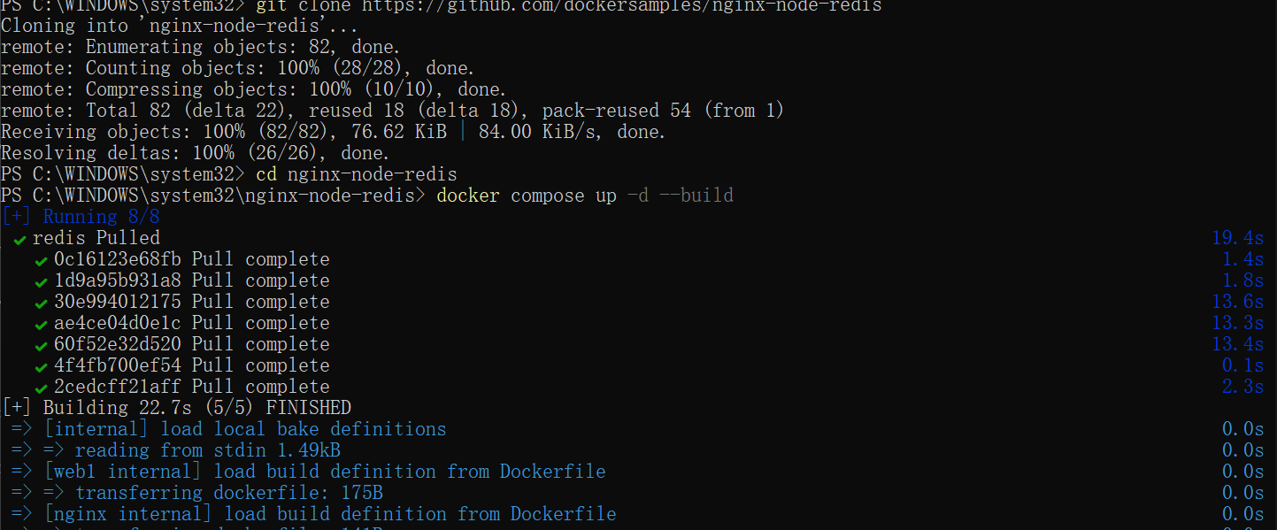
> Note: Nginx automatically distributes requests to web1 and web2, and Redis stores the global access count.

IV. Related Resources
- Official Documentation: [Docker Documentation](https://docs.docker.com/)
- Image Repository: [Docker Hub](https://hub.docker.com/)
- Code Repository: [Document Source Code and Screenshots](https://github.com/your-username/docker-tutorial)

