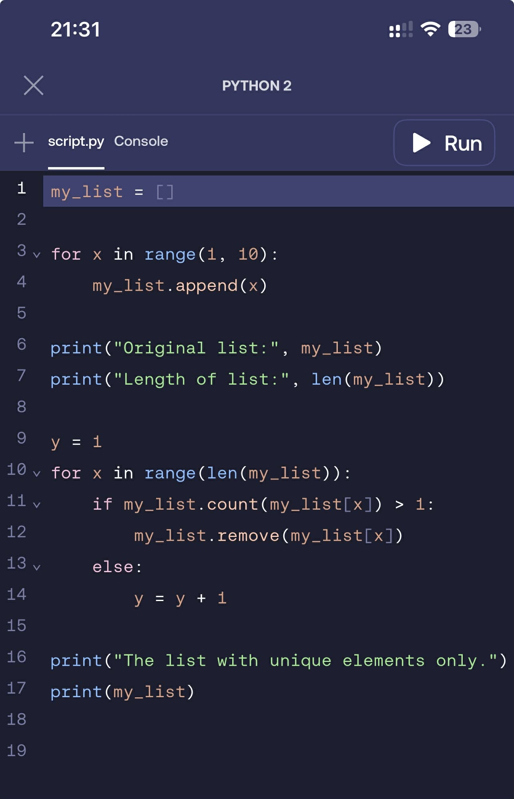
This is my code, which I create a program that generates a list of numbers from 1 to 9 using the range functions and for a loop.
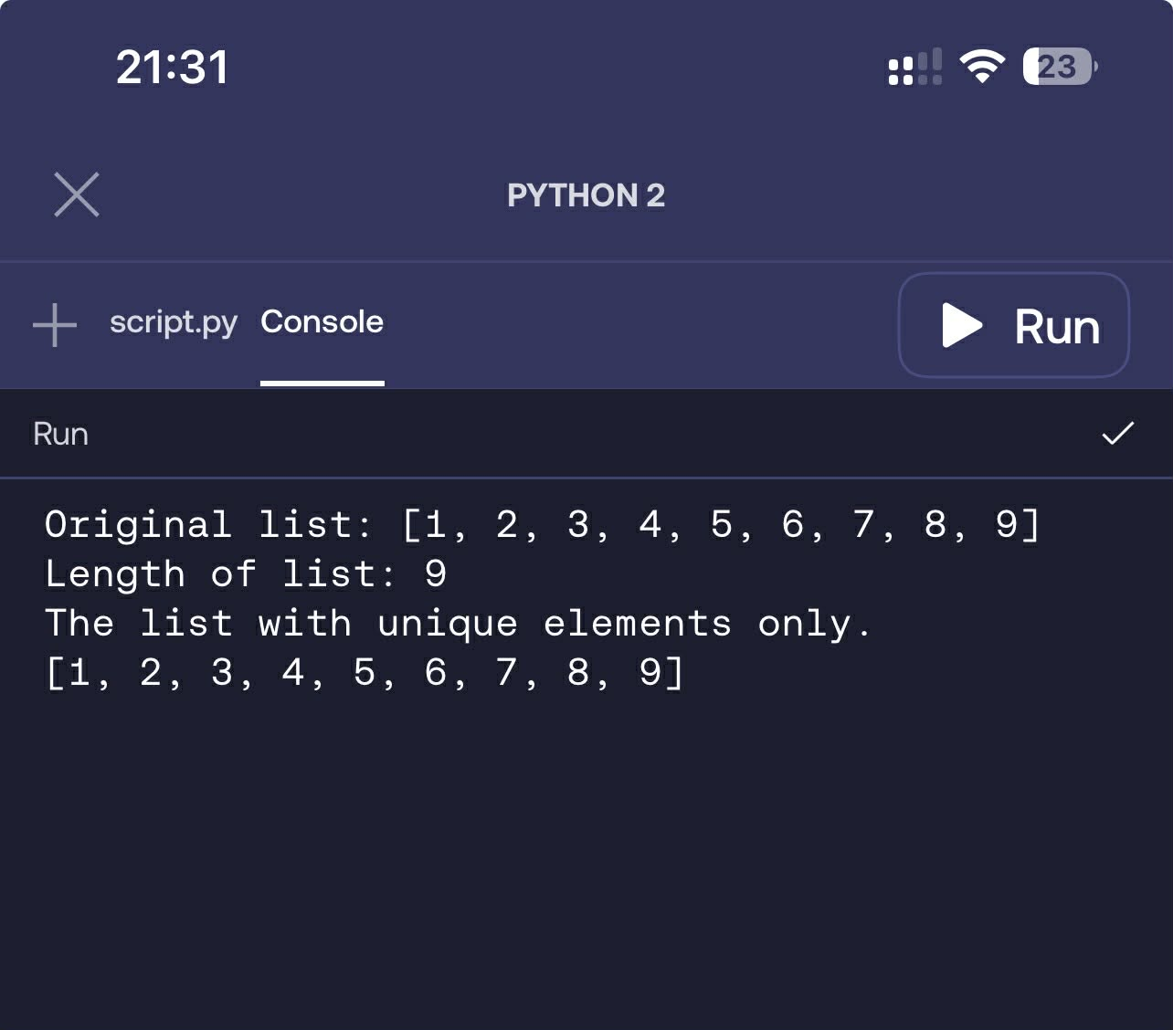
This is the final output, which shows the list with unique elements only.

1st line: my_list = [] I made a list. It is empty.
2nd line: for x in range(1, 10): This loop goes from 1 to 9.
3rd line: my_list.append(x) I put the number into the list.
4th line: print("Original list:", my_list) This shows the list with the numbers.
5th line: print("Length of list:", len(my_list)) This shows how many numbers are in the list.
6th line: y = 1 I made a counter called y. It starts at 1.
7th line: for x in range(len(my_list)): This loop goes through each number in the list.
8th line: if my_list.count(my_list[x]) > 1: This checks if the number shows up more than once.
9th line: my_list.remove(my_list[x]) If it shows up more than once, I take it out.
10th line: else: This runs if the number is not repeated.
11th line: y = y + 1 I add 1 to the counter.
12th line: print("The list with unique elements only.") This shows a message before the final list.
13th line: print(my_list) This shows the list after removing repeats.

Final Output Original list: [1, 2, 3, 4, 5, 6, 7, 8, 9]
Length of list: 9
The list with unique elements only. [1, 2, 3, 4, 5, 6, 7, 8, 9]

