
QET

SYSTEMS

L T D

SOLUTION PROPOSAL

Jan - June, 2016

Q-SHULE:
SCHOOL INFORMATION MANAGEMENT SYSTEM

CONTACT:

www.qet.co.ke |  | Solution Proposal |  | info@qet.co.ke

QET
~ Dr. P. K. Kihato

☻HOW ARE WE DIFFERENT?

SYSTEMS

L T D

“A fresh perspective. Eager to deliver and

very dilligent in their work...”

HISTORY

QET Systems is a limited liability

company based in Nairobi and Thika,

Kenya. Founded in 2010, and

incorporated in 2015 our prime focus

is on ICT services

which include:

Technical assessment ICT consulting

Design and building of web based transactional systems

Network design and implementation Web design

Embedded systems programming Industrial PLC and SCADA systems implementation

The founding partners are a group

of Electronic and Computer engineers from JKUAT with diverse specialties like cyber security, system optimizati--on and communication design∏

EXPERIENCE

Our team has a combination of over 12,000 man hours in personal and industry assignments.

Agile development teams ensure that clients are promptly informed on progress changes made to their work.

We have created all our inhouse applications; from email to project collaboration to payroll systems. Our senior engineers attend workshops both locally and abroad in order to ensure reliability of our systems and to keep upwith modern trends in this dynamic computer age.

At QET Systems, we strive to go the extra mile for our clients. We incorporate rich, intuitive user interfaces and simplified control logic to ensure a seamless user experience∏

PHILOSOPHY

Here at QET, we live by one simple philosophy:

‘something is what it is and not something else’

Translation: there are no excuses for bad design, a project is never complete until the client says it is.

By using this as our ethical guide--line, we have been able to satisfy all our clients∏

Smart Business Solutions | Contact: QET Systems Ltd., 3rd Flr. Kigio Plaza, Thika
Web: www.qet.co.ke | Email: info@qet.co.ke


QET

SYSTEMS

L T D

INTRODUCTION

Education is the conerstone of our country. Over the past few years, there has been significant advancements in technology and this has in turn provided new methods of solving problems.

With this kinds of developments prolifirating all over, a college/university needs to streamline its information access, coursework administration, financial management and strategic management frameworks. Also, with the information age and vision 2030 promises, your institution needs to step up and embrace the digital era.

For your institution to break ground on new brands of business and attract a new breed of students, the stakeholders must ensure that digitization is paramount in their mainstreaming agenda. This would also open the institution up to external investments and therefore make your enterprise a foremost in the provision of quality education.

Enter QET Systems Ltd., an ICT company with big ideas and a focus on achieving next level accomplishments. We have extensive experience in building digital infrastructure for both public and enterprise use. HISTORY EXPERIENCE PHILOSOPHY

Our portfolio spans a mixture of products that have been developed over the past 5 years. They span diverse fields of application and have been developed using chief tenets of experience, market evolution, quality management processes and uncompromising professionalism. These products are considered by our wide client base to be cutting edge and a strategic move in building the core capacity of your enterprise.

SOFTWARE SYSTEMS WEB & MOBILE APPSBUSINESS PROCESS RE-EINGINEERINGIT CONSULTING CLOUD COMPUTING COMPUTER & NETWORK ENGINEERINGOUTSOURCED IT SERVICESENTERPRISE DATA MANAGEMENT

Smart Business Solutions

Contact: QET Systems Ltd., 3rd Flr. Kigio Plaza, Thika

Web: www.qet.co.ke

Email: info@qet.co.ke


QET

SYSTEMS

L T D

PRODUCT OVERVIEW

NAME |  | Q-SHULE - School Information Management System
DESCRIPTION |  | Q-Shule is a new generation school management operating system. It gives you complete
 |  | visibility across all entities of your enterprise by showing how both the individual divisions
 |  | and the whole institution are performing
MOULES |  | 01>> Students
 |  | New student registration, Edit student information, Comprehensive student file, Alumni data
HISTORY02>> CourseworkEXPERIENCEManagement
OVERVIEW |  | management
PHILOSOPHY

Departments, Subjects, Classes, Registration, Class Attendance Records, Time Tabling (regular coursework & exam schedules), Grading (scores entry & result processing), Incident Management

03>> Library

Library Inventory Management, Book Reservation, Book Issuance, Receiving Books 04>> Accounts

Invoicing Students, Receiving Fees, Printing Receipts, Tracking Accounts (almost due, due, overdue), Student Statements, Ledgers panel, Make journal entries, Find journal entries, Supplier Accounts, Bank Reconcilliation, Expenses Accounting
05>> Inventory

Find stock items, Add/Edit items, Goods received inwards, Stock issue, Stock taking, Stock adjustment, Stock valuation, Stock usage register, Goods returned outwards, Purchase Order Generation,

06>> Asset Management

Asset Records, Asset Assignment, Asset Tracking, Asset Recovery, Asset Disposal, Asset Census, Asset Valuation (depreciation and appreciation)

07>> School Clinic

Clinical Records - Patient Demographics, Patient History, Diagnosis, Investigations, Prescriptions 08>> Human Resource Management [for teaching and support staff]

Add/Edit employee info., Search employee, Delete employee record, Employee chart, Terminate employment, Ex-employee panel, Attendance manager, Request leave, Authorize leave, Create payroll, Edit payroll, Payroll setting, Employee benefits

07>> Reports

Student reports, Departmental reports, Financial reports, Procurement reports, Library reports, Inventory reports, HR reports, Payroll reports, Assets reports, Clinic Reports, System reports 08>> Web Access Portals

Students portal, Staff portal, Guardians portal, Suppliers portal, Stakeholders portal 09>> System Tools

Company details, System users manager, User access rights, System licencing, Import/Export database

SOFTWARE SYSTEMS WEB & MOBILE APPSBUSINESS PROCESS RE-EINGINEERINGIT CONSULTING CLOUD COMPUTING COMPUTER & NETWORK ENGINEERINGOUTSOURCED IT SERVICESENTERPRISE DATA MANAGEMENT

Smart Business Solutions | Contact: QET Systems Ltd., 3rd Flr. Kigio Plaza, Thika
Web: www.qet.co.ke | Email: info@qet.co.ke


QET

SYSTEMS

L T D

OUR ADVANTAGE

Computer software has revolutionized how we find, share and store information. The digital world is moving at a rapid pace and doesn’t show any signs of slowing. For education institutions, digitized operations have become a fundamental part of success. But why is this software so important? How significant is the impact of using it to run your operations? We’re glad you asked

01>> Shorter to No-more Queues

Have the pleasure of processing thousands of transactions automatically. With the use of a web based platform

02>> Market Expansion

The Internet has allowed businesses to break through the geographical barriers and become accessible, virtually, from anywhere with Internet access.

03>> Digital Presence
A websiteHISTORYisnotjustamedium for representationEXPERIENCEofyourinstitution, it is a formPHILOSOPHYofmediafromwhich everybody can acquire information. You can use this media to advertise your institution.

04>> 24-7-365

No more turning students away when it’s time to close shop, putting up a note saying closed for public holiday , or leaving an irritating message on your answering service specifying your working hours .Tell them to visit your website for information they are looking for.

05>> Offer Convenience

It is far more convenient for a person to research a product on the Internet than it is to get in a car, drive somewhere and look for or ask someone for information on a product. Also, a potential customer won’t have to judge a call center agent to determine whether he/she has their best interests in mind, or just wants to make a sale. The potential customer can visit your website whenever they like in their own privacy and comfort, without the stresses and distractions that exist in the real world.

06>> Instantaneous Reporting

Get all the information you need right at your finger tips. Information sourced from the website gets audited and analyzed then presented to the administrator(s) and or stakeholder(s) via graphs, charts and other data visualization models. Experience the unmatched analytics and visualization capabilities that modern technology has to offer

SOFTWARE SYSTEMS WEB & MOBILE APPSBUSINESS PROCESS RE-EINGINEERINGIT CONSULTING CLOUD COMPUTING COMPUTER & NETWORK ENGINEERINGOUTSOURCED IT SERVICESENTERPRISE DATA MANAGEMENT

Smart Business Solutions | Contact: QET Systems Ltd., 3rd Flr. Kigio Plaza, Thika
Web: www.qet.co.ke | Email: info@qet.co.ke


QET

SYSTEMS

L T D

OUR ADVANTAGE ... [cont]

07>> Rebuild the system to your specifications

With the option of customization available, clients are able to enjoy full flexibility and control of the end product. ** This service is available on request and is billed separately

08>> Guaranteed lifetime maintenance and support

Business availability is important, and that is why we have made significant investments in building our support team to ensure that your business is insured from lack of technical capability. Our support teams are backed with a panel of professional engineers, architects and consultants to guarantee masterful insight and flawless performance.

09>> Enterprise-grade software specifications

All software is not of the same quality. At QET Systems we pride ourselves on the measures we take to ensure that the client gets the best above the rest. Our quality management processes run through the entire system
development_{HISTORY}lifecycle.From inception to elaboration_{EXPERIENCE}throughconstruction and finally_{PHILOSOPHY}thetransitionphase,we painstakingly design and test our software systems till they meet the conditions set forth by our clients.
10>> Disaster recovery management

Our business revolves around data, for without data there can be no information, and information is the resource from which we extract value. We have taken the necessary steps to train dedicated teams in the art of data and disaster recovery. Whenever the unforseeable happens, rest assured that our rapid response teams have you covered.

11>> Stable architecture, Bleeding edge technology

In a field as dynamic as IT, the true master only focuses on understanding the art and no more. Our software systems have evolved over time indiviadually across many different fields of application, giving us the advantage of insight that is priceless. This translates into high quality software that is built on stable analysis patterns, freeing us from any particular language and giving you the advantage of optimized algorithims and patterns. Be it a hospital, a bank, an airport or the military, our systems give your enterprise a scalable, highly available and flexible software core that is always ready for your next growth move as it is in the principle of progressive enhancement.

12>> Friendly and Caring Service

From the way our service executives engage with clients to the way our designers craft user interfaces and delighting user experiences; from the way our architects design the application systems to the way our engineers code the software, our goal is the same: How best can we transform great technology and beautiful design into enduring experiences for our customers?

SOFTWARE SYSTEMS WEB & MOBILE APPSBUSINESS PROCESS RE-EINGINEERINGIT CONSULTING CLOUD COMPUTING COMPUTER & NETWORK ENGINEERINGOUTSOURCED IT SERVICESENTERPRISE DATA MANAGEMENT

Smart Business Solutions | Contact: QET Systems Ltd., 3rd Flr. Kigio Plaza, Thika
Web: www.qet.co.ke | Email: info@qet.co.ke

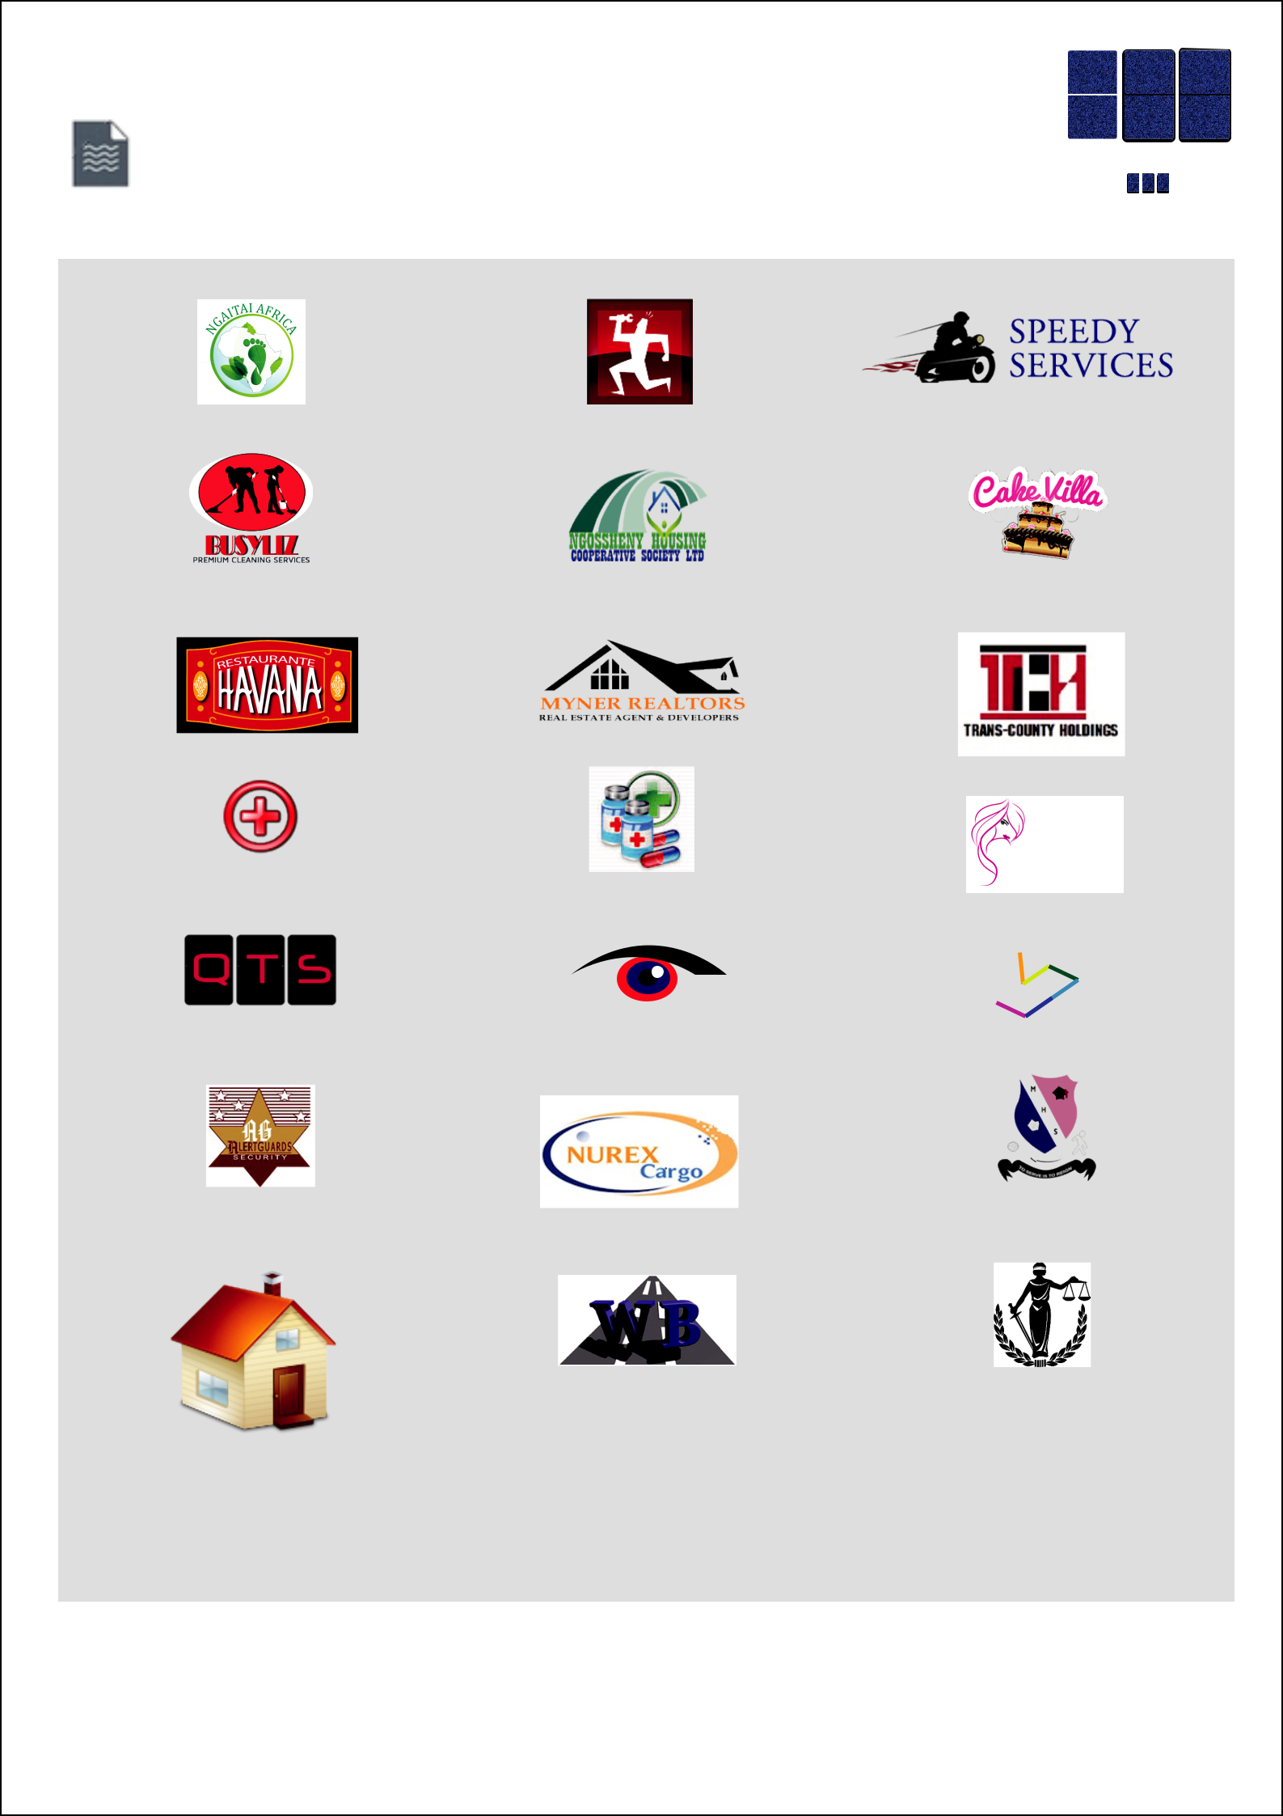
QET

SELECTED CLIENTS

SYSTEMS

L T D

Ngaitai Afrika, Meru

Busylizz Cleaning Services,

Nairobi

Havana Restaurant, Nairobi

Jaffa Pharmaceuticals,
Thika

Quantal Tech Solutions,
Nairobi

Alert Guard Services,
Wajir

Kaganda Enterprises, Thika

Conrad Kenya Services,
Nairobi

Ngossheny Sacco, Thika

Myner Realtors, Nairobi

Joypharm Pharmaceuticals,

Thika

ONPOINT BRANDS
BE SEEN THROUGH US

Onpoint Brands, Kisii

Nurex Cargo, Nairobi

Westbuild Contractors, Thika

Speedy Services Kenya, Nairobi

Cake Villa, Nairobi

Trans-County Holdings, Meru

EBONY
COSMETICS

Ebony Cosmetics, Nairobi

Fractal

Fractal, Thika

Muhoho High School,
Muranga

Kivuva Omuga & Co. Advocates,

Nairobi

SOFTWARE SYSTEMS WEB & MOBILE APPSBUSINESS PROCESS RE-EINGINEERINGIT CONSULTING CLOUD COMPUTING COMPUTER & NETWORK ENGINEERINGOUTSOURCED IT SERVICESENTERPRISE DATA MANAGEMENT

Modernising core enterprise systems | Contact: 3rd Floor, Kigio Plaza, Thika CBD.
Web: www.qet.co.ke | Email: info@qet.co.ke

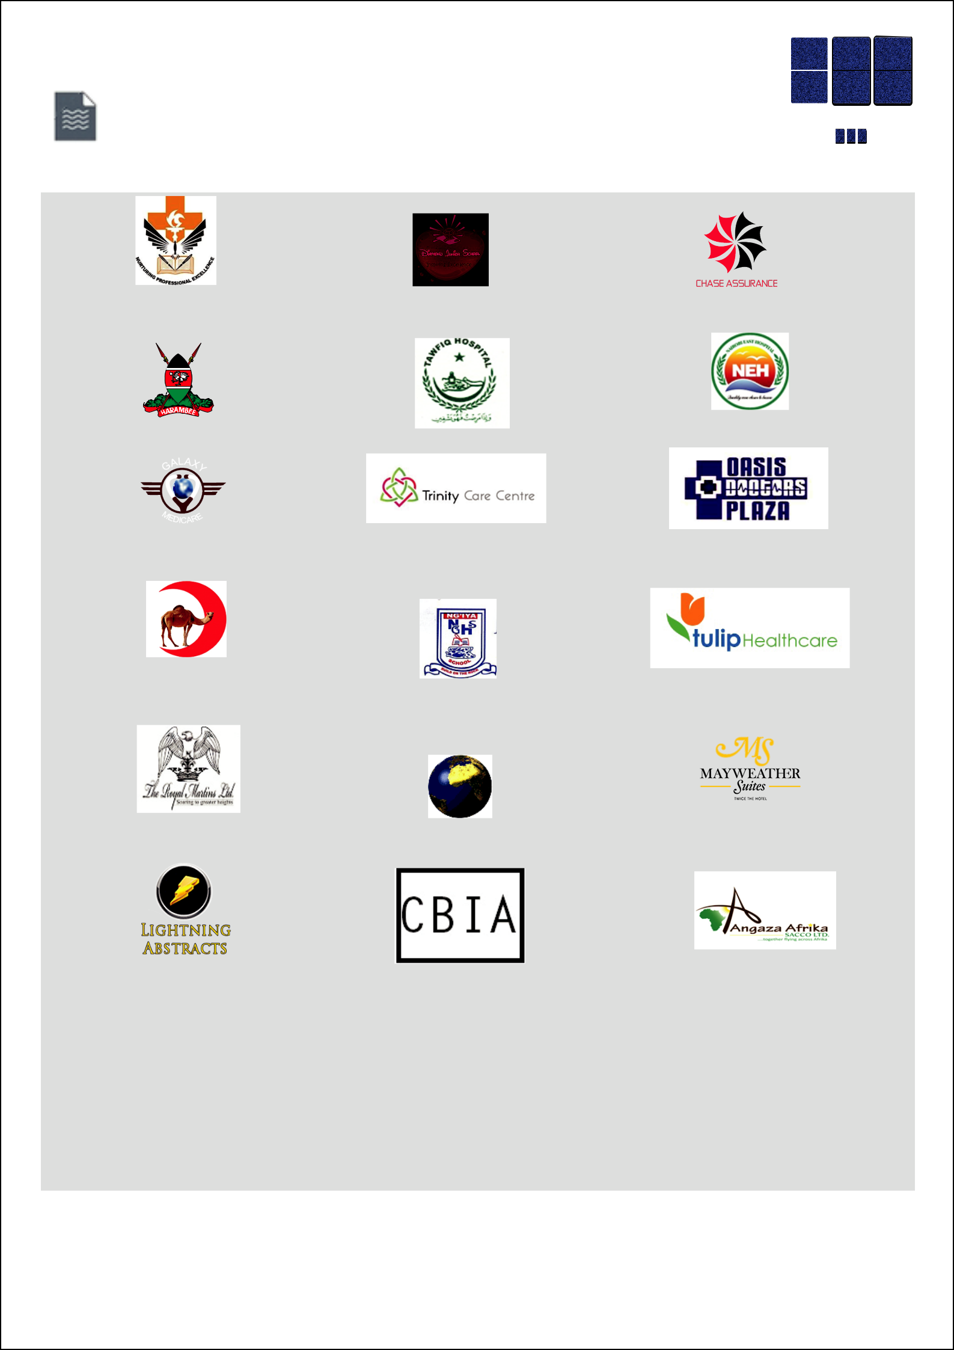
QET
SELECTED CLIENTS | L T D
 | SYSTEMS

Thika School of Medical
and Health Sciences, Thika

Wajir Level 4 Hospital, Wajir

Galaxy Medicare Consultants,

Thika

Mandeq Medical Services
Mogadishu

The Royal Martins, Nairobi

Lightning Abstracts,
Colorado

Diamond Junior School,
Nairobi

Tawfiq Hospital, Malindi

Trinity Care Center, Nairobi

Ngiya High School, Siaya

Marafique Arcade, Thika

Customer Bound Insurance Agency, Nairobi

Chase Assurance, Nairobi

Nairobi East Hospital, Nairobi

Kitui Oasis Doctors Plaza, Kitui

Tulip Healthcare, Nairobi

Mayweather Suites Hotel,
Nairobi

Angaza Africa Sacco, Thika

SOFTWARE SYSTEMS WEB & MOBILE APPSBUSINESS PROCESS RE-EINGINEERINGIT CONSULTING CLOUD COMPUTING COMPUTER & NETWORK ENGINEERINGOUTSOURCED IT SERVICESENTERPRISE DATA MANAGEMENT

End-to-end IT Solutions | Contact: 3rd Floor, Kigio Plaza, Thika CBD.
Web: www.qet.co.ke | Email: info@qet.co.ke

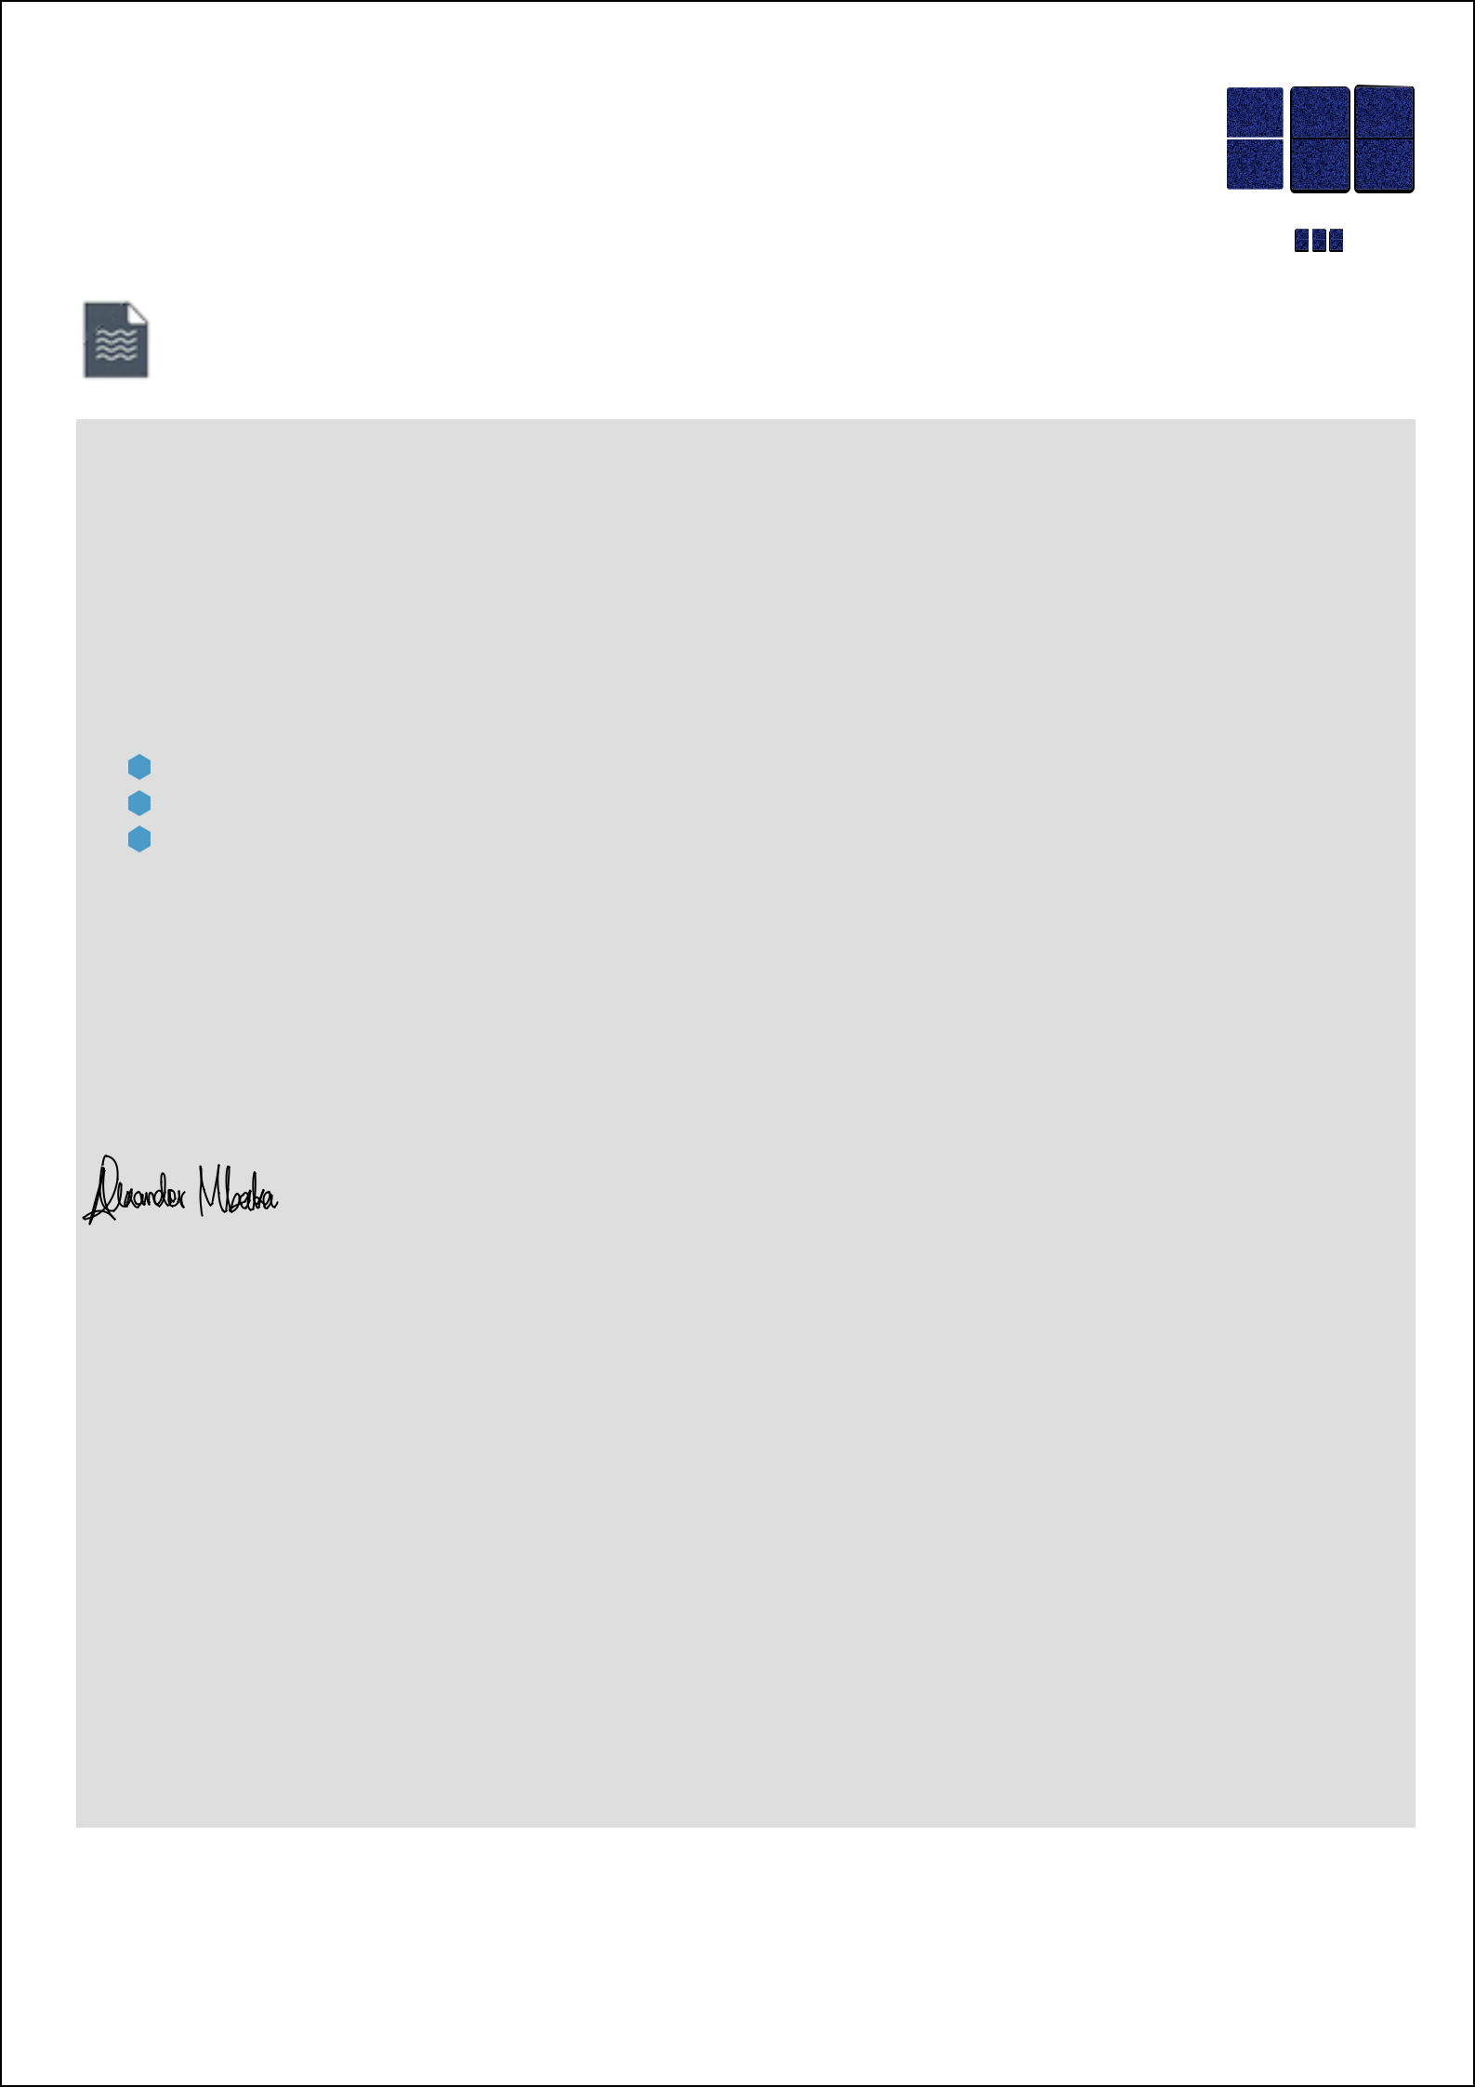
QET

SYSTEMS

L T D

CONCLUSION

QET Systems is confident that our proposed plan to install this system will go a long way in helping you to optimize your institutional operations. We sincerely hope that you will consider us not only as a short-term but also a long-term partner and allow us to enter into a mutually beneficial relationship. We are available to for a demonstration and also to answer any questions you may have and look forward to discussing this opportunity further.

After reviewing this document, the following steps should be performed in order to come to a final agreement.

Call us for demonstration and elaboration.

Submission of questions/suggestions.

Negotiations of fees, terms, clauses and conditions.

We agreeHISTORYtoholdourproposal open for acceptanceEXPERIENCEtillyouareready to proceed.PHILOSOPHY

Thank you for your interest.

Sincerely,

Alexander Mbaka,

info@qet.co.ke

Enterprise Solutions Desk.

SOFTWARE SYSTEMS WEB & MOBILE APPSBUSINESS PROCESS RE-EINGINEERINGIT CONSULTING CLOUD COMPUTING COMPUTER & NETWORK ENGINEERINGOUTSOURCED IT SERVICESENTERPRISE DATA MANAGEMENT

Smart Business Solutions | Contact: QET Systems Ltd., 3rd Flr. Kigio Plaza, Thika
Web: www.qet.co.ke | Email: info@qet.co.ke

