**1-20**

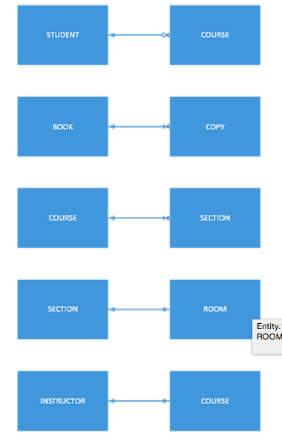

STUDENT 🡪 COURSE – Many to Many

BOOK 🡪 BOOK COPY – One to Many

COURSE 🡪 SECTION – One to Many

SECTION 🡪 ROOM – Many to Many

INSTRUCTOR 🡪 COURSE – One to Many

**1-21**

Images, sound, video and other advanced data types require higher capacity, performance, and monitoring/quality assurance capabilities than numeric or text data. For example, singular files containing basic structured data are of nominal sizes in a modern environment, but video in particular can impose a significant drain on resources.

Consider an environment in which there are gigabytes of structured data files, e.g. balance sheets for customers in a lending institution. Even if the network and computing bandwidth required to disseminate that information is significant, that information is going to hundreds of endpoints at once most likely. At the same time, gigabytes of video will tax the same number of resources while being utilized by only one endpoint. Thousands of users on thousands of resources vs. one user and one resource.

Maintenance for unstructured data is more complex as well. Structured data files are less susceptible to major flaws due to correction, and modern systems are more capable of automated repair. A database of photographs, however, is far less durable in this context.

**1-22**

|  |  |  |
| --- | --- | --- |
| **Location** | **Modified On** | **Frequency of Access** |
| Schedule of Classes Table | 8/27/2015 | 3 |
| Schedule of Classes Table | 9/1/2015 | 12 |
| Schedule of Classes Table | 4/3/2015 | 3 |
| Student Table | 5/31/2015 | 1 |
| Student Table | 5/31/2015 | 1 |
| Student Table | 8/15/2015 | 8 |

**1-23**

There are multiple reasons to create several databases rather than one enormous one. Physically, infrastructure can handle a varied group of databases easier for many reasons. A SAN in a large, corporate environment may use a tier structure for data storage, and will certainly utilize drives that operate at a variety of speeds. Having one, incredibly large database limits the effectiveness of systems that rely on arranging data for the best allocation of resources.

Logically, it makes sense to categorize our data in a way that allows us to locate it quickly. If we are an accountant, and must ask the DBMS to query 15,000 human resource records while finding our 2,000 accounting records, that is rather inefficient.

From a security perspective, separating databases ensures departments have access to the appropriate data, and not data for which they have no need-to-know.

Different kinds of data require different types of resources and storage methodologies. For this reason, multiple vendors could be involved with one datacenter’s physical storage. One part of the organization might have a Hadoop expert that enable more efficient use of a data warehouse. Another part of the organization may be technically inept, still require access to that database, and use a less effective tool for access and analysis. Expertise of individual DBAs may also factor into the choice of DBMS, storage system, and integrating technologies, which will have an affect on the database use of the entire organization.

**1-24**

**Entities**

Student Associates

Images

Articles

Subscriber

Orders

Order Line

Inventory

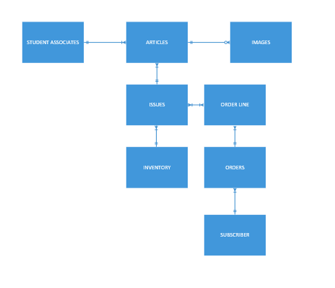

**1-25**

1. Data - structured
2. Metadata – property
3. Data – unstructured
4. Data – unstructured
5. Metadata – context
6. Metadata – property
7. Metadata - property