1. Dependency Diagram

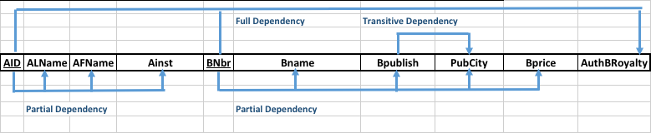

2a. No, the given database is not a relation or in 1NF. Because there are several multivaried attributes in the original database, we must eliminate these to achieve 1st NF. 1NF is depicted below (WITH ERRORS):

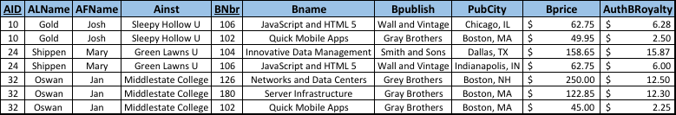

2b. This is only 1NF, in order to achieve 2NF, we must remove the partial dependencies depicted in part 1 and 2. An insertion anomaly occurs here when another co-author to JavaScript and HTML 5 is entered, requiring entry of several redundant data points (BPrice, BPublish, etc.).

2NF, and part of 3NF is depicted in the dependency diagram below:

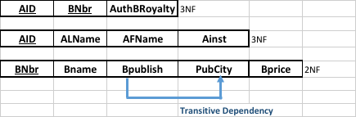

2c. Only two of the diagrams are now in 3NF. The attributes under determinant **BNbr** still contain a transitive dependency between **BPublish** and **PubCity**. Updating a publisher’s city would require that every associated book name, book price, etc. 3NF is depicted below:

