Project Overview

Customer Shopping Behavior Analysis
This project analyzes customer shopping behavior using transactional data from 3,900 purchases across various product categories. The goal is to uncover insights into spending patterns, customer segments, product preferences, and subscription behavior to guide strategic business decisions.

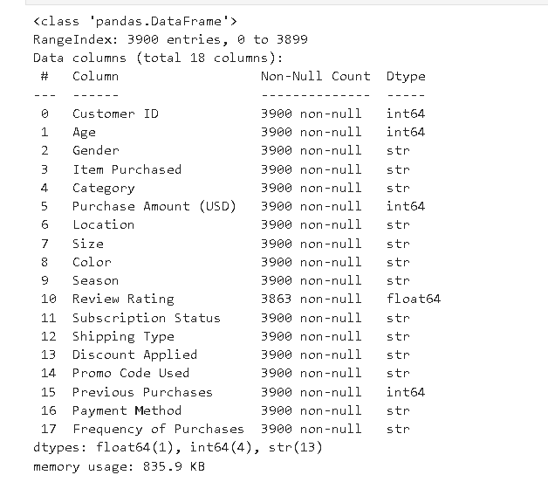
Dataset Summary
- Rows: 3,900
  - Columns: 18
  - Key Features:
    - Customer demographics (Age, Gender, Location, Subscription Status)
    - Purchase details (Item Purchased, Category, Purchase Amount, Season, Size, Color)
    - Shopping behavior (Discount Applied, Promo Code Used, Previous Purchases, Frequency of Purchases, Review Rating, Shipping Type)
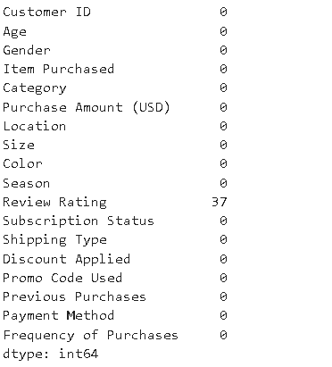
  - Missing Data: 37 values in Review Rating column

Exploratory Data Analysis using Python
I began with data preparation and cleaning in Python:

- Data Loading: Imported the dataset using pandas.

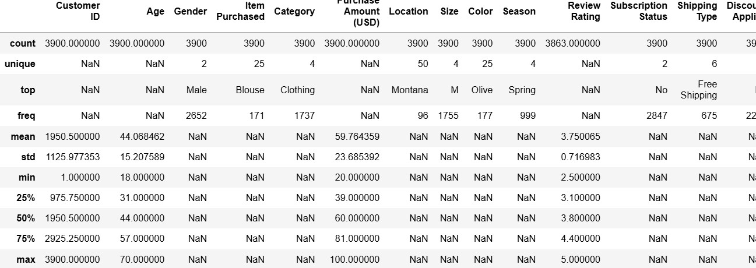
- Initial Exploration: Used df.info () to check structure and. describe () for summary statistics.

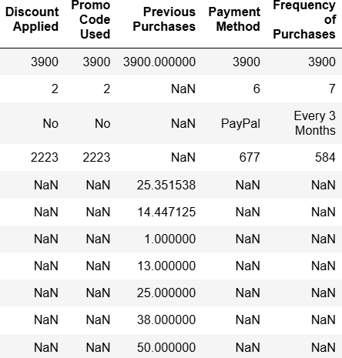

- Missing Data Handling: Checked for null values and imputed missing values in the
Review Rating column using the median rating of each product category.

- Column Standardization: Renamed columns to snake case for better readability and documentation.

Feature Engineering:

  - Created age_group column by binning customer ages.

  - Created purchase_frequency_days column from purchase data.

- Data Consistency Check: Verified if discount_applied and promo_code_used
were redundant; dropped promo_code_used.

- Database Integration: Connected Python script to MySQL and loaded the cleaned DataFrame into the database for SQL analysis.

Data Analysis using SQL (Business Transactions)
I performed structured analysis in MySQL to answer key business questions:

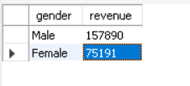
- Revenue by Gender – Compared total revenue generated by male vs. female customers.
Business Insight:
Male customers generated the highest total revenue, contributing 157,890 compared to 75,191 from female customers. This indicates a substantial difference in revenue contribution between genders and may warrant further investigation into customer preferences and purchasing behavior.

- High-Spending Discount Users – Identified customers who used discounts but still spent above the average purchase amount.
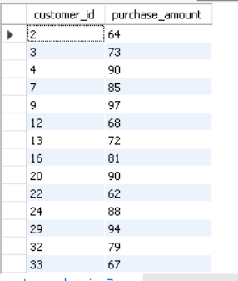

Business Insight:
A total of 839 customers used discounts while still spending above the overall average purchase amount. This suggests that discounts were effective in encouraging higher-value purchases rather than simply attracting low-spending customers. The results indicate that promotional strategies may have positively influenced customer spending behavior.

- Top 5 Products by Rating – Found products with the highest average review ratings.
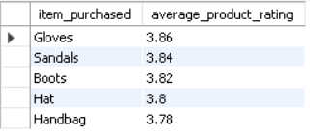
Business Insight:
Gloves received the highest average review rating (3.86), followed closely by Sandals (3.84) and Boots (3.82). The small differences among the top-rated products suggest relatively consistent customer satisfaction across these items. Businesses may consider highlighting these products in marketing campaigns, as they demonstrate stronger customer approval compared to other products in the dataset.

- Shipping Type Comparison – Compared average purchase amounts between Standard and Express shipping.
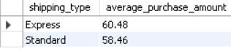

Business Insight:
Customers who selected Express Shipping recorded a slightly higher average purchase amount (60.48) compared to those using Standard Shipping (58.46). Although the difference is relatively small, it may indicate that customers making higher-value purchases are somewhat more willing to pay for faster delivery services.

- Subscribers vs. Non-Subscribers – Compared average spend and total revenue across subscription status.
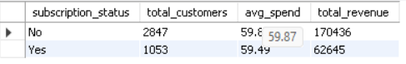

Business Insight:
Non-subscribed customers generated the majority of revenue (170,436) and recorded a slightly higher average purchase amount (59.87) compared to subscribed customers (59.49). Additionally, non-subscribers represented a much larger customer base. These findings suggest that subscription status alone was not associated with higher spending behavior in this dataset.

- Discount-Dependent Products – Identified 5 products with the highest percentage of discounted purchases.
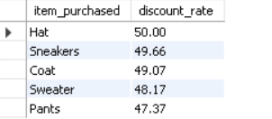

Business Insight:
Hat recorded the highest discount utilization rate at 50.00%, followed closely by Sneakers (49.66%) and Coat (49.07%). The relatively small differences among the top five products suggest that discount usage was fairly consistent across these items. This indicates that promotional discounts played a similar role in influencing purchases across multiple product categories rather than being concentrated on a single product.

- Customer Segmentation – Classified customers into New, Returning, and Loyal segments based on purchase history.
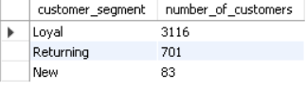

Business Insight:
Loyal customers accounted for the vast majority of the customer base, representing 3,116 customers compared to 701 Returning customers and only 83 New customers. This suggests that the business has a strong foundation of repeat purchasers and customer retention. However, the relatively small number of new customers may indicate an opportunity to strengthen customer acquisition efforts and attract new buyers.

- Top 3 Products per Category – Listed the most purchased products within each category.
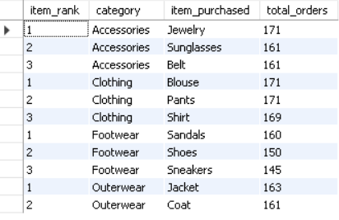

Business Insight:
Several products consistently stood out as the most frequently purchased items within their categories. Jewelry led the Accessories category with 171 orders, while Blouse and Pants jointly ranked first in Clothing with 171 orders each. In Footwear, Sandals recorded the highest demand with 160 orders, and Jacket was the top-performing product in Outerwear with 163 orders. The relatively small differences in order volume among the top-ranked products suggest that customer demand was fairly balanced within each category rather than being dominated by a single product.

- Repeat Buyers & Subscriptions – Checked whether customers with >5 purchases are more likely to subscribe.
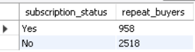

Business Insight:
Among customers with more than five previous purchases, the majority were non-subscribers (2,518 customers), compared to 958 subscribed customers. This suggests that repeat purchasing behavior was not strongly associated with subscription status in this dataset. Many customers continued to make frequent purchases without enrolling in a subscription program,
indicating that factors other than subscriptions may play a larger role in driving customer loyalty.

- Revenue by Age Group – Calculated total revenue contribution of each age group.
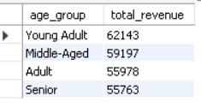

Business Insight:
Young Adult customers generated the highest total revenue, contributing 62,143 in sales. However, the revenue distribution across all age groups was relatively balanced, with each segment contributing between 55,000 and 62,000 in total revenue. This suggests that the business serves a diverse customer base and is not heavily dependent on a single age group for revenue generation.

Dashboard in Power BI

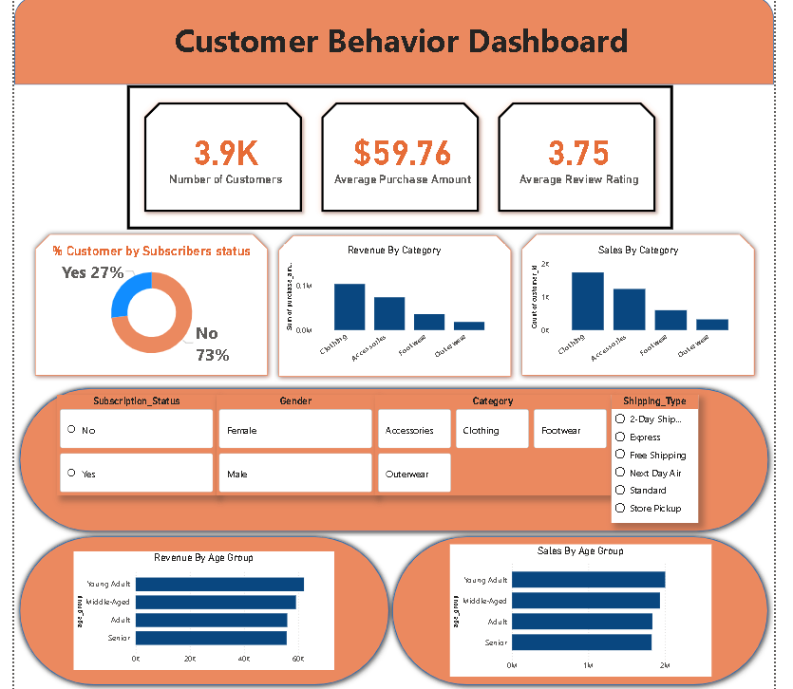
Finally, I built an interactive dashboard in Power BI to present insights visually.

Business Recommendations

- Boost Subscriptions – Promote exclusive benefits for subscribers.
- Customer Loyalty Programs – Reward repeat buyers to move them into the “Loyal” segment.

- Review Discount Policy – Balance sales boosts with margin control.

- Product Positioning – Highlight top-rated and best-selling products in campaigns.

- Targeted Marketing – Focus efforts on high-revenue age groups and express-shipping users.

