When Does Bank Layout Pay? Function-Preserving Channel Relabeling and Tap Skew on a Lockstep Zero-Skipping FPGA CNN Core

Lee Yoo Joon
School of Computer Science and Engineering, Yeungnam University
Information and Communication Engineering Major
Gyeongsan, Republic of Korea
(e-mail)
(Advisor name)
(Dept. name of organization)
(Name of organization)
(City, Country)
(e-mail address)

Abstract—A zero-skipping convolution core whose input banks run in lockstep waits, in every window, for the bank with the most nonzero activations, so the assignment of window taps to banks sets its cycle count. On our integer CNN core for a Zynq XC7Z020, a condition on the layer shapes alone tells where no tap-to-bank layout can change the cycles. We compare three layouts that keep the bitstream and the integer output unchanged: a channel relabeling fitted offline and folded into the adjacent layers, a data-free skew that spreads each channel's taps over the banks, and the two combined. At four values per cycle, two relabelings of a 32-channel denoiser cut the core cycles measured on one image by 7.02% and 7.60%, as a model pushed before the export predicted to the cycle. In counts over 79 test images the skew saves 9.20% and the combination 9.93%, against 7.46% and 8.10% for the relabelings; under pre-registered protocols this order held on all nine networks whose channel count is a multiple of four, and no layout changed the count where the shape condition says it cannot.
Keywords—zero skipping, activation sparsity, load balancing, bank layout, channel permutation, FPGA, CNN accelerator, cycle model

Introduction
A core that skips zero activations saves multiplications, but lanes that advance together make each window cost as much as the busiest one, a stall Cnvlutin measures as its own category [1]. Known remedies change the network or add hardware: S2TA bounds the nonzeros per block [2], and Sense rebalances channels at run time, noting that input maps "cannot be trained offline to balance IFM workload" [3]. Offline reorderings target weights: SparTen sorts filters by density [4], and Pool and Yu fold a channel permutation into the preceding layer for N:M pruning [5]; VARA permutes inputs offline to cluster co-zero inputs behind an index unit [6], and skewed storage gives conflict-free parallel access to a matrix's rows and columns [7]. Permutation, folding, profiling and skewing are thus not new; our search (Crossref, arXiv, web; October 2026) found no work that spreads co-active channels over lockstep zero-skipping banks by an exact, folded relabeling.
In our core, four tap banks run in lockstep, and the slot in which the host puts a tap decides its bank. We contribute (i) a shape-only condition necessary for any layout to change a layer's cycles (Section II); (ii) three layouts that keep the bitstream and the integer output unchanged: a folded channel relabeling, a data-free skew and both combined (Section III); (iii) board cycles of two relabelings, predicted to the cycle (V-A); (iv) two pre-registered ten-network studies (V-B, V-C).

Core, Cost Model and Shape Condition
Core. The host builds each layer's windows (im2col), sends them with the layer's weights and requantizes between layers; the core computes every convolution with INT8 weights, 7-bit unsigned activations and INT32 accumulation. Its 64 multipliers form P = 16 output lanes times T = 4 tap banks; its window port takes W values per cycle (W = 2 only in RTL simulation). In sparse mode, used throughout, each bank processes only its nonzero taps; slot j of a window belongs to bank j mod 4.
Cost of a window. For a window with K taps and COUT outputs, and m the largest number of nonzero taps in one bank, the core spends C cycles:
C = max( ⌈K/W⌉ + 1, ⌈COUT/P⌉ · max(1, m), COUT ), (1)
for loading the next window, computing ⌈COUT/P⌉ output groups and emitting COUT results. Each layer adds a fill and drain of min(load, compute of the last window) + 3 + g cycles, g being the outputs in the last group of P, a rule read off board runs of four networks on one image; the first layer has a measured constant (17 cycles for the board network at W = 4). We call (1) summed over the windows the count, and the count plus the fill and drain the exact prediction.
When a layout can pay. A bank holds at most ⌈K/T⌉ taps. No window is then compute-bound for any input, and no layout can change the count, if
⌈COUT/P⌉ · ⌈K/T⌉ ≤ max( ⌈K/W⌉ + 1, COUT ). (2)
Failing (2) is thus necessary for a gain; without the rounding, (2) reads COUT ≤ P·T/W, the ridge point of a roofline [8] whose bandwidth roof is the load. So 32-output hidden layers (K = 288: 144 against 145 at W = 2 and 73 at W = 4) can pay only at W = 4, layers with 45 or 64 outputs also at W = 2, and none at W = 1 or in the last layer (COUT ≤ 4). Perfect balance, m = ⌈n/T⌉ for n nonzero taps, bounds every tap-to-bank assignment.

Three Function-Preserving Layouts
In (ky, kx, channel) order, tap s·N + p (s the 3×3 position, p the channel, N the input channels) is in bank p mod 4 when 4 divides N: in this conventional order, L0 or the Original, each bank holds N/4 whole channels (Fig. 1a).
Relabeling (L1). Let π map a position p of a hidden map to its original channel. The producer computes its output channels in the order π, with weight rows, biases and requantization scales reordered, and the consumer's weight column for tap s·N + p comes from channel π(p). As ReLU and requantization act per channel and the consumer adds the same INT32 products, the integer output is identical for every input, while π decides which channels share a bank (Fig. 1b). We permute the outputs of conv1 to conv(L−2) of an L-layer network; the last layer, which can never pay, keeps its input. In the maxout and averaging networks (maximum or mean of maps j and j + N), both maps move with π.
Skew (L2). Skewed storage [7] applied to the taps: the host puts channel p of position s in slot s·N + (p + s) mod N, bank (p + s) mod 4, which spreads each channel's nine taps 3/2/2/2 over the banks (Fig. 1c). It permutes each window's taps and the consumer's weight columns alike and needs no data and no RTL change; no partial sum, in any order, exceeds |bias| + K·127·128 < 2³¹, so the INT32 result is unchanged.
Skew + relabeling (L3). Under the skew, bank b holds at position s the channels of class (b − s) mod 4 (class: p mod 4): class b at positions 0, 4 and 8, each other class at two. The skew thus dilutes a class's excess of nonzeros without removing it, and which channels form a class is still free: L3 refits the relabeling under this rule, then skews (Fig. 1d).
Fitting. Each layer is fitted alone, as relabeled windows are the original's with permuted columns. The recipe draws 2048 windows per fitted layer from Set12 01.png (Cal-1; σ = 25, one noise draw), minimizes their mean of (1) at W = 4, and searches from the identity with 400 proposals, each swapping two channels of different classes (position mod 4), kept only if the objective falls. Under the conventional rule it gave Frozen, the first board layout, and under the skewed rule L3. A second relabeling of the board network, Multi-start, adds Set12 02–03, two noise draws per image (Cal-3) and four random starts.
Function preserved. In host emulation every folded L1 reproduced the original's output on Set12 05.png and BSD68 test001.png (Frozen and Multi-start: all 80 images); on 05.png, L2 and L3 reproduced every network's INT32 accumulators in every window (L3 up to its column order) and the folded L3 the output; the board driver's skew path gave identical accumulators and PNGs on both images.
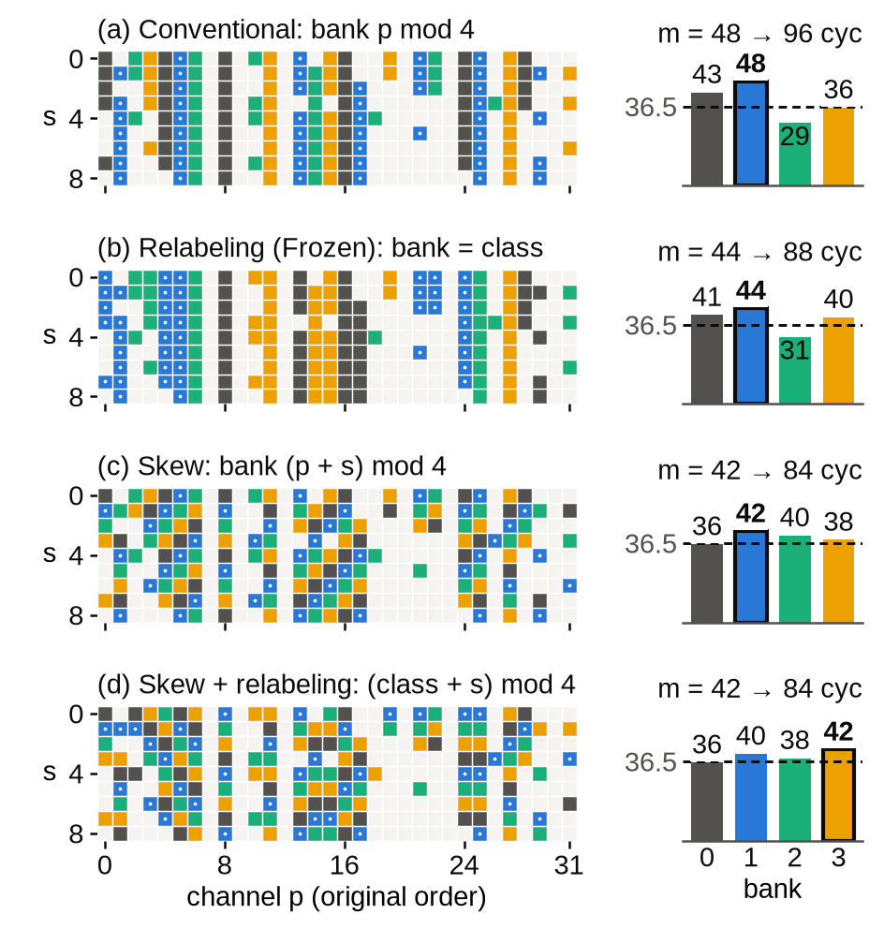
Fig. 1. A conv5 input window of the board network on Set12 05.png (the first compute-bound one at W = 4 with the median m, 48). Filled: nonzero, colored by bank (bank 1 dotted). (a) L0, bank p mod 4; (b) Frozen, an L1 (16 of 32 channels change bank); (c) L2, bank (p + s) mod 4; (d) L3, bank (class + s) mod 4. Bars: nonzeros per bank; the fullest, m, costs 2m cycles; dashed: m = 36.5, where 2m equals the load of 73 cycles. Here L3 ties L2; over all of conv5's windows the mean m is 47.6, 42.1, 40.4 and 39.7.

Experimental Setup
Networks and images. Ten trained integer DnCNN-style networks [9] for Gaussian noise of σ = 25 on 7-bit inputs: A, 7 layers of 32 channels; B, 10 layers of 64 channels behind a 2×2 space-to-depth input; B-32, the same with 32 channels, with ReLU (R1–R3, training seeds s1–s3), maxout over pairs of 64 computed outputs (M1–M3) or their mean (Av2, seed s2); and 45, a 45-channel ReLU variant. All but A had quantization-aware training. The board network, B-32 ReLU s1 (R1), reaches 29.54 dB on Set12 05.png; 37–55% of its hidden layers' window values are nonzero. Test images: Set12 [9] and BSD68 [10], 80 images, one noise draw each; savings are pooled over the 79 other than Set12 01.png, with paired bootstrap 95% intervals over images.
Board. The W = 4 bitstream for the XC7Z020 closes timing at 100 MHz (slack +0.130 ns), uses 11,151 LUTs (21%), 71 of 140 BRAM36-equivalent tiles and no DSP slice, and ran at the board preset's 50 MHz. One bitstream ran all layouts; per layer the driver checks the output against the integer model and reads the cycle counter CYCLES and the DMA-wait counter IN_STALL. On 05.png the Original ran once as a canary, then each layout three times in alternation. Until the raw reports are committed (only an earlier run of the Original is), these board cycles are transcribed from run notes, each checked by a script against its line. All other cycle numbers are counts in the host emulation, which reproduces every network's reference PSNR on all 80 images.
What was fixed when (GitHub push times, UTC). The fill-and-drain rule (6dc0e60, 10-17 13:15) preceded both exports, and Frozen's per-layer count savings on 05.png (9cf9c79, 10-17 18:38) preceded the board runs. PROTOCOL (c2299e2, 10-18 18:32) fixed the recipe, the evaluation, condition (2) per layer and hypotheses H0–H3 before any fit on the other nine networks; PROTOCOL_2 (951c8f1, 10-19 06:07) fixed L2, L3, the bootstrap and H4–H6 before the L3 fit and the study's counts (earlier ones: Sec. VI).

Results

Board Measurement
On Set12 05.png, Multi-start lowered the board cycles by 7.60% and Frozen by 7.02% (Table I). The repeats gave the same numbers, except 12 more cycles in Frozen's third run, all in conv10, where IN_STALL was also 12; none of their 90 layer runs had an output mismatch. In all 63 comparisons (every layer of Original and Multi-start, sums and totals of canary, repeats and the earlier run), CYCLES − IN_STALL equaled the exact prediction. As the fill-and-drain rule was read off runs including the Original's layers, the repeats are deterministic and conv1 and conv10 see the same windows in every layout, nine comparisons are out of sample, all on one image: Multi-start's conv2–conv9 and Frozen's conv2–9 sum. This bitstream's IN_STALL misses DMA starvation at window boundaries; the rule could absorb a stall common to all layouts, so the match excludes only stalls that differ between them. Board runs of L0, Frozen, Multi-start and L2 on Set12 05–08, every layer predicted before them (7312a84), and of L3 (addendum d6521ec) are under way; no result of them is claimed here.
Table I. Board cycles of B-32 ReLU s1 on Set12 05.png at W = 4 (repeat 1, transcribed), each equal to its exact prediction, and savings from them.
Layout | conv2–9 | Total | Saving (%), conv2–9/total
Original | 11,421,202 | 13,289,030 | —
Frozen | 10,487,986 | 12,355,814 | 8.17/7.02
Multi-start | 10,410,591 | 12,278,419 | 8.85/7.60

Ten Networks under Two Protocols
PROTOCOL's two checks and two sign predictions all held. H0: our code reproduced Frozen in all eight layers, and its export byte for byte. H1: wherever (2) holds, at W = 1 on all networks and at W = 2 on A and R1–R3, the relabeled count equaled the original on all 80 images. H2: the pooled W = 4 saving of L1 was positive on all ten networks, 1.09–10.80% (Fig. 2; the sign was known for B, M1 and R1). H3: the pooled W = 2 saving was positive on all six networks where (2) allows it, 3.36–7.37% on five and 0.022% on 45.
PROTOCOL_2's three also held. H4: wherever (2) holds, L2 and L3 counted exactly as L0 on all 80 images, in every layer. H5: at W = 4, L2 saved more than L1 on all nine networks with N mod 4 = 0, by 0.90–2.36 points (known for R1). H6: L3 saved more than L2 on all nine, by 0.48–1.18 points, on R1 by 0.73 (95% interval [0.70, 0.75]). L3 was fitted on 01.png alone, so this gain is out of sample, and it is consistent: on each of the nine networks the interval of L3 − L2 excludes 0; L3 counted fewer cycles than L2 on all 711 image–network pairs and, pooled, in all 69 fitted layers; on R1, 01.png itself gained 0.71 points, the test images a median of 0.72. At W = 2, L3 > L2 > L1 held on the five networks with N mod 4 = 0 where (2) allows a gain, L3 by 0.46–0.85 points; no image counted more cycles under any layout at any W.
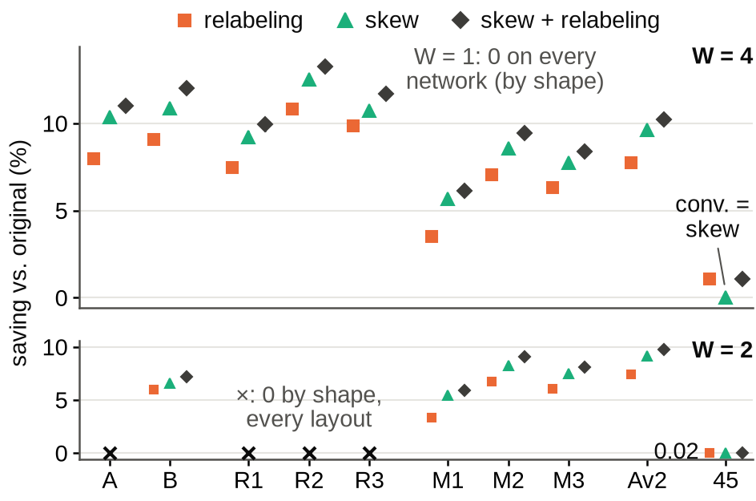
Fig. 2. Pooled saving over the 79 images (count, conv1–convL) at W = 4 (top) and W = 2 (bottom) of L1 (relabeling), L2 (skew) and L3 (skew + relabeling); 95% intervals (at most ±0.39 points) are narrower than the markers. ×: (2) holds in every layer; all layouts count as L0 on all 80 images. On 45 (N mod 4 = 1), L2 = L0 and L3 = L1. Networks: Sec. IV (R1: board network).

The Board Network on 79 Images
At W = 4, L2 saved more than both board relabelings, and L3 more than L2, on each of the 79 images (Fig. 3). L3 removed 26% of the imbalance that L2 leaves, reaching 82.6% of the perfect-balance saving against 76.6% (Table II), with the same host reorder as L2. On 05.png the counts give 9.39% (L3) and 8.64% (L2), against 7.02% and 7.60% for Frozen and Multi-start and 11.49% for perfect balance. Pooled, L2 also beat L1 fitted on each test image (8.45%) and a Sense-like sort by each channel's nonzero count in it; a density deal after SparTen [4] saved least (a comparison of procedures, not of co-activation against density).
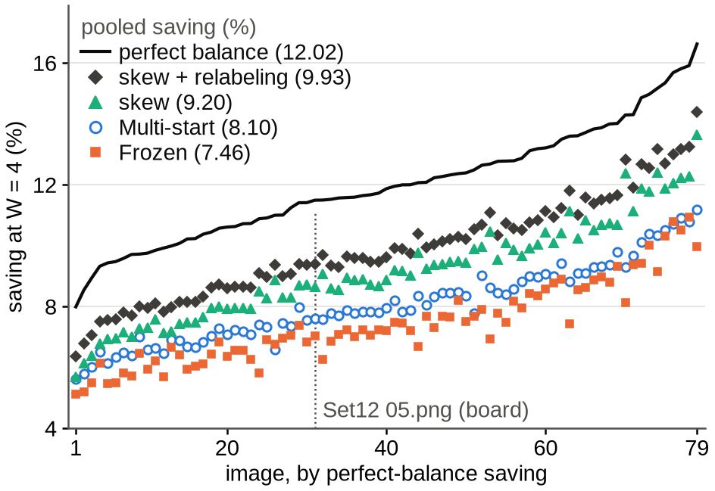
Fig. 3. Per-image W = 4 saving (count) of the board network on the 79 images other than Set12 01.png (calibration of Frozen and L3; Multi-start also used 02–03), sorted by the bound; legend: pooled saving; dotted: the board image.
Table II. B-32 ReLU s1 at W = 4 (count, 79 images): pooled saving against L0 [95% interval] and share (%) of the perfect-balance saving. p.i.: uses the test image (no interval); †: Cal-3 includes two of the 79; density, Sense-like: best of three variants on these images.
Layout | Data | Pooled (%) | Share
Density balance [4] | Cal-1 | 3.69 [3.50, 3.88] | 30.7
Sense-like sort [3] | p.i. | 4.89 | 40.7
L1 Frozen | Cal-1 | 7.46 [7.16, 7.78] | 62.1
L1 Multi-start | Cal-3† | 8.10 [7.80, 8.39] | 67.4
L2 skew | none | 9.20 [8.82, 9.58] | 76.6
L3 skew + relabeling | Cal-1 | 9.93 [9.54, 10.32] | 82.6
Perfect balance | — | 12.02 [11.59, 12.44] | 100

Cost
Fitting a network took under 30 s (L1 or L3); L2 needs none. Single-threaded on an x86 server, the host's work for 05.png (input, im2col, requantization) took 31 ms (32 ms on the Multi-start export) against the core's 266 ms at 50 MHz: back to back, Multi-start's 7.60% core saving is 6.3–6.8% end to end, and all of it if the host overlaps the next image; the skew's reordering after im2col adds 4.2 ms. This omits the transfer of windows and results and the JTAG harness that ran the board (315 s per image); the Zynq's ARM cores would be slower than the server; energy was not measured.

Limitations
• Board evidence. The board measured just two relabelings, on one network and one image; L2 and L3 are counts.
• Scope and selection. Only DnCNN-family denoisers at σ = 25, one noise draw per image (the intervals resample images only); BSD68 was part of the networks' development; FIFO-decoupled banks and other P, T or kernel sizes were not evaluated. Multi-start was chosen for the board after its BSD68 counts had been seen. Before PROTOCOL_2, L2 had been counted on R1 (and on 05.png of four others), and uncommitted counts of L2 on eight images of B and M1 and of L3 on seven of R1 had been seen (PROTOCOL_2 lists them).

Conclusion
The layer shapes tell where the tap-to-bank layout of a lockstep zero-skipping core can matter. Where it can, in counts over 79 images, the data-free skew removed more bank imbalance than a fitted relabeling, and a relabeling fitted under the skew removed more still, on all nine networks with N mod 4 = 0, on every test image and in every fitted layer. The two are complementary: the skew spreads each channel over the banks, the relabeling chooses which channels travel together. Scripts, layouts, per-image counts and the source of every number are at https://github.com/qewr1234/FPGA (bankperm/).

Acknowledgment
This study was conducted with the support of the Ministry of Science and ICT and the Institute for Information & Communications Technology Planning & Evaluation (IITP) under the 'SW-oriented University Program.'

References
- J. Albericio, P. Judd, T. Hetherington, T. Aamodt, N. Enright Jerger, and A. Moshovos, "Cnvlutin: Ineffectual-neuron-free deep neural network computing," in Proc. ACM/IEEE 43rd Annu. Int. Symp. Comput. Archit. (ISCA), 2016, pp. 1–13.
- Z.-G. Liu, P. N. Whatmough, Y. Zhu, and M. Mattina, "S2TA: Exploiting structured sparsity for energy-efficient mobile CNN acceleration," in Proc. IEEE Int. Symp. High-Perform. Comput. Archit. (HPCA), 2022, pp. 573–586.
- W. Sun, D. Liu, Z. Zou, W. Sun, S. Chen, and Y. Kang, "Sense: Model-hardware codesign for accelerating sparse CNNs on systolic arrays," IEEE Trans. Very Large Scale Integr. (VLSI) Syst., vol. 31, no. 4, pp. 470–483, 2023.
- A. Gondimalla, N. Chesnut, M. Thottethodi, and T. N. Vijaykumar, "SparTen: A sparse tensor accelerator for convolutional neural networks," in Proc. 52nd Annu. IEEE/ACM Int. Symp. Microarchit. (MICRO), 2019, pp. 151–165.
- J. Pool and C. Yu, "Channel permutations for N:M sparsity," in Proc. Adv. Neural Inf. Process. Syst. (NeurIPS), vol. 34, 2021, pp. 13316–13327.
- P. Dang, Y. He, and H. Li, "VARA: A voltage-aware ReRAM-based accelerator for energy-efficient computing," arXiv:2609.00421, 2026.
- P. Budnik and D. J. Kuck, "The organization and use of parallel memories," IEEE Trans. Comput., vol. C-20, no. 12, pp. 1566–1569, 1971.
- S. Williams, A. Waterman, and D. Patterson, "Roofline: An insightful visual performance model for multicore architectures," Commun. ACM, vol. 52, no. 4, pp. 65–76, 2009.
- K. Zhang, W. Zuo, Y. Chen, D. Meng, and L. Zhang, "Beyond a Gaussian denoiser: Residual learning of deep CNN for image denoising," IEEE Trans. Image Process., vol. 26, no. 7, pp. 3142–3155, 2017.
- S. Roth and M. J. Black, "Fields of experts," Int. J. Comput. Vis., vol. 82, no. 2, pp. 205–229, 2009.

