**GRAMMAR IN USE**

**PRESENT CONTINOUS**

We use the continuous for things happening at or around the time of speaking. The action is not complete.

Sarah is in her car. She is on her way to work. She is driving to work.

I am doing something = I'm in the middle of doing it; I've started doing it and I haven't finished:

Sometimes the action is not happening at the time of speaking. For example: Steve is talking to a friend on the phone. He says:

I'm reading a really good book at the moment. It's about a man who ..

We use the present continuous when we talk about changes happening around now, especially with these verbs:

Is your English getting better?

The population of the world is increasing very fast.

**PRESENT SIMPLE**

We use the present simple to talk about things in general. We use it to say that something happens all the time or repeatedly, or that something is true in general:

Alex is a bus driver, but now he is in bed asleep. He is not driving a bus. (He is asleep.)

The earth goes round the sun.

Rice doesn't grow in cold climates.

We use do/does to make questions and negative sentences:

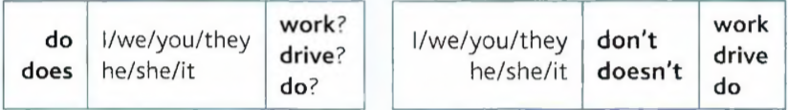

We use the present simple to say how often we do things:

I get up at 8 o'clock every morning.

I work... but He works...

'What do you do?' ‘I work in a shop.’

The following verbs are not normally used in the present continuous: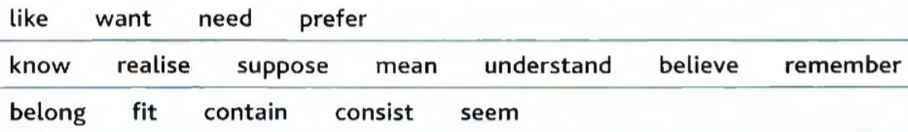

We don't say 'I am knowing' or ‘they are liking'; we say ‘I know', 'they like'.

I’m hungry. I want something to eat. (not I'm wanting)

When think means ‘believe' or ‘have an opinion', we do not use the continuous:

I think Mary is Canadian, but I'm not sure, (not I'm thinking)

When think means ‘consider', the continuous is possible:

Nicky is thinking of giving up her job. (= she is considering it)

**See hear smell taste**

We normally use the present simple (not continuous) with these verbs:

Do you see that man over there? (not Are you seeing)

This room smells. Let’s open a window.

Look feel

You can use the present simple or continuous to say how somebody looks or feels now:

You look well today, or You're looking well today.

How do you feel now? or How are you feeling now?

But :

I usually feel tired in the morning. (not I'm usually feeling)

**PAST SIMPLE**

Very often the past simple ends in -ed (regular verbs):

I work in a travel agency now. Before that I worked in a department store.

Laura passed her exam because she studied very hard.

But many verbs are irregular. The past simple does not end in -ed. For example:

write —**>** wrote : Mozart wrote more than 600 pieces of music

see *—>* saw : We saw Tanya in town a few days ago.

go —> went : I went to the cinema three times last week

shut —» shut : It was cold, so I shut the window.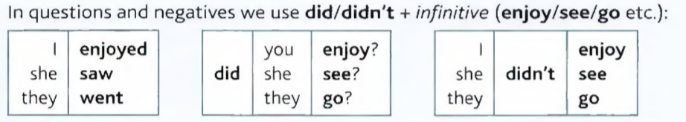

I was angry because they were late.

Did you go out last night or were you too tired?

**PAST CONTINUOUS**

I was doing

What were you doing at 10 o’clock last night ?

We were having dinner when she arrived.

It was raining when I got up.

We don’t use it with know and want, so you say he wanted to go home and not he was wanting to go home.

**PRESENT PERFECT SIMPLE**

Have/Has + past participle

We use it to say that the action in the past has a result now.

I have lost my keys

She has finished her work

He has gone to Italy

Is Zak here ? No he’s gone out

I can’t find my bag, have you seen it ?

I’ve forgotten to tell you something.

We use it with already, just and yet

Don’t forget to pay your bill ! I’ve already paid it !

Use yet only in questions and negative sentences:

Has it stopped raining yet ?

I’ve written the email, but I haven’t sent it yet

Have you travelled a lot ? Yes I’ve been to lots of places.

Have you ever been to Malaysia ? No I haven’t been there

Everything is going well, we haven’t had any problems so far.

I’m hungry, I haven’t eaten anything since breakfast.

I haven’t seen him for a long time.

Is the first time he has driven a car.

I have never driven a car in this country

Have you ever eaten pasta ?

I have never been there or I haven’t been there

**PRESENT PERFECT CONTINUOUS**

Cc

**FOR AND SINCE**

We use for + a period of time (two hours, six weeks etc.):

I've been waiting for two hours.

We use since +the start of a period (8 o'clock, Monday, 1999 etc.):

I've been waiting since 8 o'clock.

Z