0330作業

計財所碩二 108071601 賴冠維

2021/3/29

## -- Attaching packages --------------------------------------- tidyverse 1.3.0 --

## √ ggplot2 3.3.2 √ purrr 0.3.4  
## √ tibble 3.0.4 √ dplyr 1.0.2  
## √ tidyr 1.1.2 √ stringr 1.4.0  
## √ readr 1.3.1 √ forcats 0.5.0

## Warning: package 'tibble' was built under R version 4.0.3

## -- Conflicts ------------------------------------------ tidyverse_conflicts() --  
## x dplyr::filter() masks stats::filter()  
## x dplyr::lag() masks stats::lag()

一開始利用 $LCG(Linear congruential generator)$ 製造自 $Uniform(0,1)$ 抽樣的樣本。  
圖左邊為以LCG製造的 $Uniform(0,1)$ 樣本所畫的直方圖及以該樣本所估計的Density Plot，與右圖 $runif()$ 相比起來十分相似，從盒狀圖來看，也可看出兩組資料十分相近。

# 此為LCG生成所用之演算法  
lcg <- function(a,c,m,run.length,seed) {  
 x <- rep(0,run.length)  
 x[1] <- seed  
 for (i in 1:(run.length-1)) {  
 x[i+1] <- (a*x[i] + c) %% m  
 }  
 U <- x/m   
 return(list(x=x,U=U))  
}

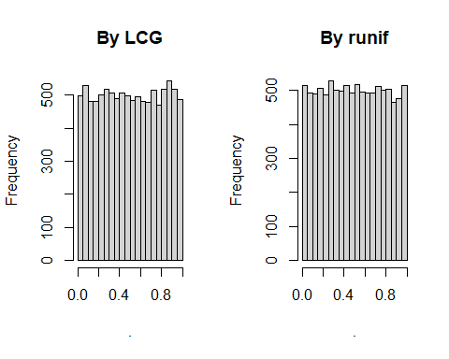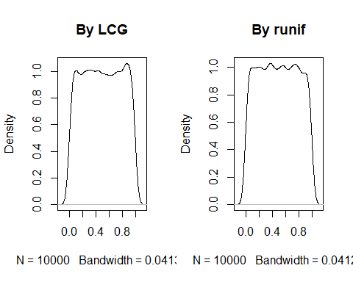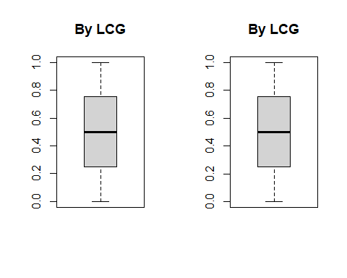

# Problem 1

## (a)

以 $Box-Muller$ 法製造出10000個標準常態  
圖左邊為以LCG製造的 $Box-Muller$ 方法所畫的直方圖及DensityPlot，與右圖 $rnorm()$ 相比起來十分相似。  
從盒狀圖來看，也可看出兩組資料十分相近，僅在Q1,Q3以外， $Box-Muller$ 法較 $rnorm()$ 些微多一些。

# 此為Box-Muller所用之演算法  
fnc = function(U1,U2){  
 sqrt(-2*log(U1))*cos(2*pi*U2)  
}

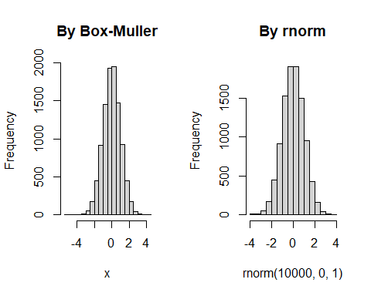

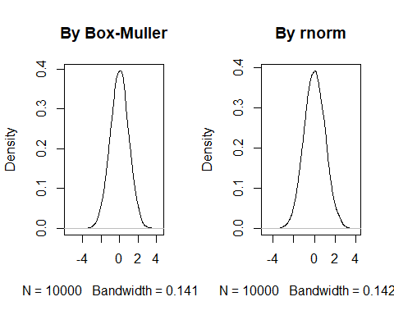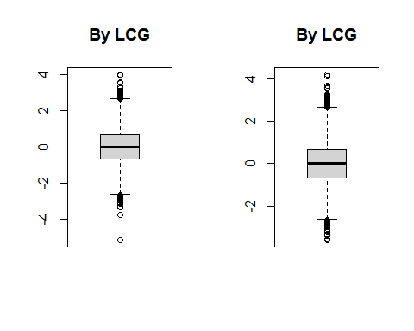

## (b)

需要用到指數分配，放在第二題結束的地方

# Problem 2

## (a)

圖左邊為自製以上課所教的演算法所得到 $Poisson(10)$ 的樣本，所畫的直方圖及DensityPlot，與右圖 $rpois()$ 相比起來十分相似。  
從盒狀圖來看，也可看出兩組資料十分相近。

# 此生成Poisson分配所用之演算法  
  
Poisson = function(mu,n){  
 X = sapply(1:n, function(a){  
 t = 0 ; X = 0 ; lambda = mu  
 while (t<1) {  
 U = sample(Uni$U,1)  
 t = t - (1/lambda)*log(U)  
 X = X+1  
 }  
 X = X-1  
 X  
 })   
   
 return(X)  
}

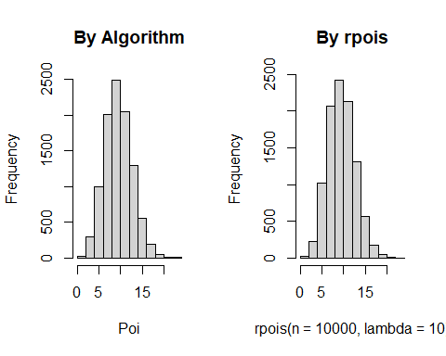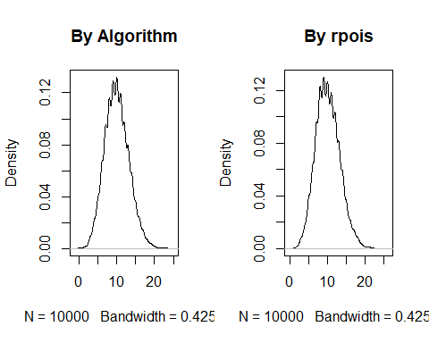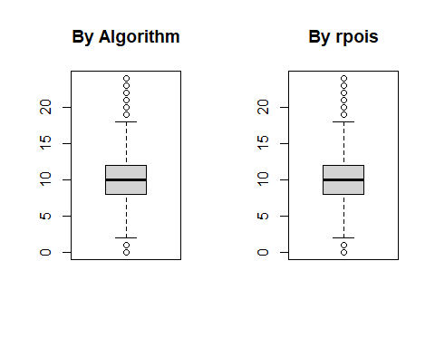

## (b)

先以上課所教的演算法，生成 $Exponential Distribution$，再將 $EXP(1)$ 連加，即可得到 $Gamma(3,1)$ 的樣本。  
圖左所生成樣本畫的直方圖及DensityPlot，與右圖 $rgamma()$ 相比起來十分相似。  
從盒狀圖來看，也可看出兩組資料十分相近，但自己生成的Gamma有較易有偏離期望值很多的值產生，也因此自生成樣本的全距較大。

# 此為生成Exponential分配所用之演算法  
EXP = function(mu,n){  
 lambda =mu  
 N = sapply(1:n, function(a){  
 U = sample(Uni$U,1)  
 X = -(1/lambda)*log(U)  
 })  
 N  
}

# 此為生成Gamma 分配所用之演算法  
GAM = function(a,b,n){  
 i = 1  
 x = matrix(0,nrow = n)  
 repeat{  
 if(i>a) break  
 y = EXP(b,n) %>% as.matrix()  
 x = x+y   
 i = i+1  
 }  
 return(x)  
}

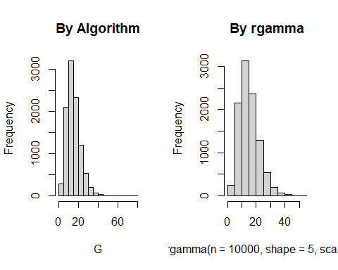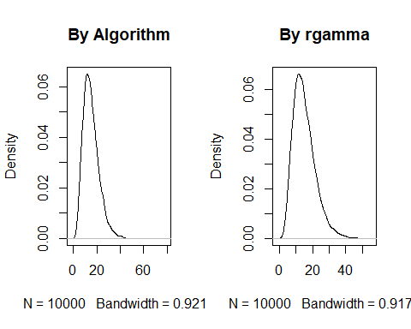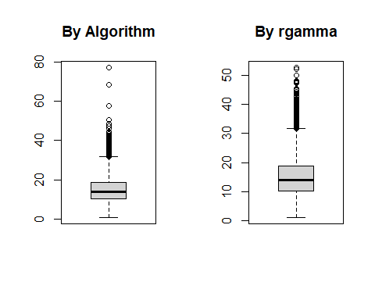

## Problem 1

### (b)

以下為 $Acceptance-Rejection Approach$ 的演算法

E = EXP(1,10000)  
  
NormalAR = function(c,n){   
 f = function(z){ #設定f為標準常態分配   
 sqrt(2/pi)*exp(-z^2/2)   
 }  
 g = function(z){ #設定g為exp(1)   
 exp(-z)  
 }  
   
 f_z = as.vector(rep(0,n))  
 i = 0 #設定i迭代至所需樣本數  
 b = 1   
 a = c() #設定a,b紀錄該次是否接受，計算Acceptance Rate  
 while (i< n){  
 b = b+1  
 z = -log(sample(Uni$U,1))   
 u1 = sample(Uni$U,1)   
 a[b] = ifelse(u1 < f(z)/(c*g(z)),"Y","N")  
   
 if(u1 < f(z)/(c*g(z))){  
   
 u2 = sample(Uni$U,1)  
 if(u2 < 0.5) { Z = z } else {Z = -z }  
 i = i+1  
 f_z[i] = Z  
 }  
 }  
 return(list(f_z,a))  
}

## Acceptance Rate

首先設定 $c=\frac{1}{\sqrt{2π}}exp(\frac{1}{2})$，可得到此時 $Acceptance Rate$ 約為75%。  
但若是改變c，令 $c^{*}=\frac{2}{\sqrt{2π}}exp(\frac{1}{2})=2c$，則此時的 $Acceptance Rate$ 下降至約38%。

## [1] "Acceptance_Rate_1 : 74.86%"

## [1] "Acceptance_Rate_2 : 37.83%"

先生成 $Normal Distribution$，圖左所生成樣本畫的直方圖及DensityPlot，與右圖 $rnorm()$ 相比起來十分相似。  
從盒狀圖來看，也可看出兩組資料十分相近。 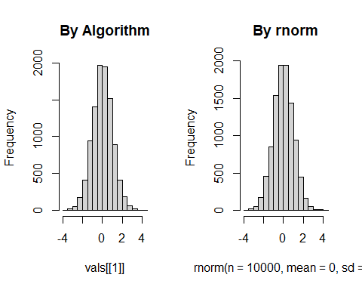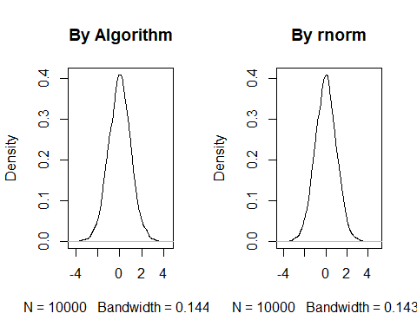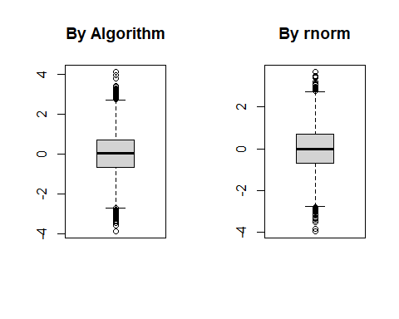

# Problem 3

## (c)

# 樣本產生方式，將Gamma生成樣本帶入Poisson分配  
  
G = GAM(a = 5,b = 1/3,n = 10000)  
x = matrix(0,nrow=10000)  
for (i in 1:10000) {  
 x[i,] = Poisson(mu = G[i],n=1)  
}

由上兩題可得知此混和分配為負二項分配，將生成樣本與 $rnbinom()$ 比較。  
圖左所生成樣本畫的直方圖及DensityPlot，與右圖 $rnbinom()$ 相比起來十分相似。  
從盒狀圖來看，也可看出兩組資料十分相近，但自生成的樣本有偏離較大的值出現。 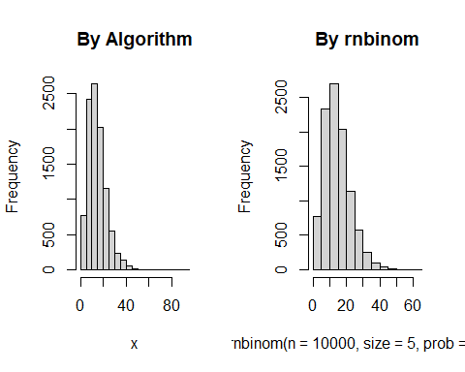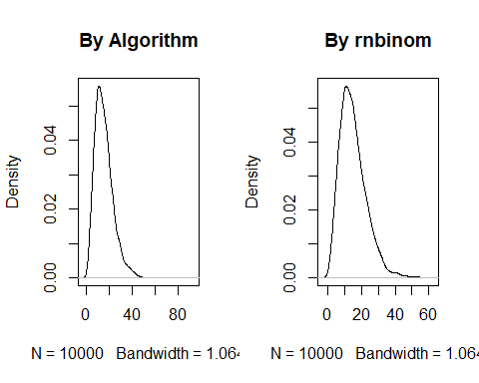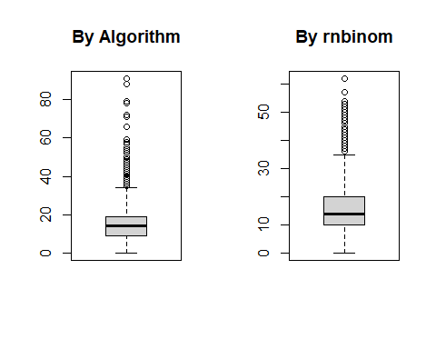

可發現自生成樣本的平均數約為15，變異數約為60，  
與使用 $rnbinom()$ 所產生的樣本結果相似。

## [1] "Mean from the samples by myself: 15.0759"

## [1] "Mean from the samples by rnbinom(): 15.0826"

## [1] "Variance from the samples by myself: 64.649404130413"

## [1] "Variance from the samples by rnbinom(): 59.2290229022902"

# Problem 4

## (b)

由(a)小題可得知其機率密度函數，其生成樣本之演算法解釋如下： 1. 自 $Uniform(0,1)$ 抽一項, $X$ 2. 若 $X>0.75$，則生成 $N(3,1)$，若 $X<=0.75$ 則生成 $N(0,1)$

vals <- NormalAR(c = sqrt(2/pi)*exp(1/2),n = 10000)  
  
N = 10000   
U =runif(N)  
rand.samples = rep(NA,N)  
for(i in 1:N){  
 if(U[i]<0.75){  
 rand.samples[i] = sample(vals[[1]],1)  
 }else{  
 rand.samples[i] = sample(vals[[1]],1)+3 #自N(0,1)平移3，變成N(3,1)  
 }  
}

生成樣本後，畫出該分配的直方圖及DensityPlot，可發現在 $X$ 在0,3的地方有雙峰的現象，符合我們一開始的想像。

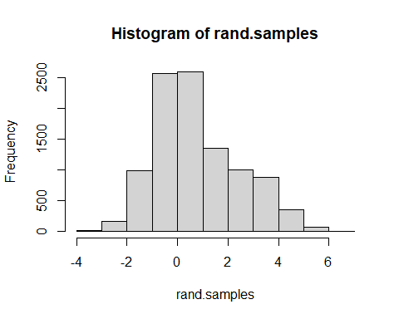

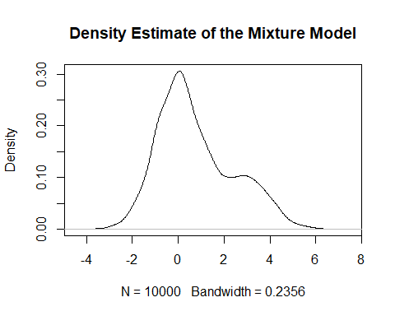

附錄(程式碼)

library(tidyverse)

lcg <- function(a,c,m,run.length,seed) {

x <- rep(0,run.length)

x[1] <- seed

for (i in 1:(run.length-1)) {

x[i+1] <- (a*x[i] + c) %% m

}

U <- x/m

return(list(x=x,U=U))

}

Uni = lcg(a = 7^5,c = 0,m = 2^31-1,run.length = 10000,seed = 5)

par(mfrow=c(1,2))

Uni$U %>% as.numeric() %>% hist(.,main="By LCG")

runif(10000) %>% hist(.,main="By runif")

par(mfrow=c(1,2))

plot(density(Uni$U),main="By LCG")

plot(density(runif(10000)),main="By runif")

boxplot(Uni$U,main="By LCG");boxplot(runif(10000),main="By LCG")

# Problem 1

## (a)

fnc = function(U1,U2){

sqrt(-2*log(U1))*cos(2*pi*U2)

}

x = fnc(sample(Uni$U,10000),sample(Uni$U,10000))

y = fnc(sample(Uni$U,10000),sample(Uni$U,10000))

par(mfrow=c(1,2))

hist(x,main = "By Box-Muller");hist(rnorm(10000,0,1),main = "By rnorm")

plot(density(x),main="By Box-Muller");plot(density(rnorm(10000,0,1)),main="By rnorm")

boxplot(x,main="By LCG");boxplot(rnorm(10000,0,1),main="By LCG")

## (b)

# Problem 2

## (a)

Poisson = function(mu,n){

X = sapply(1:n, function(a){

t = 0 ; X = 0 ; lambda = mu

while (t<1) {

U = sample(Uni$U,1)

t = t - (1/lambda)*log(U)

X = X+1

}

X = X-1

X

})

return(X)

}

par(mfrow=c(1,2))

Poi = Poisson(10,10000)

hist(Poi,main="By Algorithm");hist(rpois(n = 10000,lambda = 10),main="By rpois")

plot(density(Poi),main="By Algorithm");plot(density(rpois(n = 10000,lambda = 10)),main="By rpois")

boxplot(Poi,main="By Algorithm");boxplot(rpois(n = 10000,lambda = 10),main="By rpois")

## (b)

EXP = function(mu,n){

lambda =mu

N = sapply(1:n, function(a){

U = sample(Uni$U,1)

X = -(1/lambda)*log(U)

})

N

}

GAM = function(a,b,n){

i = 1

x = matrix(0,nrow = n)

repeat{

if(i>a) break

y = EXP(b,n) %>% as.matrix()

x = x+y

i = i+1

}

return(x)

}

E = EXP(3,10000)

G = GAM(5,1/3,10000)

par(mfrow=c(1,2))

hist(G,main="By Algorithm");hist(rgamma(n=10000,shape = 5,scale = 3),main="By rgamma")

plot(density(G),main="By Algorithm");plot(density(rgamma(n=10000,shape = 5,scale = 3)),main="By rgamma")

boxplot(G,main="By Algorithm");boxplot(rgamma(n=10000,shape = 5,scale = 3),main="By rgamma")

## Problem 1

### (b)

E = EXP(1,10000)

NormalAR = function(c,n){

f = function(z){ #設定f為標準常態分配

sqrt(2/pi)*exp(-z^2/2)

}

g = function(z){ #設定g為exp(1)

exp(-z)

}

f_z = as.vector(rep(0,n))

i = 0 #設定i迭代至所需樣本數

b = 1

a = c() #設定a,b紀錄該次是否接受，計算Acceptance Rate

while (i< n){

b = b+1

z = -log(sample(Uni$U,1))

u1 = sample(Uni$U,1)

a[b] = ifelse(u1 < f(z)/(c*g(z)),"Y","N")

if(u1 < f(z)/(c*g(z))){

u2 = sample(Uni$U,1)

if(u2 < 0.5) { Z = z } else {Z = -z }

i = i+1

f_z[i] = Z

}

}

return(list(f_z,a))

}

## Acceptance Rate

vals <- NormalAR(c = 1*sqrt(2/pi)*exp(1/2),n = 10000)

rate = table(vals[[2]])

r = rate[2]/sum(rate)*100

r = round(r,2)

paste0("Acceptance_Rate_1 : ",r,"%")

vals <- NormalAR(c = 2*sqrt(2/pi)*exp(1/2),n = 10000)

rate = table(vals[[2]])

r = rate[2]/sum(rate)*100

r = round(r,2)

paste0("Acceptance_Rate_2 : ",r,"%")

par(mfrow=c(1,2))

vals <- NormalAR(c = sqrt(2/pi)*exp(1/2),n = 10000)

hist(vals[[1]],main="By Algorithm");hist(rnorm(n=10000,mean = 0,sd = 1),main="By rnorm")

plot(density(vals[[1]]),main="By Algorithm");plot(density(rnorm(n=10000,mean = 0,sd = 1)),main="By rnorm")

boxplot(vals[[1]],main="By Algorithm");boxplot(rnorm(n=10000,mean = 0,sd = 1),main="By rnorm")

# Problem 3

## (c)

G = GAM(a = 5,b = 1/3,n = 10000)

x = matrix(0,nrow=10000)

for (i in 1:10000) {

x[i,] = Poisson(mu = G[i],n=1)

}

par(mfrow=c(1,2))

hist(x,main="By Algorithm");hist(rnbinom(n =10000,size = 5,prob = 0.25),

main="By rnbinom")

plot(density(x),main="By Algorithm");plot(density(rnbinom(n =10000,size = 5,prob = 0.25)),

main="By rnbinom")

boxplot(x,main="By Algorithm");boxplot(rnbinom(n =10000,size = 5,prob = 0.25),

main="By rnbinom")

paste0("Mean from the samples by myself: ",mean(x))

paste0("Mean from the samples by rnbinom(): ",mean(rnbinom(n =10000,size = 5,prob = 0.25)))

paste0("Variance from the samples by myself: ",var(x))

paste0("Variance from the samples by rnbinom(): ",var(rnbinom(n =10000,size = 5,prob = 0.25)))

# Problem 4

## (b)

vals <- NormalAR(c = sqrt(2/pi)*exp(1/2),n = 10000)

N = 10000

U =runif(N)

rand.samples = rep(NA,N)

for(i in 1:N){

if(U[i]<0.75){

rand.samples[i] = sample(vals[[1]],1)

}else{

rand.samples[i] = sample(vals[[1]],1)+3 #自N(0,1)平移3，變成N(3,1)

}

}

hist(rand.samples)

plot(density(rand.samples),main="Density Estimate of the Mixture Model")