HW3

賴冠維

2020/11/1

library(magrittr)  
options(scipen = 999)

## (1)

set.seed(36)  
n = 100; sigma = 5; beta0 = c(2,-2,0.5,1,-3)  
cormat = diag(1,nrow=5,ncol=5) ; cormat[cormat==0] = 0.5  
cholmat = chol(cormat) #Choleskey分解  
x= matrix(rnorm(5*n,0,1), ncol = 5) %*% cholmat  
err = rnorm(n,0,sigma)  
y = x %*% beta0 + err

## (2)

#### (a)

先對 $X_{i}$ 進行標準化,產生 $Z_{i}$,  
並且對 $Y_{i}$ 進行去中心化，產生 $\tilde{Y_{i}}$

library(glmnet)

## Warning: package 'glmnet' was built under R version 4.0.3

## Loading required package: Matrix

## Loaded glmnet 4.0-2

x_center = sapply(1:5,function(a)  
 {  
 mean(x[,a])  
 }  
 )  
  
x_sd = sapply(1:5, function(a){  
 sd(x[,a])  
 }  
 )  
  
z = sapply(1:5, function(a){  
 (x[,a] - x_center[a])/x_sd[a]  
})  
  
y_1 = y - mean(y)

首先固定 $λ$ 為0.01，再利用glmnet函式估計Ridge Regression的OLS解， 分為 $(x_{i},y_{i})$、 $(z_{i},\tilde{Y_{i}})$ 兩組進行，  
求得參數**par1**及**par2**，分別代表 $\hat{β}$ 以及 $\tilde{β}$

fit_ridge = glmnet(x = x,y = y,alpha = 0)  
(par1 = fit_ridge %>% coef(s=0.01) %>% as.numeric())

## [1] -0.5588065 4.2011865 -1.2774805 -0.3433947 1.1131355 -3.7603531

fit1_ridge = glmnet(x = z,y = y_1,alpha = 0)  
(par2 = fit1_ridge %>% coef(s=0.01) %>% as.numeric())

## [1] -0.00000000000000005961494 3.74019025532804860745273  
## [3] -1.25768969424733034756514 -0.32447521474505081062745  
## [5] 1.18504269468205314375098 -3.98623379718136572336107

因為 $z_{i}$ 不為方陣，因此在求反矩陣時使用 $Moore−Penrose偽逆矩陣$。  
藉此我們便可從 $\tilde{β}$ 推得 $\hat{β}$,矩陣表示式如下：

$$X\hat{β}=Z\tilde{β}$$

$$\hat{β}=X^{−1}Z\tilde{β}$$

* 表一為從 $\tilde{β}$ 推導 $\hat{β}$ 的數值
* 表二為上題從glmnet()函式所得到的參數。

library(MASS)  
ginv(x) %*% z %*% par2[2:6]

## [,1]  
## [1,] 4.1991588  
## [2,] -1.2218201  
## [3,] -0.3430106  
## [4,] 1.0933922  
## [5,] -3.7700609

paste0("Beta_hat ",seq(1:5),": ",par1[2:6]) %>% as.matrix()

## [,1]   
## [1,] "Beta_hat 1: 4.20118651254475"   
## [2,] "Beta_hat 2: -1.27748052895946"  
## [3,] "Beta_hat 3: -0.34339467379893"  
## [4,] "Beta_hat 4: 1.11313549138748"   
## [5,] "Beta_hat 5: -3.76035306912517"

此外也可從 $\hat{β}$ 推得 $\tilde{β}$ 的數值，  
承列如下：

ginv(z) %*% x %*% par1[2:6]

## [,1]  
## [1,] 3.7401903  
## [2,] -1.2576897  
## [3,] -0.3244752  
## [4,] 1.1850427  
## [5,] -3.9862338

paste0("Beta_Standardize ",seq(1:5),": ",par2[2:6]) %>% as.matrix()

## [,1]   
## [1,] "Beta_Standardize 1: 3.74019025532805"   
## [2,] "Beta_Standardize 2: -1.25768969424733"   
## [3,] "Beta_Standardize 3: -0.324475214745051"  
## [4,] "Beta_Standardize 4: 1.18504269468205"   
## [5,] "Beta_Standardize 5: -3.98623379718137"

#### (b)

產生 $λ_{i}:2^{−10}、2^{−9}...、2^{4}、2^{5}$ 共16組

(num = 2^c(-10:5)%>% sort(decreasing = T)) %>% as.matrix()

## [,1]  
## [1,] 32.0000000000  
## [2,] 16.0000000000  
## [3,] 8.0000000000  
## [4,] 4.0000000000  
## [5,] 2.0000000000  
## [6,] 1.0000000000  
## [7,] 0.5000000000  
## [8,] 0.2500000000  
## [9,] 0.1250000000  
## [10,] 0.0625000000  
## [11,] 0.0312500000  
## [12,] 0.0156250000  
## [13,] 0.0078125000  
## [14,] 0.0039062500  
## [15,] 0.0019531250  
## [16,] 0.0009765625

由於此題定義的Loss Function如下：

$$min\frac{1}{2N}Σ_{i=1}^{N}(y_{i}−Σ_{j=1}^{p}x_{ij}β_{j})^{2}+λΣ_{j=1}^{j}β_{j}^{2}$$

故一階導數為0之最小值，其矩陣表示式為：

$${\hat{β}}_{λ}^{ridge}=(\frac{1}{N}X^{T}X+2λI_{p})^{−1}\frac{1}{N}X^{T}Y$$

且上式X需要標準化，Y需去中心化，可得結果如下

1. 依不同的 $λ_{i}$ 所求之 $\hat{β}(λ)$ 畫出Solution Path Line Plot

par_own = sapply(1:16, function(a){  
 q = solve((1/length(y_1))*t(z)%*%z + 2*num[a]*diag(1,nrow=5,ncol=5))  
 p = (1/length(y_1))*t(z) %*% y_1  
 ans = q %*% p  
})  
  
n = log(num)  
plot(par_own[1,],x=n,type = "b",ylim = c(-5,5),pch=2,xlab = "Log Lambda",  
 ylab= "Coifficient")  
  
for (i in 2:5) {  
 par(new=T)  
 plot(par_own[i,],x=n,type = "b",ylim = c(-5,5),pch=i+1,ylab= "",xlab = "")  
}

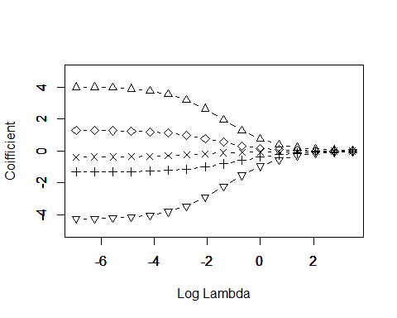

1. 列出從 $(2^{−10}..{.2}^{5})$ 之下的 $\hat{β}(λ)$

par_own = sapply(1:16, function(a){  
 par_own[,a] = par_own[,17-a]  
})  
  
par_own %>% as.matrix()

## [,1] [,2] [,3] [,4] [,5] [,6]  
## [1,] 4.020300 4.0041486 3.9722278 3.9098700 3.7907745 3.5728162  
## [2,] -1.312362 -1.3093520 -1.3033565 -1.2914645 -1.2680992 -1.2231561  
## [3,] -0.376736 -0.3735725 -0.3673717 -0.3554547 -0.3334134 -0.2954987  
## [4,] 1.290542 1.2844804 1.2725069 1.2491435 1.2046274 1.1235493  
## [5,] -4.261262 -4.2454611 -4.2142277 -4.1531895 -4.0365239 -3.8226664  
## [,7] [,8] [,9] [,10] [,11] [,12]  
## [1,] 3.2033346 2.6513172 1.9648283 1.28366151 0.74709780 0.39976831  
## [2,] -1.1407041 -1.0033481 -0.8092079 -0.58874990 -0.38835442 -0.23601979  
## [3,] -0.2382756 -0.1688230 -0.1077309 -0.07128855 -0.05369614 -0.04079682  
## [4,] 0.9874544 0.7880784 0.5489850 0.32561934 0.16494763 0.07368899  
## [5,] -3.4589043 -2.9116415 -2.2218062 -1.52005123 -0.94257961 -0.54214434  
## [,13] [,14] [,15] [,16]  
## [1,] 0.20408642 0.10222344 0.050961069 0.025409120  
## [2,] -0.13426479 -0.07262863 -0.037967456 -0.019442321  
## [3,] -0.02785124 -0.01690186 -0.009424342 -0.004993725  
## [4,] 0.03071533 0.01273554 0.005489593 0.002488339  
## [5,] -0.29568199 -0.15556787 -0.080010647 -0.040609009

$\hat{β}(2)$ 在Origin Scale下的估計值

a = solve(t(x)%*%x + 2*diag(1,nrow=5,ncol=5))  
a %*% t(x) %*% y %>% as.matrix()

## [,1]  
## [1,] 4.3202397  
## [2,] -1.4257163  
## [3,] -0.3573408  
## [4,] 1.2204615  
## [5,] -3.8767087

#### (c)

使用glmnet()函式所求給定在 $λ_{i}$ 之下的 $\hat{β}(λ)$ 的估計值

num = 2^c(-10:5)%>% sort(decreasing = T)  
fit2_ridge = glmnet(x = z,  
 y = y_1,  
 alpha = 0,  
 lambda = num)  
par_glment = fit2_ridge$beta %>% as.matrix()  
  
par_glment = sapply(1:16, function(a){  
 par_glment[,a] = par_glment[,17-a]  
})  
par_glment

## [,1] [,2] [,3] [,4] [,5] [,6] [,7]  
## V1 4.0354887 4.0342465 4.0321537 4.0277084 4.0187853 3.9998389 3.9629047  
## V2 -1.3154439 -1.3154067 -1.3149106 -1.3138770 -1.3125249 -1.3081668 -1.3009412  
## V3 -0.3797479 -0.3794963 -0.3791142 -0.3782932 -0.3766445 -0.3728343 -0.3655736  
## V4 1.2960005 1.2954515 1.2945884 1.2927764 1.2889759 1.2822591 1.2685813  
## V5 -4.2757784 -4.2744406 -4.2722708 -4.2678197 -4.2583968 -4.2407819 -4.2050531  
## [,8] [,9] [,10] [,11] [,12] [,13] [,14]  
## V1 3.891004 3.7550071 3.509723 3.1032234 2.5158766 1.81736870 1.15729912  
## V2 -1.287130 -1.2605472 -1.209400 -1.1171954 -0.9673876 -0.76427394 -0.54427435  
## V3 -0.351754 -0.3267444 -0.284791 -0.2240416 -0.1544224 -0.09791823 -0.06660194  
## V4 1.242014 1.1915913 1.100699 0.9514429 0.7405346 0.49950974 0.28633785  
## V5 -4.135156 -4.0021456 -3.761532 -3.3606441 -2.7770164 -2.07197881 -1.38684773  
## [,15] [,16]  
## V1 0.65994053 0.34870677  
## V2 -0.35245312 -0.21100990  
## V3 -0.05096718 -0.03808681  
## V4 0.14080939 0.06167905  
## V5 -0.84498895 -0.47989915

將glmnet()所求之 $\hat{β}(λ)$ 畫出Solution Path Line Plot

plot(fit2_ridge, xvar = "lambda",label = T)

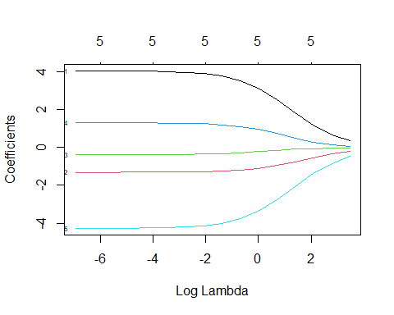

* 從(b),(c)小題兩種估計的Coefficients可發現:

1. 兩者的所估計的值於 $2^{−10}$ 的時候近乎相同，但隨 $i$ 變動，兩數之間開始出現差異，可見到 $2^{5}$ 時，兩數已明顯不相同。
2. 由Solution Line Plot 更可明顯看出 自行推導的矩陣解並未收斂。  
   由上述兩點推測，差異的來源可來自於:  
   glmnet()函式所用的Loss Function與課程上所推導的有差別。

使用vignette()查閱glmnet套件的說明後發現，

glmnet的默認的分配為Gaussian，以下為glmnet所用Ridge Regression的Loss Function：

$$min\frac{1}{2N}Σ_{i=1}^{N}(y_{i}−β_{0}−x_{i}^{T}β)^{2}+λ[||β||_{2}^{2}/2]$$

與此題所使用的Loss Function 不相同，

$$min\frac{1}{2N}Σ_{i=1}^{N}(y_{i}−Σ_{j=1}^{p}x_{ij}β_{j})^{2}+λΣ_{j=1}^{j}β_{j}^{2}$$

因此兩者差異可能來自：  
後面 $λ$ 項差了一個除以2的部分，而導致我們自己求的矩陣解的 $λ_{i}$ 效果為套件的2倍， 因此隨著 $λ_{i}$ 的值增加兩者的差異擴大，也導致自行求的矩陣解收斂速度快於glmnet()

vignette("glmnet")

#### (d)

使用Cross Validation的方式計算模型在不同 $λ_{i}$ 之下的表現，表現如下：  
可以發現不管是min或lse之下，都是5個參數，並未達到變數篩選的功能， 其原因可能來自我們使用模擬的隨機項，變數間並無意義上的差別。

set.seed(10)  
CVRidge = cv.glmnet(x = z,y = y_1,family = "gaussian",lambda = num,nfold = 10,alpha = 0)  
CVRidge

##   
## Call: cv.glmnet(x = z, y = y_1, lambda = num, nfolds = 10, family = "gaussian", alpha = 0)   
##   
## Measure: Mean-Squared Error   
##   
## Lambda Measure SE Nonzero  
## min 0.25 32.50 4.682 5  
## 1se 4.00 36.49 4.746 5

plot(CVRidge)

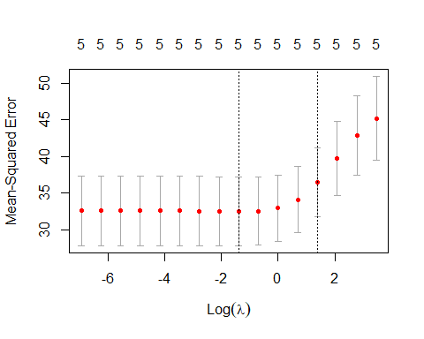

我們將資料以 $(75\%,25\%)$ 分為Train、Test Set  
接著以 $λ_{min}$ 及 $λ_{lse}$ 配飾兩個 $RidgeRegression$ 
以Train Set 配飾模型，比較其預測Test Set 的SSE，借此衡量兩模型的表現。

set.seed(123)  
index = sample(1:100,size = 75,replace = F)  
trainx = z[index,]  
trainy = y_1[index,]  
testx = z[-index,]  
testy = y_1[-index,]

ridge1 = glmnet(x = trainx,y = trainy,family = "gaussian",alpha = 0,lambda = CVRidge$lambda.min)   
  
ridge2 = glmnet(x = trainx,y = trainy,family = "gaussian",alpha = 0,lambda = CVRidge$lambda.1se )

兩個模型估計出不同的 $\hat{β_{i}}$

print(ridge1$beta)

## 5 x 1 sparse Matrix of class "dgCMatrix"  
## s0  
## V1 3.5223511  
## V2 -2.3957434  
## V3 -0.2242332  
## V4 2.1627620  
## V5 -4.4781497

print(ridge2$beta)

## 5 x 1 sparse Matrix of class "dgCMatrix"  
## s0  
## V1 1.9071403  
## V2 -1.5158969  
## V3 -0.2215735  
## V4 0.9047308  
## V5 -2.3901481

由此可見使用 $λ_{lse}$ 的模型的SSE較小，表現較佳

pred_ridge1 = predict(ridge1,testx)  
pred_ridge2 = predict(ridge2,testx)  
  
paste0("SSE of lambda.min: ",sum((pred_ridge1-testy)^2))

## [1] "SSE of lambda.min: 1034.73466015926"

paste0("SSE of lambda.lse: ",sum((pred_ridge2-testy)^2))

## [1] "SSE of lambda.lse: 851.897302170231"

但由Predict-Y Plot可見，圓圈為真實值，另兩個符號為預測值，表現皆不佳，無法有效預測Y。

plot(testy,xlim = c(0,25),ylim = c(-5,10),main = "Lambda_min")  
points(pred_ridge1,col=2,pch=2)

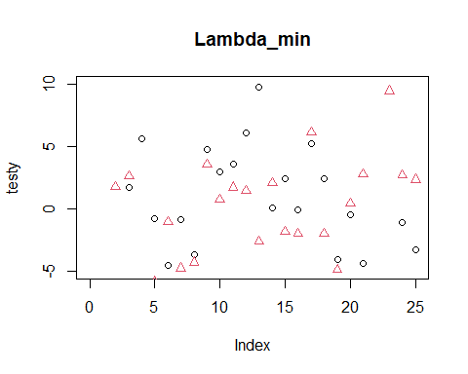

plot(testy,xlim = c(0,25),ylim = c(-5,10),main = "Lambda_lse")  
points(pred_ridge2,col=2,pch=3)

