HW6

計財所 108071601 賴冠維

2020/12/22

## Warning: package 'magrittr' was built under R version 4.0.3

## (8)

本題使用資料為 $ISLR$ 裡的 $Carseats$ 
有 400 observations 及 11 variables，變數解釋如下：  
* Sales  
Unit sales (in thousands) at each location  
* CompPrice  
Price charged by competitor at each location  
* Income  
Community income level (in thousands of dollars)  
* Advertising  
Local advertising budget for company at each location (in thousands of dollars)  
* Population  
Population size in region (in thousands)  
* Price  
Price company charges for car seats at each site  
* ShelveLoc  
A factor with levels Bad, Good and Medium indicating the quality of the shelving location for the car seats at each site  
* Age  
Average age of the local population  
* Education  
Education level at each location  
* Urban  
A factor with levels No and Yes to indicate whether the store is in an urban or rural location  
* US  
A factor with levels No and Yes to indicate whether the store is in the US or not

### (a)

將 $Carseats$ 以 $[80,20]$ 比例分割成 $Train,Test$

## Warning: package 'tree' was built under R version 4.0.3

## Train: 320 12 Test: 80 12

### (b)

建立 $Regression Tree$ 預測 $Sales$，下圖為預測結果，節點左邊為 $Yes$，右邊為 $No$ 
模型裡僅用到$"ShelveLoc" "Price" "Age" "CompPrice" "Advertising"

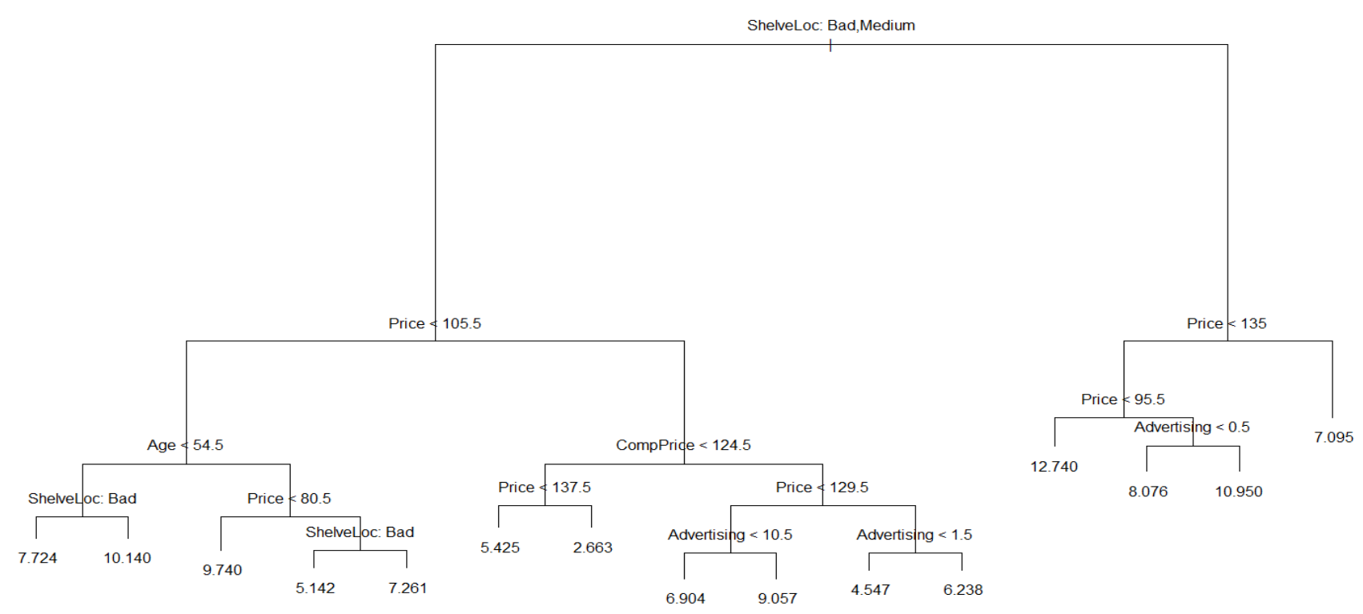

一共有15個 $terminal nodes$

##   
## Regression tree:  
## tree(formula = Sales ~ ., data = train[, -12])  
## Variables actually used in tree construction:  
## [1] "ShelveLoc" "Price" "Age" "CompPrice" "Advertising"  
## Number of terminal nodes: 15   
## Residual mean deviance: 2.641 = 805.4 / 305   
## Distribution of residuals:  
## Min. 1st Qu. Median Mean 3rd Qu. Max.   
## -4.54700 -1.08400 -0.09094 0.00000 1.17500 3.88500

以 $Train$ 建立迴歸樹後，導入 $Test$ 資料，首先看到 $Test RMSE$ 為 4.728284  
將預測結果以是否大於8為界，分為 $[Low,High]$ 
列出 $ConfusionTable$，以及 $Test Error Rate$ 為0.2875

## [1] "Test Error MSE: 4.72828433855961"

## actual  
## predicted High Low  
## High 15 5  
## Low 18 42

## Test Error Rate: 0.2875

### (c)

使用 $Cross Validation$，選出具有最佳的預測力的樹複雜度  
以 $K=10$， $10 Fold$ 進行 $Cross Validation$，選到15個 $Terminal Nodes$ 
由圖亦可看到誤差隨著 $Size$ 增加而遞減至收斂  
與上述模型相同，因此得到相同的 $Test Error Rate$

## [1] "Best Size : 15"

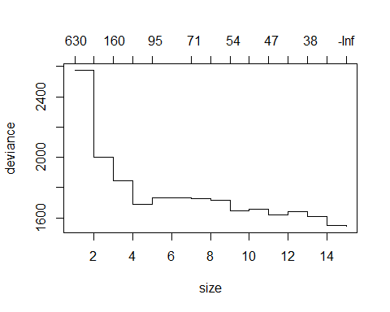

## [1] "Test Error MSE: 4.72828433855961"

## actual  
## predicted High Low  
## High 15 5  
## Low 18 42

## Test Error Rate: 0.2875

### 

### (d)

接下來以 $Bagging$ 方式預測， $Bagging$ 與$Random Forest $僅差在建立子集$ (Subset) $時，是否也對$ Columns $進行抽樣，因此以$ random Forest $套件進行即可以相同流程對$ Test $估計，$ RMSE $明顯較低並且從$ Confusion Table $及$ Test  Error  Rate $亦可看出，預測表現較佳。由$ Variance  Importance Plot $可看出個別變數對模型的貢獻度，發現$ Price、SheleveLoc$這兩個變數解釋力為最佳。

## Warning: package 'randomForest' was built under R version 4.0.3

## randomForest 4.6-14

## Type rfNews() to see new features/changes/bug fixes.

## [1] "Test Error MSE: 2.4401977490189"

## actual  
## predicted High Low  
## High 22 4  
## Low 11 43

## Test Error Rate: 0.1875

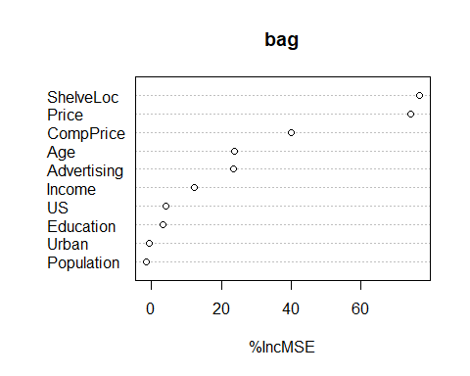

### (e)

接下來以 $Random Forest$ 進行配適，選取 $Column Split$ 以 $p/3$ 為標準 $=4$ 
以相同步驟估計，最後可看到 $Random Forest$ 表現比 $Bagging$ 更佳。

## [1] "Test Error MSE: 2.32105249762642"

## actual  
## predicted High Low  
## High 23 4  
## Low 10 43

## Test Error Rate: 0.175

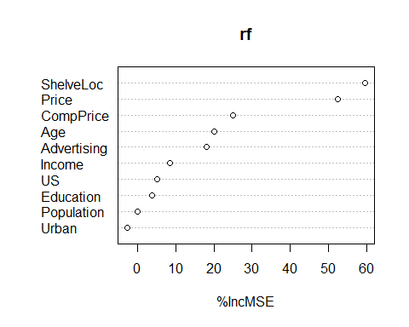

## (9)

本題使用資料為 $ISLR$ 裡的 $OJ$ 
有 1070 observations 及 18 variables，變數解釋如下：  
* Purchase  
A factor with levels CH and MM indicating whether the customer purchased Citrus Hill or Minute Maid Orange Juice  
* WeekofPurchase  
Week of purchase  
* StoreID  
Store ID  
* PriceCH  
Price charged for CH  
* PriceMM  
Price charged for MM  
* DiscCH  
Discount offered for CH  
* DiscMM  
Discount offered for MM  
* SpecialCH  
Indicator of special on CH  
* SpecialMM  
Indicator of special on MM  
* LoyalCH  
Customer brand loyalty for CH  
* SalePriceMM  
Sale price for MM  
* SalePriceCH  
Sale price for CH  
* PriceDiff  
Sale price of MM less sale price of CH  
* Store7  
A factor with levels No and Yes indicating whether the sale is at Store 7  
* PctDiscMM  
Percentage discount for MM  
* PctDiscCH  
Percentage discount for CH  
* ListPriceDiff  
List price of MM less list price of CH  
* STORE  
Which of 5 possible stores the sale occured at

## 

## (9)

### (a)

把 $OJ$ 資料，以前 $800$ 筆為 $Train$，剩下分為 $Test$

## Train: 800 18 Test: 270 18

### (b)

以 $Purchase$ 為目標被解釋變數，其餘為解釋變數，建立類別樹  
可看到共用到$“LoyalCH” “SalePriceMM” “ListPriceDiff” “PriceDiff” $  
這幾個變數，最後的 $Terminal Nodes$ 為7， $Misclassificationerrorrate:$ 
為0.1638

##   
## Classification tree:  
## tree(formula = Purchase ~ ., data = train)  
## Variables actually used in tree construction:  
## [1] "LoyalCH" "PriceDiff"  
## Number of terminal nodes: 8   
## Residual mean deviance: 0.7916 = 626.9 / 792   
## Misclassification error rate: 0.1762 = 141 / 800

以 $Terminal Nodes (10)$ 為例解釋，當 $LoyalCH<0.48285，LoyalCH>0.0356415$，且 $PriceDiff<0.085$ 時，  
在 $TrainSet$ 裡共有97筆資料落在此 $Nodes$，將此 $Nodes$ 預測為 $MM$，並且正確率為0.82474

## node), split, n, deviance, yval, (yprob)  
## * denotes terminal node  
##   
## 1) root 800 1064.000 CH ( 0.61750 0.38250 )   
## 2) LoyalCH < 0.48285 292 330.600 MM ( 0.25342 0.74658 )   
## 4) LoyalCH < 0.0356415 54 9.959 MM ( 0.01852 0.98148 ) *  
## 5) LoyalCH > 0.0356415 238 293.400 MM ( 0.30672 0.69328 )   
## 10) PriceDiff < 0.085 97 90.040 MM ( 0.17526 0.82474 ) *  
## 11) PriceDiff > 0.085 141 189.500 MM ( 0.39716 0.60284 )   
## 22) LoyalCH < 0.104032 18 7.724 MM ( 0.05556 0.94444 ) *  
## 23) LoyalCH > 0.104032 123 169.100 MM ( 0.44715 0.55285 ) *  
## 3) LoyalCH > 0.48285 508 468.300 CH ( 0.82677 0.17323 )   
## 6) LoyalCH < 0.764572 245 300.200 CH ( 0.69796 0.30204 )   
## 12) PriceDiff < -0.165 33 31.290 MM ( 0.18182 0.81818 ) *  
## 13) PriceDiff > -0.165 212 224.300 CH ( 0.77830 0.22170 )   
## 26) PriceDiff < 0.265 116 145.300 CH ( 0.68103 0.31897 ) *  
## 27) PriceDiff > 0.265 96 64.160 CH ( 0.89583 0.10417 ) *  
## 7) LoyalCH > 0.764572 263 109.400 CH ( 0.94677 0.05323 ) *

### (d)

由圖亦可看到上述結果

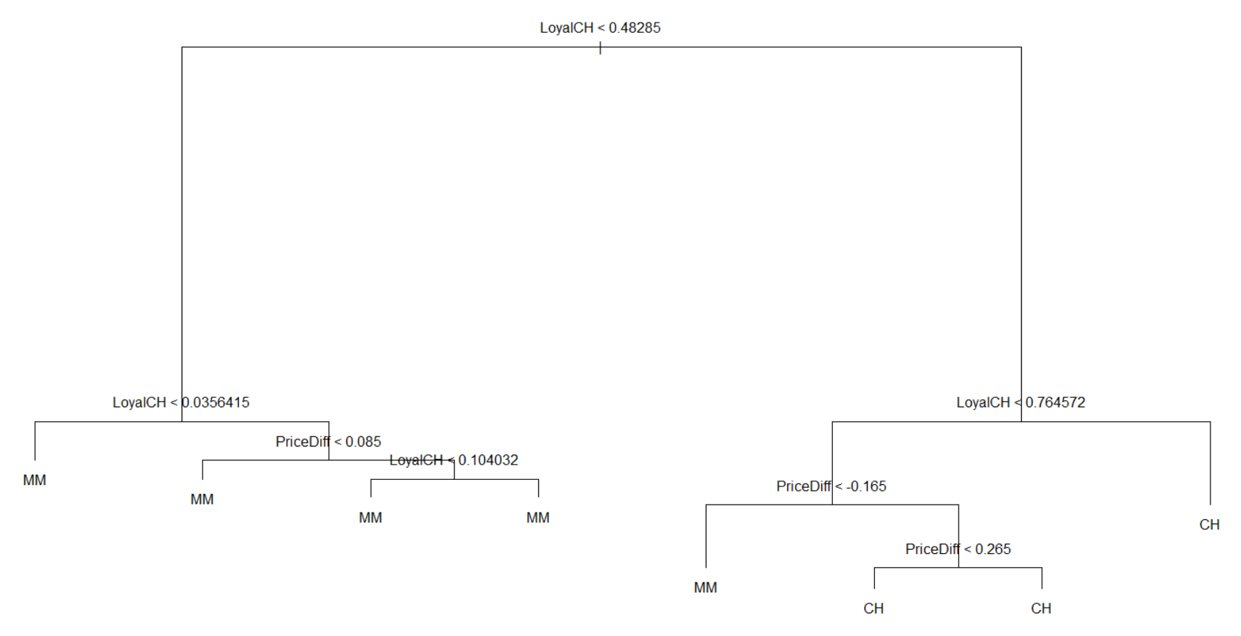

### (e)

由 $ConfusionTable$ 及 $Test Error Rate$ 看出對Test的估計結果， $Test Error Rate$ 
為0.1518519

## actual  
## predicted CH MM  
## CH 133 15  
## MM 26 96

## Test Error Rate: 0.1518519

### (f)

以 $cv.tree$ 優化模型

## Length Class Mode   
## size 4 -none- numeric   
## dev 4 -none- numeric   
## k 4 -none- numeric   
## method 1 -none- character

### (g)

可以看到優化結果顯示， $Nodes$ 為8時，有最佳的表現。 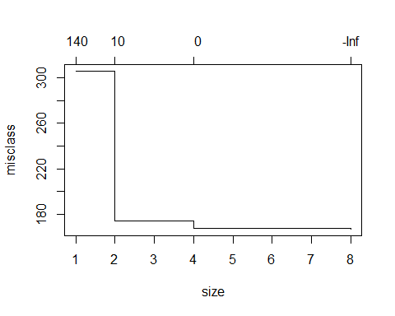

### (h)

由上述結果，以 $Terminal Nodes$ 為8，進行配飾

## Best Size: 8

### (i)

以上述優化結果與先前相同，因此並無改善。

## actual  
## predicted CH MM  
## CH 133 15  
## MM 26 96

## Test Error Rate: 0.1518519

### (j)

優化前後模型並無差別，因此 $Train Error Rate$ 並無改善。

## [1] "Train_Unpruned Error Rate: 0.17625"

## [1] "Train_Pruned Error Rate: 0.17625"

### (k)

優化前後模型並無差別，因此 $Test Error Rate$ 並無改善。

## [1] "Test_Unpruned Error Rate: 0.151851851851852"

## [1] "Test_Pruned Error Rate: 0.151851851851852"

## (10)

本題使用資料為 $ISLR$ 裡的 $Hitters$ 
有 322 observations 及 20 variables，變數解釋如下：  
* AtBat  
Number of times at bat in 1986  
* Hits  
Number of hits in 1986  
* HmRun  
Number of home runs in 1986  
* Runs  
Number of runs in 1986  
* RBI  
Number of runs batted in in 1986  
* Walks  
Number of walks in 1986  
* Years  
Number of years in the major leagues  
* CAtBat  
Number of times at bat during his career  
* CHits  
Number of hits during his career  
* CHmRun  
Number of home runs during his career  
* CRuns  
Number of runs during his career  
* CRBI  
Number of runs batted in during his career  
* CWalks  
Number of walks during his career  
* League  
A factor with levels A and N indicating player’s league at the end of 1986  
* Division  
A factor with levels E and W indicating player’s division at the end of 1986  
* PutOuts  
Number of put outs in 1986  
* Assists  
Number of assists in 1986  
* Errors  
Number of errors in 1986  
* Salary  
1987 annual salary on opening day in thousands of dollars  
* NewLeague  
A factor with levels A and N indicating player’s league at the beginning of 1987

### (a)

首先將由遺漏值的資料刪去後，再將目標解釋變數 $Salary$ 取對數

### (b)

以前200筆為 $Train$，剩下為 $Test$

## Train: 200 20 Test: 63 20

### (c)

取 $0.001到0.01$ 之間10等分為 $shrinkage$，可以看到 $TrainError$ 隨 $shrinkage$ 增加而降低。

## Warning: package 'gbm' was built under R version 4.0.3

## Loaded gbm 2.1.8

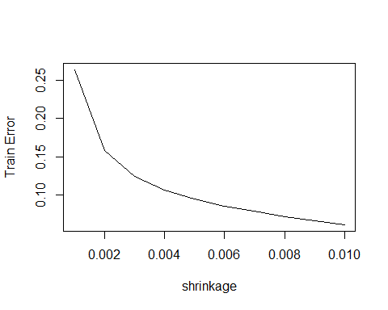

### (d)

以相同 $Shrinkage Set$ 進行 $Train$ 的配適，但所得到的 $TestError$ 並不像 $TrainError$ 穩健遞減，偶有反升的趨勢。

## Using 1000 trees...  
##   
## Using 1000 trees...  
##   
## Using 1000 trees...  
##   
## Using 1000 trees...  
##   
## Using 1000 trees...  
##   
## Using 1000 trees...  
##   
## Using 1000 trees...  
##   
## Using 1000 trees...  
##   
## Using 1000 trees...  
##   
## Using 1000 trees...

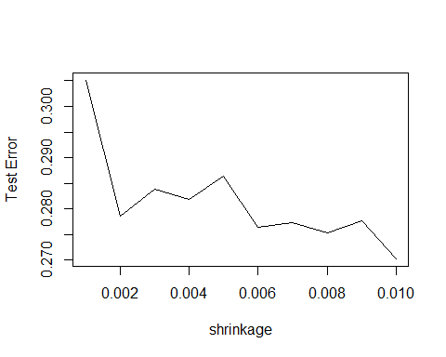

### (e)

以多元回歸及Lasso方式估計與Boosting比較，可得下列之Test MSE  
明顯Boosting 的MSE比另外兩個方法更佳。

## Warning: package 'glmnet' was built under R version 4.0.3

## Loading required package: Matrix

## Loaded glmnet 4.0-2

## [1] "Test Error MSE of LM: 0.491795937545494"

## [1] "Test Error MSE of Lasso: 0.457028250141243"

## Using 1000 trees...

## [1] "Test Error MSE of Boosting: 0.287606612725594"

### (f)

由 $Variance Importance Plot$ 與下表可得到 $CAtBat、CRBI$ 為最有解釋力的前兩個變數。 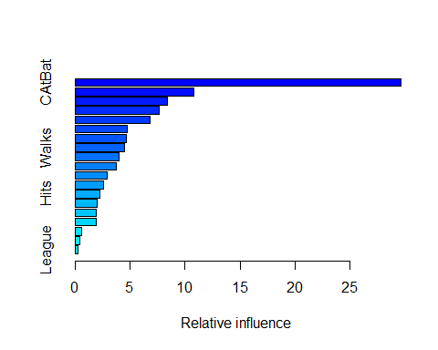

## var rel.inf  
## CAtBat CAtBat 29.6511477  
## CWalks CWalks 10.8355583  
## CHits CHits 8.3629778  
## CRuns CRuns 7.6238787  
## CRBI CRBI 6.8453865  
## PutOuts PutOuts 4.7338062  
## Years Years 4.6380926  
## Walks Walks 4.5147326  
## AtBat AtBat 3.9595985  
## CHmRun CHmRun 3.7707869  
## Assists Assists 2.9486224  
## RBI RBI 2.5755878  
## Hits Hits 2.2579686  
## HmRun HmRun 1.9932002  
## Runs Runs 1.9551249  
## Errors Errors 1.9504051  
## NewLeague NewLeague 0.6191589  
## Division Division 0.4644946  
## League League 0.2994717

### (g)

此處使用 $Bagging$，發現 $TestMSE$ 表現比 $Boosting$ 更佳。

## [1] "Test Error MSE of Bagging: 0.234267450868388"

附錄(Code)

set.seed(123456)

X1 = rnorm(10000)

X2 = runif(10000)

X3 = rexp(10000)

X4 = rt(10000,10)

Y = 10*X1+15*X2+20*X3+25*X4

data= cbind(X1,X2,X3,X4,Y) %>% as.data.frame()

library(tree)

data = mtcars

controls = tree.control(nobs = 33,mincut = 5,minsize = 10)

tree.Y = tree(mpg~.,control = controls,data = data)

summary(tree.Y)

plot(tree.Y)

# 8

## (a)

library(ISLR)

library(tree)

data("Carseats")

Carseats$Sales_1 = as.factor(ifelse(Carseats$Sales <= 8, "Low", "High"))

set.seed(1234567)

index = sample(1:400,size = 320,replace = F)

train = Carseats[index,]

test = Carseats[-index,]

## (b)

model = tree(Sales~.,data = train[,-12])

plot(model)

text(model)

summary(model)

fit= predict(model,test[,-12])

sum((test$Sales - fit)^2)/nrow(test) #rmse

fit = ifelse(fit<=8,"Low","High")

table(predicted = fit, actual = test$Sales_1)

accuracy = function(actual, predicted) {

mean(actual == predicted)

}

1-accuracy(predicted = fit, actual = test$Sales_1)

## (c)

set.seed(1234)

tree_cv = cv.tree(model, FUN = prune.tree,K = 10)

min_idx = which.min(tree_cv$dev)

tree_cv$size[min_idx]

tree_cv$dev/length(index)

# default plot

plot(tree_cv)

tree_prune = prune.tree(model,best = tree_cv$size[min_idx])

fit= predict(tree_prune,test)

sum((test$Sales - fit)^2)/nrow(test) #rmse

fit = ifelse(fit<=8,"Low","High")

table(predicted = fit, actual = test$Sales_1)

1-accuracy(predicted = fit, actual = test$Sales_1)

##(d)

library(randomForest)

bag = randomForest(Sales ~., data = train[,-12], mtry= 10,

importance = TRUE, ntrees = 500)

fit= predict(bag,test[,-12])

sum((test$Sales - fit)^2)/nrow(test) #rmse

fit = ifelse(fit<=8,"Low","High")

table(predicted = fit, actual = test$Sales_1)

1-accuracy(predicted = fit, actual = test$Sales_1)

varImpPlot(bag, type = 1)

## (e)

library(randomForest)

rf = randomForest(Sales ~., data = train[,-12],mtry=4,

importance = TRUE, ntrees = 500)

fit= predict(rf,test[,-12])

sum((test$Sales - fit)^2)/nrow(test) #rmse

fit = ifelse(fit<=8,"Low","High")

table(predicted = fit, actual = test$Sales_1)

1-accuracy(predicted = fit, actual = test$Sales_1)

varImpPlot(rf, type = 1)

# (9)

## (a)

data(OJ)

index = sample(1:1070,800,replace = F)

train = OJ[index,]

test = OJ[-index,]

## (b)

tree = tree(Purchase~.,data = train)

summary(tree)

#(c)

tree

#(d)

plot(tree)

text(tree)

#(e)

fit=predict(tree,test,type = "class")

table(predicted = fit, actual = test$Purchase)

1- accuracy(predicted = fit, actual = test$Purchase)

#(f)

cv_tree = cv.tree(tree, FUN = prune.misclass)

#(g)

plot(cv_tree)

#(h)

min_idx = which.min(cv_tree$dev)

cv_tree$size[min_idx]

#(i)

tree_prune = prune.tree(tree,best = cv_tree$size[min_idx])

fit= predict(tree_prune,test,type="class")

table(predicted = fit, actual = test$Purchase)

1- accuracy(predicted = fit, actual = test$Purchase)

#(j)

fit= predict(tree,train,type="class")

fit_1= predict(tree_prune,train,type="class")

cat("Train_Unpruned Error Rate: ",1- accuracy(predicted = fit, actual = train$Purchase))

cat("Train_Pruned Error Rate: ",1- accuracy(predicted = fit_1, actual = train$Purchase))

#(k)

fit= predict(tree,test,type="class")

fit_1= predict(tree_prune,test,type="class")

cat("Test_Unpruned Error Rate: ",1- accuracy(predicted = fit, actual = test$Purchase))

cat("Test_Pruned Error Rate: ",1- accuracy(predicted = fit_1, actual = test$Purchase))

#(10)

## (a)

data("Hitters")

Hitters = na.omit(Hitters)

Hitters$Salary = log(Hitters$Salary)

## (b)

train = Hitters[1:200,]

test = Hitters[201:263,]

## (c)

library(gbm)

s = seq(0.001,0.01,by = 0.001)

t = sapply(1:10, function(a){

boost = gbm(Salary ~ ., data = train, distribution = "gaussian",

n.trees = 1000, interaction.depth = 4, shrinkage = s[a])

c(boost$shrinkage,tail(boost$train.error,1))

})

t = t(t) %>% as.data.frame()

names(t)= c("shrinkage","train_error")

plot(x=t$shrinkage,y=t$train_error,type="l",xlab = "shrinkage",ylab = "Train Error")

## (d)

s = seq(0.001,0.01,by = 0.001)

t = sapply(1:10, function(a){

boost = gbm(Salary ~ ., data = train, distribution = "gaussian",

n.trees = 1000, interaction.depth = 4, shrinkage = s[a])

fit = predict(boost,test)

mse = mean((fit-test$Salary)^2)

c(boost$shrinkage,mse)

})

t = t(t) %>% as.data.frame()

names(t)= c("shrinkage","test_error")

plot(x=t$shrinkage,y=t$test_error,type="l",xlab = "shrinkage",ylab = "Test Error")

#(e)

library(glmnet)

lm = lm(Salary ~ ., data = train)

fit = predict(lm,test)

mean((fit - test$Salary)^2)

train_1 = model.matrix(Salary ~ ., data = train)

test_1 = model.matrix(Salary ~ ., data = test)

y = train$Salary

lasso = glmnet(train_1, y, alpha = 0)

fit = predict(lasso, s = 0.01, newx = test_1)

mean((fit - test$Salary)^2)

#(f)

summary(boost)

#(g)

bag <- randomForest(Salary ~ ., data = train, mtry = 19, ntree = 500)

fit <- predict(bag, newdata = test)

mean((fit - test$Salary)^2)