ASSIGNMENT/QUIZ — RNN / LSTM / GRU
Stacked Recurrent Models and CNN + SimpleRNN — Hourly Energy Price Forecasting
Frances Frangelico S. Friginal, MIT | September 30, 2026
DOES 1C3-DIT / DENG11G1 | Prof. Rolando Pula
AI USE DECLARATION
I declare that an AI assistant (Gemini and Gemini Notebook) was used in the preparation of this activity in the following ways:
Code support — preparing and test-running the two-layer LSTM and GRU notebooks, supplying the edited model cells (a second layer of the same type; a Conv1D layer before the recurrent layer), and assembling the test-set metrics cell used to produce MAE, MSE, RMSE, MAPE, and R².
Debugging — identifying runtime errors encountered during the sessions, including undefined names after Colab session restarts, function and variable names that did not match the training cells, the Conv1D padding needed for single-timestep inputs, and the change to causal padding in the many-to-many synced model.
Methodological guidance — guiding me step by step to interpret the results, to hedge conclusions that a single training run cannot support, and to compare the Item 4 model with the one-layer baseline.
Verification — recomputing the reported metrics independently, auditing the notebook files (real dataset, 100 epochs, no errors), and checking my written statements against the recorded results, flagging any claim not supported by the data.
Document preparation — assembling my written paragraphs, the result tables from the notebook outputs, and my screenshots into this document.
The interpretations and discussions in Items 3, 5, and 6 are my own. Every metric reported was produced by running the notebooks myself; no value was estimated or reproduced from any source other than the actual training runs.

1. Project / Experiment Information
Project / Experiment Title | Stacked Recurrent Models (SimpleRNN, LSTM, GRU) and a CNN + SimpleRNN Comparison on Hourly Energy Price Forecasting
Dataset Used | Kaggle Hourly Energy Demand, Generation, Weather and Price (Spain), 35,064 hourly rows; target: price actual (EUR/MWh)
Notebook / File Reference | 01_vanilla_rnn_energy_forecasting_3.ipynb; 02_lstm_2layer.ipynb; 03_gru_2layer.ipynb; 04_cnn_simplernn_1layer.ipynb
Models Evaluated | 15 two-layer models (5 typologies × SimpleRNN, LSTM, GRU) and 5 CNN + SimpleRNN models; 100 epochs each
Prepared By | Frances Frangelico S. Friginal, MIT
Date | September 30, 2026
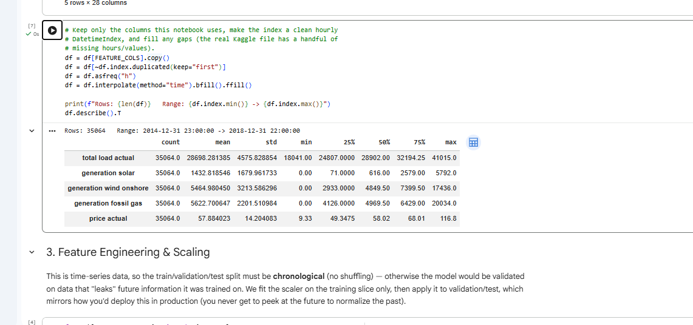
Figure 1. Dataset loading output: 35,064 hourly rows (2014-12-31 23:00 to 2018-12-31 22:00), summary statistics.

2. Item 2 — Test-Set Performance Metrics (Two-Layer Models)
MAE, RMSE, and price values are in EUR/MWh; MSE is in (EUR/MWh)²; MAPE is in %.
Table 1. SimpleRNN, two layers
Typology | Params | MAE | MSE | RMSE | MAPE (%) | R²
one_to_one | 3,329 | 2.3593 | 10.0614 | 3.1720 | 3.4128 | 0.8389
many_to_one | 3,329 | 1.5200 | 4.0923 | 2.0229 | 2.2349 | 0.9347
one_to_many | 7,489 | 4.7558 | 41.9964 | 6.4805 | 6.9288 | 0.3283
many_to_many_synced | 3,329 | 1.6012 | 4.7698 | 2.1840 | 2.3618 | 0.9239
many_to_many_seq2seq | 7,489 | 4.1572 | 25.6173 | 5.0614 | 5.9777 | 0.5914
Table 2. LSTM, two layers
Typology | Params | MAE | MSE | RMSE | MAPE (%) | R²
one_to_one | 13,217 | 2.0406 | 8.4450 | 2.9060 | 2.9911 | 0.8648
many_to_one | 13,217 | 1.5638 | 4.2722 | 2.0669 | 2.2935 | 0.9318
one_to_many | 29,857 | 4.7030 | 42.8348 | 6.5448 | 6.8397 | 0.3149
many_to_many_synced | 13,217 | 1.6319 | 5.0009 | 2.2363 | 2.3921 | 0.9202
many_to_many_seq2seq | 29,857 | 3.3442 | 18.8980 | 4.3472 | 4.8825 | 0.6985
Table 3. GRU, two layers
Typology | Params | MAE | MSE | RMSE | MAPE (%) | R²
one_to_one | 10,113 | 2.1646 | 9.1096 | 3.0182 | 3.1527 | 0.8542
many_to_one | 10,113 | 1.4845 | 3.9985 | 1.9996 | 2.1835 | 0.9362
one_to_many | 22,785 | 4.7199 | 42.3220 | 6.5055 | 6.8982 | 0.3231
many_to_many_synced | 10,113 | 1.6275 | 4.9420 | 2.2231 | 2.3899 | 0.9211
many_to_many_seq2seq | 22,785 | 3.3434 | 19.4308 | 4.4080 | 4.8897 | 0.6900
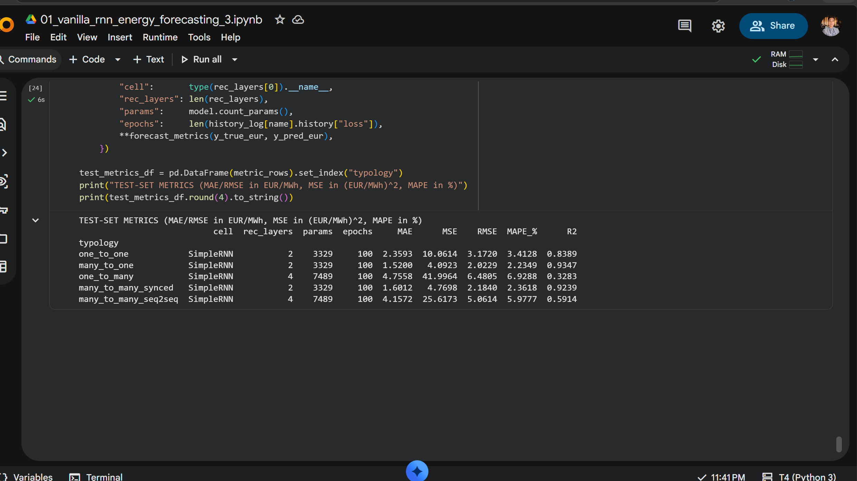
Figure 2. Test-set metrics output of the two-layer SimpleRNN notebook (01_vanilla_rnn_energy_forecasting_3.ipynb).
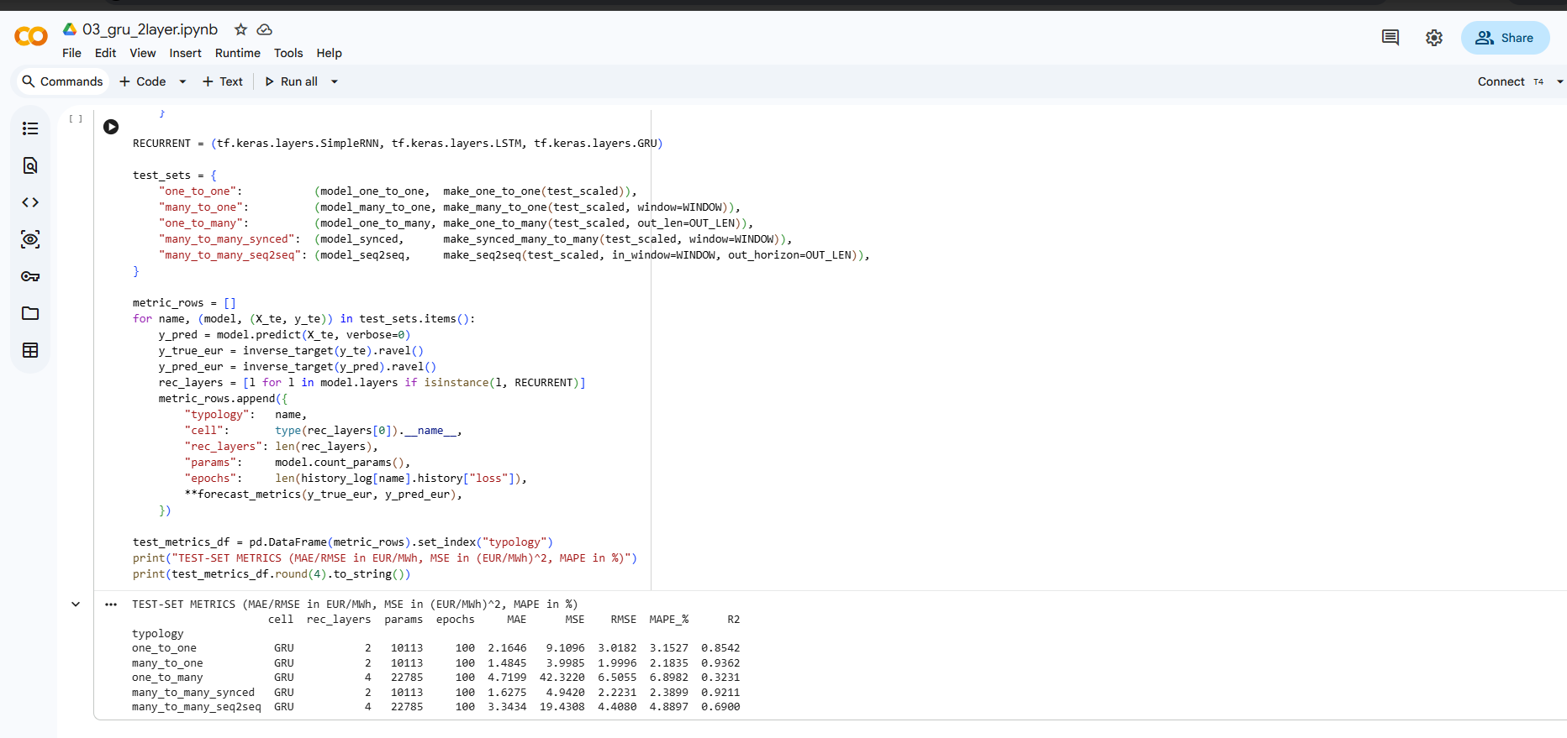
Figure 3. Test-set metrics output of the two-layer GRU notebook (03_gru_2layer.ipynb).

3. Item 3 — Best-Performing Typology
Across the fifteen model configurations evaluated, many-to-one consistently emerged as the overall best-performing sequence typology, achieving the highest R² scores across all three recurrent architectures (ranging from 0.9318 to 0.9362). Among all individual configurations, GRU many-to-one achieved the highest single R² score (0.9362) alongside the lowest overall error metrics across the entire benchmark (MAE = 1.4845, MSE = 3.9985, RMSE = 1.9996). In contrast, the one-to-many typology remained the weakest performer overall, recording the lowest R² values regardless of cell type (ranging from 0.3149 to 0.3283). Comparing the individual cell architectures within each setup, LSTM led in the one-to-one (R² = 0.8648) and many-to-many seq2seq (R² = 0.6985) typologies; GRU achieved the highest score in many-to-one (R² = 0.9362); and SimpleRNN recorded the top R² in one-to-many (R² = 0.3283) as well as many-to-many synced (R² = 0.9239).
For instance, in the one-to-many setup, R² scores dropped sharply to between 0.3149 and 0.3283 across all three architectures. This substantial performance gap likely stems from the setup of the forecasting task itself, which requires generating a 6-hour future horizon from only a single hour of historical input. Predicting extended future sequences without sufficient historical context or temporal momentum introduces significant uncertainty, suggesting that a single-hour input snapshot lacks the necessary temporal signal for the model to reliably project multi-hour electricity price trends.
Comparing the single-layer baseline to the two-layer SimpleRNN architecture, adding a second recurrent layer produced mixed results across the sequence typologies. While slight R² gains were observed in many-to-one (+0.0031) and many-to-many synced (+0.0012), performance declined in one-to-one (−0.0206), with sharper reductions in encoder-decoder setups: one-to-many (−0.0620) and many-to-many seq2seq (−0.1427). The sharper drops in the encoder-decoder architectures (one-to-many and seq2seq) suggest that stacking ungated SimpleRNN cells may heighten optimization challenges, though substantial run-to-run variance—evidenced by the seq2seq model achieving an R² of 0.7099 in an earlier run compared to 0.5914 in this run—indicates that random initialization likely accounts for a significant portion of these declines. Given that these benchmark metrics reflect single training runs, multi-seed testing remains essential to separate true architectural depth effects from training variance.
When comparing recurrent cell types across sequence typologies, gated architectures (LSTM and GRU) did not demonstrate uniform superiority over ungated SimpleRNN, as SimpleRNN recorded the top R² score in both the one-to-many and many-to-many synced setups. Across four of the five typologies (one-to-one, many-to-one, one-to-many, and many-to-many synced), the R² gaps between the highest- and lowest-performing cell types were narrow, ranging from 0.0037 in synced to 0.0259 in one-to-one. In contrast, the many-to-many seq2seq typology formed a distinct outlier with a substantially wider gap of 0.1071, where LSTM (R² = 0.6985) and GRU (R² = 0.6900) markedly outperformed SimpleRNN (R² = 0.5914). Although the 0.1071 gap in seq2seq appears substantial alongside the narrower spreads in the other four typologies (0.0037 to 0.0259)—where the three smallest gaps fall within the variation scale observed between two runs—the fact that SimpleRNN achieved an R² of 0.7099 in an earlier seq2seq run, surpassing even the current top-performing LSTM (0.6985), demonstrates that cell-type rankings remain sensitive to random initialization and require systematic multi-seed testing to verify true architectural advantages.

4. Item 4 — CNN + SimpleRNN Results (Advanced Challenge)
Table 4. CNN + SimpleRNN (Conv1D, 32 filters, kernel size 3), one recurrent layer
Typology | Params | MAE | MSE | RMSE | MAPE (%) | R²
one_to_one | 2,625 | 2.2013 | 9.1435 | 3.0238 | 3.2022 | 0.8536
many_to_one | 2,625 | 1.6012 | 4.5024 | 2.1219 | 2.3609 | 0.9281
one_to_many | 4,705 | 4.6251 | 40.3556 | 6.3526 | 6.7319 | 0.3546
many_to_many_synced | 2,625 | 1.5592 | 4.6285 | 2.1514 | 2.2914 | 0.9261
many_to_many_seq2seq | 4,705 | 3.1648 | 16.3195 | 4.0397 | 4.5905 | 0.7397
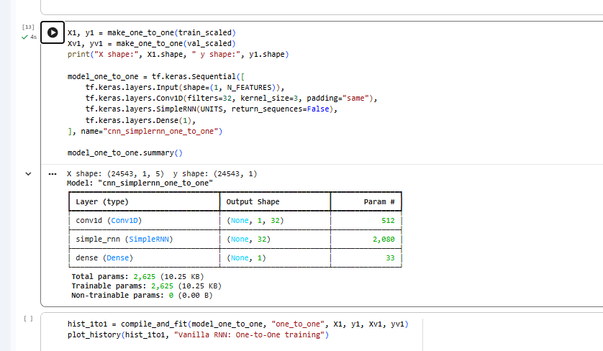
Figure 4. Model summary: cnn_simplernn_one_to_one (Conv1D added before the SimpleRNN).
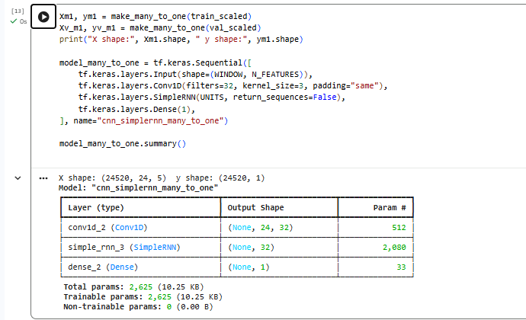
Figure 5. Model summary: cnn_simplernn_many_to_one.
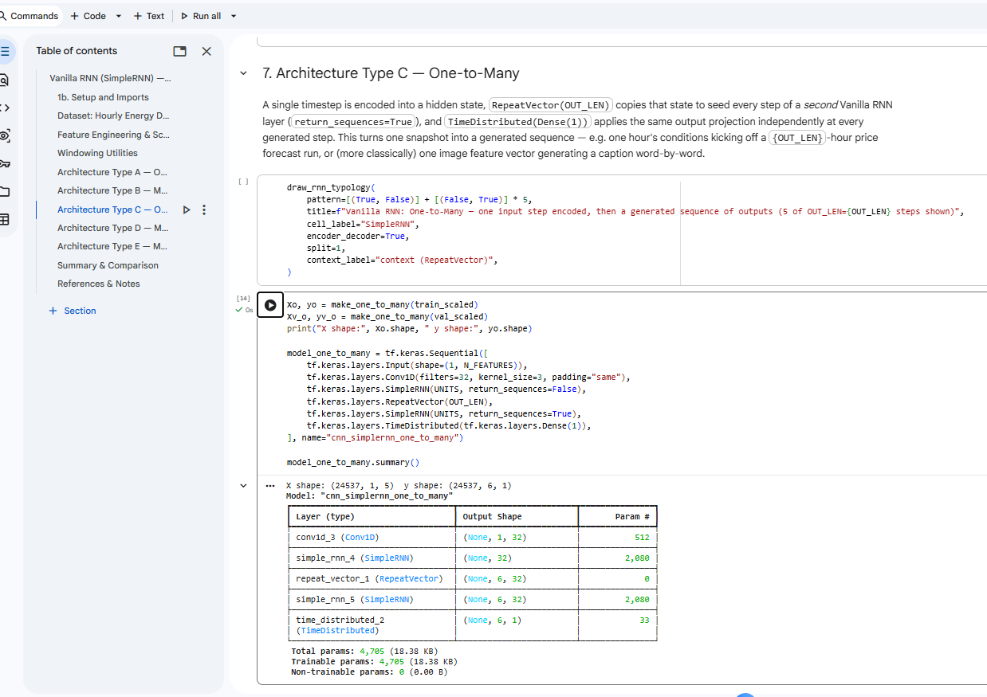
Figure 6. Model summary: cnn_simplernn_one_to_many (encoder-decoder).
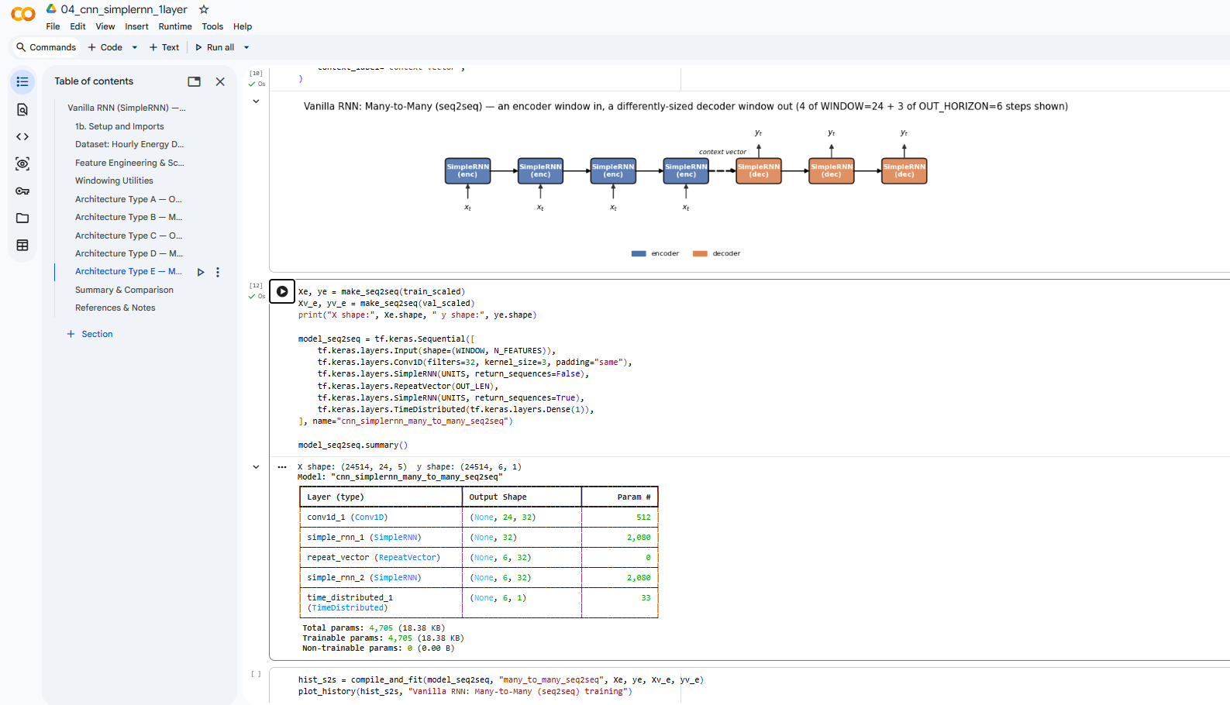
Figure 7. Model summary: cnn_simplernn_many_to_many_seq2seq (encoder-decoder).
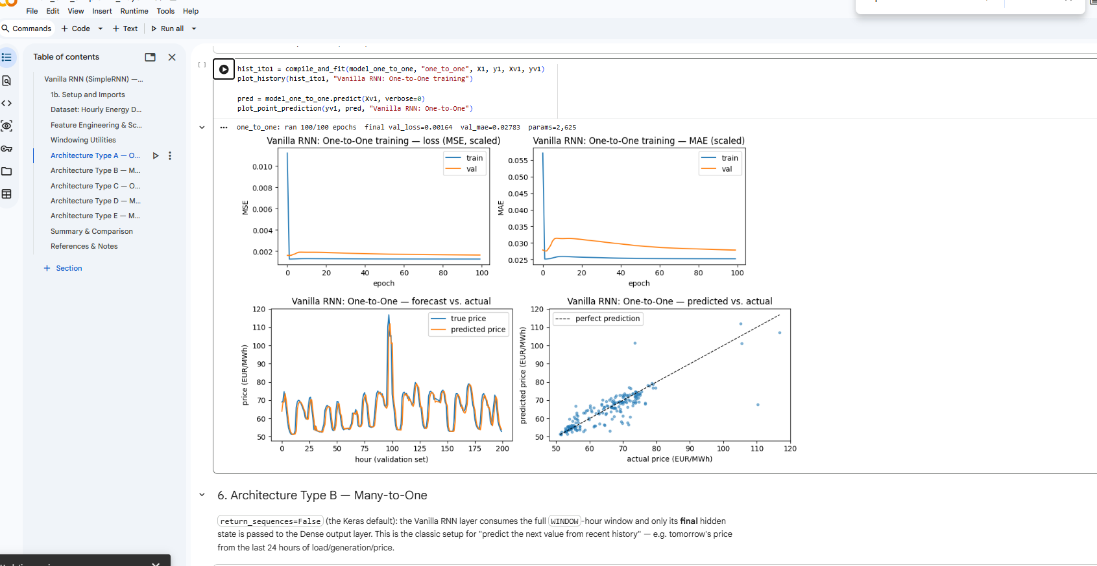
Figure 8. Training and validation curves and sample predictions: one_to_one, 100 epochs.
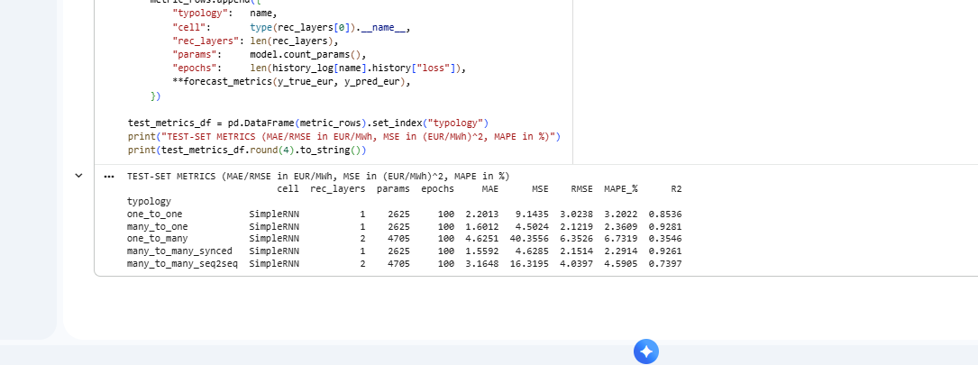
Figure 9. Test-set metrics of the five CNN + SimpleRNN models (04_cnn_simplernn_1layer.ipynb).
Table 5. One-layer SimpleRNN baseline
Typology | Params | MAE | MSE | RMSE | MAPE (%) | R²
one_to_one | 1,249 | 2.1288 | 8.7762 | 2.9625 | 3.1089 | 0.8595
many_to_one | 1,249 | 1.5676 | 4.2850 | 2.0700 | 2.3003 | 0.9316
one_to_many | 3,329 | 4.5113 | 38.1206 | 6.1742 | 6.5898 | 0.3903
many_to_many_synced | 1,249 | 1.6078 | 4.8447 | 2.2011 | 2.3732 | 0.9227
many_to_many_seq2seq | 3,329 | 3.1877 | 16.6672 | 4.0825 | 4.6342 | 0.7341

5. Item 5 — Conclusion on the Item 4 Model
Across the five sequence typologies, the CNN + SimpleRNN hybrid model achieved its highest performance in the many-to-one setup (R² = 0.9281), whereas the one-to-many typology remained the weakest performer (R² = 0.3546). Compared to the single-layer SimpleRNN baseline, integrating a Conv1D front-end resulted in marginal R² gains for many-to-many synced (+0.0034) and seq2seq (+0.0056), slight drops for one-to-one (−0.0059) and many-to-one (−0.0035), and a more pronounced reduction for one-to-many (−0.0357). While R² differences across four of the typologies were minimal (≤ 0.0060), the larger drop observed in the one-to-many setup should still be viewed with caution. Because each architecture was evaluated on only a single training run, conducting multi-seed testing across multiple runs is necessary to determine whether adding a convolutional layer systematically alters forecasting performance or if these variations stem from random initialization.

6. Item 6 — Comparison Against the One-Layer SimpleRNN Baseline
Table 6. R² of the one-layer SimpleRNN baseline versus the Item 4 model
Typology | One-layer SimpleRNN (R²) | Item 4 CNN + SimpleRNN (R²) | Difference
one_to_one | 0.8595 | 0.8536 | −0.0059
many_to_one | 0.9316 | 0.9281 | −0.0035
one_to_many | 0.3903 | 0.3546 | −0.0357
many_to_many_synced | 0.9227 | 0.9261 | +0.0034
many_to_many_seq2seq | 0.7341 | 0.7397 | +0.0056

For single-timestep sequence typologies (one_to_one and one_to_many), where the input sequence length is 1, a 3-tap Conv1D filter operates with no temporal context to exploit, functioning primarily as a linear projection of the input features that increases parameter count without leveraging sequential relationships. Conversely, for the 24-timestep typologies (many_to_one, many_to_many_synced, and many_to_many_seq2seq), where the 3-tap Conv1D kernel captures local temporal context across 3 consecutive hourly time steps—utilizing padding="causal" in synced and padding="same" in the other two—the resulting R² shifts against the baseline were minimal, ranging from −0.0035 to +0.0056. Additionally, while adding the Conv1D front-end increased model parameters by exactly 1,376 across all setups—from 1,249 to 2,625 for single-recurrent-layer models and from 3,329 to 4,705 for encoder-decoder models—only two typologies demonstrated slight R² gains while three experienced reductions, providing no clear systematic benefit for the added parameters and highlighting that multi-seed evaluations across multiple training runs are necessary to confirm whether these performance shifts stem from the architectural modification or random seed variance.

