CNN HYPERPARAMETER TUNING: KERAS TUNER VS. MANUAL TUNING
2D CNN Model — Dogs vs. Cats Image Classification
Frances Frangelico S. Friginal, MITOctober 5, 2026
DOES 1C3-DIT / DENG11G1Prof. Rolando Pula
AI USE DECLARATION
I declare that an AI assistant (Gemini and Gemini Notebook) was used in the preparation of this activity in the following ways:
Guidance — step-by-step hints on which notebook cells to modify so that the source notebook ran on my train, validation, and test splits.
Debugging — identifying an indentation error, a missing comma, and incomplete cell contents encountered during the session.
Verification — checking the values in my comparison table and the figures in my written discussion against the outputs of my own runs.
Document preparation — assembling this document from my completed table, written discussion, and screenshots.
All reported accuracy, loss, and training values were produced by running the notebook myself, and the discussion in Section 6 is my own writing.
1. Project / Experiment Information
Project / Experiment Title | Keras Tuner Hyperparameter Optimization vs. Manual Tuning of a CNN on the Dogs vs. Cats Dataset
Model Architecture | 2D Convolutional Neural Network (Conv2D)
Dataset Used | Kaggle Dogs vs. Cats images (Dog/ and Cat/ folders)
Notebook / File Reference | CNN_Keras_Tuner_FRIGINAL.ipynb (adapted from Loading_Dataset_and_CNN_optimized.ipynb by Rolando A. Pula)
Platform | Google Colab, T4 GPU runtime
Prepared By | Frances Frangelico S. Friginal, MIT
Date | October 2, 2026
Experiment / Trial No. | 10 Hyperband trials (search) + 1 final training run
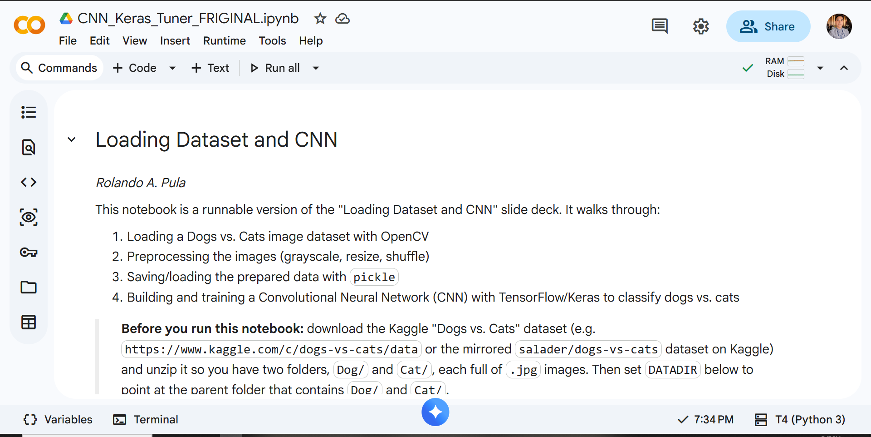
Figure 1. Google Colab notebook and T4 GPU runtime used for this activity.
2. Data and Split
Parameter | Value
Images | 24,997 images, resized to 100 × 100, grayscale
Pixel Normalization | X / 255.0, applied once
Train-Test Split | Stratified 80/20, random_state = 42: 19,997 training and 5,000 test images (same split as the manual tuning)
Tuner Validation Split | Training set split again, stratified 80/20, random_state = 42: 15,997 training and 4,000 validation images
Test Set Use | Held out; not used during the search or training; evaluated once after training
3. Keras Tuner Configuration
Setting | Value
Tuner | Hyperband
Objective | val_accuracy
max_epochs / factor | 6 / 3 (the notebook default of max_epochs = 15 was reduced to keep the search time manageable)
Trials / Search Time | 10 trials, 16 minutes 12 seconds
Search Callback | EarlyStopping (monitor = val_loss, patience = 3)
Final Training | Up to 50 epochs; EarlyStopping (patience = 5, restore_best_weights = True) and ReduceLROnPlateau (factor = 0.5, patience = 2)
Outcome | Training stopped at Epoch 16; weights from Epoch 11 (lowest validation loss, 0.3512) were restored

Search Space — Hyperparameter | Range
Number of convolutional blocks | 2 to 4 (step 1)
Filters per convolutional layer | 32 to 256 (step 32)
Kernel size per convolutional layer | 3 or 5
Number of dense layers | 1 to 2
Units per dense layer | 32 to 256 (step 32)
Dropout rate | 0.0 to 0.5 (step 0.1)
Learning rate | 0.0001 to 0.01 (log scale)
Optimizer | Adam or RMSprop
Batch size | 32, 64, or 128
4. Comparison: Manual Tuning vs. Keras Tuner
Hyperparameter / Metric | Manual Tuning (Final Model) | Keras Tuner (Best Trial)
1. Architecture | 3 Conv2D layers (8 - 64 - 64 filters, 3×3) + 1 Dense (64 units) | 4 Conv2D layers (64 - 128 - 32 - 32 filters, 3×3) + 2 Dense (192 - 32 units)
2. Optimizer | Adam | RMSprop
3. Learning Rate | 0.001 | 0.00039186
4. Batch Size | 128 | 32
5. Epochs | 40 (fixed) | 16 total (stopped by Early Stopping; best weights restored from Epoch 11)
6. Dropout | 0.25 (Conv layers) + 0.50 (Dense layer) | 0.1
7. Train Accuracy | 0.8937 | 0.9379 (Epoch 11)
8. Validation Accuracy | 0.8543 | 0.8637 (Epoch 11)
9. Test Accuracy | 0.8538 | 0.8628
10. Test Loss | 0.3476 | 0.3518
5. Run Evidence (Screenshots)
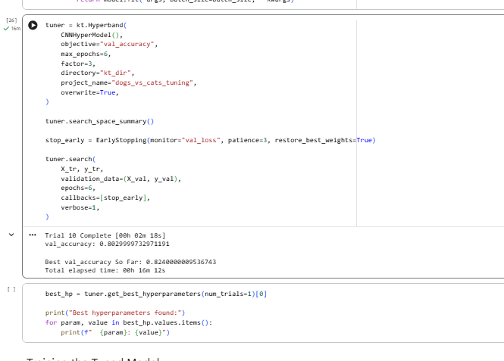
Figure 2. Completion of the Hyperband search (Trial 10, total elapsed time 16 min 12 s).
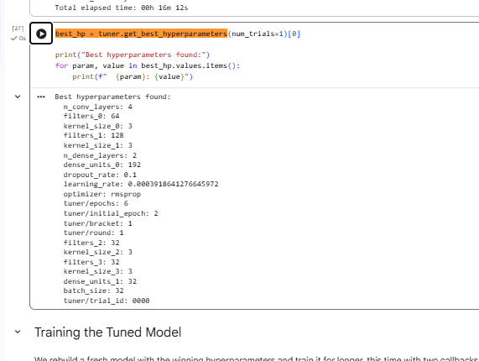
Figure 3. Best hyperparameters found by Keras Tuner.
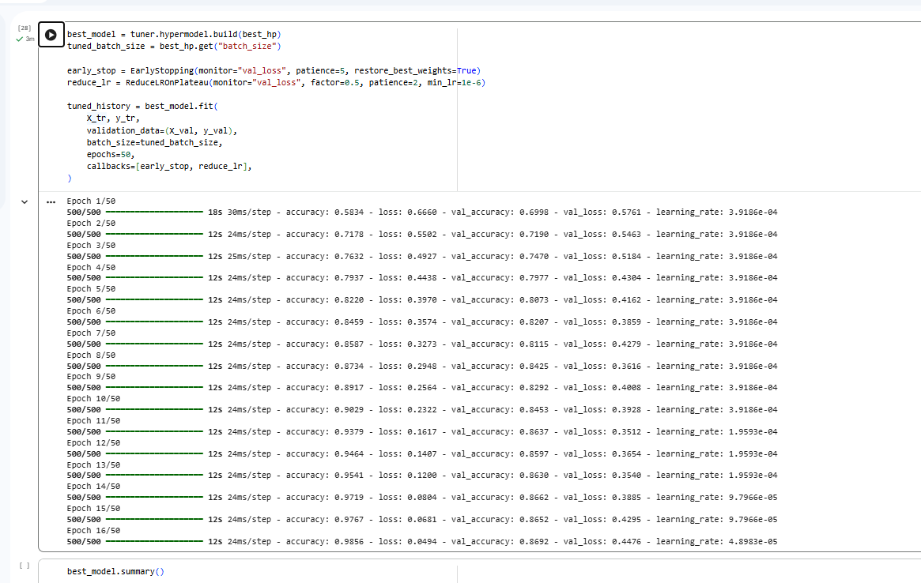
Figure 4. Training log of the tuned model (stopped at Epoch 16, best weights from Epoch 11).
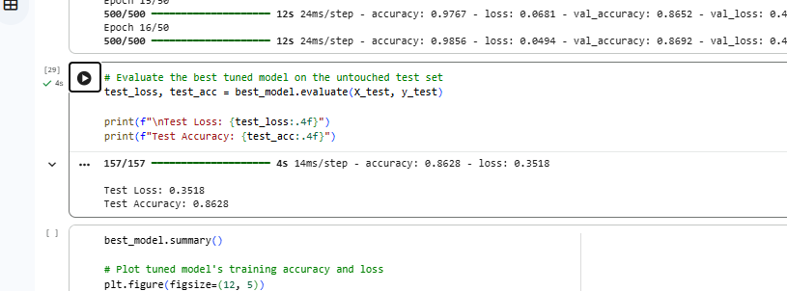
Figure 5. Evaluation of the tuned model on the held-out test set.
6. Overall Discussion / Remarks
The Keras Tuner model achieved a slightly higher test accuracy of 86.28% compared to the manual model's 85.38% (a 0.90 percentage point improvement), though its test loss was marginally higher at 0.3518 versus 0.3476. However, regarding generalization, the manual model maintained a much tighter train-test gap of 3.99 percentage points (89.37% train vs. 85.38% test), whereas the Keras Tuner model produced nearly double the gap at 7.51 percentage points (93.79% train vs. 86.28% test) likely because the selected architecture utilized a deeper 4-Conv structure alongside lighter regularization (0.1 dropout versus 0.25/0.50), despite actually containing fewer trainable parameters (348,225 vs. 451,409).
In terms of workflow efficiency, manual tuning demanded tedious trial-and-error setup for every iteration, whereas Keras Tuner fully automated the search across candidate architectures within 16 minutes. Ultimately, drawing definitive conclusions from a single run remains statistically limited due to random initialization variance, and neither approach succeeded in reaching Prof. Pula's target threshold of 90% test accuracy.
7. Notes on the Notebook
The Keras Tuner section of the notebook (from the pip install of keras-tuner through the test-set evaluation) was run by me in this session. The earlier cells that show saved outputs without a run number, such as the first baseline training and the sample predictions, carry outputs from the source notebook and are not results of this activity.

