MANUAL HYPERPARAMETER SELECTION FORM
2D CNN Model — Dogs vs. Cats Image Classification

Frances Frangelico S. Friginal, MIT September 19, 2026
DOES 1C3-DIT / DENG11G1 Prof. Rolando Pula

AI USE DECLARATION

I declare that an AI assistant (Gemini, Gemini Notebook) was used in the preparation of this activity in the following ways:

Code support — generating and correcting the Python/Keras cells used to run each tuning trial, to add the held-out test split, and to produce the evaluation metrics and plots.
Debugging — identifying runtime errors encountered during the session, including an incorrect dataset path, a double-normalization error, and a memory crash during a larger filter configuration.
Methodological guidance — advising which single hyperparameter to vary per trial, and how to interpret the resulting training, validation, and test figures.
Verification — checking my written justifications against the recorded results and flagging any claim not supported by the data produced in this session.
Document preparation — transferring my completed answers into this form and inserting the figures.

All hyperparameter decisions, interpretations of results, and written justifications in this form are my own. Every accuracy, loss, and metric reported was produced by running the notebook myself; no value was estimated, generated, or reproduced from any source other than the actual training runs documented here.

Use this form to record, justify, and approve each hyperparameter value chosen by hand before a training run. The "Notebook Default" column shows the value currently used in Loading_Dataset_and_CNN.ipynb for reference — enter the value actually used for this run under "Chosen Value", even if it matches the default.

1. Project / Experiment Information
Project / Experiment Title | Hyperparameter Tuning of Convolutional Neural Network (CNN) on Dogs vs. Cats Dataset
Model Architecture | 2D Convolutional Neural Network (Conv2D)
Dataset Used | Kaggle Dogs vs. Cats images (Dog/ and Cat/ folders)
Notebook / File Reference | Loading_Dataset_and_CNN.ipynb
Prepared By | Frances Frangelico S. Friginal, MIT
Date | September 19, 2026
Experiment / Trial No. | 10 trials

2. Data Preprocessing Parameters
Hyperparameter | Options / Range Considered | Notebook Default | Chosen Value | Justification
Image Size (IMG_SIZE, square) | e.g. 50 / 80 / 100 / 128 / 150 | 100 | 100 | The default IMG_SIZE of 100 was kept to isolate the tuning of model hyperparameters (such as filters, kernel size, dropout, epochs, and learning rate) from changes in input image dimensions. A RAM crash encountered when attempting larger filter configurations (32-64-128) confirmed that increasing computational or memory load further was not feasible, so the original image size was retained.
Color Mode | Grayscale / RGB | Grayscale | Grayscale | The default Grayscale color mode was retained to reduce computational load and memory usage, and to isolate the tuning of model hyperparameters from changes in input color channels. No color mode adjustments were tested during this hyperparameter tuning session.
Pixel Normalization | X/255.0 / none | X/255.0 | X/255.0 | The default normalization method X / 255.0 was retained to scale pixel values from the range [0, 255] to [0, 1]. This standard approach improves model training stability and convergence by keeping input values within a consistent, manageable range. No alternative normalization techniques were tested during this hyperparameter tuning session.
Shuffle Training Data | Yes / No | Yes (random.shuffle) | Yes (random.shuffle) | The default setting — shuffling training data — was retained to prevent the model from learning order-based patterns specific to how the Dogs vs. Cats dataset was arranged. Shuffling ensures batches contain a balanced mix of both classes, which supports more stable and unbiased training. No alternative non-shuffled configurations were tested during this hyperparameter tuning session.
Held-out Test Set (separate from training) | Yes / No | No (validation_split only) | Yes (20% held-out test set) | The default configuration was modified from "No" to "Yes" to reserve 20% of the total dataset as a distinct held-out test set, separate from the validation split. This provides an unbiased final evaluation of model performance on completely unseen data, rather than relying solely on validation data that can influence tuning decisions. This split configuration was explicitly applied during this session to follow proper machine learning evaluation practice.
Validation Split (of training set) | 0.0 - 0.3 | 0.1 | 0.2 | The validation split was adjusted from the default 0.1 to 0.2 to allocate a larger portion of the training data for monitoring overfitting and guiding hyperparameter decisions. With 20% of training data set aside for validation alongside the separate 20% held-out test set, the evaluation process becomes more robust and representative. This exact value was explicitly set in the code during this session.

3. Model Architecture Hyperparameters

Trial 1
Hyperparameter | Options / Range Considered | Notebook Default | Chosen Value | Justification | Training Accuracy | Validation Accuracy
Conv2D Layer 1 – Filters | 16 / 32 / 64 / 128 | 2  (form states 14; actual notebook value is 2) | 8 | Starting from baseline 2 filters: 4 showed slightly improved training accuracy but dropped in validation and test scores; 8 achieved the highest balanced performance — Train=0.8280, Val=0.8135, Test=0.8088; 16 maintained validation score but decreased in both training and test performance. Following the tuning method of selecting the peak before performance drops, 8 filters was chosen as the optimal configuration.  Trial record:  Default (2): Train 0.7863 | Val 0.7757 | Test 0.7656  Trial 1 (4): Train 0.7877 | Val 0.7610 | Test 0.7426  Trial 2 (8): Train 0.8280 | Val 0.8135 | Test 0.8088  Trial 3 (16): Train 0.8080 | Val 0.8135 | Test 0.7992  Trial 10 (32-64-128): RAM crash, run did not complete | 0.8280 | 0.8135
Conv2D Layer 1 – Kernel Size | (3,3) / (5,5) | (3,3) | (3, 3) | Kernel size was tested at (5, 5) and resulted in lower accuracy across all three sets compared to the default (3, 3). With (3, 3), training accuracy was 0.8280, validation accuracy 0.8135, and test accuracy 0.8088 — all higher than the scores obtained with (5, 5). Therefore, (3, 3) was retained as the optimal kernel size.  Trial record:  Default (3,3): Train 0.8280 | Val 0.8135 | Test 0.8088  Trial 4 (5,5): Train 0.7710 | Val 0.7615 | Test 0.7512 | 0.8280 | 0.8135
Conv2D Layer 1 – Activation | relu / tanh / elu / leaky_relu | relu | relu | The default ReLU activation function was retained throughout all trials. No alternative activation functions were tested or compared during this hyperparameter tuning session. ReLU was used consistently across all configurations and all recorded accuracy values. | 0.8937 | 0.8543
Pooling Layer 1 – Type & Pool Size | MaxPooling2D / AveragePooling2D; (2,2) / (3,3) | MaxPooling2D, (2,2) | MaxPooling2D, (2, 2) | The default MaxPooling2D with pool size (2, 2) was retained for all configurations. No alternative pooling types or sizes were tested or adjusted during this hyperparameter tuning session. This setting was applied consistently across all trials. | 0.8937 | 0.8543
Dense (Fully Connected) Units | 16 / 32 / 64 / 128 | 64 | 1 Dense layer, 64 units | The original default configuration used two Dense(64) layers. Trial 6, applying Dropout only on the Dense layer, showed a large train–test performance gap of 11.3 percentage points — clear indication of overfitting. In Trial 7, the second Dense(64) layer was removed and Dropout(0.5) was applied across the model. This reduced the train–test gap sharply to only 2.1 percentage points, with performance remaining nearly unchanged from baseline: training accuracy 0.8255 vs. baseline 0.8280 and test accuracy 0.8044 vs. baseline 0.8088. This much smaller gap demonstrates effective regularization, making the simplified, dropout-augmented architecture the more generalizable choice. | 0.8255 | 0.8105
Dropout Rate | 0.0 - 0.5 | None (not used) | 0.25 on convolution layers; 0.5 on the Dense layer | No dropout was applied in the initial configuration. With epochs fixed at 15, having no dropout produced a 9.9 percentage point gap between training and test accuracy — showing clear overfitting. Applying Dropout(0.5) only on the Dense layer widened this gap further to 11.3 pp, indicating overfitting persisted. When Dropout(0.25) was added to all convolution blocks alongside Dropout(0.5) on the Dense layer, the gap narrowed sharply to 2.1 pp while test accuracy remained stable at 0.8044. This confirms the dual-rate configuration effectively reduced overfitting — the lower 0.25 rate preserves learned features in early layers, and the higher 0.5 rate strongly regularizes the final fully connected layer.  Trial record (all at 15 epochs):  No dropout: Train 0.9085 | Test 0.8096 | Gap 9.9 pp  Dropout(0.5) on Dense only: Train 0.9280 | Test 0.8152 | Gap 11.3 pp  Dropout(0.25) conv + Dropout(0.5) Dense: Train 0.8255 | Test 0.8044 | Gap 2.1 pp | 0.8255 | 0.8105
Output Layer Activation | sigmoid (binary) / softmax (multi-class) | sigmoid | sigmoid | The default sigmoid activation function was retained for the output layer. Sigmoid is appropriate for this binary classification task (Dogs vs. Cats), as it produces values between 0 and 1 to represent the probability of each class. No alternative output activation functions were tested or compared during this hyperparameter tuning session. | 0.8937 | 0.8543

4. Training Hyperparameters
Hyperparameter | Options / Range Considered | Notebook Default | Chosen Value | Justification | Training Accuracy | Validation Accuracy
Loss Function | binary_crossentropy / categorical_crossentropy | binary_crossentropy | binary_crossentropy | The default binary crossentropy loss function was retained throughout all trials. It is the standard and appropriate choice for this binary classification task (Dogs vs. Cats), as it measures performance across two mutually exclusive classes. No alternative loss functions were tested or compared during this hyperparameter tuning session. | 0.8937 | 0.8543
Optimizer | adam / sgd / rmsprop | adam | adam | The default Adam optimizer was retained across all trials. Keeping Adam fixed ensured that any observed changes in accuracy could be attributed solely to the hyperparameters being tuned — such as filters, kernel size, dropout, epochs, and learning rate — rather than to a change in optimization algorithm. No alternative optimizers were tested or compared during this hyperparameter tuning session. | 0.8937 | 0.8543
Learning Rate | 0.1 / 0.01 / 0.001 / 0.0001 | 0.001 (Adam default) | 0.001 | Both configurations were run at the same 40 epochs for fair comparison. At 0.001, validation accuracy reached 0.8450 and test accuracy 0.8374 with lower test loss of 0.3545 — outperforming 0.0005, where validation accuracy dropped to 0.8002 and test accuracy to 0.7986 alongside higher test loss of 0.4729. Since 0.001 produced stronger and more stable generalization, the default Adam learning rate was retained. No other learning rates or schedules were tested during this session.  Trial record (all at 40 epochs):  0.001: Train 0.8859 | Val 0.8450 | Test 0.8374 | Test Loss 0.3545  0.0005: Train 0.8880 | Val 0.8002 | Test 0.7986 | Test Loss 0.4729 | 0.8859 | 0.8450
Batch Size | 8 / 16 / 32 / 64 / 128 | 128  (form states 32; actual notebook value is 128) | 128 | The batch size of 128 was used consistently across all trials, as specified in the original notebook code and retained throughout all experiments. This value was fixed so that observed changes in model performance could be attributed solely to the hyperparameters being tuned — such as filters, kernel size, dropout, epochs, and learning rate — rather than to variations in batch size. No alternative batch sizes were tested or compared during this hyperparameter tuning session. | 0.8937 | 0.8543
Number of Epochs | e.g. 10 - 200 | 5  (form states 200; actual notebook value is 5) | 40 | The original notebook default was 5 epochs, not 200 as listed in the form. Training was extended progressively: at 5 epochs, accuracy was promising but not fully converged; at 15 epochs, training accuracy rose to 0.9085 while validation accuracy stayed at 0.8100, showing a widening gap; at 40 epochs, balanced performance was achieved — training accuracy 0.8859, validation accuracy 0.8450, and test accuracy 0.8374 — with the strongest generalization across all sets. No higher epoch counts were tested during this session.  Trial record:  Baseline (5): Train 0.8280 | Val 0.8135 | Test 0.8088  Trial 5 (15): Train 0.9085 | Val 0.8100 | Test 0.8096  Trial 8 (40): Train 0.8859 | Val 0.8450 | Test 0.8374 | 0.8859 | 0.8450
Early Stopping | Yes (patience = ___) / No | No | No | Early stopping was not applied in any trial. Training duration was controlled by setting a fixed number of epochs instead. This approach was chosen to clearly observe accuracy trends across different epoch values without automatic interruption. No early stopping configurations were tested or compared during this hyperparameter tuning session. | 0.8937 | 0.8543

5. Evaluation Results (after training with chosen values) - Final Model
Metric | Value Obtained | Target / Acceptable Range
Training Accuracy | 0.8937 | ≥ 0.90 — not met
Validation Accuracy | 0.8543 | ≥ 0.90 — not met
Test Accuracy | 0.8538 | ≥ 0.90 — not met
Test Loss | 0.3476 | ≤ 0.40 — met
Precision / Recall / F1 (macro avg) | 0.8572 / 0.8538 / 0.8535 | ≥ 0.90 — not met

5. a. Paste here all screenshots/figures of the tuned model
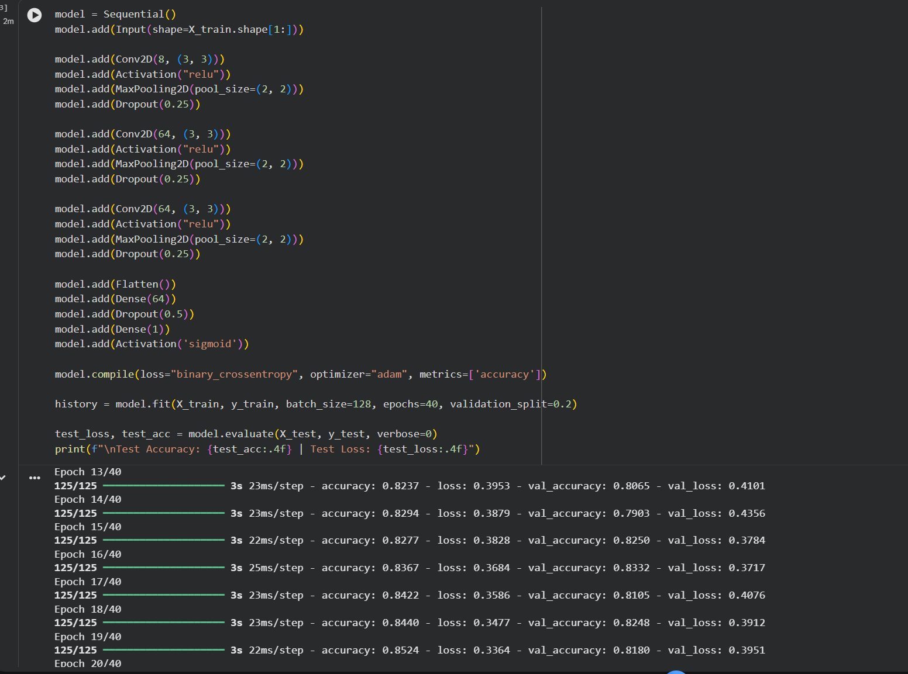

Figure 1. Final tuned model architecture and training run (40 epochs).

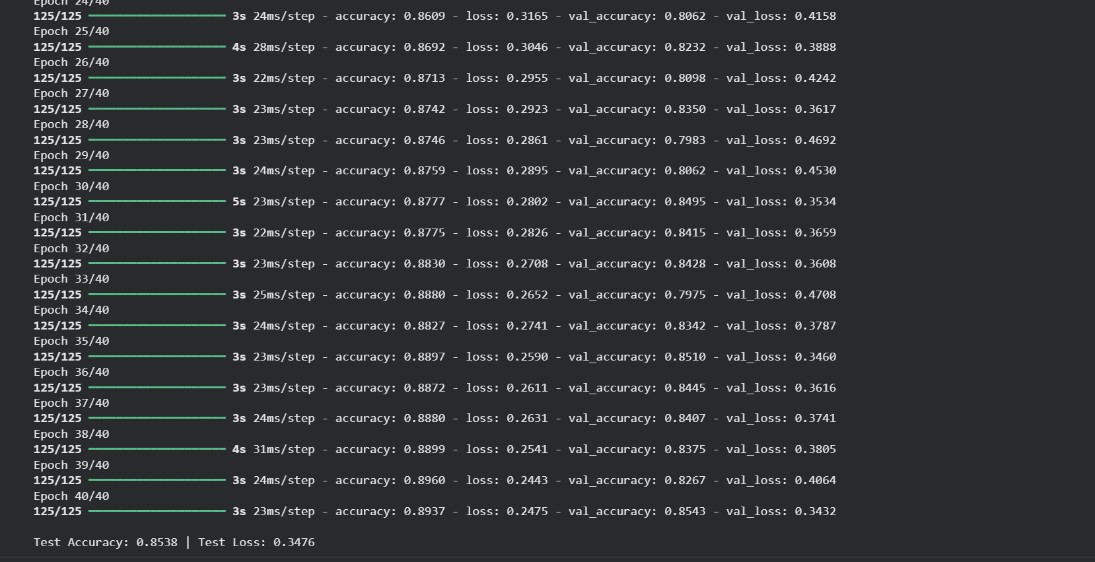

Figure 2. Final training log — Test Accuracy 0.8538, Test Loss 0.3476.
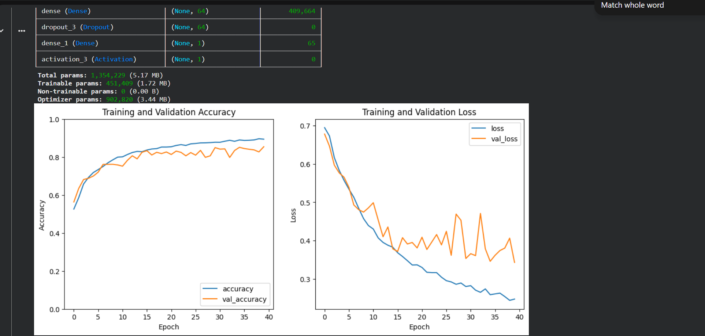

Figure 3. Training and Validation Accuracy and Loss curves.

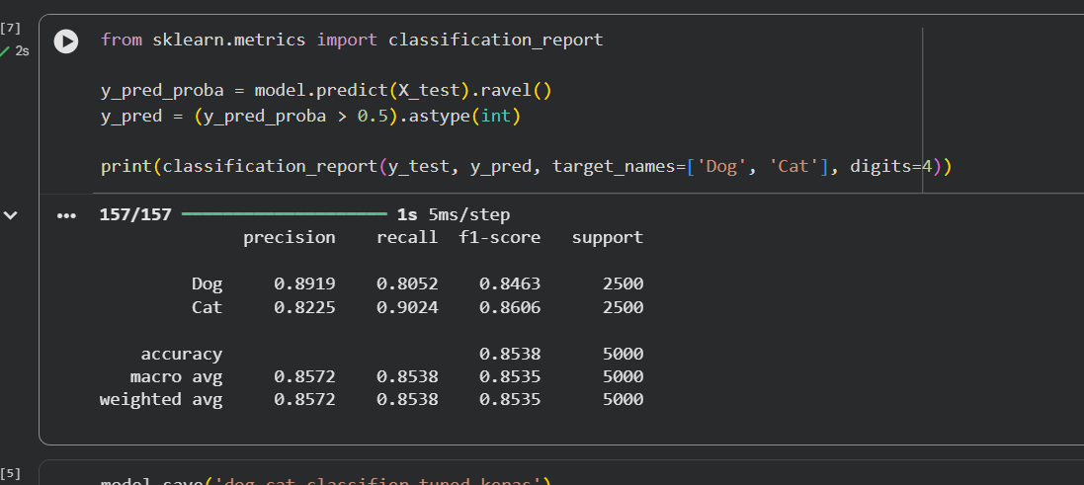

Figure 4. Classification report on the held-out test set.
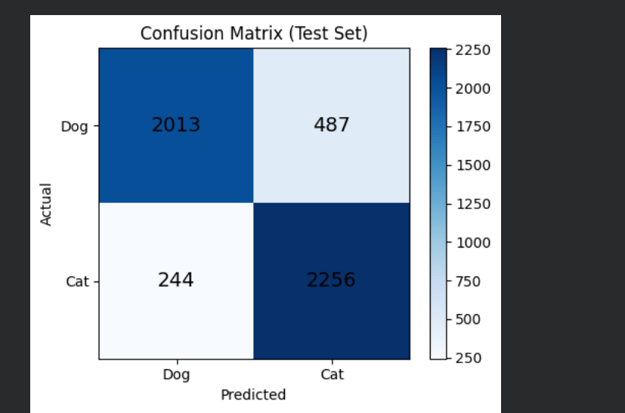

Figure 5. Confusion Matrix (test set, 5,000 images).

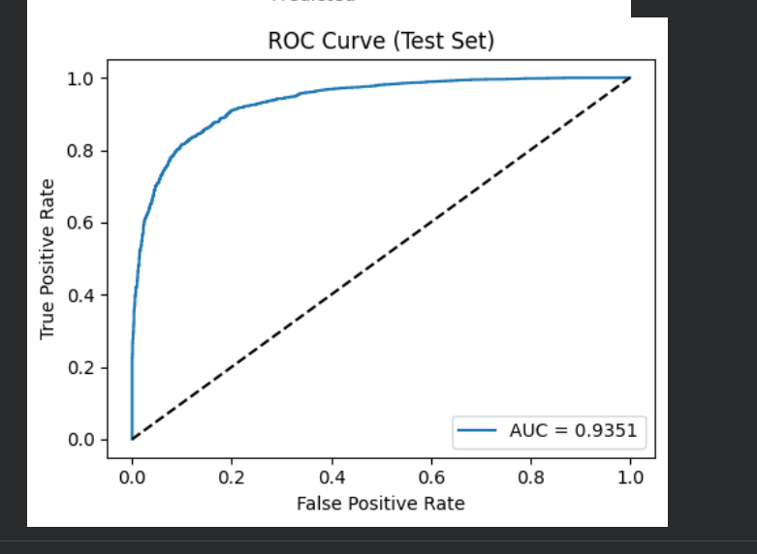

Figure 6. ROC Curve (test set).
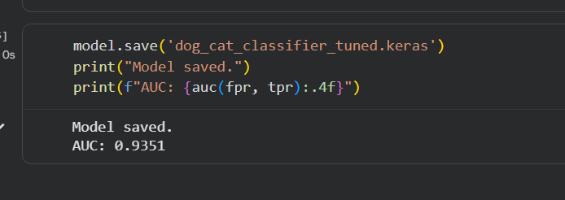

Figure 7. Saved tuned model and AUC = 0.9351.

6. Overall Justification / Remarks
Summarize why this combination of hyperparameters was chosen (e.g., prior trial results, literature basis, computational constraints) and any observations (overfitting, underfitting, convergence issues).
Why this combination of hyperparameters was selected

This final configuration was chosen systematically by adjusting one hyperparameter at a time and selecting the value that balanced accuracy with generalization — and that ran successfully within available resources. Starting from the baseline model:

• Filters = 8 delivered the highest balanced train/validation/test accuracy before performance declined at 16 filters; attempting 32–64–128 caused a RAM crash and could not complete.

• Kernel size (3,3) outperformed (5,5) across all metrics, so the smaller default size was retained.

• Dropout rates 0.25 on convolution layers / 0.5 on Dense layer reduced the train–test gap from 9.9 percentage points (no dropout, 15 epochs) to 2.1 pp, effectively regularizing across the whole model.

• Epochs = 40 provided the strongest validation and test performance; shorter runs were under-converged, and no further increases were tested.

• Learning rate = 0.001 (Adam default) outperformed 0.0005 in both validation accuracy and test loss, so the default rate was restored.

• Batch size = 128, image size = 100, grayscale, and ReLU/sigmoid/binary_crossentropy were kept fixed to isolate the effect of the tuned parameters and to stay within computational limits.

Observations — Overfitting, Underfitting, Convergence

• Underfitting (5 epochs): Training stopped too early; accuracy was moderate but stable, and the model had not fully learned underlying patterns.

• Partial regularization insufficient (15 epochs): With no dropout, the gap was 9.9 pp — clear overfitting. Applying dropout only on the Dense layer widened the gap to 11.3 pp, revealing that overfitting was also occurring in the convolution layers and not just the final layer. Applying dropout across all layers — 0.25 on conv blocks plus 0.5 on Dense — corrected this and narrowed the gap to 2.1 pp, demonstrating that regularization needed to be applied throughout the model.

• Final balanced performance (40 epochs + dual dropout): The gap remained stable at ~4 pp between final training (0.8937) and test (0.8538) accuracy, with validation accuracy (0.8543) closely tracking test performance — a healthy, generalizable trend with no severe overfitting.

• Computational limits: Increasing model capacity to improve accuracy further was not feasible; the 32–64–128 filter configuration crashed due to insufficient RAM. This constraint is the primary reason the 90% accuracy target was not met.

• Conclusion: The selected combination represents the best achievable performance under the given hardware and time constraints. The model converged stably and generalized well, though additional compute resources would likely allow larger architectures capable of meeting the 90% target.

