[**McMurphy**](https://quickfingerstraders.slack.com/team/U735G40J3)[9:42 AM](https://quickfingerstraders.slack.com/archives/C6UD4DXQD/p1518532967000037)

ATMS/BTC :cryptopia: 0.62 vol

Consistent ranges 20-30% and spikes once or twice a week 40-70%. Just bought in at 700 and selling at 900 this time around. Next time aiming for 1050(edited)

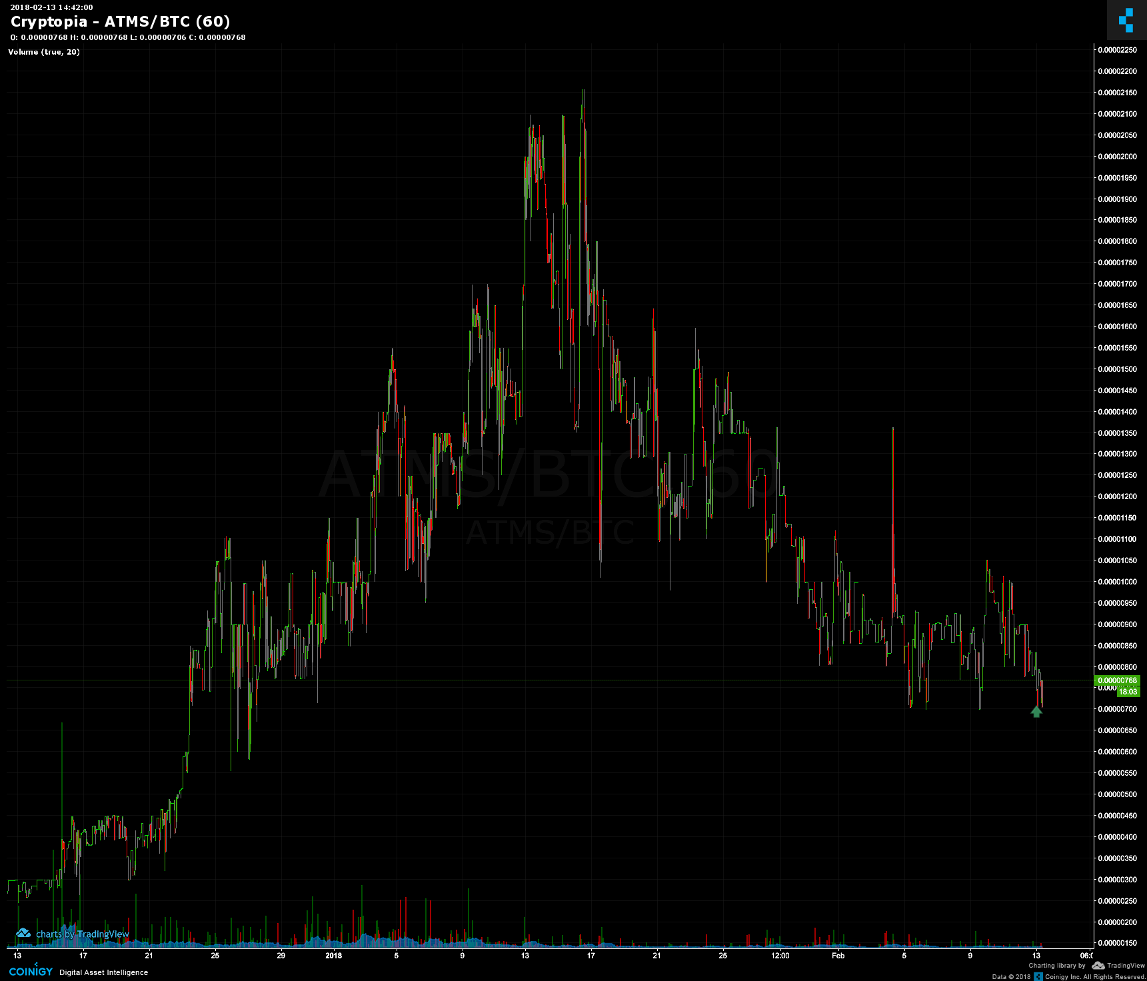

[**PTRS**](https://quickfingerstraders.slack.com/team/U7F72F4MS)[10:29 AM](https://quickfingerstraders.slack.com/archives/C6UD4DXQD/p1518535749000725)

IZE/BTC :cryptopia: 0.17 vol

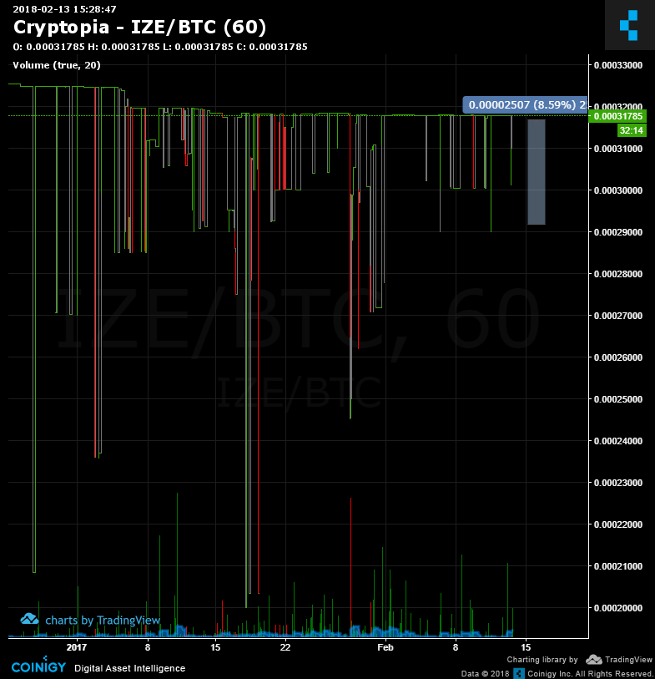

[**fulloflife**](https://quickfingerstraders.slack.com/team/U6QMWLJ23)[11:27 AM](https://quickfingerstraders.slack.com/archives/C6UD4DXQD/p1518539265000808)

8BIT/BTC:cryptopia:0.06BTC

I'm setting order on low of this range

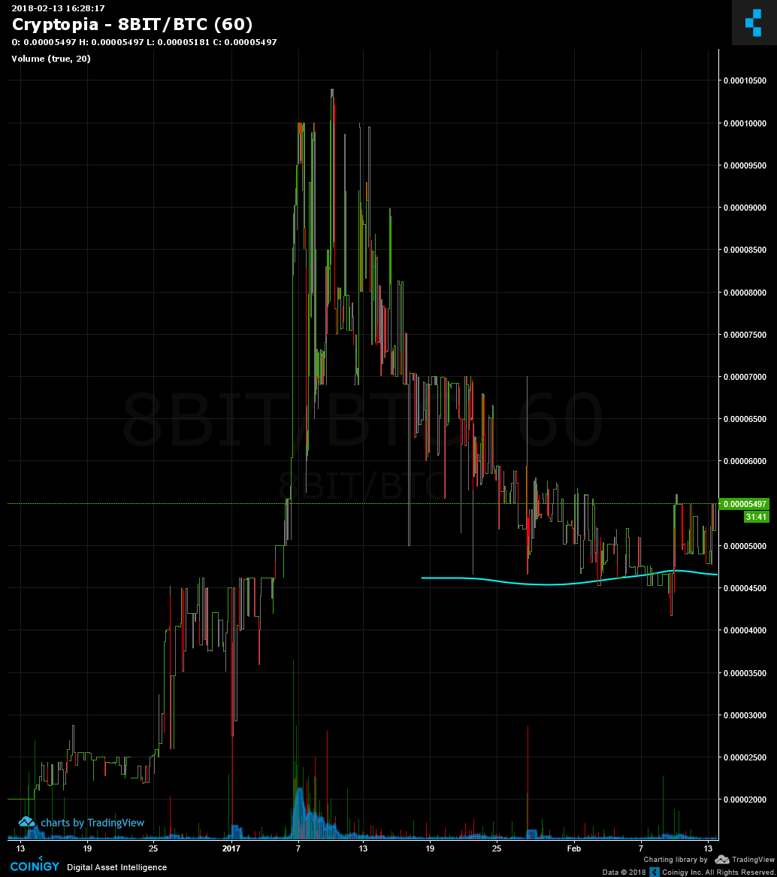

[**fulloflife**](https://quickfingerstraders.slack.com/team/U6QMWLJ23)[11:36 AM](https://quickfingerstraders.slack.com/archives/C6UD4DXQD/p1518539775000552)

AC/BTC :cryptopia: 1.18BTC

30% range ..I'm setting order on the bottom

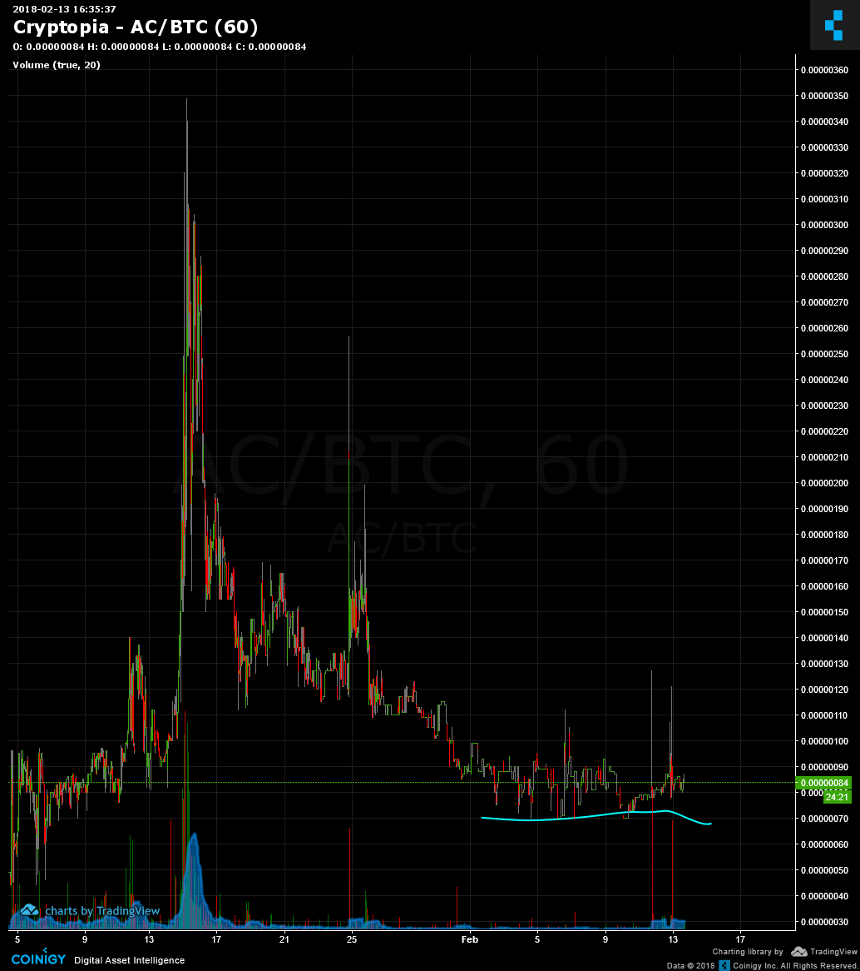

[**fulloflife**](https://quickfingerstraders.slack.com/team/U6QMWLJ23)[11:39 AM](https://quickfingerstraders.slack.com/archives/C6UD4DXQD/p1518539987000332)

ACOIN/BTC :cryptopia: 0.07 BTC

big range. I'm setting order lower waiting for those drops

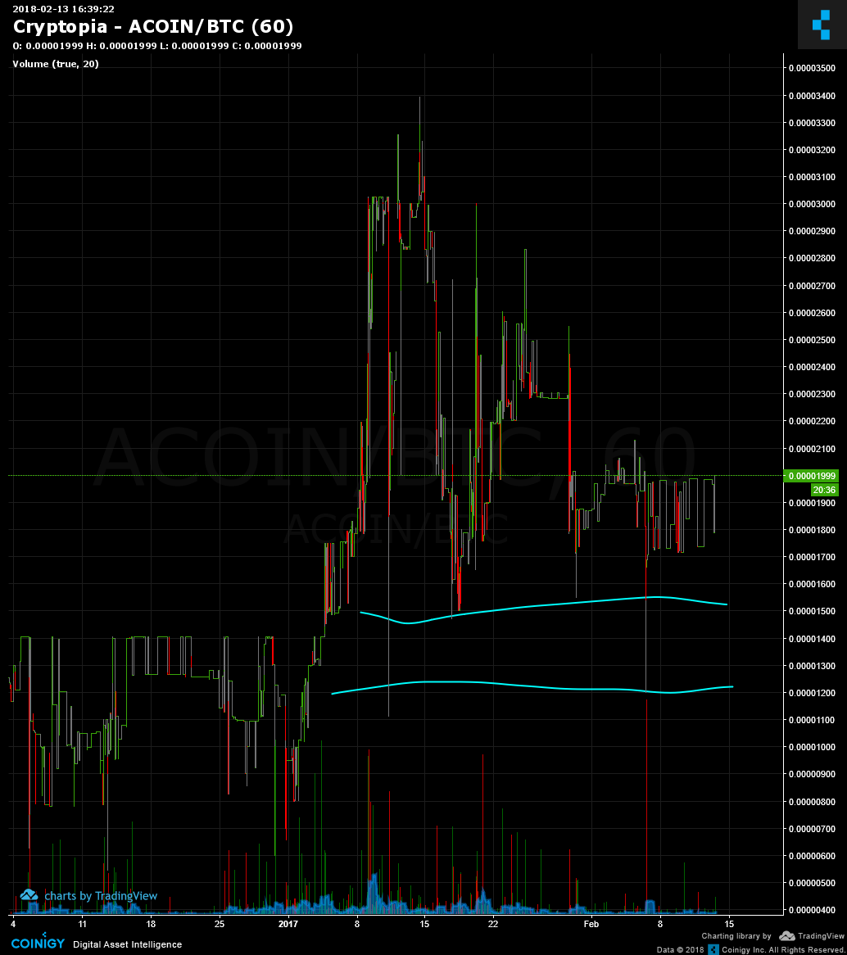

[**fulloflife**](https://quickfingerstraders.slack.com/team/U6QMWLJ23)[11:56 AM](https://quickfingerstraders.slack.com/archives/C6UD4DXQD/p1518541011000062)

ARCO/BTC :cryptopia: 0.07BTC

I'm setting orders on the bottom of those spikes

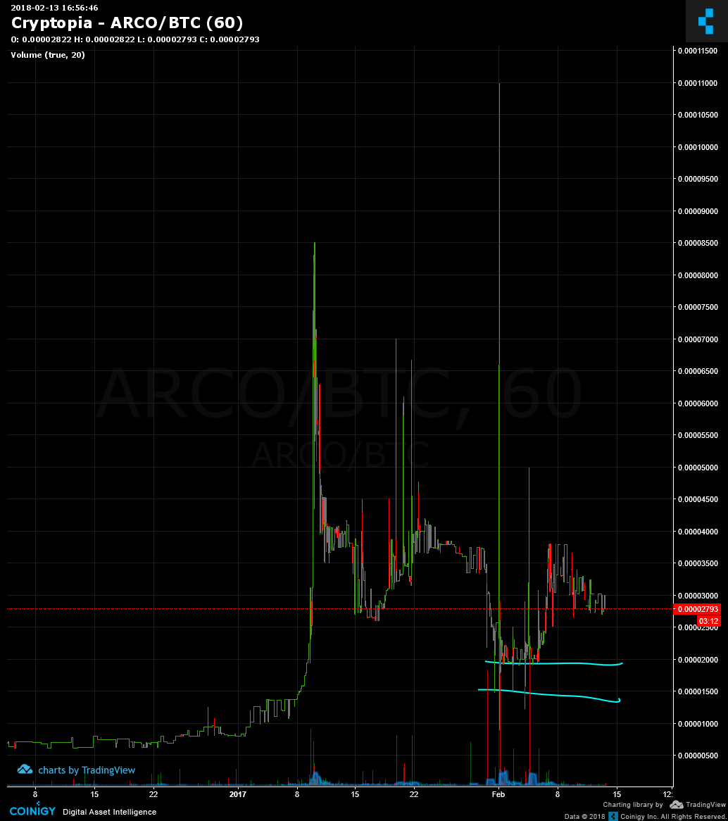

[**fulloflife**](https://quickfingerstraders.slack.com/team/U6QMWLJ23)[12:00 PM](https://quickfingerstraders.slack.com/archives/C6UD4DXQD/p1518541221000204)

ARG/BTC :cryptopia: 0.31 BTC

20% range ... setting orders on those to lower ones

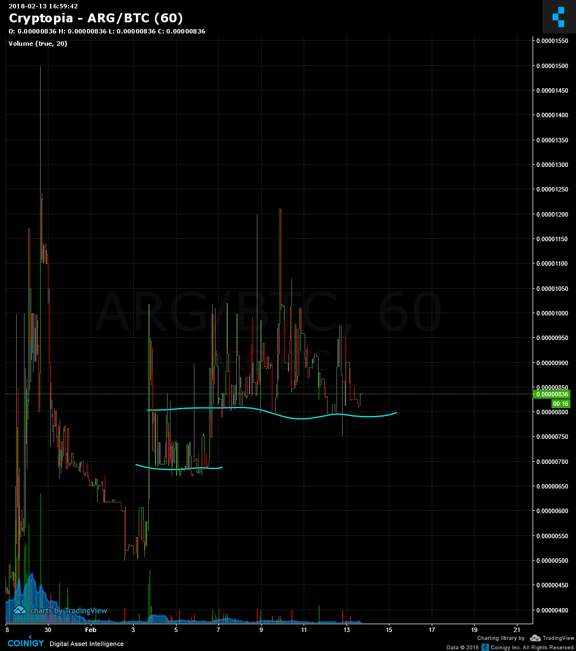

[**fulloflife**](https://quickfingerstraders.slack.com/team/U6QMWLJ23)[12:04 PM](https://quickfingerstraders.slack.com/archives/C6UD4DXQD/p1518541456000520)

ARGUS/BTC :cryptopia: 0.13BTC

with spikes it's like 70-100% range. I'm setting order on bottom line

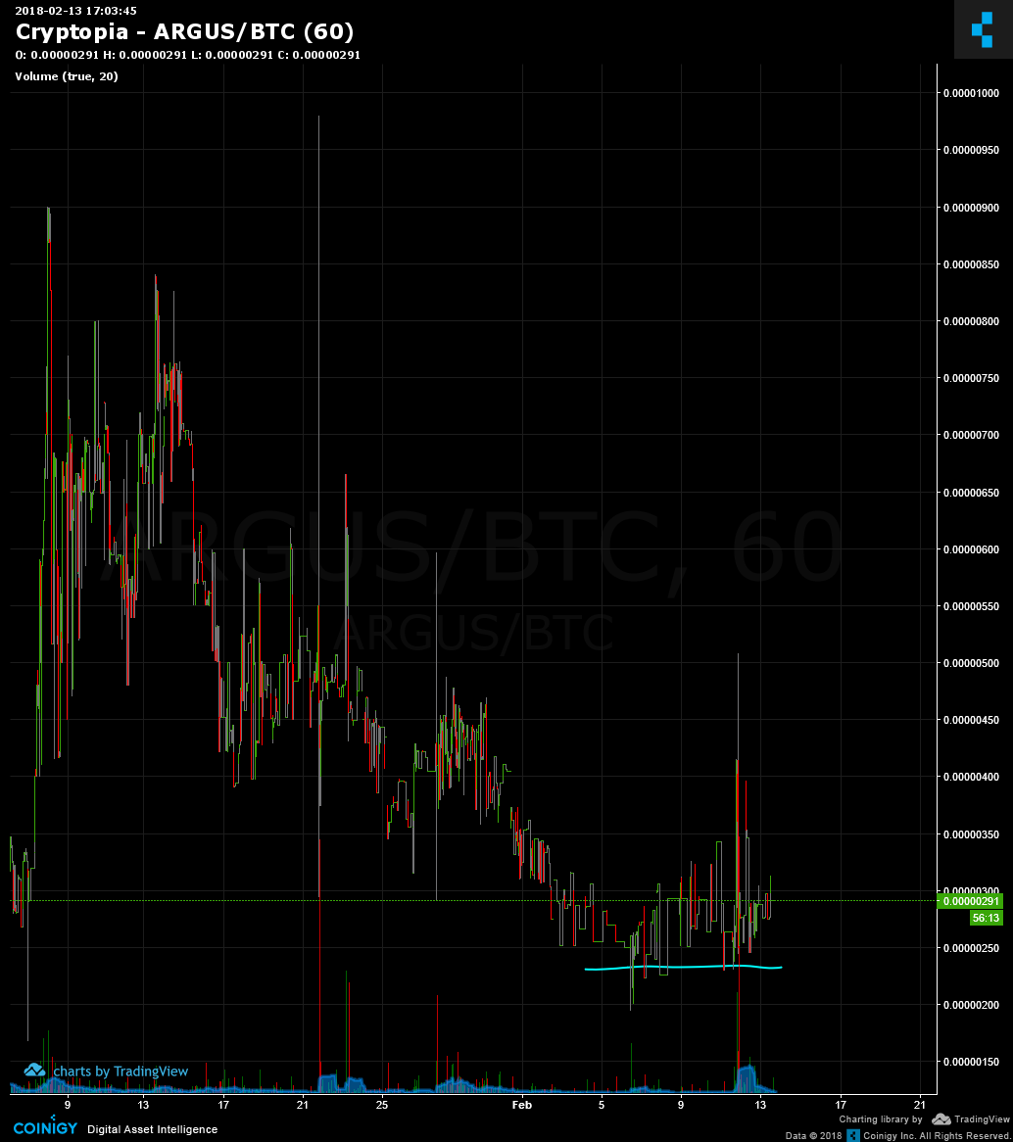

[**fulloflife**](https://quickfingerstraders.slack.com/team/U6QMWLJ23)[12:10 PM](https://quickfingerstraders.slack.com/archives/C6UD4DXQD/p1518541835000194)

BEEZ/BTC :cryptopia: 0.03 BTC

40% range + spikes. Order in the bottom of the range.

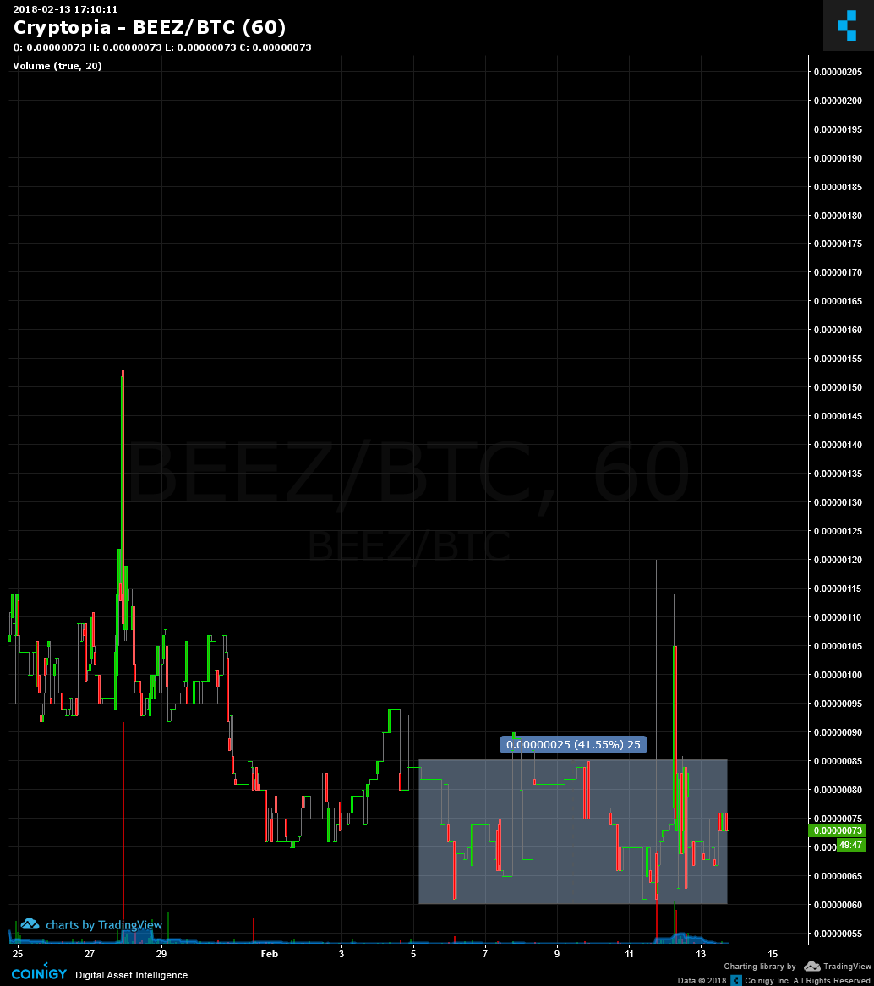

[**fulloflife**](https://quickfingerstraders.slack.com/team/U6QMWLJ23)[12:12 PM](https://quickfingerstraders.slack.com/archives/C6UD4DXQD/p1518541965000544)

BENJI/BTC :cryptopia: 0.97BTC

min 80% range. Order in the bottom of those down spikes.

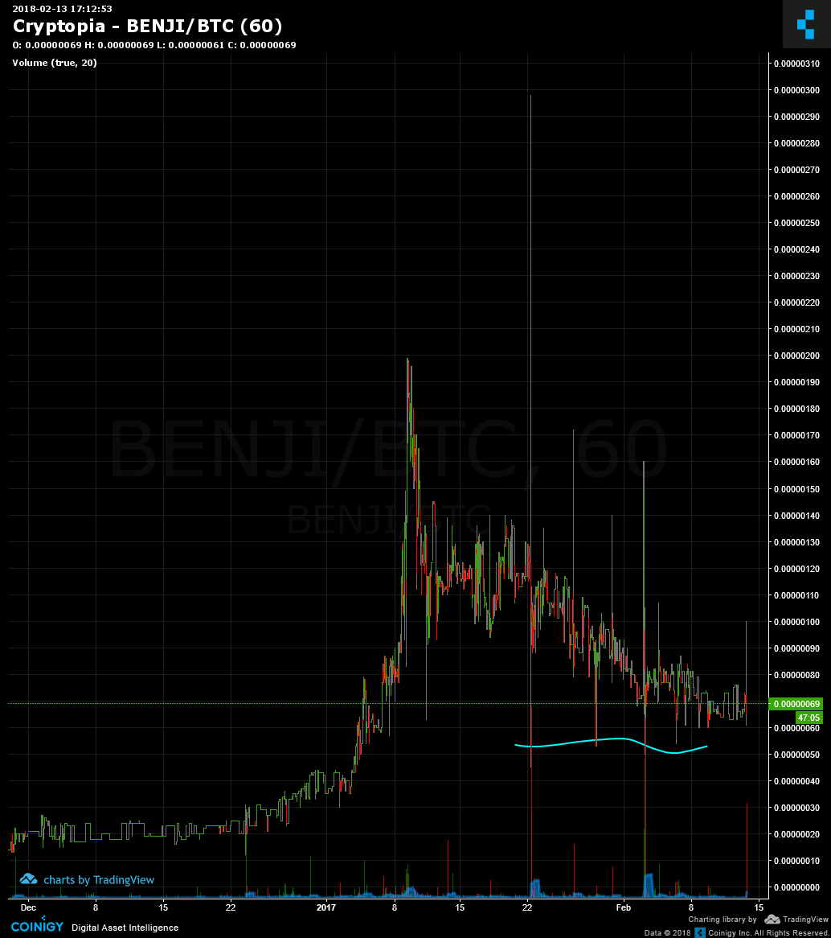

[**akpolarbeartamer**](https://quickfingerstraders.slack.com/team/U6QBD33DK)[12:14 PM](https://quickfingerstraders.slack.com/archives/C6UD4DXQD/p1518542071000389)

EUC/BTC :cryptopia: 0.14 BTC

100+% upspikes from the 0.00000250 range/floor semi consistently the last few weeks

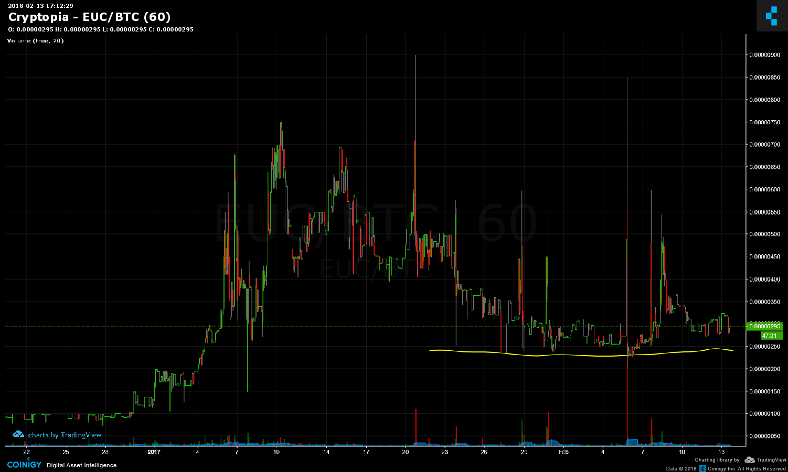

[**Canyon**](https://quickfingerstraders.slack.com/team/U7265488L)[12:16 PM](https://quickfingerstraders.slack.com/archives/C6UD4DXQD/p1518542180000126)

UIS/BTC :cryptopia: .024 BTC Vol

nibbles below 500 and layer out the sell orders.

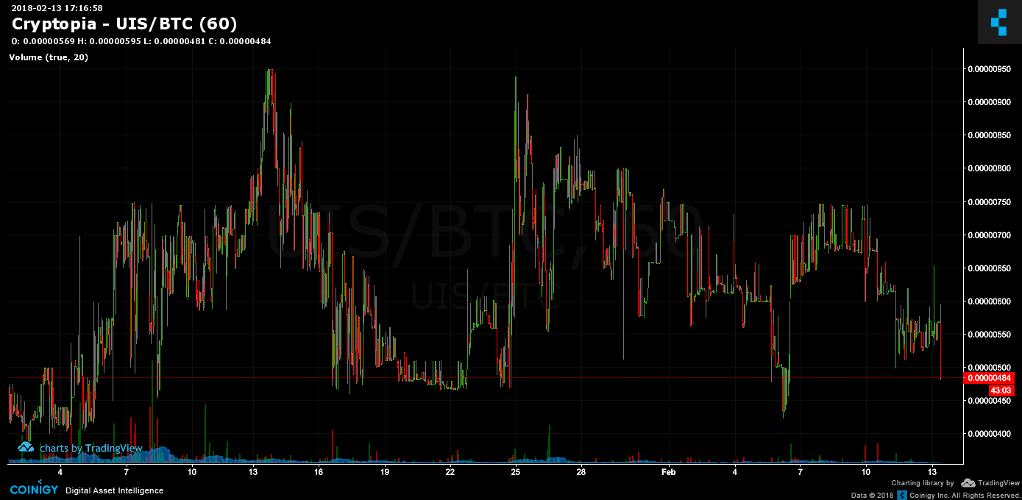

[**fulloflife**](https://quickfingerstraders.slack.com/team/U6QMWLJ23)[12:34 PM](https://quickfingerstraders.slack.com/archives/C6UD4DXQD/p1518543284000253)

BLC/BTC :cryptopia: 0.18BTC

100% range ... order on bottom spikes

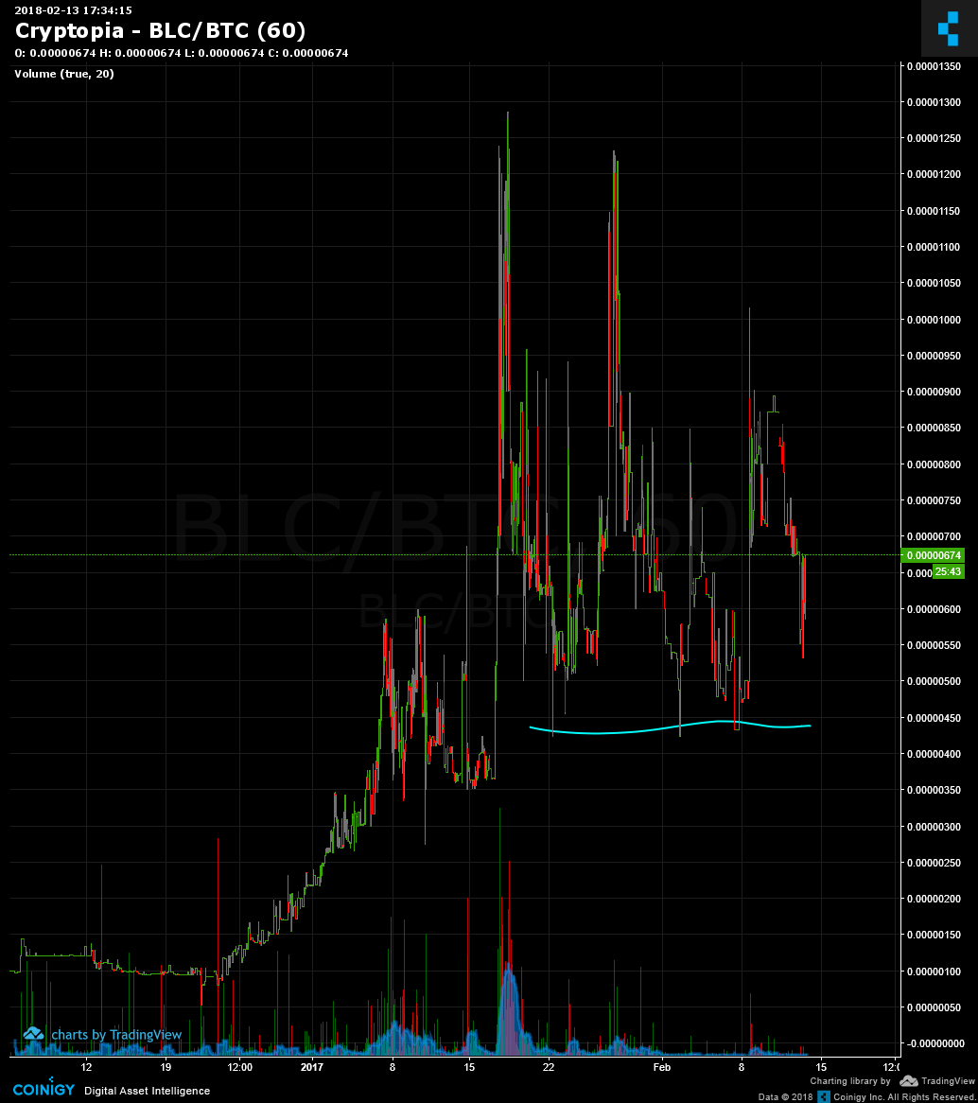

[**freethinkingaway**](https://quickfingerstraders.slack.com/team/U6S7JCELX)[1:54 PM](https://quickfingerstraders.slack.com/archives/C6UD4DXQD/p1518548049000542)

CAT/USDT :hitbit: 0.4774 BTC Vol

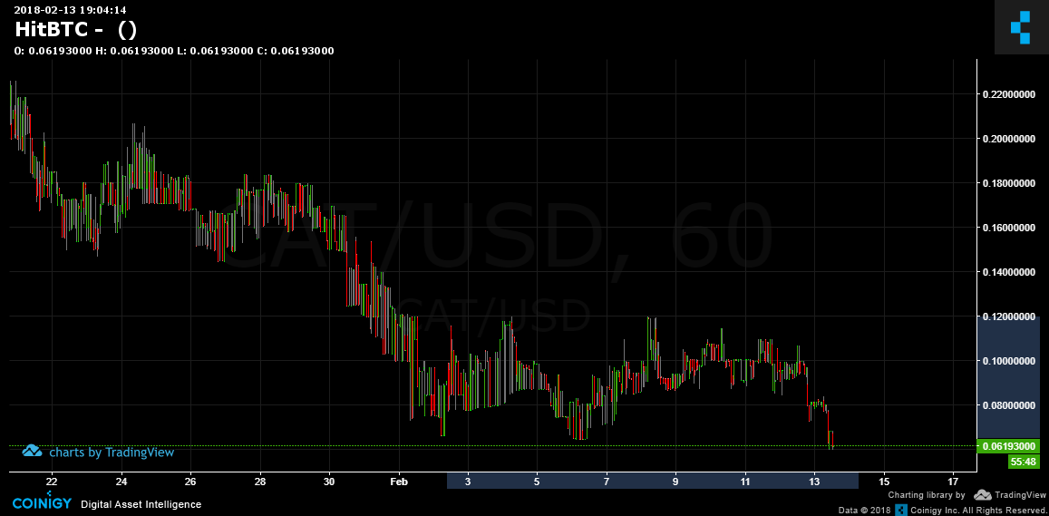

[**Turrican**](https://quickfingerstraders.slack.com/team/U77AAG8KH)[2:44 PM](https://quickfingerstraders.slack.com/archives/C6UD4DXQD/p1518551096000560)

CRX/BTC :cryptopia: 0.091 BTC

Spikes to ~100 order at 73-80

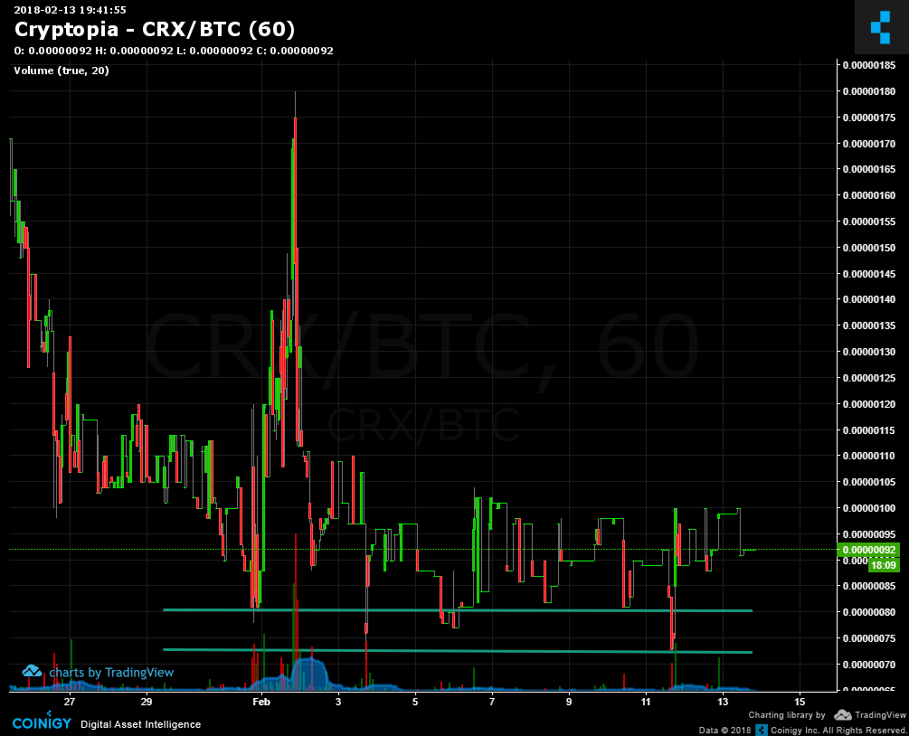

[**FromLittleAcorns**](https://quickfingerstraders.slack.com/team/U8001B2AK)[3:58 PM](https://quickfingerstraders.slack.com/archives/C6UD4DXQD/p1518555539000625)

LBT/BTC :cryptopia: 0.29 BTC

Good spikes, just bought in on this drop, looking for 100% spike

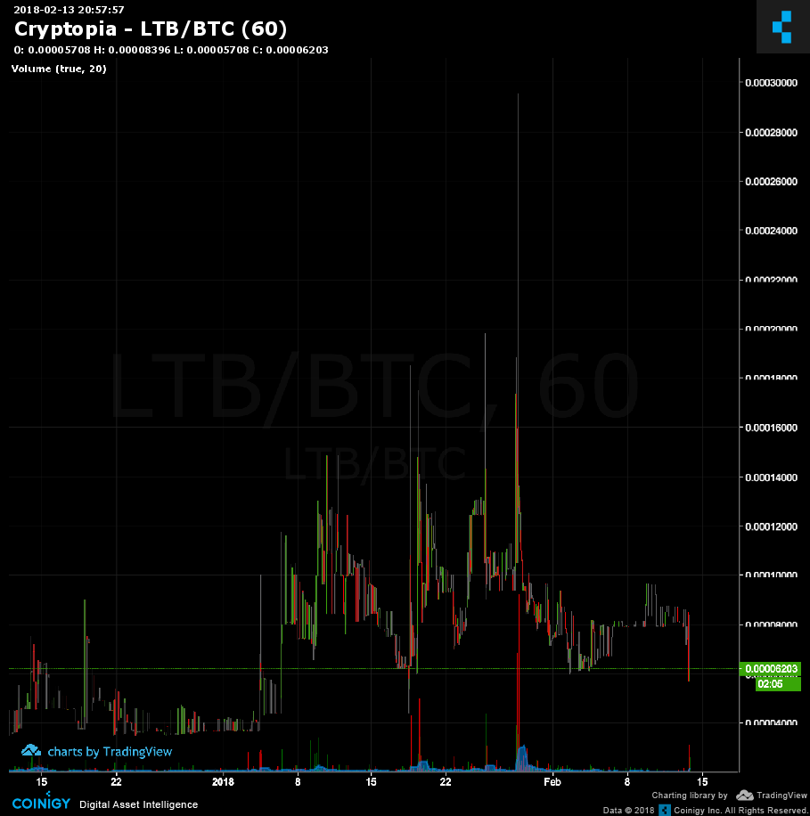

[**FromLittleAcorns**](https://quickfingerstraders.slack.com/team/U8001B2AK)[4:08 PM](https://quickfingerstraders.slack.com/archives/C6UD4DXQD/p1518556092000070)

CNO/BTC :cryptopia: 0.14 BTC

Just dropped to a good buy in position I think, reasonable range

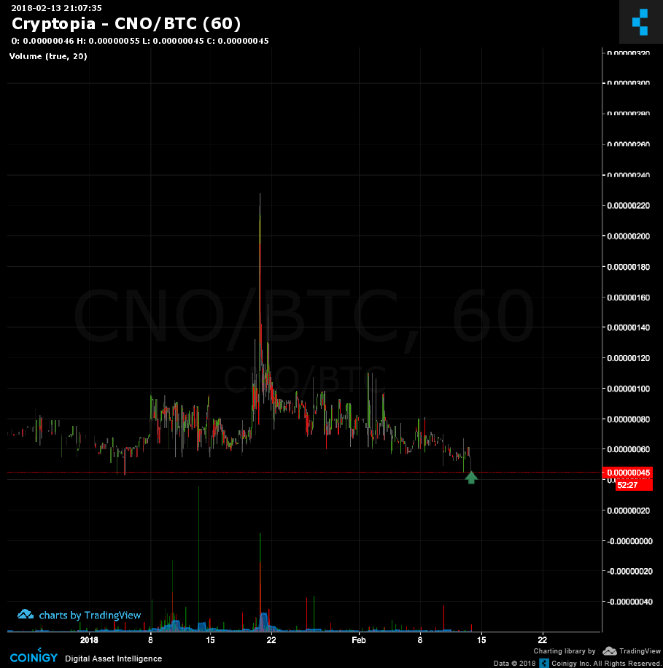

[**grayman**](https://quickfingerstraders.slack.com/team/U6KLYTAEA)[4:18 PM](https://quickfingerstraders.slack.com/archives/C6UD4DXQD/p1518556717000090)

HAV/BTC :cryptopia: 1.1BTC

FFs and 80% spikes, the whole package

