**Crystal-amorphous transition based on graphene nanoribbon knot**

Mechanical and thermal transport properties of graphene nanoribbon knots, are systematically investigated using nonequilibrium molecular dynamics. It is found that the thermal conductivity of the ribbon decreases largely due to the presence of the knots as a defect, but with the increasing of strain, the Kapitza resistance decreases, which is due to a tighter contacting of the ribbon with itself or the other. Local phonon analysis is applied to the contacting regime to reveal the influence of the contacts on the transport. This work would be helpful for a deeper understanding of thermal conducting at nanoscale and give a guidance to the field of phonon management material design.

Keywords: Thermal conductivity,, knots , nonequilibrium, molecular dynamics

I.INTRODUCTION

Graphene and graphene nanoribbon (GNR) are the key role of condensed matter physics because of its excellent mechanical, electrical, and thermal properties. For example, the strength of a graphene ribbon is 10F/m^2 which is able to hangup a 10t car even if it’s only 1us width. And the Thermal conductivity is 5000W/mK at room temperature, making it the most conducting material in this world.

However, as in the polymers, knots and canrao defects widely exists in one-dimension materials and they affects a lot both the mechanical and thermal properties. Some works has been done in this field, for example, Kagimura et al1 has investigated the single knot defects using DFT and some information about energy and electronics are found. In experiment, Zhang et al has prepared an extremely long (up to 1m) graphene ribbon concluding a knot. Besides single knots, canrao can produce double knot and a contacting regime builds. This contacting can conduct heat but is much weaker and this part of heat is sensitive to the strain.

In this paper, we systematically investigate the strain and the thermal conducitivity of several types of knots. The content is arranged as follows: in section II we give a thoughout description of the method in this paper; in section III we discuss the mechanics properties and in section IV the thermal conducitivity is concerned. We believe this work could give some information about low-demensional nano materials and guide a way to a deeper understanding of phonon engagement field.

II. COMPUTATIONAL DETAILS

The strain are applied directly on the ends atoms with given magnitudes and directions.

Non-equilibrium molecular dynamics (NEMD) simulation2 is used to calculate thermal conductivity. In NEMD simulations, thermal conductivity in the x direction is calculated from Fourier formula.

, (1)

where is the average gradient of temperature calculated with linear fitting. And is heat flux calculated from the Nose-Hover work h, and the angular bracket denotes an ensemble average. S is the crossover area.

A periodic boundary condition is applied in the y (transverse) direction, and a free boundary condition is applied in the other two directions. For each realization, all the atoms are initially placed at their equilibrium positions and then minimized at zero pressure. Then, the most two ends are fixed to reduce the drift and rotation, and the unfixed part has a random velocity according to Gaussian distribution which are then equilibrated at a given temperature 300K with a Nose-Hover thermostat3 of steps (0.1ns). After that, the temperature difference is built using two Nose-Hoover heat bath of 290K and 310K respectively at the two region behind the fixed region while the main parts remain NVE for another steps (5.0 ns) to drive the system to a stable temperature and heat flux distribution. After that, thermal conductivity is calculated according to Eq. (1). The final result is averaged over 5 realizations with different initial conditions. The calculation configuration is shown in Fig. 1.

The structures are prepared using interactive molecular dynamics (IMD). A graphene ribbon is mapped isodistantly to part of the knot curve described by the Trefoil equation,

x=s(sin t+2sin2t)

y= s(cost-2cos2t)

z= s(-sin3t)

we chose s large enough to avoid oversuppesing according to the length and width of the ribbon. The structures are shown in Fig. 2.

Then the system is given an initial velocity distribution of guassian at 300K while two strains are applied at the two ends towards the opposite directions. Meanwhile the mass center drifting is removed. We apply Verlet algorithm for 200000 steps when the system is in a stable state.

Various unit cells are constructed to explore the dopants ratio and distribution dependence of thermal conductivity. A typical view of unit cells of graphene,, and CN respectively is showed in Fig. 2. The atomic structure of is initially constructed from graphene structure with unit cells in the x, y, and z directions, respectively. The unit cell is chosen to be rectangular in the demand of NEMD. Each of them includes 208 atoms and is large

enough in the y direction so we can ignore the transverse size-confinement effect.

The BCN Tersoff potential is used as it can accurately describe the elastic properties. In the BCN potential both two-body term and three-body term are concerned that are able to stabilize the graphene-like structure. Numerically, velocity Verlet algorithm4 is employed to integrate Newton's equations of motion, and each MD step is set as 0.5 fs. We do not adapt quantum correction in this study as its effect is quite small at room temperature. The whole trends of our results are verified using Muller-Plathe method5.

All the simulations are carried out with LAMMPS6.

III.RESULTS AND DISCCUSION

The knot has a weak mechanical strength compared to the original graphene ribbon. Fig.3 shows the strain-displacement curve of the knot at different temperatures.

The thermal conductivity of random alloys are dopant ratio sensitive while that of regular alloys are not. Fig. 3(a) shows the calculated thermal conductivity of with different distribution versus doping ratio at 300K. For the usual random doping, only a 1% doping of nitrogen induces the reduction of thermal conductivity of 35% due to the presence of doping results in scatter of phonons and produce more localized modes. And it is reduced to almost 0 when the dopant ratio reaches 0.2, beyond which the structure is no more stable and we won’t consider it. Besides, for the regular distribution of nitrogen we have a much different curve. It not only has a much slower reduction at low dopant ratio, but increase when the ratio is beyond 1/13. If the ratio is small, these curves will overlap because of the less difference between regular and random alloys.

The distribution of dopants affects the thermal conductivity of alloys a lot. When the distribution of nitrogen is optimized using metropolis MC before the usual minimization of their positions, the curve moves upwards. The points along y axis in Fig. 3(a) represent the thermal conductivity of structures with the same dopant ratio but different distribution.

A more stable structure is more thermal conductive. Fig. 3(b) shows the thermal conductivity of with different ratio versus atom-averaged energy. It is clear that with the same dopant ratio, the thermal conductivity increases when the atom-averaged energy decreases. As the structure being more stable, the energy changes slower and slower, and a small change in energy leads to a relatively large thermal conductivity difference. Usually a more stable structure is more regular in its symmetry, and it’s of significant importance to explore how thermal conductivity depends on the structure symmetry.

For the specific graphene knot, the simulation is carried 5 times with different seeds.

The first small drop comes from the dislocation of the knot. As you can see, a new column of atoms are stretched out from the knot

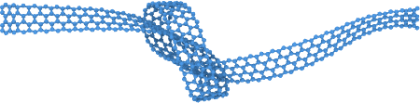

The curve is history dependent, but it can return to the initial state if the strain is not beyong the start from strain=0, the max positive strain is chosen to be 0.05 to avoid irreversible splitting.

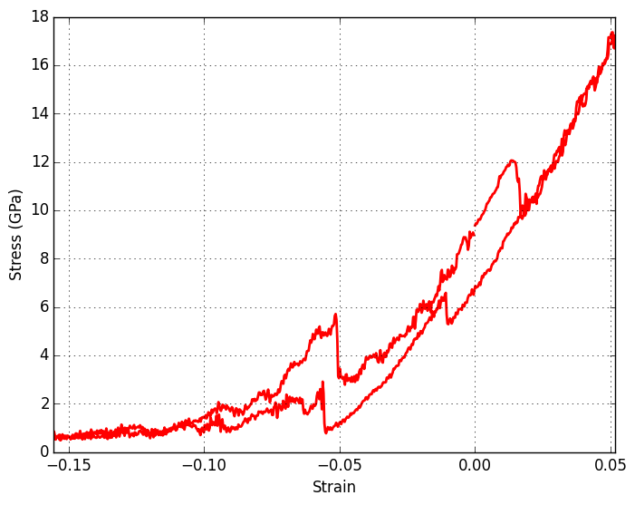

The area embraced by the curve is the work we do to the graphene knot

Mode localization of phonons is believed to account for the dopant distribution dependence of thermal conductivity. To understand the underlying physical mechanism of thermal conductivity trends of alloys in Fig. 3(a), we have carried out a vibrational eigen-mode analysis on the regular ones. Mode localization can be quantitatively characterized by, the participation ratio7 for each eigen-mode

, (3)

where N is the total number of atoms and is the complex amplitude of atom s for eigen-mode. The participation ratio presents the fraction of atoms participating in a given mode and effectively indicates the localized modes with and delocalized modes with O (1). It can provide a more detailed information about the localization effect to each mode.

C12N

CN

The eigenvectors and frequencies are obtained using Phonopy8 with and mesh sampling. Fig. 4 shows the participation ratio of graphene,,. A reduction of p-ratio for both low frequency phonons and high frequency phonons comes out compared with graphene. Most of the eigen-modes in regular have p-ratio over 0.98, showing characteristic of delocalized mode, while some of the eigen-modes of the others showing a characteristic of localized mode. The average participation ratio are 1.00, 0.80, 0.86 and 0.95 respectively, which obeys the same trends as the thermal conductivity.

The average participation ratio is found to be the key quantity to connect the alloy structure and its thermal conductivity. Fig. 5 compares the average participation ratio for several structures. It can be seen that thermal conductivity depends on participation ratio almost linearly, regardless of dopant ratio and distribution. This means that structure changing influences thermal conductivity directly via the average phonon participation ratio.

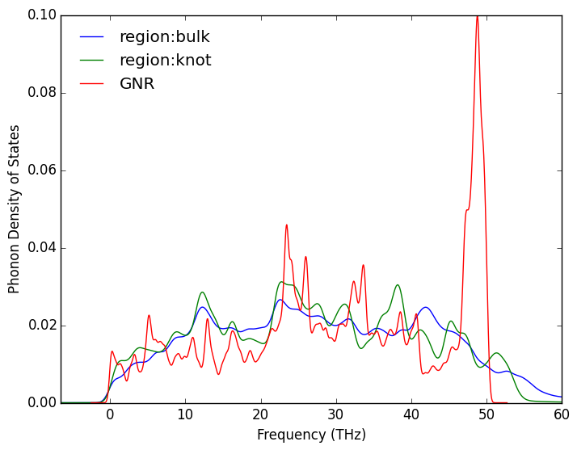

Fig 5. The vibrational dos of contacting region and bulk region.

The structure determines its average participation ratio mainly through the atom inequality. With ,we can reshape the participation ratio as

, (4)

which means that a mode with a larger vibrational amplitude variation is more localized. Although participation ratio can describe mode localization in a quantitative manner, it does not provide detailed information about the spatial distribution of a specific mode. To get a better understanding about the localization modes, we present the spatial vibration strength distribution of a typical mode of in Fig. 6. As we can see, with the presence of nitrogen dopant, carbon atoms are grouped into three invariant subspaces, under the operation of translation and inversion. So we can define the number of invariant subspaces under such a group as the inequality number of the structure. And the of graphene,, are 1,7,4,2 respectively. Fig. 7 shows the relationship between thermal conductivity and reciprocal of Ne for the four regular lattices. To be concluded, at least for the regular lattices, the presence of the dopants increases the inequality number of the structure. And they can interfere with the phonons, making them localized, which is responsible for the decrease of thermal conductivity.

For a relatively random system there should be another way to determine the inequality, because all the atoms are inequivalent in the most restrict sense. Here, we define a quantity only determined by the structure, called disorder degree, as

, (5)

where

, (6)

is the average radial distribution function of nitrogen atoms and is the radial distribution function9 with the nitrogen atom being the center atom.

, (7)

is the standard error of at r. In other words, we can define disorder degree as the average of the relative error of atom dependent radial distribution function. For a large enough r, because , so this quantity is converged. It could be proved that this quantity is insensible to the interval you use to calculate. As the consideration, reflects the environment of atom, and the larger relative error means the less equality. So it is a good quantity to describe inequality and disorder in the alloy. With this definition, the relation between the thermal conductivity and the structure could be easily clarified.

The thermal conductivity is found to depend on disorder degree linearly. Fig. 8 shows the relationship between the thermal conductivity and disorder degree for and relatively. Furthermore, when d reaches 0, thermal conductivity gets its largest value. The largest value of d due to the finite size of the cell gives out a minimal limit of thermal conductivity. Therefore, we can predict the thermal conductivity just use the radial distribution function.

Obviously it could be the dopant ratio r that causes the difference of the slope of the two lines. The thermal conductivity vs. is shown in Fig. 9, which means

(8)

is a good relation of thermal conductivity and structure for . This may be a universal scaling for binary alloys, which will be verified in future works. With this relation, it’s easy to estimate the thermal conductivity of an alloy with the knowledge of some points on this line, and we can also connect thermal conductivity and electric conductivity via disorder degree, which is helpful to find some more efficiency thermoelectric materials.

IV. CONCLUSIONS

To summarize, in this work, we propose to study the effects of doping distribution on thermal conductivity of alloys. Our numerical results demonstrate that a random distribution will deduce thermal conductivity rapidly as expected while a regular distribution leads to much slower deduction at room temperature. Moreover, thermal conductivity of will increase abnormally when x is beyond a value. The localization mode analysis demonstrates that the [inequivalent](http://www.baidu.com/s?f=13&nojc=1&wd=inequivalent) of the atoms within the same unit cell is responsible for the change of thermal conductivity in the alloy. To describe the [inequivalent](http://www.baidu.com/s?f=13&nojc=1&wd=inequivalent) for random alloys, we define a quantity named disorder degree and found thermal conductivity depends on it linearly, which is valuable for thermal conductivity manipulation and it maybe a universal scaling for a wide range of nanomaterials. These results would be helpful to the development of nonequilibium statistic mechanics and the theory of heat transportation in nanoscale systems.

ACKNOWLEGEMENTS

This paper was partially supported by the National Natural Science Foundation of China, the Special Funds for Major State Basic Research, the Foundation for the Author of National Excellent Doctoral Dissertation of China, the Program for Professor of Special Appointment at Shanghai Institutions of Higher Learning, and the Research Program of Shanghai Municipality and the Ministry of Education.

REFERENCES

(1) Kagimura, R.; Mazzoni, M. S. C.; Chacham, H. *Phys. Rev. B - Condens. Matter Mater. Phys.* **2012**, *85* (12), 1–4.

(2) Schelling, P. K.; Phillpot, S. R.; Keblinski, P. *Phys. Rev. B* **2002**, *65* (14), 144306.

(3) Ladd, A. J. C.; Moran, B.; Hoover, W. G. *Phys. Rev. B* **1974**, *34* (8), 5058–5064.

(4) Dickey, J. M.; Paskin, A. *Phys. Rev.* **1969**, *188* (1967), 1407–1418.

(5) Müller-Plathe, F. *Phys. Rev. E* **1999**, *59* (5), 4894–4898.

(6) Lammps. *Dev. - Lammps* **2011**, 1–9.

(7) Yang, L.; Yang, N.; Li, B. *Sci. Rep.* **2013**, *3*, 1143.

(8) Togo, a. **2013**.

(9) Kirkwood, J. G.; Boggs, E. M.; Kirkwood, G.; Boggs, E. M. **1992**, *394* (1942).

(1) Kagimura, R.; Mazzoni, M. S. C.; Chacham, H. *Phys. Rev. B - Condens. Matter Mater. Phys.* **2012**, *85* (12), 1–4.

(2) Schelling, P. K.; Phillpot, S. R.; Keblinski, P. *Phys. Rev. B* **2002**, *65* (14), 144306.

(3) Ladd, A. J. C.; Moran, B.; Hoover, W. G. *Phys. Rev. B* **1974**, *34* (8), 5058–5064.

(4) Dickey, J. M.; Paskin, A. *Phys. Rev.* **1969**, *188* (1967), 1407–1418.

(5) Müller-Plathe, F. *Phys. Rev. E* **1999**, *59* (5), 4894–4898.

(6) Lammps. *Dev. - Lammps* **2011**, 1–9.

(7) Yang, L.; Yang, N.; Li, B. *Sci. Rep.* **2013**, *3*, 1143.

(8) Togo, a. **2013**.

(9) Kirkwood, J. G.; Boggs, E. M.; Kirkwood, G.; Boggs, E. M. **1992**, *394* (1942).

**FIG. 1.** (color online) The simulation configuration of NEMD. The system actually used is made of unit cells while a system is here to skech the computational detail. The boundary condition of y direction is periodic while that of the two other directions are nonperioic. The most two ends ( labeleld as gray) are fixed after optimizing the system under zero pressure. The next two ends (labeld as red and blue respectively) are under Nose-hoover thermostat of 310K and 290K respectively in order to produce heat flux. The rest of this system is firstly heated to 300K with Nose-hoover thermostat and after that conducted by velocity verley algorithm. The whole configuration is kept until 5ns to have the temperature and heat flux converged.

