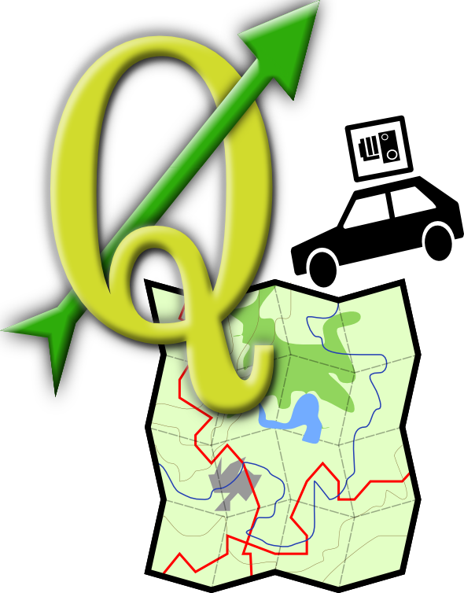

Qgis-mapper project
user documentation
Yellow background color indicates, that this is already integrated into the manual trunk

Project description
Qgis-mapper project is aimed to provide tools for end-users, which enable him to record GPS and accompanying data (video, audio) – and later process them and store in a reusable way.
Whole Qgis-mapper was developed as a group of extensions to already-existing project – Quantum GIS (QGis). Before user starts using Qgis-mapper, it's recommended to get familiar with work flow of GIS editing, especially inside QGis. However, a short introduction to terminology and general usage of QGis is included in this user documentation.
Contents
Table of Contents
GIS and Quantum GIS introduction 5
GIS introduction 5
Advantages and disadvantages 6
Topological modeling 6
QuantumGIS 6
Qgis-mapper project 7
Installation 8
Preparing source code 8
Prerequisites 8
Compiling the project 9
Initial settings 9
Beata (Better Attribute Table) 11
Selection in the Attribute table 11
Displaying capabilities 11
Editing rows 12
Searching 12
Advanced search 12
Feature cache 14
Map editing tools 15
Undo/Redo 15
Extended tolerance setting 15
Attribute edit widget 15
Line edit, Classification, File name, Enumeration, Immutable 16
Unique values 16
Value map 16
Range 17
Map tools 18
Node Tool 18
Basic work with node tool 18
Operations 19
Simplify feature 20
Delete part 21
Delete ring 21
Topology plugin 22
About Topology Checking 22
Launching Topology Checker 22
Test Result Dock 22
Controls 23
Validating topology 23
Test Configuration Dialog 24
Available Tests 24
Intersections 24
Geometry Validity 24
Geometry Duplicity 25
Polygon Containment 25
Dangling lines 25
Minimal Segment Length 25
Points Covered By Segment 26
Features Too Close 26
Symbology-NG 27
Why design new symbology 27
Current capabilities 27
Current limitations 27
Understanding the new symbology 27
Symbols and symbol layers 27
Color ramps 28
Styles 28
Renderers 28
Testing the new symbology 28
Using the next generation symbology 29
Single Symbol Renderer 30
Categorized rendering 32
Graduated rendering 33
Symbol Properties 34
Style Manager 36
Gather plugin 37
General data recording work flow 37
Installation 37
Basic user interface 37
Simple interface 38
Data sources 39
Gps 39
GPS 40
Audio 41
Video 41
Defining used cameras 42
Configuring cameras 42
Configuring compression codecs 43
Notes 44
Example of setup procedure 45
Player plugin 46
General data replay work flow 46
Installation 46
Basic user interface 46
Data sources 48
Gps 48
Audio 49
Video 49
Notes 50
Photo 51
PostGIS manager 53
Short intro to PostGIS 53
Database view 54
Central view 54
Metadata tab 54
Table tab 55
Preview tab 55
Database connections 55
Database info 55
Management of schemas 55
Management of tables 55
Data Import 57
Load data from shapefile 57
DBF Import 57
Data Export 58
Advanced features 58
Geometry processing 58
Table versioning 58
OpenStreetMap support 60
OpenStreetMap 60
QGIS-OSM Connection 61
Instalation 62
Basic user interface 62
Loading OSM data 63
Viewing OSM data 64
Editing basic OSM data 65
Changing feature tags 65
Point creation 65
Line creation 66
Polygon creation 66
Map feature moving 66
Map feature removing 67
Editing relations 67
Examining relation 67
Relation creation 68
Changing relation 68
Downloading OSM data 68
Uploading OSM data 69
Saving OSM data 70
Import OSM data 71

GIS and Quantum GIS introduction

GIS introduction
GIS system captures, stores, analyzes, manages, and presents data that is linked to location. In the strictest sense, the term describes any information system that integrates, stores, edits, analyzes, shares, and displays geographic information. In a more generic sense, GIS applications are tools that allow users to create interactive queries (user created searches), analyze spatial information, edit data, maps, and present the results of all these operations.
The primary requirement for the source data consists of knowing the locations for the variables. Location may be annotated by x, y, and z coordinates of longitude, latitude, and elevation, or by other geocode systems like ZIP Codes or by highway mile markers. Any variable that can be located spatially can be fed into a GIS. Different kinds of data in map form can be entered into a GIS.
A GIS can also convert existing digital information, which may not yet be in map form, into forms it can recognize and use.
GIS data represents real world objects (roads, land use, elevation) with digital data. Real world objects can be divided into two abstractions: discrete objects (a house) and continuous fields (rain fall amount or elevation). There are two broad methods used to store data in a GIS for both abstractions: Raster and Vector.
Quantum GIS supports work with both raster and vector data layers.
A raster data type is, in essence, any type of digital image represented in grids. Anyone who is familiar with digital photography will recognize the pixel as the smallest individual unit of an image. A combination of these pixels will create an image, distinct from the commonly used scalable vector graphics which are the basis of the vector model. Raster data type consists of rows and columns of cells, with each cell storing a single value. Raster data can be images (raster images) with each pixel (or cell) containing a color value. Additional values recorded for each cell may be a discrete value, such as land use, a continuous value, such as temperature, or a null value if no data is available. While a raster cell stores a single value, it can be extended by using raster bands to represent RGB (red, green, blue) colors, colormaps (a mapping between a thematic code and RGB value), or an extended attribute table with one row for each unique cell value. The resolution of the raster data set is its cell width in ground units.
Raster data is stored in various formats; from a standard file-based structure of TIF, JPEG, etc. to binary large object (BLOB) data stored directly in a relational database management system (RDBMS) similar to other vector-based feature classes.
In a GIS, geographical features are often expressed as vectors, by considering those features as geometrical shapes. Different geographical features are expressed by different types of geometry:
- Points (the locations of wells, peak elevations, features of interest or trailheads)
- Lines or polylines (rivers, roads, railroads, trails, and topographic lines)
- Polygons (lakes, park boundaries, buildings, city boundaries, or land uses)
Each of these geometries is linked to a row in a database that describes their attributes. For example, a database that describes lakes may contain a lake's depth, water quality, pollution level. This information can be used to make a map to describe a particular attribute of the dataset. For example, lakes could be coloured depending on level of pollution. Different geometries can also be compared. For example, the GIS could be used to identify all wells (point geometry) that are within 1-mile (1.6 km) of a lake (polygon geometry) that has a high level of pollution.
Vector features can be made to respect spatial integrity through the application of topology rules such as 'polygons must not overlap'.

Advantages and disadvantages
There are advantages and disadvantages to using a raster or vector data model to represent reality. Raster datasets record a value for all points in the area covered which may require more storage space than representing data in a vector format that can store data only where needed. Raster data also allows easy implementation of overlay operations, which are more difficult with vector data. Vector data can be displayed as vector graphics used on traditional maps, whereas raster data will appear as an image that, depending on the resolution of the raster file, may have a blocky appearance for object boundaries. Vector data can be easier to register, scale, and re-project. This can simplify combining vector layers from different sources. Vector data is more compatible with relational database environments. They can be part of a relational table as a normal column and processed using a multitude of operators.
The file size for vector data is usually much smaller for storage and sharing than raster data. Image or raster data can be 10 to 100 times larger than vector data depending on the resolution. Another advantage of vector data is that it is easy to update and maintain.

Topological modeling
A GIS can recognize and analyze the spatial relationships that exist within digitally stored spatial data. These topological relationships allow complex spatial modelling and analysis to be performed. Topological relationships between geometric entities traditionally include adjacency (what adjoins what), containment (what encloses what), and proximity (how close something is to something else).

QuantumGIS
Quantum GIS is a free software desktop Geographic Information Systems (GIS) application that provides data viewing, editing, and analysis capabilities. Gary Sherman began development of Quantum GIS in early 2002. Version 1.0 was released in January 2009. QGIS is written in C++, and its GUI uses the Qt library. Quantum GIS allows integration of plugins developed using either C++ or Python.
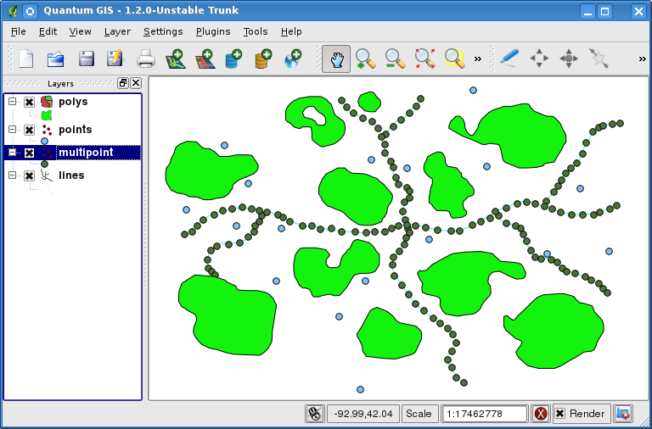
In brief, map in Quantum GIS consist of some number of vector layers, each vector layer displays features of the same geometry type. Quantum GIS works with these types of geometries: Point, Line, Polygon, UnknownGeometry.
Parts of gis introduction were taken mainly from wikipedia, for more information about QuantumGIS, please visit http://www.qgis.org/.

Qgis-mapper project
The idea about this project comes from the effort of creation of high-quality street map with good support for routing and geocoding. This type of data consists of coordinates of the map features and additional metadata containing e.g. type of the road or driving restrictions. Usually, geographic part of data is captured in field by GPS or digitized from satellite imagery to vectors in Geographic Information System (GIS). The problem is to capture metadata with enough details, some road properties are essential for good decisions in routing software.
Aim of this project is to help with collection of geographical data in field (i.e. driving a car with GPS) by creating a flexible system that stores collected data from different sources (GPS, microphone, camera). This part is mainly implemented by the Gather plugin.
Then, the software will allow viewing the collected data easily (Player plugin) and help the user with digitizing process providing effective editing tools and visualization options – Beata, Map editing tools, Topology plugin, Symbology-NG. As a result, users should get system capable to work with big amounts of geographical data with no need to use other (commercial) GIS software.
This software also allows users to upload captured data to a OpenStreetMap database by using the OSM plugin - or a Postgis database for that matter. Postgis databases may be easily administrated by the PostGIS manager.

Installation
QGis-mapper project is highly dependent on QuantumGIS software. Efforts were made to make the code platform-independent, so it's possible to use QGis-mapper on virtually any plaform, that QuantumGIS itself runs on (e.g. Linux, Solaris, Windows). However, it's highly recommended to use the Ubuntu linux, as that is the platform the project was primarily developed and tested on. There shouldn't be any problems with different CPU architectures whatsoever. Memory requirements are the same as those of QGis too, 0.5GiB or more of RAM is recommended – depending on size of processed data, this could of course be more (e.g. for a OSM map of whole Czech republic, 2GiB would be the bare minimum). The hard-drive space required, including the build-intermediate files, is about 0.5 GiB (when using Release, not Debug mode, of source compilation).

Preparing source code
The current version of project is being kept in a few places now. Parts of project's efforts have been already integrated into main QuantumGIS trunk source tree. Symbology-NG is currently being held in a separate branch of QuantumGIS repository. Plugins Gatherer, Player, Postgis manager and OSM plugin are placed inside qgis-mapper project svn. To get the whole project running, it's required to get all of this source code and merge it:
svn co http://svn.osgeo.org/qgis/branches/Release-1_2_0/ qgis-120
svn co http://svn.osgeo.org/qgis/branches/symbology-ng-branch/ qgis
svn co svn+ssh://user@urtax.ms.mff.cuni.cz/home/projects/qgis-mapper/svn svn
#now merge sources...
Obviously, this is a pretty non-trivial task, so we provide an already-merged source code on the DVD, which has to be extracted from archive. Also, we provide a VirtualBox virtualized system image for more convenience, which contains pre-built and pre-configured version of the whole project (i.e. you don't have to repeat all the steps below, just run the system image and qgis command inside it).
After the source code is merged, it's either possible to repeat the following steps, or simply start the provided install-script.sh.

Prerequisites
Either way, we assume QGis is installed on Ubuntu 9.04 platform. It also worked on previous versions of Ubuntu and some version of Fedora, so it probably shouldn't be a problem to port it to any platform.
Before we start compiling the project, there are some packages that need to be installed:
sudo aptitude -y install libqt4-core libqt4-debug libqt4-dev libqt4-gui libqt4-qt3support libqt4-sql lsb-qt4 qt4-designer qt4-dev-tools qt4-doc qt4-qtconfig uim-qt gcc libapt-pkg-perl resolvconf
sudo aptitude -y install gdal-bin libgdal1-dev libgeos-dev proj libgdal-doc libhdf4g-dev libhdf4g-run python-dev libgsl0-dev g++ libjasper-dev libtiff4-dev subversion libsqlite3-dev sqlite3 ccache make libpq-dev flex bison cmake txt2tags python-qt4 python-qt4-dev python-sip4 sip4 python-sip4-dev
sudo aptitude -y install portaudio19-dev mplayer libavcodec-dev libavdevice-dev libavformat-dev libavutil-dev libswscale-dev libvorbis-dev pyqt4-dev-tools python-serial python-psycopg2 postgis
For 100% correct behaviour on Ubuntu 9.04, updating system libgdal to version 1.6 and Qt to 4.5.2 is recommended. Following repositiories contain these updates:
deb http://les-ejk.cz/ubuntu jaunty multiverse
deb-src http://les-ejk.cz/ubuntu jaunty multiverse
deb http://ppa.launchpad.net/kubuntu-ppa/backports/ubuntu jaunty main
deb-src http://ppa.launchpad.net/kubuntu-ppa/backports/ubuntu jaunty main

Compiling the project
The first step of making the project is to build QGis itself. QGis uses standard set of CMake scripts, so the build process is quite standard too:
cd qgis
mkdir build; cd build
cmake ..
make
sudo make install
The compilation is followed by compilation of mapper (gather and player plugin):
export PYTHONPLUGINS="/usr/local/share/qgis/python/plugins"
cd svn/trunk/sandbox/mapper
export INSTALL_DIR="${PYTHONPLUGINS}"
sudo -E make install
OSM Plugin:
cd svn/trunk/sandbox/osm_plugin
make
cd ..
sudo cp -R osm_plugin ${PYTHONPLUGINS}/
And finally the PostGIS manager:
cd svn/trunk/sandbox/postgis_manager
make
cd ..
sudo cp -R postgis_manager ${PYTHONPLUGINS}/
After all these steps have been successful, QGis-mapper should be installed – and it should be possible to start it by executing the qgis command.

Initial settings
However, after a clean installation, the initial settings of QGis aren't optimal.
User is definitely required to enable external plugins (especially the ones of Qgis-mapper project) in the Plugins → Manage plugins dialog:
- Data gather plugin
- Data player plugin
- PostGIS manager
- OSM plugin
Additionally, we highly encourage user to change values inside Settings → Options / Digitizing / Snapping:
- Default snapping tolerance in layer units: 10 pixels
- Search radius for vertex edits in layer units: 10 pixels
Now the qgis environment is installed and ready to be used. Feel free to try out e.g. the example data provided on installation DVD.

Beata (Better Attribute Table)
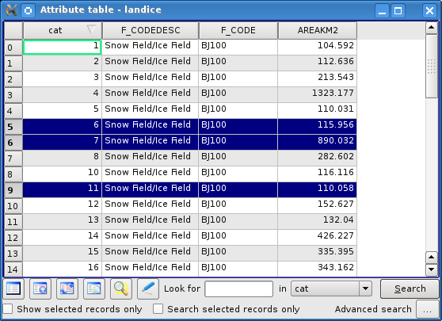
The Attribute Table ( ) displays features of the selected layer. Each row in the table represents one map feature with its attributes shown in columns. The features in the table can be searched, selected, moved or even edited. There is more information on these subjects in the following sections.

Selection in the Attribute table
Selected lines in the Attribute Table represent current selected features in the layer. The Attribute Table reflects any changes in the layer selection and vice versa. Changed selection in the table causes change in the selected feature set and different layer selection means different rows are to be selected.
Rows are selected by clicking on the vertical header next to the row. Selecting a row doesn't change the current cursor position.
Multiple lines can be marked by holding the Control key (Ctrl on most keyboards)
A continuous selection can be made by holding the Shift key and by clicking on the header. All rows between the current cursor position and the clicked row are selected.
A selection can be inverted by hitting the Invert selection ( ) button.
To clear the selection press the Remove selection ( ) button.
Layer extent can be focused to the selected features with Zoom to map to the selected rows ( ) button .

Displaying capabilities
The Attribute Table offers a set of display operations.
The table can be sorted by columns, the Attribute Table can show only selected rows (by checking Show selected records only checkbox ( ) ) and the selected rows may be moved to the top of the table by Move selected to the top button ( ).

Editing rows
Attributes in the Attribute Table can be edited only if the layer was made editable, otherwise the data can't be changed. A simple shortcut for shifting into the editable mode is available with the Toggle editing mode ( ). When this button is checked, layer is set to the editable mode and the data in the table can be modified by clicking on a cell and changing the data. Editing uses the same standard dialog for editing of attributes in one feature. Field values are directly visible, but when user tries to edit value, editable widget appears in cell which is to be edited. After editing value assigned to this cell appears. Unchecking the button displays a saving dialog to the user (but only if the layer has been modified).

Searching
A simple search is directly available in the table dialog. The search term is looked for in the specified column.
For a more thorough search, hit the Advanced search button ( ) to enter the Search query builder dialog (described later).
The resulting rows are selected in the table (and in the layer). But if the search query returns an empty result, current selection is left unchanged.
Checkbox Search selected records only ( ) , when checked, causes that the search is performed only against currently selected features.

Advanced search
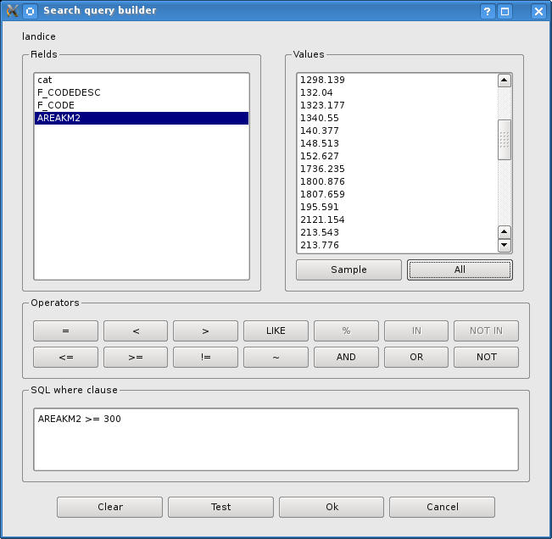
The Advanced search button displays the Search query builder , where a more complex queries can be build, using a SQL-like WHERE clause. The Fields, Values and Operators sections help the user to construct a SQL-like WHERE clause easily in the text field SQL where clause .
The Fields list contains all attributes of the table to be searched. To add an attribute to the SQL where clause field, double click its name in the Fields list.
The Values list lists the values of an attribute. To list all possible values of an attribute, select the attribute in the Fields list and click the All button ( ). To list all values of an attribute that are present in the sample table, select the attribute in the Fields list and click the Sample button ( ). To add a value to the SQL where clause field, double click its name in the Values list.
The Operators section contains all usable operators. To add an operator to the SQL where clause field, click the appropriate button. Relational operators ( , , …), string comparison operator ( ), logical operators ( , , … ) are available.
The Clear button ( ) clears the text in the SQL where clause text field. The Test button ( ) shows a message box with the number of features satisfying the current query, which is usable in the process of query construction. The OK button closes the window and selects the features satisfying the query. The Cancel button closes the window without changing the current selection.

Feature cache (qgis 1.4?)
Feature cache speeds up vector layer drawing and snapping operations by keeping features stored in memory - instead of always reading them over again from the data provider (which might be pretty costly e.g. in case the provider uses data from a remote database server).
Feature cache can be enabled in Quantum GIS settings, in Rendering tab:
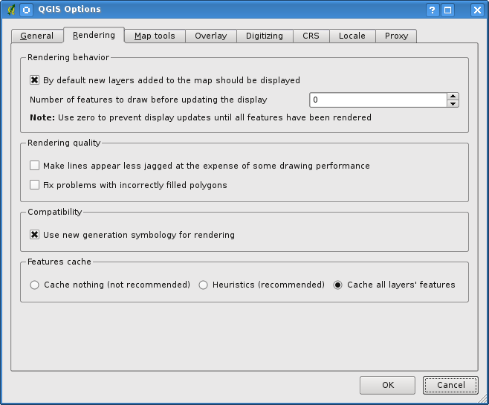
- The "Cache nothing" option completely disables caching and features are always retrieved from data provider.
- The "Heuristics" option keeps reasonable amount of features in memory, by releasing some of them when the current extent is much smaller than the cached area.
- The "Cache all layer's features" option allows cache to store all features displayed. This doesn't necessarily mean that all vector layers' data will be cached - once the cache is enabled, it only holds features from the biggest extent displayed (i.e. if user zooms-out, and required data are superset of the currently cached data extent - the cache is freed and refilled with the superset data - which are of course read from the data provider). Also, if user moves current extent, so that the already cached extent only partially overlaps with the new one, the previous data will be released and the new extent cached. This "filling behaviour" is the same as the one of "Heuristics" option.

Map editing tools
To simplify and make feature editing more convenient, new set of editing tools was implemented and added to QuantumGIS. They're discussed in the following sub-sections.

Undo/Redo
Quantum GIS now supports undo/redo functionality (in a classical way). All integrated editing functions for vector layers support undo/redo operations.
Basic view of undo/redo operations is a widget, where all operations are shown. This widget is not displayed by default. Widget can be displayed by right clicking on toolbar and checking Undo/Redo check box. Undo/redo is however active, even if the widget is not displayed. When Undo is hit, state of all features and attributes are reverted to the state before reverted operation happened. Changes which are done elsewhere (for example from some plugin), than in some command which appears in this box will have unspecified behavior. They can be reverted as well or they can stay same.
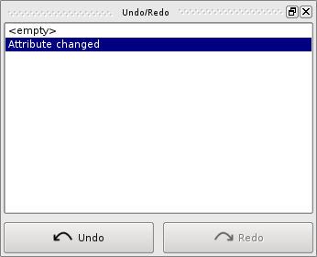
Undo/Redo widget
An action can be triggered by clicking on Undo or Redo buttons or by clicking directly on the item to which we will return to. Another possibility to trigger undo operation is to click on undo/redo buttons in advanced digitizing tool bar.

Extended tolerance setting
Tolerance setting has been extended that now also tolerance in pixels can be set. This tolerance setting then affect all tools which work with tolerance. This setting has advantage that tolerance doesn't have to be changed after zoom operations. Tolerance can be set on Settings → Options dialog in Digitizing tab.

Attribute edit widget
New dialog for setting attribute's type/value is now available. Appearance changed from combo box to this new dialog. Main part of this dialog is a combo box, where users select edit widget. After deselecting the widget, a short description appears on the top of the displayed page. And if needed, some editing items relevant for this type of widget are displayed. Enumeration dialog is disabled when enumeration is not supported by the provider. The Range dialog is disabled when the attribute is not of a numeric type.
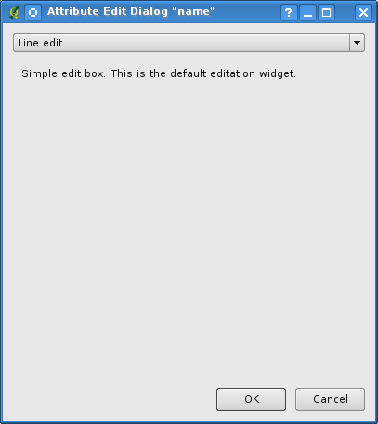
Attribute edit widget dialog
Description of some basic elements in the dialog:

Line edit, Classification, File name, Enumeration, Immutable
All of these types are represented only by simple pages which carry description for each of these types. There is no configuration possible and the page is similar to the one displayed in Illustration 2.

Unique values
This page contains one additional element, the Editable check box. This check box changes the combo box used for unique values to a Line edit widget with completer to advise the user as he is writing.

Value map
Value map creates editing combo box. Values in this combo box are stored in Value column and Description value is shown in combo box during editing. All data can be entered manually:
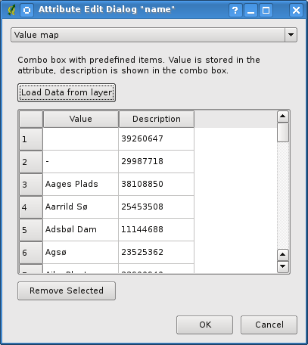
Value Map Dialog
This data is to be entered and modified manually. But for initial load, the vector layer data can be used. This method will replace all data in current value map with new data. The data loading method from the layer is started by clicking on the button Load Data from layer . New dialog (see next picture) will be displayed.
Some layer is preselected. Layer from which data will be taken has to be selected, and then specification which data will be used by selecting combo boxes. During these changes preview data are appearing. Preview is just first 10 rows which are selected. To show all data click on View all button. Then select Ok if data are ok or cancel this dialog by pushing Cancel. It may take some time to transfer all the data to parent dialog especially when large datasets are selected. Loaded data can be edited normally as any other value map data.
Note that data loaded into Quantum Gis doesn't have to be only layers, also dbf files can be loaded - even if they don't contain geometries.
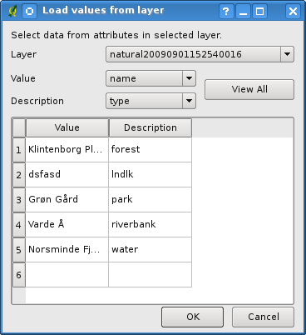
Load values from layer

Range
Range can only be used for numeric types of attributes. Dialog differs when using real and integer type.
- Slider can be used only for integer type.
- Correct type of spin box is shown for data type.
- When checkbox editable is checked, a spin box will appear to enter value. Slider button displays slider when editing value.
Step represents:
- step for slider, when slider option is defined
- one step for spin box if editable radio button is checked.
See picture below for example of dialog.
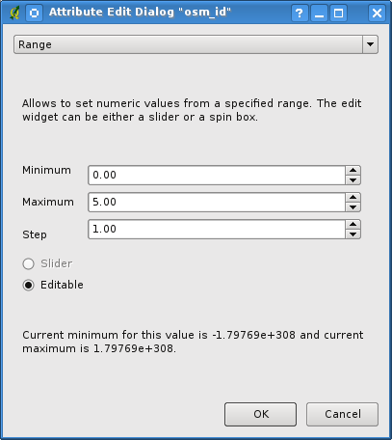
Range dialog

Map tools

Node Tool
Node tool is an advanced tool for work with vertices. The tool was “invented”, because many tool had to be used for simple editing purposes such as delete vertex, add vertex or move vertex. This tool is, unlike other tools in Quantum Gis, persistent – so when some operation is done selection stays active for this feature and tool.

Basic work with node tool
Start by selecting tool by clicking on it's toolbar icon.
Select some feature simply by clicking on it. Now red boxes appear at each vertex of this feature. This is basic select of the feature.

Operations
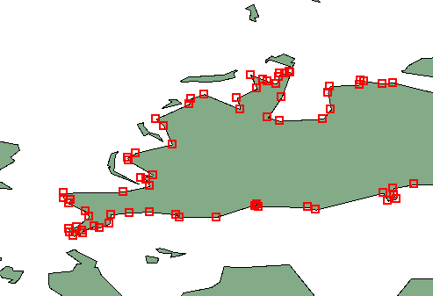Selected feature for editing in node tool
- Selecting vertex
Selecting is easy just click on vertex and color of this vertex will change to blue. When selecting more vertices Shift key can be used to select more vertices. Or also Ctrl key can be used to invert selection of vertices (if selected then it will be deselected and when not selected vertex will be selected). Also more vertices can be selected at once when clicking somewhere outside feature and moving will create rectangle where all vertices inside will be selected.
- Another possibility is to select edge. Just click on the edge and both adjacent vertices should be selected.
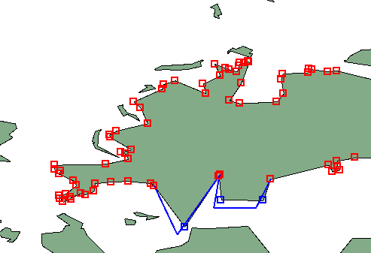Moving selected vertices and example how selected vertices look
- Adding vertex
Adding vertex is simple just double click near some edge and new vertex will appear on the edge near to the cursor. Note that vertex will appear on edge not on cursor position, there it has to be moved if necessary.
- Deleting vertex
Deleting is also simple. After selecting vertices to be deleted press Delete key and vertices will be deleted. Note that according to standard Quantum Gis behavior, it will leave at least necessary number of vertices for this type of feature. When delete feature is needed then extra tool must be used.
- Moving vertex
Moving vertex is an easy task.
- First select all vertices which will be moved.
- Press button on some selected vertex. All selected vertices are moving same way as the cursor. Snapping is enabled so sometimes whole selection jump to nearest vertex or line.
- Release button stores all changes and new entry appears in undo dialog.
- Note that all operations support topological editing when turned on. On the fly projections are also supported.
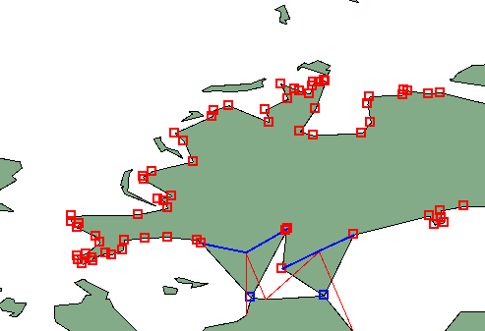Topology editing for moving vertices

Simplify feature
Purpose of this tool is to simplify one feature's geometry. After choosing this tool, a feature needs to be selected by clicking at it. When some feature is selected, it's highlighted by red rubber band and slider appears. When moving slider, red rubber band is changing its shape as feature is being simplified - and when OK button's clicked, simplified geometry will be stored.
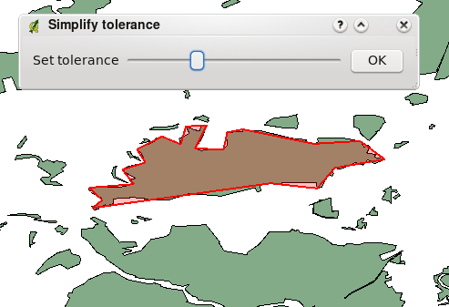Simplifying polygon example

Delete part
This tool is used for working with multi-part geometries. This tool allows deleting part of this feature. It won't delete last part of the feature, this last part will stay untouched. This tool works with all multi-part geometries point, line and polygon.

Delete ring
Delete of inner ring of polygon. This tool is available only for polygon layer and it deletes inner ring of polygon. It doesn't change anything when used on outer ring of the polygon. This tool can be used on polygon and mutli-polygon features.

Topology plugin
A topology describes spatial properties of objects. It models topological relations between adjacent point, line or polygon geometries. The topology plugin allows user to check, whether defined spatial constraints are fulfilled – and allows a simple fixation of errors.

About Topology Checking
Topology rules ensure data integrity, that only correct features are inserted into the geodatabase. This is achieved by using set of rules that describe spatial relationship. Tests can be created to verify these rules and thus identify possible colliding geometries.
Common topological tests are checking for intersecting geometries (such as some administrative areas), dangling lines ( lines not connected to any other) or geometries inside a polygon.
Topology validating is a CPU-consuming task, requiring many geometries to be processed.
Therefore, it's preferred to check smaller areas of interest instead of entire layers.

Launching Topology Checker
The topology checking component is developed as a QGIS plugin. To launch it, click on the red-blue cross icon () in the plugin toolbar.

Test Result Dock
The Test Result Dock is the main interface of the topology plugin. It allows the user to launch the validation process and/or to adjust the tests via the Test Configuration Dialog. After validating the topology, the resulting errors re displayed in the Error Table.
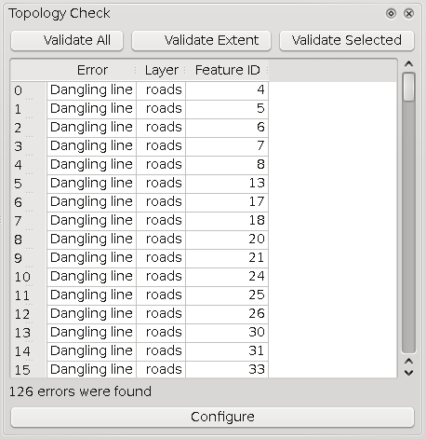
Error Table
The Error Table lists errors found during validation. Each row represents a single topology error. The line shows the type of the error, the corresponding error and the incident feature Id. Using them, it's trivial to find the corresponding features in the Attribute Table.
When the user clicks on a row in the table, the map zooms to the error's immediate neighbourhood. The topology conflict's boundary is coloured yellow, colliding features are shown with blue and red border.
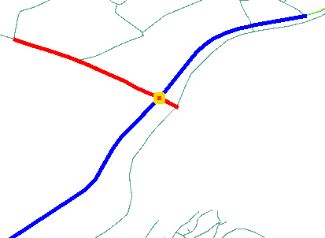
Example illustrating topology error in the map – two intersecting lines.

Controls
- Validate Extent – Runs tests specified in the Test Configuration Dialog against features in the current extent.
- Validate All – Runs tests against all features in specified layers.
- Validate Selected – Runs tests against selected features from the first specified layer.
- Configure button – launches Test Configuration Dialog .

Validating topology
Before topology can be validated, the user have to configure a set of tests, that will be performed on the opened layers.
There are three validating buttons for launching the tests.
- Validate All button causes the tests to check every feature in the specified layer. Because topology testing requires quite an amount of computing time, the latter two ways are often preferred.
- Validate Extent tests only features in current layer extent, aka the part of the layer currently visible in the map window.
- Validate Selected checks only features from the layer, that are selected at the test's launch time.
At this time, all tests are validated using a single specified test method (Extent / All / Selected ) together , so it is not possible to configure this on per-test basis yet.

Test Configuration Dialog
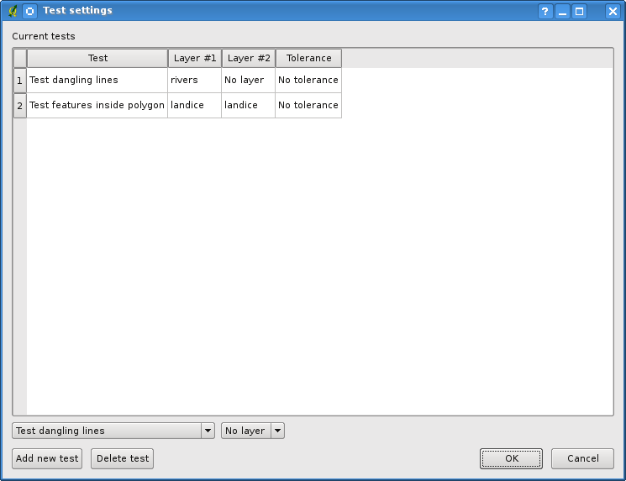
In this dialog users can add or delete new tests. Test settings are automatically saved to the current project and later can be loaded via opening the project. A new test is added when Add New Test button or OK button is pressed. More tests can be added by Add New Test button, OK button adds current test and closes the dialog. Delete Test button removes selected test from the table.

Available Tests
Tests differ in using one layer (eg. geometry validity, segment length) or two layers (eg. close features, features inside polygon). Some two-layers tests can also be used to check one layer against itself (intersections, close features).
A short desription of every topology test follows:

Intersections
Requires that no two distinct geometries from the selected layers intersect each other. Useful for mutually exclusive areas, for example administrative borders, buildings, etc.
Test requires two layers.
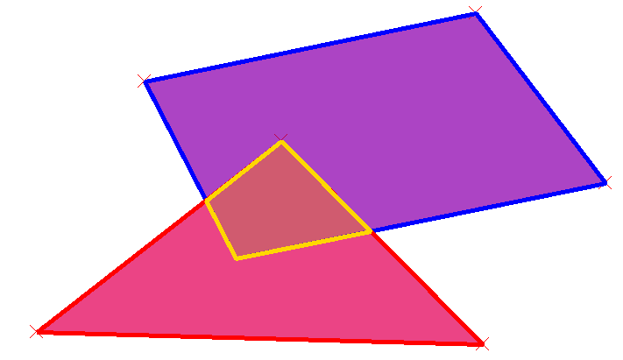
Example of two intersecting polygons. (Conflicting area is shown with yellow boundary

Geometry Validity
Scans layer for geometries which are not valid. This can mean crossing itself or containing one or less point for a line geometry. Invalid polygon could have no inner ring, be self intersecting, or contain less than three points in any ring.
Test uses just one layer.
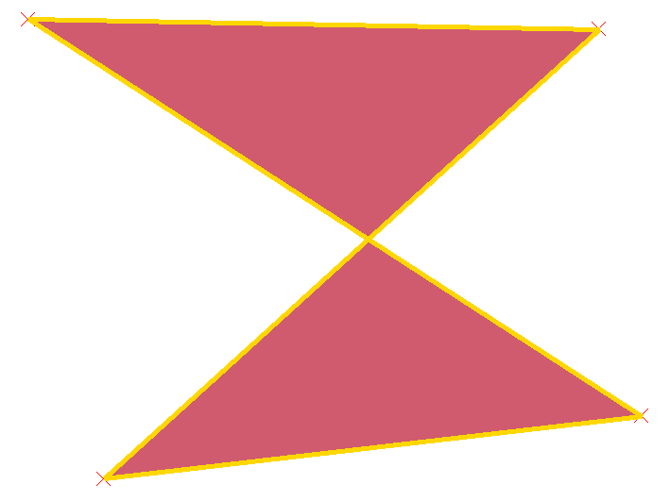
Example of invalid geometry – a self intersecting polygon.

Geometry Duplicity
This test finds any features with exactly the same geometry and marks them as a conflict.
Test uses just one layer.

Polygon Containment
Requires that a polygon does not contain any geometry from the second tested layer. The whole conflicting geometry must be within tested polygon.
Test uses two layers. (First layer must be of a polygon type)
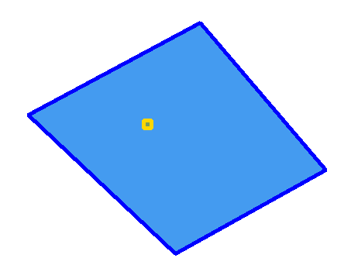
Example of point contained in a polygon.

Dangling lines
Detects lines which are not connected to any other line in the layer. Geometries with one unconnected endpoint are considered valid in this test.
Test uses just one layer.
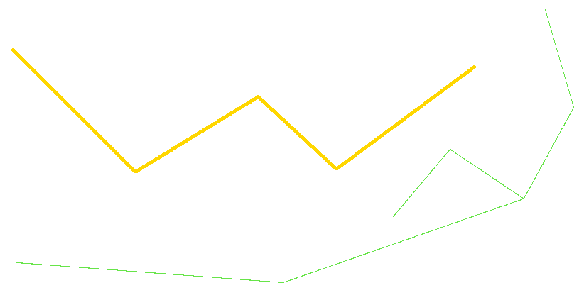
Example of a dangling line (coloured yellow).

Minimal Segment Length
All segments in a line geometry must be larger than tolerance specified in this test. Test also applies (for polygon layers) to all segments in every polygon ring.
Test uses just one layer. (Layer must be of either a line or a polygon type)
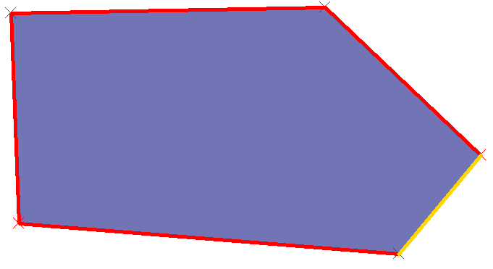
Example of a polygon with a too short segment.

Points Covered By Segment
All points in the first specified layer must be covered by a segment from the second layer.
Test uses two layers. (First layer must be of a point type, second either a line or a polygon type)
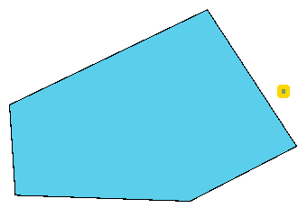
Example showing a point not covered by polygon segment boundary.

Features Too Close
All geometries in the two specified layers must not be closer than the tolerance specified in the test settings.
Test uses two layers.

Symbology-NG

Why design new symbology

Current capabilities
In the 1.0 version of QGis, users are able to apply the following properties for different feature types:
- lines - set line width, pen style and color
- polygons - set fill color and pattern
- points - use hardcoded symbols (plus set line and fill settings) or SVG symbols, set size and/or angle
Symbols are then used by renderers:
- single symbol - one symbol is used for rendering of all features
- graduated symbol - given a set of ranges of some numerical attribute, objects are rendered with symbol based on the attribute value
- continuous color - based on numerical attribute object gets drawn with a symbol with color interpolated between two colors. Actually a special case of graduated symbol
- unique symbol - given a set of categories from attribute's unique values, objects are rendererd with symbol based on the attribute value

Current limitations
This section summarizes limitations of current implementation for production of high-quality maps that need bigger amount of customization, including examples:
- impossible to combine basic symbols and form complex symbols from them
  - point symbol "star in a circle"
  - line symbol made by thicker and thinner line with different colors
- impossible to draw lines with a decoration
  - line with an arrow (at the end of line)
  - line made by repeating a marker along it
- impossible to develop custom rendering styles
  - polygon with numbered vertices
  - point rendered as a combination of icons based on attributes

Understanding the new symbology

Symbols and symbol layers
There are three types of symbols: marker symbols (for points), line symbols, fill symbols (for polygons). Symbols consist of one or more symbol layers.
It is possible to set color of a symbol - this color is set to all symbol layers. Some layers might have the color locked - for them the color is not altered. This is useful when setting color of a multilayer symbol. Similarly, it's possible to set width for line symbols, size and angle for marker symbols.
Available symbol layer types:
- simple marker - rendering with one of hardcoded markers
- simple line - usual rendering of a line (with specified width, color and pen style)
- simple fill - usual rendering of a polygon (with defined fill color, fill pattern and outline)
- svg marker - rendering with a SVG picture
- marker line - a line rendered by repeating a marker symbol

Color ramps
Color ramps are used for defining a range of colors that can be used during creation of renderers - symbol's color will be set from the color ramp.
There are two types of color ramps:
- gradient - linear gradient from one color to some other
- random - randomly generated colors from a specified area of color space

Styles
Style groups a set of various symbols and color ramps.
User can define his or her own prefered / frequently used symbols, then he or she will be able to use them without having to recreate them everytime.
Style items (symbols and color ramps) have always a name by which they can be queried from the style. There is one default style in QGIS (modifiable), user have the possibility to add new styles.

Renderers
Renderer is responsible for drawing a feature with correct symbol. There are three types of renderers:
- single symbol
- categorized (called unique color before)
- graduated
There is no continuous color renderer because it is in fact only a special case of graduated renderer.
Categorized and graduated renderer can be created by specifying a symbol and color ramp - they will set colors for symbols appropriately.

Testing the new symbology
First the user has to enable the next generation symbology. This is done through the main menu,
in the Settings tab click on Options,
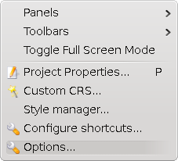

then in the dialog select the Rendering tab

and here check the Use new generation symbology for rendering checkbox on the bottom.

Using the next generation symbology
To change the layer's rendering properties, click with the right button on the layer name in the legend and selecting Properties and then choose the Symbology tab.
The Symbology Tab allows to choose one of the three renderers available - single symbol, categorized and graduated. Depending on the renderer chosen, the Symbology tab provides different settings and options, that will be described in the following sections.

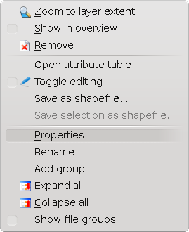

Single Symbol Renderer
The Single Symbol Renderer is used to render all features of the layer using a single user-defined symbol. The properties, that can be adjusted in the Symbology tab, depend partially on the type of the layer, but all types share the following structure. In the top left part of the tab, there is a preview of the current symbol to be rendered. In the bottom part of the tab, there is a list of symbols already defined for the current style, prepared to be used via selecting them from the list. The current symbol can be modified using the Properties button, which opens a Symbol Properties dialog, or the Set Color button, which opens an ordinary color dialog.
After having done any needed changes, the symbol can be added to the list of current style symbols (using the Add to style button) and then be easily used in the future.
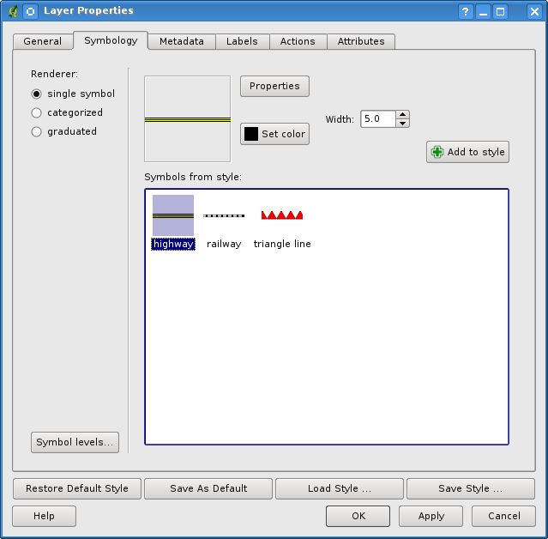
Example: A line layer symbology properties.
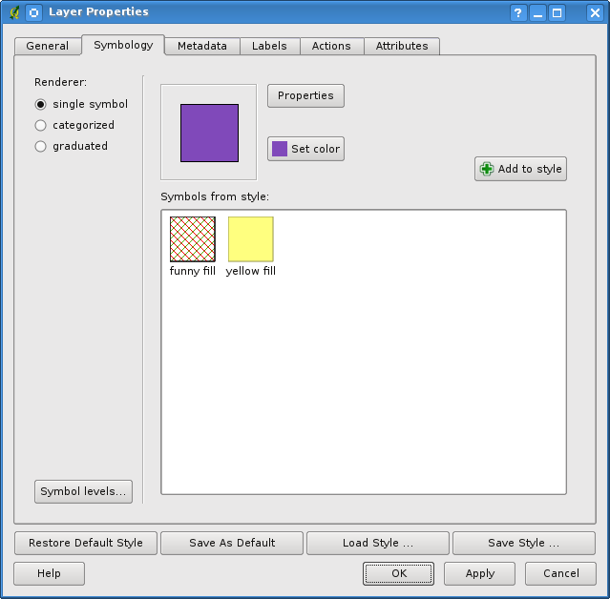
Example: A polygon layer symbology properties.

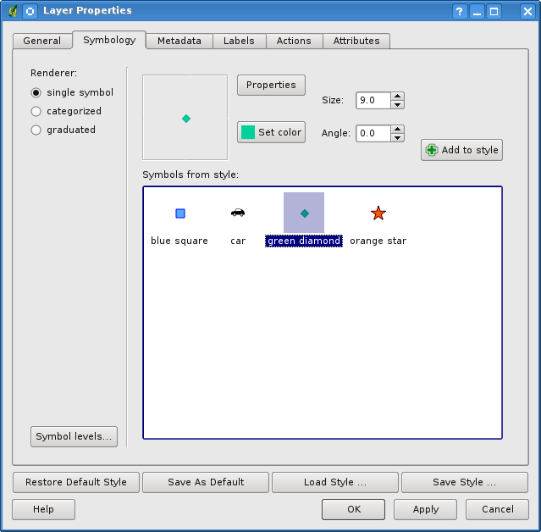
Example: A point layer symbology properties.
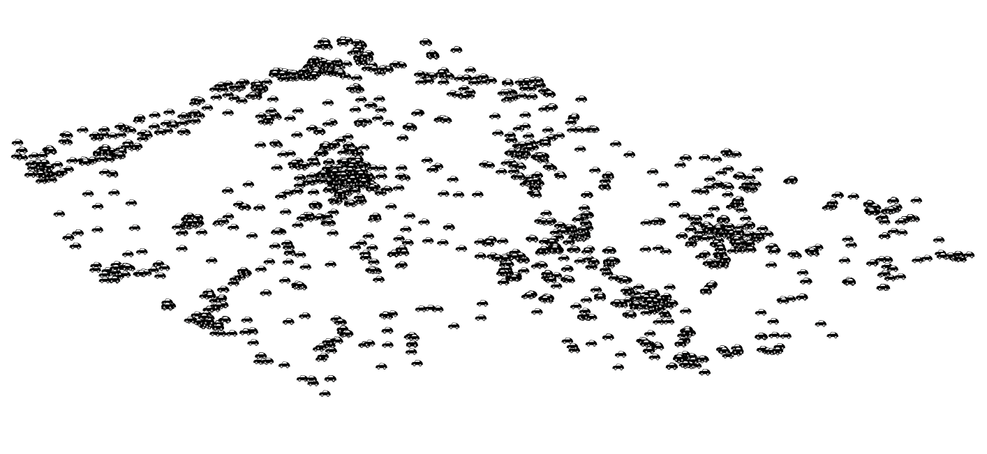
Example: Using a single symbol (a small car) rendering on a point layer.

Categorized rendering
The Categorized Renderer is used to render all the features from the layer, using a single user-defined symbol, whose color reflects the value of a selected feature's attribute. The Symbology tab allows user to select:
- The attribute (using the Column listbox)
- The symbol (using the Symbol Properties dialog)
- The colors (using the Color Ramp listbox)
For convenience, the list in the bottom part of the tab lists the values of all currently selected attributes together, including the symbols that will be rendered for them.
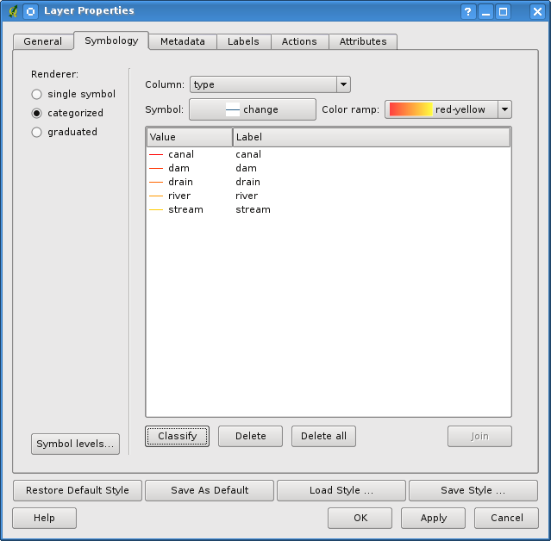
Here is an example, how the categorized rendering looks on the map canvas:
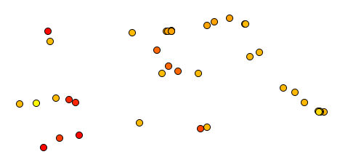
Example: Using categorized rendering on a point layer, classified by feature id.

Graduated rendering
The Graduated Renderer is used to render all the features from a layer, using a single user-defined symbol, whose color reflects the classification of a selected feature's attribute to a class.
Analogous to the case of the categorized rendered, the Symbology tab allows user to select:
- The attribute (using the Column listbox)
- The symbol (using the Symbol Properties button)
- The colors (using the Color Ramp list)
Additionally, the user can specify the number of classes and also the mode how to classify features into them (using the Mode list). The listbox in the bottom part of the tab lists the classes together with their ranges, labels and the symbols that will be rendered for them.
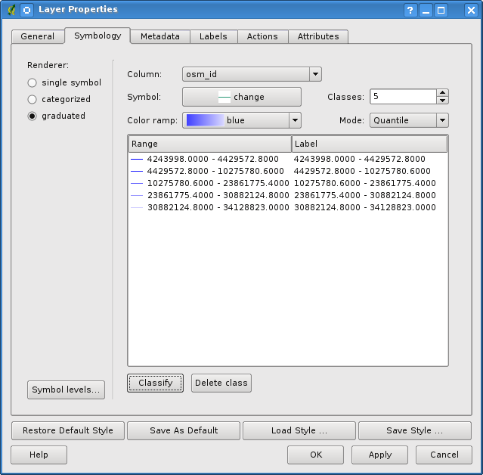
Again, an example of graduated rendering on the map:

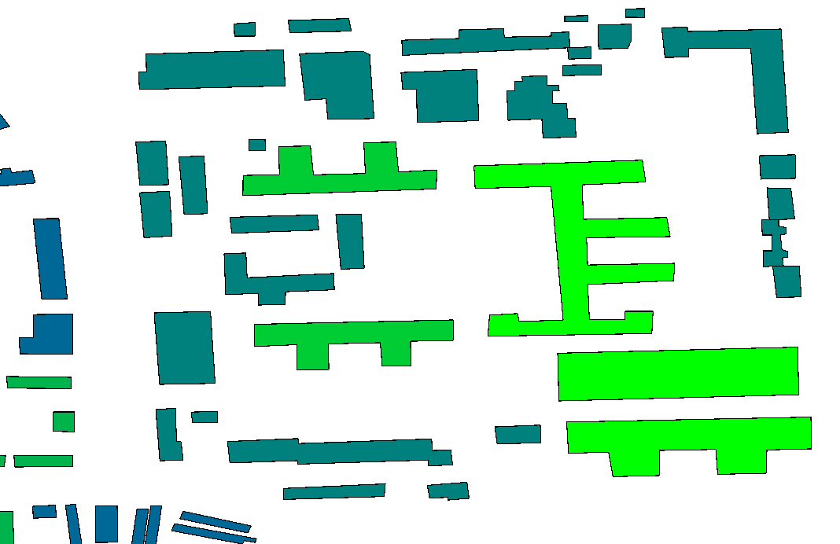
Example: Buildings rendered with graduated renderer, classified by feature id and using the quantile mode.

Symbol Properties
The Symbol properties dialog allows the user to specify different properties of the symbol to be rendered. In the top left part of the dialog, there is the preview of the current symbol as it will be displayed. Bellow the preview is the list of symbol layers.
The controls allow adding or removing layers, changing position of layers, or locking layers for color changes.
In the right part of the dialog, there are shown the settings applicable to the single symbol layer selected in the symbol layer list. The most important is the Symbol Layer Type combobox, which allows the user to choose the type of the layer. The available options are SimpleLine, SvgMarker and SimpleFill.
Depending on the value chosen, these settings are available in the right part of the dialog:
- SimpleLine - Color, Pen width, Pen style, Offset, Join style and Cap style;
- SvgMarker - Size, Angle, Offset X, Offset Y and SVG Image
- SimpleFill - Color, Border color, Fill style.

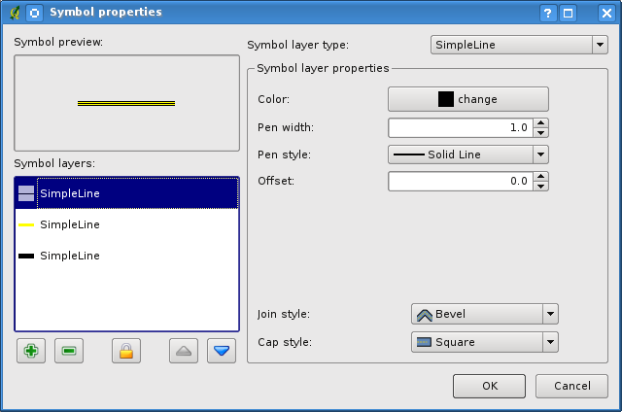
Example: A picture showing a line symbol composed from three simple lines with different pen widths.

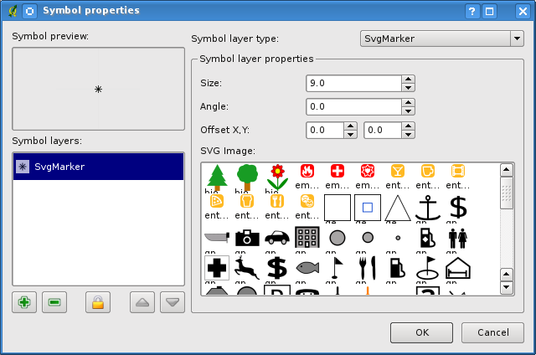
Example: Symbol properties for a point layer

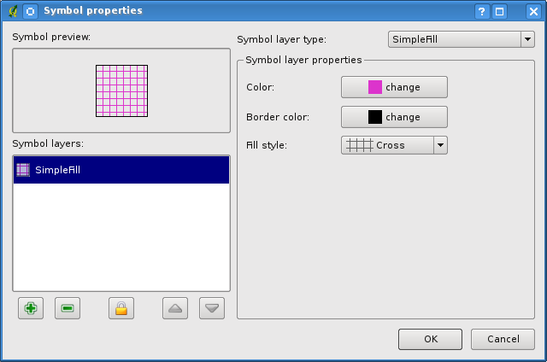
Example: Symbol properties – filling pattern for a polygon layer

Style Manager
The Style Manger is a small helper application, that lists symbols and color ramps available in a style. It also allows the user to add and/or remove items.
To launch the Style Manager, select Settings tab from the main menu

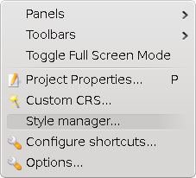
and then click on the Style Manager item.

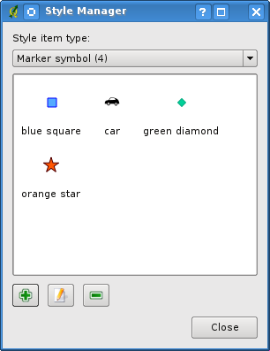
Example: The Style Manager dialog.

Gather plugin
Gather plugin is a plugin for QuantumGIS software, that enables users to record travel path and other accompanying informations - audio and video, for example. The primary purpose of the software (combined with player counterpart of the plugin duo) is to enable easy mapping of cities by using a vehicle, touchscreen, microphone and cameras.
After the data are recorded, it's possible to replay them later using player plugin (and thus use in some way, e.g. to create maps or note road types).

General data recording work flow
The following usage is assumed: User starts the qgis, configures output directory and data inputs (video cameras, audio devices...). After that, he starts recording data and 'traveling'. Data are continuously recorded and user is also enabled to leave short notes for the current position. Most of the data sources are visualised during recording (see later sections), so the user knows, whether all hardware working as it should. When all planed places are driven-thru, the recording is stopped. All data stored between start and stop of recording are called a ' recording '.

Installation
Gather plugin is used inside qgis environment, so obviously it's necessary to install qgis first. After that it's required to build some parts of the plugin. Here are the steps required to use gather plugin inside qgis:
- You have to have python support enabled in qgis
- Download the Gather+Player package and unpack it to ~/.qgis/python/plugins . You should have gatherplugin and playerplugin inside the directory now.
- Several libraries are required compile so called source plugins. For ubuntu 9.04, these are portaudio19-dev, libavcodec-dev, libavdevice-dev, libavformat-dev, libavutil-dev, libswscale-dev, libvorbis-dev (e.g. use command aptitude install portaudio19-dev libavcodec-dev libavdevice-dev libavformat-dev libavutil-dev libswscale-dev, libvorbis-dev, python-serial ). It's also recommended to have development packages required to compile qgis itself to have installed, however package sip4 should suffice.
- More development packages could be needed to build additional 3rdparty source plugins.
- cd ~/.qgis/python/plugins/gatherplugin
- make
Now you should be able to use the plugin by starting qgis and enable the plugin inside plugin manager.

Basic user interface
The first time gather plugin is started, something like the following should show up:
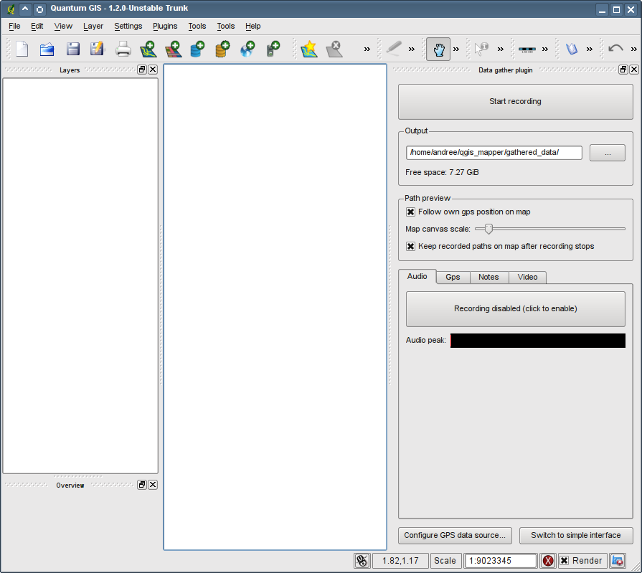
The "Data gather plugin" dockwidget contains complete user interface of the plugin. It consists of several parts:
- Start recording button. By pressing this button the recording is started, using the current settings of output directory and source plugins.
- Output groupbox . Here it's possible to specify directory, where recording are stored. It also contains free space information, that contains current free space in the specified output directory (well, disk where the directory resides, to be precise).
- Path preview groupbox . Here it's possible to configure visualisation of path travelled (received from gps data source).
  - If Follow own gps position on map is checked, the map canvas extent will always be moved so that current gps position is centered in it.
  - Map canvas scale slider allows to choose scale of the displayed map.
  - Keep recorder paths... checkbox, if checked, ensures, that after recording ends, the recorded path will stay on the map canvas. When unchecked, all previous paths are erased from the map.
- Source plugins configuration tab box. Configuration options are described in the data source section, for each source separately.
- Configure GPS data source button. By pressing this button, a configuration dialog appears, where it's possible to set up the GPS data source.
- Switch to simple interface button. Using this button it's possible to switch the dockwidget to a smaller one - which is more of just an informative widget (it's not possible to set up much of the recording there). See simple interface subsection .

Simple interface
By pressing the Switch to simple interface button, the 'big' userinterface reduces to a smaller one to only contain as little information as needed to know, that the recording is working correctly. This mode is useful e.g. for small touchscreens:
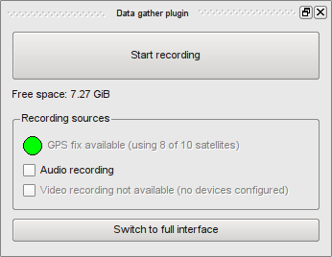
It's of course possible to return to full interface by pressing the Switch to full interface button. The Start recording and Free space widgets have the same functionality as before.
The main change is that there only is a Recording sources groupbox. There are a few widgets inside it:
- GPS fix - indicates status of GPS device. If the icon is red, connection to gps device failed and no gps data is available. Yellow icon means successful connection to GPS device, but no GPS fix (i.e. the position is yet to be determined by gps device). Green icon means full operation mode.
- Audio recording - if checked, the audio is recorded.
- Video recording - if checked, the video is recorded (using the configured cameras). Also, if there is some error, the text of checkbox would indicate it.

Data sources

Gps
Unlike other devices, the Gps device is configured using the "Configure GPS data source" button. The following dialog appears:
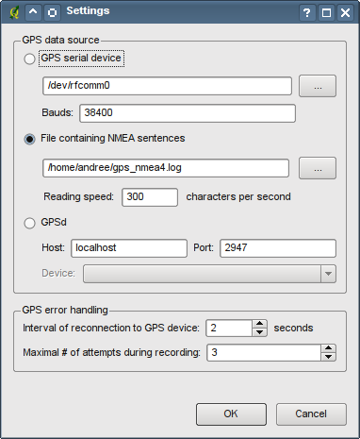
In the GPS data source it is possible to choose one of the available GPS sources. Gather plugin currently supports the following sources:
- GPS serial device - support for serial devices providing NMEA data. When using this source, it's required to enter path to the serial device (could be e.g. /dev/rfcomm0 for linux and a bluetooth gps device). It's also required to specify baud rate of the serial connection (e.g. 3600, 38400). Note that a standard 8-N-1 'protocol' is used to communicate with the device at the specified baudrate.
- File - this option may be used to simulate a gps device and is mostly used to test the software. Parameters are (probably) previously recorded NMEA data file and number of characters read per second from the file.
- GPSd - to use data from GPSd daemon, it's required to enter it's address and port where it's listening. It's of course required to have the gpsd daemon running and configured to use it as a data source...
The connection to a gps device might be not stable (esp. if using e.g. bluetooth and there is some EM noise). Gather plugin therefore enables to specify, how often it should try to reconnect to a gps device (in case of lost connection) - and after how many failed attempts it should notify user about an error. Note that the notification is quite tough - the recording is stopped after lost gps connection and user is informed why. This is, because without valid GPS data it's pretty meaningless to continue mapping...

GPS
The first source plugin actually is a special type of plugin - it doesn't store any data :-) It's purpose is solely to inform user, in a visual way, about current GPS 'status'.
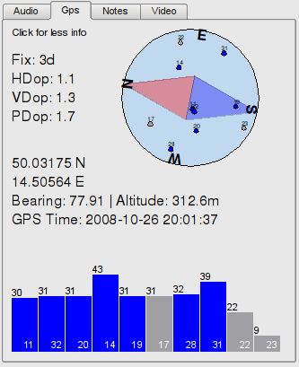
The GPS tab is split into two parts - top and bottom.
The top part may be in a simple or verbose mode (switched by clicking somewhere into the tab space). In simple mode only a sky graph is displayed, in the verbose one, also current position, orientation, altitude and other GPS parameters are displayed (see your GPS device's documentation for more informations).
The sky graph is a basically a compass containing satellites' positions. The graph rotates according to current bearing - at each time point, the top part of graph is oriented to the direction given by bearing. In other words, if the bearing is the movement angle (depends on GPS device sometimes, but should be true most of the time), then if you hold the screen pointed in the direction of movement - e.g. north is always where the compass shows. Besides this information, the graph also contains satellites' positions on the sky (relative to current bearing and position) - each satellite is drawn with it's id, and is blue (if used to calculate current position) or grey (it's not...). The position of satellite on graph is given by it's angle and elevation.
The bottom part shows a list of available GPS satellites. Each column contains a satellite ID in the bottom part. Height of the bar depends on signal strength (the better signal, the higher the bar) - and numerical value of signal strength is placed above the bar. Also each bar has a color - blue, if the according satellite is used to calculate current position; grey otherwise.

Audio
Audio plugin enables user to record audio using standard soundcard input. The default system audio source is used - it's not possible to choose specific source inside plugin (do this using your system settings instead, please).
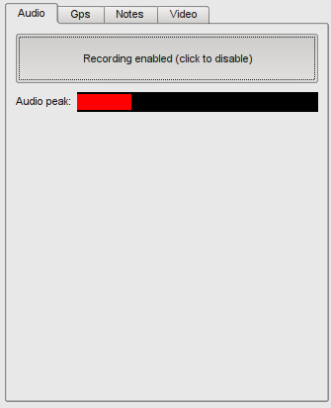
The only thing that the plugin allows to set is whether or not audio recording will be on during data recording. This is chosen by the Recording enabled/disabled button. It's only possible to change the settings outside data recording session. Note that after enabling of audio recording (regardless if data recording is on or off), a audio peak meter starts showing audio peak values. The purpose of this meter is to show some indication to the user, whether any audio is being detected/captured (by speaking to the microphone, the meter should show some activity).

Video
Video plugin enables user to capture video from video devices to compressed avi files. All video cameras supported by kernel, using V4L(2) interface and providing raw output (like yuv, rgb - i.e. not jpeg) are supported. First time the plugin is started, a dialog like the following is presented to the uer:
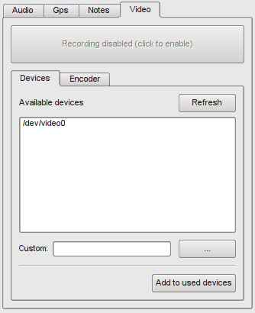
The recording enabled button is disabled until at least one video device is configured to be recorded.

Defining used cameras
The configuration of cameras begins by choosing a camera from the list of available devices (you can use the refresh button, if the camera was added after program started - to get new list of available devices) and pressing Add to used devices button. Video plugin automatically only recognizes devices within /dev filesystem, with filename beginning with 'video' string. If the camera isn't listed, and you know which device file it uses, it's possible to enter path to the device in the "custom" line edit widget (or press ... button to browse for the device). Again - only V4L(2) devices are supported.
After adding the camera to used devices, a tab is added, containing configuration options for the chosen camera:
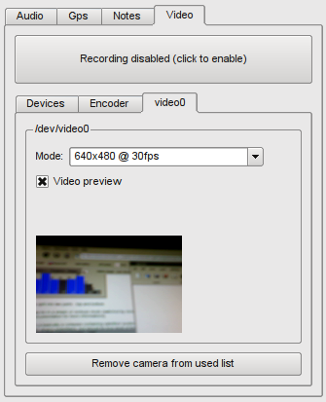

Configuring cameras
It's possible to choose mode of the camera - resolution and frames per second (FPS) recorded. Mode combo box pre-filled with available modes detected from the camera. However it's possible to enter custom value into the mode combo box. Note that the V4L2 doesn't guarantee, that the FPS will be the same that you choose. However - video plugin tries it's best to keep the FPS constant, so that the video is always recorded at constant speed. After choosing the mode, it's possible to enable the video preview - if you get some image there, it's almost certain, that the camera is working correctly. Otherwise, the camera probably doesn't support the selected mode combination (resolution and/or fps). This might have many reasons - you can see error messages in console.
Hint 1: Please note, that some cameras (or v4l drivers) don't particularly 'like' too fast changes of mode (which could end up with camera being unable to provide any data until unconnected and reconnected to the PC).
Hint 2: If you need to configure more than 1 USB camera (e.g. 4 of them), it's possible that you will encounter problems with capacity of the USB bus. Some cameras don't support USB hubs (so more than 1 camera connected to 1 PC USB port will end up with error), and the bigger you choose resolution and fps, the less data rate is available to other cameras. It's therefore pretty problematic to have 2x 1024x768@30fps connected to the same USB port. There are more problems - all cameras we tested only supported different fps's virtually in driver - regardless what fps is chosen, the camera 'occupies' the same amount of data transfer rate of the usb port (so it doesn't really matter if you choose 1fps or 30fps).
Hint 3: As you might see by now, it's pretty tricky to get a few cameras running at the same time. We suggest the following workflow: add cameras, configure modes, enable camera previews. After this, you will see, which cameras are going to work during recording. This is, because after you start recording, the camera device 'connections' aren't restarted - so cameras showing data in previews are going to continue working during recording.

Configuring compression codecs
The last thing that can be set is codec used to encode the video data:
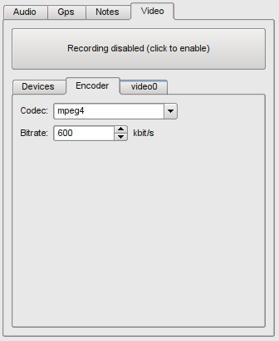
Video plugin uses ffmpeg libraries to encode video - available codecs are thus equivalent to the ones ffmpeg is compiled with. In case of ubuntu and debian, the standard ubuntu 9.04 ffmpeg doesn't support enhanced codecs (because of patent issues) like mpeg4 and x264 - one is required to use e.g. mjpeg codec, which should always be available. For each codec it is possible to choose bitrate - use of this parameter is however codec-dependent. Please note that the more sophisticated codec you chooose, the more powerful cpu you have to have to be able to compress the data realitme. In case the cpu is too slow, uncompressed data are stored in ram until compressed - and you might get into ugly memory-full problems. Please test that you are able to compress video realtime (and you have some cpu-power reserves) before you start using video recording in terrain.
All available codecs can be listed by using the ffmpeg -formats |grep DEV command. Not all of these codecs are usable (e.g. bmp would output a bunch of bmp images, which is not supported by gatherer) - if you are unsure whether particular codec is 'good', try setting it and you'll see, whether it works.
Recommended codecs, if installed, are mpeg4, x264, mpeg2 and mjpeg (in specified order). The better codec, the less disk space is needed, the better the quality - however, also more powerful cpu is needed, as mentioned. The optimal bitrate depends on chosen codec and mode - it's recommended to try out different bitrates with chosen video mode and codec (and replay the data afterwards - to see if there aren't too many compression artifacts). The bitrate and codec setting is common for all cameras - so be sure to test the setting for the best mode, whether it's sufficient.

Notes
Notes plugin enables user to store notes during the recording - useful if e.g. microphone doesn't work, or if the notes are processed automatically later. Notes plugin functionality is only available after recording starts (for the obvious reasons).
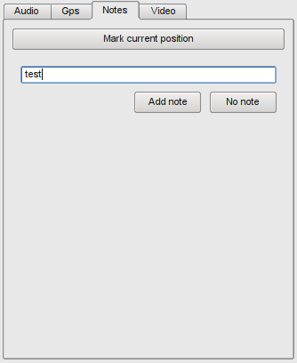
Once the recording started, the Mark current position button is enabled. After clicking it, the current position on the map is marked (a red cross is shown on the map - see the example picture below). Also, an edit widget is shown under the button, where it's possible to add a note to the mark. After the note is entered, it's required to press Add note button. After adding the note, the mark on map changes color to blue (to indicate that it contains a note). After pressing the No note button, or the Mark current position button again, the last entered mark is considered 'note-less' and is colored to green.
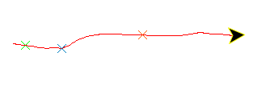

Example of setup procedure
The following short text gives an example on how to setup gather plugin for a recording session.
- Install qgis and gather plugin. Start qgis and enable the gather plugin in plugin manager.
- Configure output directory - should be (for best performance) placed on a local harddrive.
- Configure GPS device. After the device is configured, the GPS position should be shown in the GPS source tab.
- Now, depending on what devices are going to be used, configure them and enable the recording. Please remember the Hint 3 of video camera setting.
- Perform a test recording before the real usage - to be sure that everything is working as required, a test replay (using player plugin) is recommended.
- Record=gather data.
- Transfer data from recording computer to the replay/processing one.

Player plugin
Player plugin is a plugin for QuantumGIS software, that enables users to record travel path and other accompanying informations - audio and video, for example. The primary purpose of the software (combined with player counterpart of the plugin duo) is to enable easy mapping of cities by using a vehicle, touchscreen, microphone and cameras.
After the data are recorded, it's possible to replay them later using player plugin (and thus use in some way, e.g. to create maps or note road types).

General data replay work flow
After data are recorded by the recorder part of software, they are transferred into computer used to convert the stored data to whatever format required. By opening selected recording (see data recording for clarification, what a recording is), the user not only gets view of path travelled during recording (which may be processed by several gis tools of qgis), but also he may replay audio and video tracks recorded etc. These tracks currently mainly serve the purpose of tagging roads (e.g. if recording operator saw a one-way only street, he could mention it in the audio track. Or this fact could be seen in the video track) and the similar - it's however possible to extend the functionality in the future (like exporting video to a group of bitmaps, cutting recorded audio and creating a sight-seeing instructor by using recorded data).

Installation
Player plugin is used inside qgis environment, so obviously it's necessary to install qgis first. After that it's required to build some parts of the plugin. Here are the steps required to use player plugin inside qgis:
- You have to have python support enabled in qgis
- Download the Gather+Player package and unpack it to ~/.qgis/python/plugins . You should have gatherplugin and playerplugin inside the directory now.
- Several libraries are required compile and use so called source plugins. For ubuntu 9.04, these are portaudio19-dev and mplayer . It's also recommended to have development packages required to compile qgis itself to have installed, however package sip4 should suffice.
- More development packages could be needed to build additional 3rdparty source plugins.
- cd ~/.qgis/python/plugins/playerplugin
- make
Now you should be able to use the plugin by starting qgis and enable the plugin inside plugin manager.

Basic user interface
The first time player plugin is started, something like the following should show up:
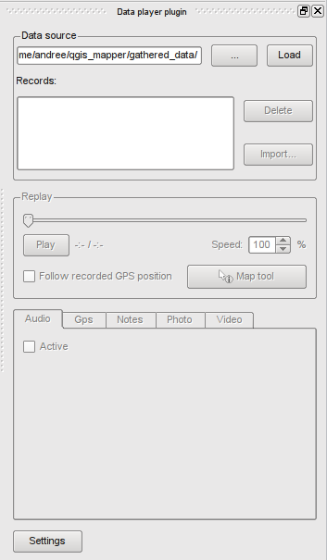
The "Data player plugin" dockwidget contains complete user interface of the plugin. It consists of several parts:
- Data source groupbox. The first edit line box contains path to directory containing recordings from gatherer. After the path is enter (either by writing the path, or by pressing the " ... " button and browsing for the directory), press the Load button to load the recordings list.
- After the recordings list is loaded, it's possible to select one of them in the list below. The selected recording is loaded and it's possible to use the rest of dialog afterwards. Also, it's possible to delete the currently selected recording from disk by using Delete button. The Import... button enables user to import an arbitrary NMEA log file and create a regular recording from it (only containing the converted gps track, obviously).
- Replay groupbox . This part of dialog is used to control replay of the data. The main part of it is the replay position slider. Using this slider, it is possible to rewind the recording to any recorded time. The current time and total time of recording is shown under the slider, to the right of Play button
  - The Play button starts automatic replay of data at speed specified by the Speed spinbox. At 100%, the data is replayed at the speed at which it was recorded. Note that not all combinations of plugins enable replay at other than nominal speed (this is e.g. currently the case of audio plugin - if audio data is to be replayed, only 100% speed is available). The replay can be stopped by pressing the Stop button (it's the same button, that previously was "Play").
  - Keep recorded GPS position in extent - this checkbox, if checked, will ensure, that current gps position in the recording will always be visible on the map canvas (i.e. the map extent will be moved, when needed, so that current GPS position is always within the extent).
  - Map tool - this button, if checked, will set plugins special map tool to be used, instead of the current qgis map tool... The map tool enables sources plugins to perform certain special actions by clicking their canvas items (like showing photos after clicking their map canvas icon). The standard functionality of player plugin map tool is a regular map moving "hand" - after clicking on the map and dragging it, the map gets scrolled accordingly. If you however click on/near the gps track, a second mode is used - after releasing the mouse button, the current position in recording is rewinded to the time associated with the point at the track (i.e. the recording is rewinded so that the gps position at current recording time is the about the same as the mouse position in map).
- Source plugins replay tab box. Replay options are described in the data source section, for each source separately.
- Settings button. By pressing this button, a configuration dialog appears, containing additional configuration options of the player plugin (it's currently empty).
After loading a recording (once again - the steps are - choosing recordings directory, pressing "Load" button, clicking a recording in the list), something like the following windows is shown:
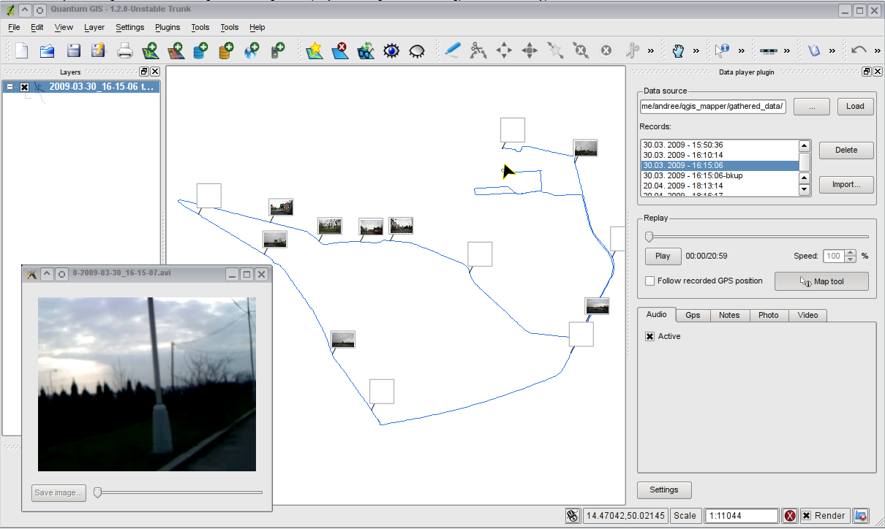
You can see some standard plugins' tabs, a loaded track in the map canvas and a video plugin window. The following section describes interface used to navigate in the recording.

Data sources
The main part of the recording is measured GPX data - stored in form of a GPX track. The track contains several informations about gps status at the time of gathering=recording, and is automatically displayed in the map canvas after loading according recording. On the image above, it's the blue track.

Gps
Apart from the track showed on map canvas, in the gps tab informations about gps position at the current time of recording position are also displayed - in the GPS tab. It probably contains all important navigational informations - you can always dig more from raw nmea data, which are also recorded by gatherer. The format of data displayed is a simple key-value table:
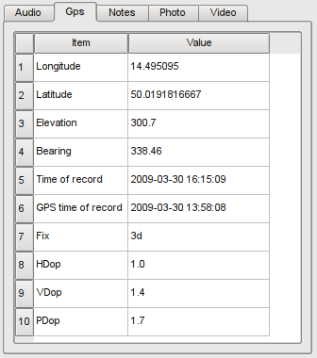
Probably the only two non-trivially understandable values are "Time of record" and "GPS time of record". The first value is the time of computer at the time of recording the gps data. GPS time is the time that was received by the gps device. The two values should be preferably (for users sake) as close as possible, however only the computer time is used - GPS time is only stored for checking reasons.

Audio
Audio plugin enables user to replay audio using standard soundcard output. The default system audio output is used - it's not possible to choose specific source inside plugin (do this using your system settings instead, please).
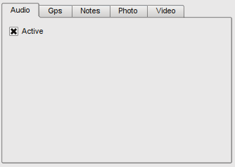
The only thing that the plugin allows to set is whether or not audio replay will be on during automatic data replay (when Play is pressed). This is chosen by the checking the Active checkbox. Note that the Active checkbox is only enabled, if audio data is present in the recording. Also note, that after activating the audio replay, it's not possible to change replay speed.

Video
Video source plugin enables user to replay data previously recorded by the video source plugin of gatherer. After loading the recording, the combo box of the video tab is filled with stored video files. It should look like this:
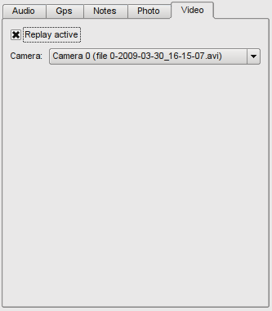
Also, if Replay active checkbox is enabled, the selected video file is opened in a separate window. Position in video file is synchronized with position in the recording - although there are some tolerances (which should stay under 1-2s). Please note that if video replay is active, the speed of replay is always 100% and can't be changed.

Notes
Notes plugin enables user to see and read notes stored during recording. Unless a text note is clicked (see later), the notes tab looks following:
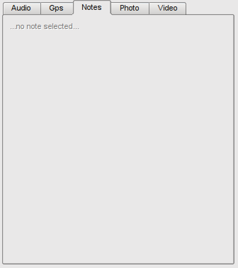
They are displayed the same way as during the recording - the notes marks are placed on the map at the place, where they were entered. Example of the map marks follows:
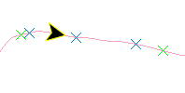
Green mark crosses are placed where only a note without text was left. Blue ones contain some textual information, that is accessible by clicking the area of note mark cross - after clicking (if the player map tool is active), the note is displayed in the note tab.
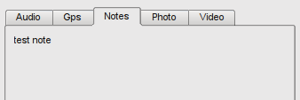

Photo
The photo source plugin doesn't have equivalent source plugin for gatherer (mostly because it doesn't make a lot of sense). The main purpose is to enable user to associate photos, captured during recording, with the track - and display them at according parts of the track. The photos are displayed nearby the recorded track on map in small balloon-like boxes (see later). The main interface of plugin:
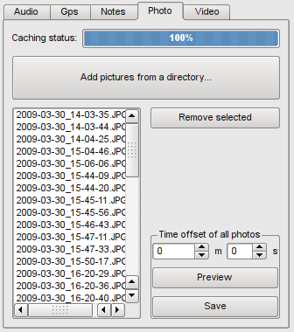
Every time new recording is loaded, photos' thumbnails have to be generated and loaded into memory. The progress bar on the top of the tab shows - well, progress of this operation. After it's finished, photos are placed on the map canvas and are ready to be worked with.
The most important is the Add pictures from a directory button. After pressing it, a dialog has to be chosen, from which the photos are copied into the recording and loaded. Each photo has to contain so called EXIF information, so that the photo source plugin is able to determine date and time of it's creation and to insert it into appropriate part of recording correctly.
After photos are inserted into the recording, loaded and cached, it's possible to work with them further. List of available photos enables user to choose some of them and remove them by the appropriate button.
In case time was set differently on the recording PC and on the camera, the Time offset of all photos might come in handy. Functions in that groupbox help changing the time of all photos to correct one (so that they fit correctly to the map). The functionality is of course completely manual - no offset detection of any kind is provided. After setting time offset of photos, it's possible to use the Preview button - which causes, that photos are moved only on the map. User might then check, that the offset was correct - and if yes, it's possible to commit changes by using Save button. The button causes storing photos with new times (the files' contents stay untouched, so no worries about JPEG quality degrading). This way, it's possible to easily fix e.g. 1 hour differences between PC and camera time.
Another part of photo interface is placed on the map canvas - each photo is shown near the track in a balloon-like box:
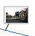
By clicking the box (again, if player plugin map tool is active), a full version of the photo is displayed in a external window.
If there are more photos occupying the same map canvas space (so they would overlap), photos are grouped:
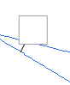
By clicking the box, photos are expanded around it and it's possible to click individual photos (which works as with regular photo balloon):
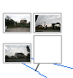
Note that all external photo windows are closed after unloading the player recording (or loading another recording, for that matter).

PostGIS manager
PostGIS Manager is a plugin for Quantum GIS that aims to be a simple yet powerful tool for management of PostgreSQL databases with emphasis on support of spatially enabled tables in PostGIS. Target audience for this plugin are users that want to do some administration tasks on the tables in user-friendly graphical interface without having to type SQL commands. This plugin is not meant to be a complex tool supporting virtually all PostgreSQL/PostGIS functionality. Instead, it should help users with typical tasks and speed up the work.
We hope that PostGIS Manager will help to lower the burden when it comes to usage of geodatabases which are for many considered as an interesting but too complex concept to use for real work.
The user should have some basic knowledge about relational databases and their usage. For the simplest use for only viewing database structure and contents of tables, it's necessary to understand what the databases and tables. Before doing any modifications, it's highly recommended to understand the views, schemas, indexes, constraints, SQL syntax, triggers and rules. Otherwise one can do some serious harm to the data stored in the database.
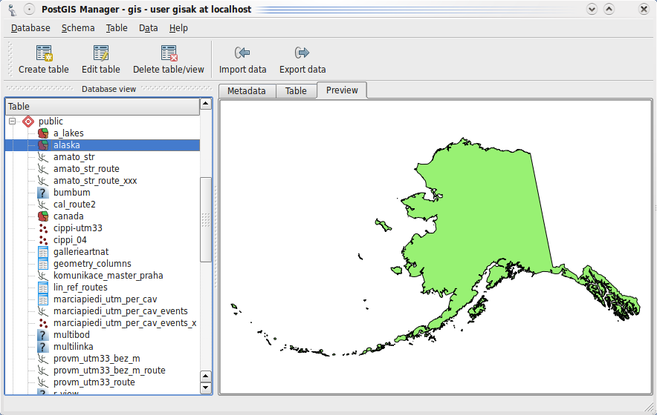
Main window of PostGIS Manager
Main window consists basically of two parts:
- database view - this is a widget that lists all tables and views in the database
- central view - displays metadata, tabular preview or map preview

Short intro to PostGIS
If you're familiar with PostGIS, feel free to skip this section.
PostGIS is an extension for PostgreSQL database that adds support for spatial data. Much of the objects we recognize in the world have some location: a restaurant can be defined by a point, a road can be described as a line with several segments and border of a forest can be represented as a polygon. This means that we can extend our tables (containing restaurants, roads, forests or anything else) with another column which will specify object's location. PostGIS implements adds a new geometry type that stores the spatial information. Once such table contains such column, we call it spatial table or geotable.
When working with a large set of data (think millions of rows), it's necessary to access the data effectively. Relational databases use indexes on columns to achieve better performance of queries. Traditional indexes however can't be used for the spatial data because they're two (or even more) dimensional. PostGIS comes with a spatial index (R-tree, as opposed to B-tree used for traditional indexes).
GIS software typically organizes data into layers: one layer is a set of objects with common properties, e.g. roads, railroads, rivers or cities. In relational databases one layer is represented with a table where one row represents one object: geometry column determines the position and the rest of the columns are object's attributes.

Database view
This widget displays database content in a hierarchy. Top-level items are always schemas (i.e. namespaces), their children are both tables and views.
You can find following icons that differentiate the items in the view:
Schema Table View
If the database has PostGIS support, the plugin will detect which geometry type is used for the table (points, lines or polygons) and set appropriate icon (instead of the original table/view icon):
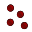 Point layer 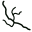 Line layer  Polygon layer Unknown layer type
Unknown layer type means that the geometry column is either not listed in geometry_columns or some special type is used.
Tables that contain more geometry columns are listed multiple times, each time for one geometry column. This is however not very common.
Schemas can be expanded and collapsed, by default all schemas are expanded if the database contains less than 100 tables or views.
Note: by default, there is a public schema in every database and is used implicitly. This means that tables in public schema can be accessed just by their name and not necessarily with schema.table syntax.

Central view
The central part consists of three tabs for inspection of the table metadata and their contents.

Metadata tab
Displays basic information about the table:
- table name
- row count
- owner
- user's privileges
- detailed list of columns with their name, type and length
- constraints (primary and foreign keys, unique columns, checks) with thier definitions
- list of indexes
- list of triggers and rules with possibility to enable/disable or delete them
For spatial tables it adds a section about geometry type, number of dimensions, coordinate reference system and layer's extent.
This tab is used also used to show schema and database information.

Table tab
Shows contents of the table in a table. Geometry columns are excluded from the view. The table is read-only.

Preview tab
Available only for spatial tables. Displays a simple map from the objects' geometries.

Database connections
In Database menu there's a list of available database connections. The list is loaded from QGIS settings and if you'd like to add, modify or delete any connections, you can do it within Quantum GIS, menu Layer » Add PostGIS Layer. Once connected, you can disconnect from the database (menu Database » Disconnect) or reconnect to a different database.
When started, PostGIS Manager tries to connect to the recently used database for convenience.

Database info
When the user selects menu Database » Show info, the metadata tab is filled with information about the database connection: host computer name, current user (role), user's privileges and server version. If the PostGIS support is installed for the database, it will also show information about version of PostGIS and its support libraries.
There may be also a warning stating there's a mismatch of versions of PostGIS scripts. This might be a result of incorrect upgrade of PostGIS: when installing a newer version, you should also re-run the initialization scripts for every database on the PostgreSQL server that has PostGIS support enabled. The scripts are in lwpostgis.sql and spatial_ref_sys.sql files, located in the PostGIS installation directory (depends on the platform).

Management of schemas
When clicked a schema, some basic information about the schema is shown: number of tables, owner and permissions of the current user.
It's possible to change schema's name by either clicking schema's name once more when selected or by pressing F2 . When renaming schemas in spatial database, the geometry_columns table is altered too to reflect the change in schema's name.
In Schema menu it's possible to create a new schema and to delete an existing schema. The schema for deletion must be empty.

Management of tables
Whenever a table is selected in the database view, the central view is updated with data from the table. Double clicking table name in database view, clicking Edit table action in toolbar or Table menu, opens table properties dialog. The dialog comprises of three tabs: Columns, Constraints and Indexes - each of them containing a list and some actions.
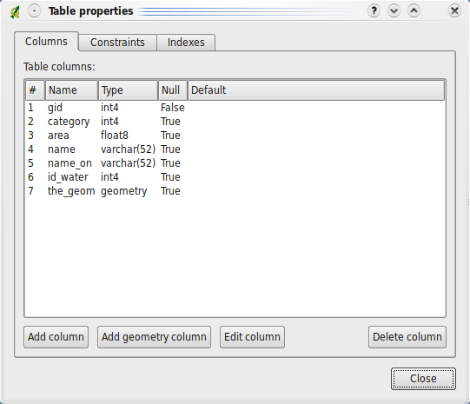
Table properties dialog
You can do following operations with tables:
- Add column - a new dialog is opened with new options for new field, it is appended to the table after accepting the dialog
- Add geometry column - to add spatial information to the table. In a new dialog it's possible to select name, geometry type, number of dimensions and spatial reference ID. AddGeometryColumn function is used for creation of the column
- Edit column - opens column properties (identical to add column dialog) and allows to modify one or more column settings
- Delete column - drops the selected column, in case of a spatial column uses DropGeometryColumn function
- Add constraint - in a dialog allows to specify constraint type and the column on which the constraint will be applied. Currently supporting only creation of primary keys and uniques on one column
- Delete constraint
- Add index - opens a dialog for creation of index. The user is able to specify the column and index name
- Add spatial index - goes through the geometry columns and asks whether to create spatial index
- Delete index
It's possible to create new tables in a simple table creation dialog. You can open it by clicking Create table action in toolbar or doing the same in the Table menu. The dialog aims for simplicity and offers only basic options: schema, table name, list of columns with their types, column which will be used as a primary key. In case user's going to create a spatial table, it's possibly to specify geometry column name and type, optionally to create a spatial index.
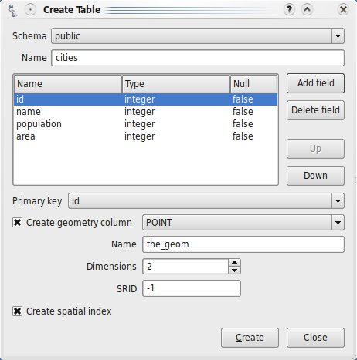
Create table dialog
There are also several more operations available in the Table menu:
- Run VACUUM ANALYZE - in case your database server doesn't use autovacuum functionality, you should run this command manually as a part of maintenance. Failing to do so will result in suboptimal queries and bad usage of space with frequently modified tables
- Move to a different schema - also updates geometry_columns table when used with spatial tables
- Emtpy table - deletes all rows within the selected table
- Delete table/view

Data Import

Load data from shapefile
Clicking menu Data » Load data from shapefile will open a dialog for import of shapefiles into the database as spatial tables. The dialog acts as a simple frontend for the shp2pgsql command line utility from PostGIS. See Using the Loader section from the PostGIS manual for more information.
There are several available import actions: only create table, only insert rows or both creation of table and insertion of rows. The tool supports several options, most of them can be set within the dialog. Finally, the resulting SQL commands can be either stored in a text file or directly applied in the current database connection.
Note: not having PostGIS installed on your local machine or being installed in some non-standard location will render this feature unusable because of the missing shp2pgsql tool.

DBF Import
For those willing to import some tables without geometries into the database, there's import wizard. Although currently supports only import from DBF files, it might eventually get support for more formats. The first step is to select input file and encoding. In the second step, one can see how the table will look like and optionally do some modifications to the table. Clicking Finish button the file gets imported into the database and the wizard is closed.

Data Export
There's a possibility to export spatial tables into shapefiles: use Dump data to shapefile (in Data menu). Similarly to the Load data from shapefile, this is a frontend to pgsql2shp utility from PostGIS. See Using the Dumper section from the PostGIS manual for more information.
A dialog will pop up where the user can set the source table to be used for import and the output shapefile. The resulting shapefile will be generated after clicking the Dump button.

Advanced features

Geometry processing
In many case you may want to do some analyses with your spatial tables. Often it's useful to know the area of every polygon or length of every linestring in a spatial table. Just imagine situation where you would like to see polygons symbolized depending on their size. Or as a part of cleaning process you want to delete some of the smallest polygons. In these cases it's handy to have the area or length value precalculated in a separate attribute. Of course it's possible to let PostgreSQL calculate the values on the fly (e.g. using a view with such calculated column), but that leads to performance penalties on retrieval of data.
Geometry processing dialog greatly simplifies the task of calculation of features' area or length. You just select the table and appropriate geometry column (usually there's just one per table) and the attribute which will receive the calculated values.
If data in your table are being added or modified, the calculated values become soon invalid. But don't worry. There's a check box "Add a trigger for calculation on insert and update". If checked, the dialog not only calculates the values (one-time action) but it also creates a trigger function that does the calculation and assigns it to the table. On each modification of the table trigger function updates the area/length attribute to make sure the value is correct.
Note: both area and length are calculated in the units of layer's projection. If the layer has meters as map units, the resulting length is in meters and area in square meters. When using lat/lon coordinates, the map unit is one degree and the resulting length (in degrees) and area (in square degrees) doesn't have much use (IMHO).

Table versioning
(This is currently an experimental feature.)
Having table with versioning means that you can go back to any moment in the history of the table and see its state. This is achieved by only appending changes to the table instead of doing modifications in place. Every record has additional start and end time attribute. In case the record is still actual, its end time is null. The write operations on the table are modified as follows:
- INSERT - start time is set to current time, end time is set to null
- UPDATE - original record gets its end time set to current time, new record is inserted to the table containing the new version of the record
- DELETE - end time of the record is set to the current time.
To get actual view of the table, you must set a condition that end time is null, otherwise you would fetch contents of the table in the whole history. It's common to use a convenience ("current") view that has this constraint included in the definition.
It's recommended to read TimeTravelling in PostgreSQL [PDF] presentation as the table versioning feature is heavily based on it. Another good source of information (for those understanding German) is Historisierung von Tabellen in PostGIS [PDF] which discusses the topic more in context of GIS application and gives examples of the implementation.

OpenStreetMap support
In recent years OpenStreetMap project has gained popularity because in many countries there were no freely available digital roadmaps. Target of the OSM project is to create a free editable map of the world from GPS data, aerial photography or simply from local knowledge. To support this idea we decided to create a plugin for QuantumGIS software that enables its users to work with OSM data.
The plugin is a part of Qgis-mapper project and provides all basic functionalities for OSM data manipulation, such as data loading, importing, saving, downloading, editing and uploading back to OpenStreetMap server.
While implementing OSM plugin an inspiration was taken from existing OSM data editors. The purpose was to combine their functionalities to get the best possible result.
The following two sections gives you brief introduction to principles of both aforementioned projects. If you are not interested in information on OSM and QGIS just skip both sections. Parts of the following few paragraphs are copied from the OpenStreetMap web site.

OpenStreetMap
OpenStreetMap is a project to create a free editable map of the world. The maps are created using data from portable GPS devices, aerial photography, other free sources or simply from local knowledge. The project was started because most maps have legal or technical restrictions on their use, holding back people from using them in creative, productive, or unexpected ways. Both rendered images and the vector dataset of OSM are available for download under a Creative Commons Attribution ShareAlike 2.0 licence.
OpenStreetMap was inspired by sites such as Wikipedia – the map display features a prominent 'Edit' tab and a full revision history is maintained. Registered users can upload GPS track logs and edit the vector data using the given editing tools.
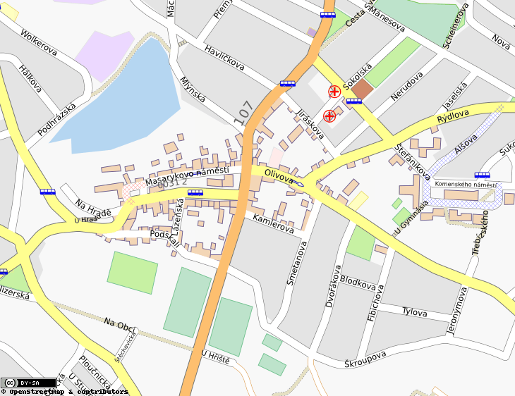
OSM data primitive is an object class that can be stored via the API in the server. Three types of data primitives are supported: Node, Way and Relation.
A node is a latitude/longitude pair. It is used as building block for other features and as features themselves (Points Of Interest) if they're tagged as required. A way is a list of at least two nodes that describe a linear feature such as a street, or similar. Nodes can be members of multiple ways. A relation is a group of zero or more primitives with associated roles. It is used to specify relationships between objects, and may also model an abstract object.
Several different logical things in common map (like "Point Of Interest", "Street", "Tram Line", "Bus Stop" etc.) are defined out of these primitives by specifying appropriate "Map Features". Map features are well-known in OSM community and are stored as pairs of a key and a value – tags. OSM is usually distibuted in XML format. XML payload is used for communication with OSM server also.
For more information visit project presentation: http://www.openstreetmap.org/.

QGIS-OSM Connection
There were some questions while designing OSM and QuantumGIS connection. In this guide first of all we show the way how OSM data primitives are displayed in QGIS vector layers.
OSM data consists of Nodes, Ways and Relations. In our design they are displayed in three QGIS layers: Point layer, Line layer and Polygon layer. It's not possible to remove any of these layers and work with the other ones.
Point layer displays all features of type Node that stands alone. That means that only Nodes that are not included in any Way belongs to the Point layer.
Line layer displays those OSM features of type Way that are not closed. That means that none of these Ways starts and ends with the same Node.
Polygon layer displayes all Ways that are not included in Line layer.
OpenStreetMap has one more data primitive except for the three mentioned above - Relation. In our design there is purposely no vector layer to display Relations. Relation defines relation between any number of data primitives. After Point, Line or Polygon is identified on map, plugin shows a list of all relations the identified feature is part of.

A problem was discovered when designing interconnection between OSM data and standard QGIS editing tools. Those tools are made to edit single vector layer at a time, no matter of what feature types it displays. It means that if OSM data are loaded to QGIS through the plugin, you could (teoretically) edit Point layer, Line layer or Polygon layer with these standard tools separately.
The problem is that Line layer consists of two different types of OSM features – Ways and Nodes. Why? Because in OSM format Way is composed of Nodes. If you start editing of Line layer and change the shape of some line, your action must affect not only the OSM Way but also OSM Nodes that are part of it. But QGIS standard editing cannot tell the OSM Provider which members of which line has changed and how. It can tell only what's the new geometry of which line and that's not enough to propagate changes to OSM database correctly. The Line layer doesn't even know identifiers of line members.
The same problem occurs when you try to edit the Polygon layer.
For this reason plugin has its own simple tools for editing OSM data. While they are used plugin can react on every moving, removing or adding of line/polygon member and so it can change OSM data correctly. Plugin editing set consists of tools for Point, Line, Polygon and Relation creation, deletion and moving.
To create the real connection between OSM plugin and standard editing tools, changes in QuantumGIS core code would be necessary.

Instalation
Plugin is used inside QuantumGIS environment, so obviously it's necessary to install QGIS first. After that you must build some parts of the plugin. Here are the steps required to use OpenStreetMap plugin:
- You have to have python support enabled in QuantumGIS
- Download the plugin package and unpack it to ~/.qgis/python/plugins .
You should have the plugin inside the directory now.
- cd ~/.qgis/python/plugins/osmplugin
- make
Now you should be able to use the plugin by starting QGIS and enabling it in the Plugin manager. Just search for the name: "OpenStreetMap plugin".
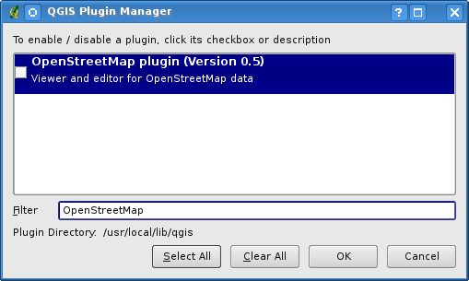

Basic user interface
The first time OSM plugin is started (and after the first data are loaded), something like the following should show up:
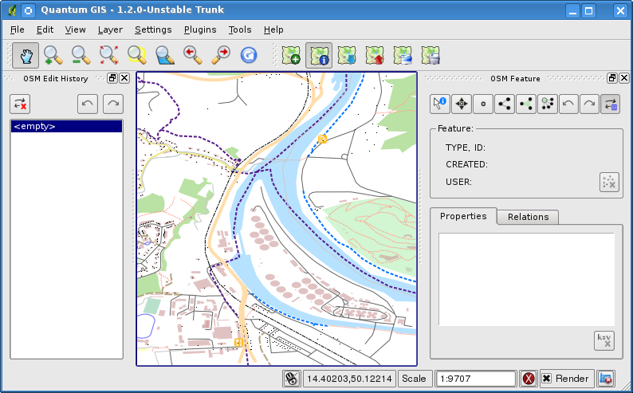
As you can see plugin consists of few graphic components.
Here is brief information on them:
OSM Feature
Dockable widget that helps QGIS user with OSM feature identification. It shows basic information on features type and identifier as well as info on who and when changed feature lately. OSM Feature widget holds all editing tools also (in the top part of it). More information on those tools can be found in section focused on editing. Widget is initially disabled. It activates itself after successfull loading of some OSM data.
OSM Undo / Redo
Dockable widget intended to help user with reverting edit actions. It consists not only of clasical Undo button and Redo button, it shows even list of brief description of edit actions that were done. OSM Undo / Redo widget is initially closed. You can show it using special button on OSM Feature widget.
Tool-buttons
Load OSM from file – used to show dialog for loading data from special OpenStreetMap XML file
Show/Hide OSM Feature Manager – to show or hide OSM Feature widget; OSM Feature widget is panel that helps with OSM feature identification and with OSM data editing
Download OSM data – used to show dialog purpose of which is to help user to download data from the OpenStreetMap server
Upload OSM data – to show dialog for uploading changes (on current data)
Import data from a layer – to show dialog for importing data from a vector layer; at least one vector layer must be loaded and current OSM data must be selected
Save OSM to file – to show dialog purpose of which is to help user with saving OSM data back to XML file
More detailed information on all the widgets, buttons and dialogs can be found in appropriate sections of this Guide according to their functionality (editing, identification, etc.).

Loading OSM data
The first action that should be done after starting OSM Plugin is opening data from OSM file, import them from the shapefile or downloading data from OpenStreetMap server. Here we are focusing on the first mentioned action.
To load data from file use the "Load OSM from file" tool button . If there is no such button, maybe someone disabled OpenStreetMap toolbar in your QGIS instalation. You can enable it at Settings->Toolbars->OpenStreetMap.
After using the button following dialog should show up.
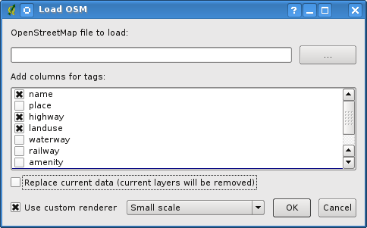
Purpose of its elements is explained below.

- OpenStreetMap file to load
Click on the button to select the .osm file you want to load data from.
- Add columns for tags
This option determines inter-connection between OSM and QGIS data. Each feature of OSM data has some tags (pairs of key and value), that define feature properties. Each feature of QGIS vector layer has its attributes (key and value also). With this option you can define which properties of OSM objects should be visible when displaying detailed info about QGIS features.
- Replace current data
Checking this option means that new data should replace current data user is working with. Layers of current data will be removed and new ones will be loaded. When loading first OSM data, this option is not active, because there is nothing to replace.
- Use custom renderer
Option determines how rich will be the map in detail. The are three pre-defined OSM styles for map displaying. Use "Small scale" if you want to view OSM data at low level, to see all details and to edit something. If not you can use "Medium scale" or "Large scale". At present days QGIS doesn't support changing renderer style dynamically.
Click "Ok" to load your data.
If this is the first time OSM file is loaded, plugin must first parse it into database.
This may take few seconds or minutes – it depends on amount of loaded data.

Viewing OSM data
After OSM data were loaded you can identify map features using the appropriate tool. Use "Identify feature" button on the top-left of OSM Feature widget. Using this tool you can easily explore map objects.
When mouse cursor is over an object, you can see all information on it directly in the OSM Feature widget. There is also dynamic rubberband displayed on the map so that user was able to determine which feature is currently identified.
Properties table of the widget contains of all feature tags.
Clicking on the Relation tab shows you list of all relations connected with identified feature.
If you want to hold a feature for a while to be able to read it's properties, relations and move mouse cursor at the same time, try left-clicking while you are over it. Identifyication process will become paused til next left-clicking.
Sometimes there are more than one feature at the point where left-clicking was performed. This happens especially when clicking on cross-roads or if map is not zoomed-in sufficiently. In this situation only one of such features is identified (and marked with rubberband) but plugin remembers all of them. Then (still in the pause mode) you can change identified features cyclical with right-clicking.

Editing basic OSM data
In the title of this section "basic data" means non-relation OSM features - nodes and ways. If you prefer reading information on relations editing just skip this section and read the next one.
Basic data editing is key part of OSM Plugin. You can change property, position or shape of any existing basic feature, you can remove features or add some new ones. All such changes on nodes and ways are remembered – both for comfortable usage of Undo/Redo operations and for easy upload of changes to OpenStreetMap server.

Changing feature tags
Changing property/tag of OSM feature can be done directly in table of feature tags. Tags table of basic feature can be found on OSM Feature widget. Don't forget to identify feature first.
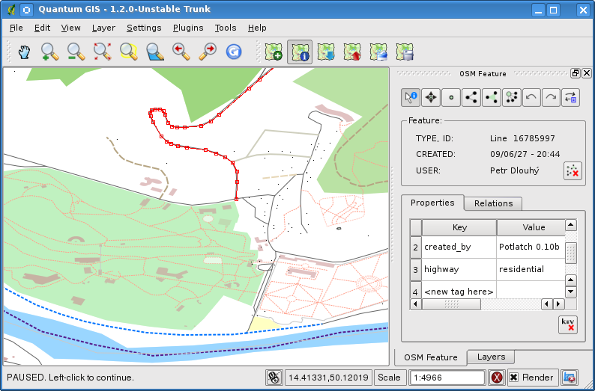
If you want to change tag value, just double-click in the appropriate row of column Value and type or select new value. If you want to remove tag click in its row, then use button on the right under the table – "Remove selected tags"
To add new tag just type its key and value into the last row of the table – where "<next tag value>" is written. Notice that you cannot change key of existing tag pair. For comfortable usage there are some combo boxes of all existing tag keys and their typical values.

Point creation
For point creation there is a "Create point" button on OSM Feature widget
To create some points just click on the button and start clicking on the map. If your cursor is over some map feature, the feature is marked/identified immediately. If you click on the map when line/polygon is marked, new point is created directly on such line/polygon – as its new member.
If your cursor is over an existing point, new point cannot be created.
In such case OSM plugin will tell you:
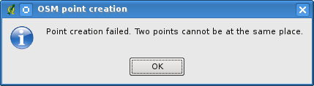
The mechanism of helping user to hit the line or polygon is called snapping and is enabled by default. If you want to create point very close to some line (but not on it) you must disable snapping by holding Ctrl key first.

Line creation
For line creation there is "Create line" button on OSM Feature widget
To create a line just click the button and start left-clicking on the map. Each your left-click is remembered as member vertex of new line. Line creation ends when first right-click is performed. New line will immediately appear on the map.
Line with less than two members cannot be created. In such case operation is ignored.
Snapping is performed to all map vertexes - points from Point vector layer and all Line and Polygon members.
Snapping can be disabled by holding Ctrl key.

Polygon creation
For polygon creation there is "Create polygon" button on OSM Feature widget
To create a polygon just click the button and start left-clicking on the map. Each your left-click is remembered as member vertex of new polygon. Polygon creation ends when first right-click is performed. New polygon will immediately appear on the map.
Polygon with less than three members cannot be created. In such case operation is ignored.
Snapping is performed to all map vertexes - points (from Point vector layer) and all Line and Polygon members.
Snapping can be disabled by holding Ctrl key.

Map feature moving
If you want to move a feature (no matter what's its type) please use the "Move feature" button from OSM Feature widget menu
Then you can browse the map (features are identified dynamically when you go over them) and click on the feature you want to move. If wrong feature is selected after your click, don't move from the place. Repeat right-clicking till the right feature is identified. When selection is done and you move cursor you are no more able to change your decision what to move.
To confirm moving click with left mouse button.
To cancel moving click with another one.
If you are moving a feature that is connected to other features, these connections won't be damaged. Other features will just adapt themselves to new position of moved feature.
Snapping is supported in this operation.
When moving a standalone (not part of any line/polygon) point, snapping to all map segments and vertexes is performed.
When moving a point that is member of some lines/polygons, snapping to all map segments and vertexes is performed, except for vertexes of point parents.
When moving a line/polygon, snapping to all map vertexes is performed. Note that OSM Plugin tries to snap only 3 closest-to-cursor vertexes of moved line/polygon, otherwise operation would by very slow.
Snapping can be disabled by holding Ctrl key during the operation.

Map feature removing
If you want to remove feature, you must identify it first.
To remove identified feature use "Remove this feature" button on OSM Feature widget
When removing a line/polygon, the line/polygon itself is deleted, so are all its member points that doesn't belong to any other line/polygon.
When removing a point that is member of some lines/polygons, point is deleted and geometries of parent lines/polygons are changed. New parent geometries has less vertexes than the old ones.
If parent was a polygon with three vertexes, its new geometry has only two vertexes. And because there cannot exist polygon with only two vertexes, feature type is automatically changed to Line.
If parent was a line with two vertexes, its new geometry has only one vertex. And because there cannot exist line with only one vertex, feature type is automatically changed to Point.

Editing relations
Thanks to existency of OSM relations we can join OSM features into groups and give them common properties – in such way we can model any possible map object: borders of a region (as group of ways and points), road of a bus, etc. Each member of relation has its specific role.
There is a pretty good support for OSM Relations in our plugin.
Let's see how to examine, create, update or remove them.

Examining relation
If you want to see relation properties, first identify one of its members.
After that open tab "Relations" on OSM Feature widget. At the top of the tab you can see a list of all relations the identified feature is part of. Please choose the one you want to examine and look at information thereunder.
In the first table called "Relation tags" there are properties of selected relation.
In table called "Relation members" you can see brief info on relation members.
If you click on a member, plugin will make a rubberband on it in map.

Relation creation
There are 2 ways of creating a relation.
First you can use the button on OSM Feature widget
Second you can create it from the Relation tab of OSM Feature widget by using special button
In both cases dialog will appear. In second case feature that is currently identified is automatically considered to be the first relation member, so dialog is pre-filled a little.
When creating relation please select its type first. You can select one of predefined relation types or write your own type. After that fill relation tags and choose its members.
If you have relation type already selected try using button with "Generate tags" label . It will generate typical tags to your relation type. Then you are expected to enter values to the keys.
Choosing relation members can be done either simply by writting member identifiers, types and roles or by using an identify tool and clicking on map.
Finally when type, tags and members are chosen dialog can be submitted – in such case plugin creates new relation for you.

Changing relation
If you want to change an existing relation, identify it first (follow steps written above in Examining relation). After that click the "Edit relation" button, you will find it on OSM Feature widget
Special dialog appears, nearly the same as for Create relation action.
The dialog is pre-filled with information on given relation. You can change relation tags, members or even its type. After submiting the dialog your changes will be commited.

Downloading OSM data
To download data from OpenStreetMap server click "Download OSM data" button .
If there is no such button, OSM toolbar is disabled in your QGIS instalation. You can enable it again at Settings->Toolbars->OpenStreetMap.
After clicking the button following dialog will appear:
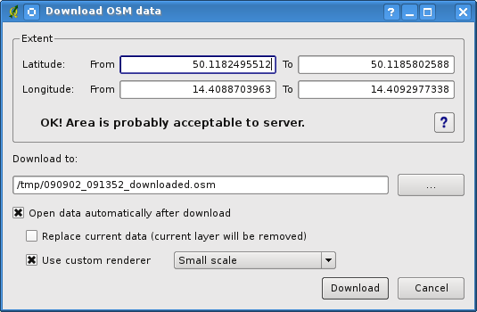
- Extent
Specifies area to download data from - intervals of latitude and longitude degrees. Because there is some restriction of OpenStreetMap server on how much data can be downloaded, the intervals mustn't be too wide. More detailed info on extent specification can is shown after clicking the help button on the right .
- Download to
Here you are expected to write path to the file where data will be stored. If you can't remember structure of your disk, don't panic. The browse button will help you.
- Open data automatically after download
Determines if download process should be followed by loading data process or not. If you prefer not to load data now, you can do it later by using "Load OSM from file" .
- Replace current data
This option is active only if the "Open data automatically after download" is checked. Checking this option means that downloaded data should replace current data we are working with now. Layers of current data will be removed and new ones will be loaded. When starting QGIS and downloading first data this option is initially inactive, because there is nothing to replace.
- Use custom renderer
This option is active only if the "Open data automatically after download" checkbox is checked. It determines how rich will be the map in detail. The are three predefined OSM styles for map displaying. Use "Small scale" if you want to view OSM data at low level, to see all details and to edit something. If not you can use "Medium scale" or "Large scale". At present days QGIS doesn't support changing renderer style dynamically.
Click "Download" to start download process.
A progress dialog will continuously inform you about how much of data is already downloaded. When an error occure during download process dialog tell you its details. When action finishes succesfully both the progress dialog and download dialog will close themselves.

Uploading OSM data
Note that upload is always done on current OSM data. Before opening OSM Upload dialog, please be sure that you really have the right active layer ~ OSM data.
To upload current data to OSM server click on "Upload OSM data" button .
If there is no such button, OSM toolbar in your QuantumGIS instalation is disabled. You can enable it again at Settings->Toolbars->OpenStreetMap.
After clicking on upload button following dialog will appear:
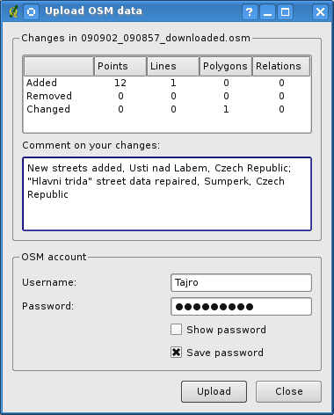
At the top of dialog you can check if you are uploading correct data. There is a short name of current database. In the table there is information on how many changes will be uploaded. Statistics are displayed separately for each feature type.
In "Comment on your changes" box you can write brief information on meaning of your upload operation. Just write in brief what data changes you've done or let the box empty.
Fill "OSM account" arrays so that server could authenticate you. If you don't have account on OSM server, it's the best time to create one. Please visit www.openstreetmap.org.
Use Upload to start an upload operation.

Saving OSM data
To save data from current map extent to XML file click on "Save OSM to file" button .
If there is no such button, OSM toolbar in your QuantumGIS instalation is disabled. You can enable it again at Settings->Toolbars->OpenStreetMap.
After click on the button the following dialog will appear:
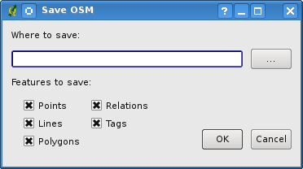
Select features you want to save into XML file and the file itself.
Use Ok button to start the operation.
The process will create an XML file, in which OSM data from your current map extent are represented. OSM version of the output file is 0.6. Elements of OSM data (<node>, <way>, <relation>) do not contain information on their changesets and uids. These informations are not compulsory yet, see DTD for OSM XML version 0.6.
In the output file OSM elements are not ordered.
Notice that not only data from current extent are saved. Into the output file the whole polygons and lines are saved even if only small part of them is visible in current extent. For each saved line/polygon all its member nodes are saved too.

Import OSM data
To import OSM data from opened non-OSM vector layer follow this instructions:
Choose current OSM data by clicking on one of their layers.
Click on "Import data from a layer" tool button .
If there is no such button, someone has disable OpenStreetMap toolbar in your QuantumGIS instalation. You can enable it again at Settings->Toolbars->OpenStreetMap.
After clicking on button following message may show up:
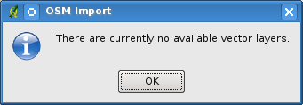
In such case there is no vector layer currently loaded. Import must be done from an opened layer – please open vector layer from which you want to import data. After layer is opened your second try should give you better result (don't forget to mark current OSM layer again):
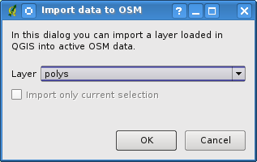
Submit dialog to start the process of OSM data importing.
Reject it if you are not sure you want to import something.

