#机器狗连接wifi
nmcli dev wifi connect "1haojiwei" password "jqr15209" ifname wlan0
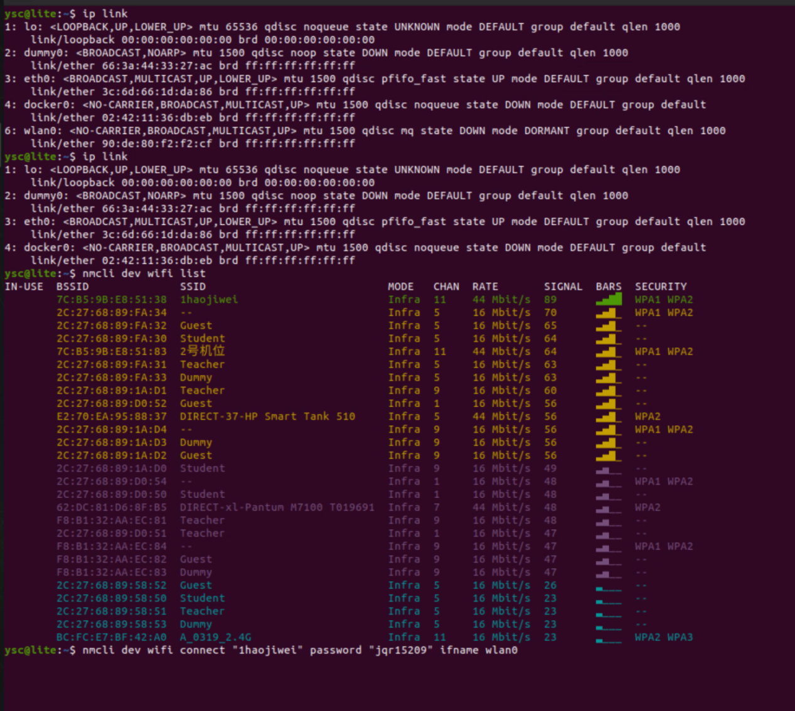

A狗
sudo nmcli con modify "1haojiwei" \
ipv4.method manual \
ipv4.addresses 10.10.0.101/24

B狗
sudo nmcli con modify "1haojiwei" \
ipv4.method manual \
ipv4.addresses 10.10.0.102/24
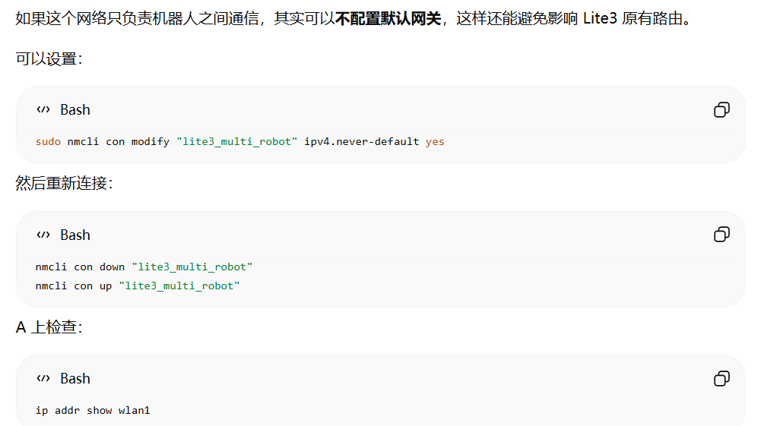
sudo nmcli con modify "1haojiwei" ipv4.never-default yes
nmcli con down "1haojiwei"
nmcli con up "1haojiwei"
ip addr show wlan0
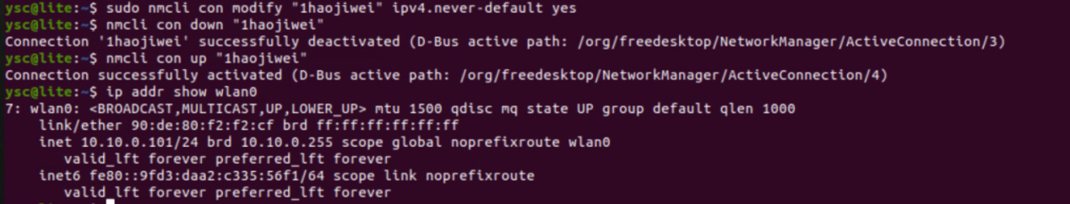

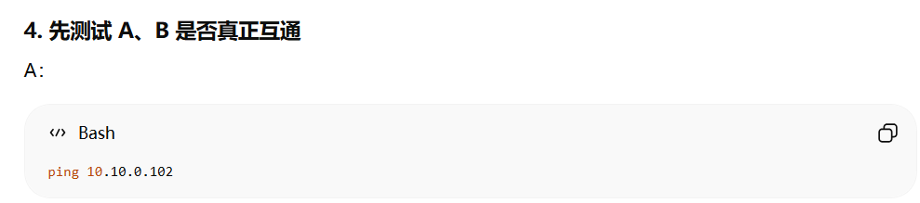
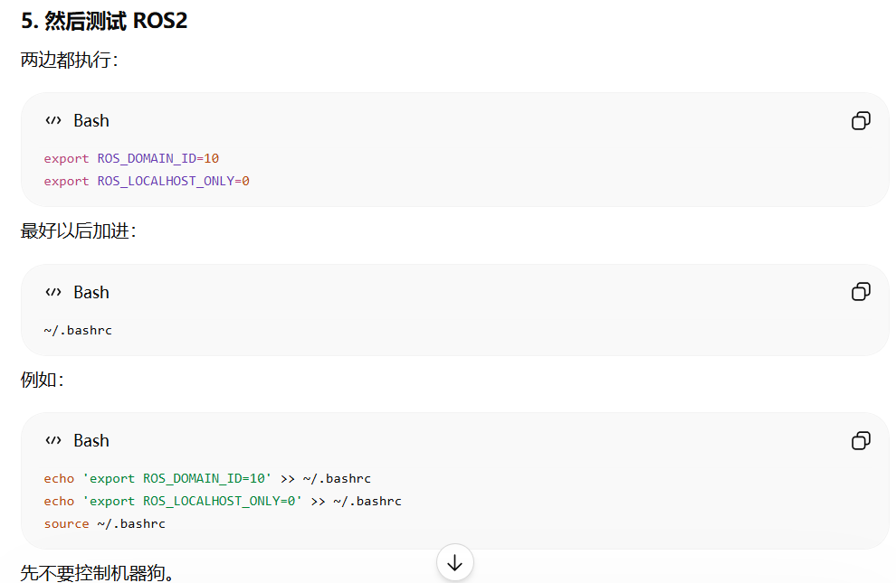
echo 'export ROS_DOMAIN_ID=10' >> ~/.bashrc
echo 'export ROS_LOCALHOST_ONLY=0' >> ~/.bashrc
source ~/.bashrc
检查
echo $ROS_DOMAIN_ID
echo $ROS_LOCALHOST_ONLY
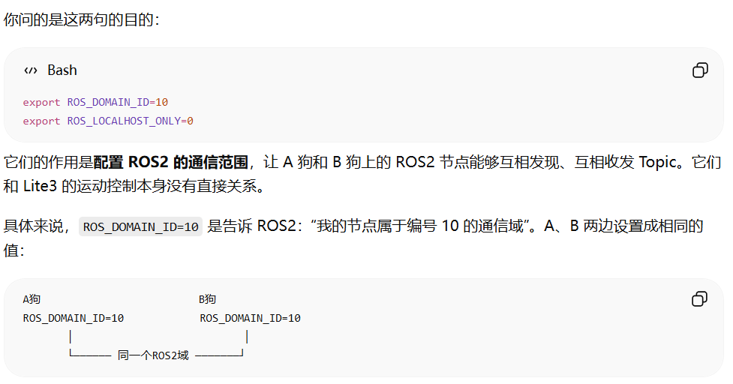
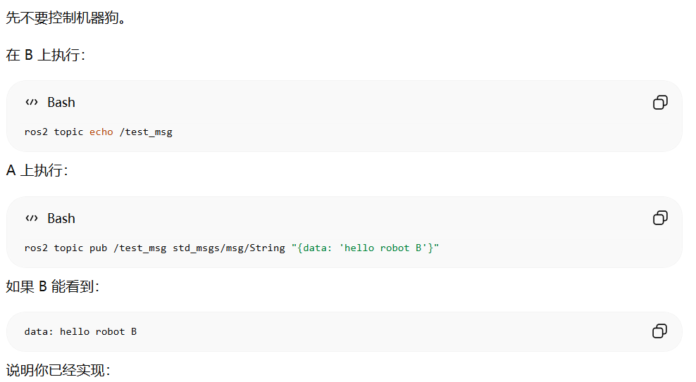
A: ros2 topic pub /test_msg std_msgs/msg/String "{data: 'hello robot B'}"
B: ros2 topic echo /test_msg

