CREEP T1

B3 law (prof.Bazant Northwestern university - Chicago)
Beam from 2D elements
F
F
2F
2400
400
x
y
26

56
Time(days)
Loadings kN
28
Forces
-1000
-2000

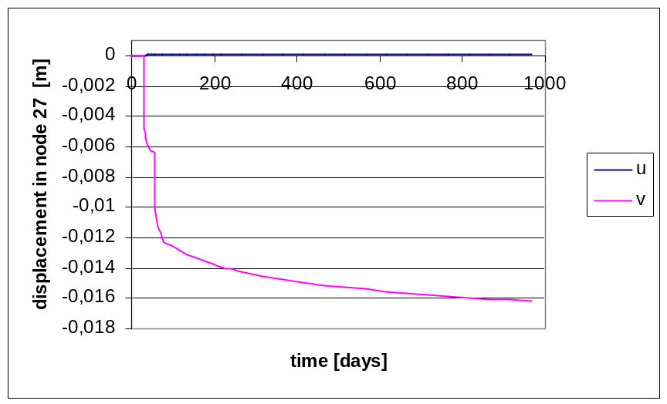

CREEP T2
Wall from 2D elements
F/10
F
2F
6000
4500
13
16
1
4
x
y

56
Time(days)
Loadings kN
28
Forces
-100
-200

