Uniaxial Terzaghi’s consolidation
f = -σ
h
z
p(t,z)
-σ^{ef} (t,z)
p=0
dp/dz=0
impermeable
σ
Isochrone at time t=0
Isochrone at time t
porous

Soil is thin layer value (fig. 1)

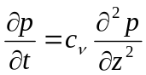,
where
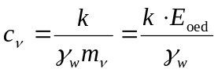 , k (m.s⁻¹ ) (10⁻⁵ to 10⁻⁸ m.s⁻¹ = 1 až 10⁻³ m.day⁻¹ ), 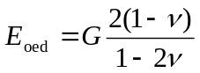

Incremental solution for a continuous footing (two parameter model)
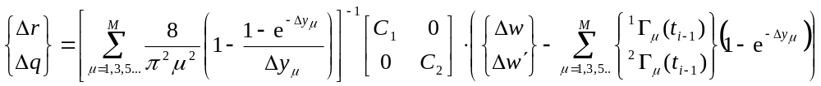.
2b
Δr
y
Fig. 2 Shear slope
Δq
Δq
-Δw´
Δw

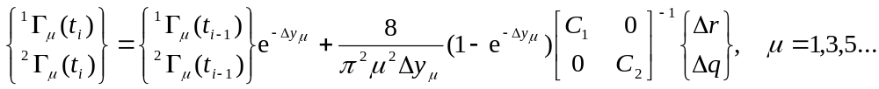
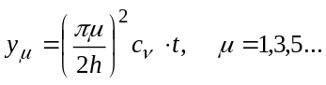
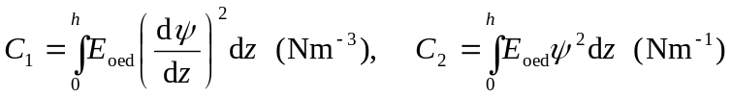.
b/h
c₁
b/h
c₂

Fig. 3 c₁ c₂ depends on active depht

Example

Fundamental plate 20x20m is 1 m under original level. Soil has γ=18kN/m³ and poisson number ν=0,25.

Estimate of depht compress layer is
with respect to load
According to EC is h = 1 to 3 multiplay widht (b ) h = 2.10 = 20 m
Where b is half dimension = 10m for this example.

Foundation parameters - stiffnesses for h =10m, C₁ = 10 000 kN/m³, C₂ = 500 kN/m for b/(2h) = 1,0, and real h is accounted automaticaly by program.
Coefficient of consolidation, c_{v} = 0,01; 0,05 m²/day
1
2
11 x F=1600 kN
20m
20m
Fig. 3 Foundation
11 x F_{i}=1600 kN
Top of soil
Bottom of foundationm-1m
h₀ = 1
Influence zone

0
100
days
F=800 kN
F=800 kN
F=1600 kN
F=1600 kN
Fig. 4 Increasing of loading

Displacement of point 1 for c_{v}=0,01 and for c_{v}=0,05
