**CSC 131**

**Computer Software Engineering**

**Software Design Document (SDD)**

**Project Deliverable # 3**

**Due: 12/17/2021**

**Team Awesome:**

**Gary Shatraw**

**April Ngai**

**Ismaeel Khan**

**Bryan Barrera Cortes**

**Quintilian Huynh**

**Erick Delgado**

1. Introduction

This project is an update/replacement of the Caltrans “Project Construction Stormwater Review Report”. That report is a PDF that allows Caltrans field inspectors to gather data, note findings (issues needing corrective action), add pictures to those findings, be sent to the company’s Resident Engineer (RE), allows that RE to make corrections to the found issues, and attach pictures of those corrections. Our project replaces that PDF with an HTML5, and JavaScript based web form, which does not require an internet connection, which is used by the Caltrans inspector for all of their data gathering, and then outputs a PDF report which is sent to the RE for the corrective actions and RE data entry. It runs on any modern standard compliant web browser, regardless of operating system and outputs the PDF report which can be emailed to an RE.

1. Functional Requirements
   1. FR1: Create a Report

**Purpose:** Create a new report for a site inspection, entering data and outputting a PDF.

**Processing:** Webform based data entry system which accepts all the relevant textual, and pictorial data.

**Input:** Caltrans Inspector enters data for the site.

**Output:** Caltrans Inspector publishes a PDF report which can be emailed to Resident Engineer.

* 1. FR2: Auto fill data

**Purpose:** Specific text fields auto fill data from Standards to save time.

**Processing:** Webform selections choose and fill in appropriate Standards data to specific fields.

**Input:** Caltrans Inspector chooses specific entries, triggering the auto fills.

**Output:** Standards are copied to all relevant text fields automatically.

* 1. FR3: Edit a Report

**Purpose:** Open an existing report and edit it.

**Processing:** Webform loads entire data set based on contract number.

**Input:** Caltrans Inspector enters contract number for the site and clicks “load”.

**Output:** Webform fills in all existing data for form with that contract number.

* 1. FR4: Insert and Resize Photos

**Purpose:** Allow report to have pictures associated with the various “findings”.

**Processing:** Webform accepts picture data in the relevant findings sections.

**Input:** Caltrans Inspector either uploads a photo from the computer or uses a camera built into the computer to take and add the photo.

**Output:** Report keeps all photos and resizes them to make them smaller.

1. **Data Design – Entity Relationship Diagram**

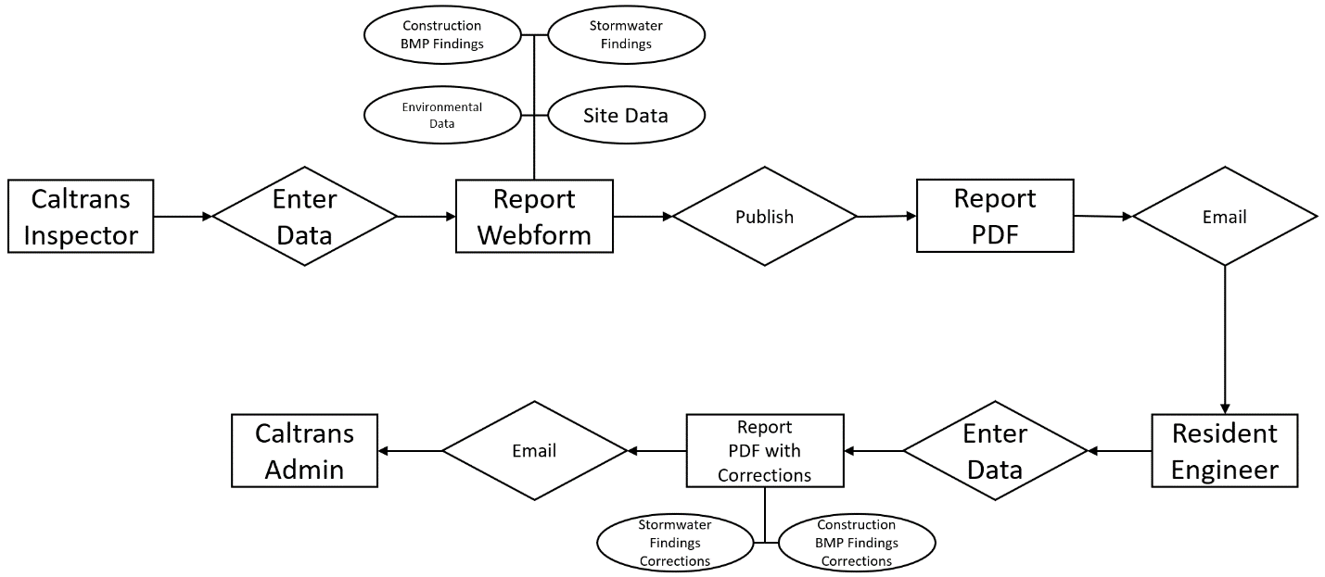

* 1. Description

The ERD shows the standard process for a Caltrans Inspector to create, publish and email a report to the Resident Engineer, who adds corrective findings and emails the final report to Caltrans Admin.

* + 1. Entities
       1. Caltrans Inspector

Caltrans employee who inspects a site, has access to the Webform, publishes PDF report, emails to Resident Engineer.

* + - 1. Webform

Form used by Caltrans Inspector to enter data used to publish the PDF report.

* + - 1. PDF Report

PDF version of report created from data entered in Webform, created when Caltrans Inspector publishes via Webform.

* + - 1. Resident Engineer

Employee of company working the construction site, has no access to Webform, receives PDF report via email and makes corrections to site per report, updates report with corrections and pictures of corrections. Emails report to Caltrans Admin.

* + - 1. Caltrans Admin
         1. Caltrans employee who receives and files report.
    1. Relationships
       1. Caltrans Inspector and Webform
          1. An Inspector can access the Webform many times, either to create new reports or edit existing reports.
       2. Caltrans Inspector and PDF Report
          1. An Inspector can publish many different reports
       3. Resident Engineer and Webform
          1. Resident Engineer does not have access to the Webform
       4. Resident Engineer and PDF Report
          1. A Resident Engineer can be sent many PDF reports, most often due to repeated visits, or if they work multiple sites.
       5. Resident Engineer and Report PDF with Corrections
          1. A Resident Engineer can make multiple Report PDFs with Corrections, but only needs to create one per PDF they are sent by the Caltrans Inspector and sends all of the corrected reports to Caltrans Admin.
       6. Caltrans Admin and Webform
          1. Caltrans Admin has no access to the Webform.
       7. Caltrans Admin and PDF Report
          1. Caltrans Admin has no access to the PDF Report.
       8. Caltrans Admin and Report PDF with Corrections
          1. Caltrans Admin receives multiple discrete Report PDFs with Corrections and files them.

1. Architectural Design

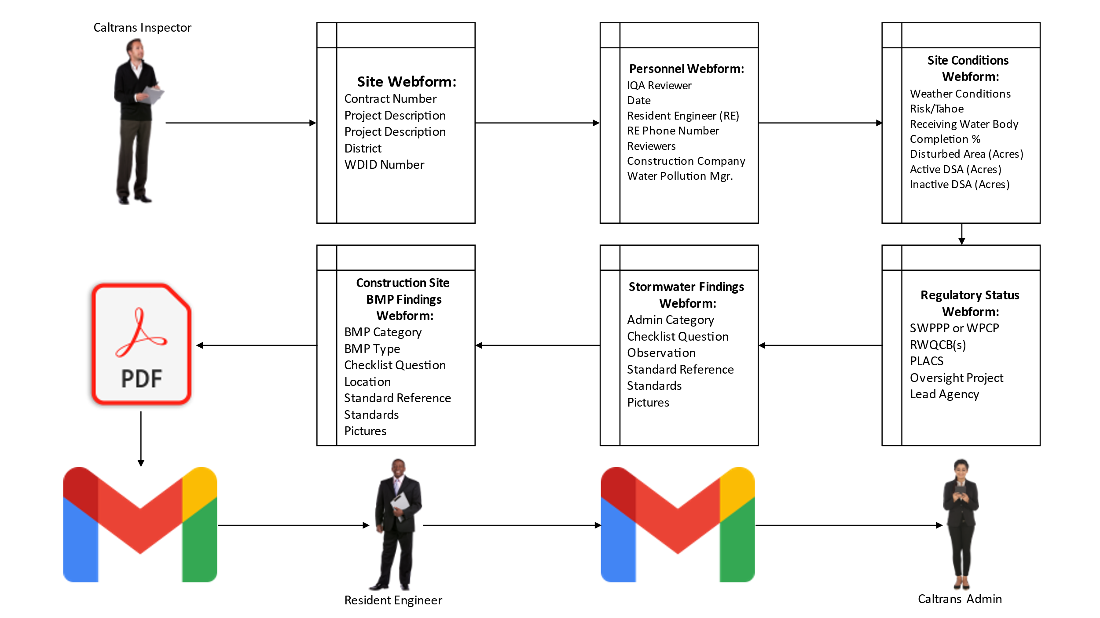

* 1. Description
     1. The Diagram above shows the overall architecture of the system, including external users and components such as email which are required for the system to meet the Functional Requirements of the Client.

1. Detailed Design

|  |  |
| --- | --- |
| Class Name | Site Webform |
| Pseudo Code | Create Form  Add Elements:   * Text Box: Contract Number * Button: Load from Contract Number * Text Box: Project Description * Text Box: Project Description * Dropdown: District * Text Box: WDID Number * Button: Next Form |
| Restrictions and Limitations | Only Caltrans Inspectors have access to this form. |

|  |  |
| --- | --- |
| Class Name | Personnel Webform |
| Pseudo Code | Create Form  Add Elements:   * Text Box: IQA Reviewer * Date Box: Date * Text Box: Resident Engineer (RE) * Text Box: RE Phone Number * Text Box: Reviewers * Text Box: Construction Company * Text Box: Water Pollution Mgr. * Button: Previous * Button: Next |
| Restrictions and Limitations | Only Caltrans Inspectors have access to this form. |

|  |  |
| --- | --- |
| Class Name | Site Conditions Webform |
| Pseudo Code | Create Form  Add Elements:   * Text Box: Weather Conditions * Dropdown: Project Risk Level/Tahoe CGP * Text Box: Receiving Water Body * Text Box: Percent Complete by Time * Text Box: Total Disturbed Soil Area (Acres) * Text Box: Active DSA (Acres) * Text Box: Inactive DSA (Acres) * Button: Previous Form * Button: Next Form |
| Restrictions and Limitations | Only Caltrans Inspectors have access to this form. |

|  |  |
| --- | --- |
| Class Name | Regulatory Status Webform |
| Pseudo Code | Create Form  Add Elements:   * Dropdown: SWPPP or WPCP * Checkbox List: RWQCBs (Select All That Apply) * Checkbox List: PLACs (Select All That Apply) * Checkbox: PLACs: Text Box: Project Description * Radio Button: Oversight Project (Y/N) * Text Box: Lead Agency * Button: Previous Form * Button: Next Form |
| Restrictions and Limitations | Only Caltrans Inspectors have access to this form. |

|  |  |
| --- | --- |
| Class Name | Stormwater Findings Webform |
| Pseudo Code | Create Form  Add Elements:   * Tiered Dropdown1: Administrative Category * Tiered Dropdown2: Checklist Question * Button: Add (reset only this form to add additional) * Text Box: Observation * Text Box: Standard Reference * Text Box: Standard * Button: Camera * Button: Browse Pictures * Canvas: Picture Display * Button: Previous Form * Button: Next Form |
| Restrictions and Limitations | Only Caltrans Inspectors have access to this form. |

|  |  |
| --- | --- |
| Class Name | Construction BMP Findings Webform |
| Pseudo Code | Create Form  Add Elements:   * Tiered Dropdown1: BMP Category * Tiered Dropdown2: BMP Type * Tiered Dropdown3: Checklist Question * Button: Add (reset only this form to add additional) * Text Box: Location * Text Box: Standard Reference * Text Box: Standard * Button: Camera * Button: Browse Pictures * Canvas: Picture Display * Button: Previous Form * Button: Submit (Creates PDF resets entire Form) |
| Restrictions and Limitations | Only Caltrans Inspectors have access to this form. |

1. User Interface Design
   1. Site Webform

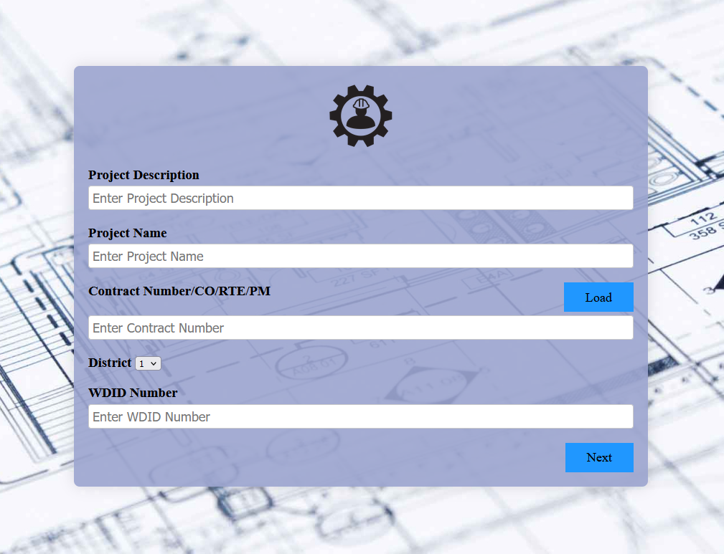

Caltrans Inspector enters new data or can load data based on contract number

* 1. Personnel Webform

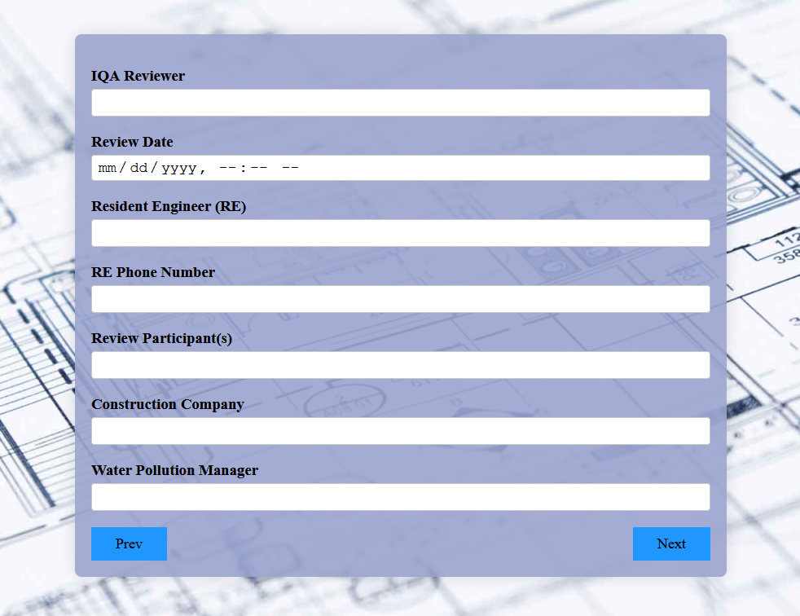

Caltrans Inspector enters personnel data for the inspection.

* 1. Site Conditions Webform

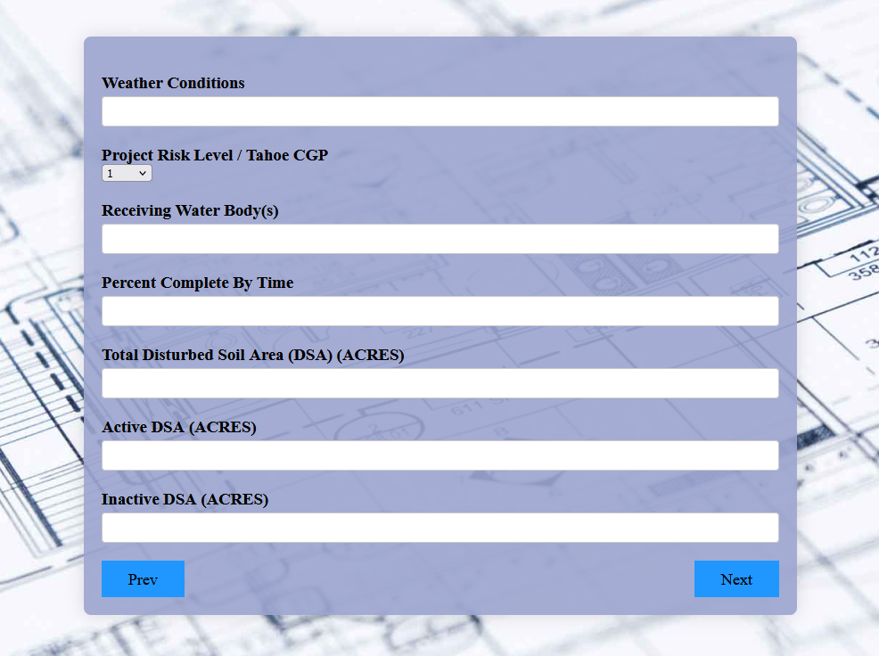

Caltrans Inspector enters the site conditions

* 1. Regulatory Status Webform

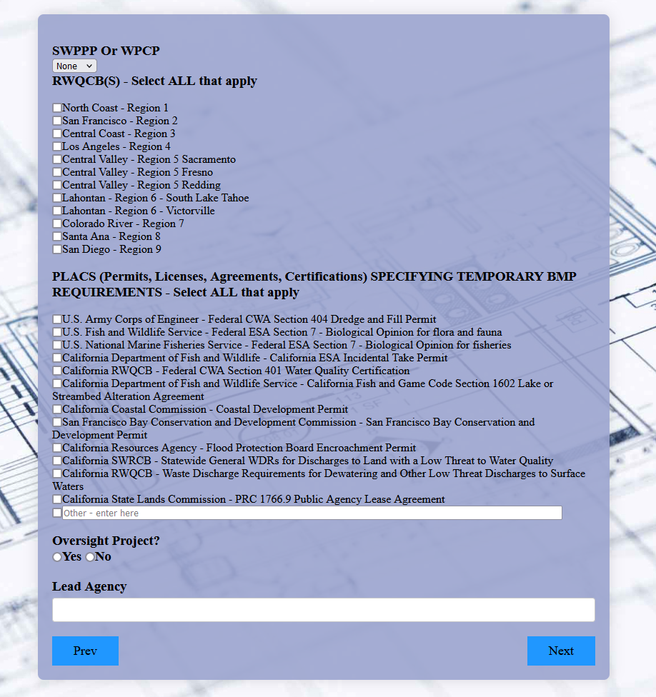

Caltrans Inspector enters Regulatory status, choosing all that apply for the RWQCBs and PLACs.

* 1. Stormwater Findings Webform

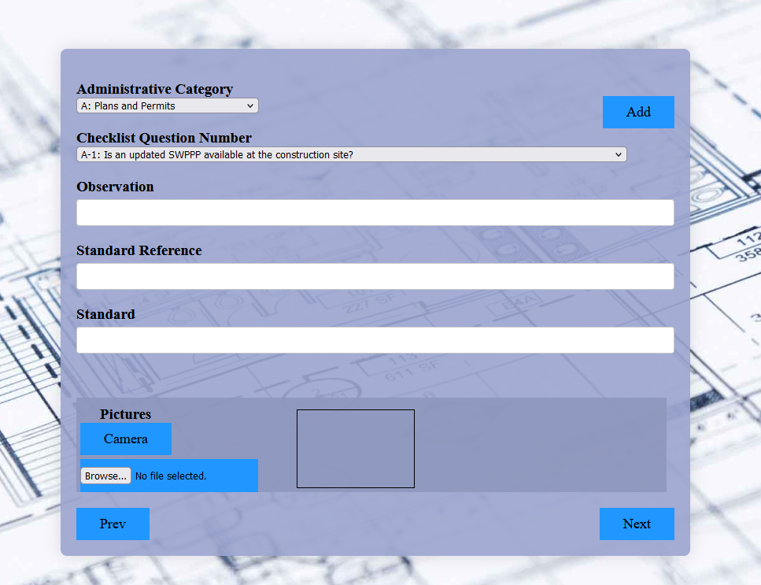

Caltrans Inspector enters Stormwater findings. They can use the Add button to add that finding and all data and reset this form to add another Stormwater finding, for as many as needed.

* 1. Construction BMP Findings Webform

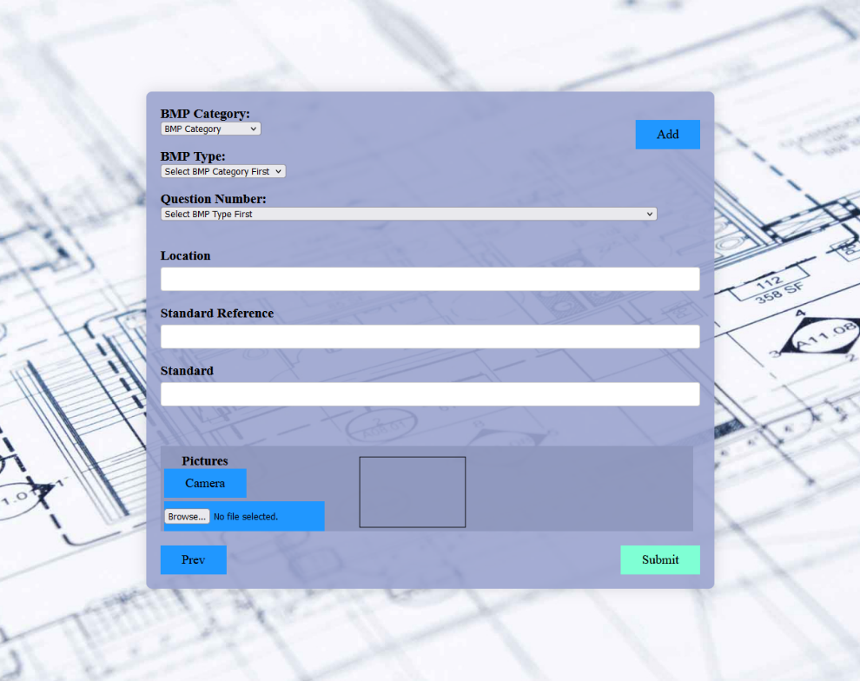

Caltrans Inspector enters Construction BMP findings. They can use the Add button to add that finding and all data and reset this form to add another finding, for as many as needed. They can also use the Submit button to take all data in all forms and publish the PDF report.

1. Technology and Tools
   1. Operating Systems: Windows, Mac OSX: Used for development of the Webform as well as testing deployment of the Webform
   2. HTML5/CSS: Used to create and style the Webform
   3. JavaScript: Powers the backend of the Webform
   4. Browsers: Chrome, Opera, Firefox, Edge used for development and deployment testing.
2. Assumptions and Constraints
   1. Assumptions:
      1. Users would have devices capable of running mainstream browsers.
      2. Users would have devices with built in cameras
      3. Users would have devices with software to open PDFs
      4. Users would have devices with access to email, not needed on site.
   2. Constraints:
      1. Due Dates set by client/professor.
      2. Must output a PDF, we cannot get Resident Engineers to use the Webform instead of a PDF.
      3. Needs to be multiplatform.
      4. End report must be less than 10MB due to email constraints.
3. Team Member’s Roles and Approvals

|  |  |  |
| --- | --- | --- |
| **Name** | **Initial (Signature)** | **Date** |
| Gary Shatraw - (Team Lead, Programmer) | G.S. | 12/17/2021 |
| Ismaeel Khan - Programmer | I.K | 12/17/2021 |
| Bryan Barrera Cortes - Programmer | B.B | 12/17/2021 |
| April Ngai - Programmer | A.N | 12/17/2021 |
| Quintilian Huynh - Programmer | Q.H | 12/17/2021 |
| Erick Delgado - Programmer | E.L | 12/17/2021 |