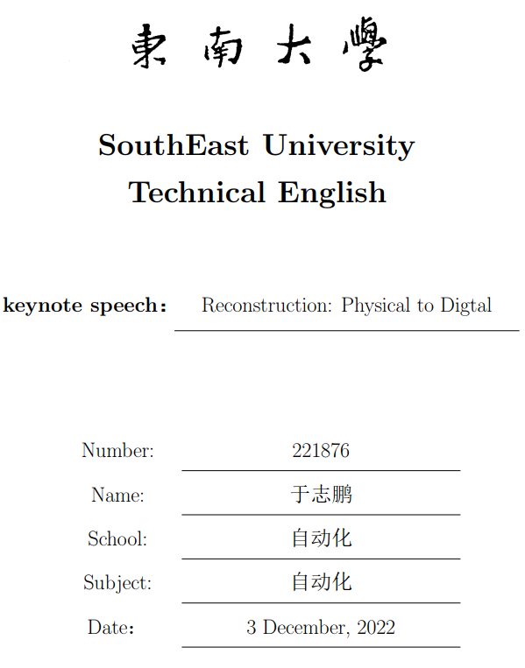

Dear colleagues, first of all, I would like to thank our Chairman and our generous host for providing many professionals from all over the world with such a pleasant atmosphere to meet, exchange views, and share thoughts and findings. My talk will last about 2 minutes and I'd ask you to save your question for the Q&A section of this meeting.

Today, what I'd like to talk about is the virtual reality reconstruction technical, or I prefer to call it the bridge from the real world to the virtual world.

*What reconstrution technical do*

The fundamental goal of virtual reality reconstruction technology is to map everything in the real world to the virtual world. Imagine how cool it is that you can easily do things that are difficult to do in the real world. You can enjoy countless streams and waterfalls, visit famous relics, or communicate with people thousands of miles away in a virtual space just at home.

*What reconstrution technical we have today*

Today, reconstruction technology has been developed to a certain extent. We can reconstruct the scene just using the camera in your cell phone. Also we can reconstruct a fairly realistic three-dimensional avatar for specific persons just using one of their pictures. whats more, we can use the physics engine to simulate what will happen in real life.

*future of reconstrution technical*

In the future, the reconstruction from the physical world to the digital world will be faster, finer, and more accurate. I believe that the digital world will eventually become our second world, and all of us will be able to enjoy the fun of wandering in the digital ocean.

The themes I have dealt with can be boiled down as the goals, present situation, and future of virtual reality reconstruction technical. That's all for my talk. Thanks for your attention!