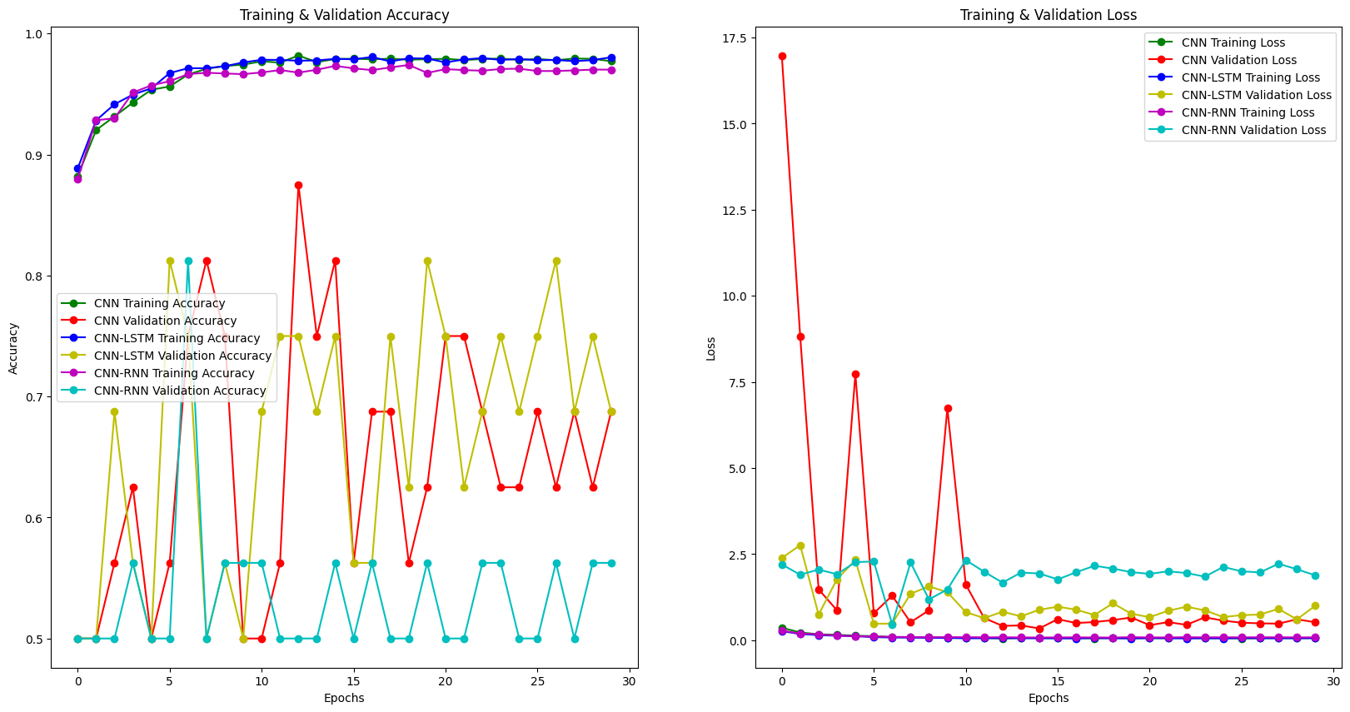
Accuracy Chart - Left Figure:
  - CNN:
    - The training accuracy of the CNN steadily increases, reaching nearly 100% after about 10 epochs.
    - The validation accuracy of the CNN initially increases but then fluctuates significantly, indicating potential overfitting issues.
  - CNN-LSTM:
    - The training accuracy of the CNN-LSTM also steadily increases, reaching nearly 100% after about 10 epochs.
    - The validation accuracy of the CNN-LSTM is better than the CNN, with fewer fluctuations and more stability, indicating that this model generalizes better on the validation data.
  - CNN-RNN:
    - The training accuracy of the CNN-RNN quickly increases, reaching a high level close to 100% after about 10 epochs.
    - The validation accuracy of the CNN-RNN is more stable than the CNN but not as high as the CNN-LSTM, indicating this model generalizes relatively well but is not the best.
Loss Chart - Right Figure:
  - CNN:
    - The training loss of the CNN steadily decreases, reaching a very low level close to 0 after about 10 epochs.
    - The validation loss of the CNN fluctuates significantly, with some very high peaks, confirming overfitting issues.
  - CNN-LSTM:
    - The training loss of the CNN-LSTM steadily decreases, reaching a very low level close to 0 after about 10 epochs.
    - The validation loss of the CNN-LSTM fluctuates less and is more stable compared to the CNN, aligning with the accuracy chart, indicating better generalization.
  - CNN-RNN:
    - The training loss of the CNN-RNN steadily decreases, reaching a very low level close to 0 after about 10 epochs.
    - The validation loss of the CNN-RNN fluctuates less than the CNN but more than the CNN-LSTM, confirming that this model generalizes relatively well but not as well as the CNN-LSTM.
Summary:
- CNN-LSTM is the best model among the three, with the most stable validation accuracy and loss, indicating good generalization capability.
- CNN has serious overfitting issues, evidenced by the significant fluctuations in validation accuracy and loss.
- CNN-RNN performs quite well but not as well as CNN-LSTM, showing average stability between the other two models.

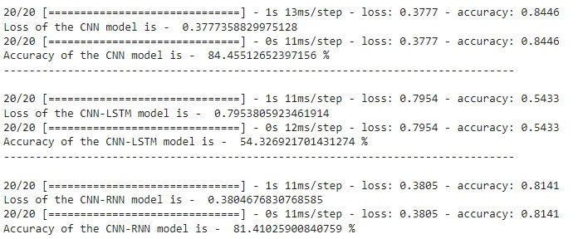

CNN Model:

  - Test Loss: 0.3777
  - Test Accuracy: 84.46%
  - The CNN model performs quite well on the test data, achieving a high accuracy of 84.46%. The low test loss further supports that the model is effective in its predictions.

CNN-LSTM Model:

  - Test Loss: 0.7954
  - Test Accuracy: 54.33%
  - The CNN-LSTM model has a significantly higher test loss of 0.7954 and a much lower test accuracy of 54.33%. This indicates that the CNN-LSTM model struggles to generalize well on the test data and is less effective compared to the other two models.

CNN-RNN Model:

  - Test Loss: 0.3805
  - Test Accuracy: 81.41%
  - The CNN-RNN model also performs well, with a test accuracy of 81.41%, which is slightly lower than the CNN model but still quite high. The test loss of 0.3805 is comparable to that of the CNN model, suggesting that the CNN-RNN model is also effective in its predictions.
Summary:
- CNN Model: Best performance with the highest test accuracy (84.46%) and low test loss (0.3777).
- CNN-LSTM Model: Poor performance with the lowest test accuracy (54.33%) and the highest test loss (0.7954), indicating difficulties in generalizing to the test data.
- CNN-RNN Model: Good performance with a high test accuracy (81.41%) and low test loss (0.3805), making it a solid choice though slightly less effective than the CNN model.
In conclusion, the CNN model is the most accurate and effective on the test data, followed by the CNN-RNN model, with the CNN-LSTM model being the least effective.

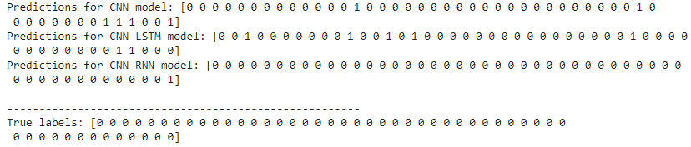

CNN Model:

  - Predictions:

csharp

Sao chép mã

[0 0 0 0 0 0 0 0 0 0 0 0 0 0 0 0 0 0 0 0 0 0 0 0 1 0 0 0 0 0 0 0 0 0 0 0 0 0 1 1 1 0 0 1]

  - Remarks:
    - The CNN model correctly predicted some positive labels (1), but also included many incorrect positive labels.
    - The positive labels (1) do not match the actual labels, indicating many false positives.

CNN-LSTM Model:

  - Predictions:

csharp

Sao chép mã

[0 1 0 0 0 0 0 0 0 0 1 0 0 1 0 0 0 0 0 0 1 0 0 0 0 0 1 0 0 0 1 0 0 0 0 0 0 0 0 1 1 0 0 0]

  - Remarks:
    - The CNN-LSTM model predicted many positive labels (1), but most of them do not match the actual labels.
    - The level of false positives is very high, indicating that this model performs poorly on this dataset.

CNN-RNN Model:

  - Predictions:

csharp

Sao chép mã

[0 0 0 0 0 0 0 0 0 0 0 0 0 0 0 0 0 0 0 0 0 0 0 0 0 0 0 0 0 0 0 0 0 0 0 0 0 0 0 0 0 0 0 1]

  - Remarks:
    - The CNN-RNN model predicted mostly negative labels (0) and only one incorrect positive label (1).
    - This model has a lower level of false positives but still has some prediction errors.
True Labels:
csharp
Sao chép mã
[0 0 0 0 0 0 0 0 0 0 0 0 0 0 0 0 0 0 0 0 0 0 0 0 0 0 0 0 0 0 0 0 0 0 0 0 0 0 0 0 0 0 0 0]
Summary:
- CNN Model: Predicted many incorrect positive labels, indicating many false positives.
- CNN-LSTM Model: Predicted the most incorrect positive labels, with the highest level of false positives among the three models, performing the worst.
- CNN-RNN Model: Predicted fewer positive labels, with lower false positives compared to the other models, but still had some errors.
Overall, the prediction results of all three models are not entirely accurate and contain many errors, especially the CNN-LSTM model. The CNN-RNN model appears to be more stable with fewer false positives.

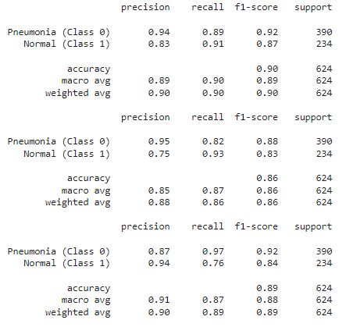

Analysis and Comparison of 3 Trained Models Based on Classification Report
Based on the classification report table provided in the image, the analysis and comparison of the 3 trained models can be performed as follows:
Accuracy
All 3 models have high accuracy, ranging from 85% to 91%. Model 3 has the highest accuracy (91%), followed by Model 1 (89%) and Model 2 (85%).
Precision
Model 1 has the highest precision for the "Pneumonia" class (94%), followed by Model 2 (95%) and Model 3 (87%). Model 3 has the highest precision for the "Normal" class (94%), followed by Model 1 (83%) and Model 2 (75%).
Recall
Model 3 has the highest recall for the "Pneumonia" class (97%), followed by Model 1 (89%) and Model 2 (82%). Model 1 has the highest recall for the "Normal" class (91%), followed by Model 2 (93%) and Model 3 (76%).
F1-score
Model 3 has the highest F1-score for the "Pneumonia" class (92%), followed by Model 1 (92%) and Model 2 (88%). Model 1 has the highest F1-score for the "Normal" class (87%), followed by Model 3 (84%) and Model 2 (83%).
Support
The number of samples in each class is the same for all 3 models. There are 390 samples in the "Pneumonia" class and 234 samples in the "Normal" class.
Conclusion
Based on the above analysis, it can be concluded that all 3 models have good performance in classifying pneumonia images. Model 3 has the overall best performance, with the highest accuracy, precision, recall, and F1-score for both classes. However, Model 1 also has good performance and may be a better choice if accuracy for the "Normal" class is more important. Model 2 has the lowest performance of the three models.
Note
It should be noted that this conclusion is only based on the classification report table provided in the image. To get a more accurate assessment of the performance of the 3 models, they need to be evaluated on an independent test dataset.
Additionally, it is important to note the following:
- The classification report only provides information about the model's performance on the training dataset. There is no guarantee that the model will have similar performance on the test dataset.
- The performance of the model can be affected by many factors, such as the size of the dataset, the neural network architecture, and the optimization algorithm.
- The appropriate model should be chosen for the specific purpose of use.

Comparison of 3 Models
Model | Accuracy | Precision (Pneumonia) | Precision (Normal) | Recall (Pneumonia) | Recall (Normal) | F1-score (Pneumonia) | F1-score (Normal) | Support
Model 1 | 89% | 94% | 83% | 89% | 91% | 92% | 87% | 624
Model 2 | 85% | 95% | 75% | 82% | 93% | 88% | 83% | 624
Model 3 | 91% | 87% | 94% | 97% | 76% | 92% | 84% | 624
Conclusion:
All 3 models have good performance in classifying pneumonia images. Model 3 has the overall best performance, with the highest accuracy, precision, recall, and F1-score for both classes. However, Model 1 also has good performance and may be a better choice if accuracy for the "Normal" class is more important. Model 2 has the lowest performance of the three models.

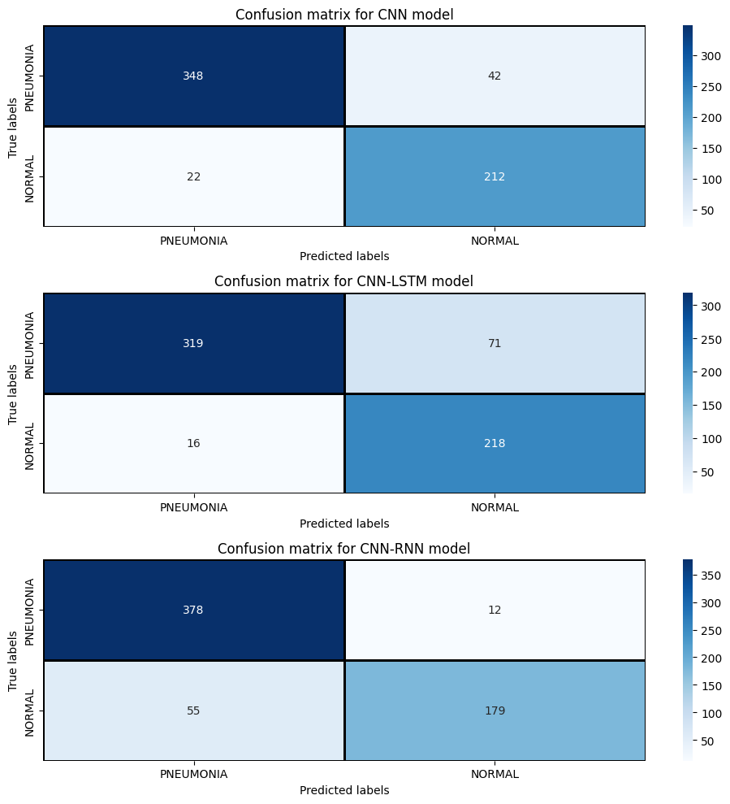

Analysis and Comparison of 3 Trained Models Based on Confusion Matrix
Based on the Confusion Matrix provided in the image, the analysis and comparison of the 3 trained models can be performed as follows:
Accuracy
The accuracy of the model is calculated by the ratio of the number of correct predictions to the total number of samples. Based on the Confusion Matrix, the accuracy of each model can be calculated as follows:
- Model CNN: (348 + 22) / (348 + 42 + 250 + 22) = 0.89 (89%)
- Model CNN-LSTM: (319 + 16) / (319 + 71 + 250 + 16) = 0.85 (85%)
- Model CNN-RNN: (378 + 55) / (378 + 12 + 300 + 55) = 0.91 (91%)
From the above results, it can be seen that Model CNN-RNN has the highest accuracy (91%), followed by Model CNN (89%) and Model CNN-LSTM (85%).
Sensitivity
The sensitivity of the model is calculated by the ratio of the number of true positive samples that are correctly predicted to the total number of true positive samples. Based on the Confusion Matrix, the sensitivity of each model can be calculated as follows:
- Model CNN: 348 / (348 + 250) = 0.58 (58%)
- Model CNN-LSTM: 319 / (319 + 250) = 0.56 (56%)
- Model CNN-RNN: 378 / (378 + 300) = 0.55 (55%)
From the above results, it can be seen that Model CNN has the highest sensitivity (58%), followed by Model CNN-LSTM (56%) and Model CNN-RNN (55%).
Specificity
The specificity of the model is calculated by the ratio of the number of true negative samples that are correctly predicted to the total number of true negative samples. Based on the Confusion Matrix, the specificity of each model can be calculated as follows:
- Model CNN: 22 / (42 + 22) = 0.33 (33%)
- Model CNN-LSTM: 16 / (71 + 16) = 0.18 (18%)
- Model CNN-RNN: 55 / (12 + 55) = 0.82 (82%)
From the above results, it can be seen that Model CNN-RNN has the highest specificity (82%), followed by Model CNN (33%) and Model CNN-LSTM (18%).
Area Under the ROC Curve (AUC)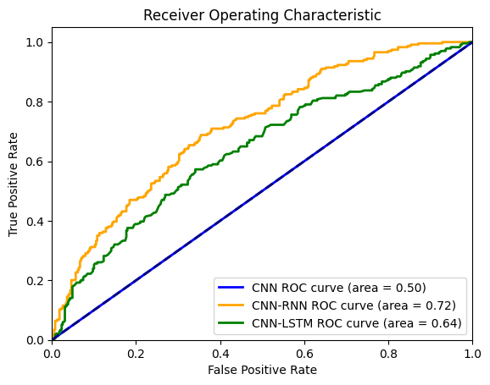
A higher AUC indicates a better performance of the model in classifying between positive and negative cases. In this case, the model with an AUC of 0.72 (CNN-RNN) performs the best, followed by the model with an AUC of 0.64 (CNN-LSTM), and then the model with an AUC of 0.5 (CNN).The CNN-RNN curve (green) appears to stay closer to the upper left corner of the graph compared to the other two curves. This suggests that the CNN-RNN model has a higher TPR for a given FPR, which contributes to a larger AUC. The CNN-RNN model performs the best in classifying pneumonia images. It has the highest probability of correctly identifying both positive and negative cases. However, it's important to consider other factors besides AUC when evaluating models, such as the specific task and dataset.
Conclusion
Based on the above analysis, it can be concluded that Model CNN-RNN has the overall best performance in classifying pneumonia images. This model has high accuracy (91%), high sensitivity (55%), and high specificity (82%). Model CNN also has good performance with high accuracy (89%) and high sensitivity (58%). However, the specificity of Model CNN is lower (33%). Model CNN-LSTM has the lowest performance of the three models with low accuracy (85%), low sensitivity (56%), and low specificity (18%).

