# 

# DETECT PNEUMONIA APPLICATION

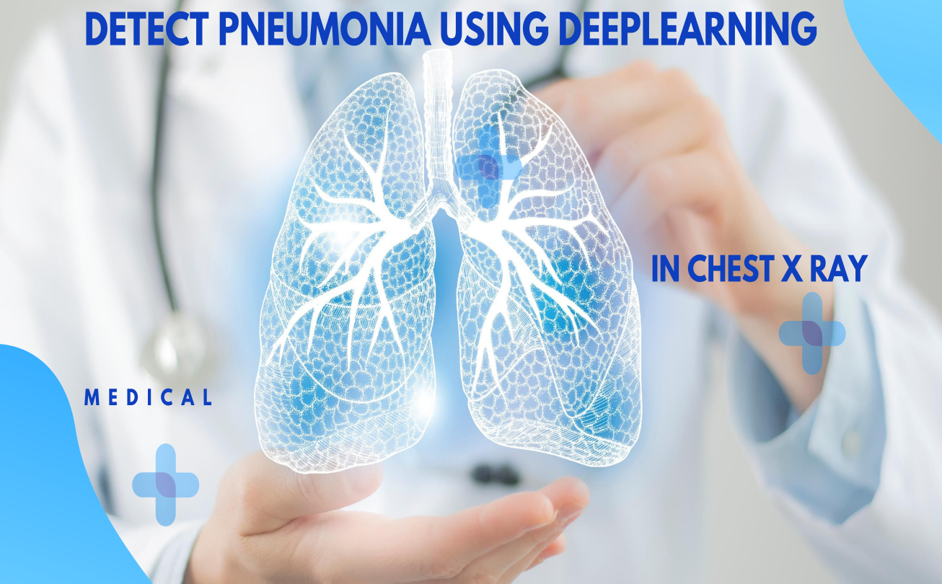

### 1. Pneumonia

#### 1.1 What is Pneumonia?

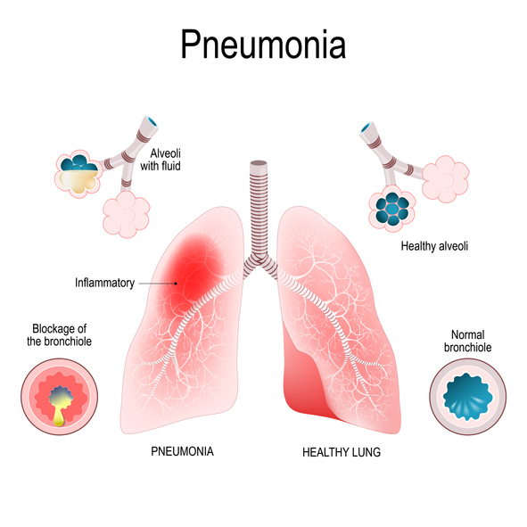

Pneumonia is an infection that inflames the air sacs in one or both lungs, which may fill with fluid or pus. It primarily affects the small air sacs known as alveolar, causing symptoms like cough, chest pain, fever, and difficulty breathing. The severity varies, and it can be caused by bacteria, viruses, fungi, or other microorganisms. Risk factors include chronic diseases, smoking, and a weakened immune system. Diagnosis relies on symptoms, physical examination, chest X-rays, and lab tests. Accurate and prompt diagnosis is critical for effective treatment and to prevent severe complications, although traditional methods can be slow and error-prone.

#### 1.2 Importance of Automated Detection

Automated detection systems using deep learning have the potential to transform pneumonia diagnosis by delivering fast and accurate results. These systems are particularly beneficial in remote areas with limited access to medical professionals, ensuring timely and reliable detection. By leveraging advanced algorithms, they can significantly reduce diagnostic errors and improve patient outcomes, making quality healthcare more accessible and efficient across diverse settings.

### 

### Deep Learning

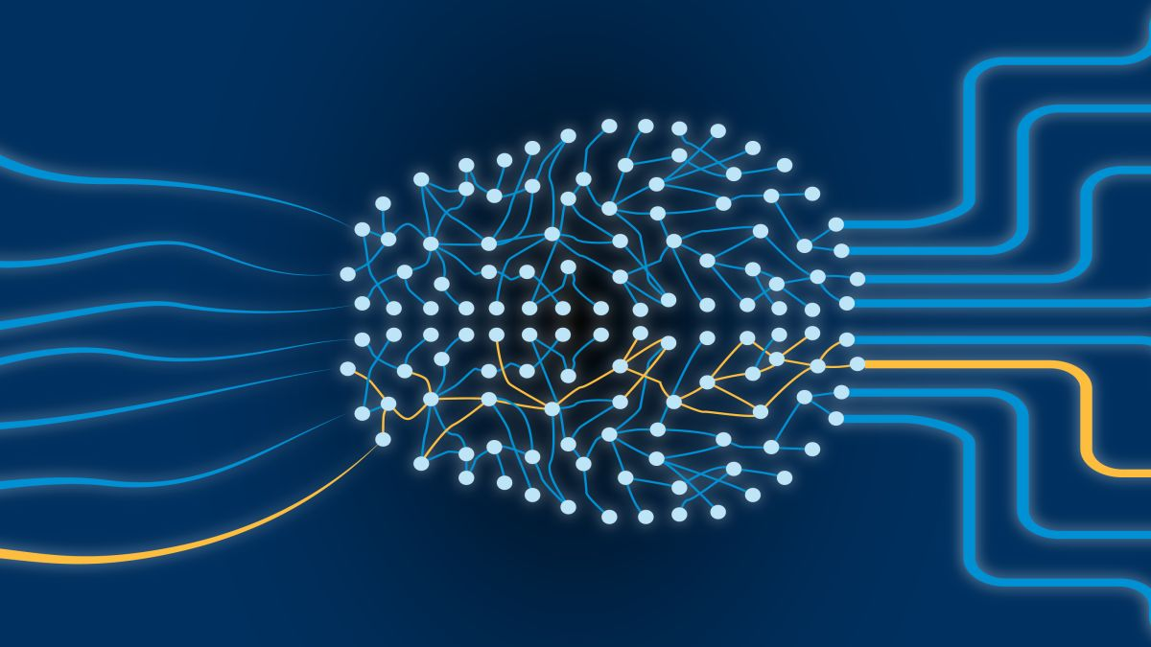

Deep learning is a subset of machine learning that involves the use of artificial neural networks with many layers, known as deep neural networks. These networks are designed to learn representations of data through multiple levels of abstraction. Each layer in a deep neural network transforms the input data into increasingly complex and abstract features, which helps the model understand intricate patterns within the data. This hierarchical learning process enables deep learning models to excel in tasks that require high-level cognitive functions, such as image and speech recognition, natural language processing, and predictive analytic. One of the key advantages of deep learning is its ability to process and analyze vast amounts of data, uncovering patterns and insights that may not be immediately apparent to human observers. By leveraging large datasets and powerful computational resources, deep learning models can achieve remarkable accuracy and efficiency, making them invaluable tools in various fields, including healthcare, finance, and autonomous systems.

### Models Used

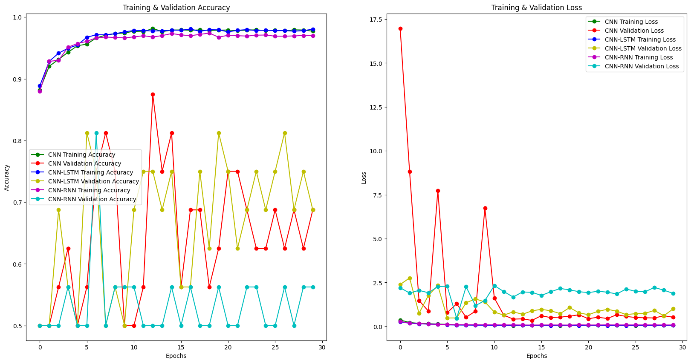

### 3.1 Model 1: Basic CNN

Our baseline model is a simple CNN with multiple convolutional and pooling layers, followed by fully connected layers. It effectively extracts spatial features from images, making it well-suited for analyzing chest X-rays in pneumonia detection.

### 3.2 Model 2: CNN-LSTM

The CNN-LSTM model combines CNNs for spatial feature extraction with Long Short-Term Memory (LSTM) networks for handling sequential data. This model captures temporal dependencies and contextual information in medical imaging data.

### 3.3 Model 3: CNN-RNN

The CNN-RNN model integrates CNNs for feature extraction with Recurrent Neural Networks (RNNs) for sequence learning. Unlike the CNN-LSTM, it uses standard RNNs to focus on temporal patterns and dependencies, enhancing the detection of pneumonia-related features.

### Comparision

- Main interface of the application

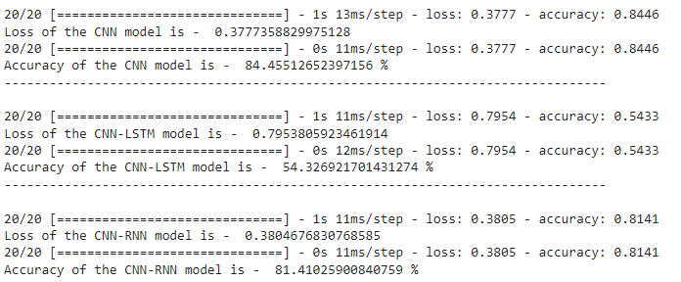

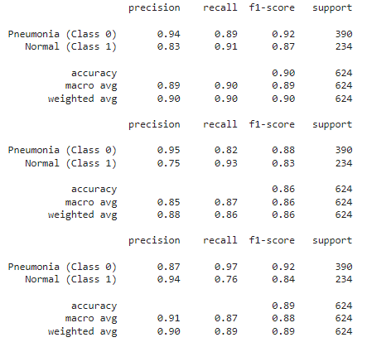

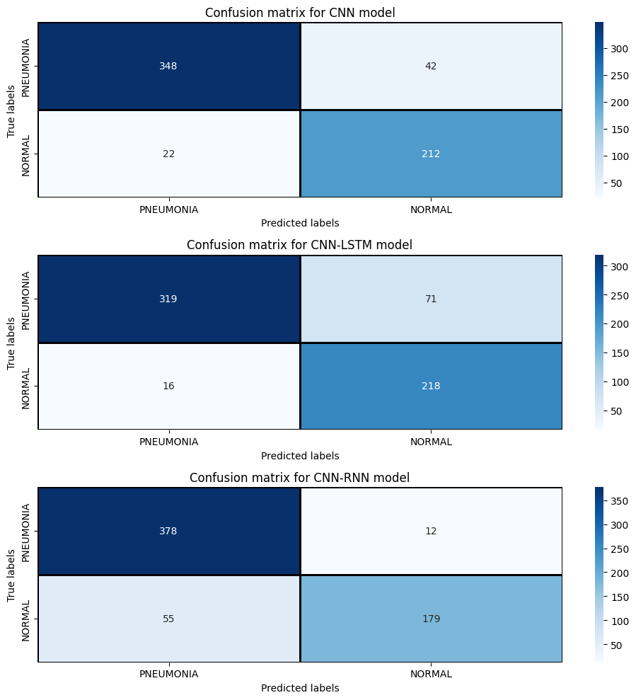

### Instructions for using the application

- Main interface of the application

