LIBRARY MANAGEMENT SYSTEM

Executive Scope & Purpose
This specification and design document establishes the complete functional baseline, quality attributes, process decomposition, object-oriented domain model, relational database schema, and graphical user interface architecture for the Library Management System (LMS). It serves as the authoritative reference for software engineers, database administrators, quality assurance testers, and project stakeholders.

Document Structure Overview
In accordance with the software engineering specification and design standard, this document is structured into seven sequential sections:
1. Functional Requirements: User-level and system-level services, operational workflows, system constraints, and domain glossary.
2. Non-Functional Requirements: Product, organizational, and external quality attributes alongside supplementary technical specifications.
3. Data Flow Diagram: Context-level (Level 0) and system decomposition (Level 1) data flows, processes, and data stores.
4. Use Case Diagram: Actor catalog, use-case inventory, and exhaustive step-by-step use-case specifications.
5. Class Diagram: Domain class hierarchy, attributes, methods, associations, and layered MVC software architecture.
6. Data Model: Physical relational database schema (ERD), referential integrity rules, and table-by-table data dictionary.
7. Interface Design Description: Role-based navigation architecture, GUI wireframes, and screen-level component specifications.

Functional Requirements
Functional requirements define the core services that the Library Management System (LMS) must provide, how the system reacts to specific user inputs, how it behaves under operational conditions, and the explicit boundaries of what the system must not allow. The requirements below are organized by functional domain and user role, covering both high-level user capabilities and granular system rules.

Authentication & Account Management

Role-Based Login and Logout:
  - The system shall allow Readers (Members), Librarians, and Administrators (Admins) to log in and log out using their assigned credentials (registered email address/User ID and password).
  - Upon successful authentication, the system verifies the account status (ACTIVE vs. SUSPENDED) and routes the user to their role-specific workspace (Member Portal, Circulation & Inventory Desk, or Administrative Dashboard).
  - Users can update their personal profile details (full name, contact information, password) while logged in, except for their primary immutable User ID and assigned library card number.

Member Account & Library Card Management:
  - Librarians shall be able to register new library members, issue unique library membership cards (membershipCardNo), and configure default borrowing quotas (maxQuota).
  - Librarians shall be able to update existing member profiles or lock/suspend membership cards (setting account status to SUSPENDED) if a member violates library regulations, accumulates excessive unpaid fines, or fails to return long-overdue items.

Staff Account Administration:
  - Administrators shall be able to create, update, and deactivate Librarian staff accounts, assign staff codes (staffCode) and desk shifts (deskShift), and manage administrative privilege levels (adminLevel).

Search & Catalog Browsing

Multi-Criteria Catalog Search:
  - Members and Librarians shall be able to search and browse the library catalog by Title, Author, Category, or ISBN keyword filters.
  - Search results display bibliographic metadata for each matching book title, including Book ID, ISBN, Title, Author, Publisher, Publication Year, Category Name, and physical Shelf Zone.
  - Result lists support sorting by title, publication year, or availability, as well as pagination for large result sets.

Real-Time Availability Status Reaction:
  - When a user selects a specific book title from the catalog, the system must immediately query all associated physical copies (BookCopy) and display the exact real-time status of each copy: Available on shelf (with its exact rackLocation), Currently borrowed (with expected return/due date), Reserved / On Hold, or Lost / Damaged.

Book Inventory Management (For Librarians)

Catalog & Physical Copy CRUD Operations:
  - Librarians shall be able to add new book titles (Book) into the catalog, update bibliographic metadata (title, author, publisher, publication year, ISBN, category), or remove obsolete titles that are no longer in circulation.
  - Because a single book title may have multiple physical exemplars in the library, Librarians shall be able to register individual physical copies (BookCopy) linked to a parent Book, assigning each copy a unique scannable barcode and specific rackLocation.

Categorization & Shelf Zone Mapping:
  - The system shall allow tagging and organizing books by subject Category (categoryId,
categoryName) and physical ShelfZone to streamline shelf auditing and physical retrieval.

Borrowing, Returning & Reservation Processing

Issue / Borrow Books:
  - When a Member requests to borrow a physical book copy at the circulation desk, the Librarian scans or enters the Member's card number and the copy's barcode.
  - The system automatically validates borrowing eligibility: verifying that the member's account is active, active loans (activeLoansCount) are strictly below maxQuota, the member holds no currently overdue loans, and totalUnpaidFines equals zero.
  - Upon passing validation, the system creates a new Loan transaction record, records the issueDate, automatically calculates the dueDate according to library policy (e.g., 14 days from issue), updates the

physical copy status (copyStatus) to BORROWED, increments the member's activeLoansCount by 1, and deducts 1 from the available stock count.

Return Books:
  - When a Member returns a borrowed book copy, the Librarian scans the copy's barcode.
  - The system records the actual returnDate, updates the Loan record status to RETURNED, decrements the member's activeLoansCount by 1, and increments the available book stock by setting the physical copy status back to AVAILABLE (or ON_HOLD if an active reservation queue exists for that title).

Automatic Overdue Fine Calculation:
  - During book return processing, if the actual returnDate is later than the recorded dueDate, the system automatically computes the number of late days (daysOverdue = returnDate - dueDate) and generates a Fine record calculated according to the configured daily penalty rate.
  - When the member pays the fine, the Librarian records the payment in the system, which updates paidStatus to PAID, logs the paymentDate, clears the member's unpaid fine balance, and generates an official payment receipt.

Book Reservation (Hold Unavailable Book) & Loan Renewal:
  - Members shall be able to place a reservation (Reservation) on book titles where all physical copies are currently borrowed by other users. The system records the requestDate, assigns a queue status, and notifies the member with an expiryDate window once a copy is returned.
  - Members shall be able to view their active loans online and request a loan renewal (incrementing renewalCount and extending dueDate) provided the loan is not overdue and no other member has placed a hold on the book.

System Constraints (What the System Shall NOT Do)
- Overdue & Unpaid Fine Block: The system shall not allow a member to borrow any new book or renew an existing loan if they are currently holding one or more overdue books or have any unpaid fines (totalUnpaidFines > 0).
- Referential Deletion Lock on Checked-Out Books: The system shall not allow deleting a book title (Book) or physical copy (BookCopy) from the database if any copy of that book is currently checked out (copyStatus
= 'BORROWED') by a member.
- Maximum Quota Enforcement: The system shall not allow a member to borrow more than the maximum permitted number of books simultaneously (e.g., a hard ceiling of maxQuota = 5 active borrowed books at the same time).

Glossary of Domain Terms

Tern | Definition & System Usage
BookCopy (Physical Copy) | A tangible, barcoded physical book exemplar (identified by copyId and barcode) stored at a specific rackLocation. Loans are issued against a specific BookCopy, whereas reservations are placed against a Book title.
Borrowing Quota (maxQuota) | The maximum number of concurrent active loans permitted for a single Member account (default policy: 5 books).
Hold / Reservation | A queued request placed by a Member for a book title that currently has zero available copies on the shelf.
Overdue Fine | A monetary penalty automatically assessed when a borrowed copy is returned after its dueDate, computed as daysOverdue × dailyRate.
Shelf Zone & Rack Location | Physical indexing coordinates indicating the library floor/zone (ShelfZone on Category) and specific shelf rack (rackLocation on BookCopy).

Non-Functional Requirements
In accordance with software engineering quality standards, the Non-Functional Requirements (NFRs) for the Library Management System are classified into three primary categories—Product Requirements, Organizational Requirements, and External Requirements—followed by a consolidated Supplementary Specification table.

Product Requirements

Efficiency — Performance Requirements:
  - Catalog search queries (across Title, Author, Category, or ISBN for a database of up to 10,000–50,000 book titles) must return and render results within 2.0 seconds under normal operating load.
  - Book borrowing (checkout) and returning (check-in) transactions, including eligibility verification and stock updates, must be processed and committed within 3.0 seconds.

Efficiency — Space & Capacity Requirements:
  - The relational database architecture must be capable of storing at least 50,000 book titles, 150,000+ physical copies, and 100,000+ borrowing/returning transaction records without degrading query response times.

Dependability & Data Integrity Requirements:
  - The system must enforce strict ACID transactional integrity: available copy status (copyStatus) and member loan counts (activeLoansCount) must be updated atomically and immediately upon each checkout or return, preventing race conditions where two users simultaneously check out or reserve the same single physical copy.
  - Overall system availability must reach at least 99.0% during the library's scheduled operating hours.

Usability Requirements:
  - The Graphical User Interface (GUI) must be clean, responsive, and task-oriented, enabling a newly onboarded Librarian to master circulation desk operations (scanning barcodes, issuing loans, processing returns, and collecting fines).

Security Requirements:
  - All user passwords must be cryptographically hashed (using SHA-256 / bcrypt with a minimum 160-bit to 256-bit digest stored in passwordHash: varchar(64)) prior to database persistence; plaintext passwords shall never be stored or logged.
  - Strict Role-Based Access Control (RBAC) must be enforced across all controller endpoints: Members are restricted to catalog browsing, placing holds, and viewing their own active loans/fines; they are strictly blocked from accessing inventory CRUD screens, circulation desk controls, or administrative audit interfaces.
  - Parameterized queries (prepared statements) and input sanitization must be used across all database operations to prevent SQL Injection and Cross-Site Scripting (XSS).

Organizational Requirements

Development Standards & Architecture:
  - The system must be implemented using an object-oriented programming language (Python / Java / C++) within a standard integrated development environment (VS Code, PyCharm, IntelliJ IDEA, Eclipse, or Visual Studio).
  - All source code and database migration scripts must be managed in a distributed version control repository (GitHub or GitLab) and strictly adhere to the Model–View–Controller (MVC) architectural pattern to decouple GUI presentation from business logic and relational data persistence.

Operational & Peripheral I/O Requirements:
  - The circulation and inventory interfaces must support seamless input from peripheral hardware I/O devices—specifically optical barcode scanners (HID keyboard wedge or serial input)—to rapidly scan physical book barcodes (barCode) and member library cards (membershipCardNo) in addition to manual keyboard
entry.

External Requirements

Legislative & Ethical Privacy Requirements:
  - Members' personally identifiable information (full name, email address, account status, and personal borrowing/reading history) must be kept strictly confidential in compliance with data protection regulations and never disclosed to unauthorized third parties.

Financial & Accounting Audit Requirements:
  - Every overdue fine assessment and payment transaction must be immutably logged with a unique Fine ID (fineId), associated Loan ID (loanId), overdue duration (daysOverdue), monetary amount (amount), payment status (paidStatus), and exact paymentDate to support periodic financial auditing and reconciliation by Library Administrators.

Supplementary Specification Summary

Specification Category | System Requirement & Target Metric
Usability | Intuitive role-based GUI with clear status badges and full compatibility with USB/wireless barcode scanners; ≤ 30 minutes onboarding time for new library staff.
Reliability | ≥ 99.0% uptime during library operating hours; ACID-compliant relational transactions preventing concurrent double-booking of physical book copies.
Performance | Catalog search response ≤ 2.0 seconds (up to 50,000 titles); circulation checkout/return processing ≤ 3.0 seconds (supporting 100,000+ historical loan records).
Supportability | Modular 3-tier MVC architecture managed via Git (GitHub/GitLab), enabling independent maintenance of View templates, Controller rules, and SQL schema.
Security | SHA-256/bcrypt password hashing (varchar(64)), strict session-based RBAC between Member, Librarian, and Administrator roles, and SQL Injection protection.
Design Constraints | Object-oriented implementation (Python/Java/C++), relational RDBMS (MySQL / PostgreSQL / SQL Server) enforcing foreign key constraints, and standard desktop/web GUI.

Data Flow Diagram
The Data Flow Diagrams (DFDs) model how information enters, transforms within, and exits the Library Management System across two levels of abstraction: the Context Diagram (DFD Level 0) and the System Decomposition Diagram (DFD Level 1).

Context Diagram (DFD Level 0)
The DFD Level 0 (Context Diagram) represents the entire Library Management System (Process 0.0) as a single central transformation hub interacting with three external entities: Member, Librarian, and Administrator.
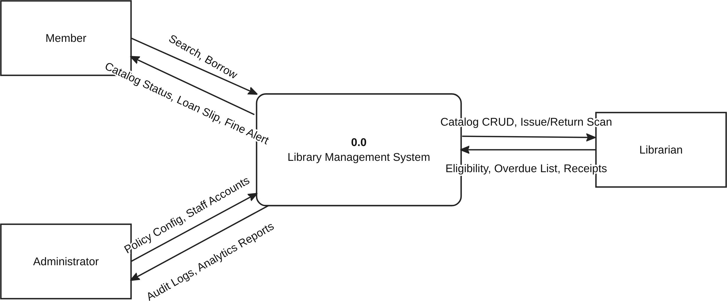

Figure 3.1: DFD Level 0 (Context Diagram) of the Library Management System.

Context-Level Data Flow Dictionary (DFD Level 0)
External Entity | Direction | Data Flow Lable | Data Content & Purpose
Member | Member → Process 0.0 | Search, Borrow | Login credentials, catalog search keywords, book hold requests, and loan renewal/borrowing requests.
Member | Process→ Member 0.0 | Catalog Status, Loan Slip, Fine Alert | Real-time book availability status, digital loan details/due dates, hold readiness notifications, and overdue fine alerts.
Librarian | Librarian → Process 0.0 | Catalog CRUD, Issue/Return Scan | New/updated book and copy records, member registration data, scanned member card/copy barcodes for checkout and return, and fine payment entries.
Librarian | Process→ Librarian 0.0 | Eligibility, Overdue List, Receipts | Member quota/eligibility verification results, active/overdue loan lists, calculated fine amounts, and printed/digital payment receipts.
Administrator | Administrator → Process 0.0 | Policy Config, Staff Accounts | System policy parameters (loan duration, max quota, daily fine rates), staff account creation/updates, and report generation queries.
Administrator | Process→ Administrator 0.0 | Audit Logs, Analytics Reports | Consolidated circulation statistics, inventory summaries, financial fine collection totals, and security audit logs.

System Decomposition Diagram (DFD Level 1)
The DFD Level 1 decomposes Process 0.0 into five core functional processes (Processes 1.0 to 5.0) and four persistent relational data stores (Users & Members, Books & Copies, Loans & Holds, and Fines & Payments). Each process encapsulates a distinct operational domain and communicates with external actors and internal data stores through strictly typed data flows.

Specification of Level 1 Processes & Data Stores
ID | Process / Data Store Name | Functional Transformation / Stored Entities
Process 1.0 | Authenticate & Manage Users | Validates login credentials against hashed passwords, manages active user sessions and role permissions, processes member profile updates, and handles staff account provisioning by Administrators.
Process 2.0 | Search & Manage Book Catalog | Executes keyword and category queries for Members and Librarians, returns real-time copy availability, and processes Librarian CRUD operations on bibliographic titles, categories, and physical copies.
Process 3.0 | Process Borrowing, Return & Hold | Verifies member borrowing quota and eligibility from Users & Members, records new checkouts, processes returns, manages book reservation queues in Loans & Holds, and updates copy availability in Books & Copies.
Process 4.0 | Calculate & Process Fines | Receives overdue day counts from Loans & Holds, computes monetary penalties, records fine payments collected by Librarians, updates Fines & Payments, and clears unpaid balances.

ID | Process / Data Store Name | Functional Transformation / Stored Entities
Process 5.0 | Generate Reports & Configure Rules | Applies Administrator policy configurations and aggregates circulation statistics from Loans & Holds and financial fine totals from Fines & Payments into audit reports.
Store D1 | Users & Members | Stores base user credentials and role subtypes (maps to relational tables User, Member, Librarian, and Administrator).
Store D2 | Books & Copies | Stores subject classifications, bibliographic records, and physical copy barcodes/statuses (maps to tables Category, Book, and BookCopy).
Store D3 | Loans & Holds | Stores active and historical borrowing transactions and queued book reservations (maps to tables Loan and Reservation).
Store D4 | Fines & Payments | Stores overdue penalty assessments, payment statuses, and settlement dates (maps to table Fine).
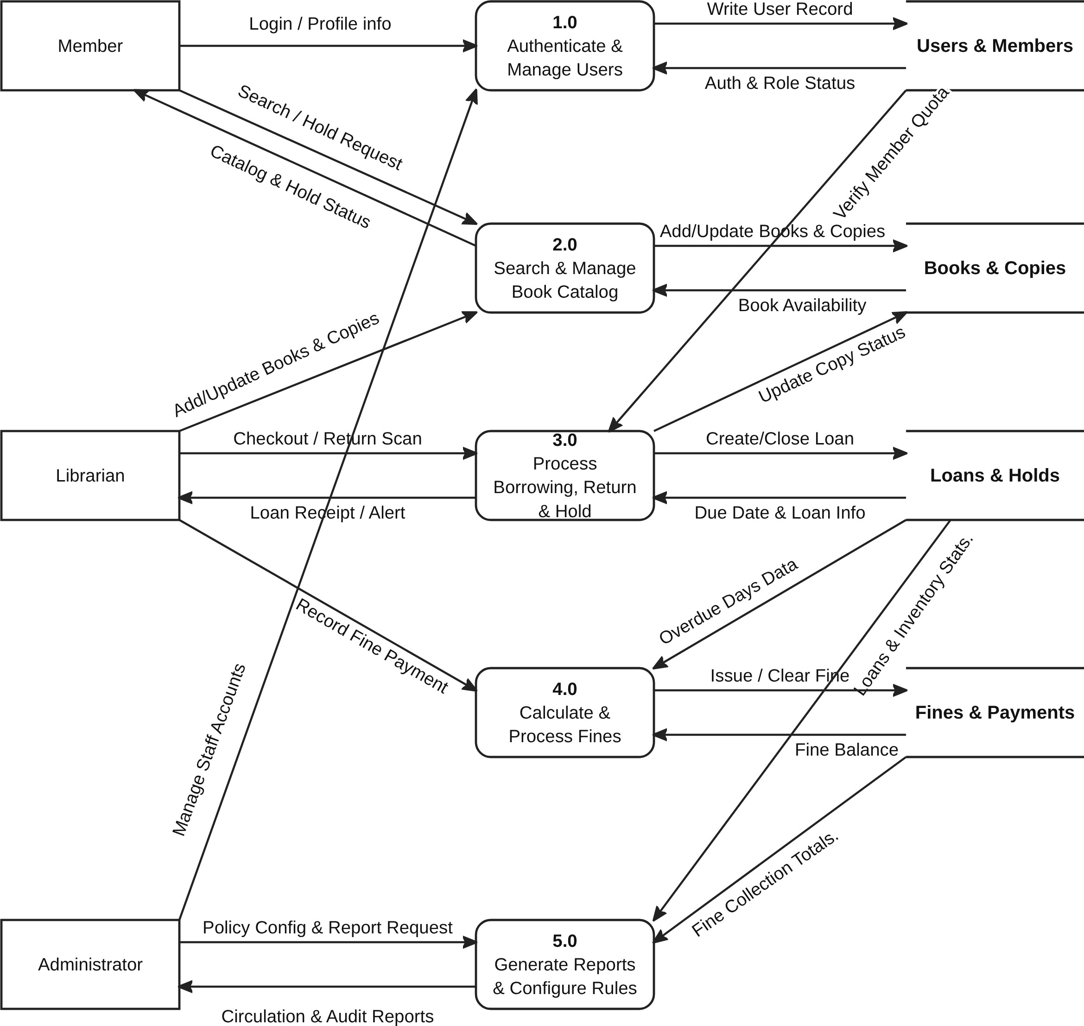
Figure 3.2: DFD Level 1 — Functional Decomposition and Data Store Interactions.

3.2.2. Complete Level 1 Data Flow Mapping

Data Flow Name | Source | Destination | Flow Type
Login / Profile info | Member | 1.0 Authenticate & Manage Users | External Input
Manage Staff Accounts | Administrator | 1.0 Authenticate & Manage Users | External Input
Write User Record | 1.0 Authenticate & Manage Users | Users & Members (D1) | Data Store Write
Auth & Role Status | Users & Members (D1) | 1.0 Authenticate & Manage Users | Data Store Read
Search / Hold Request | Member | 2.0 Search & Manage Book Catalog | External Input
Catalog & Hold Status | 2.0 Search & Manage Book Catalog | Member | External Output
Add/Update Books & Copies | Librarian | 2.0 Search & Manage Book Catalog | External Input
Add/Update Books & Copies | 2.0 Search & Manage Book Catalog | Books & Copies (D2) | Data Store Write
Book Availability | Books & Copies (D2) | 2.0 Search & Manage Book Catalog | Data Store Read
Checkout / Return Scan | Librarian | 3.0 Process Borrowing, Return & Hold | External Input
Loan Receipt / Alert | 3.0 Process Borrowing, Return & Hold | Librarian | External Output
Verify Member Quota | Users & Members (D1) | 3.0 Process Borrowing, Return & Hold | Data Store Read
Update Copy Status | 3.0 Process Borrowing, Return & Hold | Books & Copies (D2) | Data Store Write
Create/Close Loan | 3.0 Process Borrowing, Return & Hold | Loans & Holds (D3) | Data Store Write
Due Date & Loan Info | Loans & Holds (D3) | 3.0 Process Borrowing, Return & Hold | Data Store Read
Record Fine Payment | Librarian | 4.0 Calculate & Process Fines | External Input
Overdue Days Data | Loans & Holds (D3) | 4.0 Calculate & Process Fines | Data Store Read
Issue / Clear Fine | 4.0 Calculate & Process Fines | Fines & Payments (D4) | Data Store Write
Fine Balance | Fines & Payments (D4) | 4.0 Calculate & Process Fines | Data Store Read
Policy Config & Report Request | Administrator | 5.0 Generate Reports & Configure Rules | External Input
Circulation & Audit Reports | 5.0 Generate Reports & Configure Rules | Administrator | External Output
Loans & Inventory Stats | Loans & Holds (D3) | 5.0 Generate Reports & Configure Rules | Data Store Read
Fine Collection Totals | Fines & Payments (D4) | 5.0 Generate Reports & Configure Rules | Data Store Read

- Use Case Diagram

4.1. Overview Use-Case Diagram

The UML Use-Case Diagram below illustrates the functional boundary of the Library Management System (LMS), the three primary human actors (Member, Librarian, and Administrator), and all twelve core and inclusion/extension use cases.

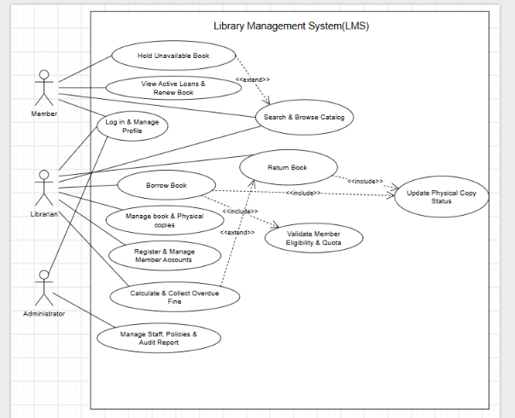
Figure 4.1: Overview UML Use-Case Diagram of the Library Management System (LMS)

4.1.1. List of Actors

No. | Actor | Description & Role Meaning
1 | 1 Member | A registered library reader/patron holding a library membership card who logs into the system to search the catalog, place holds on unavailable books, view active loans, and renew borrowed books.
2 | Librarian | Authorized library circulation and cataloging staff responsible for managing book titles and physical copies, registering/managing member accounts, issuing book loans, processing returns, and collecting overdue fines.
3 | Administrator | High-privilege system administrator responsible for managing librarian staff accounts, configuring global library policies (quotas, loan periods, fine rates), and exporting financial/circulation audit reports.

4.1.2. List of Use-Cases

No. | Use-Case Name | Primary Actor(s) | Meaning & UML Relationships
1 | Log in & Manage Profile | Member, Librarian, Administrator | Authenticate into the LMS using email/password and update personal account details.
2 | Search & Browse Catalog | Member, Librarian | Search books by Title, Author, Category, or ISBN and view real-time copy availability.
3 | Hold Unavailable Book | Member | Place a reservation on a book when all copies are borrowed (<<extend>> Search & Browse Catalog).
4 | View Active Loans & Renew Book | Member | Inspect currently borrowed books, due dates, and extend loan duration if eligible.
5 | Borrow Book | Librarian | Issue a physical book copy to a Member (<<include>> Validate Member Eligibility & Quota; <<include>> Update Physical Copy Status).
6 | Return Book | Librarian | Process the return of a borrowed physical book copy (<<include>> Update Physical Copy Status).
7 | Calculate & Collect Overdue Fine | Librarian | Compute late fees on overdue returns and record payment receipts (<<extend>> Return Book).
8 | Manage book & Physical copies | Librarian | Add, update, or delete bibliographic book records, categories, and barcoded physical copies.
9 | Register & Manage Member Accounts | Librarian | Issue new library cards, update member quotas/details, or suspend non-compliant member cards
10 | Manage Staff, Policies & Audit Report | Administrator | Create staff accounts, configure borrowing/fine rules, and export system audit reports.
11 | Validate Member Eligibility & Quota | System / Librarian | Mandatory inclusion sub-use-case (<<include>> by Borrow Book) verifying quota, overdue status, and unpaid fines.
12 | Update Physical Copy Status | System / Librarian | Mandatory inclusion sub-use-case (<<include>> by Borrow Book and Return Book) synchronizing copyStatus

4.2. Use-Case: Log in & Manage Profile
4.2.1. Summary

This use-case describes how a Member, Librarian, or Administrator authenticates into the Library Management System and views or updates their personal profile and password.

4.2.2. Flow of Events
4.2.2.1. Basic Flow (Main Success Scenario)

The use-case begins when a user opens the LMS login screen or selects the Profile Management function.
- The system displays the authentication form requesting the user's Email Address (or User ID) and Password.
- The user enters their email and password and clicks the "Login" button.
- The system hashes the submitted password, verifies it against passwordHash in the User table, checks that the account status is ACTIVE, and routes the user to their role-specific dashboard.
- If the authenticated user selects "Update Profile", the system displays their current profile attributes (Full Name, Email, Role/Card info).
- The user modifies editable fields (Full Name or Password) and submits the update request.
- The system validates the input, updates the User record in the database, and displays a confirmation message.

4.2.2.2. Alternative Flows
4.2.2.2.1. Invalid Email or Password: If the user enters an unrecognized email or incorrect password in Step 2, the system displays an authentication error message and returns to Step 1 or allows the user to cancel login.
4.2.2.2.2. Suspended Account: If the account status is SUSPENDED, the system denies access and displays a notification instructing the user to contact the circulation desk.
4.2.2.2.3. Missing Mandatory Profile Fields or Weak Password: If the user leaves Full Name blank or enters a new password shorter than 6 characters during profile update, the system displays a validation error and retains the previous data.

4.2.3. Special Requirements
Passwords must be hashed using SHA-256 / bcrypt (minimum 160-bit/256-bit security) prior to comparison or storage.

4.2.4. System State Before Executing Use-Case (Pre-conditions)
For login: The user is in an unauthenticated state. For profile management: The user is authenticated into the system.

4.2.5. System State After Executing Use-Case (Post-conditions)
If successful, an authenticated session is established (or profile attributes are updated in the User table); otherwise, the system state remains unchanged.

  - . Use-Case: Search & Browse Catalog

4.3.1. Summary
This use-case allows Members and Librarians to search and browse the library catalog by Title, Author, Category, or ISBN and inspect the real-time availability status of physical book copies.

4.3.2. Flow of Events
4.3.2.1. Basic Flow (Main Success Scenario)
The use-case begins when a Member or Librarian navigates to the Catalog Search screen.
- The system displays the catalog search bar, category filter dropdown, and a paginated list of featured/recent books.
- The user enters a search keyword (Title, Author, or ISBN) or selects a specific Category and submits the query.
- The system queries the Book, Category, and BookCopy tables and displays matching book titles along with available copy counts within 2 seconds.
- The user selects a specific book title from the list to view detailed information.
- The system displays complete bibliographic metadata (Book ID, ISBN, Title, Author, Publisher, Publication Year, Category, Shelf Zone) and lists every physical copy (copyId, barcode, rackLocation) with its live status (AVAILABLE, BORROWED, ON_HOLD, or LOST).
4.3.2.2. Alternative Flows
4.3.2.2.1. No Matching Books Found: If no catalog records match the keyword or category filter in Step 3, the system displays "No matching books found in the catalog" and suggests clearing filters.

4.3.3. Special Requirements
Search response time must not exceed 2.0 seconds for a catalog of up to 50,000 book titles.

4.3.4. System State Before Executing Use-Case (Pre-conditions)
The catalog database is online; the user is accessing the Catalog Inventory View.

System State After Executing Use-Case (Post-conditions)
Read-only operation; the database state remains unchanged unless the user triggers the extension point to place a hold.

Extension Points
Use-Case Hold Unavailable Book (<<extend>>): Triggered if all physical copies of the selected book have status BORROWED and the Member chooses to reserve the book.
4.4. Use-Case: Hold Unavailable Book
4.4.1. Summary
This use-case enables a logged-in Member to reserve (place a hold on) a book title when all of its physical copies are currently checked out by other patrons.

4.4.2. Flow of Events
4.4.2.1. Basic Flow (Main Success Scenario)
The use-case begins when a Member viewing an unavailable book in Search & Browse Catalog clicks "Hold / Reserve Book".
1. The system verifies that the Member is logged in, has an ACTIVE status, has zero unpaid fines, and does not already have an active hold or loan for the same bookId.
2. The system confirms that available copies for the selected bookId equal zero.
3. The system creates a new Reservation record with a unique reservationId, the current requestDate, an expiryDate window, and status PENDING.
4. The system displays a reservation confirmation slip showing the Member's queue position.
4.4.2.2. Alternative Flows
4.4.2.2.1. Member Has Unpaid Fines or Suspended Card: The system rejects the hold request and displays an alert explaining that outstanding fines or card suspensions must be resolved first.
4.4.2.2.2. Copy Currently Available on Shelf: If a copy is available on the shelf, the system informs the Member of the rackLocation and disables the hold queue function.

4.4.3. System State Before Executing Use-Case (Pre-conditions)
The Member is logged in; the selected book title has 0 available copies on the shelf.

System State After Executing Use-Case (Post-conditions)
If successful, a new Reservation record is persisted in the database; otherwise, system state is unchanged.

4.5. Use-Case: View Active Loans & Renew Book
4.5.1. Summary
This use-case allows a logged-in Member to view their currently borrowed books, check due dates, and extend (renew) an active loan prior to its due date.
4.5.2. Flow of Events
4.5.2.1. Basic Flow (Main Success Scenario)
The use-case begins when a logged-in Member selects "My Active Loans".
1. The system retrieves and displays all Loan records for the Member ordered by issueDate descending, showing Book Title, Copy Barcode, Issue Date, Due Date, Renewal Count, and Status.
2. The Member selects an active loan and clicks "Renew Book".
3. The system checks renewal eligibility: the loan is not overdue, renewalCount is below the policy limit (e.g., max 2 renewals), the Member has no unpaid fines, and no pending Reservation exists from another member for that book title.
4. The system increments renewalCount by 1, extends dueDate by the standard loan period (14 days), and displays the updated due date.

4.5.2.2. Alternative Flows
4.5.2.2.1. Book Reserved by Another Member or Renewal Limit Reached: The system denies the renewal, displays the specific reason, and instructs the Member to return the book by the current dueDate.

4.5.3. System State After Executing Use-Case (Post-conditions)
The Member is authenticated into the LMS.

4.5.4. System State After Executing Use-Case (Post-conditions)
If renewal succeeds, dueDate and renewalCount on the Loan record are updated; otherwise, state is unchanged.

4.6. Use-Case: Borrow Book (Issue Loan)
4.6.1. Summary
This use-case allows a Librarian at the circulation desk to issue a physical book copy to a Member after automatically validating member eligibility and updating physical inventory status.
4.6.2. Flow of Events
4.6.2.1. Basic Flow (Main Success Scenario)
The use-case begins when a Librarian opens the Circulation Desk screen and selects "Borrow / Issue Book".

1. The Librarian scans (via barcode scanner) or enters the Member's membershipCardNo and the physical book's barcode (copyId).

2. The system executes Include Use-Case:
  - Verifies Member account status is ACTIVE.
  - Verifies activeLoansCount < maxQuota (maximum 5 books).
  - Verifies the Member has zero currently overdue loans and totalUnpaidFines == 0.0.
3. The system verifies that the scanned BookCopy has status AVAILABLE (or is reserved specifically for this Member).

4. The system creates a new Loan record linking memberId, librarianId, and copyId, sets issueDate = CurrentDate, computes dueDate = CurrentDate + 14 days, and sets loan status to ACTIVE.

5. The system executes Include Use-Case: Update Physical Copy Status, setting BookCopy.copyStatus = 'BORROWED' and incrementing Member.activeLoansCount by 1.

6. The system displays and prints the loan slip confirming checkout

4.6.2.2. Alternative Flows
4.6.2.2.1. Member Ineligible (Overdue Books, Unpaid Fines, or Quota Reached): If eligibility validation fails in Step 2, the system blocks the checkout immediately and displays the exact blocking reason (e.g., "Member holds unpaid fine of $4.00" or "Max quota of 5 books reached").

4.6.2.2.2. Copy Unavailable or Reserved by Another Patron: If the copy is not available or is on hold for a different member, the system aborts checkout and alerts the Librarian.

4.6.3. Special Requirements
Checkout transaction processing must complete within 3.0 seconds inside an atomic database transaction.

4.6.4. System State Before Executing Use-Case (Pre-conditions)
The Librarian is logged in; the Member card and physical book copy exist in the database.

4.6.5. System State After Executing Use-Case (Post-conditions)
If successful, a new Loan record is created, BookCopy.copyStatus becomes BORROWED, and Member.activeLoansCount increases by 1. If unsuccessful, no state changes occur.

4.6.6. Extension Points
Includes Validate Member Eligibility & Quota and Update Physical Copy Status.

4.7. Use-Case: Return Book
4.7.1. Summary
This use-case enables a Librarian to process the return of a borrowed physical book copy, update inventory stock, and trigger overdue fine calculation if the item is returned late

4.7.2. Flow of Events
4.7.2.1. Basic Flow (Main Success Scenario)
The use-case begins when a Librarian selects "Return Book" and scans the returned book's physical barcode.
- The system locates the active Loan record associated with the scanned copyId.
- The system records returnDate = CurrentDate, updates the Loan status to RETURNED, and decrements the borrowing Member's activeLoansCount by 1.
- The system executes Include Use-Case: Update Physical Copy Status:
  - If no pending Reservation exists for the parent Book, the system sets BookCopy.copyStatus = 'AVAILABLE'.
  - If a pending Reservation exists, the system sets BookCopy.copyStatus = 'ON_HOLD' and notifies the first Member in the reservation queue.
- The system compares returnDate against dueDate. If returnDate ≤ dueDate, the system confirms on-time return and completes the transaction.

4.7.2.2. Alternative Flows
4.7.2.2.1. Late Return (Overdue Book): If returnDate > dueDate in Step 4, the system automatically triggers the extension use-case Calculate & Collect Overdue Fine.

4.7.2.2.2. Invalid Barcode or No Active Loan Found: If the scanned barcode has no active loan, the system notifies the Librarian that the copy is already marked as available

4.7.3. Special Requirements
Return processing and stock restoration must complete within 3.0 seconds.

4.7.4. System State Before Executing Use-Case (Pre-conditions)
The Librarian is logged in; the scanned physical copy has an active loan record.

4.7.5. System State After Executing Use-Case (Post-conditions)
The Loan is marked RETURNED, activeLoansCount is decremented by 1, and BookCopy.copyStatus is updated to AVAILABLE or ON_HOLD.

4.7.6. Extension Points
Use-Case Calculate & Collect Overdue Fine (<<extend>>): Triggered automatically when returnDate > dueDate.

4.8. Use-Case: Calculate & Collect Overdue Fine
4.8.1. Summary
This use-case calculates the monetary penalty for an overdue book return, logs the fine against the loan, and allows the Librarian to record fine payment and issue an audit receipt.

4.8.2. Flow of Events
4.8.2.1. Basic Flow (Main Success Scenario)
The use-case begins automatically when an overdue book is returned during Return Book or when a Librarian selects an unpaid fine record for settlement.
- The system calculates daysOverdue = returnDate - dueDate and computes amount = daysOverdue × dailyFineRate.
- The system creates a Fine record (fineId, loanId, daysOverdue, amount, paidStatus = 'UNPAID') and adds amount to the Member's totalUnpaidFines.
- If the Member pays the fine immediately at the desk, the Librarian clicks "Record Payment".
- The system updates Fine.paidStatus = 'PAID', records paymentDate = CurrentDate, deducts the paid amount from Member.totalUnpaidFines, and generates a numbered payment receipt logging the collecting Librarian.
4.8.3. Special Requirements
All fine payments must be logged with receipt ID, amount, date, and librarian ID for accounting reconciliation.

4.8.4. System State Before Executing Use-Case (Pre-conditions)
A loan is returned after its due date, or an unpaid fine exists on a Member's account.

4.8.5. System State After Executing Use-Case (Post-conditions)
A Fine record is created/updated in the database and the Member's unpaid fine balance is synchronized

4.9. Use-Case: Manage Book & Physical Copies
4.9.1. Summary
This use-case enables a Librarian to perform CRUD operations on book categories, bibliographic book titles, and individual barcoded physical copies.

4.9.2. Flow of Events
4.9.2.1. Basic Flow (Main Success Scenario)
The use-case begins when a logged-in Librarian selects the "Catalog & Inventory Management" function.

- The system displays the catalog inventory list with options to filter by Category.
- To Add a Book or Copy: The Librarian enters bibliographic metadata (ISBN, Title, Author, Publisher, Publication Year, Category) or scans a new physical copy barcode and rack location, then submits. The system validates uniqueness and inserts the Book / BookCopy record.
- To Update a Book or Copy: The Librarian edits metadata or shelf location (`rackLocation`, `ShelfZone`) and saves; the system validates and commits the changes.
- To Delete a Book or Copy: The Librarian selects a title or copy and requests deletion. The system verifies that zero copies of the target record are currently borrowed (copyStatus != 'BORROWED'), prompts for confirmation, and removes the record.
4.9.2.2. Alternative Flows
4.9.2.2.1. Attempt to Delete a Currently Checked-Out Book: If any copy of the selected book is currently borrowed by a member, the system blocks deletion and displays an error message enforcing the referential constraint.
4.9.2.2.2. Duplicate ISBN or Copy Barcode: If a newly entered ISBN or copy barcode already exists, the system alerts the Librarian and prevents duplicate insertion.
4.9.3. Special Requirements
Supports optical barcode scanner input for rapid registration of physical copy barcodes.

4.9.4. System State Before Executing Use-Case (Pre-conditions)
The Librarian is authenticated into the system.

4.9.5. System State After Executing Use-Case (Post-conditions)
If successful, Category, Book, or BookCopy records are added, updated, or deleted; otherwise, state is unchanged.

4.10. Use-Case: Register & Manage Member Accounts
4.10.1. Summary
This use-case allows a Librarian to register new library members, issue library cards, update member information/quotas, or suspend/reactivate member accounts.

4.10.2. Flow of Events
4.10.2.1. Basic Flow (Main Success Scenario)
The use-case begins when a Librarian selects "Member Account Management".
- The system displays a paginated list of registered Members and a search filter by card number or name.
- To Register a New Member: The Librarian enters Full Name, Email, initial Password, and scans/assigns a membershipCardNo and default maxQuota (5). The system validates email/card uniqueness, hashes the password, and creates linked records in User and Member.
- To Update or Suspend a Member: The Librarian selects a Member, modifies profile fields or toggles account status between ACTIVE and SUSPENDED, and saves changes.
4.10.2.2. Alternative Flows
4.10.2.2.1. Duplicate Email or Membership Card Number: The system rejects registration and highlights the conflicting email or card number.

4.10.3. Special Requirements
Member lists must be paginated to maintain high UI responsiveness across thousands of registered readers.

4.10.4. System State Before Executing Use-Case (Pre-conditions)
The Librarian is authenticated into the system.

4.10.5. System State After Executing Use-Case (Post-conditions)
Member account records in User and Member are created or updated.

4.11. Use-Case: Manage Staff, Policies & Audit Report
4.11.1. Summary
This use-case enables an Administrator to manage Librarian staff accounts, configure system-wide circulation/fine policies, and export circulation and financial audit reports
4.11.2. Flow of Events
4.11.2.1. Basic Flow (Main Success Scenario)
The use-case begins when an authenticated Administrator accesses the Administrative Dashboard.

- Manage Staff Accounts: The Administrator views staff records and creates or updates a Librarian account (assigning userID, staffCode, deskShift, and status).
- Configure System Policies: The Administrator updates circulation policy parameters (default maxQuota, loan duration days, daily overdue fine rate) and saves the configuration.
- Export Audit Report: The Administrator selects a date range and report type (Circulation Statistics, Inventory Health, or Fine Collection Audit). The system aggregates data from Loan, BookCopy, and Fine, updates Administrator.lastAuditDate, and exports the report.

4.11.2.2. Alternative Flows
4.11.2.2.1. Invalid Policy Parameter Values: If the Administrator inputs a negative fine rate or a non-positive loan quota, the system rejects the configuration and displays a validation error.

4.11.3. Special Requirements
Restricted strictly to users with the Administrator role via RBAC middleware.

4.11.4. System State Before Executing Use-Case (Pre-conditions)
The Administrator is logged into the system.

4.11.5. System State After Executing Use-Case (Post-conditions)
Staff accounts, policy parameters, and lastAuditDate are updated in the database.

5. Class Diagram

Domain Class Diagram
The object-oriented Domain Class Diagram models the ten core domain classes of the Library Management System, encapsulating attributes, visibility scopes (# protected, - private, + public), business methods, inheritance hierarchies, compositions, and multiplicity constraints.

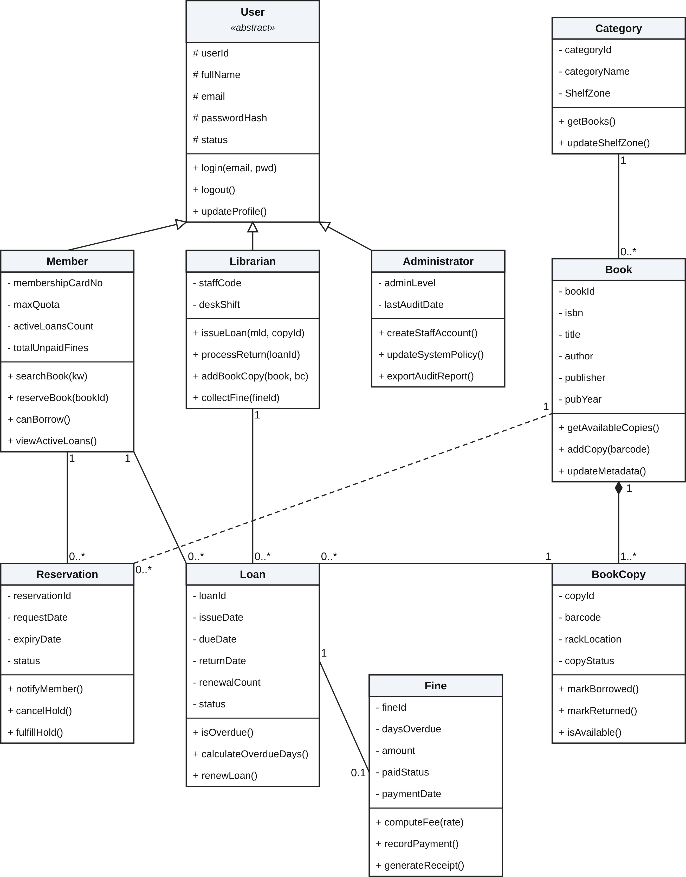
Figure 5.1: UML Domain Class Diagram of the Library Management System.

Class, Attribute, Method & Relationship Specifications
Class Name | Attributes (Visibility & Name) | Methods (Operations) | Relationships
User  «abstract» | # userId  # fullName  # email  # passwordHash status  # | + login(email, pwd)  + logout()  + updateProfile() | Abstract superclass generalized by Member, Librarian, and  Administrator.
Member | - membershipCardNo  - maxQuota  - activeLoansCount  - totalUnpaidFines | + searchBook(kw)  + reserveBook(bookId)  + canBorrow()  + viewActiveLoans() | Inherits User; 1 to 0..* Loan; 1 to 0..* Reservation.
Librarian | - staffCode  - deskShift | + issueLoan(mId,copyId)  + processReturn(loanId)  + addBookCopy(book,bc)  + collectFine(fineId) | Inherits User; 1 to 0..* Loan  (processes loans).
Administrator | - adminLevel  - lastAuditDate | + createStaffAccount()  + updateSystemPolicy()  + exportAuditReport() | Inherits User; manages system rules and audit logs.
Category | - categoryId  - categoryName  - ShelfZone | + getBooks()  + updateShelfZone() | Associates 1 to 0..* with Book.
Book | - bookId  - isbn  - title  - author  - publisher  - pubYear | + getAvailableCopies()  + addCopy(barcode)  + updateMetadata() | Belongs to 1 Category; Composes (◆) 1..* BookCopy; Target of  0..* Reservation
BookCopy | - copyId  - barcode  - rackLocation  - copyStatus | + markBorrowed()  + markReturned()  + isAvailable() | Composed by 1 Book (1..*);  Referenced by 0..* Loan.
Loan | - loanId  - issueDate  - dueDate  - returnDate  - renewalCount  - status | + isOverdue()  + calculateOverdueDays()  + renewLoan() | .Links 1 Member, 1 Librarian, and 1 BookCopy; Associates 1 to 0..1 with Fine.
Reservation | - reservationId  - requestDate  - expiryDate  - status | + notifyMember()  + cancelHold()  + fulfillHold() | Links 1 Member(0..*) to 1 Book title (0..*).
Fine | - fineId  - daysOverdue  - amount  - paidStatus  - paymentDate | + computeFee(rate)  + recordPayment()  + generateReceipt() | Associated 0..1 with 1 overdue Loan.

Software Architecture Pattern (MVC Architecture)
To satisfy the organizational development requirements, the system is structured around a three-tier Model–View–Controller (MVC) architecture backed by a Relational Database. This separation of concerns ensures that user interface screens remain decoupled from domain validation rules and SQL persistence.

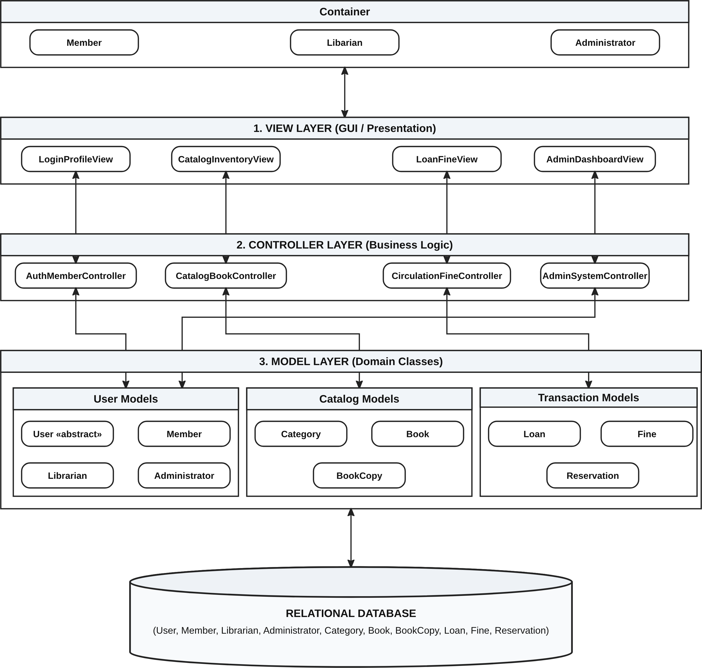
a Figure 5.2: Layered Model–View–Controller (MVC) Software Architecture of the LMS.

Architectural Layer | Modules / Components | Responsibilities & Inter-Layer Interactions
User Container (Actors) | Member, Librarian, Administrator | Initiates UI events (searches, barcode scans, button clicks) and receives rendered visual feedback from the View Layer.
1. View Layer (GUI / Presentation) | LoginProfileView CatalogInventoryView LoanFineView AdminDashboardView | Renders forms, tables, and status alerts; captures keyboard and barcode scanner inputs and dispatches actions to the corresponding Controller
2. Controller Layer (Business Logic) | AuthMemberController CatalogBookController CirculationFineController AdminSystemController | Enforces RBAC permissions, validates business constraints (quota checks, overdue blocks, deletion locks), coordinates domain models, and returns view state.
3. Model Layer (Domain Classes) | User Models: User, Member, Librarian, Administrator Catalog Models: Category, Book, BookCopy  Transaction Models: Loan, Fine, Reservation | Encapsulates domain state, business methods (canBorrow(), calculateOverdueDays(), computeFee()), and ORM/DAO mapping to the Relational Database.

Data Model
  - Relational Schema Architecture & Foreign Key Cardinalities
The physical relational Data Model maps the ten object-oriented domain classes into ten normalized relational database tables adhering to Third Normal Form (3NF). Every non-key attribute depends strictly on the primary key of its respective table, eliminating transitive dependencies and redundant data storage across catalog, user, and transaction records.
- User Subtype Hierarchy (1 : 0..1 Shared Primary Key): User(userID) serves as the supertype base table storing common authentication credentials (fullName, email, passwordHash, status). The role-specific subtype tables—Member(userID), Librarian(userID), and Administrator(userID)—each declare userID: char(10) as a composite Primary Key and Foreign Key (PK, FK) referencing User(userID) with 1 to 0..1 cardinality.
- Catalog & Physical Inventory Hierarchy (1 : 0..*): One subject Category(categoryID) classifies 0..* bibliographic Book(categoryId) records. Because a library holds multiple physical exemplars of a single title, one Book(bookId) owns 0..* physical BookCopy(bookID) records, where each physical exemplar is tracked independently by its scannable optical barCode, shelf rackLocation, and circulation copyStatus.
- Circulation & Reservation Relationships (1 : 0..*): One Member(userID) can initiate 0..* Loan(memberid) transactions and place 0..* Reservation(memberid) holds. One Librarian(userID) authorizes and processes 0..* Loan(librarianid) transactions. Each BookCopy(copyID) participates in 0..* historical Loan(copyId) records over its service life, whereas holds in Reservation(bookId) reference the parent bibliographic title Book(bookId).
- Overdue Fine Assessment Relationship (1 : 0..1): Each borrowing transaction in Loan(loanid) is associated with at most one overdue penalty record in Fine(loanId) (enforced via a unique foreign key constraint).
- Referential Integrity & Indexing Strategy: All foreign keys enforce ON UPDATE CASCADE and ON DELETE RESTRICT rules so that active loans, historical fine logs, and checked-out book copies can never be orphaned. Secondary B-Tree indexes are maintained on Book(isbn), Book(title), BookCopy(barCode), and Member(membershipCardNo) to guarantee sub-2-second catalog lookups.

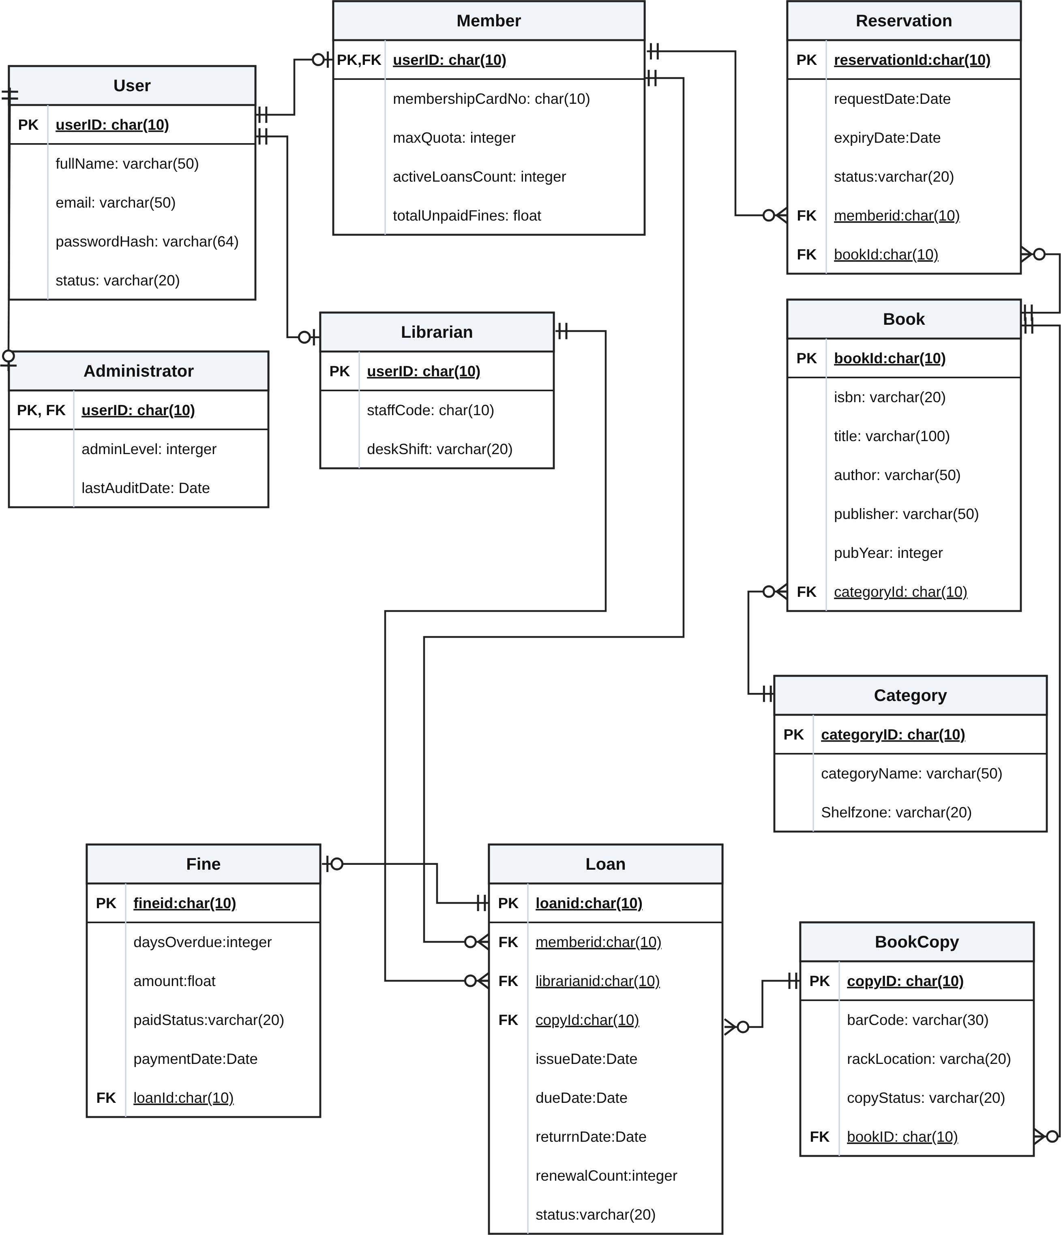
  - Physical Entity-Relationship Diagram (Database Schema)

Figure 6.1: Physical Relational Database Schema (ERD) of the Library Management System.
Table Name | Column Name | Data Type | Key | Description & Constraints
User | userID | char(10) | PK | Unique system-wide user identifier (e.g., USR0000001).
User | fullName | varchar(50) |  | Full legal name of the user (NOT NULL).
User | email | varchar(50) |  | Unique login email address (UNIQUE, NOT NULL).
User | passwordHash | varchar(64) |  | SHA-256 / bcrypt hashed password digest (NOT NULL).
User | status | varchar(20) |  | Account state: ACTIVE, SUSPENDED, or INACTIVE.
Member | userID | char(10) | PK, FK | References User(userID).
Member | membershipCardNo | char(10) |  | Unique scannable library card code (UNIQUE, NOT NULL).
Member | maxQuota | integer |  | Maximum concurrent books allowed (default: 5).
Member | activeLoansCount | integer |  | Current number of checked-out books (0..maxQuota).
Member | totalUnpaidFines | float |  | Total outstanding unpaid fine balance (default: 0.0).
Librarian | userID | char(10) | PK, FK | References User(userID).
Librarian | staffCode | char(10) |  | Unique employee/librarian badge code (UNIQUE).
Librarian | deskShift | varchar(20) |  | Assigned circulation shift (e.g.,  MORNING, AFTERNOON).
Administrator | userID | char(10) | PK, FK | References User(userID).
Administrator | adminLevel | integer |  | Administrative clearance level (e.g., 1 = SuperAdmin).
Administrator | lastAuditDate | Date |  | Date of the most recent system/financial audit export.
Category | categoryID | char(10) | PK | Unique category identifier (e.g.,  CAT-CS-001).
Category | categoryName | varchar(50) |  | Subject classification name (e.g., Computer Science).
Category | Shelfzone | varchar(20) |  | Physical floor/zone location in the library (e.g., Zone A-02).
Book | bookId | char(10) | PK | Unique bibliographic catalog title ID.
Book | isbn | varchar(20) |  | International Standard Book Number (UNIQUE, NOT NULL).
Book | title | varchar(100) |  | Full title of the book (NOT NULL)
Book | author | varchar(50) |  | Primary author(s) of the book.
Book | publisher | varchar(50) |  | Publishing house name.
Book | pubYear | integer |  | Year of publication (e.g., 2024).
Book | categoryId | char(10) | FK | References Category(categoryID).
BookCopy | copyID | char(10) | PK | Unique identifier of the physical copy exemplar.
BookCopy | barCode | varchar(30) |  | Scannable optical barcode label on the physical book.
BookCopy | rackLocation | varchar(20) |  | Exact shelf/rack coordinate (e.g.,  Rack A2-S4).
BookCopy | copyStatus | varchar(20) |  | State: AVAILABLE, BORROWED, ON_HOLD, or LOST.
BookCopy | bookID | char(10) | FK | References parent Book(bookId) (ON DELETE RESTRICT).
Loan | loanid | char(10) | PK | Unique borrowing transaction identifier.
Loan | memberid | char(10) | FK | References borrowing  Member(userID).
Loan | librarianid | char(10) | FK | References issuing/receiving  Librarian(userID).
Loan | copyId | char(10) | FK | References borrowed physical  BookCopy(copyID).
Loan | issueDate | Date |  | Date the book was checked out (NOT NULL).
Loan | dueDate | Date |  | Scheduled return deadline date (NOT NULL).
Loan | returrnDate | Date |  | Actual date returned (NULL while loan is active).
Loan | renewalCount | integer |  | Number of times the loan has been renewed (default: 0).
Loan | status | varchar(20) |  | Loan state: ACTIVE, RETURNED, or OVERDUE.
Reservation | reservationId | char(10) | PK | Unique hold request identifier.
Reservation | requestDate | Date |  | Date the member placed the hold request.
Reservation | expiryDate | Date |  | Expiration date for picking up a held book copy.
Reservation | status | varchar(20) |  | Hold state: PENDING, READY, FULFILLED, or CANCELLED.
Reservation | memberid | char(10) | FK | References requesting  Member(userID).
Reservation | bookId | char(10) | FK | References target catalog title  Book(bookId).
Fine | fineid | char(10) | PK | Unique overdue fine assessment identifier.
Fine | daysOverdue | integer |  | Number of calendar days returned past dueDate.
Fine | amount | float |  | Calculated monetary fine amount (daysOverdue × rate).
Fine | paidStatus | varchar(20) |  | Settlement status: UNPAID or PAID.
Fine | paymentDate | Date |  | Date the fine payment was collected (NULL if unpaid).
Fine | loanId | char(10) | FK | References the overdue Loan(loanid) (UNIQUE 1:0..1).

7. Interface Design Description
7.1 Authentication Screens.
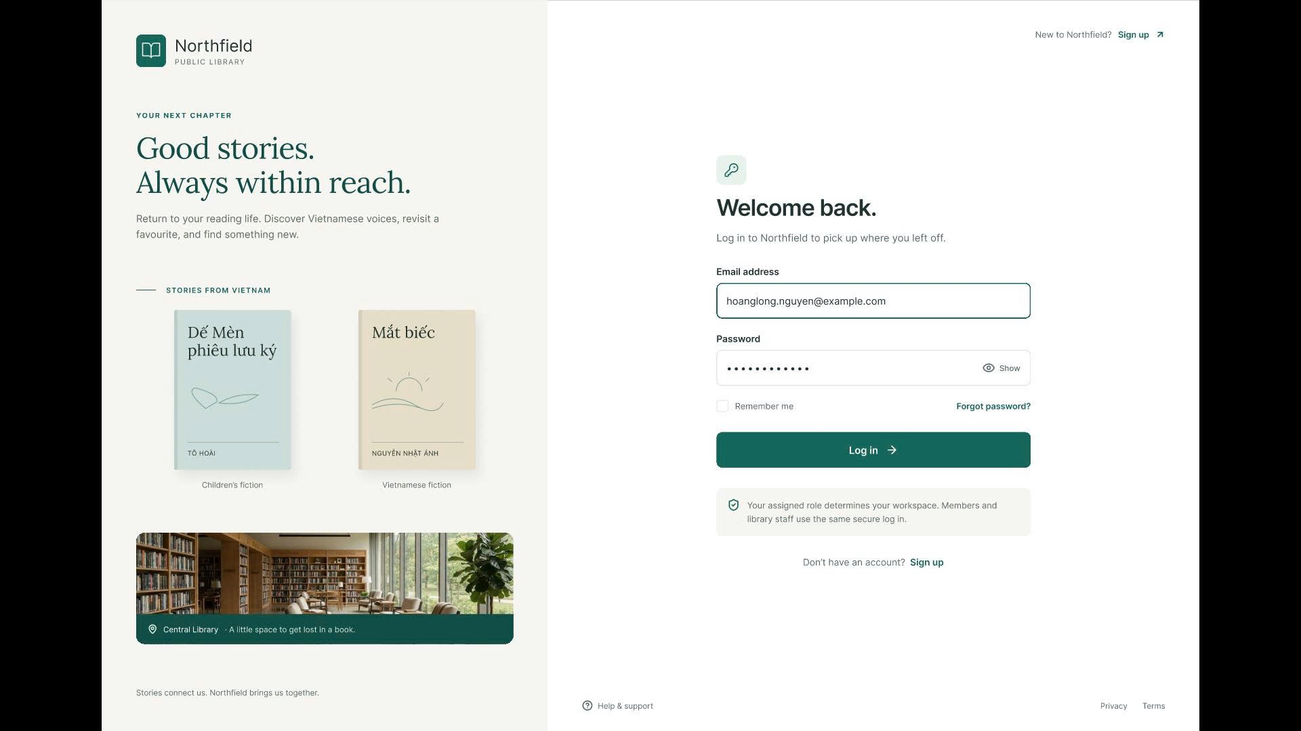
- Login Screen: A unified authentication portal using Email and Password for both Members and Library Staff. The system automatically detects the user's assigned role and routes them to their corresponding workspace.
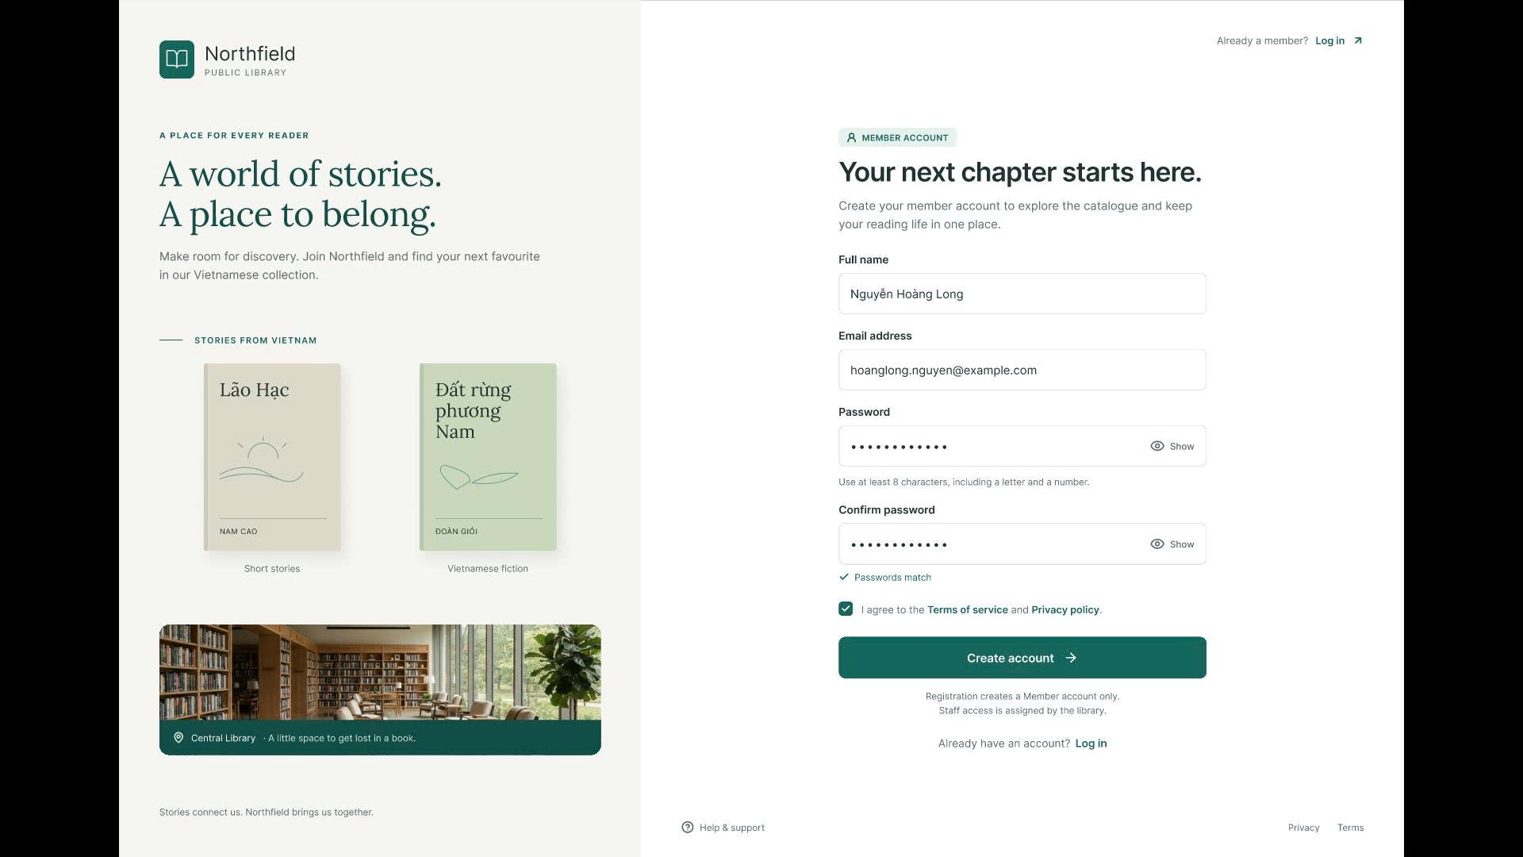
- Sign Up Screen: Allows new readers to register for a Member account with real-time password policy validation and password matching confirmation.

7.2 Librarian Workspace.
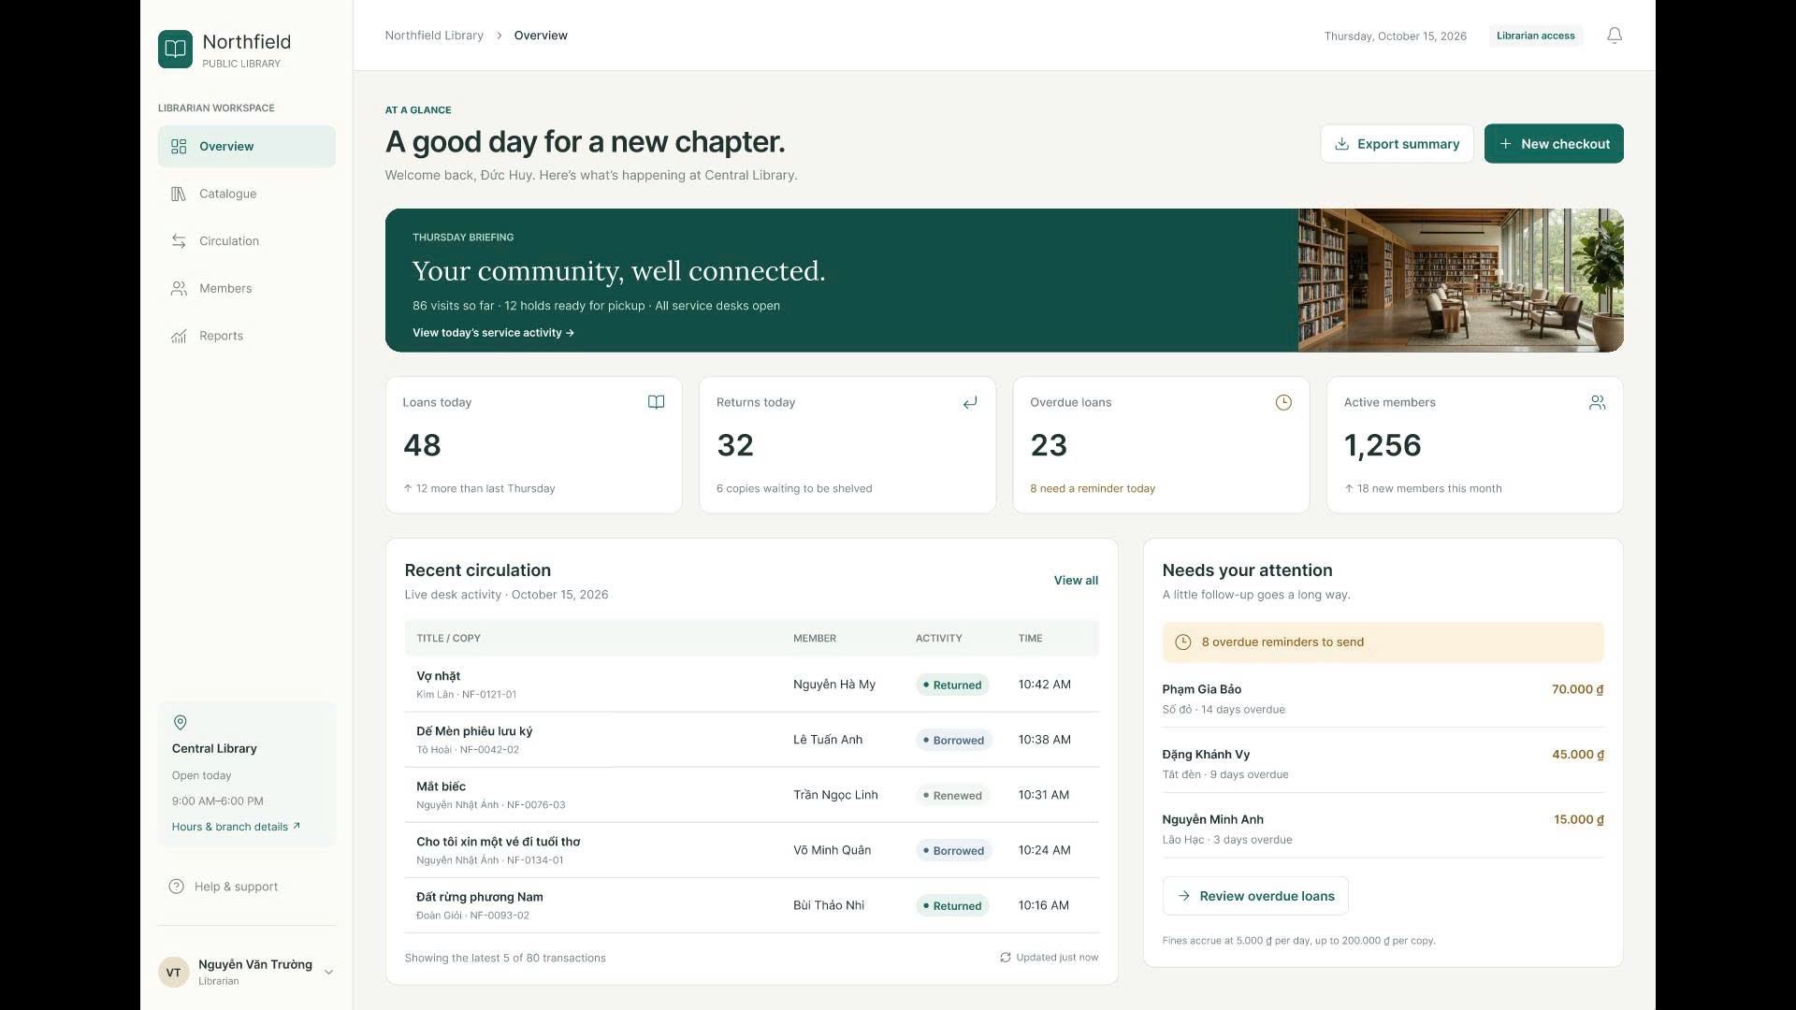
- Overview Dashboard: Displays 4 daily KPI cards (Loans today, Returns today, Overdue loans, Active members), a real-time Recent circulation activity table, and an overdue reminder alert list.
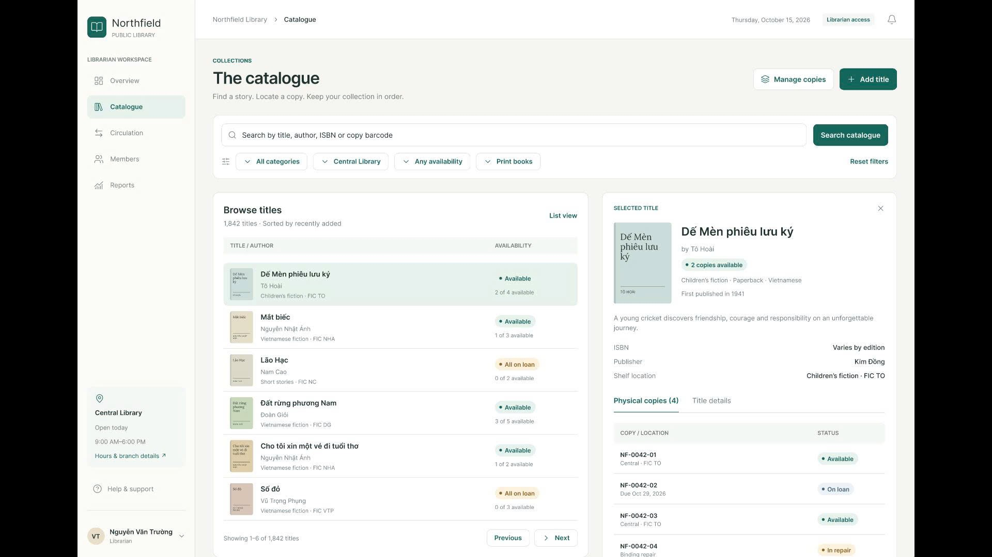
- The Catalogue: Uses a 2-column Master-Detail layout that enables searching and filtering book titles on the left while inspecting bibliographic metadata and individual physical copy statuses (Available, On loan, In repair) on the right.
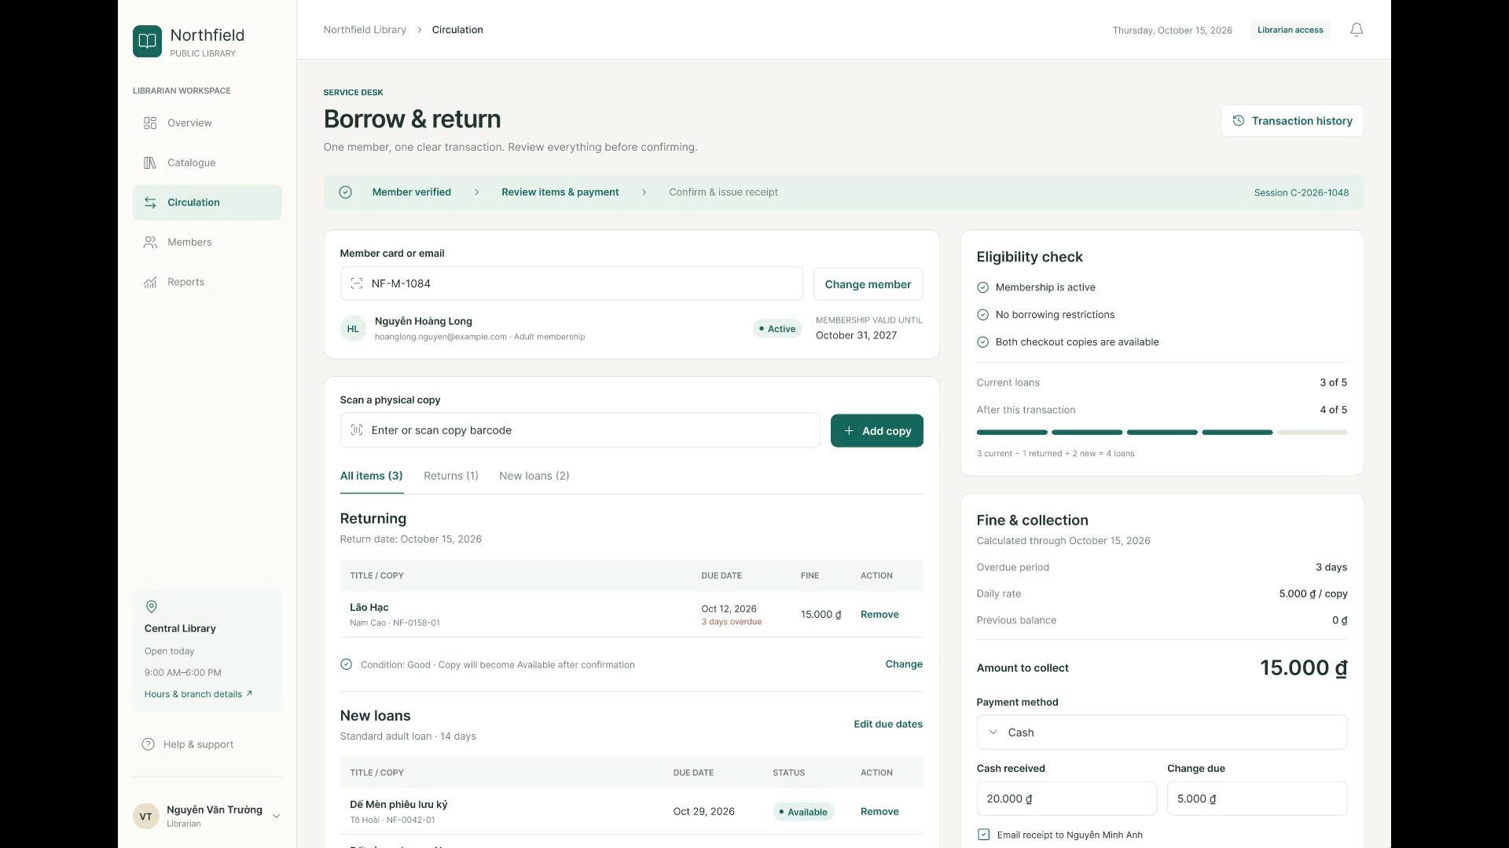
- Borrow & Return: A 3-step service desk interface for verifying member cards, scanning book barcodes for checkouts/returns, checking borrowing eligibility (up to 5 copies), and calculating overdue fines and cash change.
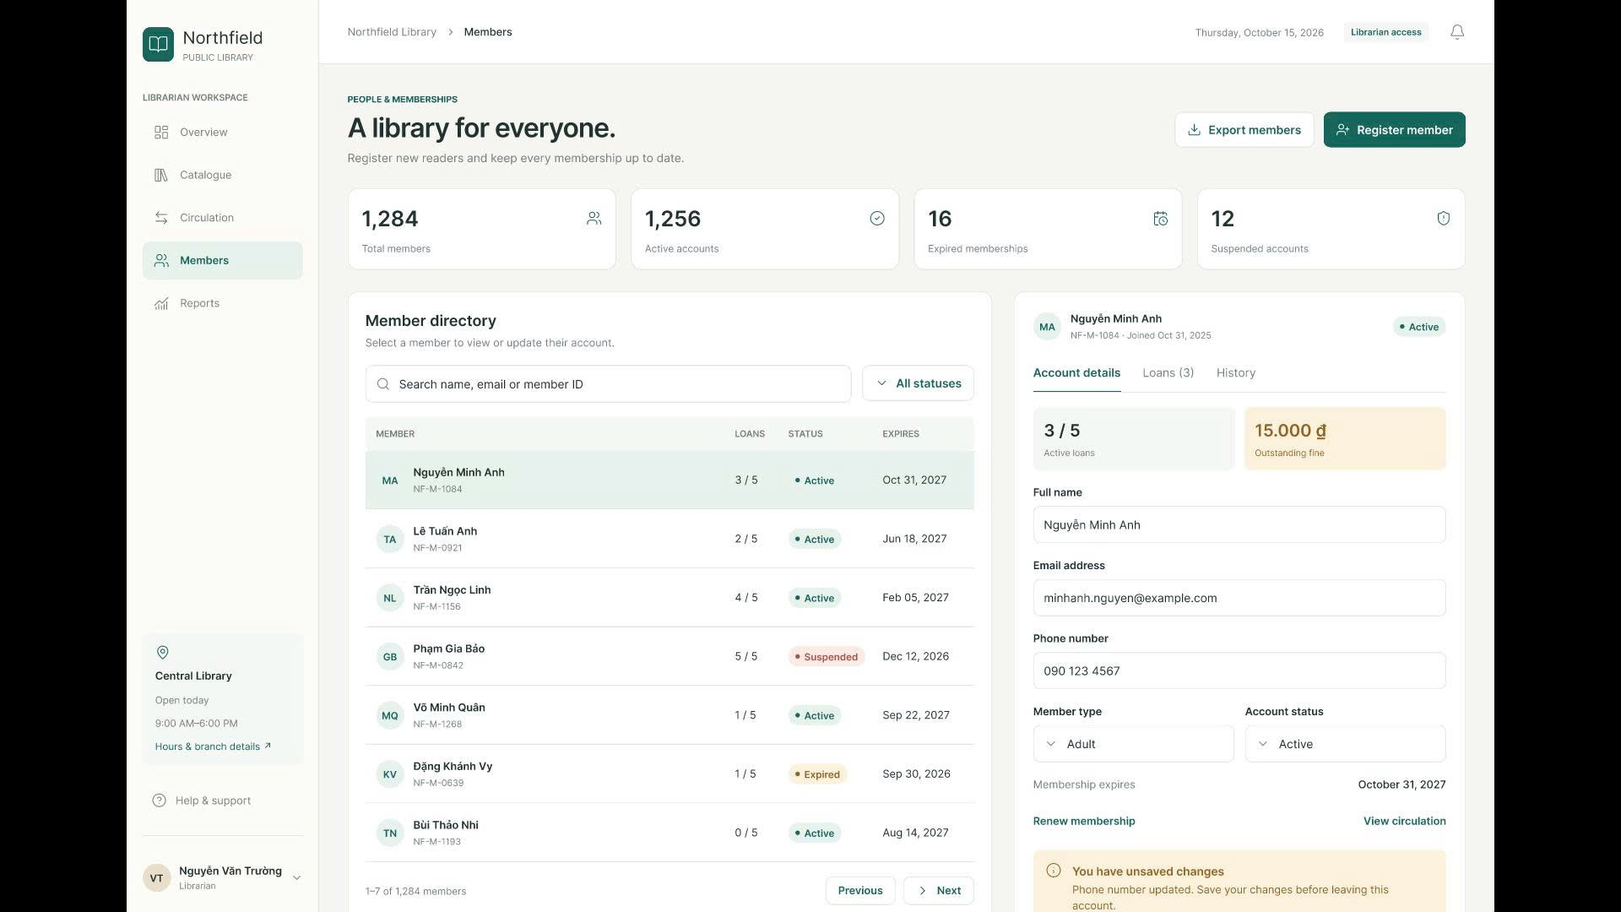
- Members Directory: Summarizes membership metrics, offering a searchable directory on the left and a detailed profile editor on the right to update member details, renew memberships, or change account statuses (Active, Suspended, Expired).

7.3 Member Workspace.
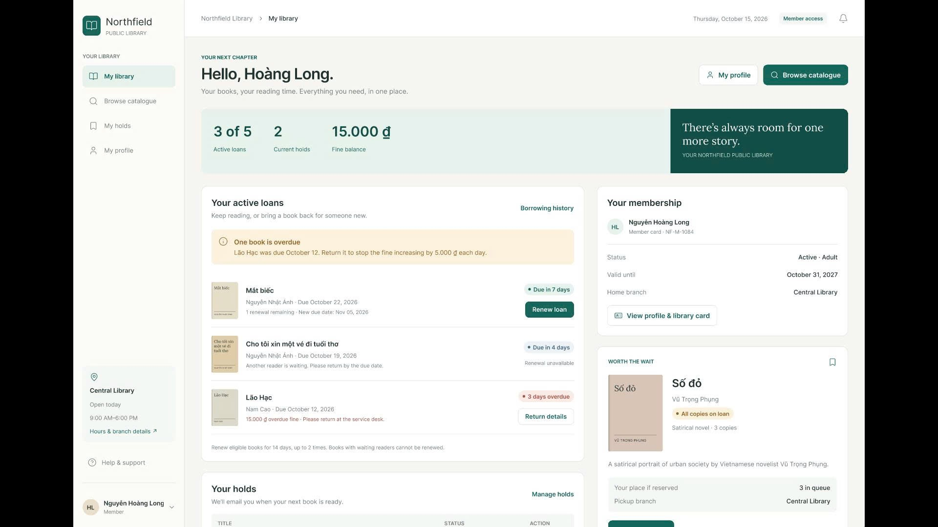
- My Library (Member Portal): A self-service dashboard displaying active loans, current holds, and fine balances. Members can renew eligible books online, view overdue warnings, access their digital library card, and place holds on popular titles.
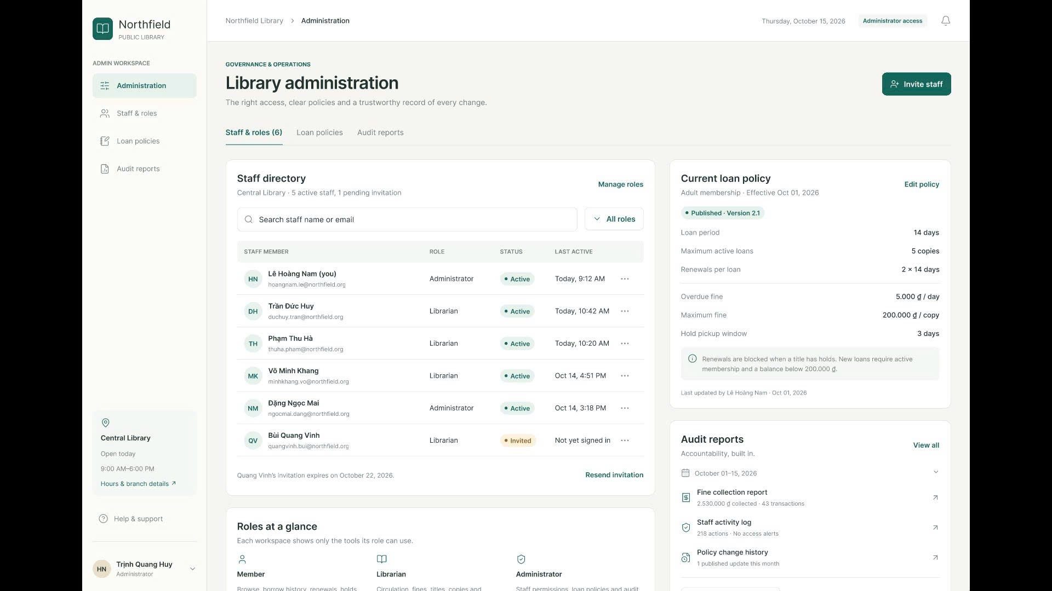
- Library Administration: Dedicated to system governance, allowing administrators to manage staff accounts, assign Role-Based Access Control (Administrator, Librarian), configure loan policy parameters (e.g., 14-day loan period, 5,000đ/day overdue fine, 200,000đ cap), and review system audit reports.

