普通状态
使用([*])绘制状态图的起点或终点。
使用-->添加箭头。
@startuml

[*] --> State1
State1 --> [*]
State1 : this is a string
State1 : this is another string

State1 -> State2
State2 --> [*]

@enduml
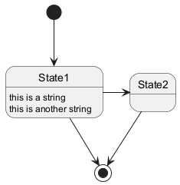
简化状态
你可以使用隐藏空描述，即 hide empty description 关键字，渲染一个简单的状态。
@startuml
hide empty description
[*] --> 状态1
状态1 --> [*]
状态1 : 这是一段字符串
状态1 : 这是另一段字符串

状态1 -> 状态2
状态2 --> [*]
@enduml
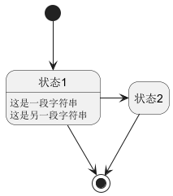
复杂状态
一个状态也可能是嵌套的，必须使用关键字state和花括号来定义复杂状态。
内部子状态
@startuml
scale 350 width
[*] --> NotShooting

state NotShooting {
[*] --> Idle
Idle --> Configuring : EvConfig
Configuring --> Idle : EvConfig
}

state Configuring {
[*] --> NewValueSelection
NewValueSelection --> NewValuePreview : EvNewValue
NewValuePreview --> NewValueSelection : EvNewValueRejected
NewValuePreview --> NewValueSelection : EvNewValueSaved

state NewValuePreview {
State1 -> State2
}

}
@enduml
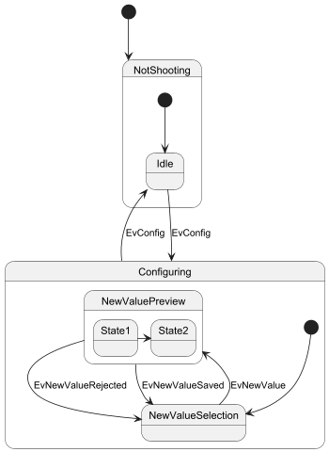
子状态间的连接
@startuml
state A {
state X {
}
state Y {
}
}

state B {
state Z {
}
}

X --> Z
Z --> Y
@enduml
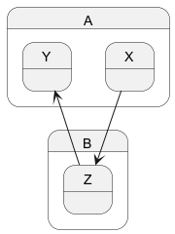
长状态名
也可以使用关键字state来给状态描述较长的状态名，并定义其指代名。
@startuml
scale 600 width

[*] -> State1
State1 --> State2 : Succeeded
State1 --> [*] : Aborted
State2 --> State3 : Succeeded
State2 --> [*] : Aborted
state State3 {
state "Accumulate Enough Data\nLong State Name" as long1
long1 : Just a test
[*] --> long1
long1 --> long1 : New Data
long1 --> ProcessData : Enough Data
}
State3 --> State3 : Failed
State3 --> [*] : Succeeded / Save Result
State3 --> [*] : Aborted

@enduml
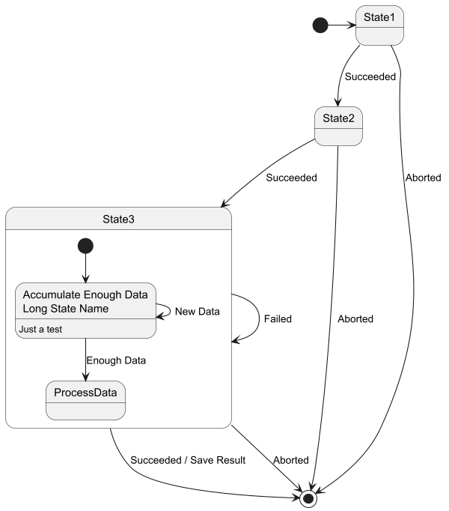
历史状态 [[H], [H*]]
在嵌套状态中，你可以用 [H] 来表示历史状态， [H*] 表示深层历史状态.
@startuml
[*] -> State1
State1 --> State2 : Succeeded
State1 --> [*] : Aborted
State2 --> State3 : Succeeded
State2 --> [*] : Aborted
state State3 {
state "Accumulate Enough Data" as long1
long1 : Just a test
[*] --> long1
long1 --> long1 : New Data
long1 --> ProcessData : Enough Data
State2 --> [H]: Resume
}
State3 --> State2 : Pause
State2 --> State3[H*]: DeepResume
State3 --> State3 : Failed
State3 --> [*] : Succeeded / Save Result
State3 --> [*] : Aborted
@enduml
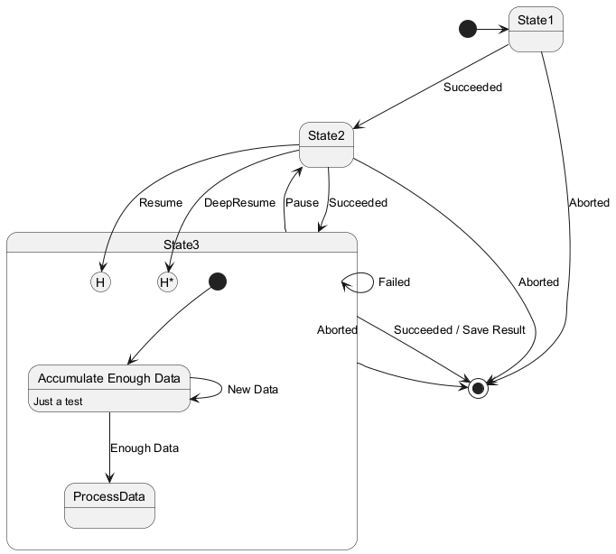
分支状态 [fork, join]
你可以使用版型 <<fork>> 和 <<join>> 来表示状态的分叉及合并。
@startuml

state fork_state <<fork>>
[*] --> fork_state
fork_state --> State2
fork_state --> State3

state join_state <<join>>
State2 --> join_state
State3 --> join_state
join_state --> State4
State4 --> [*]

@enduml
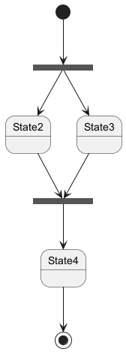
并发状态 [--, ||]
用-- or ||作为分隔符来合成并发状态。
水平分隔 --
@startuml
[*] --> Active

state Active {
[*] -> NumLockOff
NumLockOff --> NumLockOn : EvNumLockPressed
NumLockOn --> NumLockOff : EvNumLockPressed
--
[*] -> CapsLockOff
CapsLockOff --> CapsLockOn : EvCapsLockPressed
CapsLockOn --> CapsLockOff : EvCapsLockPressed
--
[*] -> ScrollLockOff
ScrollLockOff --> ScrollLockOn : EvCapsLockPressed
ScrollLockOn --> ScrollLockOff : EvCapsLockPressed
}

@enduml
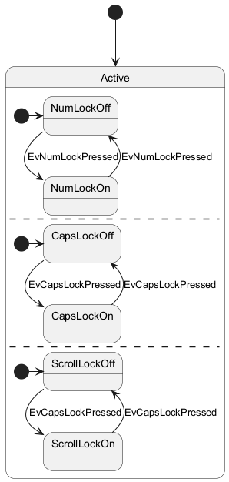
竖直分隔 ||
@startuml
[*] --> Active

state Active {
[*] -> NumLockOff
NumLockOff --> NumLockOn : EvNumLockPressed
NumLockOn --> NumLockOff : EvNumLockPressed
||
[*] -> CapsLockOff
CapsLockOff --> CapsLockOn : EvCapsLockPressed
CapsLockOn --> CapsLockOff : EvCapsLockPressed
||
[*] -> ScrollLockOff
ScrollLockOff --> ScrollLockOn : EvCapsLockPressed
ScrollLockOn --> ScrollLockOff : EvCapsLockPressed
}

@enduml
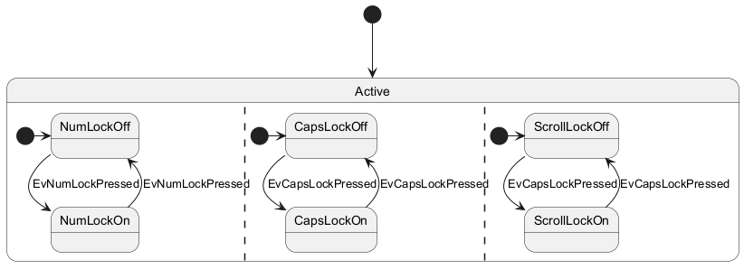
选择结点 [choice]
版型 <<choice>>可以用来表示一个选择结点，表示状态条件。
@startuml
state "Req(Id)" as ReqId <<sdlreceive>>
state "Minor(Id)" as MinorId
state "Major(Id)" as MajorId

state c <<choice>>

Idle --> ReqId
ReqId --> c
c --> MinorId : [Id <= 10]
c --> MajorId : [Id > 10]
@enduml
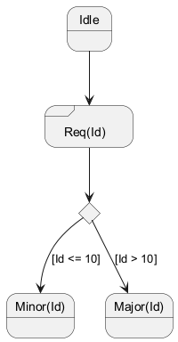
一个使用版型的完整样例 [start, choice, fork, join, end]
@startuml
state start1 <<start>>
state choice1 <<choice>>
state fork1 <<fork>>
state join2 <<join>>
state end3 <<end>>

[*] --> choice1 : from start\nto choice
start1 --> choice1 : from start stereo\nto choice

choice1 --> fork1 : from choice\nto fork
choice1 --> join2 : from choice\nto join
choice1 --> end3 : from choice\nto end stereo

fork1 ---> State1 : from fork\nto state
fork1 --> State2 : from fork\nto state

State2 --> join2 : from state\nto join
State1 --> [*] : from state\nto end

join2 --> [*] : from join\nto end
@enduml
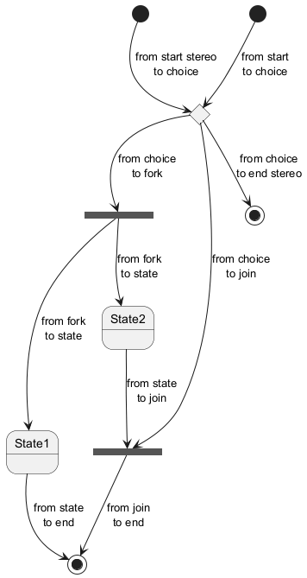
入口和出口 [entryPoint, exitPoint]
你可以用以下版型给合成状态添加入口结点<<entryPoint>>和出口结点 <<exitPoint>>。
@startuml
state Somp {
state entry1 <<entryPoint>>
state entry2 <<entryPoint>>
state sin
entry1 --> sin
entry2 -> sin
sin -> sin2
sin2 --> exitA <<exitPoint>>
}

[*] --> entry1
exitA --> Foo
Foo1 -> entry2
@enduml
