账户：

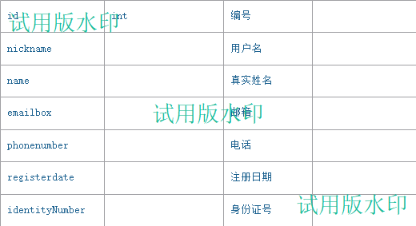

|  |  |  |  |
| --- | --- | --- | --- |
| address |  | 家庭住址 |  |

贷款信息：

|  |  |  |  |
| --- | --- | --- | --- |
|  |  | 贷款编号 |  |
|  |  | 贷款人（账户） |  |
|  |  | 贷款利率 |  |
|  |  | 还款时间 |  |
|  |  | 申请贷款金额 |  |
|  |  | 贷款类型 |  |
|  |  | 贷款时间 |  |
|  |  |  |  |