# Task 1

The same coordinates may refer to different places when different datums are used. In this exercise, you will see how the location on the earth shift when the datum is changed.

1. Open Google Maps (maps.google.com) in your web browser, and search for Statue of Liberty. Zoom in and right-click on the head of the statue, and click what’s here. You will see the coordinates of the point where you clicked.

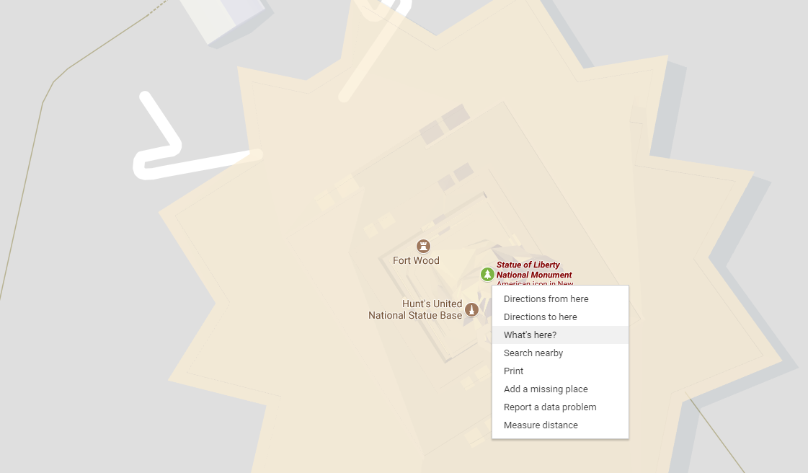

1. Click on the coordinates, **Add a Label,** and name it “Statue of Liberty”.

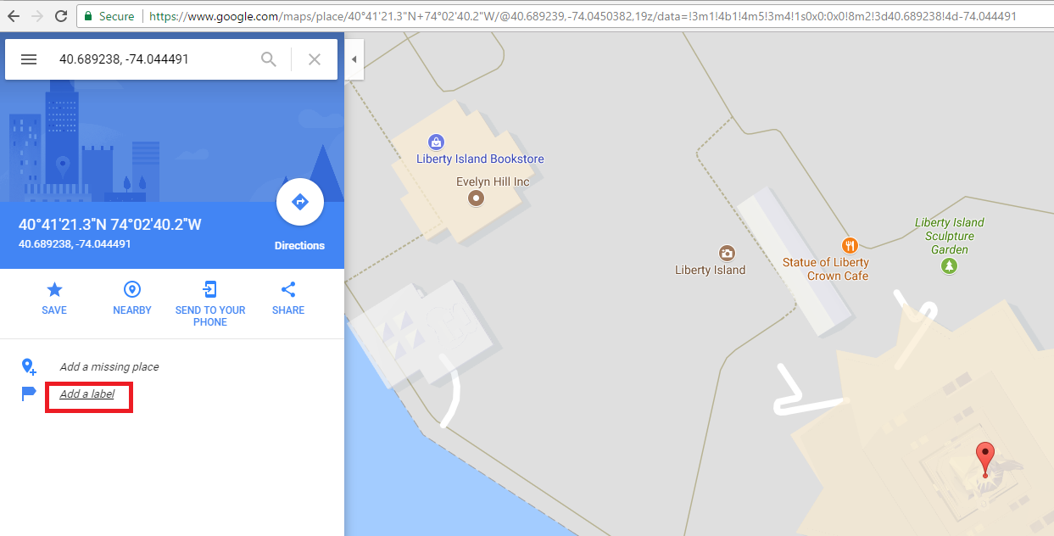

1. Open a new tab in your browser and go to the website <http://tagis.dep.wv.gov/convert/>. Copy the coordinates in Google Maps to the first text box in the website. Choose **Lat/Lon WGS 1984** in the first drop-down list. This is the datum of the coordinates that point to the head of the Statue of Liberty. (Note: Coordinates in Google Maps and Earth are using WGS 1984 datum, a global datum). Choose **Lat/Lon 27** in the second drop-down list, which is the datum the coordinates will be transformed to.

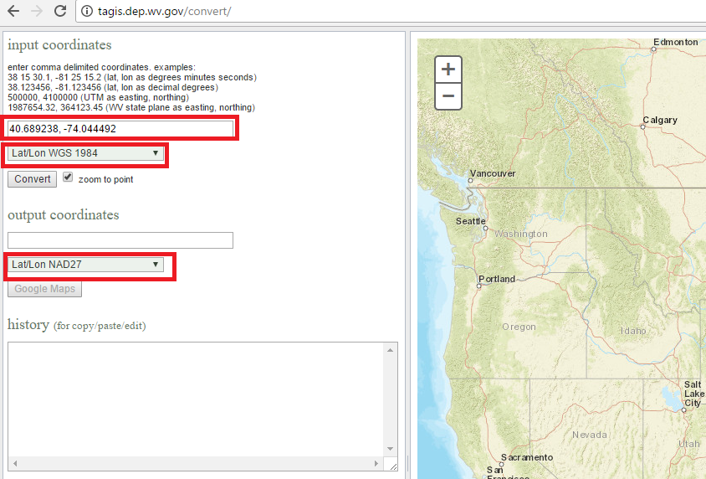

1. Click Convert, you will see coordinates showing in the text box of **output coordinates**. These coordinates refer to the location of the Statue of Liberty in the NAD27 datum, which is a local datum for the contiguous U.S. (excluding Alaska and Hawaii).
2. Copy the transformed coordinates to the search box of Google Maps, you will see the map pin is displaced from the statue. This means that the coordinates transformed to NAD27 datum point to a different location in Google Maps, which is based on the WGS1984 datum. You can right click on the new location and click **Measure distance** to see how far the location has shifted.

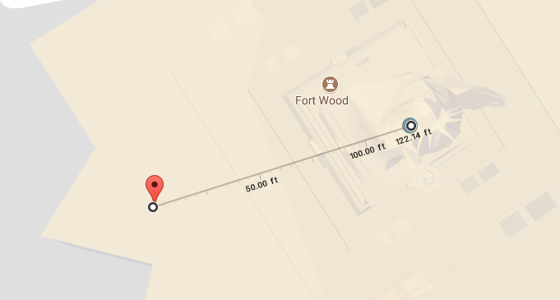

**Question 1: Use the above approach to examine the shift between the two datums (WGS1984 and NAD27) at another four locations and fill the following table. You can use landmarks at different continents as the reference locations.**

|  |  |  |  |  |
| --- | --- | --- | --- | --- |
| Location | Place name | Lat/Long in WGS1984 | Lat/Long in NAD27 | Location shift in meter |
| 1 |  |  |  |  |
| 2 |  |  |  |  |
| 3 |  |  |  |  |
| 4 |  |  |  |  |

# Task 2

Download Global Map Projector from . Unzip the folder and double-click to open **G.Projector.exe** in the folder. Open **world_topo_bathy_200407.jpg** in the **sample_maps** folder as the input map image. Then click **OK** and you will see a topographic globe.

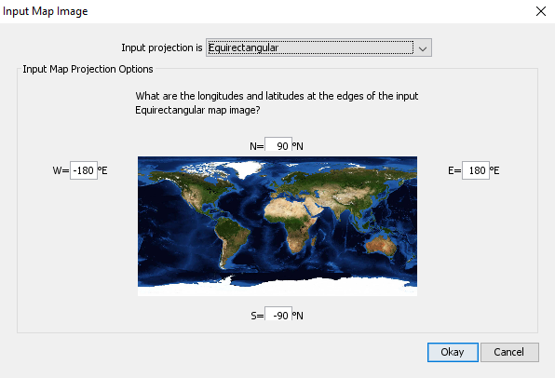

You can change map projection from the **Projection** drop-down list.

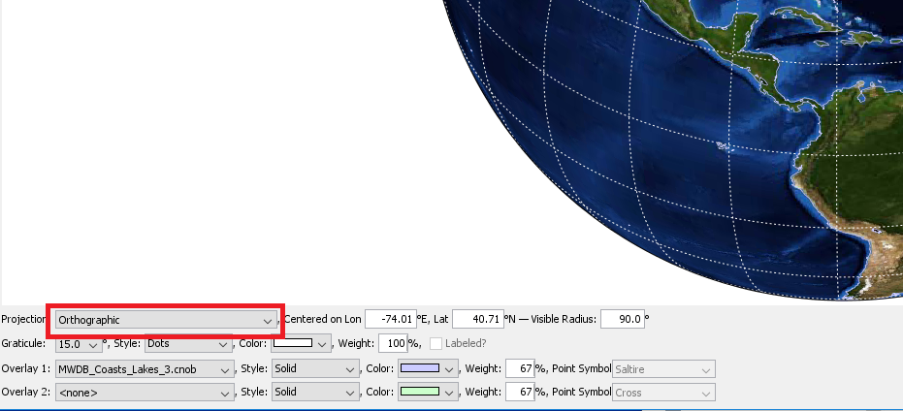

You can change **Centered on Lon/Lag** to make the globe centered at different places or change visible radius to zoom in or out.

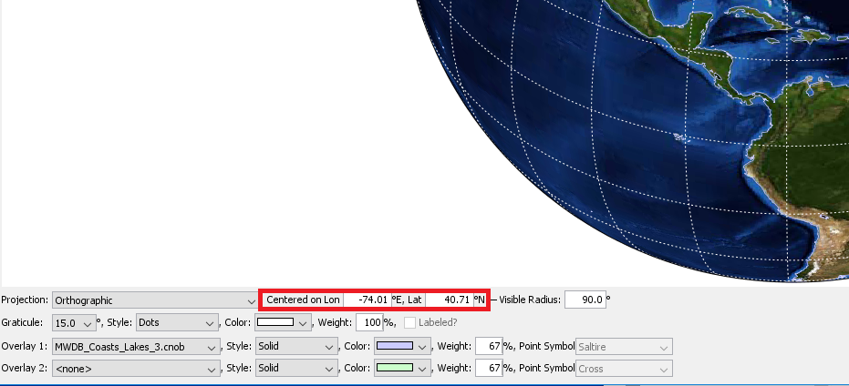

For cylindrical and conic projections, you can change the standard parallels. For conic projections, you can change the height angles.

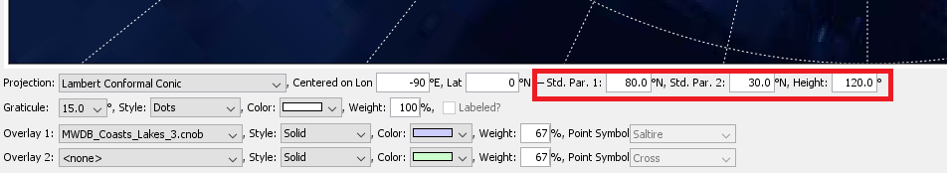

**Question 2: Change the projection of the map to ‘Orthographic projection’, ‘Mercator’, ‘Albers equal area conic’, and, ‘Mollweide’. Discuss the characteristics of these projections and their potential uses (consider what properties are preserved/distorted) (less than a page).**