# Find the least-cost path

The primary goal of this and the next exercise is to find the least-cost path for a proposed power transmission line between a fictional power plant site (Otay Valley Power Plant) and substation (Jamul Substation) in Southern California. You must balance two important considerations: keeping construction costs down and minimizing risks to public safety.

Consider the following objectives:

* The least-cost path should be primarily composed of land with shallow slope because steep terrain will increase the cost of operating construction equipment.
* On the other hand, the longer the path, the higher the construction costs; therefore, you must also consider the distance between the two sites.
* You will consider the cost of construction through various land use types. In order to minimize costly delays, you will try to avoid construction in possibly contentious areas, such as residential locations, commercial zones, and open space preserves.
* For safety reasons, power lines should not be located near certain areas, such as airports and lakes.

The process of preparing a total cost surface involves deriving surfaces from existing surfaces. You will need to add the slope and land use layers in order to create your total cost surface. First, you must reclassify their value ranges to a common scale. In this case, you will use a scale of 1 to 10, where 1 indicates best and 10 indicates worst.

## Determine source and destination

Start ArcMap.

Open the FindPath.mxd located in the data folder. The map opens showing the area of southern California where you will be working. The dashed red line in the lower-left corner represents an existing power line.

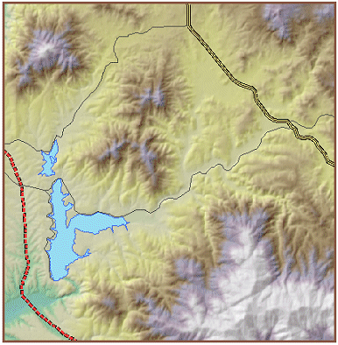

Now you will set the default geodatabase for your map. Open the **Catalog** window. Create a folder connection to the data folder, if necessary.

In **Catalog**, expand the data folder, right-click Otay.gdb, and choose Make Default Geodatabase.

In order to determine an optimum path, first you need to identify two points: where the path will begin and where the path will end.

Turn on the Otay Valley Power Plant layer.